Massachusetts Department of Public Health
Bureau of Infectious Disease and Laboratory Sciences
Massachusetts HIV Epidemiologic Profile: Data as of 1/1/2022
Population Report: Women, Accessible Version, optimized for screen reader use
Please note that while the content of this report is the same as the PDF version, the format and pagination have been modified significantly to optimize use with screen readers to ensure access for blind or visually impaired audiences.
Suggested citation:
Massachusetts Department of Public Health, Bureau of Infectious Disease and Laboratory Sciences. Massachusetts HIV Epidemiologic Profile: Data as of 1/1/2022, Population Report: Women, https://www.mass.gov/lists/hivaids-epidemiologic-profiles Published April 2023. Accessed [date].
Bureau of Infectious Disease and Laboratory Sciences
Massachusetts Department of Public Health
Jamaica Plain Campus/State Public Health Laboratory
305 South Street
Jamaica Plain, MA 02130
Questions about this report
Tel: (617) 983-6560
To reach the Reporting and Partner Services Line
Tel: (617) 983-6999
To speak to the on-call epidemiologist
Tel: (617) 983-6800
Questions about infectious disease reporting
Tel: (617) 983-6801
Requests for additional data
https://www.mass.gov/lists/infectious-disease-data-reports-and-requests
Slide sets for HIV Epidemiologic Profile Reports
https://www.mass.gov/lists/hivaids-epidemiologic-profiles
Please note the following data among women represent that of individuals assigned female at birth (AFAB) only and therefore do not represent the gender identity or expression of transgender women (N=17 transgender women diagnosed with HIV infection from 2018 – 2020 and N=129 transgender women living with HIV infection in Massachusetts as of 12/31/2020, according to data current as of 1/1/2022). These data may include transgender men diagnosed with HIV infection, who were assigned female sex at birth.
WOMEN AT A GLANCE
N=448, 27% of 1,635 new HIV diagnoses from 2018–2020 were among individuals AFAB
N=6,722, 29% of 23,368 persons living with HIV infection in MA as of 12/31/2020 were individuals AFAB

RACE/ETHNICITY
FIGURE 1. Percentage of individuals AFAB diagnosed with HIV infection by race/ethnicity, Massachusetts 2018–2020 (N=448)
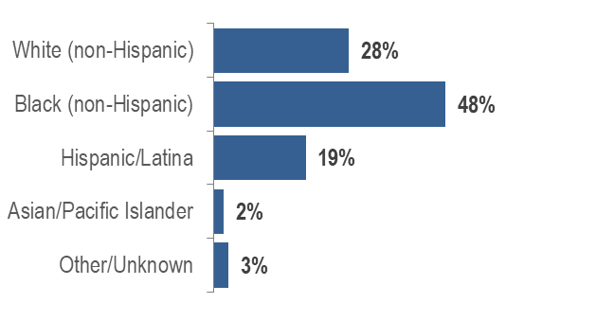
- Sixty-seven percent of individuals AFAB recently diagnosed with HIV infection were either black (non-Hispanic) or Hispanic/Latina.
- Forty-seven percent of individuals AFAB living with HIV infection were black (non-Hispanic), 28% were Hispanic/Latina, 23% were white (non-Hispanic), and 3% were other/unknown race/ethnicity.
FIGURE 2. Average age-adjusted rate of HIV infection diagnosis per 100,000 population among individuals AFAB by race/ethnicity, Massachusetts 2018–2020
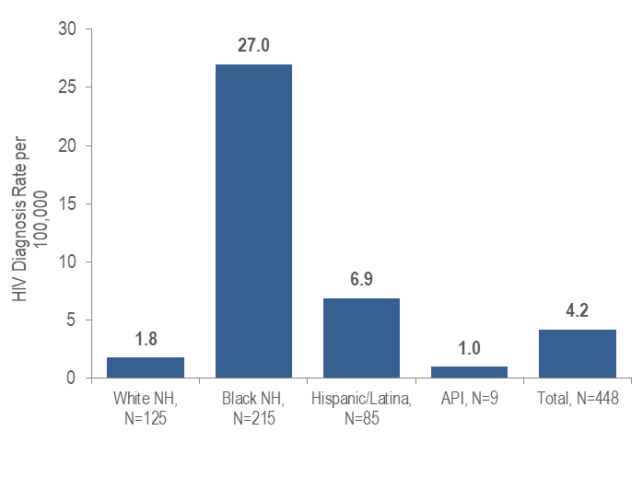
Note: Total includes other/unknown race/ethnicities (N=14)
KEY FINDING
- The average annual age-adjusted HIV diagnosis rate for 2018 to 2020 among black (non-Hispanic) individuals AFAB was 15 times, and among Hispanic/Latina individuals AFAB was four times, that of white (non-Hispanic) individuals AFAB.
FIGURE 3. Age-adjusted HIV prevalence rate per 100,000 population among individuals AFAB by race/ethnicity, Massachusetts 2020
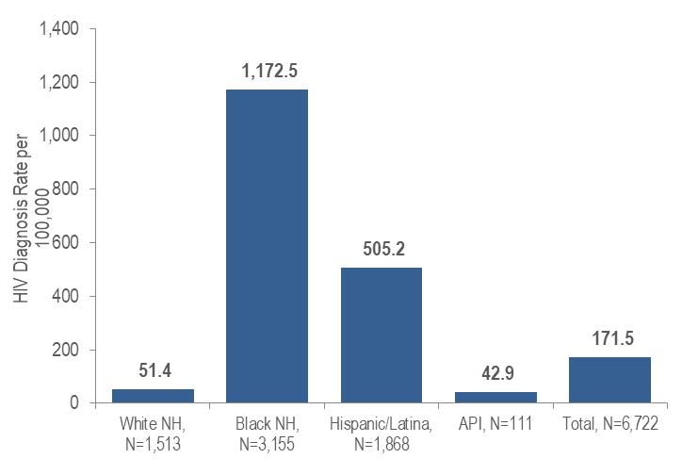
Note: Total includes other/unknown race/ethnicities (N=75)
KEY FINDING
- The age-adjusted prevalence rate of HIV infection among black (non-Hispanic) individuals AFAB was 23 times, and among Hispanic/Latina individuals AFAB was 10 times, greater than the rate among white (non-Hispanic) individuals AFAB.

EXPOSURE MODE
- Thirty-five percent of 448 individuals AFAB diagnosed with HIV infection during 2018 to 2020 were reported with no identified risk, 25% with presumed heterosexual exposure mode, 20% with injection drug use, 19% with heterosexual sex, and less than 1% with other exposure modes.
- Thirty-five percent of 6,722 individuals AFAB living with HIV infection on 12/31/2020 were reported with heterosexual exposure mode, 31% with presumed heterosexual, 19% with injection drug use, 12% with no identified risk, and 3% with other exposure modes.
FIGURE 4. Individuals AFAB diagnosed with HIV infection by race/ethnicity and exposure mode, Massachusetts 2018–2020
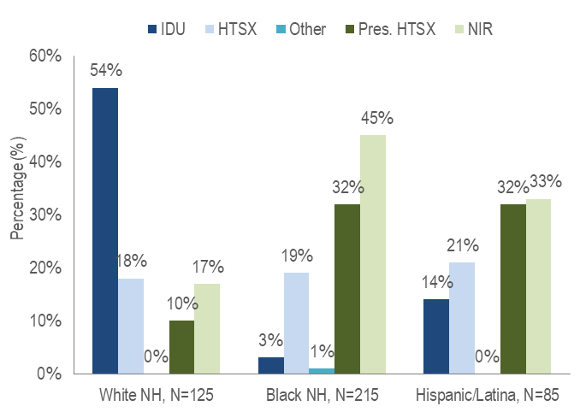
Note: IDU=injection drug use; HTSX=heterosexual sex; Pres. HTSX=presumed heterosexual exposure, includes individuals assigned female at birth with a negative history of injection drug use who report having sex with an individual that identifies as male of unknown HIV status and risk; NIR=no identified risk; NH=non-Hispanic
- Injection drug use was the predominant exposure mode among white (non-Hispanic) individuals AFAB recently diagnosed with HIV infection, while NIR, followed by presumed heterosexual sex, accounted for the largest proportions among both black (non-Hispanic) and Hispanic/Latina individuals AFAB.

PLACE OF BIRTH
- Fifty-one percent of 448 individuals AFAB diagnosed with HIV infection during 2018 to 2020 were born outside the US [compared to 33% of 1,187 individuals assigned male at birth (AMAB)], 47% were born in the US (compared to 63% of individuals AMAB), and 2% were born in Puerto Rico (compared to 4% of individuals AMAB).
- Forty-seven percent of 6,722 individuals AFAB living with HIV infection on 12/31/2020 were born in the US (compared to 66% of 16,646 individuals AMAB), 41% were born outside the US (compared to 25% of individuals AMAB), and 12% were born in Puerto Rico/US Dependency (compared to 9% of individuals AMAB).
FIGURE 5. Percentage of individuals AFAB diagnosed with HIV infection by race/ethnicity and place of birth, Massachusetts 2018–2020

KEY FINDING
- Seventy-two percent of black (non-Hispanic) individuals AFAB recently diagnosed with HIV infection were born outside the US, compared to 51% of Hispanic/Latina and ten percent of white (non-Hispanic) individuals AFAB. An additional nine percent of Hispanic/Latina individuals AFAB were born in Puerto Rico compared to less than one percent of white (non-Hispanic) and no black (non-Hispanic) individuals AFAB.

AGE
FIGURE 6. Percentage of individuals AFAB diagnosed with HIV infection by age at diagnosis (years), Massachusetts 2018–2020 (N=448)
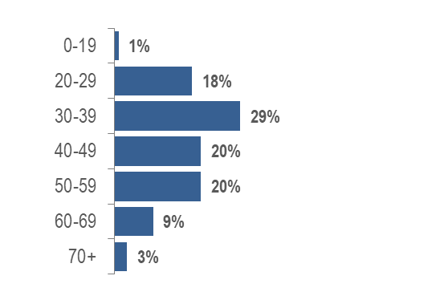
- Individuals AFAB newly diagnosed with HIV infection in Massachusetts during 2018 to 2020 were predominantly in their thirties, forties, and fifties (29% 30–39 year-olds, 20% 40–49 year-olds, and 20% 50-59 year olds).
- Individuals AFAB living with HIV infection on 12/31/2020 were predominantly 50 years of age or above (1% 0–19 years, 4% 20–29 years, 12% 30–39 years, 22% 40–49 years, 34% 50–59 years, 21% 60–69 years, and 6% 70+ years).

AREA OF RESIDENCE
TABLE 1. Massachusetts cities/towns with the highest percentage of HIV diagnoses among individuals AFAB, 2018–2020
 | HIV Diagnoses Among individuals AFAB (N) | HIV Diagnoses Among Individuals AFAB as Percent of Total HIV Diagnoses in City/Town (%)
Massachusetts Total | 443 | 27%
Top Cities/Towns
Brockton | 42 | 51%
Lowell | 25 | 38%
Everett | 12 | 35%
Worcester | 31 | 33%
Lawrence | 17 | 33%
Framingham | 7 | 30%
Waltham | 7 | 30%
New Bedford | 8 | 29%
Fall River | 9 | 28%
Lynn | 12 | 28%
All Other Cities/Towns | 278 | 24%
- Among cities and towns with at least 20 reported HIV diagnoses during 2018 to 2020, Brockton had the highest percentage of HIV diagnoses among individuals AFAB at 51%.
INFORMATION FROM ADDITIONAL DATA SOURCES
Behavioral Risk Factors: Recent statewide surveys describe sexual and drug use behaviors among individuals AFAB in Massachusetts.
Massachusetts Behavioral Risk Factor Surveillance Survey (BRFSS): A continuous anonymous telephone survey of adults ages 18 and older that collects data on a variety of health risk factors, preventive behaviors, chronic conditions, and emerging public health issues.
- Among sexually active individuals AFAB ages 18–64 years from 2018 to 2020:
  - 21.5% (95% confidence interval [CI]: 19.2%–23.9%) reported condom use at their last sexual encounter, compared to 27.0% (95% CI: 24.6%–29.5%) of individuals AMAB; and
  - 8.5% (95% CI: 7.0%–10.0%) reported two or more sexual partners in the past year, 66.8% (95% CI: 64.6%–69.1%) reported one partner, and 24.7% (95% CI: 22.6%–26.7%) reported none; compared to 12.8% (95% CI: 11.2%–14.5%), 65.1% (95% CI: 62.7%–67.4%), and 22.1% (95% CI: 20.1%–24.2%), respectively, of individuals AMAB.
Data Source: Office of Data Management and Outcomes Assessment, Massachusetts Behavioral Risk Factor Surveillance System (BRFSS). For more information, see: Office of Data Management and Outcomes Assessment, Massachusetts Department of Public Health. A Profile of Health Among Massachusetts Adults, 2020, Results from the Behavioral Risk Factor Surveillance System, January 2022, https://www.mass.gov/doc/a-profile-of-health-among-massachusetts-adults-2020/download
Massachusetts Youth Risk Behavior Survey (YRBS): An anonymous survey of public high school students conducted every odd year that collects data on health-related behaviors that may threaten the health and safety of young people.
Sexual behaviors
- Respondents AFAB to the 2019 YRBS were significantly more likely than respondents AMAB to report ever experiencing sexual violence: 13.6% (95% CI: 11.0%–16.6%, n=975) vs. 5.8% (95% CI: 4.0%–8.4%, n=945).
- Respondents AFAB to the 2019 YRBS were significantly less likely than respondents AMAB to report:
  - having sexual intercourse before age 13: 1.0% (95% CI: 0.5%–2.0%, n=1,031) vs. 3.9% (95% CI: 2.5%–6.1%, n=909);
  - alcohol or drug use at last intercourse: 17.7% (95% CI: 13.3%–23.1%, n=219) vs. 29.5% (95% CI: 23.3%–36.7%, n=211).
- Respondents AFAB to the 2019 YRBS reported the following rates of sexual behaviors (none differed significantly from rates reported among respondents AMAB):
  - ever having sexual intercourse: 36.2% (95% CI: 30.9%–41.9%, n=1,030);
  - having four or more lifetime sexual partners: 6.3% (95% CI: 4.4%–9.0%, n=1,026);
  - not using any method to prevent pregnancy at last intercourse: 9.7% (95% CI: 6.3%–14.6%, n=211);
  - using a condom at last intercourse: 44.5% (95% CI: 37.5%–51.7%, n=215);
  - ever being tested for HIV infection: 12.8% (95% CI: 10.4%–15.6%, n=1,072).
Drug use
Both injection and non-injection substance use have been documented to increase risk for HIV and hepatitis C virus infection.
- Respondents AFAB to the 2019 YRBS reported the following rates of drug use (none differed significantly from rates reported among respondents AMAB):
  - ever using marijuana: 41.7% (95% CI: 36.3%–47.3%, n=979);
  - ever using cocaine: 2.4% (95% CI: 1.6%–3.6%, n=982);
  - ever using heroin: 1.1% (95% CI: 0.4%–2.8%, n=1,101);
  - ever using ecstasy: 2.8% (95% CI: 1.7%–4.8%, n=982);
  - ever using methamphetamines: 1.0% (95% CI: 0.5%–1.9%, n=1,104).
Data Source: Centers for Disease Control and Prevention (CDC). 2019 High School Youth Risk Behavior Survey Data. Available at http://nccd.cdc.gov/youthonline/. Accessed on 9/2/2020, CDC, Accessed at Youth Online, https://nccd.cdc.gov/Youthonline/App/Default.aspx.
HIV Surveillance Data Source: MDPH Bureau of Infectious Disease and Laboratory Sciences, data are current as of 1/1/2022 and may be subject to change

Providers may use this number to report individuals newly diagnosed with a notifiable sexually transmitted infection, including HIV, or request partner services. Partner services is a free and confidential service for individuals recently diagnosed with a priority infection. The client-centered program offers counseling, linkage to other health and social services, anonymous notification of partners who were exposed and assistance with getting testing and treatment. For more information, see: https://www.mass.gov/service-details/partner-services-program-information-for-healthcare-providers)
Please consider the impact of the COVID-19 pandemic on infectious disease screening, treatment, and surveillance in the interpretation of 2020 data
As of 1/1/2020, BIDLS calculates rates per 100,000 population using denominators estimated by the University of Massachusetts Donahue Institute using a modified Hamilton-Perry model (Strate S, et al. Small Area Population Estimates for 2011 through 2020, report published Oct 2016). Note that rates and trends calculated using previous methods cannot be compared to these. All rates are age-adjusted using the 2000 US standard population.
Please consider the impact of the COVID-19 pandemic on infectious disease screening, treatment, and surveillance in the interpretation of 2020 data
As of 1/1/2020, BIDLS calculates rates per 100,000 population using denominators estimated by the University of Massachusetts Donahue Institute using a modified Hamilton-Perry model (Strate S, et al. Small Area Population Estimates for 2011 through 2020, report published Oct 2016). Note that rates and trends calculated using previous methods cannot be compared to these. All rates are age-adjusted using the 2000 US standard population.
Please consider the impact of the COVID-19 pandemic on infectious disease screening, treatment, and surveillance in the interpretation of 2020 data
Please consider the impact of the COVID-19 pandemic on infectious disease screening, treatment, and surveillance in the interpretation of 2020 data
All individuals diagnosed with HIV infection from 2018–2020 and 98% of persons living with HIV infection on 12/31/20 who were born in a US dependency were born in Puerto Rico, PR/USD = Puerto Rico/US Dependency
Please consider the impact of the COVID-19 pandemic on infectious disease screening, treatment, and surveillance in the interpretation of 2020 data
City/town is based on residence at HIV infection diagnosis
All Other Cities/Towns includes individuals diagnosed in a correction facility

