INDOOR AIR QUALITY ASSESSMENT
Woodland School
80 Powder Mill Road
Southwick, Massachusetts

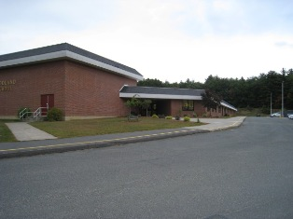

Prepared by:
Massachusetts Department of Public Health
Bureau of Environmental Health
Indoor Air Quality Program
February 2010

Background/Introduction
At the request of Thomas Fitzgerald, Health Agent for the Southwick Board of Health, the Massachusetts Department of Public Health (MDPH), Bureau of Environmental Health (BEH) provided assistance and consultation regarding indoor air quality concerns at Woodland Elementary School (WES), 80 Powder Mill Road, Southwick, Massachusetts. The request was prompted by parental concerns regarding indoor air quality.
On September 28, 2009 a visit to conduct an assessment was made to the WES by Lisa Hébert, Environmental Analyst/Indoor Air Quality Inspector in BEH’s Indoor Air Quality (IAQ) Program. Ms. Hébert was accompanied by Eric Morgan, Supervisor of Buildings and Grounds, during the assessment.
The school is a single-story brick structure built in 1959 that originally contained 20 classrooms. A small addition on the north side of the building was constructed in 1962 that added six classrooms (north wing). In 1990, a renovation included the addition of a wing on the south side of the building containing the gymnasium, and classrooms 31 through 43 (south wing). In 2004, three portable classrooms (Rooms 44-46) were added onto the northwest side of the building (northwest wing). The WES has a rubber membrane roof.
Methods
Air tests for carbon monoxide, carbon dioxide, temperature and relative humidity were conducted with the TSI, Q-Trak, IAQ Monitor, Model 7565. BEH staff also performed visual inspection of building materials for water damage and/or microbial growth. Moisture content of porous building materials was measured with a Delmhorst, BD-2100 Model, Moisture Detector equipped with a Delmhorst Standard Probe.
Results
The WES has an employee population of approximately 70 and serves 640 children in grades Pre-K through fourth. Tests were taken under normal operating conditions and air sampling results appear in Table 1. Moisture meter readings appear in Table 2.
Discussion
Ventilation
It can be seen from Table 1 that carbon dioxide levels were above 800 parts per million (ppm) in 8 of 59 areas at the time of the assessment, indicating adequate air exchange in the majority of areas surveyed. It is important to note that several classrooms had open windows and were empty/sparsely populated, which can greatly reduce carbon dioxide levels. Carbon dioxide levels would be expected to increase with full occupancy and windows closed.
Fresh air is supplied to the original section of the WES by means of an air handling unit (AHU). Fresh air enters these classrooms via ceiling mounted fresh air diffusers (Picture 1). Air is returned to the AHU by means of a plenum located below floor level (Picture 2). Both subsequent additions were provided with fresh air by means of unit ventilators (Picture 3). Both systems exhaust air via rooftop motors. WES staff informed BEH that the south wing does not have a mechanical exhaust; however a passive system consisting of vents and ductwork was present.
Numerous exhausts were found obstructed by classroom items and personal belongings, including the return vent located in the closet of the cafeteria. Likewise, several unit ventilators were also obstructed by classroom items. These conditions impede proper functioning of the ventilation system. At the time of the assessment, school staff reported that the HVAC contractor hired to perform work at the WES discovered that heating coils were in need of cleaning in the south wing and a HVAC system timer was set improperly to activate exhaust fans in the north wing. Once the timer was adjusted, the exhaust system in the north wing began to function properly.
The three modular classrooms are ventilated by means of separate roof mounted AHUs (Picture 4). At least one modular classroom contained a thermostat set to the “auto” position. The automatic setting on the thermostat activates the HVAC system at a preset temperature. Once a preset temperature is measured by the thermostat, the HVAC system is deactivated. Therefore no mechanical ventilation is provided until the thermostat re-activates the system. Spacers were lacking between filters in the AHUs. The existence of space between the filters allows for air to by-pass the installed filters, resulting in aerosolization of materials (e.g. dust).
To maximize air exchange, the MDPH recommends that both supply and exhaust ventilation operate continuously during periods of school occupancy. In order to have proper ventilation with a mechanical supply and exhaust system, the systems must be balanced to provide an adequate amount of fresh air to the interior of a room while removing stale air from the room. It is recommended that HVAC systems be re-balanced every five years to ensure adequate air systems function (SMACNA, 1994). The date of the last balancing of these systems was not available at the time of the assessment.
The Massachusetts Building Code requires that each room have a minimum ventilation rate of 15 cubic feet per minute (cfm) per occupant of fresh outside air or openable windows (SBBRS, 1997; BOCA, 1993). The ventilation must be on at all times that the room is occupied. Providing adequate fresh air ventilation with open windows and maintaining the temperature in the comfort range during the cold weather season is impractical. Mechanical ventilation is usually required to provide adequate fresh air ventilation.
Carbon dioxide is not a problem in and of itself. It is used as an indicator of the adequacy of the fresh air ventilation. As carbon dioxide levels rise, it indicates that the ventilating system is malfunctioning or the design occupancy of the room is being exceeded. When this happens, a buildup of common indoor air pollutants can occur, leading to discomfort or health complaints. The Occupational Safety and Health Administration (OSHA) standard for carbon dioxide is 5,000 parts per million parts of air (ppm). Workers may be exposed to this level for 40 hours/week, based on a time-weighted average (OSHA, 1997).
The MDPH uses a guideline of 800 ppm for publicly occupied buildings. A guideline of 600 ppm or less is preferred in schools due to the fact that the majority of occupants are young and considered to be a more sensitive population in the evaluation of environmental health status. Inadequate ventilation and/or elevated temperatures are major causes of complaints such as respiratory, eye, nose and throat irritation, lethargy and headaches. For more information concerning carbon dioxide, consult Appendix A.
Temperature measurements in the school ranged from 71° F to 77° F, which were within the MDPH recommended range in all of the areas surveyed (Table 1). The MDPH recommends that indoor air temperatures be maintained in a range of 70° F to 78° F in order to provide for the comfort of building occupants. In many cases concerning indoor air quality, fluctuations of temperature in occupied spaces are typically experienced, even in a building with an adequate fresh air supply.
The relative humidity measured in the building ranged from 48 to 69 percent at the time of the assessment, which was within the MDPH recommended comfort range in the large majority of (47 of 59) areas at the time of the assessment (Table 1). The MDPH recommends a comfort range of 40 to 60 percent for indoor air relative humidity. Relative humidity levels in the building would be expected to drop during the winter months due to heating. The sensation of dryness and irritation is common in a low relative humidity environment. Low relative humidity is a very common problem during the heating season in the northeast part of the United States.
Microbial/Moisture Concerns
Numerous exterior conditions may contribute to moisture entering the WES. BEH staff examined the exterior of the building to identify conditions in or around the building envelope that could provide a source of water penetration. Several potential sources were identified:
- Standing water was noted on all areas of the roof, but was particularly evident on the roof of the modular classrooms (Picture 5). A portion of the standing water drains off of the flat roof and onto the pitched roof of the hallway that runs outside of the modular units. From there, the water spills onto the pavement and splashes up onto the exterior walls of the modular units. Portions of the units exhibited buckled, water damaged exterior siding (Picture 6).
- Deterioration was observed in sections of the roof membrane (Picture 7).
- Roof drains were obstructed by a heavy accumulation of moss and accumulated debris (Picture 8). Moss was also evident on areas of the roof proper, on the modular unit siding and at the juncture of the pavement and the building. The presence of moss on the roof shown in Picture 9 is indicative of repeated and sustained water exposure. The two main requirements of moss growth are substantial moisture and accessible nutrients. “For example, the moist environment of a rooftop shaded by trees seems just fine for mosses, [which] prefer to colonize shingles above the eaves, on detritus that builds up in the eaves' troughs or other depressions. Mosses will be at their best in the winter when there is plenty of water, little light, and low temperatures” (OSU, 2000).
- Rooftop gutters are missing/in disrepair (Picture 10).
- A downspout missing its elbow extension terminates at the base of a modular classroom (Picture 11).
- An open utility hole was observed on the exterior of the building (Picture 12).
- Weep holes were observed to be obstructed (Picture 13). Exterior wall systems should be designed to prevent moisture penetration into the building interior. An exterior wall system should consist of an exterior curtain wall (Figure 1). Behind the curtain wall is an air space that allows for water to drain downward and for the exterior cladding system to dry. In order to allow for water to drain from the exterior brick system, a series of weep holes is customarily installed in the exterior wall, at or near the foundation slab/exterior wall system junction. Weep holes allow for accumulated water to drain from a wall system (Dalzell, 1955). Opposite the exterior wall and across the air space is a continuous, water-resistant material adhered to the back up wall that forms the drainage plane. The purpose of the drainage plane is to prevent moisture that crosses the air space from penetrating the interior of the building. The plane also directs moisture downwards toward the weep holes. The drainage plane can consist of a number of water-resistant materials, such as tarpaper or, in newer buildings, plastic wraps (Figure 1). The drainage plane should be continuous. Where breaks exist in the drainage plane (e.g., window systems, door systems, air intakes), additional materials (e.g., flashing) are installed as transitional surfaces to direct water to weep holes. If the drainage plane is discontinuous, missing flashing or lacking air space, rainwater may accumulate inside the wall cavity and lead to moisture penetration into the building (Figure 2).
- Efflorescence was observed on portions of exterior brick (Picture 14). Efflorescence is a characteristic sign of water intrusion. As penetrating moisture works its way through mortar around brick, it leaves behind characteristic mineral deposits. (It is important to stress that while efflorescence is an important sign of water intrusion, it is not mold growth).
- Some mortar around exterior brick was missing and/or damaged.
- Caulking is damaged and deteriorated on windows and in expansion joints.
- Peeling paint was observed on the soffit (Picture 15). This condition allows moisture to enter the building envelope.
- A leaking faucet was observed on the exterior of the building.
- Trees and plants were observed growing in close proximity to the building (Pictures 16 and 17). The growth of roots against exterior walls can bring moisture in contact with the foundation. Plant roots can eventually penetrate, leading to cracks and/or fissures in the sublevel foundation.
The aforementioned conditions represent potential water penetration sources. Over time, these conditions can undermine the integrity of the building envelope and provide a means of water entry into the building via capillary action through foundation concrete and masonry (Lstiburek & Brennan, 2001). In addition, these breaches may provide a means for pests/rodents to enter the building.
Several potential sources of water damage and/or mold growth were observed indoors at the WES. Water damaged ceiling tiles were observed throughout the WES (Table 1/Picture 18). Some of these tiles appeared to have been painted over rather than replaced. Water-damaged ceiling tiles can provide a source of mold and should be replaced after a water leak is discovered and repaired.
It was reported by WES staff that the carpets located in the modular classrooms were wet cleaned during the late summer; however, they do not appear to have been properly dried. As a result, two days prior to school opening, musty odors were discovered in these classrooms. BEH staff observed darkened surfaces on some areas of carpet (Picture 19). In an effort to ascertain moisture content of carpeting within these classrooms, moisture content was measured with a Delmhorst Moisture Detector equipped with a Delmhorst Standard Probe. The Delmhorst probe is equipped with three lights that function as visual aids that indicate moisture level. Readings that activate the green light indicate a sufficiently dry or low moisture level, those that activate the yellow light indicate borderline conditions and those that activate the red light indicate elevated moisture content.
Materials with increased moisture content over normal concentrations may indicate the possible presence of mold growth. Two of the three modular classrooms were observed to have elevated moisture content in the carpets at the time of the assessment (Table 2). These moisture samples would indicate that the carpeting remained moistened for nearly 3 weeks. In order for building materials to support mold growth, a source of water exposure is necessary. Identification and elimination of the source of water moistening building materials is necessary to control mold growth.
Please note, moisture content is detected as a real time measurement of the conditions present in the building at the time of the assessment. The building was evaluated on a partly cloudy day, with an outdoor temperature of 66° F and relative humidity of 73 percent. Moisture content of materials may increase or decrease depending on building and weather conditions. For example, during the normal operation of a heating, ventilating and air-conditioning (HVAC) system, moisture is introduced into a building during weather with high relative humidity. As indoor relative humidity levels increase, porous building materials, such as GW, plywood or carpeting, can absorb moisture. The moisture content of materials can fluctuate with increases or decreases in indoor relative humidity.
The US Environmental Protection Agency (US EPA) and the American Conference of Governmental Industrial Hygienists (ACGIH) recommend that porous materials be dried with fans and heating within 24 to 48 hours of becoming wet (US EPA, 2001; ACGIH, 1989). If not dried within this time frame, mold growth may occur. Once mold has colonized porous materials such as carpeting and ceiling tiles, they are difficult to clean and should be removed/ discarded.
Additional sources of moisture within the WES were observed including numerous aquariums and terrariums. In addition, a small water fountain was observed in one classroom. Aquariums/fountains should be properly maintained to prevent microbial/algae growth, which can also emit unpleasant odors. Similarly, terrariums should be properly maintained to ensure soil does not become a source for mold growth.
Plants were observed throughout the WES, many of which were located on unit ventilators (Picture 20). Plant soil and drip pans can serve as a source of mold growth. Plants should be properly maintained and be equipped with drip pans. Plants should also be located away from the air stream of mechanical ventilation to prevent aerosolization of dirt, pollen or mold.
Other IAQ Evaluations
Indoor air quality can be negatively influenced by the presence of respiratory irritants, such as products of combustion. The process of combustion produces a number of pollutants. Common combustion emissions include carbon monoxide, carbon dioxide, water vapor and smoke (fine airborne particle material). Of these materials, exposure to carbon monoxide can produce immediate, acute health effects upon exposure. To determine whether combustion products were present in the school environment, BEH staff obtained measurements for carbon monoxide.
Carbon Monoxide
Carbon monoxide is a by-product of incomplete combustion of organic matter (e.g., gasoline, wood and tobacco). Exposure to carbon monoxide can produce immediate and acute health effects. Several air quality standards have been established to address carbon monoxide and prevent symptoms from exposure to these substances. The MDPH established a corrective action level concerning carbon monoxide in ice skating rinks that use fossil-fueled ice resurfacing equipment. If an operator of an indoor ice rink measures a carbon monoxide level over 30 ppm, taken 20 minutes after resurfacing within a rink, that operator must take actions to reduce carbon monoxide levels (MDPH, 1997).
The American Society of Heating Refrigeration and Air-Conditioning Engineers (ASHRAE) has adopted the National Ambient Air Quality Standards (NAAQS) as one set of criteria for assessing indoor air quality and monitoring of fresh air introduced by HVAC systems (ASHRAE, 1989). The NAAQS are standards established by the US EPA to protect the public health from six criteria pollutants, including carbon monoxide and particulate matter (US EPA, 2006). As recommended by ASHRAE, pollutant levels of fresh air introduced to a building should not exceed the NAAQS levels (ASHRAE, 1989). The NAAQS were adopted by reference in the Building Officials & Code Administrators (BOCA) National Mechanical Code of 1993 (BOCA, 1993), which is now an HVAC standard included in the Massachusetts State Building Code (SBBRS, 1997). According to the NAAQS, carbon monoxide levels in outdoor air should not exceed 9 ppm in an eight-hour average (US EPA, 2006).
Carbon monoxide should not be present in a typical, indoor environment. If it is present, indoor carbon monoxide levels should be less than or equal to outdoor levels. Carbon monoxide levels measured in the school were non-detect (ND) on the day of the assessment.
TVOCs
Indoor air concentrations can be greatly impacted by the use of products containing volatile organic compounds (VOCs). VOCs are carbon-containing substances that have the ability to evaporate at room temperature. Frequently, exposure to low levels of total VOCs (TVOCs) may produce eye, nose, throat and/or respiratory irritation in some sensitive individuals. For example, chemicals evaporating from a paint can stored at room temperature would most likely contain VOCs. In an effort to identify materials that can potentially increase indoor VOC concentrations, BEH staff examined classrooms for products containing these respiratory irritants.
In an effort to reduce noise from sliding chairs and tables, tennis balls were sliced open and placed on chair legs (Picture 21). Tennis balls are made of a number of materials that are a source of respiratory irritants. Constant wearing of tennis balls can produce fibers and off-gas VOCs. Tennis balls are made with a natural rubber latex bladder, which becomes abraded when used as a chair leg pad. Use of tennis balls in this manner may introduce latex dust into the school environment. Some individuals are highly allergic to latex (e.g. spina bifida patients) (SBAA, 2001). It is recommended that the use of materials containing latex be limited in buildings to reduce the likelihood of symptoms in sensitive individuals (NIOSH, 1997).
Some classrooms contained dry erase boards and dry erase markers. Materials such as dry erase markers and dry erase board cleaners may contain volatile organic compounds (VOCs) (e.g., methyl isobutyl ketone, n-butyl acetate and butyl-cellusolve), which can be irritating to the eyes, nose and throat (Sanford, 1999).
Photocopiers and a laminator were observed in the copy room. Photocopiers produce VOCs and ozone, particularly if the equipment is older and in frequent use. VOCs and ozone are respiratory irritants (Schmidt Etkin, 1992). Lamination machines can give off waste heat and odors as well. It is recommended that local separate exhaust systems that do not recirculate into the general ventilation system be used (US DOE).
Other Conditions
Other conditions that can affect indoor air quality were observed during the assessment. Accumulated chalk dust was noted in many classrooms. Chalk dust is a fine particulate, which can be easily aerosolized and serve as an eye and respiratory irritant. Numerous personal fans were in use, many with accumulated dust. In addition, several areas lacked ceiling tiles, which can expose the occupied areas to dusts, vapors, odors and particulates, all of which can serve as respiratory irritants.
Pet bedding was observed on the carpet in one of the classrooms beside an animal cage (Picture 22). Porous materials (i.e., wood shavings) can absorb animal wastes and can be a reservoir for mold and bacterial growth. Animal dander, fur and wastes can all be sources of respiratory irritants. Animals and animal cages should be cleaned regularly to avoid the aerosolization of allergenic materials and/or odors.
A number of classrooms contained upholstered furniture and pillows. Upholstered furniture is covered with fabric that comes in contact with human skin. This type of contact can leave oils, perspiration, hair and skin cells. Dust mites feed upon human skin cells and excrete waste products that contain allergens. In addition, if relative humidity levels increase above 60 percent, dust mites tend to proliferate (US EPA, 1992). In order to remove dust mites and other pollutants, frequent vacuuming of upholstered furniture is recommended (Berry, M.A., 1994). It is also recommended that upholstered furniture (if present in schools), be professionally cleaned on an annual basis. If an excessively dusty environment exists due outdoor conditions or indoor activities (e.g., renovations), cleaning frequency should be increased (every six months) (IICRC, 2000).
Damaged or missing floor tiles were observed in some areas (Picture 23). These floor tiles may contain asbestos. Intact asbestos-containing materials do not pose a health hazard. If damaged, asbestos-containing materials can be rendered friable and become aerosolized. Friable asbestos is a chronic (long-term) health hazard, but will not produce acute (short-term) health effects (e.g., headaches) typically associated with buildings believed to have indoor air quality problems. Where asbestos-containing materials are found damaged, these materials should be removed or remediated in a manner consistent with Massachusetts asbestos remediation laws (MDLI, 1993).
Conclusions/Recommendations
The conditions related to indoor air quality at the WES raise a number of issues. Some of these conditions can be remedied by actions of building occupants. Other remediation efforts will require alteration to the building structure and equipment. For these reasons, a two-phase approach is required for remediation. The first consists of short-term measures to improve air quality and the second consists of long-term measures that will require planning and resources to adequately address the overall indoor air quality concerns.
Short-term Recommendations
- Remove water damaged carpeting from modular classrooms and replace with impervious floor covering. Prior to installing new floor covering, ensure sub-floor is free from mold colonization and that it has been adequately dried.
- Use openable windows in conjunction with mechanical ventilation to facilitate air exchange. Care should be taken to ensure windows are properly closed at night and weekends to avoid the freezing of pipes and potential flooding.
- Consider adopting a balancing schedule of every 5 years for all mechanical ventilation systems, as recommended by ventilation industrial standards (SMACNA, 1994). Maintain ventilation equipment in accordance with manufacturers’ instructions.
- Change filters for air-handling equipment (e.g., univents, AHUs and ACs) as per the manufacturer’s instructions or more frequently if needed. Vacuum interior of units prior to activation to prevent the aerosolization of dirt, dust and particulates. Ensure filters fit flush in their racks with no spaces in between allowing bypass of unfiltered air into the unit.
- Operate all ventilation systems throughout the building continuously during periods of occupancy to maximize air exchange. Set thermostat controls in modular classrooms to the fan “on” position to provide constant supply and exhaust ventilation during periods of occupancy.
- Repair areas of roof that exhibit deterioration.
- Repair/replace buckled water damaged exterior siding on modular classrooms.
- Eliminate heavy moss growth from in front of roof drains and debris on roof.
- Repair deteriorated areas of gutter/downspout system. In addition, examine feasibility of engineering the downspout system in such a way as to prohibit rainwater from being deposited at the base of the building and splashing against the siding of the modular classrooms.
- Seal all open utility holes (interior and exterior) throughout the building.
- Remove debris from all obstructed weep holes.
- Repair damaged/missing mortar.
- Repair deteriorated caulking and expansion joint sealant in accordance with EPA guidelines.
- Repair leaking exterior faucet.
- Trim trees and plants to within five feet of building envelope.
- Ensure leaks are repaired and replace water damaged or missing ceiling tiles. Examine the area above and around these areas for mold growth. Disinfect areas of water leaks with an appropriate antimicrobial.
- Clean and maintain aquariums, water fountains and terrariums to prevent mold growth and associated odors.
- Examine plant drip pans periodically for mold growth. Disinfect with an appropriate antimicrobial where necessary.
- Locate plants away from the airstream of mechanical ventilation to prevent aerosolization of dirt, pollen or mold.
- Eliminate the use of latex tennis balls on chair legs. Consider replacing with latex-free tennis balls or alternative “glides”.
- Clean residues from dry erase board trays and utilize low odor markers in order to reduce VOCs.
- Eliminate storage of classroom supplies in the vicinity of unit ventilators and exhaust/return vents.
- Provide spacers between filters in the AHU in order to prevent air by-pass.
- In order to eliminate dusts and fine particulates from entering occupied space, clean chalk trays and personal fans.
- Clean animal cages regularly to avoid the aerosolization of allergenic materials and to prevent odors.
- Frequently vacuum upholstered furniture and pillows. Ensure upholstered furniture is professionally cleaned on an annual basis. If not possible/practical consider removal.
- Determine composition of damaged floor tiles. If found to contain asbestos, remediate damaged floor tiles in conformance with Massachusetts asbestos remediation and hazardous waste disposal laws (MDLI, 1993).
- For buildings in New England, periods of low relative humidity during the winter are often unavoidable. Therefore, scrupulous cleaning practices should be adopted to minimize common indoor air contaminants whose irritant effects can be enhanced when the relative humidity is low. To control for dusts, a high efficiency particulate arrestance (HEPA) filter equipped vacuum cleaner in conjunction with wet wiping of all surfaces is recommended. Avoid the use of feather dusters. Drinking water during the day can help ease some symptoms associated with a dry environment (throat and sinus irritations).
- Store cleaning products properly and out of reach of students. Ensure spray bottles are properly labeled. All cleaning products used at the facility should be approved by the school department with MSDS’ available at a central location.
- Relocate or consider reducing the amount of materials stored in classrooms to allow for more thorough cleaning of classrooms. Clean items regularly with a wet cloth or sponge to prevent excessive dust build-up.
- Consider adopting the US EPA (2000) document, “Tools for Schools”, as an instrument for maintaining a good indoor air quality environment in the building. This document is available at: http://www.epa.gov/iaq/schools/index.html.
- Refer to resource manual and other related indoor air quality documents located on the MDPH’s website for further building-wide evaluations and advice on maintaining public buildings. These documents are available at: http://mass.gov/dph/iaq.
Long-Term Recommendations
- Consider installing means of ventilating space beneath modular classrooms.
- Consider providing local exhaust ventilation for photocopiers and laminations machines.
- Consider installing mechanical exhaust ventilation in the south wing. Contact and HVAC engineering firm to determine if existing vents and ductwork for the passive system can be retro-fitted for mechanical exhaust.
References
ACGIH. 1989. Guidelines for the Assessment of Bioaerosols in the Indoor Environment. American Conference of Governmental Industrial Hygienists, Cincinnati, OH.
ASHRAE. 1989. Ventilation for Acceptable Indoor Air Quality. American Society of Heating, Refrigeration and Air Conditioning Engineers. ANSI/ASHRAE 62-1989
Berry, M.A. 1994. Protecting the Built Environment: Cleaning for Health, Michael A. Berry, Chapel Hill, NC.
BOCA. 1993. The BOCA National Mechanical Code/1993. 8th ed. Building Officials and Code Administrators International, Inc., Country Club Hill, IL.
Dalzell, J.R. 1955. Simplified Masonry Planning and Building. McGraw-Hill Book Company, Inc. New York, NY.
IICRC. 2000. IICRC S001 Reference Guideline for Professional On-Location Cleaning of Textile Floor Covering Materials Institute of Inspection, Cleaning and Restoration Certification. Institute of Inspection Cleaning and Restoration, Vancouver, WA.
Lstiburek, J. & Brennan, T. 2001. Read This Before You Design, Build or Renovate. Building Science Corporation, Westford, MA. U.S. Department of Housing and Urban Development, Region I, Boston, MA.
MDLI. 1993. Regulation of the Removal, Containment or Encapsulation of Asbestos, Appendix 2. 453 CMR 6,92(I)(i).
MDPH. 1997. Requirements to Maintain Air Quality in Indoor Skating Rinks (State Sanitary Code, Chapter XI). 105 CMR 675.000. Massachusetts Department of Public Health, Boston, MA.
NIOSH. 1997. NIOSH Alert Preventing Allergic Reactions to Natural Rubber latex in the Workplace. National Institute for Occupational Safety and Health, Atlanta, GA.
OSHA. 1997. Limits for Air Contaminants. Occupational Safety and Health Administration. Code of Federal Regulations. 29 C.F.R 1910.1000 Table Z-1-A.
OSU 2000. Basic Moss Biology. Retrieved August 19, 2008, from Oregon State University, Living with Mosses website: http://bryophytes.science.oregonstate.edu/mosses.htm.
Sanford. 1999. Material Safety Data Sheet (MSDS No: 198-17). Expo® Dry Erase Markers Bullet, Chisel, and Ultra Fine Tip. Sanford Corporation. Bellwood, IL.
SBAA. 2001. Latex In the Home And Community Updated Spring 2001. Spina Bifida Association of America, Washington, DC. Http://www.sbaa.org/html/sbaa_mlatex.html
SBBRS. 1997. Mechanical Ventilation. State Board of Building Regulations and Standards. Code of Massachusetts Regulations. 780 CMR 1209.0
Schmidt Etkin, D. 1992. Office Furnishings/Equipment & IAQ Health Impacts, Prevention & Mitigation. Cutter Information Corporation, Indoor Air Quality Update, Arlington, MA.
SMACNA. 1994. HVAC Systems Commissioning Manual. 1st ed. Sheet Metal and Air Conditioning Contractors’ National Association, Inc., Chantilly, VA.
US DOE. Unknown. School Design Guidelines for Hot, Dry Climates. US. Department of Energy, High Performance School Initiative, Washington, DC
US EPA. 1992. Indoor Biological Pollutants. US Environmental Protection Agency, Environmental Criteria and Assessment Office, Office of Health and Environmental Assessment, Research Triangle Park, NC. ECAO-R-0315. January 1992.
US EPA. 2000. Tools for Schools. Office of Air and Radiation, Office of Radiation and Indoor Air, Indoor Environments Division (6609J). EPA 402-K-95-001, Second Edition. http://www.epa.gov/iaq/schools/tools4s2.html
US EPA. 2000. Tools for Schools. Office of Air and Radiation, Office of Radiation and Indoor Air, Indoor Environments Division (6609J). EPA 402-K-95-001, Second Edition. http://www.epa.gov/iaq/schools/tools4s2.html
US EPA. 2001. Mold Remediation in Schools and Commercial Buildings. US Environmental Protection Agency, Office of Air and Radiation, Indoor Environments Division, Washington, D.C. EPA 402-K-01-001. March 2001.
US EPA. 2006. National Ambient Air Quality Standards (NAAQS). US Environmental Protection Agency, Office of Air Quality Planning and Standards, Washington, DC. http://www.epa.gov/air/criteria.html.
Picture 1

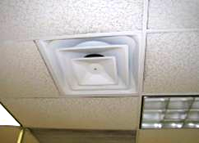

Fresh Air Diffuser

Picture 2



Exhaust Vents Leading to Plenum

Picture 3

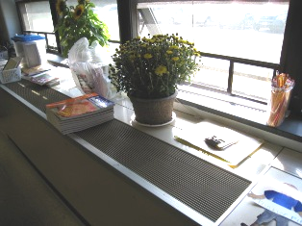

Unit Ventilator

Picture 4

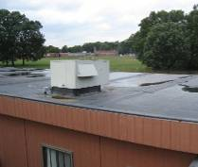

Air Handling Unit on Roof of Modular Classroom

Picture 5

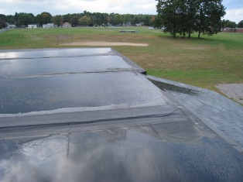

Standing Water on Roof of Modular Classrooms

Picture 6

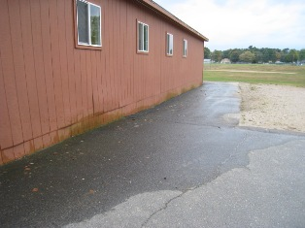

Buckled, Water Damaged Exterior Siding, Also Note Splashback on Base of Wall

Picture 7

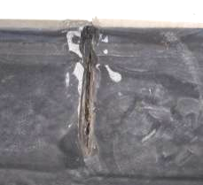

Deteriorated Rubber Membrane Roofing Material

Picture 8

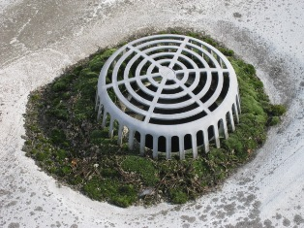

Heavy Moss Growth/Debris Clogging Roof Drain

Picture 9

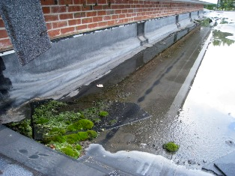

Standing Water and Moss Growth on Roof

Picture 10

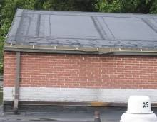

Gutter System in Disrepair

Picture 11

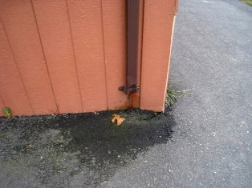

Downspout Terminates at Base of Building, Note Missing Elbow Extension

Picture 12

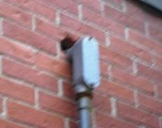

Large Open Utility Hole on Exterior of Building

Picture 13

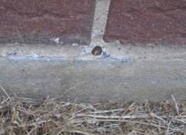

Obstructed Weephole

Picture 14

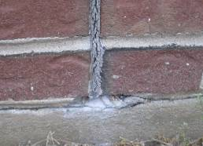

Efflorescence on Mortar and Concrete
Note Deteriorated Expansion Joint
Picture 15

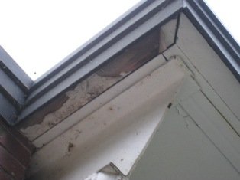

Peeling Paint on Soffit

Picture 16

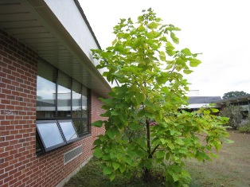

Plant Growth Adjacent to Building

Picture 17

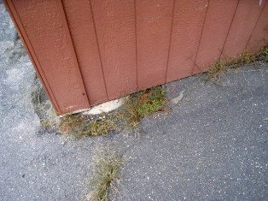

Plant Growth at Base of Modular Classrooms

Picture 18

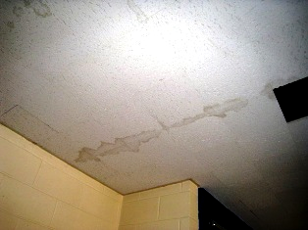

Water Damaged Ceiling Tiles

Picture 19

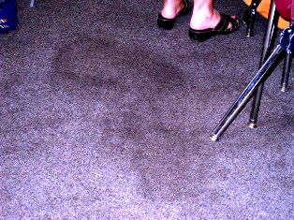

Darkened Area of Carpet

Picture 20

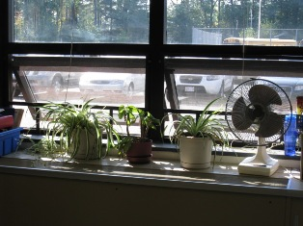

Plants Located on Unit Ventilator

Picture 21

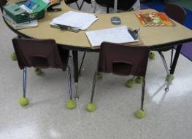

Tennis Balls on Chair Legs

Picture 22

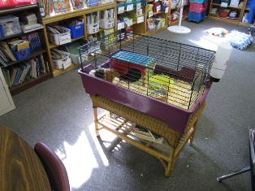

Animal Bedding on Carpet

Picture 23

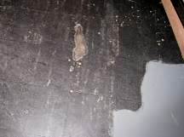

Worn Floor Tiles
Location/ Room | Occupants  in Room | Temp  (°F) | Relative  Humidity  (%) | Carbon  Dioxide  (ppm) | Carbon Monoxide  (ppm) | Windows  Openable | Ventilation |  | Remarks
 |  |  |  |  |  |  | Supply | Exhaust | Remarks
Conference Room | 2 | 75 | 55 | 617 | ND | N | Y Off | Y Off | DO, CD, WD CT
Room 32 | 1 | 74 | 58 | 519 | ND | Y | Y On  Univent | Y Off | DO, WD CT, TB, UF, PF, DEM, paper accumulation
Art Room | 24 | 73 | 62 | 699 | ND | Y | Y On  Univent | Y Off | DO
Room 34 | 1 | 74 | 61 | 772 | ND | Y  2/4 | Y On  Univent | Y Off | DO, DEM, plant on univent
Room 36 | 2 | 74 | 59 | 701 | ND | Y  2/2 | Y On  Univent | Y Off | DO, DEM, plants on univent,  PF, 5 comp.
Room 37 | 3 | 75 | 58 | 746 | ND | Y  2/2 | Y On  Univent | Y Off | DC, WD CT, PF, plant on univent, pillows
Room 39 | 23 | 75 | 61 | 826 | ND | Y | Y On  Univent | Y Off | DO, CD, aqua, 5 comp.
Room 41 | 24 | 74 | 60 | 790 | ND | Y | Y On  Univent | Y Off | DO, WD CT, aqua, terra, plants, cloth curtains
Room 43 | 18 | 75 | 60 | 758 | ND | Y | Y On  Univent | Y Off | DO, PF, plants on univents, terrariums
Room 42 | 23 | 72 | 60 | 576 | ND | Y | Y On  Univent | Y Off | DO, WD CTs, TB, CD, DEM
Room 40 | 2 | 72 | 62 | 708 | ND | Y | Y On  Univent | Y Off | DO, WD CT, DEM, univent blocked
Room 38 | 17 | 73 | 63 | 686 | ND | Y  2/4 | Y On  Univent | Y Off | DO, Plant on univent
Room 35 | 23 | 73 | 62 | 840 | ND | Y  1/4 | Y On  Univent | Y Off | DO, DEM, TB
Men’s Bathroom | 0 | 74 | 63 | 718 | ND | N | Y On  Weak | Y On | DO
Women’s Bathroom | 0 | 74 | 61 | 668 | ND | N | Y On  Weak | Y On | DO, WD CT
Room 31 | 7 | 74 | 69 | 543 | ND | Y  4/4 | Y On  Univent | Y Off | DC, DEM, PF
Cafeteria | 171 | 75 | 50 | 743 | ND | N | Y On | Y  In closet | DO, WD CT, DEM
Kitchen | 5 | 77 | 66 | 696 | ND | N | Y | Y On | DO, PF
Gymnasium | 0 | 76 | 53 | 804 | ND | N | Y | Y | DO
Room 8 | 1 | 75 | 55 | 548 | ND | Y  1/2 | Y | Y  Blocked | DC
Room 7D | 0 | 74 | 55 | 451 | ND | Y | Y On | Y | DC
Room 7C | 0 | 74 | 56 | 491 | ND | N | Y | N | DC
Room 7A | 0 | 74 | 56 | 483 | ND | Y | Y | Y | DO, CD
Room 7B | 2 | 74 | 57 | 503 | ND | Y | Y | N | DC
Music | 0 | 73 | 59 | 651 | ND | N | Y  Univent | Y Off | WD CT
Room 6 | 20 | 73 | 60 | 676 | ND | Y | Y On | Y On | DC
Room 4 | 19 | 75 | 57 | 680 | ND | Y | Y On | Y On | DC, DEM, 2 comp.
Room 2 | 17 | 75 | 55 | 572 | ND | Y | Y On | Y On | DO
Room 1 | 15 | 75 | 55 | 571 | ND | Y  1/2 | Y On | Y On | DC, DEM, PF
Room 3 | 17 | 75 | 56 | 671 | ND | Y  2/2 | Y | Y | DC, DEM, PF, CD, TB
Room 5 | 19 | 74 | 56 | 632 | ND | Y  2/2 | Y | Y | DC, DEM, PF
Room 9 | 4 | 74 | 55 | 650 | ND | Y | Y | Y | DO, TB, WD CT, DEM
Room 12 | 18 | 74 | 52 | 740 | ND | N | Y | Y | 24 Comp., CD, DEM
Room 14 | 0 | 74 | 55 | 471 | ND | Y  2/2 | Y | Y | DO, CD, DEM
Room 16 | 23 | 74 | 57 | 697 | ND | Y  2/2 | Y | Y | DO, DEM
Room 18 | 23 | 75 | 59 | 695 | ND | Y  2/2 | Y | Y | DO, PF, DEM, UF, pillows
Room 20 | 17 | 76 | 57 | 818 | ND | Y | Y | Y | DO, TB, DEM, plants
Room 19 | 18 | 75 | 56 | 619 | ND | Y | Y | Y | DO, DEM
Room 17 | 18 | 75 | 56 | 645 | ND | Y | Y | Y | DC, DEM, PF
Room 15 | 20 | 75 | 55 | 572 | ND | Y | Y | Y | DO, TB, DEM
Room 13 | 1 | 75 | 54 | 481 | ND | Y  2/2 | Y On | Y | DO, plants
Room 11 | 1 | 74 | 55 | 424 | ND | Y  1/2 | Y | Y | DO, PF, CD, FC
Boys’ Bathroom | 0 | 74 | 58 | 608 | ND | N | Y | Y | DO
Girls’ Bathroom | 2 | 73 | 57 | 557 | ND | N | Y | Y | DO
Room 22 | 23 | 75 | 57 | 570 | ND | Y  4/8 | Y  Univent | Y  Blocked | DC, DEM, PF
Room 21 | 8 | 75 | 55 | 647 | ND | Y  4/4 | Y On  Univent | Y On | DC, DEM, PF
Room 24 | 21 | 76 | 55 | 623 | ND | Y  4/4 | Y On  Univent | Y Off | DO, PF, TB, CD
Room 26 | 22 | 76 | 58 | 751 | ND | Y  1/4 | Y Off  Univent | Y Off | DO, TB, plant on univent
Room 25 | 18 | 74 | 59 | 710 | ND | Y  2/3 | Y  Univent | Y On* | DO, PF, TB, DEM  * After timer was adjusted
Room 23 | 0 | 74 | 56 | 674 | ND | Y | Y On | Y On | DO, Aqua, UF, CD, AT
Office (front) | 4 | 74 | 50 | 829 | ND | Y | Y On  Ceiling | Y | DC, plants, copier
Assistant Principal | 1 | 74 | 49 | 546 | ND | Y | Y On  Ceiling | Y | DO
Principal | 5 | 76 | 48 | 649 | ND | Y | Y | Y | DO
Nurse | 1 | 75 | 48 | 581 | ND | Y | Y | Y | DO, UF
Teachers’ Copy Room | 3 | 74 | 55 | 661 | ND | N | Y Off | Y | DO, laminator, AT
Teachers’ Lounge | 0 | 76 | 54 | 673 | ND | N | Y Off | Y On | DO, UF, TB
Room 45 | 20 | 74 | 49 | 1164 | ND | Y  2/2 | Y | Y | DC, WD CT, DEM, WD carpet
Room 46 | 23 | 71 | 64 | 1547 | ND | Y  1/2 | Y | Y | DC, DEM, PF, Plants, aqua, curtains
Room 44 | 23 | 74 | 62 | 1414 | ND | Y | Y | Y | DC, DEM, WD CTs
Outdoors | - | 66 | 73 | - | - | - | - | - | Obtained through Weather Underground for 9/28/09

- Location | Moisture Measurement  (Low = Normal) | - Material/Comments
Classroom 44 | 2” from coving under table =Low  6” from coving under table =Low  12” from coving under table =Low | Carpeting  Carpeting  Carpeting
Classroom 44 | 2”from coving between bookcases = Low  6”from coving between bookcases = Low  12” from coving between bookcases = Low | Carpeting  Carpeting  Carpeting
Classroom 44 | Darkened area on carpet in front of dry erase board = Low  2” from coving under dry erase board = Low  6” from coving under dry erase board = Low  12” from coving under dry erase board = Low | Carpeting  Carpeting  Carpeting  Carpeting
Classroom 44 | 2” from base of cabinet = Low  6” from base of cabinet = Low  12” from base of cabinet = Low | Carpeting  Carpeting  Carpeting
Classroom 45 | 2” from base of bookcase 1 = Low  Dark spot on carpet = Low  2” from base of bookcase 2 = Low  2” from base of bookcase 3 = Low  2” from base of bookcase 4 = Low | Carpeting  Carpeting  Carpeting  Carpeting  Carpeting
Classroom 45 | 2” from wall under metal cabinet = Low  Darkened area on carpet = Low | Carpeting  Carpeting
Classroom 45 | 2” from bookcase on cabinet wall = Low  6” from bookcase on cabinet wall = Low  12” from bookcase on cabinet wall = Low  2” from back of bookcase = Low | Carpeting  Carpeting  Carpeting  Carpeting
Classroom 45 | 6” from front of cabinet = Low  2” from back of metal cabinet = Low  2” from coving on coat wall = Low  Darkened area 1 on carpeting near Becky’s desk = Low  Darkened area 2 on carpeting near Becky’s desk = Moderate  Darkened area on carpeting near Jason’s desk = High | Carpeting  Carpeting  Carpeting  Carpeting  Carpeting  Carpeting
Classroom 46 | Darkened area on carpet near palm tree = Moderate  2” from bookcase 1 (window wall) = Low  6” from bookcase 1 (window wall) = Low | Carpeting  Carpeting  Carpeting
Classroom 46 | 12” from bookcase 1 (window wall) = Low  2” from bookcase 2 (window wall) = Low  6” from bookcase 2 (window wall) = Low  12” from bookcase 2 (window wall) = Low | Carpeting  Carpeting  Carpeting  Carpeting
Classroom 46 | 2” from bookcase 3 (window wall) = Low  6” from bookcase 3 (window wall) = Low  12” from bookcase 3 (window wall) = Low | Carpeting  Carpeting  Carpeting
Classroom 46 | 2” from bookcase to left of dry erase board = Low  6” from bookcase to left of dry erase board = Low  12” from bookcase to left of dry erase board = Low  Darkened area on carpet 32” from dry erase board = High | Carpeting  Carpeting  Carpeting  Carpeting
Classroom 46 | 2” from wall below window = Low  6” from cleaning supply cabinet = Low  12” from cleaning supply cabinet = Moderate | Carpeting  Carpeting  Carpeting

