**WATER DAMAGE/REMEDIATION ASSESSMENT**

**Woods Memorial Library**

**19 Pleasant Street**

**Barre, Massachusetts**

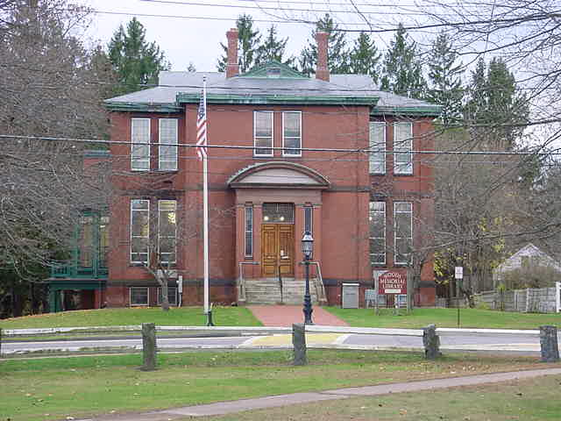

Prepared by:

Massachusetts Department of Public Health

Bureau of Environmental Health

Indoor Air Quality Program

August 2016

# BACKGROUND

|  |  |
| --- | --- |
| Building: | Woods Memorial Library |
| Address: | 19 Pleasant Street, Barre, MA |
| Assessment Requested by: | Stephanie Young, Director, Woods Memorial Library |
| Reason for Request: | Water damage/remediation |
| Date of Assessment: | June 17, 2016 |
| Massachusetts Department of Public Health/Bureau of Environmental Health (MDPH/BEH) Staff Conducting Assessment: | Michael Feeney, Director, Indoor Air Quality (IAQ) Program |
| Date of Building Construction: | 1886, addition in 2001 |
| Building Description: | Two-story, brick-faced building. |
| Building Population: | The affected areas have an employee population of approximately 6. |
| Windows: | Openable |

# Methods

Please refer to the IAQ Manual and appendices for methods, sampling procedures, and interpretation of results (MDPH, 2015).

# Discussion

The hallway floor of the original building appears to be cement. Paint was peeling from the floor surface. BEH staff conducted moisture testing of the cement at the center of floor where paint was peeling. Results demonstrated that the cement was wet (Pictures 1 and 2).

Floor covering used in this hallway needs to be non-porous to prevent water damage/ mold growth. It is likely a vapor barrier should be installed over the cement to reduce moisture movement. Additional work regarding drainage around this building may also be useful in reducing moisture to the building.

# Recommendations

In view of the findings at the time of the visit, the following recommendations are made:

1. Consult with drainage and waterproofing professionals to examine the best practice for preventing/minimizing water penetration through the basement cement floor.
2. It is recommended to use non-porous floor covering with a moisture-resistant adhesive.
3. Do not store anything on or in contact with the floor. Ensure all shelving is raised (e.g., using wedges) to prevent the trapping of water vapor in ground floor area.
4. Refer to resource manual and other related IAQ documents located on the MDPH’s website for further building-wide evaluations and advice on maintaining public buildings. These documents are available at: <http://mass.gov/dph.iaq>.REFERENCES

MDPH. 2015. Massachusetts Department of Public Health. Indoor Air Quality Manual: Chapters I-III. Available at: <http://www.mass.gov/eohhs/gov/departments/dph/programs/environmental-health/exposure-topics/iaq/iaq-manual/>.

**Picture 1**

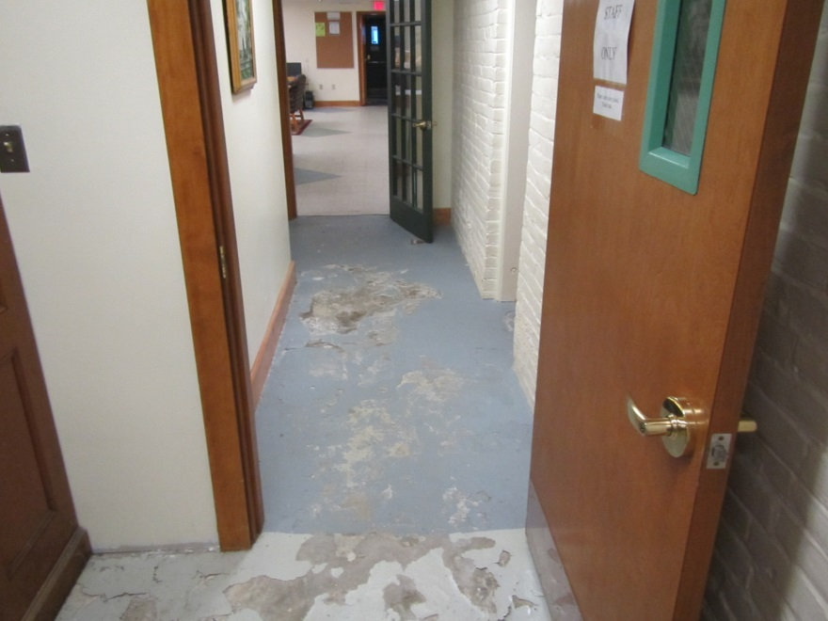

**Location of peeling floor paint**

**Picture 2**

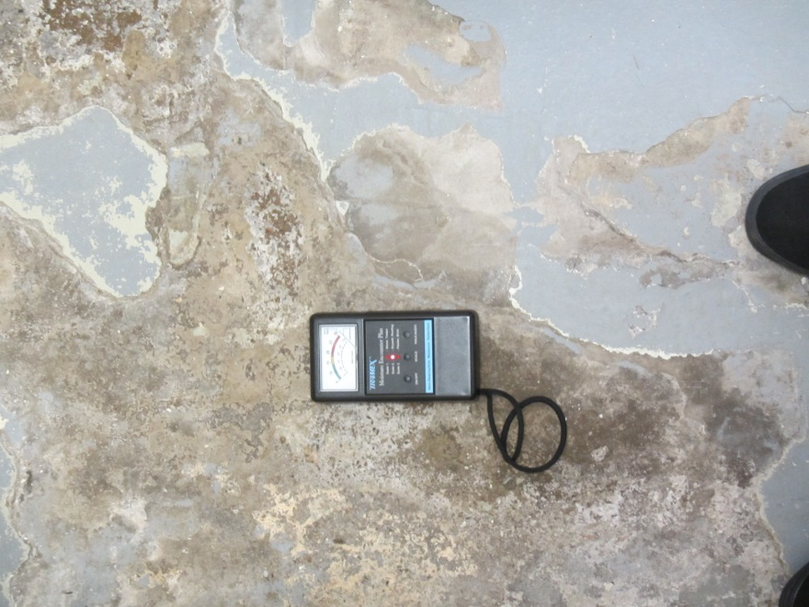

**Moisture measurement indicating floor cement is wet**