Background/Introduction

INDOOR AIR QUALITY ASSESSMENT

Woods Memorial Library
19 Pleasant Street
Barre, Massachusetts 01005



Prepared by:
Massachusetts Department of Public Health
Bureau of Environmental Health
Indoor Air Quality Program
November 2008

At the request of Stephanie Young, Acting Director of the Woods Memorial Library, the Massachusetts Department of Public Health (MDPH), Bureau of Environmental Health (BEH) provided assistance and consultation regarding indoor air quality concerns at the Woods Memorial Library (WML), 19 Pleasant Street, Barre, Massachusetts.
On September 9, 2008, a visit to conduct an indoor air quality assessment was made to the WML by Lisa Hébert, Environmental Analyst/Regional Inspector for BEH’s Indoor Air Quality (IAQ) Program. The WML is a two-story brick building constructed in 1886. The library was renovated in 2001, during which a wing to the rear of the building was added and the basement was finished. The second floor contains a meeting room, storerooms and a museum. The first floor contains the main book collection and offices. The basement, which was extended under the new wing, contains the children’s library, activity room, book storage and various mechanical rooms. Both the original building and new wing contain sump pumps. Windows are openable throughout the WML. The building was previously visited by BEH staff in November 2005. A report was issued detailing conditions observed at the time of the visit (MDPH, 2006). Appendix A is a summary of actions taken in response to the previous assessment.

Methods
Air tests for carbon monoxide, carbon dioxide, temperature and relative humidity were taken with the TSI, Q-TRAK™, IAQ Monitor, Model 8551. Air tests for airborne particle matter with a diameter less than 2.5 micrometers were taken with the TSI, DUSTTRAK™, Aerosol Monitor Model 8520. BEH staff also performed a visual inspection of building materials for water damage and/or microbial growth. Moisture content of materials was measured using a Delmhorst, BD-2000 Model, Moisture Detector.

Results
The WML has an employee population of approximately 6 and an estimated 100 individuals visit on a daily basis. The tests were taken under normal operating conditions and results appear in Tables 1 and 2.

Discussion
Ventilation
It can be seen from Table 1 that the carbon dioxide levels were above 800 parts per million (ppm) in 2 of 13 areas surveyed, indicating adequate air exchange at the time of the assessment. The two areas with carbon dioxide levels above 800 ppm were the sprinkler and boiler rooms. It is important to note, however, that a number of areas were either empty or sparsely populated, which can greatly reduce carbon dioxide levels.
Mechanical ventilation for the library is provided by air-handling units (AHUs) located in an enclosure behind the new building addition. The AHUs draw in outside air through air intakes and distribute it to occupied areas via ceiling-mounted air diffusers (Picture 1). Return air is ducted back to the AHUs via ceiling-mounted exhaust vents (Picture 2). BEH staff found an AHU with its insulation exposed to the outside (Picture 3. This insulation was deteriorating and in disrepair. This condition could allow for water, mold, pests or insulation to enter the AHU.
Fresh air is supplied to the reference room, media room and the Acting Director’s office by unit ventilator (univent) systems (Picture 4). A univent draws air from the outdoors through a fresh air intake located on the exterior wall (Picture 5) of the building and returns air through an air intake located at the base of the unit (Figure 1). Fresh and return air are mixed, filtered, heated and provided to rooms through an air diffuser located in the top of the unit.
In the second floor meeting room (Alan Hall), air is exchanged through louvered vents located at the base of the walls. These vents open directly to the outdoors and are manually opened (Pictures 6 and 7). The former meeting room and the multipurpose room in the basement did not have mechanical ventilation; rather; fresh air is introduced via open windows.
To maximize air exchange, the MDPH recommends that both supply and exhaust ventilation operate continuously during periods of occupancy. In order to have proper ventilation with a mechanical supply and exhaust system, the systems must be balanced to provide an adequate amount of fresh air to the interior of a room while removing stale air from the room. It is recommended that HVAC systems be re-balanced every five years to ensure adequate air systems function (SMACNA, 1994). The system at WML was balanced after the renovations in 2001.
The Massachusetts Building Code requires a minimum ventilation rate of 20 cubic feet per minute (cfm) per occupant of fresh outside air or have openable windows in each room (SBBRS, 1997; BOCA, 1993). The ventilation must be on at all times that the room is occupied. Providing adequate fresh air ventilation with open windows and maintaining the temperature in the comfort range during the cold weather season is impractical. Mechanical ventilation is usually required to provide adequate fresh air ventilation.
Carbon dioxide is not a problem in and of itself. It is used as an indicator of the adequacy of the fresh air ventilation. As carbon dioxide levels rise, it indicates that the ventilating system is malfunctioning or the design occupancy of the room is being exceeded. When this happens a buildup of common indoor air pollutants can occur, leading to discomfort or health complaints. The Occupational Safety and Health Administration (OSHA) standard for carbon dioxide is 5,000 parts per million parts of air (ppm). Workers may be exposed to this level for 40 hours/week, based on a time weighted average (OSHA, 1997).
The MDPH uses a guideline of 800 ppm for publicly occupied buildings. A guideline of 600 ppm or less is preferred in schools due to the fact that the majority of occupants are young and considered to be a more sensitive population in the evaluation of environmental health status. Inadequate ventilation and/or elevated temperatures are major causes of complaints such as respiratory, eye, nose and throat irritation, lethargy and headaches. For more information concerning carbon dioxide, please see Appendix B.
Temperature measurements in the WML ranged from 71º F to 76º F, which were within the MDPH recommended comfort guidelines (Table 1). The MDPH recommends that indoor air temperatures be maintained in a range of 70º F to 78º F in order to provide for the comfort of building occupants. In many cases concerning indoor air quality, fluctuations of temperature in occupied spaces are typically experienced, even in a building with an adequate fresh air supply.
The relative humidity measured in the building ranged from 52 to 68 percent, which was within the MDPH recommended comfort range (Table 1). The MDPH recommends a comfort range of 40 to 60 percent for indoor air relative humidity. Relative humidity levels in the building would be expected to drop during the winter months due to heating. The sensation of dryness and irritation is common in a low relative humidity environment. Low relative humidity is a very common problem during the heating season in the northeast part of the United States.

Microbial/Moisture Concerns
The basement of the WML is sub-grade; therefore, it is prone to flooding during extended/heavy rainfall. BEH staff observed sandbags located at both basement entrances at the time of the assessment (Picture 8). These sandbags are used in the event of a heavy rain.
A dirt parking lot in the rear of library borders a wet-land. On the day of the assessment, heavy rain flooded the lower part of the parking lot and the adjacent wet-land. According to WML staff, the majority of the water originates from a culvert located adjacent to the town hall parking lot located on West Street. BEH staff was informed that when the culvert gets blocked with debris, it overflows down the street to the entrance of the parking lot. Although an asphalt berm was installed at the driveway entrance since the last assessment, a significant amount of water accumulated in the parking lot after a relatively short-lived storm on the day of the assessment (Pictures 9 - 11).
According to renovation blueprints, a catch basin that predates the renovation project appears to exist in the dirt parking lot (MDPH, 2006). BEH staff examined the parking lot for this catch basin, but could not locate it. WML staff confirmed the catch basin did exist and explained that soil from the parking lot gets pushed into the catch basin every winter by snowplowing activities, resulting in a lack of drainage for the parking area.
BEH staff found the area surrounding the AHUs overgrown with grass, plants and weeds (Picture 12). An accumulation of organic debris was observed on the concrete slab beneath the fresh air intakes. Plants can serve as sources of mold and pollen, which can be entrained into the fresh air intakes. Moist organic material can also provide a medium for mold growth.
Therefore, vegetation should be kept down and regular procedure should be provided for periodic cleanup.
Water damaged ceilings and walls, peeling paint and efflorescence were observed in several areas throughout the library (Pictures 13 and 14). The water damage is most likely the result of water penetration through the building envelope. Efflorescence is a characteristic sign of water damage to masonry (e.g., brick, concrete) and mortar, but it is not mold growth. As moisture penetrates and works its way through mortar and masonry, water-soluble compounds in mortar and masonry dissolve, creating a solution. As the solution moves to the surface of the mortar or masonry, the water evaporates, leaving behind white, powdery mineral deposits.
In the children’s library, flooring installed to replace carpeting in the main room was in good repair; however, BEH observed portions of the new epoxy/poured floor in the back hallway and storage room in disrepair. These areas exhibit peeling and chipping (Picture 15), which may indicate that some moisture remains in the concrete floor. Dehumidifiers are routinely utilized in these basement areas.
BEH staff found evidence of excess moisture and mold growth in the sprinkler room. Moist cardboard, paper and debris were strewn on the floor. Some cardboard had colonized mold (Picture 16). Oxidation of the cast iron pipes in this room suggests chronic exposure to moisture. In addition, penetration of pipes through walls are not properly sealed (Picture 17). In the multipurpose room, staining from liquid spillage was observed on the carpet.
In order for building materials to support mold growth, a source of water exposure is necessary. Identification and elimination of the source of water moistening building materials is necessary to control mold growth. Materials with increased moisture content over normal concentrations may indicate the possible presence of mold growth. In an effort to ascertain moisture content of gypsum wallboard (GW) and wood, a Delmhorst probe was inserted into the surface of GW and wood. The Delmhorst probe is set to sound a signal when a moisture reading of > 0.5 percent in GW or > 15 in wood is detected. All porous materials tested at the time of the assessment were found to have low (i.e., normal) moisture content (Table 2). Moisture content is detected as a real time measurement of the conditions present in the building at the time of the assessment.
The building was evaluated on a cloudy, rainy day, with an outdoor temperature of 69º F and relative humidity of 68 percent. Moisture content of materials may increase or decrease depending on building and weather conditions. For example, during weather with high relative humidity, the normal operation of a heating, ventilating and air-conditioning (HVAC) system introduces moisture into a building. As indoor relative humidity levels increase, porous building materials, such as GW, plywood or carpeting, can absorb moisture. The moisture content of materials can fluctuate with increases or decreases in indoor relative humidity.
The US Environmental Protection Agency (US EPA) and the American Conference of Governmental Industrial Hygienists (ACGIH) recommend that porous materials be dried with fans and heating within 24 to 48 hours of becoming wet (US EPA, 2001; ACGIH, 1989). If not dried within this time frame, mold growth may occur. Once mold has colonized porous materials, they are difficult to clean and should be removed/discarded.
BEH staff examined the exterior of the building to identify breaches in the building envelope that could provide a source of water penetration. Several potential sources were identified:
- Damaged/missing exterior brick and mortar (Picture 18);
- One weep hole exhibits a wick; and
- Moss growth was observed on exterior brick and mortar, stairs and windowsills (Picture 18), indicating heavy/continuous water exposure.
The aforementioned conditions represent potential water penetration sources. Over time, these conditions can undermine the integrity of the building envelope and provide a means of water entry into the building via capillary action through masonry (Lstiburek & Brennan, 2001). In addition, these breaches may provide a means for pests/rodents to enter the building.

Other IAQ Evaluations
Indoor air quality can be negatively influenced by the presence of respiratory irritants, such as products of combustion. The process of combustion produces a number of pollutants. Common combustion emissions include carbon monoxide, carbon dioxide, water vapor and smoke (fine airborne particle material). Of these materials, exposure to carbon monoxide and particulate matter with a diameter of 2.5 micrometers (μm) or less (PM2.5) can produce immediate, acute health effects upon exposure. To determine whether combustion products were present in the WML environment, BEH staff obtained measurements for carbon monoxide and PM2.5.

Carbon Monoxide
Carbon monoxide is a by-product of incomplete combustion of organic matter (e.g., gasoline, wood and tobacco). Exposure to carbon monoxide can produce immediate and acute health affects. Several air quality standards have been established to address carbon monoxide and prevent symptoms from exposure to these substances. The MDPH established a corrective action level concerning carbon monoxide in ice skating rinks that use fossil-fueled ice resurfacing equipment. If an operator of an indoor ice rink measures a carbon monoxide level over 30 ppm, taken 20 minutes after resurfacing within a rink, that operator must take actions to reduce carbon monoxide levels (MDPH, 1997).
The American Society of Heating Refrigeration and Air-Conditioning Engineers (ASHRAE) has adopted the National Ambient Air Quality Standards (NAAQS) as one set of criteria for assessing indoor air quality and monitoring of fresh air introduced by HVAC systems (ASHRAE, 1989). The NAAQS are standards established by the US EPA to protect the public health from six criteria pollutants, including carbon monoxide and particulate matter (US EPA, 2006). As recommended by ASHRAE, pollutant levels of fresh air introduced to a building should not exceed the NAAQS levels (ASHRAE, 1989). The NAAQS were adopted by reference in the Building Officials & Code Administrators (BOCA) National Mechanical Code of 1993 (BOCA, 1993), which is now an HVAC standard included in the Massachusetts State Building Code (SBBRS, 1997). According to the NAAQS, carbon monoxide levels in outdoor air should not exceed 9 ppm in an eight-hour average (US EPA, 2006).
Carbon monoxide should not be present in a typical, indoor environment. If it is present, indoor carbon monoxide levels should be less than or equal to outdoor levels. On the day of assessment, outdoor carbon monoxide concentrations were non-detect (ND) (Table 1). Carbon monoxide levels measured in the WML were also ND.

Particulate Matter (PM 2.5)
The US EPA has established NAAQS limits for exposure to particulate matter. Particulate matter is airborne solids that can be irritating to the eyes, nose and throat. The NAAQS originally established exposure limits to particulate matter with a diameter of 10 μm or less (PM10). According to the NAAQS, PM10 levels should not exceed 150 microgram per cubic meter (μg/m³) in a 24-hour average (US EPA, 2006). These standards were adopted by both ASHRAE and BOCA. Since the issuance of the ASHRAE standard and BOCA Code, US EPA established a more protective standard for fine airborne particles. This more stringent PM2.5 standard requires outdoor air particle levels be maintained below 35 μg/m³ over a 24-hour average (US EPA, 2006). Although both the ASHRAE standard and BOCA Code adopted the PM10 standard for evaluating air quality, MDPH uses the more protective PM2.5 standard for evaluating airborne particulate matter concentrations in the indoor environment.
Outdoor PM2.5 concentrations the day of the assessment were measured at 4 μg/m³. PM2.5 levels measured inside the WML ranged from 9 to 25 μg/m³ (Table 1). Both indoor and outdoor PM2.5 levels were below the NAAQS PM2.5 level of 35 μg/m³. Frequently, indoor air levels of particulates (including PM2.5) can be at higher levels than those measured outdoors. A number of mechanical devices and/or activities that occur indoors can generate particulate during normal operations. Sources of indoor airborne particulates may include but are not limited to particles generated during the operation of fan belts in the HVAC system, cooking in the cafeteria stoves and microwave ovens; use of photocopiers, fax machines and computer printing devices; operation of an ordinary vacuum cleaner and heavy foot traffic indoors.

Total Volatile Organic Compounds
Indoor air concentrations can be greatly impacted by the use of products containing volatile organic compounds (VOCs). VOCs are carbon-containing substances that have the ability to evaporate at room temperature. Frequently, exposure to low levels of total VOCs (TVOCs) may produce eye, nose, throat and/or respiratory irritation in some sensitive individuals. For example, chemicals evaporating from a paint can stored at room temperature would most likely contain VOCs. In an effort to identify materials that can potentially increase indoor VOC concentrations, BEH staff examined WML for products containing these respiratory irritants.
Numerous cleaning products were noted in a storage area located at the bottom of the basement stairway. Cleaning products contain VOCs and other chemicals that can be irritating to the eyes, nose and throat of sensitive individuals. Additionally, material safety data sheets (MSDS) should be obtained for each chemical utilized at WML and stored/posted in a central location within the facility.

Other Conditions
Upholstered furniture was noted in the children’s library. These items are covered with fabric that comes in contact with human skin, which can leave oils, perspiration, hair and skin cells. Dust mites feed upon human skin cells and excrete waste products that contain allergens. Furthermore, increased relative humidity levels above 60 percent can also perpetuate dust mite proliferation (US EPA, 1992). In order to remove dust mites and other pollutants, frequent vacuuming of upholstered furniture is recommended (Berry, 1994). It is also recommended that if upholstered furniture is present in schools, it should be professionally cleaned on an annual basis or every six months if dusty conditions exist (IICRC, 2000).
Fluorescent light bulbs are utilized in several locations throughout WML. BEH staff found old fluorescent light bulbs in a basement storage area where bulbs could easily be broken (Picture 19). Small amounts of mercury are components of all fluorescent light bulbs. The amount of mercury is very small, typically measured in milligrams, and varies by lamp type, date of manufacture, manufacturing plant and manufacturer. When fluorescent light bulbs are broken or leak, however, mercury vapor can released into the air be inhaled by people in the area. It is important that fluorescent light bulbs be handled carefully to avoid breakage and stored in areas where bulbs cannot be broken easily.
The storage areas also exhibited an accumulation of paper, books, cardboard and debris. One storage room was filled with boxes of stored materials. Relocate or consider reducing the amount of materials stored in basement storage rooms to allow for more thorough cleaning of these rooms. Reducing the amount of porous materials in these storage areas will reduce or eliminate opportunities for dust to accumulate and/or mold colonization to occur. Clean items regularly with a wet cloth or sponge to prevent excessive dust build-up.
The chimney cleanout door in the boiler room was broken. BEH staff found this door open with accumulated soot pouring out into the room (Picture 20). If the chimney is in use in its present condition, it could pose a potential threat of carbon monoxide accumulation/exposure, and should be repaired. If the chimney is no longer in use, both ends of the chimney should be sealed. Additionally, the exhaust duct exiting the boiler exhibits oxidation (Picture 21).
Penetrations of pipes and brackets through ceilings and walls in the sprinkler and boiler rooms are not properly sealed. Open utility holes can provide a means of egress for odors, fumes, dusts and vapors between rooms and floors. These materials can migrate into the air handling units and be distributed to occupied areas. Numerous cans of paint were also observed in close proximity to the burner on the boiler in the basement (Picture 22), which can be a fire/safety hazard.
Finally, personal fans were observed in storage area and in Alan Hall that exhibited dust accumulation. Dust can be a source for eye and respiratory irritation. Personal fans accumulated with dust can distribute particles once activated.

Conclusions/Recommendations
The conditions noted at the WML raise a number of indoor air quality issues. The general building conditions, excessive moisture pooling in close proximity to the building, maintenance, work hygiene practices, if considered individually, present conditions that could degrade indoor air quality. When combined, these conditions can serve to further degrade indoor air quality. Some of these conditions can be remedied by actions of building occupants. Other remediation efforts will require alteration to the building structure and equipment. For these reasons, a two-phase approach is required for remediation. The first consists of short-term measures to improve air quality and the second consists of long-term measures that will require planning and resources to adequately address the overall indoor air quality concerns.
In view of the findings at the time of the assessment, the following short term measures should be considered for implementation:
- Trim overgrowth in AHU enclosure. Remove organic debris beneath fresh air intake.
- Remove and repair or replace deteriorated insulation on AHUs.
- Locate catch basin in rear parking area and remove debris that has accumulated within it. Install barriers to prevent sand from being plowed into the storm drain in the future, until such time as along term solution to the drainage problem can be reached.
- Investigate and determine integrity of roofing system.
- Clean gutter system on a yearly basis to allow unobstructed flow within the drainage system. Ensure drainage lines for downspouts located below grade at the base of the building are flowing freely.
- Repair loose, broken and missing mortar on all areas of the building.
- Determine if chimney is currently in use. If chimney is currently in use, repair chimney cleanout door and clean soot out of chimney and off of floor. If not, both ends of the chimney should be properly sealed.
- Investigate water penetration into media room window, wall and ceiling. Once identified, eliminate pathway of water penetration to the interior of the building.
- Remove extraneous materials from basement storage areas and sprinkler room.
- Seal all open utility holes with appropriate fire-rated sealant.
- Remove wick material from weep hole.
- Clean upholstered furniture annually.
- Clean and dry carpeting immediately upon discovering it has become wet. The US Environmental Protection Agency and the American Conference of Governmental Industrial Hygienists (ACGIH) recommend that porous materials be dried with fans and heating within 24 hours of becoming wet (US EPA, 2001; ACGIH, 1989). If porous materials are not dried within this time frame, mold growth may occur.
- Store and dispose of fluorescent light bulbs in accordance with Massachusetts Department of Environmental Protection guidelines.
- Clean personal fans, air diffusers, exhaust and return vents on a regular basis.
- Obtain Material Safety Data Sheets (MSDS) for all cleaning products used within WML and keep them in an area that is accessible to all individuals during periods of building operations as required by the Massachusetts Right-To-Know Act (MGL, 1983).
- Consult a ventilation engineer concerning re-balancing of the ventilation systems. Ventilation industrial standards recommend that mechanical ventilation systems be balanced every five years (SMANCA, 1994). Ventilation engineer should ensure adequate air supply and ventilation is provided during periods of occupancy.
- Consult a heating systems professional to inspect the heating system components and associated ducts annually for structural integrity and proper functioning.
- For buildings in New England, periods of low relative humidity during the winter are often unavoidable. Therefore, scrupulous cleaning practices should be adopted to minimize common indoor air contaminants whose irritant effects can be enhanced when the relative humidity is low. To control for dusts, a high efficiency particulate arrestance (HEPA) filter equipped vacuum cleaner in conjunction with wet wiping of all surfaces is recommended. Drinking water during the day can help ease some symptoms associated with a dry environment (throat and sinus irritations).

The following long-term measures should be considered:
- Consider repairing roof if necessary.
- Consider constructing a concrete dike around the basement entrance of sufficient height to prevent water penetration. Consider enlarging existing berm at top of driveway to prevent street runoff from entering driveway and collecting in rear parking lot.
- Consider addressing the drainage issues at the culvert on West Street. Once these issues are resolved, parking lot could be paved and properly sloped to drain away from the building to a functioning catch basin.

References
ACGIH. 1989. Guidelines for the Assessment of Bioaerosols in the Indoor Environment. American Conference of Governmental Industrial Hygienists, Cincinnati, OH.
ASHRAE. 1989. Ventilation for Acceptable Indoor Air Quality. American Society of Heating, Refrigeration and Air Conditioning Engineers. ANSI/ASHRAE 62-1989
ASHRAE. 1992. Gravimetric and Dust-Spot Procedures for Testing Air-Cleaning Devices Used in General Ventilation for Removing Particulate Matter. American Society of Heating, Refrigeration and Air Conditioning Engineers. ANSI/ASHRAE 52.1-1992.

Berry, M.A. 1994. Protecting the Built Environment: Cleaning for Health, Michael A. Berry, Chapel Hill, NC.

BOCA. 1993. The BOCA National Mechanical Code/1993. 8th ed. Building Officials and Code Administrators International, Inc., Country Club Hill, IL. Section M-308.1.1.

IICRC. 1999. IICRC S500. Standard and Reference Guide for Professional Water Damage Restoration, 2nd Edition,. Institute of Inspection Cleaning and Restoration, Vancouver, WA.

Lstiburek, J. & Brennan, T. 2001. Read This Before You Design, Build or Renovate. Building Science Corporation, Westford, MA. U.S. Department of Housing and Urban Development, Region I, Boston, MA.

MDPH. 1997. Requirements to Maintain Air Quality in Indoor Skating Rinks (State Sanitary Code, Chapter XI). 105 CMR 675.000. Massachusetts Department of Public Health, Boston, MA.

MDPH. 2006. Indoor Air Quality Assessment. Woods Memorial Library, Barre, Massachusetts. Massachusetts Department of Public Health, Center for Environmental Health, Boston, MA. January, 2006.

OSHA. 1997. Limits for Air Contaminants. Occupational Safety and Health Administration. Code of Federal Regulations. 29 C.F.R 1910.1000 Table Z-1-A.

SBBRS. 1997. Mechanical Ventilation. State Board of Building Regulations and Standards. Code of Massachusetts Regulations. 780 CMR 1209.0

SMACNA. 1994. HVAC Systems Commissioning Manual. 1st ed. Sheet Metal and Air Conditioning Contractors’ National Association, Inc., Chantilly, VA.

US EPA. 1992. Indoor Biological Pollutants. US Environmental Protection Agency, Environmental Criteria and Assessment Office, Office of Health and Environmental Assessment, Research Triangle Park, NC. ECAO-R-0315. January 1992.

US EPA 2001, Office of Air and Radiation, Indoor Environments Division, Washington, D.C. EPA 402-K-01-001. March 2001.

US EPA. 2006. National Ambient Air Quality Standards (NAAQS). US Environmental Protection Agency, Office of Air Quality Planning and Standards, Washington, DC.
http://www.epa.gov/air/criteria.html.
Picture 1

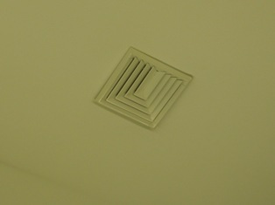

Ceiling-Mounted Air Supply Diffuser

Picture 2

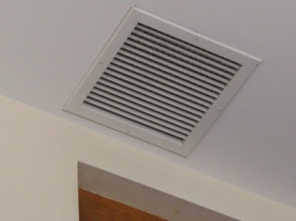

Ceiling-Mounted Exhaust Vent

Picture 3

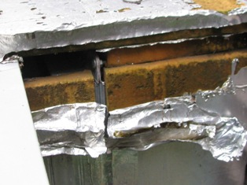

Deteriorated Insulation on AHUs

Picture 4

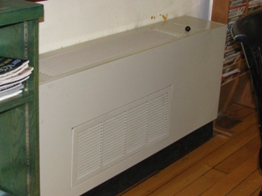

Unit Ventilator

Picture 5

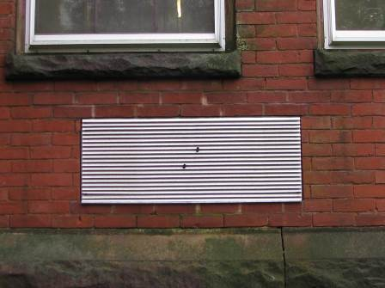

Univent Fresh Air Intake on Exterior Wall

Picture 6

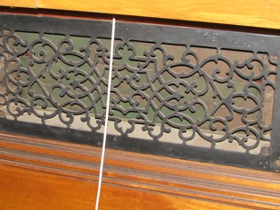

Louvered Vent in Alan Hall

Picture 7

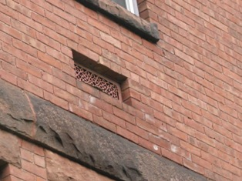

Louvered Vent on Exterior Wall

Picture 8

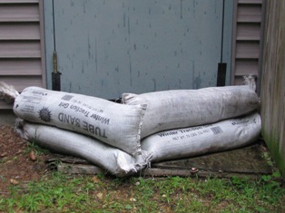

Sand Bags Used to Prevent Flooding

Picture 9

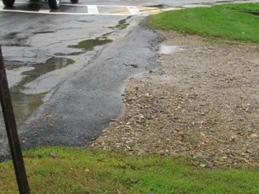

Recently Installed Asphalt Berm

Picture 10

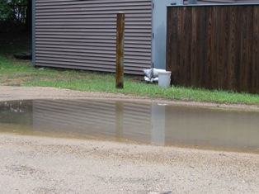

Standing Water in Rear Parking Area Adjacent to Building

Picture 11

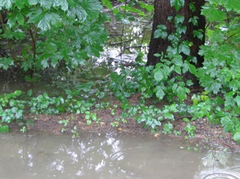

Standing Water in Parking Lot near Wetland

Picture 12

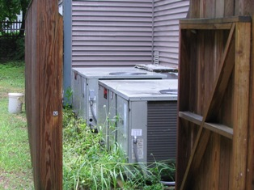

Weed Growth Surrounding Air Handling Units

Picture 13

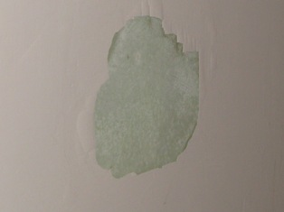

Efflorescence on Stairway Wall

Picture 14

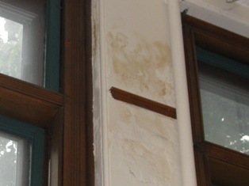

Water Damage on Wall and Window Casing of Media Room

Picture 15

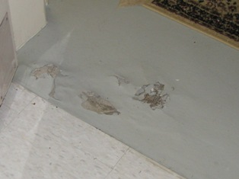

Deteriorating Basement Floor

Picture 16

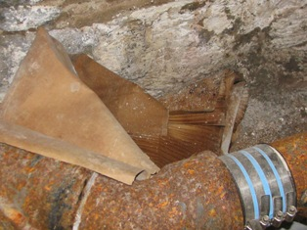

Moist Cardboard Stored in Sprinkler Room, Note Heavy Oxidation on Pipe

Picture 17

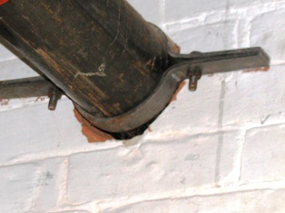

Penetration of Pipe Through Wall is not Sealed

Picture 18

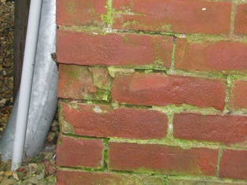

Damaged/Missing Brick and Mortar, Note Extensive Moss Growth

Picture 19

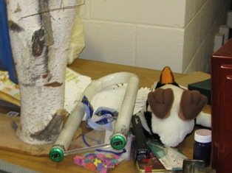

Fluorescent Light Bulb

Picture 20

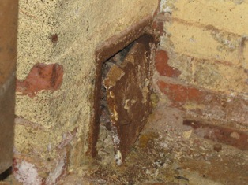

Broken Chimney Door with Soot Accumulation

Picture 21

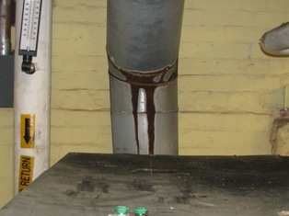

Oxidized Exhaust Duct on Boiler

Picture 22

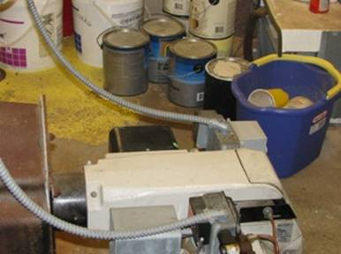

Paint Cans Stored Near Boiler
Location | Occupants  in Room | Carbon  Dioxide  (ppm) | Temp  (°F) | Relative  Humidity  (%) | Carbon Monoxide  (ppm) | PM2.5  (µg/m3) | Windows  Openable | Ventilation |  | Remarks
 |  |  |  |  |  |  |  | Supply | Exhaust | Remarks
Outside  (Background) |  | 378 | 69 | 68 | ND | 4 |  |  |  | Cloudy, rainy day
Children’s Room | 8 | 560 | 73 | 60 | ND | 25 | Y | Y | Y | 7 comp.
Storage Room 1 | 0 | 632 | 72 | 58 | ND | 20 | N | Y | Y | DO, PF, accum of debris, paper
Janitorial Area | 0 | 600 | 72 | 59 | ND | 20 | N | N | N | DO, Cleaning chemicals
Sprinkler Room | 0 | 876 | 71 | 68 | ND | 22 | N | N | N
Storage Room 2 | 0 | 752 | 72 | 60 | ND | 21 | N | N | N | DO, accum of debris
Meeting Room | 0 | 646 | 71 | 61 | ND | 22 | Y  0/1 open | N | N
Multi-Purpose Room | 0 | 608 | 72 | 63 | ND | 19 | Y  0/3 open | N | N | stove w exhaust hood
Boiler Room | 0 | 883 | 74 | 67 | ND | 9 | Y  0/2 open | Y | N
Main Library | 2 | 609 | 74 | 58 | ND | 14 | Y  0/8 open | Y | Y | 8 comp. 1 printer
Media Room | 0 | 610 | 75 | 55 | ND | 13 | Y  0/7 open | Y | Y | DO, Univents, (2)
Reference Room | 0 | 613 | 76 | 52 | ND | 12 | Y  0/5 open | Y | Y | DO, Univents (2), plant
Acting Director’s Office | 1 | 647 | 75 | 52 | ND | 12 | Y  0/2 open | Y | Y | DO, Univent, plant
Allen Hall  (second floor) | 0 | 638 | 76 | 52 | ND | 12 | Y  0/2 open | Y | Y | DO, PF

Location | Moisture Measurement  (Low = Normal) | Material/Comments
Children’s Library  (near door to parking lot) | Low | Gypsum Wallboard and Baseboard
Children’s Library  (near door to interior stairway) | Low | Gypsum Wallboard and Baseboard
Children’s Library  (exterior wall opposite front door) | Low | Gypsum Wallboard and Baseboard
Meeting Room  (in basement – exterior wall) | Low | Baseboard
Multi-Purpose Room  (in basement – exterior wall) | Low | Gypsum Wallboard and Baseboard
Hallway  (basement – outside meeting room)u | Low | Baseboard
Media Room  (exterior wall east) | Low | Baseboard
Main Library  (entrance to Acting Director’s Office) | Low | Baseboard

Actions on Previous MDPH Recommendations

The following is a status report of actions taken on MDPH recommendations (in bold). The summary is based on reports from Woods Memorial Library staff as well as from observations of BEH personnel.

- Remove water damaged materials (e.g. carpeting, gypsum wallboard and wall insulation) in a manner consistent with recommendations found in “Mold Remediation in Schools and Commercial Buildings” published by the US Environmental Protection Agency (US EPA, 2001). Consider replacing carpeting with a non-slip, nonporous material.
Action Taken: Carpet has been removed and new flooring has been installed in the basement level. Gypsum wallboard has been removed and replaced as well.

- Remove wicks from weepholes.
Action Taken: Wicks have been removed from all but one weephole.

- Consider constructing a concrete dike around the basement entrance of sufficient height to prevent water penetration.
Action Taken: An asphalt berm has been installed at the entrance of the driveway.

