INDOOR AIR QUALITY ASSESSMENT

Woodville Elementary School
30 Farm Street
Wakefield, MA

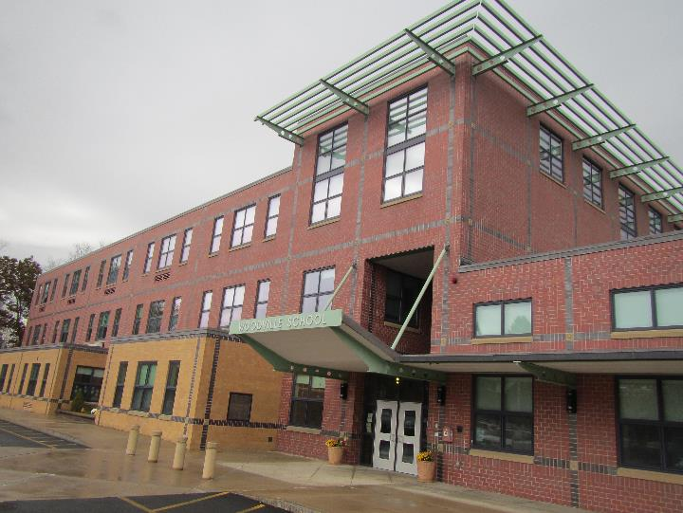

Prepared by:
Massachusetts Department of Public Health
Bureau of Environmental Health
Indoor Air Quality Program
November 2019

Background

Building: | Woodville Elementary School (WES)
Address: | 30 Farm Street, Wakefield, MA
Assessment Requested by: | Bob Schiaroli, Director of Facilities, Wakefield Public Schools
Reason for Request: | Proactive general indoor air quality (IAQ) assessment
Date of Assessment: | November 5, 2019
Massachusetts Department of Public Health/Bureau of Environmental Health (MDPH/BEH) Staff Conducting Assessment: | Jason Dustin, Environmental Analyst, IAQ Program
Building Description: | The WES is a three-story brick building built in 2003.
Building Population: | Approximately 450 total students and staff
Windows: | Some windows are openable

IAQ Testing Results
Please refer to the IAQ Manual for methods, sampling procedures, and interpretation of results (MDPH, 2015). The following is a summary of indoor air testing results (Table 1).
- Carbon dioxide levels were above the MDPH guideline of 800 parts per million (ppm) in about a third of areas tested, indicating a lack of air exchange in these areas. Some areas were empty, which can reduce carbon dioxide levels.
- Temperature was within or close to the MDPH recommended range of 70°F to 78°F the day of the assessment.
- Relative humidity was within the MDPH recommended range of 40 to 60% in all areas the day of assessment.
- Carbon monoxide levels were non-detectable (ND) in all areas tested.
- Fine particulate matter (PM2.5) concentrations measured were below the National Ambient Air Quality (NAAQS) limit of 35 μg/m³ in all areas tested.

Ventilation
A heating, ventilating and air conditioning (HVAC) system has several functions. First it provides heating and, if equipped, cooling. Second, it is a source of fresh air. Finally, an HVAC system will dilute and remove normally occurring indoor environmental pollutants by not only introducing fresh air, but by filtering the airstream and ejecting stale air to the outdoors via exhaust ventilation. Even if an HVAC system is operating as designed, point sources of respiratory irritation may exist and cause symptoms in sensitive individuals.
Fresh air is provided by a combination of unit ventilators (univents) located in most individual classrooms (Picture 1) and roof top air handling units (AHUs) for common areas (e.g., library, gymnasium). The univents draw fresh air through a vent on the exterior wall (Picture 2). Air is mixed with return air from the room, filtered, heated (if needed) and delivered to the room (Figure 1). Some univents were obstructed by items placed on top or in front (Picture 3). Both the top and the vent at the bottom need to be kept clear of obstructions for the units to operate as designed. Air from the AHUs is filtered, heated or cooled as needed, and delivered to rooms via ducted supply vents (Picture 4).
BEH/IAQ staff noted that most univents inspected were on and running quietly. Typically, the controls impact the fan operation as well as the fresh air intake louvers control. As shown in Table 1, most of the carbon dioxide readings were elevated in classes having full attendance. Another factor which greatly affects air exchange is exhaust fan operation. BEH/IAQ staff noted that several exhaust fans were not functioning at the time of the assessment. Some exhaust vents were also located near open doors which may allow air from the hallway to be drawn into the vent instead of the stale air from the classroom (Picture 5).
To maximize air exchange, the MDPH recommends that both supply and exhaust ventilation operate continuously during periods of occupancy. In addition, the fresh air louvers setting must allow adequate fresh air into the classrooms to avoid the buildup of commonly found indoor air pollutants.
In order to have proper ventilation with a mechanical supply and exhaust system, these systems must be balanced to provide an adequate amount of fresh air while removing stale air from a room. It is recommended that existing ventilation systems be re-balanced every five years to ensure adequate air systems function (SMACNA, 1994). It is unknown the last time these systems were balanced.

Microbial/Moisture Concerns
Water-damaged ceiling tiles were observed in several areas especially on the first floor (Picture 6, Table 1). Facilities staff reported that this has been an ongoing issue recently and is likely the result of HVAC leaks or lack of proper insulation on cooling lines. Plans are underway to contract with an HVAC firm to inspect those areas and make necessary repairs. Ceiling tiles are considered porous and if exposed to chronic moisture may become a source for microbial colonization. These tiles should be replaced after the source of the leaks is found and repaired.
Indoor plants were observed in a few areas. Some of these plants were placed on porous materials. Plants can be a source of pollen and mold, which can be respiratory irritants to some individuals. Plants should be properly maintained, equipped with non-porous drip pans, and should be located away from air diffusers to prevent the aerosolization of dirt, pollen and mold.

Other IAQ Evaluations
Exposure to low levels of total volatile organic compounds (TVOCs) may produce eye, nose, throat, and/or respiratory irritation in some sensitive individuals. To determine if VOCs were present, BEH/IAQ staff examined rooms for products containing VOCs. BEH/IAQ staff noted hand sanitizers, cleaners/spray bottles, plug-in air fresheners, and dry erase materials in use within the building. All of these products have the potential to be irritants to the eyes, nose, throat, and respiratory system of sensitive individuals. Due to the pervasive use of these products in schools throughout Massachusetts, the MDPH has produced a guideline called “Clean Air Is Odor-Free” which can be found at: https://www.mass.gov/lists/indoor-air-quality-guidelines.
WES Facilities staff reported that HVAC/univent filters are changed about two times per year. The MDPH recommends using pleated filters of Minimum Efficiency Reporting Value (MERV) of 8, which are adequate in filtering out pollen and mold spores (ASHRAE, 2012), if these can be used with current equipment.
In some areas, accumulated items including books, papers, toys and decorative items were observed on floors, windowsills, tabletops, counters, bookcases, and desks. Excess items on surfaces can make it more difficult for custodial staff to clean.
Many areas had carpeting. Carpeting should be vacuumed daily and cleaned annually or semi-annually in soiled high traffic areas. Many classrooms had area rugs, which should also be cleaned regularly and discarded when too worn out or soiled to be cleaned.
Most of the above noted conditions are commonly found in schools throughout Massachusetts. The MDPH guideline “Indoor Air Quality in Schools” is available to explain in further detail how to remedy most commonly-found issues. This guideline can also be found at: https://www.mass.gov/lists/indoor-air-quality-guidelines.
Note that the Environmental Protection Agency (EPA) conducted a National School Radon Survey in which it discovered nearly one in five schools had “…at least one frequently occupied ground contact room with short-term radon levels above 4 [picocuries per liter] pCi/L” (US EPA, 1993). The BEH/IAQ Program therefore recommends that every school be tested for radon, and that this testing be conducted during the heating season while school is in session in a manner consistent with USEPA radon testing guidelines. Radon measurement specialists and other information can be found at www.nrsb.org and http://aarst-nrpp.com/wp, with additional information at: http://www.mass.gov/eohhs/gov/departments/dph/programs/environmental-health/exposure-topics/iaq/radon.

Conclusions/Recommendations
The following recommendations are made to assist in improving IAQ:
- Operate all supply and exhaust ventilation equipment continuously during occupied hours. Fresh air should be supplied even when the thermostat set points are met to avoid intermittent ventilation that may allow indoor pollutants to build up.
- Check exhaust vents (in classrooms and restrooms) for draw periodically and repair any non-operating motors/vents.
- Make any necessary adjustments to univent fresh air intake louvers to allow for increased fresh air to the classrooms showing elevated carbon dioxide readings in Table 1.
- Remove items and furniture blocking univents both on top and along the front.
- Continue with plans to hire an HVAC firm to inspect and make necessary repairs (e.g., insulation/drip pans) to areas of known water leaks/condensation.
- After repairs are made to stop HVAC leaks/condensation, replace all water-damaged ceiling tiles.
- Educate occupants that the univents provide not only heat but fresh air and should never be shut off during school hours. Temperature/comfort complaints should be made through proper channels and followed up by facilities staff.
- Use openable windows to supplement fresh air during temperate weather. Ensure all windows are tightly closed at the end of the day or during the use of air conditioning.
- Consider adopting a balancing schedule of every 5 years for all mechanical ventilation systems, as recommended by ventilation industrial standards (SMACNA, 1994).
- Properly maintain plants, including drip pans, to prevent water damage to porous materials. Plants should also be located away from air diffusers to prevent the aerosolization of dirt, pollen, and mold.
- Eliminate the use of products and equipment that contain VOCs (e.g., air fresheners, scented cleaning wipes, scented hand sanitizer, etc.).
- Continue to change filters for HVAC equipment 2-4 times a year. The MDPH recommends using pleated filters of Minimum Efficiency Reporting Value (MERV) of 8, which are adequate in filtering out pollen and mold spores (ASHRAE, 2012), if these can be used with current equipment.
- Regularly clean/vacuum univent cabinets, supply/return/exhaust vents and fans to avoid aerosolizing accumulated particulate matter. To clean ceiling grills, remove and wash.
- Consider reducing the amount of items stored in classrooms to make cleaning easier. Periodically move items to clean flat surfaces.
- For buildings in New England, periods of low relative humidity during the winter are often unavoidable. Therefore, scrupulous cleaning practices should be adopted to minimize common indoor air contaminants whose irritant effects can be enhanced when the relative humidity is low. To control dusts, a high efficiency particulate arrestance (HEPA) filter equipped vacuum cleaner in conjunction with wet wiping of all surfaces is recommended. Avoid the use of feather dusters. Drinking water during the day can help ease some symptoms associated with a dry environment (throat and sinus irritations).
- HEPA vacuum carpeting daily and clean carpeting annually (or semi-annually in soiled high traffic areas). Clean area rugs similarly.
- The school should be tested for radon by a certified radon measurement specialist during the heating season when school is in session. Radon measurement specialists and other information can be found at: www.nrsb.org, and http://aarst-nrpp.com/wp.
- Consider adopting the US EPA (2000) document, “Tools for Schools”, as an instrument for maintaining a good IAQ environment in the building available at: http://www.epa.gov/iaq/schools/index.html
- Refer to resource manual and other related IAQ documents located on the MDPH’s website for further building-wide evaluations and advice on maintaining public buildings. These documents are available at: http://mass.gov/dph/iaq.

References
ASHRAE. 2012. American Society of Heating, Refrigeration and Air Conditioning Engineers (ASHRAE) Standard 52.2-2012 -- Method of Testing General Ventilation Air-Cleaning Devices for Removal Efficiency by Particle Size (ANSI Approved).
MDPH. 2015. Massachusetts Department of Public Health. “Indoor Air Quality Manual: Chapters I-III”. Available at: http://www.mass.gov/eohhs/gov/departments/dph/programs/environmental-health/exposure-topics/iaq/iaq-manual/.
SMACNA. 1994. HVAC Systems Commissioning Manual. 1st ed. Sheet Metal and Air Conditioning Contractors’ National Association, Inc., Chantilly, VA.
US EPA. 1993. Radon Measurement in Schools, Revised Edition. Office of Air and Radiation, Office of Radiation and Indoor Air, Indoor Environments Division (6609J). EPA 402-R-92-014.
US EPA. 2000. Tools for Schools. Office of Air and Radiation, Office of Radiation and Indoor Air, Indoor Environments Division (6609J). EPA 402-K-95-001, Second Edition. http://www.epa.gov/iaq/schools/index.html.
Picture 1
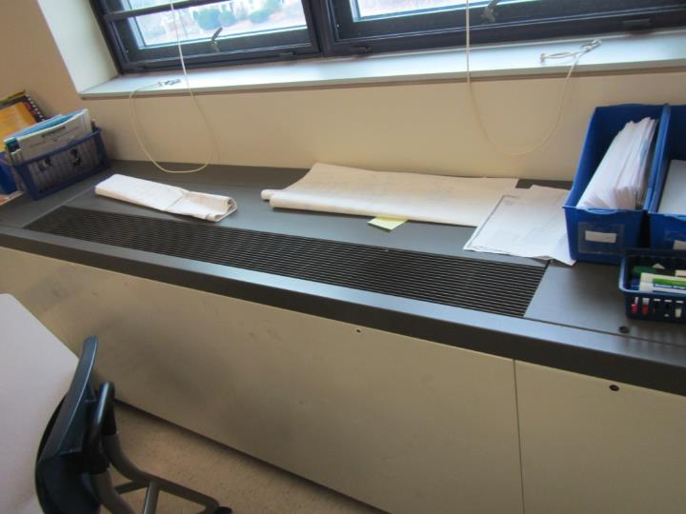
Univent in classroom
Picture 2
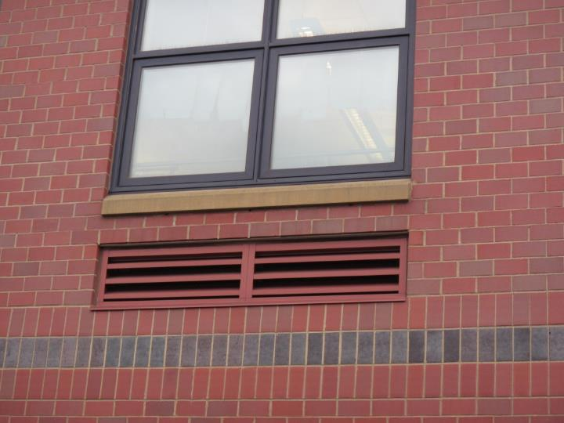
Exterior vent for univent fresh air intake
Picture 3
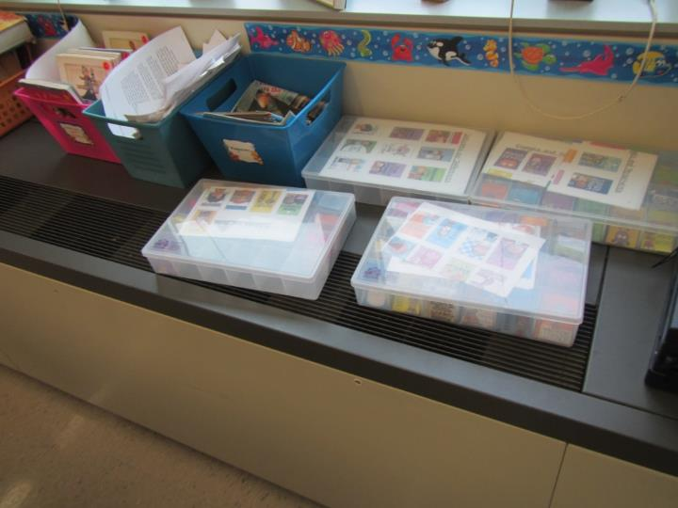
Univent partially obstructed with items on top of supply vent
Picture 4
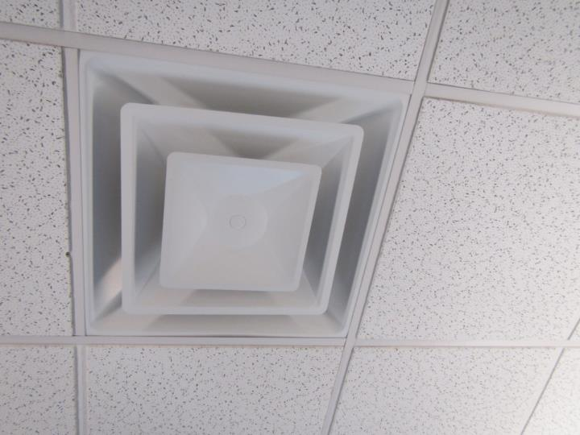
Supply air vent from roof top AHU
Picture 5
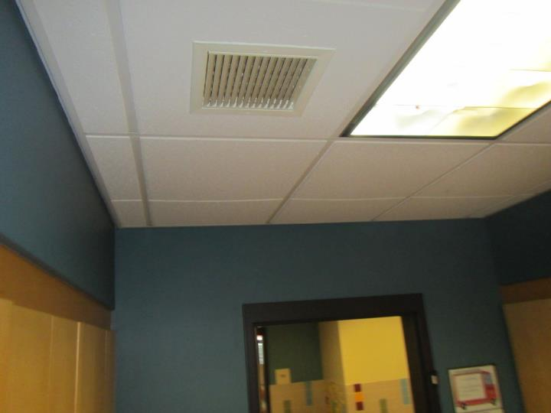
Ceiling-mounted exhaust vent in close proximity to open door
Picture 6
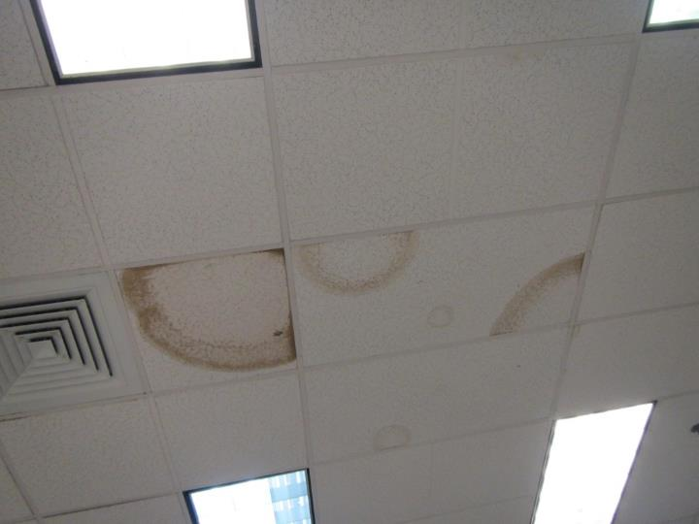
Water-damaged ceiling tiles on first floor
Location | Carbon  Dioxide  (ppm) |  | Carbon Monoxide  (ppm) | Temp  (°F) | Relative  Humidity  (%) | PM2.5  (µg/m³) | Occupants  in Room | Windows  Openable | Ventilation |  | Remarks
 |  |  |  |  |  |  |  |  | Supply | Exhaust
Background (outside) | 415 |  | ND | 58 | 71 | 12 | - | - | - | - | Slight rain
Library | 652 | ND |  | 69 | 50 | 9 | 15 | Y | Y | Y | Carpet, UF, plant
305 | 678 |  | ND | 69 | 49 | 11 | 0 | Y | Y | Y | Vinyl floor, DEM, HS
317 | 727 |  | ND | 70 | 51 | 10 | 5 | N | Y | Y | HS
316 | 626 |  | ND | 70 | 49 | 12 | 2 | Y | Y | Y | HS, CPs
315 | 681 |  | ND | 71 | 48 | 11 | 2 | Y | Y | Y | DEM, CPs
306 | 929 |  | ND | 72 | 46 | 9 | 2 | Y | Y | Y | CPs, DEM, area rug
307 | 1198 |  | ND | 72 | 46 | 8 | Class gone <20 min | Y | Y on | Y off | HS, DEM
309 | 1182 |  | ND | 73 | 46 | 8 | 7 | Y | Y on | Y | DEM
310 | 1551 |  | ND | 73 | 46 | 7 | 8 | Y | Y | Y on | AI, DEM, area rug
313 | 980 |  | ND | 72 | 45 | 9 | 2 | Y | Y | Y | HS, DEM
312 | 1180 |  | ND | 72 | 46 | 7 | 4 | Y | Y | Y | DEM, UF
311 | 1083 |  | ND | 73 | 45 | 8 | 1 | N | Y | Y | DEM, PF
210 | 1211 |  | ND | 72 | 48 | 8 | 19 | Y | Y | Y
213 | 1163 |  | ND | 72 | 47 | 8 | 20 | Y | Y | Y | AI, blocked UV, HS
212 | 1201 |  | ND | 73 | 46 | 8 | 15 | Y | Y | Y | AI, CPs, HS
209 | 913 |  | ND | 73 | 46 | 13 | 17 | Y | Y | Y
207 | 1116 |  | ND | 73 | 47 | 10 | 18 | Y | Y | Y | DEM, area rug
206 | 789 |  | ND | 72 | 45 | 9 | 17 | Y | Y | Y | DEM, CP, UV blocked
215 | 968 |  | ND | 72 | 47 | 10 | 20 | Y | Y | Y | Plants, AF, HS
217 | 601 |  | ND | 72 | 42 | 6 | 1 | Y | Y | Y | Printer
201 | 696 |  | ND | 72 | 44 | 8 | 5 | Y | Y | Y | UF, HS, DEM
Art | 588 |  | ND | 72 | 40 | 6 | 6 | Y | Y | Y | AI, art supplies
112 | 948 |  | ND | 71 | 44 | 6 | 11 | Y | Y | Y | DEM, area rug
110 | 1134 |  | ND | 72 | 47 | 8 | 19 | Y | Y | Y
109 | 590 |  | ND | 71 | 46 | 9 | 2 | Y | Y | Y | HS, DEM
113 | 542 |  | ND | 70 | 44 | 7 | 1 | Y | Y | Y | DEM
108 | 664 |  | ND | 71 | 49 | 6 | 2 | N | Y | Y | DEM, former WD CTs from HVAC leaks
114 | 718 |  | ND | 71 | 47 | 7 | 3 | N | Y | Y | WD CT (HVAC leak)
107 | 550 |  | ND | 73 | 48 | 10 | 1 | Y | Y | Y | CPs, WD CT
115 | 687 |  | ND | 73 | 45 | 9 | 23 left ~ 20 min | Y | Y | Y | CPs, plants
106 Lounge | 654 |  | ND | 73 | 46 | 5 | 7 | Y | Y | Y | PC, CPs, vinyl floor, WD CT
116 | 497 |  | ND | 71 | 48 | 9 | 2 | Y | Y | Y
104 | 605 |  | ND | 71 | 47 | 7 | 0 | N | Y | Y | DEM
117 | 661 |  | ND | 71 | 48 | 6 | 3 | N | Y | Y | HS
Cafeteria | 787 |  | ND | 72 | 48 | 10 | ~80 | N | Y | Y
125 | 715 |  | ND | 71 | 50 | 8 | 15 | N | Y | Y | WD CTs, DEM
118 | 659 |  | ND | 71 | 47 | 7 | 3 | Y | Y | Y | HS
Gym | 622 |  | ND | 71 | 49 | 8 | 25 | N | Y | Y
101 Main office | 675 |  | ND | 71 | 49 | 7 | 7 | N | Y | Y | WD CT (HVAC leak)
102 | 732 |  | ND | 72 | 45 | 6 | 5 | Y | Y | Y | Carpet, DEM
103 | 571 |  | ND | 72 | 46 | 6 | 0 | Y | Y | Y | Fridge on carpet, DEM
Conference | 533 |  | ND | 72 | 46 | 5 | 0 | Y | Y | Y | Carpet, DEM
Kitchen | - |  | ND | - | - | - | - | - | - | -

