FATALITY INVESTIGATION REPORT
FACE Facts
Occupational Health Surveillance Program February 1997 Vol. 2, No. 2

Massachusetts Department of Public Health
Woodworker Dies When Struck by Tool Knife Launched
from Overarm Router

A 32-year-old woodworker was fatally injured at work when a steel tool knife was propelled from a rosette cutter. The cutter was installed in an overarm router. The steel tool knife penetrated a polyacrylic sheet (trade name—Plexiglass) shield and then penetrated and exited his chest, subsequently ricocheting off the wall before finally landing. The victim was an experienced woodworker, whose job also included tool grinding and setup of spindle moulders.
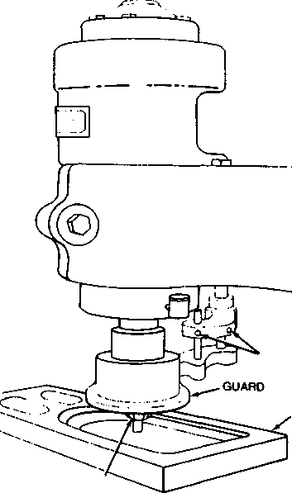
ADJUSTMENT NUTS
STOCK
The knife, measuring approximately 1-5/8 inch square, was part of a cutter head assembly which had been previously used on a drill press at much lower cutting speeds. It was custom designed and built for the drill press, not for the router which is run at much higher speeds. At the time of the incident, the router was set for 20,000 rpm and was being used to make custom rosettes. The maximum permissible speed was not indicated on the cutter head, and there were no written procedures for its use (e.g., the recommended cutting tool speed). The knife was held in the 4-3/4" diameter cutter head by flat shims and set screws. The set screws could not counteract the centrifugal forces generated by the high-speed rotation.
BASE OF ROUTER BLADE
Example of adjustable tool guard on router from Concepts and Techniques of Machine Safeguarding, 1992.

Recommendations for Woodworkers

Tooling should only be used on the type of machine for which it is intended
Cutting tools and holders (over 1/8"diameter) should be labeled with the maximum permissible spindle speed (in RPM) __________

Safety training should be provided on a regular basis to instruct new workers and avoid complacency among the experienced
All machines should be equipped with tool guards wherever possible
Written job instructions, including cutting speeds, should be available and used

References:

OSHA Regulations 29 CFR 1910.213 Safeguarding Concepts' Illustrated, National Safety
Council, 6th edition
ANSI O1.1-1992, Safety Code for Woodworking Concepts and Techniques of Machine Safeguarding,

OSHA 3067,1992.
For a copy of complete report, 95MA020, contact MA FACE at 617-624-5627
Machine Guarding Tip:
If polycarbonate had been used in the above incident, instead of the polyacrylic shield, the tool blade would have been slowed down or stopped. Polycarbonate is used to make "bullet-proof shields.
Consult the manufacturer of your equipment before making any modifications.

Fatality Assessment and Control Evaluation (FACE) Project • (617)-624-5627

