Increasing Supervision
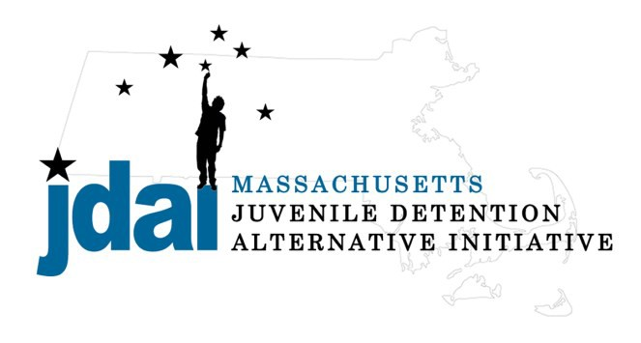Worcester County Bench Card: Alternatives to Secure Detention

An Alternative to Detention is a location or supervision that allows a juvenile with an open delinquency matter, including violation of probation, to remain out of hardware secure detention pending further court action.

JDAI Massachusetts Alternative to Detention Committee has gathered these resources from the Worcester JDAI Community. JDAI Massachusetts, and its affiliated partners, do not specifically endorse or recommend the services provided by the listed agencies and entities. Please send updates or corrections to jdai @stat e.ma.us . Updated: January 2016
Additional placement or services options may be available if the youth is involved with a state agency.
Family/ Communit y Supervision:
- Straight Release– Personal Recognizance
- Release to an Alternative/Extended Family Member
Low Sup ervision:
- Life Skills/ Afterschool: Bridging the Gap (Worcester)640 Main Street, Worcester, MA 01604 508-756-7191 ext 237, Danny Diaz
- Life Skills/ Afterschool: Bridging the Gap (Fitchburg) 739 Water Street, Fitchburg, MA 01420 978-342-3300 ext 103, Maggie Perez
Medium Supervision:
- Release with Pre-Trial Probation Conditions
- Release with Electronic Monitoring/GPS
- Day/ Evening Program: Juvenile Resource Center, 70 James Street, Suite 270, Worcester, MA, (508) 755-6843 ext. 11, Sarah Sullivan
Medium – High Supervision:
- DYS: Community Based Option (Placement to be Determined by DYS)
  - Central Region Reception Center (CRRC), Paul T. Leahy Center, 363 Belmont St., Worcester, MA, 508-368-4269, John Flaminio
- DYS: Shelter Care Options (Placement to Be Determined by DYS)
  - Carbone Hall, Eliot Human Services, 569 Salem End Road, Framingham, MA 01702, 508-532-7660, Marc Breau (Males Only)
  - Grafton Girls, Key, Inc., 30 Institute Road, North Grafton, MA 01536, 508-839-4648, Meghan Rondeau (Females Only)
- Substance Abuse : Statewide Information and Referral 866-705-2807
  - Detox & Stabilization: MYR, Community Health link, 26 Queen Street, Worcester, MA 01610, 508-860-1244, Melonie Amir
  - Detox & Stabilization: CASTLE, High Point Treatment Center, 30 Meadowbrook Road, Brockton, MA 02301, 508-638-6009, Kim Fischer

