INDOOR AIR QUALITY ASSESSMENT
MOLD INVESTIGATION

Worcester County District Attorney’s Office
180 Main Street
Worcester, Massachusetts

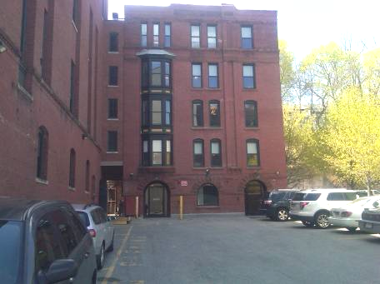

Prepared by:
Massachusetts Department of Public Health
Bureau of Environmental Health
Indoor Air Quality Program
July 2011

Background/Introduction
At the request of Virginia Platt, Project Manager, Division of Capital Asset Management (DCAM), the Massachusetts Department of Public Health (MDPH), Bureau of Environmental Health (BEH) provided assistance and consultation regarding indoor air quality (IAQ) concerns at the Worcester County District Attorney’s Office located at 180 Main Street, Worcester, Massachusetts. On April 29, 2011, a visit was made to this building by Mike Feeney, Director, of BEH’s IAQ Program. Concerns about water penetration through an exterior wall that damaged gypsum wallboard (GW) on the ground floor and an odor in a third floor office, prompted the request.
The building was constructed in 1890 and has been renovated over the years for use as office space. Windows are openable throughout the building.

Methods
BEH staff performed visual inspection of building materials for water damage and microbial growth. Moisture content of building materials (i.e., GW and wood) was measured with a Delmhorst, BD-2000 Model, Moisture Detector equipped with a Delmhorst Standard Probe.

Discussion
Microbial/Moisture Concerns
As previously discussed, the assessment was requested due to concerns of water damage to GW along the south exterior wall of the ground floor. At the time of the assessment the affected areas had GW removed (Picture 1). The water-damaged areas are located along the south wall of the building that is buried under a slope, which has a paved parking lot at the top (Picture 2). The slope that buries the below grade portions of the building consists of soil and old brickwork which is not a water resistant surface (Picture 3). The parking lot has a small portion of its tarmac slightly pitched down slope (Picture 2). Rainwater has eroded soil adjacent to the building’s exterior wall (Picture 3), which has created the conditions resulting in water penetration into the ground floor.
Adding to the water load above the ground floor offices is a scupper located on the roof parapet that pours water onto the tarmac in this area (Picture 4). This scupper appears to be the sole means for rainwater to drain from the flat lower roof. As water pours from the parapet, it is likely that brick directly below is routinely wet through seams between the tarmac and exterior wall (Picture 5). Repeated wetting of the exterior wall may also be producing moisture-related odors in the third floor office directly below the scupper. The office contains wood wainscoting, which is likely to produce a wet/woody odor if moistened chronically.

Conclusions/Recommendations
In order to address the water damage issues on the ground floor and odors on the third floor, the drainage of water from the parking lot and the lower roof must be addressed. In view of the findings at the time of the visit, several recommendations are offered. These recommendations were communicated at the time of the assessment and are reiterated below:
- A sloped apron to direct water away from the south exterior wall shown in Picture 3 should be installed. In addition, proper means of drainage for water that reaches the bottom of the slope needs to be addressed.
- A downspout should be installed on the scupper to drain water from the lower roof. The downspout should be installed in a manner to direct rainwater away from the south exterior wall. Installing the downspout in a manner to drain rainwater into the cement lined pit below the parking lot may be an option. With installation of a downspout, the odor in the third floor office will likely resolve.
- Remove unnecessary plastic coving from interior brick walls to prevent moisture trapping.
- Consider installing a water-impermeable wall material (e.g., cement board) in below grade offices which have a history of water damage.
Picture 1

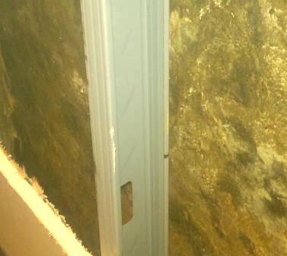

Removed Gypsum Wallboard Revealing Interior Side of Foundation Wall

Picture 2

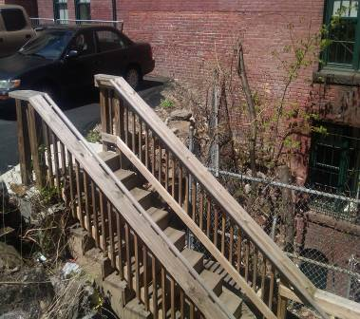

Tarmac Parking Lot above First Floor (Note Slight Downhill Slope)

Picture 3

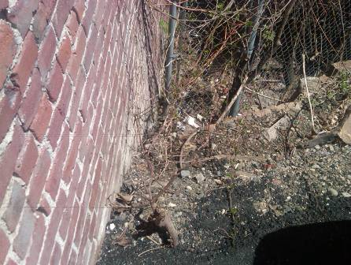

Exterior Wall Buried beneath Soil

Picture 4

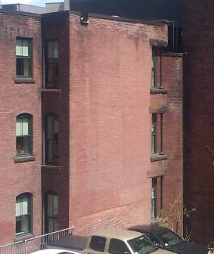

Scupper that Drains Roof (Arrow)

Picture 5

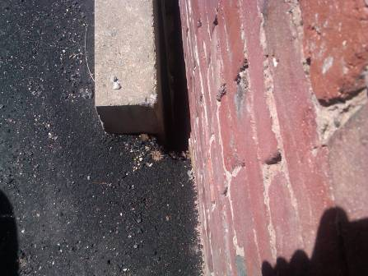

Tarmac/Wall Seams below Scupper

