INDOOR AIR QUALITY ASSESSMENT

Worcester County District Attorney Offices
180 Main Street
Worcester, Massachusetts

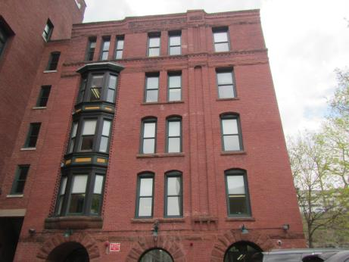

Prepared by:
Massachusetts Department of Public Health
Bureau of Environmental Health
Indoor Air Quality Program
May 2018

BACKGROUND
Building: | Worcester County District Attorney’s Offices (WDA)
Address: | 180 Main Street, Worcester
Assessment Contact: | Jamie Merrill Blood, Regional Planner/Project Manager, Division of Capital Asset Management & Maintenance (DCAMM)
Reason for Request: | Water damage concerns
Date of Assessment: | 5/3/2018
Massachusetts Department of Public Health/Bureau of Environmental Health (MDPH/BEH) Staff Conducting Assessment: | Jason Dustin, Environmental Analyst/Inspector, Indoor Air Quality (IAQ) Program
Date of Building Construction: | 1890
Building Description: | 5 story brick building
Windows: | Not openable

METHODS
Please refer to the IAQ Manual and appendices for methods, sampling procedures, and interpretation of results (MDPH, 2015).

IAQ Testing Results
The following is a summary of indoor air testing results (Table 1).
- Carbon dioxide levels were below 800 parts per million (ppm) and within MDPH guidelines in all areas assessed, indicating adequate air exchange throughout the space.
- Temperature was within the recommended range of 70°F to 78°F in all areas on the day of assessment.
- Relative humidity was within the recommended range of 40 to 60% in the areas tested.
- Carbon monoxide levels were non-detectable (ND) in all areas tested.
- Fine particulate matter (PM2.5) concentrations measured were below the National Ambient Air Quality (NAAQS) limit of 35 μg/m³ in all areas tested.
- Total Volatile Organic Compounds (TVOC’s) were ND in all areas assessed.

RESULTS and DISCUSSION

Ventilation
A heating, ventilating, and air conditioning (HVAC) system has several functions. First it provides heating and, if equipped, cooling. Second, it is a source of fresh air. Finally, an HVAC system will dilute and remove normally occurring indoor environmental pollutants by not only introducing fresh air, but by filtering the airstream and ejecting stale air to the outdoors via exhaust ventilation. Even if an HVAC system is operating as designed, point sources of respiratory irritation may exist and cause symptoms in sensitive individuals.
The WDA space utilizes air handling units (AHUs) to filter and heat or cool the supply air. The conditioned supply air is distributed through supply diffusers located throughout the space (Picture 1). Return air is drawn into the return vents and brought back to the AHUs located in the mechanical rooms of each floor. Some of these returns were noted to be passive vents leading to a hallway where a larger return vent is located (Picture 2).
WDA staff reported complaints with the ventilation in rooms 303 and 304. IAQ staff noted little to no flow coming from the supply vents in both rooms. The exhaust vent in room 304 was also blocked with a large filing cabinet (Picture 3). Blocked vents or closed dampers will interfere with the proper design flow of ventilation. Efforts should be made to increase supply/exhaust ventilation in these areas to dilute commonly found indoor air pollutants and aid in occupant comfort.
In order to have proper ventilation with a mechanical supply and exhaust system, these systems must be balanced to provide an adequate amount of fresh air while removing stale air from a room. It is recommended that existing ventilation systems be re-balanced every five years to ensure adequate air systems function (SMACNA, 1994). It is unknown the last time these systems were balanced.

Microbial/Moisture Concerns
The WDA space has two offices on the ground floor which were reportedly water-damaged and remediated (rooms G11 & G12). This space was visited by the BEH/IAQ program in 2011 and is the subject of a previous report which is attached as Appendix A. During this current assessment, WDA staff reported that water was infiltrating through the brick walls and foundation. The exterior walls of these offices were noted to be below grade and near the bottom of a steep slope. At the top of the slope was a large paved parking lot (Pictures 4 and 5). Some recent remediation efforts and interior waterproofing were reported by property management such as installing mildew resistant absorbent socks and drilling small holes in the concrete slab. Unfortunately, these methods have the potential of adding additional moisture, odors, and soil gases to the space and do not address the root cause of infiltration. Moisture should be prevented from entering the building. Property managers noted that new porous building materials were installed in these two rooms [e.g., gypsum wallboard (GW), carpeting]. One portion of GW was noted to be moist at the time of this assessment (Picture 6 and 7, Table 1) which indicates that water infiltration continues in this area.
Missing mortar around brickwork, and moss were noted in the vicinity above rooms G11 near a large retaining wall with a nearby drainage line. It was unclear where the drainage line emptied or if the alcove area formed by the retaining wall had additional storm drains to draw water away from the building exterior (Pictures 8 and 9).
WDA staff reported that a toilet backup from the men’s bathroom on the 3rd floor had occurred last year. Water-damaged carpeting was cleaned outside of the bathroom but no GW or carpet was discarded. It is important to note that porous materials (e.g., GW, carpet, cardboard) that have been in contact with blackwater cannot be effectively cleaned/sanitized or dried and must be disposed of properly (Pictures 10 and 11).
Water-damaged ceilings and walls were also noted on the 5th floor (Picture 12, Table 1). These areas were noted to have a musty odor which is typical for porous items (e.g., GW, carpeting, ceiling tiles) exposed to chronic moisture and/or not dried in a timely manner. WDA staff reported that previous roof leaks had occurred over several years with no repair.
The US Environmental Protection Agency (US EPA) and the American Conference of Governmental Industrial Hygienists (ACGIH) recommends that porous materials (e.g., wallboard, carpeting) be dried with fans and heating within 24 to 48 hours of becoming wet (US EPA, 2008; ACGIH, 1989). If porous materials are not dried within this time frame, mold growth may occur.
The WDA also has water infiltration to the rear of the building on the ground floor. This portion of the building is also below grade and built into a steep hill. The stairwell is experiencing chronic moisture through the foundation/brick wall, however this area is unoccupied. Some areas of GW have been replaced with cement/fiber board fitted with a vent to allow moisture to escape and a dehumidifier is being used (Picture 13). IAQ staff noted that some porous items are being stored in this area (e.g., paper towels). Porous items can become colonized with mold if exposed to chronic moisture.
Indoor plants were observed in some areas. Plants can be a source of pollen and mold, which can be respiratory irritants to some individuals. Plants should be properly maintained and equipped with drip pans and should be located away from air diffusers to prevent the aerosolization of dirt, pollen and mold.

Other Concerns
IAQ staff noted several areas with air fresheners, scented cleaning products, and hand sanitizers (Table 1). These products contain volatile organic compounds (VOCs) and other fragrances which may cause irritation of the eyes, nose, and respiratory system.
AHUs on each floor were noted to have filters with a Minimum Efficiency Reporting Value (MERV) of 8 as recommended to filter out dusts/mold spores. However, the AHU cabinets lacked filter assemblies that form a tight seal. Instead the filters were mounted outside the units with large gaps where dust/debris can bypass the filter and be distributed throughout occupied areas (Pictures 14 and 15). IAQ staff noted several breaches in these mechanical rooms which lead to unconditioned areas (e.g., wall cavities). These breaches may serve as pathways for dust, odors, or moisture to become entrained in the HVAC system (Picture 16). Since these mechanical spaces are essentially part of the HVAC system, they should also be kept clean.
WDA staff reported that supply and exhaust vents have been very dusty in the past. These vents were cleaned prior to this assessment and should be cleaned on a regular basis to avoid aerosolizing particulate matter.
Improved housekeeping can make a large difference in the IAQ for occupants. Daily vacuuming with a high efficiency particulate arrestance (HEPA) equipped vacuum cleaner and wet-wiping of all surfaces will help prevent irritation of the eyes and respiratory system caused by dust. Occupants can contribute to the accessibility of surfaces by organizing accumulated items in a manner to allow custodial staff to easily wet wipe surfaces and HEPA vacuum carpets.

CONCLUSIONS and RECOMMENDATIONS
In view of the findings at the time of the visit, the following recommendations are made:
- Consult with an experienced water intrusion/building envelope contractor to design and implement an effective strategy to eliminate the chronic water infiltration in below grade spaces of the WDA. The absorbent socks in wall cavities and drilled holes in the slab should also be evaluated since they may be a source of future odors, moisture, and soil gases to the space and do not prevent the infiltration of water from exterior walls. Missing mortar in brickwork should be repaired and ensure drains are properly collecting and removing water away from the building’s foundation.
- Any new or existing water-damaged porous materials (e.g., GW) in rooms G11 and G12 should be removed if not dried within 24-48 hours of becoming wet (e.g., G11 right side wall). Consider using barrier techniques (e.g., sealing vents and door) and leaving this area vacant until an effective water infiltration strategy has been designed/implemented.
- Follow EPA and industry guidelines concerning methods used to remediate buildings that are impacted by sewage (i.e., blackwater). One of these guideline links include: https://www.epa.gov/sites/production/files/2015-09/documents/floods.pdf. All GW, carpeting, or other porous items that were in contact with the blackwater in or outside of the men’s bathroom on the 3rd floor should be discarded. GW should be removed at least 12″ above the high water line from the sewage backup. Nonporous areas should be sanitized and building materials replaced new.
- Remove any porous items that were water-damaged and not dried properly on the 5th floor. Some of these items include water-damaged GW ceilings and walls as well as carpeting and area rugs.
- Remove any porous items stored in the rear stairwell subject to chronic moisture (boxes of paper, etc.). Also, consider removing remaining gypsum wallboard and replacing it with cement/fiber board. Fit the door leading to occupied space with a tight-fitting door sweep to prevent migration of moisture/odors into the WDA space.
- Operate all supply and exhaust ventilation equipment continuously during occupied periods (e.g., thermostat controls set to “fan on” not auto).
- Investigate methods to increase fresh air supply and exhaust ventilation to rooms 303 and 304. Remove any file cabinets/furniture blocking exhaust vents.
- Adjust filter assemblies on AHUs in mechanical rooms so that there are no gaps where dust/debris can bypass the filters. Also, seal any gaps leading to unconditioned areas and keep these mechanical rooms clean.
- Change filters for HVAC equipment 2-4 times a year. Continue to use pleated filters of MERV 8 (or higher), which are adequate in filtering out pollen and mold spores (ASHRAE, 2012), if these can be used with current equipment.
- Consider adopting a balancing schedule of every 5 years for all mechanical ventilation systems, as recommended by ventilation industrial standards (SMACNA, 1994).
- Properly maintain plants, including drip pans, to prevent water damage to porous materials. Plants should also be located away from air diffusers to prevent the aerosolization of dirt, pollen, and mold.
- Reduce or eliminate the use of products containing VOCs (e.g., air fresheners, scented cleaning products, and hand sanitizer).
- Reduce the amount of accumulated items and store items in a manner that allows cleaning access by custodial staff.
- Improve housekeeping and IAQ by daily HEPA vacuuming and wet-wiping of surfaces.
- Supply diffusers and exhaust grates should be cleaned regularly to avoid aerosolizing dust/debris.
- Refer to resource manual and other related indoor air quality documents located on the MDPH’s website for further building-wide evaluations and advice on maintaining public buildings. These documents are available at http://mass.gov/dph/iaq.

REFERENCES
ACGIH. 1989. Guidelines for the Assessment of Bioaerosols in the Indoor Environment. American Conference of Governmental Industrial Hygienists, Cincinnati, OH.
ASHRAE. 2012. American Society of Heating, Refrigeration and Air Conditioning Engineers (ASHRAE) Standard 52.2-2012 -- Method of Testing General Ventilation Air-Cleaning Devices for Removal Efficiency by Particle Size (ANSI Approved).
MDPH. 2015. Massachusetts Department of Public Health. “Indoor Air Quality Manual: Chapters I-III”. Available at: http://www.mass.gov/eohhs/gov/departments/dph/programs/environmental-health/exposure-topics/iaq/iaq-manual/.
SMACNA. 1994. HVAC Systems Commissioning Manual. 1st ed. Sheet Metal and Air Conditioning Contractors’ National Association, Inc., Chantilly, VA.
US EPA. 2008. Mold Remediation in Schools and Commercial Buildings. US Environmental Protection Agency, Office of Air and Radiation, Indoor Environments Division, Washington, D.C. EPA 402-K-01-001. http://www.epa.gov/mold/mold-remediation-schools-and-commercial-buildings-guide.
Picture 1
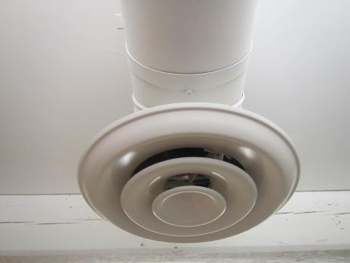
Supply air diffuser
Picture 2
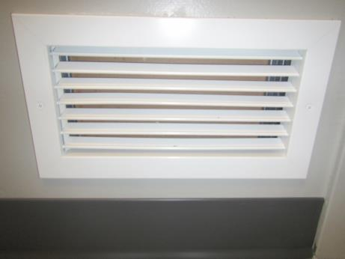
Passive return vent
Picture 3
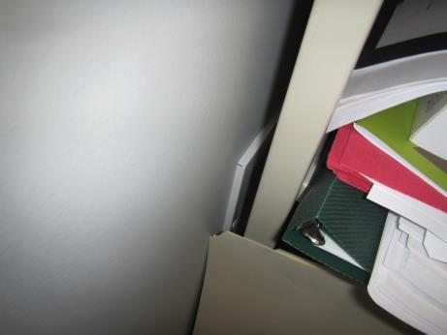
Furniture/files blocking exhaust vent in room 304
Picture 4
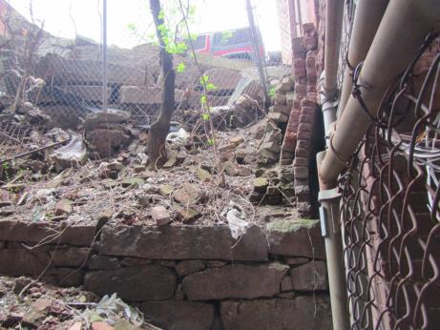
Bottom of steep hill with debris adjacent to rooms G11 and G12 (arrow)
Picture 5
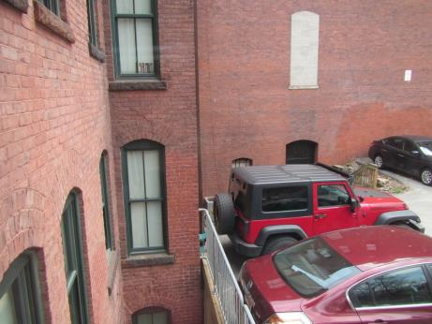
Parking lot above G11 and G12 offices (note drain line-arrow)
Picture 6
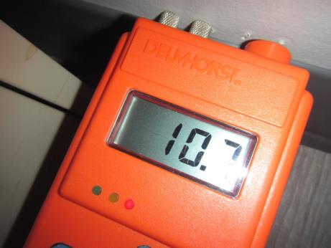
Meter showing elevated moisture in right side wall of room G11
Picture 7
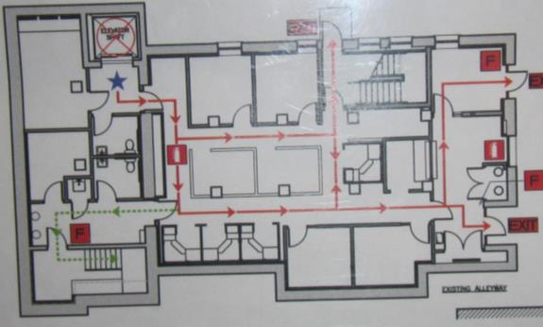
Area of moist gypsum wallboard (GW) in room G11 (arrow)
Picture 8
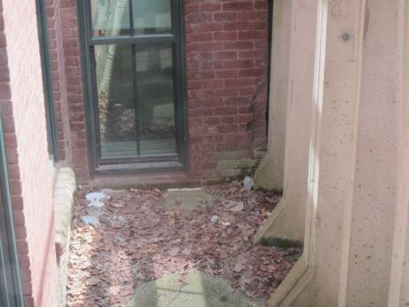
Exterior alcove area created by parking lot retaining wall
Picture 9
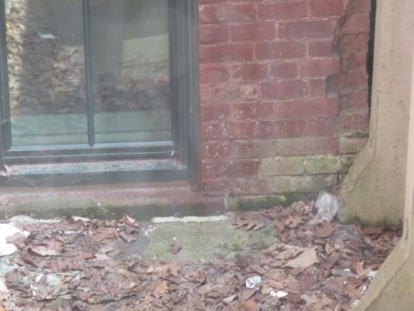
Missing mortar, damaged brick, and moss noted above room G11
Picture 10
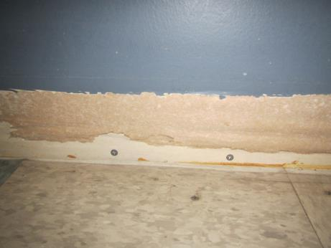
3rd floor men’s room showing reported black water-damaged GW
Picture 11
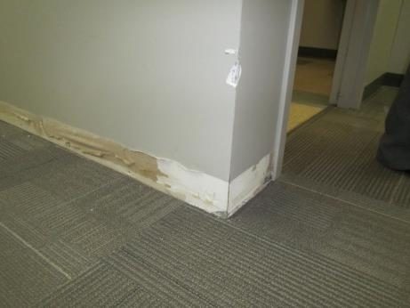
Black water-damaged GW and carpet outside men’s room on 3rd floor
Picture 12
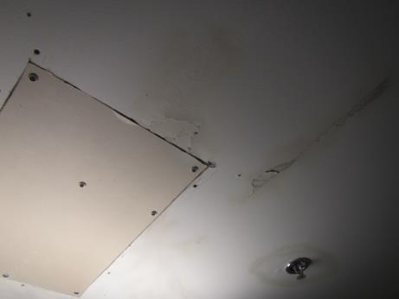
Water-damaged GW ceiling on the 5th floor
Picture 13
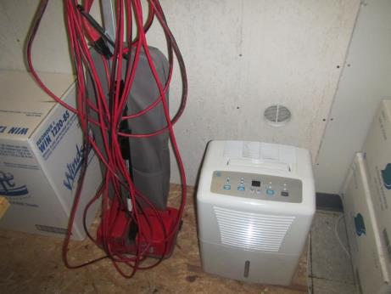
Stairwell with chronic moisture and stored porous boxes
Picture 14
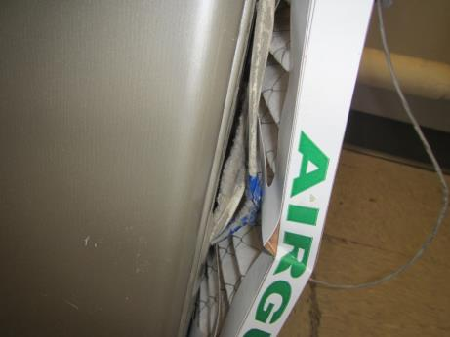
AHU filter not flush against return
Picture 15
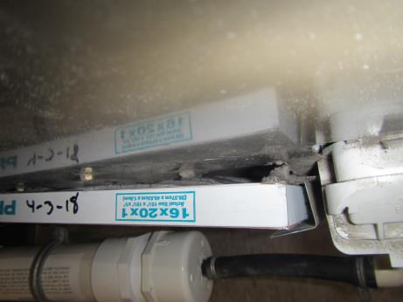
AHU filter showing large gap; not flush against return
Picture 16
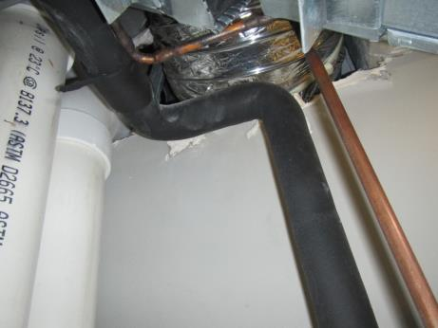
Breaches around utilities in mechanical room
Location | Carbon  Dioxide  (ppm) | Carbon Monoxide  (ppm) | Temp  (°F) | Relative  Humidity  (%) | PM2.5  (µg/m³) | TVOCs  ppm | Occupants  in Room | Windows  Openable | Ventilation |  |  | Remarks
 |  |  |  |  |  |  |  |  | Intake | Exhaust
Background (outside) | 323 | ND | 88 | 33 | 23 | ND | - | - | - |  | - | Busy street
G12 | 724 | ND | 73 | 45 | 16 | ND | 0 | N | Y |  | Y | Newly renovated, previous WD, below grade, new GW, new flooring. Some soft spots under new laminate floor (right side near wall)
G11 | 686 | ND | 73 | 44 | 17 | ND | 0 | N | Y |  | Y | Newly renovated, Moisture meter showed right side wall was wet, some slight bubbling paint observed
Left rear ground floor | 590 | ND | 72 | 47 | 12 | ND | 1 | N | Y |  | Y
G22 | 596 | ND | 73 | 46 | 12 | ND | 1 | N | Y |  | Y | DEM
G16 | 584 | ND | 74 | 46 | 14 | ND | 1 | N | Y |  | N | Door open
517 Reception | 450 | ND | 75 | 44 | 17 | ND | 1 | N | Y |  | Y | Musty odor, WD ceiling, dehumidifier, air filter (off)
518 Kitchen | 412 | ND | 72 | 43 | 19 | ND | 1 | N | Y |  | Y | Musty odor, area carpet, carpet tiles
529 | 388 | ND | 71 | 43 | 19 | ND | 0 | N | Y |  | Y | AI, carpet, DEM
528 | 385 | ND | 71 | 45 | 20 | ND | 0 | N | Y |  | Y | AI, HS, DEM
527 | 488 | ND | 71 | 45 | 20 | ND | 0 | N | Y |  | Y | DEM, HS
526 | 555 | ND | 72 | 45 | 20 | ND | 0 | N | Y |  | Y | Carpet, DEM, HS
525 | 552 | ND | 72 | 44 | 19 | ND | 1 | N | Y |  | Y | AF, plant
524 | 423 | ND | 73 | 45 | 20 | ND | 1 | N | Y |  | Y | DEM
512 | 504 | ND | 73 | 44 | 20 | ND | 2 | N | Y |  | Y | HS
520 | 594 | ND | 73 | 43 | 21 | ND | 1 | N | Y |  | Y | AI
516 | 482 | ND | 72 | 43 | 19 | ND | 0 | N | Y |  | Y | Plant
515 | 521 | ND | 71 | 44 | 19 | ND | 0 | N | Y |  | Y | Area rug over carpet tile
514 | 483 | ND | 71 | 45 | 20 | ND | 1 | N | Y |  | Y | HS
513 cubes | 500 | ND | 71 | 45 | 20 | ND | 1 | N | Y |  | Y | HS
511 cube | 515 | ND | 71 | 45 | 21 | ND | 0 | N | Y |  | Y | AF
510 | 503 | ND | 72 | 45 | 21 | ND | 1 | N | Y |  | Y | Sound insulation, area carpet
509 | 485 | ND | 71 | 46 | 21 | ND | 0 | N | Y |  | Y
507 | 501 | ND | 71 | 44 | 21 | ND | 0 | N | Y |  | Y | Area rug over carpet tile
506 | 552 | ND | 71 | 45 | 21 | ND | 2 | N | Y |  | Y
4th floor hall | 677 | ND | 71 | 43 | 9 | ND | 1 | N | Y |  | Y
Back right side 4th | 740 | ND | 71 | 45 | 9 | ND | 1 | N | Y |  | Y
423 | 677 | ND | 71 | 47 | 16 | ND | 3 | N | Y |  | Y
434 | 508 | ND | 71 | 50 | 18 | ND | 0 | N | Y |  | Y | Plant
3rd floor men’s room and hall area | 575 | ND | 73 | 44 | 10 | ND | 1 | N | Y |  | Y | Toilet backup last year, WD GW, carpet cleaned, no WD porous items removed as recommended
303 | 564 | ND | 74 | 43 | 10 | ND | 0 | N | Y off |  | Y off | HVAC complaints, no flow detected
304 | 634 | ND | 75 | 43 | 12 | ND | 0 | N | Y off |  | Y blocked | HVAC complaints, no flow detected
3rd floor front | 589 | ND | 74 | 45 | 11 | ND | 1 | N | Y |  | Y
2nd floor conference | 573 | ND | 72 | 46 | 9 | ND | 3 | N | Y |  | Y
File storage 203 | 434 | ND | 70 | 40 | 8 | ND | 2 | N | Y |  | Y | Some boxes on floor
Kitchen 1st floor | 667 | ND | 70 | 42 | 10 | ND | 2 | N | Y |  | Y | Tile, above G11 and G12 offices
119 | 692 | ND | 70 | 44 | 12 | ND | 1 | N | Y |  | Y
Back Right 1st floor/ 104 | 688 | ND | 71 | 43 | 11 | ND | 1 | N | Y |  | Y | IT equipment area

