Background

INDOOR AIR QUALITY ASSESSMENT

Worcester Career Center
Suite 400
340 Main Street
Worcester, MA

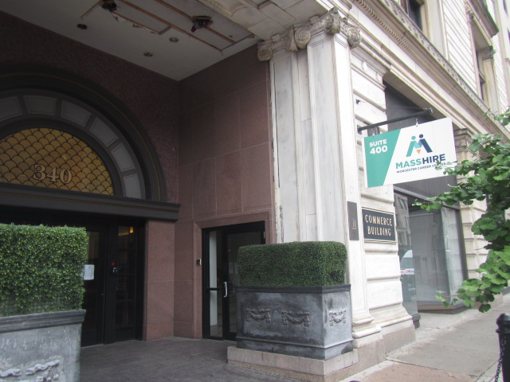

Prepared by:
Massachusetts Department of Public Health
Bureau of Environmental Health
Indoor Air Quality Program
August 2022
Building: | Worcester Career Center (WCC)
Address: | 340 Main Street, Suite 400  Worcester, Massachusetts
Assessment Requested by: | A. Harris Magloire, Construction Manager, Facilities/Operations Management  Executive Office of Labor and Workforce Development
Reason for Request: | Water damage/mold concerns in building materials due to mechanical ventilation system plumbing leak.
Date of Assessment: | August 22, 2022
Massachusetts Department of Public Health/Bureau of Environmental Health (MDPH/BEH) Staff Conducting Assessment: | Cory Holmes, Assistant Director, Indoor Air  Quality (IAQ) Program
Building Description: | The WCC is located in an office suite on the 4th floor of the historic Commerce Building in downtown Worcester. The space has gypsum wallboard (GW) walls, a suspended ceiling, and wall to wall carpet squares on concrete floors.
Windows: | Occupants are discouraged from opening windows.

METHODS
Please refer to the IAQ Manual for methods, sampling procedures, and interpretation of results (MDPH, 2015).

RESULTS AND DISCUSSION
The following is a summary of indoor air testing results (Table 1):
- Carbon Dioxide was below the MDPH recommended guideline of 800 parts per million (ppm) in all areas assessed indicating adequate airflow. However, the suite was nearly vacant at the time of assessment.
- Temperature was within or close to the MDPH recommended range of 70°F to 78°F in the areas tested.
- Relative Humidity was above the MDPH recommended range of 40 to 60% in areas tested, which was due to the HVAC system being deactivated for repairs and reflective of outside conditions.
- Carbon Monoxide was not detected (ND) in any area tested.
- Particulate Matter (PM2.5) concentrations measured were below the National Ambient Air Quality (NAAQS) level of 35 μg/m³ in all areas tested.
- Total Volatile Organic Compounds (TVOCs) were ND in all areas tested.

Ventilation
A heating, ventilating, and air conditioning (HVAC) system has several functions. First it provides heating and, if equipped, cooling. Second, it is a source of fresh air. Finally, an HVAC system will dilute and remove normally-occurring indoor environmental pollutants by not only introducing fresh air, but by filtering the airstream and ejecting stale air to the outdoors via exhaust ventilation. Even if an HVAC system is operating as designed, point sources of respiratory irritation may exist and cause symptoms in sensitive individuals.
The HVAC system consists of air handling units (AHUs) located in closets within the space (Pictures 1 and 2). Conditioned air is ducted to ceiling-mounted supply vents and returned via ceiling mounted grates allowing air to migrate into the ceiling plenum back to the AHUs (Picture 3). One of the vents had been sealed by an occupant, assumably to prevent drafts (Picture 4). This vent should be unblocked and relocated from directly over occupant.

Microbial/Moisture Concerns
At the time of assessment, the water-damaged materials (carpet squares and GW) had been remediated, dried and or replaced. Moisture measurements of carpeting and GW were taken in areas impacted by the flooding event (Table 1). All moisture measurements were normal (i.e., dry) at the time of assessment, apart from recently wetted carpet squares outside the HVAC closet in the RESEA area. It was reported that upon the completion of remediation of water-damaged materials in this area, the AHU leak reoccurred, however, the leak was minor in comparison to the original leak and only moistened carpet tiles directly outside the HVAC closet (Picture 5). Remediation staff were onsite during the assessment to conduct drying operations.
It is recommended that porous material be dried with fans and heating within 24 to 48 hours of becoming wet (US EPA, 2008, ACGIH, 1989). If porous materials are not dried within this time frame, mold growth may occur. Water-damaged porous materials cannot be adequately cleaned to remove mold growth.
Visible mold growth was observed on paper labels affixed to the AHU and at the base of GW inside the HVAC closet in the Oak conference room (Pictures 1, 6 and 7). Staining on wooden windowsills that may have been surface mold was also observed in one of the work areas (Picture 8).
A number of areas had window-mounted air conditioners installed. Several had gaps around them (Picture 9), which can allow uncontrolled drafts, moisture, and pests into the building.
Water-damaged ceilings/tiles were observed in several areas (Table 1, Picture 10), which can indicate current/historic plumbing leaks or other water infiltration. Water-damaged ceiling tiles can provide a source of mold and should be replaced after a water leak is discovered and repaired.

Other Issues
The majority of areas had carpet squares. Carpeting should be cleaned annually (or semi-annually in soiled/high traffic areas) in accordance with Institute of Inspection, Cleaning and Restoration Certification (IICRC) recommendations, (IICRC, 2012). Regular cleaning with a high efficiency particulate air (HEPA) filtered vacuum in combination with an annual cleaning will help to reduce accumulation and potential aerosolization of materials from carpeting.
Supply/return/exhaust vents were observed to have accumulated dust and debris (Table 1, Picture 3). These vents can aerosolize accumulated dust and provide a substrate on which mold can grow if moistened. Vents should be periodically cleaned.
A number of areas contained a high efficiency particulate arrestance (HEPA)-filtered air purifiers. It is important to note that filters should be changed, and these units be maintained in accordance with manufacturers’ recommendations.
Ceiling tiles were ajar in several areas (Table 1). Tiles should be properly installed to prevent dust, debris and particulate matter from entering occupied areas.

RECOMMENDATIONS
In view of the findings at the time of the visit, the following recommendations are made:

Water Damage Recommendations
- Ensure AHU leak is repaired and carpet in the RESEA area is fully dried.
- If leaks continue around AHUs, consider removing carpet and installing non-porous flooring.
- Remove moldy labels from AHU in Oak conference room and clean with soap and water or mild detergent.
- Remove water-damaged GW at base of wall in Oak conference room HVAC closet and replace.
- Clean surface of windowsill in work area (Picture 8).
- Seal spaces around window-mounted air conditioners using water-resistant materials.
- Ensure leaks above the ceiling are repaired and replace water-damaged ceiling tiles.

Ventilation recommendations
- Change HVAC filters prior to reoccupancy using the best quality/highest MERV rated filters that can be used with current equipment. During filter changes, vacuum debris from AHU cabinets.
- Ensure vents are unsealed to provide adequate airflow. Consider relocating vent to reduce drafts.

Other Recommendations
- Clean carpeting annually or semi-annually in soiled high traffic areas as per the recommendations of the Institute of Inspection, Cleaning and Restoration Certification (IICRC 2012).
- Change/clean filters and maintain HEPA units in accordance with manufacturers’ recommendations.
- Regularly clean/vacuum supply/exhaust/return vents and personal fans to avoid aerosolizing accumulated particulate matter.
- Clean AC filters prior to the start of the cooling season and on a regular basis while in use.
- Ensure ceiling tiles are flush with ceiling grid.
- Refer to the resource manual and other related indoor air quality documents located on the MDPH’s website for further building-wide evaluations and advice on maintaining public buildings. These documents are available at http://mass.gov/dph/iaq.

References
ACGIH. 1989. Guidelines for the Assessment of Bioaerosols in the Indoor Environment. American Conference of Governmental Industrial Hygienists, Cincinnati, OH.
IICRC. 2012. Institute of Inspection, Cleaning and Restoration Certification. Carpet Cleaning: FAQ.
MDPH. 2015. Massachusetts Department of Public Health. “Indoor Air Quality Manual: Chapters I-III”. Available at: Indoor air quality - manual and appendices | Mass.gov
US EPA. 2008. “Mold Remediation in Schools and Commercial Buildings”. Office of Air and Radiation, Indoor Environments Division, Washington, DC. EPA 402-K-01-001. September 2008. Available at: http://www.epa.gov/mold/mold-remediation-schools-and-commercial-buildings-guide.
Picture 1
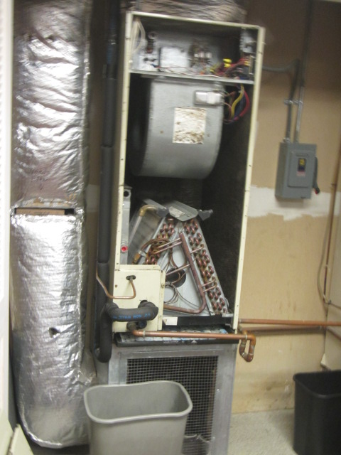
AHU in Oak Conference room, arrows indicate mold growth on paper labels on GW at base of wall
Picture 2
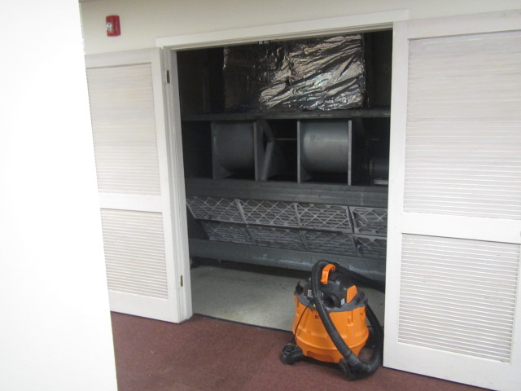
AHU in RESEA area, origin of flooding events
Picture 3
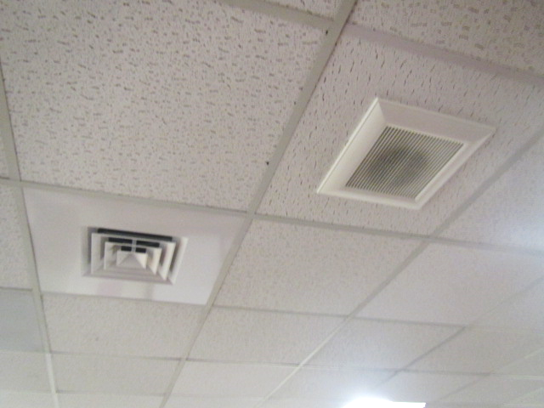
Supply diffuser and exhaust vent in conference room, note accumulated dust and debris
Picture 4
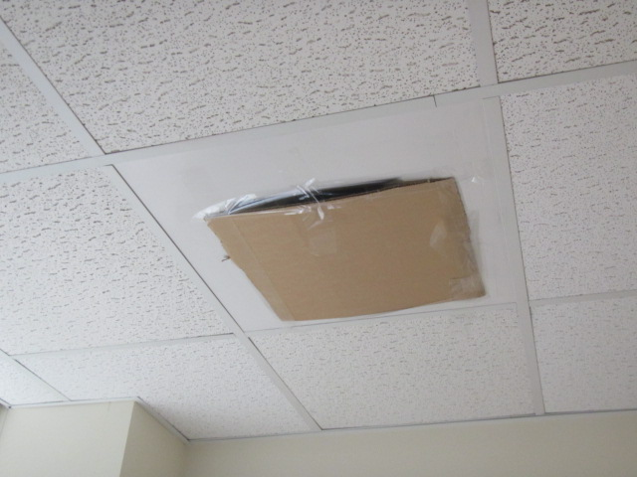
Sealed vent in office
Picture 5
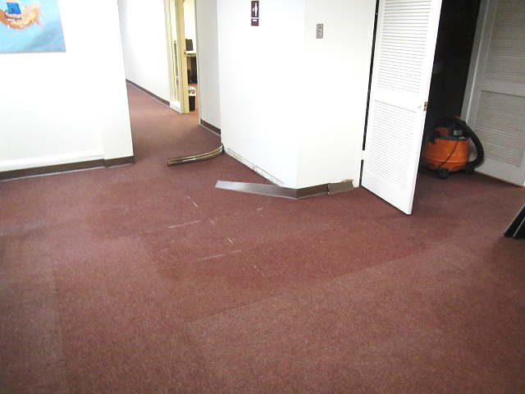
Wet carpet squares outside of HVAC closet in RESEA area
Picture 6
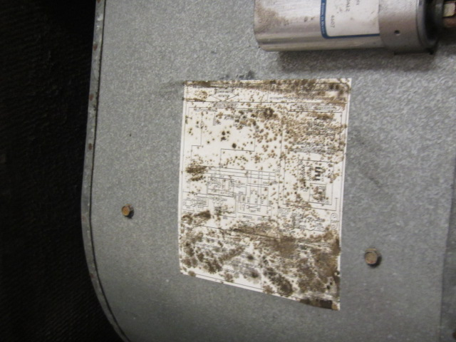
Visible mold on label of AHU in Oak conference room
Picture 7
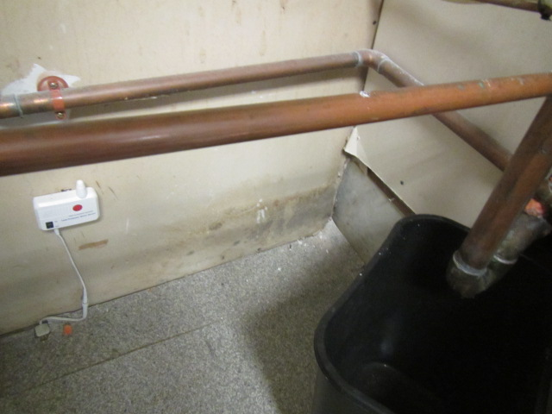
Water-damaged GW at base of wall in HVAC closet in Oak conference room
Picture 8
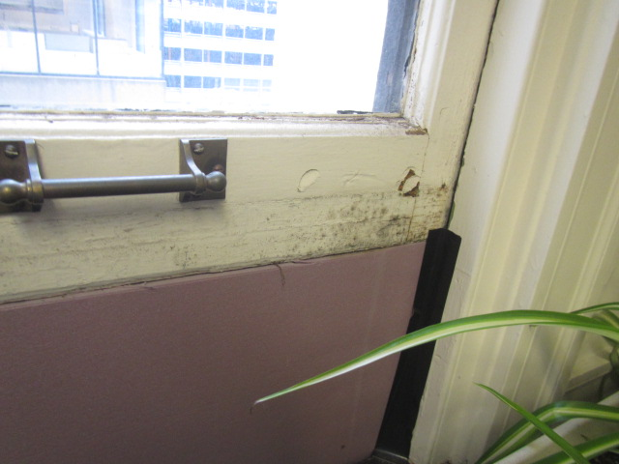
Surface staining that may be mold growth on wooden windowsill in work area
Picture 9
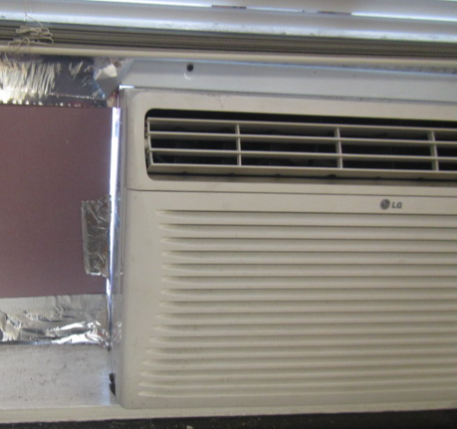
Space around window mounted air conditioner
Picture 10
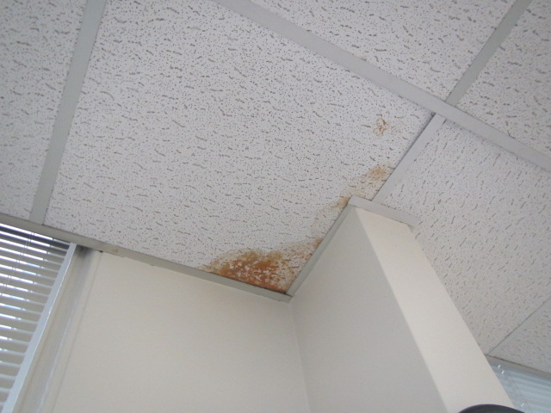
Water-damaged ceiling tile
Picture 11
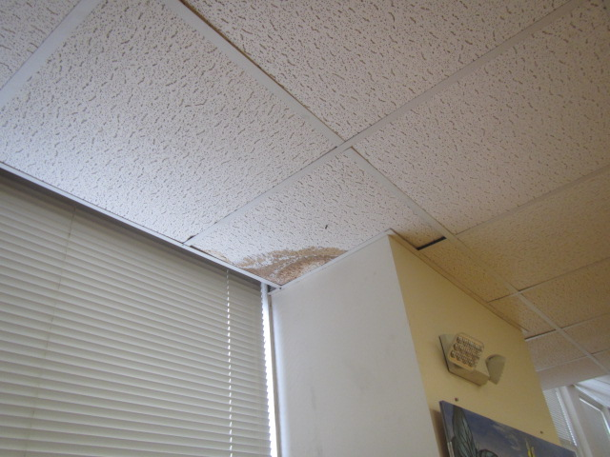
Water-damaged ceiling tile

Location | Carbon  Dioxide  (ppm) | Carbon Monoxide  (ppm) | Temp  (°F) | Relative  Humidity  (%) | PM2.5  (µg/m³) | TVOC  (ppm) | Occupants  in Room | Windows  Openable | Ventilation |  | Remarks/Moisture Testing
 |  |  |  |  |  |  |  |  | Supply | Exhaust
Background | 421 | ND | 72 | 82 | 25 | ND |  |  |  |  | Moderate traffic, light intermittent rain
Welcome Area | 453 | ND | 75 | 63 | 10 | ND | 2 | N | Y | Y | Space around AC unit, WD CT, AP
Gould (work station) | 504 | ND | 73 | 67 | 10 | ND | 0 | N | Y | Y | Carpet stain from previous leak-dry
RESEA | 502 | ND | 73 | 74 | 10 | ND | 0 | N | Y | Y | Carpet squares-wet, AHU leak
Hernandez Office | 503 | ND | 66 | 71 | 14 | ND | 0 | N | Y | Y | AC, GW-dry, carpet-dry
Aponte Office | 549 | ND | 68 | 71 | 8 | ND | 0 | N | Y | Y | AC, GW-dry, carpet-dry, dust/debris on vents
Workforce Board | 488 | ND | 69 | 68 | 5 | ND | 1 | N | Y | Y | AC, AP
Younis Office | 542 | ND | 73 | 65 | 10 | ND | 0 | N | Y | N | ATs, AC
Chambers-Boisvert Office | 523 | ND | 73 | 66 | 11 | ND | 0 | N | Y | Y | Supply vent blocked with cardboard, AP, debris on carpet, PF
Barrett-Thomas Workstation | 500 | ND | 71 | 54 | 6 | ND | 0 | N | Y | Y | Dust/debris on vents, AC, AP
Godfrey Office | 406 | ND | 71 | 62 | 9 | ND | 0 | N | Y | Y | AC, AP
Weekes Office | 406 | ND | 70 | 66 | 11 | ND | 0 | N | Y | Y | ATs, AC
Tucker-Davis | 795 | ND | 71 | 64 | 8 | ND | 1 | N | Y | Y
Breakroom | 526 | ND | 75 | 56 | 6 | ND | 0 | N | Y | Y | WD CT, dust/debris on vents, AC
Aponte-Scally | 503 | ND | 75 | 57 | 5 | ND | 0 | N | Y | Y | AP
Coglin Conference Room | 486 | ND | 74 | 59 | 6 | ND | 0 | N | Y | Y | Dust/debris on vents, ACs, PFs
Oak Conference Room | 501 | ND | 73 | 64 | 10 | ND | 0 | N | Y | Y | Visible mold on paper labels on AHU, WD GW base of closet wall

