INDOOR AIR QUALITY ASSESSMENT

North High School
150 Harrington Way
Worcester, Massachusetts

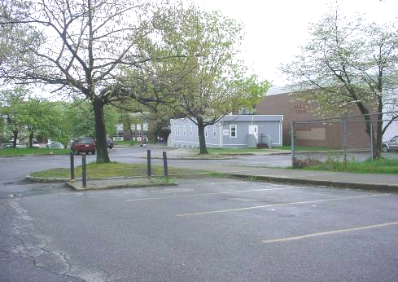

Prepared by:
Massachusetts Department of Public Health
Bureau of Environmental Health
Emergency Response/Indoor Air Quality Program
August 2007

Background/Introduction
At the request of Michael Sireci, Massachusetts Teacher’s Association, the Massachusetts Department of Public Health (MDPH), Bureau of Environmental Health (BEH) provided assistance and consultation regarding indoor air quality at the North High School, 150 Harrington Way, Worcester, Massachusetts. On May 11, 2007, a visit to conduct an assessment at the North High School (NHS) was made by Michael Feeney, Director of BEH’s Emergency Response/Indoor Air Quality (ER/IAQ) Program.
The NHS is a multi-wing red brick building constructed in 1958. The school contains classrooms, a gymnasium, auditorium, library and administrative offices. Windows were openable throughout the NHS.

Methods
Air tests carbon dioxide, temperature and relative humidity were taken with the TSI, Q-Trak, IAQ Monitor, Model 8551. BEH staff performed a visual inspection of building materials for water damage and/or microbial growth.

Results
This school has a student population of approximately 1,200 and a staff of approximately 80. The tests were taken under normal operating conditions. Test results appear in Table 1.

Discussion

Ventilation
It can be seen from the Table 1 that carbon dioxide levels were above 800 parts per million (ppm) in 16 of 54 areas surveyed, indicating a lack of adequate air exchange in some areas of the building. It is important to note that several areas were empty or sparsely populated at the time of the assessment. Low occupancy can greatly reduce carbon dioxide levels.
Fresh air in classrooms is supplied by unit ventilator (univent) systems (Figure 1). A univent draws air from the outdoors through a fresh air intake located on the exterior wall of the building and returns air through an air intake located at the base of the unit. Fresh and return air are mixed, filtered, heated and provided to classrooms through an air diffuser located in the top of the unit. Adjustable louvers control the ratio of outside to recirculated air. Univents at the NHS are of two different configurations. Those that appear to be original equipment are located in classrooms with windows (Picture 1). Windowless classrooms on the ground floor classrooms are fitted with univents of a different configuration (Picture 2).
Univents were found deactivated in a number of classrooms. In addition, fresh air diffusers from many of the original univents were found damaged. Damaged fresh air diffuser grilles in many classrooms were replaced with a wire mesh that has been repeatedly painted, essentially sealing the mesh (Picture 3). Univents with these repairs have restricted airflow, since the apertures through which air can pass are smaller than univents with intact fresh air diffuser grilles (Picture 4). This restriction of airflow can degrade the operation and reduce the life span of motors, fans and fan belts, since univent parts are designed to operate at a lower air pressure (i.e. reduced resistance provided by the original fresh air diffuser grilles). The decreased function of these univents may lead to an inadequate fresh air supply, as well as premature degradation of calibration of air velocity of univent fresh air intakes.
In the experience of BEH staff, the configuration of mechanical exhaust ventilation in a majority of classrooms appears unique. Student lockers are located along an interior classroom wall (Picture 5). It appears that air is drawn through openings in these locker doors, as well as through spaces beneath the lockers. Holes present at the rear of the locker walls show a dust accumulation pattern consistent with that often observed when air is drawn into an exhaust duct (Picture 6). As with the univent fresh air diffusers, the original design has been altered through repairs. Sheets of Masonite have been installed below the lockers (Pictures 7). The holes in the Masonite may not be of sufficient number or size to provide adequate exhaust ventilation, thereby limiting the draw of odors from classrooms.
Mechanical ventilation in large areas (e.g., gymnasium, the auditorium, and cafeteria) is provided by air-handling units (AHUs) located in mechanical rooms. The chemistry lab has an exhaust fan that is excessively noisy, which limits its use during teaching (Picture 8). Frequently, noise associated with fans is due to excessive fan blade speed.
To maximize air exchange, the MDPH recommends that both supply and exhaust ventilation operate continuously during periods of school occupancy. In order to have proper ventilation with a mechanical supply and exhaust system, the systems must be balanced to provide an adequate amount of fresh air to the interior of a room while removing stale air from the room. It is recommended that existing ventilation systems be re-balanced every five years to ensure adequate air systems function (SMACNA, 1994). The date of the last balancing was not available at the time of the assessment. The configuration of the exhaust ventilation system in many classrooms make balancing difficult, since vent louvers are not adjustable.
The Massachusetts Building Code requires that each area have a minimum ventilation rate of 15 cubic feet per minute (cfm) per occupant of fresh outside air or openable windows (SBBRS, 1997; BOCA, 1993). The ventilation must be on at all times that the room is occupied. Providing adequate fresh air ventilation with open windows and maintaining the temperature in the comfort range during the cold weather season is impractical. Mechanical ventilation is usually required to provide adequate fresh air ventilation.
Carbon dioxide is not a problem in and of itself. It is used as an indicator of the adequacy of the fresh air ventilation. As carbon dioxide levels rise, it indicates that the ventilating system is malfunctioning or the design occupancy of the room is being exceeded. When this happens a buildup of common indoor air pollutants can occur, leading to discomfort or health complaints. The Occupational Safety and Health Administration (OSHA) standard for carbon dioxide is 5,000 parts per million parts of air (ppm). Workers may be exposed to this level for 40 hours/week based on a time weighted average (OSHA, 1997).
The MDPH uses a guideline of 800 ppm for publicly occupied buildings. A guideline of 600 ppm or less is preferred in schools due to the fact that the majority of occupants are young and considered to be a more sensitive population in the evaluation of environmental health status. Inadequate ventilation and/or elevated temperatures are major causes of complaints such as respiratory, eye, nose and throat irritation, lethargy and headaches. For more information concerning carbon dioxide, please see Appendix A.
Temperature measurements ranged from 73º F to 82º F, above the MDPH recommended comfort guidelines in some areas surveyed during the assessment. The MDPH recommends that indoor air temperatures be maintained in a range of 70 º F to 78 º F in order to provide for the comfort of building occupants. A significant number of areas use box or floor fans to increase comfort. In many cases concerning indoor air quality, fluctuations of temperature in occupied spaces are typically experienced, even in a building with an adequate fresh air supply. In a building without a mechanical cooling system, temperatures measured indoor are typical of a building of this type.
The relative humidity ranged from 53 to 67 percent which was above the MDPH recommended comfort range in some areas. The MDPH recommends a comfort range of 40 to 60 percent for indoor air relative humidity. Relative humidity levels in the building would be expected to drop during the winter months due to heating. The sensation of dryness and irritation is common in a low relative humidity environment. Low relative humidity is a very common problem during the heating season in the northeast part of the United States.
Microbial/Moisture Concerns
The building has experienced water infiltration through the roof in the library. A storeroom with wall-to-wall carpeting had a musty odor. The source is likely historic water leaks that have moistened the carpet. A number of locations contained water-damaged ceiling tiles, which can indicate a leak through the window or univent fresh air intakes vents (Picture 9).
The Masonite used to replace damaged exhaust vents, which as discussed are located below student lockers, show signs of water staining (Picture 10). Such staining is likely from wet mopping of classroom floors. Masonite is a material that can support mold growth, particularly if the location is prone to generating condensation during hot, humid weather. Due to the date of construction, it is likely that floors of basement classrooms are prone to condensation, which would likely moisten these materials during hot, humid weather.
The US Environmental Protection Agency (US EPA) and the American Conference of Governmental Industrial Hygienists (ACGIH) recommend that porous materials be dried with fans and heating within 24 to 48 hours of becoming wet (US EPA, 2001; ACGIH, 1989). If porous materials are not dried within this time frame, mold growth may occur.
Plants were located in a number of areas and, in one instance, above the univent air diffuser. Plants, soil and drip pans can serve as sources of mold growth, thus should be properly maintained. Over-watering of plants should be avoided and drip pans should be inspected periodically for mold growth. Plants and related materials should also be located away porous materials (e.g., carpeting, paper products) to prevent damage and potential microbial growth in/on these materials.

Other Concerns
A number of other conditions that can affect indoor air quality were observed during the assessment. Please note that due to the configuration of the exhaust ventilation system, odors that are generated in classrooms may tend to linger, since minimal amounts of airflow are created. Use of products containing chemicals such as volatile organic compounds (VOCs) should be limited to prevent exposure to sensitive individuals. The following are sources of odors/chemicals/materials that may linger due to poor exhaust ventilation:
- Use of petroleum distillate based products for dry sweeping floors. Mop head treatments contain VOCs and may be a source of eye, nose and respiratory irritation.
- Storage of spray paint cans in some locations. Spray paint contains petroleum distillates and should be used in areas with adequate exhaust ventilation
- Use of dry erase boards and dry erase board markers in some classrooms. Materials such as dry erase markers and dry erase board cleaners may contain volatile organic compounds (VOCs), (e.g., methyl isobutyl ketone, n-butyl acetate and butyl-cellusolve) (Sanford, 1999). This configuration will allow dry erase board marker odors to be pulled into the air stream and be distributed throughout the classrooms. These products can all be irritating to the eyes, nose and throat.
- Accumulation of chalk dust in some classrooms (Table 1). Chalk dust is a fine particulate, which can be easily aerosolized and is an eye and respiratory irritant.
- Sinks that do not appear to be in use are located in a number of classrooms (Picture 11). Each sink contains a drain trap, which when filled, prevents odors from emanating from the sink’s drain system. Sewer gas (hydrogen sulfide) and other materials in drain systems can be irritating to the eyes, nose and respiratory system. If drain traps are not filled such odors and related health impacts are likely.
- An inoperable chemical hood is located in classroom B20. The B20 storeroom also contains a chemical hood. No documentation was readily available to determine if these chemical hoods were assessed to determine if each was working properly. Chemical hoods remove gases, vapors, fumes and dust produced by mixing chemical and need to have an adequate draw of air to ensure these materials are removed from the classroom.
- Photocopiers were located in the administrative office. At least one printer (Risograph®) uses a liquid toner. Photocopiers also produce VOCs. In addition, photocopiers produce ozone and excess heat, particularly if the equipment is older and in frequent use. VOCs and ozone are respiratory irritants (Schmidt Etkin, 1992).
In each of these instances, irritant materials aerosolized by normal use can tend to linger in areas without adequate exhaust ventilation. This phenomenon likely occurs in basement classrooms, since the draw of the mechanical exhaust ventilation system is minimal.

Conclusions/Recommendations
The conditions found at the NHS present issues that require a variety of remedial steps. The reconfigurations/repairs of many original univents prevent free airflow to classrooms. In addition, the configuration of the mechanical exhaust ventilation system and the installation of Masonite likely prevents removal and results in accumulation of normally occurring indoor environmental pollutants. Under these conditions, other pollutants do not appear to have a means of exiting the building, which can result in accumulation of these materials within the building. In view of the findings at the time of this visit, the following recommendations are made:
- Examine the feasibility of replacing wire mesh on univents to maximize fresh air distribution. Repair the mechanical exhaust ventilation system and operate during school hours.
- Replace Masonite with a material that will not impede exhaust airflow and is not a source for mold growth.
- Consult a ventilation engineer to ascertain the best method for increasing fresh air supply to classrooms. Operate all ventilation systems throughout the building (e.g., gym, auditorium, classrooms) continuously during periods of school occupancy independent of thermostat control to maximize air exchange. To increase airflow in classrooms, set univent controls to “high”.
- Consider adopting a balancing schedule of every 5 years for mechanical ventilation systems, as recommended by ventilation industrial standards (SMACNA, 1994).
- Use openable windows in conjunction with classroom univents and unit exhaust vents to increase air exchange where feasible. Care should be taken to ensure windows are properly closed at night and weekends to avoid the freezing of pipes and potential flooding.
- Repair chemical hoods (i.e. classroom B20) and exhaust ventilation systems for all laboratories and shop activities; use these systems as needed. Chemical hoods should be evaluated annually at minimum to ensure proper draw of air.
- Periods of low relative humidity during the winter are often unavoidable. Therefore, scrupulous cleaning practices should be adopted to minimize common indoor air contaminants whose irritant effects can be enhanced when the relative humidity is low. To control for dusts, a high efficiency particulate arrestance (HEPA) filter equipped vacuum cleaner in conjunction with wet wiping of all surfaces is recommended. Drinking water during the day can help ease some symptoms associated with a dry environment (e.g., throat and sinus irritations).
- Remove water-damaged ceiling tiles in a manner consistent with recommendations found in “Mold Remediation in Schools and Commercial Buildings” published by the US EPA (US EPA, 2001). This document is available from the US EPA website at: http://www.epa.gov/iaq/molds/mold_remediation.html.
- Ensure all plants are equipped with drip pans. Examine drip pans periodically for mold growth and disinfect with an appropriate antimicrobial where necessary. Remove plants from univents. Seal all drain on unused sinks. Be sure to shut off water supply to each sink with a sealed drain.
- Consider limiting the use of VOC-containing dust mop treatment in up to areas with adequate exhaust ventilation.
- Clean chalk dust trays and pencil sharpeners periodically to prevent dust aerosolization.
- Use VOC-containing products in a properly vented area. Store all flammable materials in a flameproof cabinet.
- Consider adopting the US EPA (2000) document, “Tools for Schools”, to maintain a good indoor air quality environment on the building. This document can be downloaded from the Internet at: http://www.epa.gov/iaq/schools/index.html.
- Refer to resource manuals and other related indoor air quality documents for further building-wide evaluations and advice on maintaining public buildings. These materials are located on the MDPH’s website: http://mass.gov/dph/indoor_air.
References
ACGIH. 1989. Guidelines for the Assessment of Bioaerosols in the Indoor Environment. American Conference of Governmental Industrial Hygienists, Cincinnati, OH.
BOCA. 1993. The BOCA National Mechanical Code-1993. 8th ed. Building Officials & Code Administrators International, Inc., Country Club Hills, IL.
OSHA. 1997. Limits for Air Contaminants. Occupational Safety and Health Administration. Code of Federal Regulations. 29 C.F.R 1910.1000 Table Z-1-A.
Sanford. 1999. Material Safety Data Sheet (MSDS No: 198-17). Expo® Dry Erase Markers Bullet, Chisel, and Ultra Fine Tip. Sanford Corporation. Bellwood, IL.
SBBRS. 1997. Mechanical Ventilation. State Board of Building Regulations and Standards. Code of Massachusetts Regulations. 780 CMR 1209.0
SMACNA. 1994. HVAC Systems Commissioning Manual. 1st ed. Sheet Metal and Air Conditioning Contractors’ National Association, Inc., Chantilly, VA.
US EPA. 2000. Tools for Schools. Office of Air and Radiation, Office of Radiation and Indoor Air, Indoor Environments Division (6609J). EPA 402-K-95-001, Second Edition. http://www.epa.gov/iaq/schools/tools4s2.html
US EPA. 2001. “Mold Remediation in Schools and Commercial Buildings”. Office of Air and Radiation, Indoor Environments Division, Washington, DC. EPA 402-K-01-001. March 2001. Available at: http://www.epa.gov/iaq/molds/mold_remediation.html

Picture 1

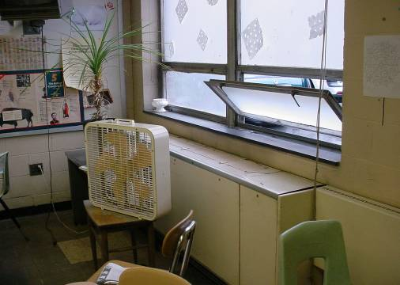

Univent on Upper Floor Classrooms

Picture 2

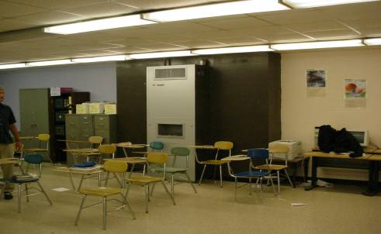

Univent in Ground Level Classrooms

Picture 3

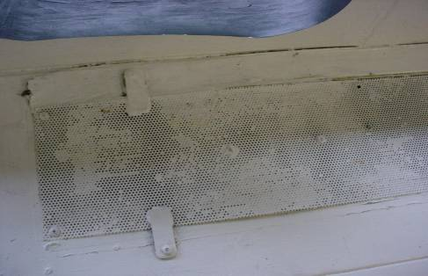

Wire Mesh That Is Mostly Painted Shut Used As Fresh Air Diffuser on Old Univents

Picture 4

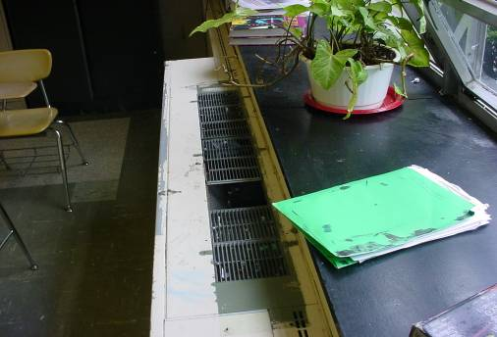

Example of Original Univent Fresh Air Diffusers, Note Size of Opening for Airflow and Compare to Picture 3
Picture 5

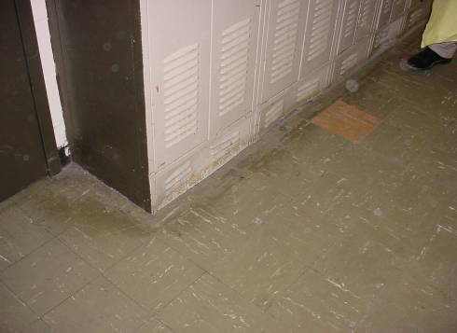

Student Lockers in Classroom, Arrow Notes Exhaust Vents at Bottom of Locker

Picture 6

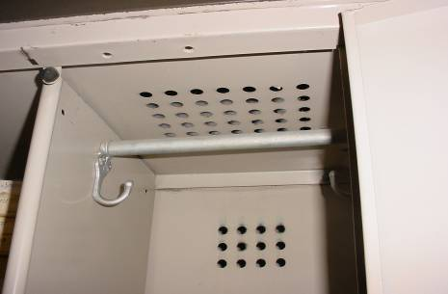

Holes in Rear Wall of Locker, Note Dust Accumulation Typically Seen On Exhaust Vents
Picture 7

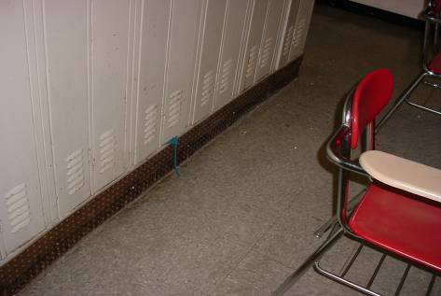

Masonite Installed In Place Of Original Vents

Picture 8

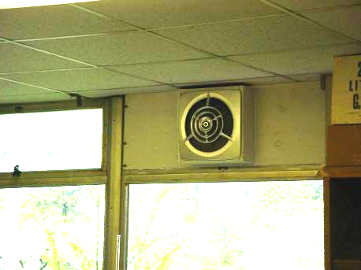

Chemistry Lab Exhaust Fan

Picture 9

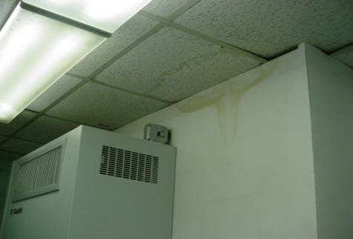

Water Damage around Univent

Picture 10

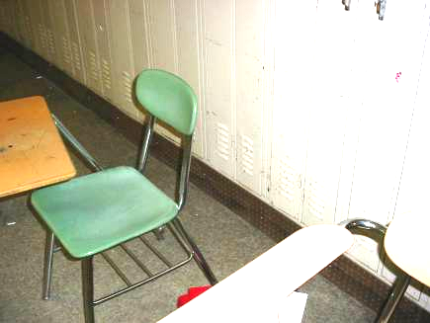
Stain On Masonite

Picture 11

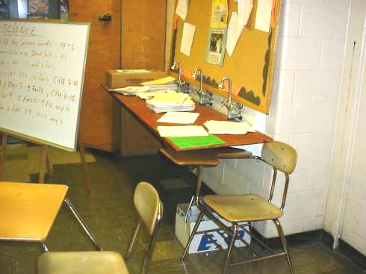

Example of Unused Sink
Location | Carbon  Dioxide  (ppm) | Temp  (°F) | Relative  Humidity  (%) | Occupants  in Room | Windows  Openable | Ventilation |  | Remarks
 |  |  |  |  |  | Supply | Exhaust | Remarks
Outside (Background) | 389 | 71 | 66
B12 | 609 | 75 | 67 | 11 | Y | Y | N | WO; DO, CD
B11 | 747 | 75 | 64 | 0 | N | Y | Y | DO
B10 | 968 | 76 | 66 | 6 | N | Y | Y | DEM
B9 | 767 | 76 | 66 | 13 | Y | Y | Y | CD
B8 | 1151 | 76 | 66 | 12 | N | Y | Y | CD
B7 | 1030 | 77 | 65 | 16 | Y | Y | Y | CD  DO
B1 | 1060 | 79 | 64 | 11 | N | Y | Y | DEM, 1 WD-CT, 22 computers, DO, WD-GW
B2 | 860 | 77 | 59 | 0 | N | Y | Y | DEM, Spray paint, DO, AD
B3 | 536 | 75 | 61 | 2 | Y | Y  off | Y | DEM, Dry drain traps, WO
B4 | 1255 | 76 | 57 | 13 | Y | Y | Y | Window-mounted air-conditioner, 21 computers
Gym | 877 | 78 | 56 | 40+ | Y | Y  off | Y  off
A23 | 1042 | 78 | 60 | 10 | Y | N | N | Window-mounted air-conditioner, 18 computers
B21 | 1212 | 80 | 63 | 16 | Y | Y | Y | CD, PF, DO, WO
B20 | 729 | 80 | 57 | 11 | Y | Y | Y | Exhaust fan broken, No air draw in chemical hood, DEM
B20 prep room | 691 | 80 | 56 | 0 | N | N | Y  off
B22 | 503 | 78 | 55 | 9 | Y | Y | Y | DEM, WO
B23 | 813 | 81 | 57 | 12 | Y | Y | Y  off | WO, Dry drain trap
B24 | 634 | 80 | 56 | 8 | Y | Y | Y | WO, CD, DO
B26 | 814 | 78 | 58 | 23 | Y | Y | N | Dry erase marker
B25 | 612 | 80 | 56 | 11 | Y | Y  off | N | 1 MT, WO, DO
Guidance | 676 | 82 | 54 | 4 | Y | Y  off | Y  off | WO, PF, DO
B27 | 901 | 82 | 55 | 11 | Y | Y | Y | WO
B28 | 622 | 80 | 53 | 18 | Y | Y | Y | WO, CD, DEM, DO
B28A | 598 | 78 | 53 | 2 | N | Y  off | N | Supply blocked by box, DO
Library | 560 | 79 | 55 | 8 | Y | Y | Y | WO, Musty odor in storage closet
B44 | 746 | 80 | 57 | 8 | Y | Y | Y | WO, 23 computers, 6 WD-CT
B43 | 640 | 79 | 57 | 0 | Y | Y | Y | WO, DO
B41 | 581 | 78 | 58 | 12 | Y | Y | Y | WO, CD
B40 | 670 | 78 | 59 | 16 | Y | Y | Y | 6 WD-CT
B39 | 717 | 79 | 60 | 12 | Y | Y | Y | WOPF, DEM
B38 | 667 | 79 | 58 | 23 | Y | Y | Y | PF, CD, WO
B37 | 843 | 81 | 61 | 15 | Y | Y | Y  off | Plants, DO
B36 | 774 | 79 | 57 | 18 | Y | Y | Y | 1 WD-CT, CD
B35 | 669 | 80 | 57 | 20 | Y | Y  off | Y | CD, WO, DO
Lounge | 444 | 78 | 55 | 2 | Y | N | N | PF, WO
B34 | 622 | 78 | 57 | 3 | Y | Y | Y | WO, DO
B33 | 908 | 79 | 58 | 27 | Y | Y | Y  off | WO, DEM, Dry drain traps, DO
B30 | 621 | 78 | 58 | 23 | Y | Y | Y | 3 WD-CT, DEM, DO
C2 | 549 | 74 | 62 | 8 | Y | Y | Y  off | 10 WD-CT, DO, outdoor DO, musty odors/mold in closet
C1 | 531 | 75 | 62 | 0 | N | Y | Y  off | PF, DEM, DO
C3 | 551 | 77 | 59 | 6 | Y | Y | Y | WO, PF, 26 computers  Exhaust blocked with box
C4 | 1122 | 78 | 55 | 0 | Y | Y | Y  off | WO, DO
C4 office | 972 | 78 | 55 | 0 | N | N | N | DO
B18 | 687 | 77 | 58 | 0 | N | Y | N
B17 | 719 | 75 | 58 | 0 | N | Y | N | DO
B16 | 745 | 75 | 60 | 1 | N | Y | N | 1 AT
B19 | 490 | 73 | 61 | 15 | Y | Y | Y | WO  Exhaust off
B15 | 565 | 74 | 66 | 0 | N | Y | Y | 1 WT-CT
B18A | 529 | 74 | 66 | 2 | N | Y | Y | DO
B13 | 678 | 74 | 65 | 4 | N | Y | Y | DO
B31 | 851 | 79 | 60 | 23 | Y | Y | Y  off | WO, Supply blocked with books
B32 | 652 | 79 | 57 | 13 | Y | Y | Y | 1 WD-CT, WO
MHS gearup | 685 | 81 | 54 | 1 | N | N | N | Ceiling fan, DO
Administration/mailroom | 553 | 79 | 57 | 4 | Y | N | N | PF, DO, Window-mounted air-conditioner, 2 Risographs®

Outdoor relative humidity on day of assessment was 66 percent, nearly equal to the highest indoor reading.

