WATER DAMAGE ASSESSMENT

Worcester Public Library
Basement Main Stacks, Storage, and Offices
3 Salem Street
Worcester, Massachusetts

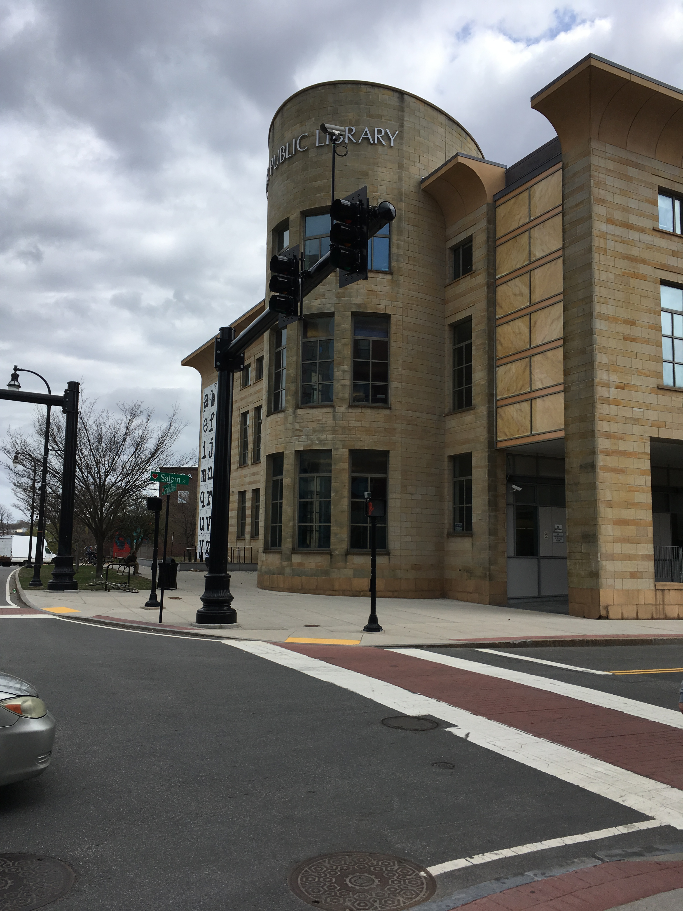

Prepared by:
Massachusetts Department of Public Health
Bureau of Environmental Health
Indoor Air Quality Program
June 2019

Background
Building: | Worcester Public Library (WPL), Basement area
Address: | 3 Salem Street, Worcester MA
Reason for Request: | General indoor air quality (IAQ) with concerns about mold in book collection
Date of Assessment: | April 19, 2019
Massachusetts Department of Public Health/Bureau of Environmental Health (MDPH/BEH) Staff Conducting Assessment: | Mike Feeney, Director, IAQ Program
Building Description: | The WPL basement contains the storage book stacks, office and storage.
Windows: | Openable in one area. No windows in all other areas.

METHODS
Please refer to the IAQ Manual for methods, sampling procedures, and interpretation of results (MDPH, 2015). DPH staff conducted a series of visual assessments, temperature measurements and use of an infrared camera to identify likely areas that could be prone to condensation in hot, humid weather. A FLIR infrared camera was used to visualize temperature ranges between floors, walls and other building materials.

Methods
Please refer to the IAQ Manual for methods, sampling procedures, and interpretation of results (MDPH, 2015).

RESULTS and DISCUSSION
The following is a summary of indoor air testing results (Table 1).
- Carbon dioxide levels were below the MDPH guideline of 800 parts per million (ppm) in all areas assessed.
- Temperature was within the recommended range of 70°F to 78°F in all areas.
- Relative humidity was within or close to the recommended range of 40% to 60% in areas tested.
- Carbon monoxide levels were non-detectable (ND) in all indoor areas assessed.
- Fine particulate matter (PM2.5) concentrations measured were below the National Ambient Air Quality Standard (NAAQS) level of 35 micrograms per cubic meter (μg/m³) in all areas.

Ventilation

The heating, ventilating and air conditioning (HVAC) system consists of rooftop air handling units (AHUs), which draw outside air through intakes and distribute it to occupied areas via ceiling-mounted diffusers. Return air is drawn through grates and ducted back to rooftop AHUs. At the time of assessment, the AHU servicing the ground floor was reportedly turned off. All other AHUs were reportedly operating.

Microbial Concerns
Handling of Book Processing
The basement is the main book processing area for the Worcester Public Library. The basement contains thousands of books awaiting assessment and processing, which is done by WPL staff. Books are made from materials that can readily become mold contaminated under moistened conditions. WPL staff physically handle books to determine condition and whether each can be reentered into circulation. The examination of mold-contaminated books can result in employee exposure to spores and other mold related pollutants, which can cause respiratory and possible dermal symptoms upon exposure. For this reason, a number of recommendations can be made with regarding best practices to reduce exposure to possible book-related mold.
Operating the HVAC system will supply fresh air and provide exhaust ventilation. The AHU is equipped with filters that remove dust/particulates from the air stream. Fresh air will reduce the concentration of airborne particles by dilution, where exhaust ventilation will physically remove airborne particles from the space. With the HVAC system operating, the combination of dilution, filtration and exhaust ventilation will help reduce airborne particles throughout the basement.
Employees directly handling possible mold-contaminated materials can be protected by several means. The most efficient manner to provide respiratory protection is to use a hood (Picture 1), which draws air away from the employee into the hood the air is then filtered and vented. Employees handling books during the assessment process should wear protective, non-latex gloves as well as long-sleeved work jackets to prevent dermal contact with possible irritants including mold.
Areas where books are examined and the inside of any hoods should be routinely wiped down to remove any mold contamination on surfaces. Any individuals who move books in the area with diagnosed respiratory conditions may need to wear a respirator with a sufficient rating appropriate to filter mold contaminants that has been fitted to them by a certified fit tester. Disposable single-use respirators (not dust masks) provided by the employer are generally sufficient to filter mold-related pollutants. Personally acquired respirators are not recommended due to issues related to proper cleaning, maintenance and storage.

Conditions of Books Stored in the Stacks
During the summer of 2018, the Boston area experienced an unprecedented period of extended hot, humid weather. According to the Washington Post, “[d]ata…show[s]…cities in the Northeast have witnessed such humidity levels for record-challenging duration...[i]ncluding Albany, Boston, Burlington Portland and Providence” during the summer of 2018 (WP, 2018). “Boston and nearby locations… [saw]…historic numbers of those warm nights with low temperatures at or above 70 degrees…Providence and Blue Hill Observatory have already broken their annual records” (WP, 2018).
If a building does not have adequate air chilling capacity to remove/reduce relative humidity from outside air, then hot, moist air introduced into a building can linger to increase occupant discomfort as well as possibly moisten materials that may lead to mold growth.
Note that both liquid water and water vapor can create conditions conducive to fungal colonization of vulnerable materials. Leaks through the building envelope (e.g., ceiling and foundation) are obvious water sources. High relative humidity combined with hot weather can also cause damage. Under certain conditions, condensation can accumulate and moisten materials. If these materials are porous, carbon-containing items (e.g., books), they can grow mold.
The key to managing condensation in hot, humid weather indoors is understanding dew point. When warm, moist air passes over a cooler surface, condensation can form. Condensation is the collection of moisture on a surface at or below the dew point. The dew point is the temperature that air must reach for saturation to occur. If a building material/component has a temperature below the dew point, condensation will accumulate on that material. Over time, condensation can collect and form water droplets.
According to American Society of Heating, Refrigerating and Air-Conditioning Engineers (ASHRAE), if relative humidity exceeds 70%, mold growth may occur due to wetting of building materials (ASHRAE, 1989). It is recommended that porous material be dried with fans and heating within 24 to 48 hours of becoming wet (US EPA, 2008, ACGIH, 1989). If porous materials are not dried within this time frame, mold growth may occur. Water-damaged porous materials cannot be adequately cleaned to remove mold growth.
It is important to note that offices and hallways in the stacks were free of musty odors and there were no signs of water leaks through ceilings, walls or the floor in these areas. The area that contains the telephone service did have water-damaged walls and ceiling (Picture 2; Table 1) attributed to cracks in tiles in the exterior walkway above this area (Picture 3). This water damage does not appear to directly affect the book collection, but may be a contributing factor to increased humidity in the basement during hot, humid weather.
Another source of water appears to be a leak in plumbing pipe (Picture 4). Accumulating water from drain leaks can evaporate which in turn may moisten nearby books.

Building Materials Prone to Condensation
A method to locate areas in a building prone to condensation would be to measure air and building material temperatures. If a wide temperature range exists between measurements, the building materials at the colder end of the range may be prone to becoming moistened with condensation in hot, humid weather.
Using a laser thermometer, the surface temperature of the floor was measured in the center along exterior foundation wall. Air temperature and relative humidity were also measured. Several conditions were noted:
Measurement of the temperature of floors ranged from 61-66°F, while the indoor temperature was in a range of 71-73°F. The difference in temperature indicates that the floor does not have insulation and can serve as a thermal bridge. Where a thermal bridge exists, condensation is likely to form on the warm side of the cold object which can moisten materials, especially during hot, humid weather. In these instances, the lower temperature of the floor combined with presence of thermal bridges make the floor vulnerable to subsequent moistening and mold growth under the weather conditions experienced in Massachusetts during the summer of 2018.

CONCLUSIONS AND RECOMMENDATIONS
The conditions related to IAQ at the WPL basement raise a number of complex issues. The book collection may have been stored in a manner to cause mold growth. This contingency should require that the employer determine what appropriate protective equipment necessary to protect the employees as well as provide the equipment. It is also the responsibility of the employer to ensure that employees receive proper training and ensuring use of protective equipment by all employees as needed.
Due to the nature of the materials used to make books, strict control of water vapor in the basement, particularly during hot, humid weather is recommended. The floors of the building may serve as thermal bridges, which can lower the temperature of metal shelving and in turn books, below the dew point during extreme temperature and humidity conditions. The IAQ Program offers to return to the WPL during hot, humid weather to assess conditions in the basement when the HVAC system is in its chilling mode to assess the possible effect on the book collection.
In general, eliminating/limiting the source of moisture is the preferred method for preventing mold growth inside of buildings. In view of the findings at the time of the visit, the following recommendations are made:
- All water-damaged materials should be handled in a manner consistent with recommendations listed in the US EPAs’ “Mold Remediation in Schools and Commercial Buildings” (US EPA, 2008), particularly mold-colonized books.
- Refrain from using the lowest shelf on book stacks to limit the possible chilling of book temperatures below the dew point.
- Ensure that employees who examine books for damage are supplied with and are properly trained in the use of protective equipment.
- Operate the book hood during business hours.
- Contact a contractor/building envelope specialist to examine whether the exterior walkway tiles can be sealed to prevent further water penetration.
- Repair source of water leak in Picture 4.
- Please note that the American Society of Heating, Refrigerating and Air-Conditioning Engineers (ASHRAE) states if relative humidity exceeds 70%, mold growth may occur due to wetting of building materials (ASHRAE, 1989). Monitor weather for predicted outdoor relative humidity over 70%; if duration last over 2 consecutive days, it is highly recommended to take measures to reduce relative humidity. These conditions are likely to occur during summer heatwaves in New England.
- Consider installing humidity measuring devices to monitor the relative humidity in the stacks, especially during hot, humid weather.
- Refer to resource manual and other related indoor air quality documents located on the MDPH’s website for further building-wide evaluations and advice on maintaining public buildings. These documents are available at http://mass.gov/dph/iaq.

REFERENCES
ACGIH. 1989. Guidelines for the Assessment of Bioaerosols in the Indoor Environment. American Conference of Governmental Industrial Hygienists, Cincinnati, OH.
ASHRAE. 1989. Ventilation for Acceptable Indoor Air Quality. American Society of Heating, Refrigeration and Air Conditioning Engineers. ANSI/ASHRAE 62-1989.
MDPH. 2015. Massachusetts Department of Public Health. Indoor Air Quality Manual: Chapters I-III. Available at: http://www.mass.gov/eohhs/gov/departments/dph/programs/environmental-health/exposure-topics/iaq/iaq-manual/.
US EPA. 2008. “Mold Remediation in Schools and Commercial Buildings”. Office of Air and Radiation, Indoor Environments Division, Washington, DC. EPA 402-K-01-001. September 2008. Available at: http://www.epa.gov/mold/mold-remediation-schools-and-commercial-buildings-guide.
WP. 2018. ‘It’s been relentless’: Smothering summer humidity in the Northeast has crushed records. Washington Post, Washington, DC. https://www.washingtonpost.com/news/capital-weather-gang/wp/2018/08/30/its-been-relentless-smothering-summer-humidity-in-the-northeast-has-crushed-records/
Picture 1
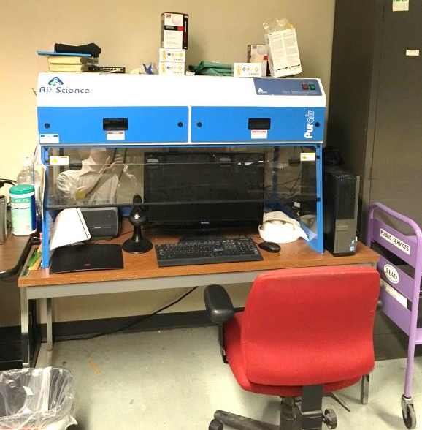
Book hood
Picture 2
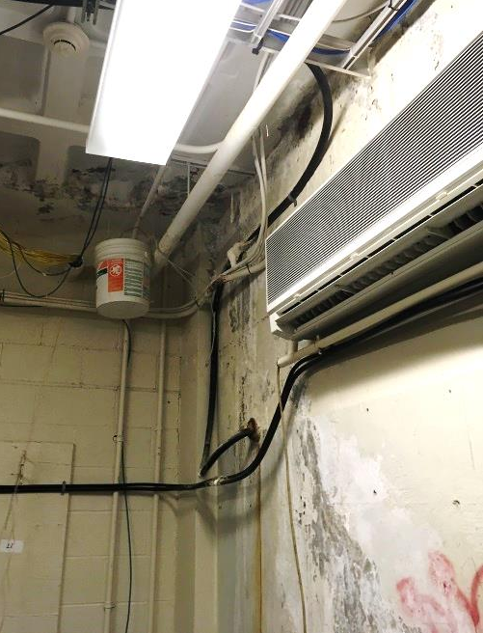
Cement water damage in the telephone room
Picture 3
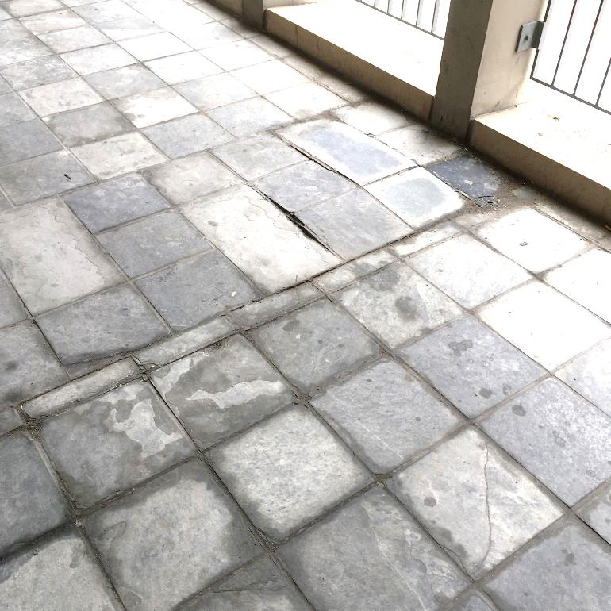
Damaged walkway tiles above telephone room
Picture 4
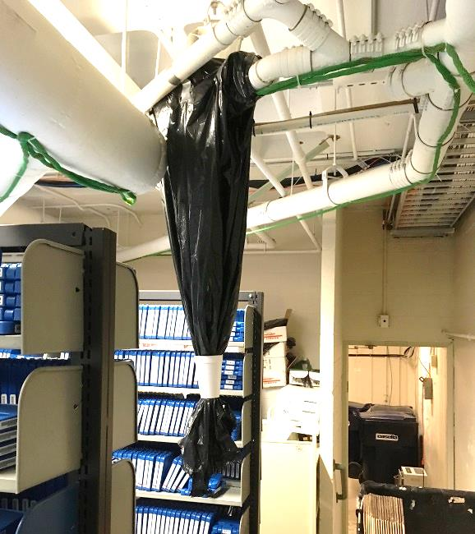
Leak from plumbing outside of telephone room
Location | Carbon  Dioxide  (ppm) | Carbon Monoxide  (ppm) | Temp  (°F) | Relative  Humidity  (%) | PM2.5  (µg/m³) | Occupants  in Room | Windows  Openable | Ventilation |  | Remarks
 |  |  |  |  |  |  |  | Supply | Exhaust
Background | 320 | ND | 72 | 69 | 9 | - | - | - | - | Overcast, intermittent sprinkles
Main stack (MS) at center of room | 365 | ND | 71 | 37 | 3 | 0 | N | Y | Y
MS SW corner | 376 | ND | 73 | 40 | 2 | 1 | N | Y | Y
MS S corner | 368 | ND | 73 | 36 | 2 | 0 | N | Y | Y
MS E wall | 364 | ND | 73 | 37 | 1 | 0 | N | Y | Y
MS NE corner | 365 | ND | 72 | 36 | 2 | 0 | N | Y | Y
MS N wall | 350 | ND | 72 | 38 | 2 | 0 | N | Y | Y
MS NW near telephone room | 379 | ND | 72 | 42 | 2 | 0 | N | Y | Y
Telephone room | 377 | ND | 71 | 47 | 2 | 0 | N | N | N | Water-damaged cement  Wall mounted air conditioner  Dehumidifier
MS NW corner | 337 | ND | 71 | 52 | 3 | 1 | N | Y | Y
B39 | 437 | ND | 72 | 53 | 4 | 2 | N | Y | Y
New Stack (NS) SW corner | 353 | ND | 72 | 35 | 4 | 0 | N | Y | Y
NS S wall | 349 | ND | 72 | 35 | 2 | 0 | N | Y | Y
NS SE corner | 366 | ND | 72 | 36 | 2 | 0 | N | Y | Y
NS E wall | 358 | ND | 71 | 36 | 1 | 0 | N | Y | Y
NS NE corner | 380 | ND | 71 | 36 | 2 | 0 | N | Y | Y
NS N wall | 360 | ND | 71 | 36 | 2 | 0 | N | Y | Y
NS NW corner | 367 | ND | 71 | 38 | 2 | 0 | N | Y | Y
NS Center | 357 | ND | 71 | 35 | 2 | 0 | N | Y | Y
B18 | 471 | ND | 74 | 47 | 2 | 0 | N | Y | Y
B33 | 406 | ND | 71 | 54 | 3 | 1 | N | Y | Y
B26 | 437 | ND | 72 | 45 | 3 | 1 | N | Y | Y
B30 | 341 | ND | 72 | 53 | 3 | 0 | Y | Y | Y
B29 | 322 | ND | 72 | 57 | 3 | 0 | N | Y | Y

A thermal bridge is an object (usually metallic) in a wall space through which heat is transferred at a greater rate than materials surrounding it. During the heating season, the window comes in contact with heated air from the interior and chilled air from the outdoors, resulting in condensation formation if the window frame temperatures are below the dew point.

