**POST-OCCUPANCY**

**INDOOR AIR QUALITY ASSESSMENT**

**Registry of Motor Vehicles Office**

**50 SW Cutoff**

**Worcester, MA**

Registry of Motor Vehicles Office
50 SW Cutoff
Worcester, MA


Prepared by:

Massachusetts Department of Public Health

Bureau of Climate and Environmental Health

Indoor Air Quality Program

December 2023

# BACKGROUND

|  |  |
| --- | --- |
| Building: | Registry of Motor Vehicles (RMV) Worcester Office |
| Address: | 50 Southwest Cutoff, Worcester, MA |
| Assessment Requested by: | Aric Warren, Transportation Program Planner, Mass Department of Transportation (DOT) |
| Reason for Request: | Post-occupancy indoor air quality (IAQ) assessment of leased space |
| Date of Assessment: | December 4, 2023 |
| Massachusetts Department of Public Health/Bureau of Climate and Environmental Health (MDPH/BCEH) Staff Conducting Assessment: | Ruth Alfasso, Environmental  Engineer/Inspector, IAQ Program |
| Building Description: | The RMV is in a one-story strip mall building in southeastern Worcester. The building was constructed in the 1980s. Other tenants include a retail pharmacy, a furniture store, other state offices and restaurants. |
| Windows: | Windows in the space are not openable |

# METHODS

Please refer to the IAQ Manual for methods, sampling procedures, and interpretation of results (MDPH, 2015).

# RESULTS AND DISCUSSION

The following is a summary of indoor air testing results (Table 1).

* ***Carbon dioxide*** measurements were below the MDPH guideline of 800 parts per million (ppm) in most areas assessed.
* ***Temperature*** was within the recommended range of 70°F to 78°F in all but one area tested, which was close.
* ***Relative humidity*** was within or close to the lower end of the recommended range of 40% to 60% in all areas tested.
* ***Carbon monoxide*** levels were non-detectable (ND) in all areas tested.
* ***Fine particulate matter (PM2.5)*** concentrations were below the National Ambient Air Quality Standard (NAAQS) level of 35 μg/m3 in all areas tested.
* ***Total Volatile Organic Compounds (TVOC)*** were non-detectable (ND) in all but two areas where levels were low.

## Ventilation

A heating, ventilation, and air conditioning (HVAC) system has several functions. First, it provides heating and, if equipped, cooling. Second, it is a source of fresh air. Finally, an HVAC system will dilute and remove normally occurring indoor environmental pollutants by not only introducing fresh air, but also filtering the airstream and ejecting stale air to the outdoors via exhaust ventilation. Even if an HVAC system is operating as designed, point sources of respiratory irritation may exist and affect symptoms in sensitive individuals.

The HVAC system uses air handling units (AHU) on the roof. Fresh air is drawn into the units, conditioned, and delivered to offices and other areas through ceiling-mounted supply vents (Picture 1). Return air is drawn into other vents and returned to the AHU/exhausted from the building (Picture 2). A few rooms with multiple people in them had levels slightly above 800 ppm. Rooms that typically experience high occupancy may need more fresh air.

Thermostats were noted in various locations in the office, with what looks like master controls for all the rooftop units in the manager’s office (Picture 3). It was reported that these thermostats are in this room to prevent occupants from changing the temperatures, however it is not clear if these thermostats are linked to temperature sensors in other areas of the office to measure and control the air to the zones served by the various rooftop units. In addition, the following was noted:

* The system time was slightly different on several of the thermostats (Picture 3). While a few minutes difference isn’t significant, it is best practice to set all thermostats the same, including any night and weekend setbacks, to save energy and ensure consistent control during occupied periods.
* The thermostats numbered 2 and 6 (upper row in Picture 3) are both indicating the filters need to be checked. Filters for all the rooftop units should be changed regularly a minimum of twice a year. It appears as though the thermostats may need to manually be reset when the filters are changed.
* Thermostat number 2 (top left in Picture 3) appears to be set for “hold” rather than following a schedule. Holding the temperature will not allow the system to change during nights and weekends.
* These thermostats do not indicate if the system has the fan on during all occupied periods or if they activate only when the temperatures need adjusting. MDPH recommends that HVAC controls be set to have the fan *on* to provide continuous air filtration and circulation throughout the space when the building is occupied, rather than only providing fresh air when a change in temperature is required.

In the public-side restrooms, a faint “toilet” odor was noted. This may indicate that exhaust vents in the restrooms are not drawing sufficiently to remove odors generated in the restrooms.

It is recommended that HVAC systems be re-balanced every five years to ensure adequate air systems function (SMACNA, 1994). The system was likely balanced during the remodeling prior to occupancy approximately a year and a half ago.

## Microbial/Moisture Concerns

No water-damaged ceiling tiles or other materials were found in the office. Water dispensers (Picture 4) and a few small refrigerators were found in carpeted areas. Water dispensers and refrigerators can spill or leak and moisten carpeting. Use of a waterproof mat underneath these appliances, or moving them to a non-carpeted area, can help prevent water damage.

The server and electrical rooms are equipped with ductless air conditioning units on the wall (Picture 5). These units have a condensation drain and pump to remove the collected condensation and transport it to an appropriate drain or outside. Over time, the pumps may malfunction, or the hoses become clogged, which can lead to leaks. This equipment should be checked periodically to ensure good condition and repaired/cleaned when necessary.

The staff break room has all new appliances which appeared to be clean and in good condition. Food preparation equipment should be kept clean to prevent odors, water damage, and pests. Food was noted in a few offices (Table 1). Food can be attractive to pests and should be stored in pest-proof containers.

## Other IAQ Concerns

Sampling for total volatile organic compounds (TVOC) was conducted in the space. Most areas had no detections (ND) but low levels of 1.0 to 1.2 ppm were noted in two rooms (Table 1). Since this building has been occupied for over a year, these readings are not likely due to building materials, paint, or furnishings. The likely source of low levels of TVOCs in the space are products in use, such as hand sanitizers, cleaners and dry erase materials which were found in various locations around the office (Table 1). In the absence of adequate fresh air and exhaust ventilation, VOCs from these products can build up and lead to irritation of the mucous membranes or irritating odors.

Wall-mounted air purifiers were noted in many of the spaces in the RMV (Picture 6). These units appear to have both HEPA (high-efficiency particulate air) filters and carbon filters. These are useful in removing odors, and particulates, including biological particulates such as microbes, from the indoor air. The units need to be cleaned and filters need to be replaced in accordance with manufacturers’ instructions (e.g., when the indicator lights go on). It is reported that the filters are changed on a regular schedule throughout the facility.

Some areas in this office are carpeted. Carpets should be cleaned regularly in accordance with Institute of Inspection, Cleaning and Restoration Certification (IICRC) recommendations (IICRC, 2012). Upholstered furniture was also noted in some rooms. These should also be cleaned regularly to remove dust and debris.

An accumulation of bird waste was noted on the exterior wall of the loading dock (Picture 7). Bird waste can carry pathogens and mold. This area is scheduled to be cleaned. Birds should be discouraged from roosting in areas that can impact the building.

# RECOMMENDATIONS

The following are recommendations made to maintain IAQ:

## Ventilation recommendations

1. Operate supply and exhaust ventilation in all areas during occupied periods.
2. In areas with higher carbon dioxide levels, consider opening system dampers or changing settings to provide more fresh air.
3. Ensure thermostats are set and operational, including system time, and scheduled temperature setbacks for occupied and unoccupied periods.
4. Ensure filters are replaced on HVAC units at least twice a year. Use filters with a minimum efficiency rating value (MERV) of 8 or better.
5. Check exhaust vent draw in the restrooms periodically to ensure adequate function.
6. It is recommended that HVAC systems be re-balanced every five years to ensure adequate air systems function (SMACNA, 1994).

## Water damage recommendations

1. Consider placing a waterproof mat underneath water dispensers and refrigerators to protect carpet from leaks.
2. Periodically check ductless air conditioning condensation drains and pumps to prevent leaks.
3. Keep refrigerators and other food-preparation appliances clean.
4. Store food in pest-proof containers.

## Other recommendations

1. Use VOC-containing products in areas with good ventilation and keep tightly closed when not in use. Avoid products with strong scents and avoid mixing incompatible products.
2. Maintain air purifiers in accordance with manufacturer’s instructions including filter changes.
3. Clean carpeting in accordance with IICRC recommendations (IICRC, 2012). Clean upholstered furniture regularly as well.
4. Clean bird waste from the loading dock wall and take measures to discourage roosting in the future.
5. For buildings in New England, periods of low relative humidity during the winter are often unavoidable. Therefore, scrupulous cleaning practices should be adopted to minimize common indoor air contaminants whose irritant effects can be enhanced when the relative humidity is low. To control dust, a high efficiency particulate arrestance (HEPA) filter equipped vacuum cleaner in conjunction with wet wiping of all surfaces is recommended. Avoid the use of feather dusters. Drinking water during the day can help ease some symptoms associated with a dry environment (throat and sinus irritations).
6. Refer to resource manual and other related IAQ documents located on the MDPH’s website for further building-wide evaluations and advice on maintaining public buildings. These documents are available at: <http://mass.gov/dph/iaq>.

# REFERENCES

ICRC. 2012. Institute of Inspection, Cleaning and Restoration Certification. Carpet Cleaning: FAQ.

MDPH. 2015. Massachusetts Department of Public Health. Indoor Air Quality Manual: Chapters I-III. Available at: <https://www.mass.gov/lists/indoor-air-quality-manual-and-appendices>.

SMACNA. 1994. HVAC Systems Commissioning Manual. 1st ed. Sheet Metal and Air Conditioning Contractors’ National Association, Inc., Chantilly, VA.

**Picture 1**

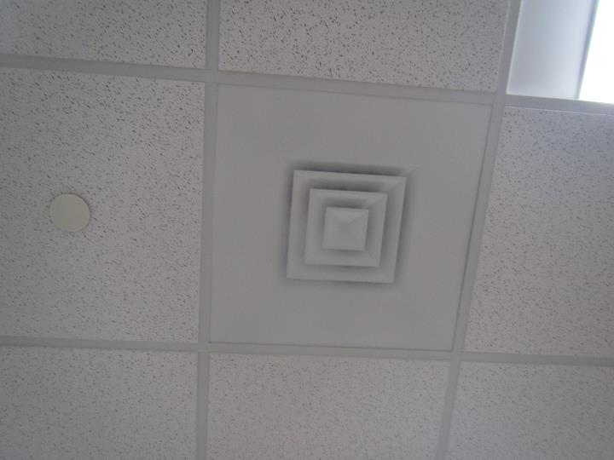

**Typical supply vent**

**Picture 2**

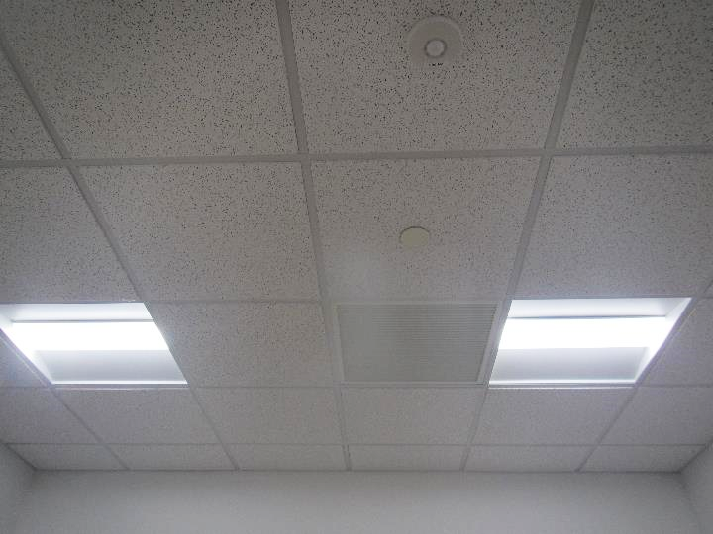

**Typical return vent**

**Picture 3**

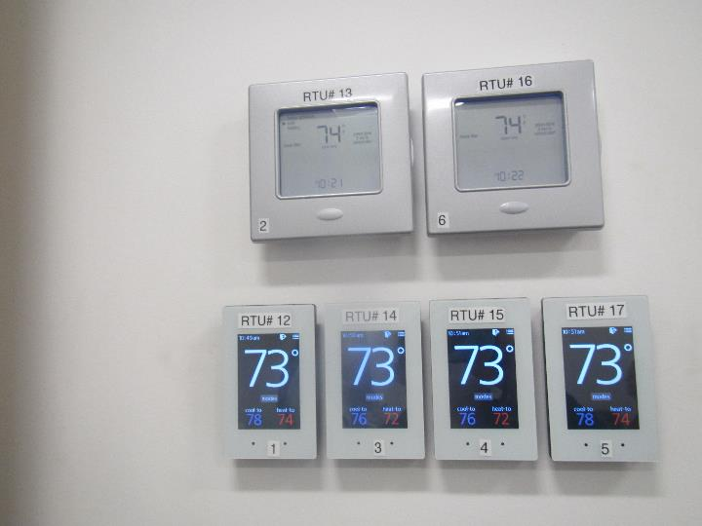

**Thermostats in the manager’s office**

**Picture 4**

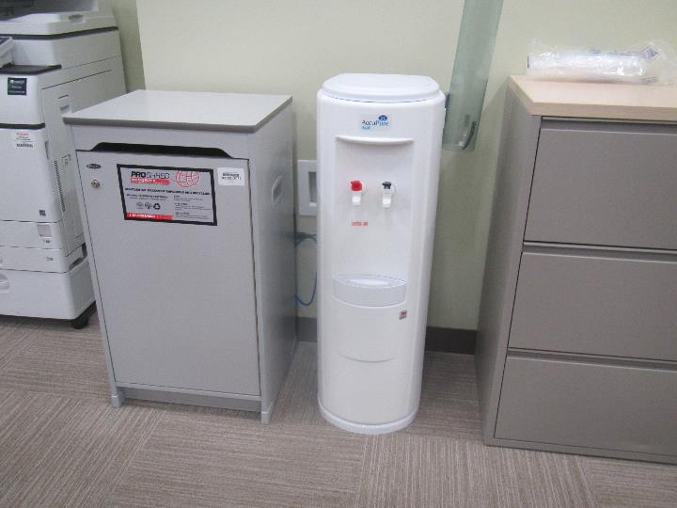

**Water dispenser on carpet**

**Picture 5**

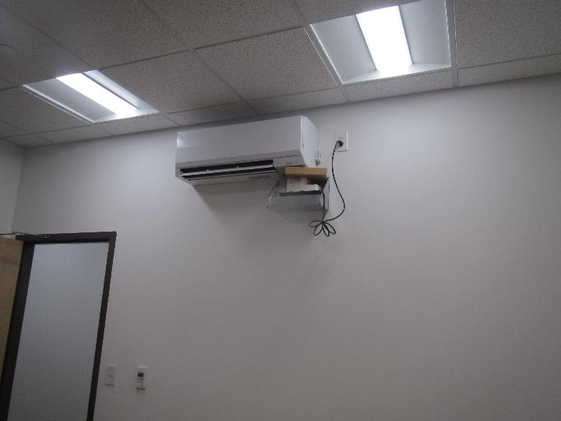

**Ductless air conditioner with condensation pump**

**Picture 6**

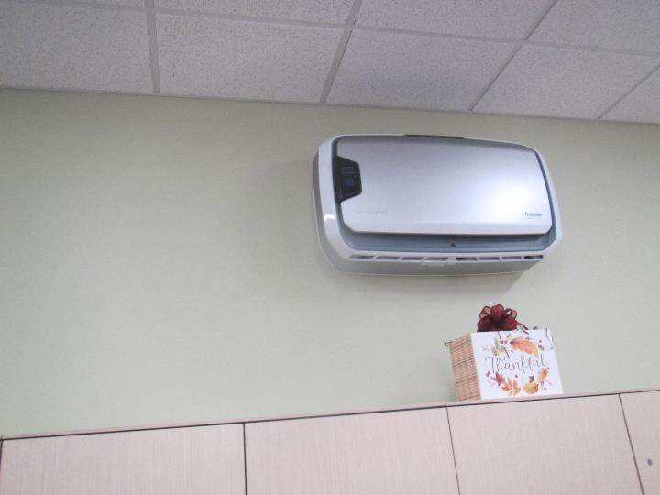

**Wall-mounted air purifier**

**Picture 7**

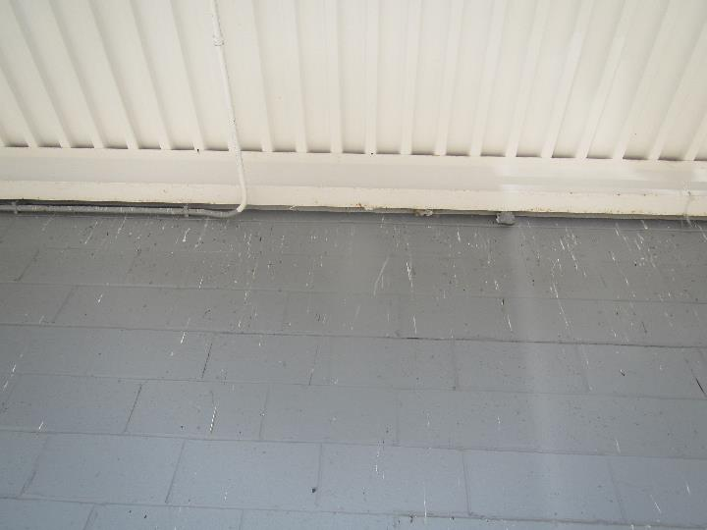

**Bird waste on loading dock exterior wall**

| **Location** | **Carbon**  **Dioxide**  **(ppm)** | **Carbon Monoxide**  **(ppm)** | **Temp**  **(°F)** | **Relative**  **Humidity**  **(%)** | **PM2.5**  **(µg/m3)** | **TVOC**  **(ppm)** | **Occupants**  **in Room** | **Windows**  **Openable** | **Ventilation** | | **Remarks** |
| --- | --- | --- | --- | --- | --- | --- | --- | --- | --- | --- | --- |
| **Supply** | **Exhaust** |
| Background | 382 | 0.4 | 50 | 53 | ND |  |  |  |  |  | Mostly sunny, breezy, and cool |
| Kitchen | 608 | ND | 69 | 43 | ND | ND | 0 | N | Y | Y | NC |
| Main Waiting | 603 | ND | 71 | 41 | ND | ND | 18 | N | Y | Y | NC |
| Permit room | 622 | ND | 71 | 41 | ND | ND | 0 | N | Y | Y | Carpet |
| Customer service | 753 | ND | 72 | 41 | ND | ND | 3 | N | Y | Y | PC, HS, carpet |
| Public side women’s restroom | 657 | ND | 72 | 39 | ND | ND | 0 | N | Y | Y | NC, toilet odor |
| Public side men’s restroom | 665 | ND | 72 | 40 | ND | ND | 0 | N | Y | Y | NC, toilet odor |
| Hearing office (rm 22) | 625 | ND | 70 | 39 | ND | ND | 0 | N | Y | Y | Carpet, printer, two-sided room with divider |
| Hearing office | 724 | ND | 70 | 41 | ND | ND | 0 | N | Y | Y | DEM, fridge on carpet |
| Service desk staff side 18/19 | 727 | ND | 71 | 41 | ND | ND | 0 | N | Y | Y | HS |
| Service Desk staff side 15/14 | 707 | ND | 71 | 41 | ND | ND | 0 | N | Y | Y |  |
| Service Desk staff side 12/11 | 718 | ND | 72 | 41 | ND | ND | 3 | N | Y | Y | HS, decorations |
| Service Desk staff side 8/7 | 708 | ND | 72 | 40 | ND | ND | 1 | N | Y | Y | HS, carpet |
| Service Desk staff side 4/3 | 706 | ND | 73 | 40 | ND | ND | 0 | N | Y | Y | HS, carpet |
| Business to business office | 679 | ND | 73 | 39 | ND | ND | 3 | N | Y | Y | Carpet |
| District mgr office | 634 | ND | 73 | 38 | ND | ND | 0 | N | Y | Y | Carpet, DEM |
| Manager’s office | 651 | ND | 73 | 41 | ND | ND | 1 | N | Y | Y | DEM, carpet |
| Assistant manager’s office | 696 | ND | 73 | 39 | ND | 1.0 | 0 | N | Y | Y | DEM |
| Counting room | 669 | ND | 74 | 38 | ND | 1.2 | 0 | N | Y | Y | Food, carpet, DEM |
| Counting room | 691 | ND | 74 | 37 | ND | ND | 0 | N | Y | Y |  |
| Plate room | 609 | ND | 70 | 39 | ND | ND | 0 | N | Y | Y | Plates and printed matter |
| Road test 2 | 667 | ND | 70 | 42 | ND | ND | 0 | N | Y | Y | Carpet, DEM |
| Wellness | 682 | ND | 71 | 41 | ND | ND | 0 | N | Y | Y | Fridge and sink, HS |
| Staff side women’s restroom | 658 | ND | 71 | 41 | ND | ND | 0 | N | Y | Y | AF |
| Staff side men’s restroom | 652 | ND | 71 | 41 | ND | ND | 0 | N | Y | Y | AF |
| Cash room | 658 | ND | 72 | 40 | ND | ND | 2 | N | Y | Y | Carpet, boxes |
| Server room |  |  |  |  |  |  | 0 | N | Y | Y | Ductless AC |
| Training | 602 | ND | 72 | 38 | ND | ND | 0 | N | Y | Y | Carpet, DEM, AP, equipment |
| Electric room |  |  |  |  |  |  |  |  |  |  | Ductless AC, NC |
| Road test room by front door | 891 | ND | 73 | 42 | ND | ND | 7+ | N | Y | Y |  |
| Office | 990 | ND | 73 | 41 | ND | ND | 2 | N | Y | Y | Carpet |