Advancing Equity with Indigenous Peoples
October 15, 2024

Tribal and Indigenous Health Summit

Massachusetts

Tribal and Indigenous Health Summit
Advancing Equity with Indigenous Peoples

Summary
The Massachusetts Department of Public Health convened its second annual Massachusetts Tribal and Indigenous Health Summit to better understand the public health issues impacting Tribal and Indigenous Peoples living in Massachusetts and to join together to work toward solutions. The summit was held on October 15, 2024.
The summit was conceived to gather a variety of interested parties to address key issues impacting the health of Tribal and Indigenous Peoples in Massachusetts. These issues included improving the collection and analysis of Tribal health data, improving communication between government health agencies and Tribal Nations, and ensuring more efficient and effective funding mechanisms to improve funding to support Tribal and Indigenous health.

Multiple Approaches
The topic of Tribal and Indigenous health is multi-faceted, and the speakers giving opening remarks reflected some of the varied approaches to improving the health of Tribal and Indigenous Peoples.
Summit participants benefitted from hearing from Roselyn Tso, the Director of Indian Health Service; Dr. Jon Santiago, Secretary, Massachusetts Executive Office of Veterans Services; Dr. Kiame Mahaniah, Undersecretary for Health, Massachusetts Executive Office of Health and Human Services; and Dr. Hafsatou “Fifi” Diop, Assistant Commissioner for Health Equity, Massachusetts Department of Public Health.

Focus on Veterans
The 2024 Summit had a special focus on Native Veterans. The Boston English High School U.S. Army Junior Reserve Officers Training Corps (JROTC) joined with Tribal and Indigenous educators for a ceremonial opening to the event. Dr. Jon Santiago, Secretary for the Massachusetts Executive Office of Veterans Services, spoke about the important contributions of Native Veterans and ensuring they are able to access the benefits and supports they are entitled to.
Aaron Eagan, the Director of the Office of Community Based Suicide Prevention for the U.S. Department of Veterans Affairs, spoke about addressing suicide prevention with Native Veterans. His talk covered his experiences working with Native Veterans to develop culturally relevant suicide prevention strategies. He also talked about the root causes of veteran suicide, and Native Veterans specifically, and to reduce stigma and enhance support for at-risk individuals.
Participants also had the opportunity to discuss and explore topics important to Native Veterans during two breakout sessions, one on connecting to resources and the other on substance use, suicide, and mental health.

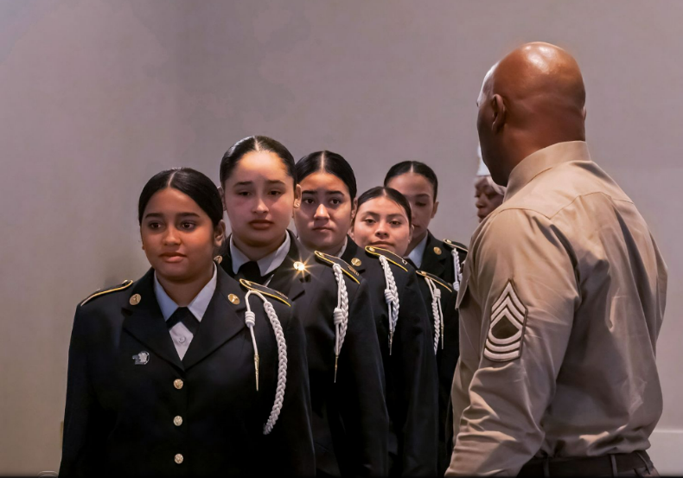

Leadership Roundtable
A roundtable discussion with several tribal leaders gave space for each to talk about the issues most affecting tribal health in their communities. Dr. Cedric Woods moderated the discussion.
One of the main themes that emerged from the discussion was the fact that health is not a distinct issue but is interconnected with housing, economic stability, environmental issues, and family and community connections.
Another main theme was the need for tribal leaders to meet with state and federal leaders at a higher level to be able to address the many factors that affect tribal health.
Leadership Roundtable participants:
- Chairwoman Cheryl Andrews-Maltais, Wampanoag Tribe of Gay Head Aquinnah
- Chairwoman Melissa Harding Ferretti, Wampanoag Herring Pond Tribe
- Chairman Brian Weeden, Mashpee Wampanoag Tribe
- Hiawatha Brown, Narragansett Indian Nation Veteran and Tribal Elder
- Nichol Brewer-Lowry, Site Director of Native American Lifelines (NAL)

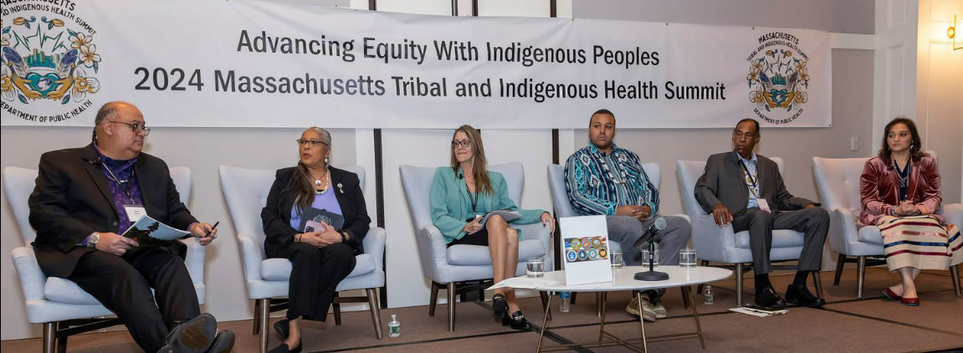

Keynote
Cedric Woods, Director of the Institute for New England Native American Studies at the University of Massachusetts Boston, gave the keynote address. He is a citizen of the Lumbee Tribe of North Carolina.
Dr. Woods’ address explored some of the foundational issues instrumental in moving toward Native Health Equity. He explained that health is not a stand-alone concept or reality, particularly when discussing Indigenous communities. Instead, physical, mental, spiritual and social components are key to understanding how health is experienced by Native communities in the Commonwealth.
In addition to these widely accepted components of health, we must also consider historical factors, such as state and federal policies, Native responses to these policies, and relationships to develop a shared framework for collaboration.
Historical factors Dr. Woods recommended considering when talking about Native Health Equity include:
- Earle Report of Native Americans, 1861
- MA Indian Enfranchisement and Allotment Act
- Mashpee Indian Land Claims
- American Indian Education and Self Determination Assistance Act
- Indian Arts and Crafts Act
- Current Massachusetts Department of Public Health surveys and Native-specific initiatives
- Federal recognition
- Other state/tribal engagement/collaboration models

Focused discussions
Eight breakout sessions allowed participants to engage with panelists on topics impacting Tribal and Indigenous health in Massachusetts. Small group sizes allowed for questions and conversation.

Tribal/State Relations: Best Practices in All Levels of Government and Programs
Just as there are 50 states within the United States, there are hundreds of individual, distinct tribal nations within those states. Each state and Tribe has its own unique history and relationship with one another, other Tribes, and the federal government. Panelists spoke about innovative approaches and engagements between tribes and states in the areas of Covid 19 pandemic response, the opioid crisis, state recognition, Indian Education, and other relevant topics.
Panelists:
- Jim Peters (Mashpee Wampanoag), Executive Director, Massachusetts Commission on Indian Affairs
- Love Richardson (Nipmuc Nation Hassanamisco Indian Tribe), Oregon State Tribal Relations Strategist
- Dr. Greg Richardson (Haliwa-Saponi Tribe) Executive Director, North Carolina Commission on Indian Affairs
- Dr. Cedric Woods (Lumbee Tribe), Director, Institute of Native New England Native American Program at UMass Boston
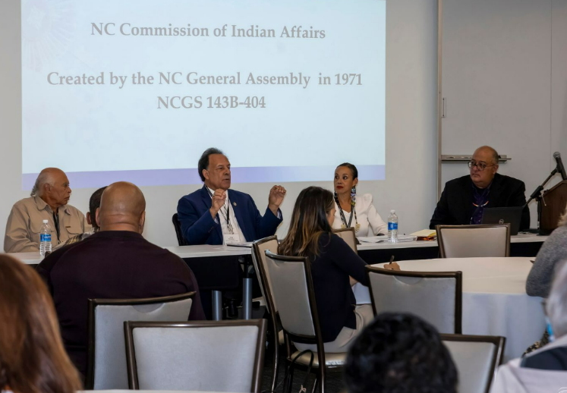
Using Storytelling to Integrate Culturally and Linguistically Appropriate Services (CLAS) in Supporting Tribal and Indigenous Communities
The session centered the historical context of inequitable access for Tribal and Indigenous communities. Panelists spoke about culture and traditions through oral history and traditional ceremonies that are effective in Tribal and Indigenous culture when healing from generational trauma and oppression. Culturally and Linguistically Appropriate Services (CLAS) Standards are a set of action steps intended to advance health equity, improve quality, and help eliminate health care disparities by providing a blueprint to implement culturally and linguistically appropriate services. Using CLAS standards can help better articulate, engage, build trust, and share practices to authentically engage Tribal and Indigenous communities.
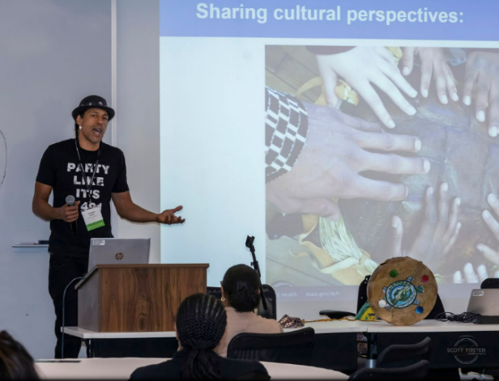
Panelists:
- Oanh Bui, DPH Manager of the CLAS Initiative
- Nandini Mallick, DPH CLAS Program Coordinator
- Annawon Weeden (Mashpee Wampanoag), First Light Fun Foundation CEO and Cultural Educator

Health and Disability Disparities in Indigenous and Veteran Populations
Strategies for engagement and outreach plans to Indigenous communities and Native Veterans were the focus of this session, which was rooted in the fact that nonphysical and physical disabilities play a critical role in quality of life. Panelists talked through defining disabilities and discussed how we can create education, outreach, accessibility and collaboration efforts to serve and provide resources to communities and individuals.
Panelists:
- Moderator: Bianey Ramirez, DPH Heath and Disability Strategist
- Dr. Darlene Flores (Taino), Veteran and chiropractic physician, Lulana Healing Center
- Kimberley Warsett, DPH Health and Disability Coordinator
Missing and Murdered Indigenous Women: A Global Public Health Crisis in Indigenous Communities
Local Indigenous women explained the devastating impact the epidemic of Missing and Murdered Indigenous Women (MMIW) has on their communities. They shared their personal experiences while highlighting the solidarity efforts made by Tribes in the northeastern region. Panelists discussed the complex jurisdictional challenges faced in the region, emphasizing the need for systemic change. Ongoing policy efforts, obstacles encountered, and the urgent call to action for legislators to support Indigenous rights and safety were also covered during the session.

Panelists:
- Chenae Billock (Shinnecock Nation), Founder and CEO of Moskehtu Consulting and NE Regional MMIW Task Force member
- Junise Bliss (Seekonk Wampanoag), MMIW Movement Founder and Strategist
- Airregina Clay, CDC Foundation, Data Standards Implementation Program Director
- Ariel Perry (Mashpee Wampanoag), MMIW Family and Victim Activist
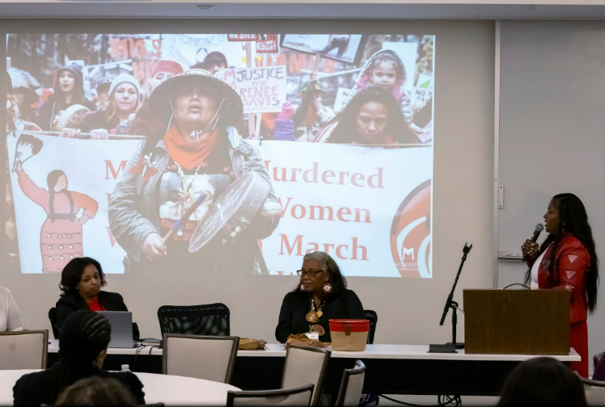
- Autaquay Peters (Mashpee Wampanoag), Doctoral researcher on violence against women, jurisdiction, data, and policy

Connecting Veterans to Services and Resources: A Roadmap to Navigate Across Agencies
This Veteran-focused session defined the difference between Veteran Health and Veteran Benefits, identified the priority health needs Veterans have and explained how to navigate the appropriate services. It allowed participants the opportunity to hear personal testimonies from Native and Indigenous Veterans and to engage with other veterans and people who to identify and support those in need.
Panelists:
- Moderator: Hiawatha Brown (Narragansett Indian Tribe), Spiritual Leader, Elder, Navy Veteran, and former Tribal Council
- Eric Charette (Chippewa Indian Tribe), Veteran, Boston VA Warrior Care Network Liaison
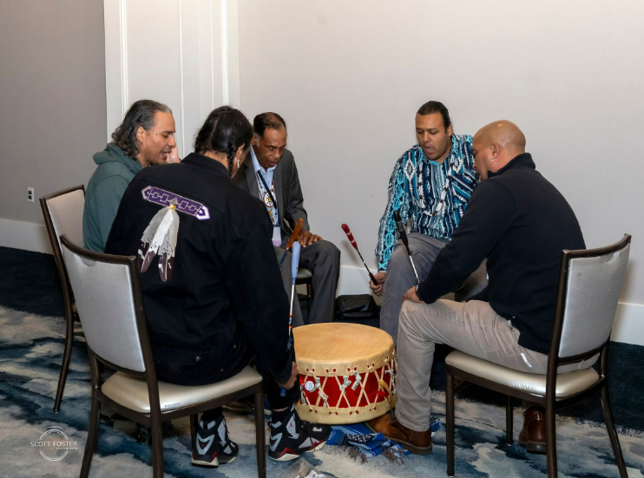

Intersectionality of Substance Use, Suicide, and Mental Health: A Discussion on Programs and Resources for Veterans and Indigenous Peoples

The intersections of substance use disorder (SUD), suicide, and mental health were the focus of this session. Panelists identified the relationships among the three entities and how we can more effectively engage, collaborate, and break down silos when providing services and resources to this vulnerable population. The VA presented resources for BH/SUD from a clinical social worker perspective, while DPH discussed resources and talked about the intersection of suicide and SUD. The Department of Mental Health gave updates on their programs and resources. The panelists engaged in a conversation about the next steps toward more effective collaboration.
Panelists:
- Moderator: Jen Miller (Native Hawaiian), Director, of DPH BSAS Grants Innovation Program
- Johanna Bridger, LICSW, Founder and Director of Safety, Hope and Healing Counseling and Consulting
- Aaron Eagan, Director, Office of Community Based Suicide Prevention, U.S. Department of Veterans Affairs
- Margaret Guyer-Deason, Director of Workforce Development and Research, Department of Mental Health
- Desiree Hendricks (Mashpee Wampanoag), Substance Abuse Case Counselor, IHS Mashpee Wampanoag Health Clinic

American Indian/Alaska Native Data across DPH and Boston VA: A New Path Forward
The session focused on how the Massachusetts Department of Public Health is working to improve representation within public health data and to improve access to that data for the Tribal and Indigenous community. The presentation and discussion expanded on and updated the presentation of work discussed at last year’s Summit.
Panelists
- Moderator: Cheryl Cromwell (Mashpee Wampanoag), Tribal and Indigenous Heath Equity Strategist, DPH Division of Community Engagement
- Arielle Coq, DPH Epidemiologist, Division of Data Science, Research and Epidemiology
- McKane Sharff, Epidemiologist, DPH Community Health Equity Initiative (CHEI), Office of Statistics and Evaluation
- Kerra Washington, Epidemiologist, DPH Community Health Equity Initiative (CHEI), Office of Statistics and Evaluation

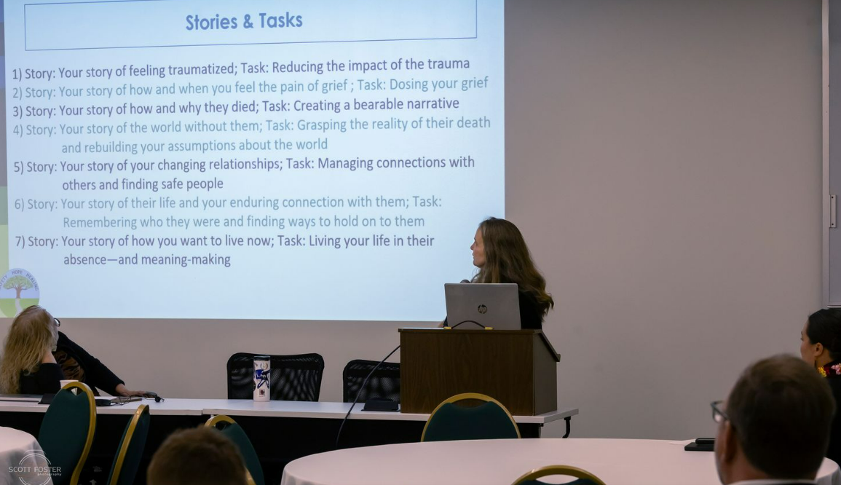
Improving Programming Collaboration with Tribes and Tribal Serving Organizations in Massachusetts: A Review of Lessons Learned from Implementation of Past Projects and Initiatives
Panelists worked with participants to foster deeper collaboration between state agencies, community partners, and Tribal and Tribal-serving organizations in Massachusetts. By reviewing lessons learned from previous initiatives, panelists reviewed strategies to enhance future programming and ensure that projects are grounded in cultural respect, community engagement, and shared decision-making.
Panelists
- Moderator: Eduardo Nettle, Deputy Director, DPH Division of Community Engagement
- Moderator: Valerie Toureau-Jean Louis, Deputy Director, DPH Division of Community Engagement
- Nichole Brewer-Lowry, Site Director, Native American LifeLines Urban Indian Program
- Melissa Harding Ferretti, Chairwoman, Herring Pond Wampanoag Tribe
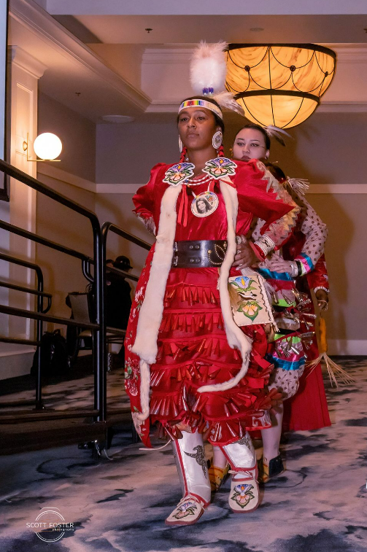
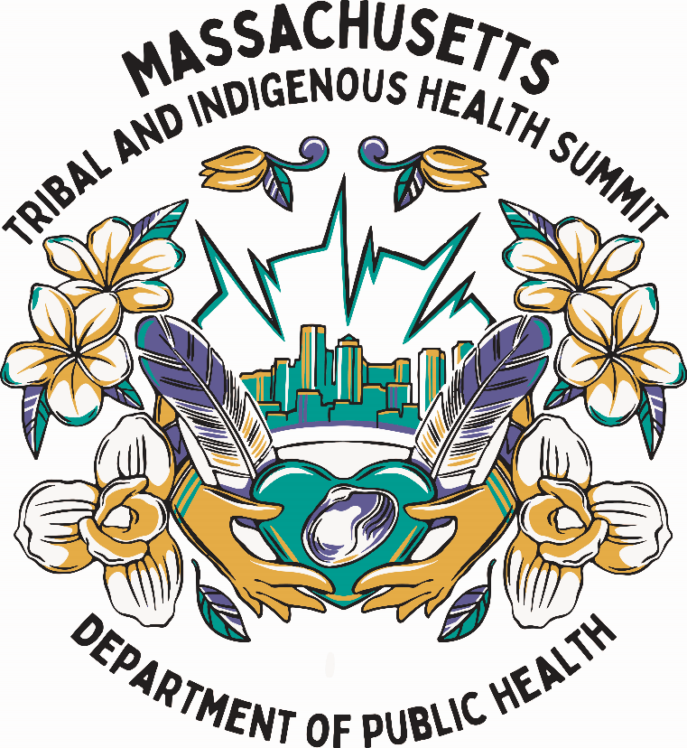
Division of Community Engagement
Office of Health Equity
Massachusetts Department of Public Health
250 Washington Street, Boston, MA 02108
dce@mass.gov

