Work-related Injuries among Massachusetts Teens, 2017 - 2021
Occupational Health Surveillance Program, Fall 2024

Background
Each year from 2017 to 2021, an estimated 44,000 teens aged 16-17 years old had a job in Massachusetts. All workers can be exposed to hazards on the job that can cause injury, illness, or even death, and teens are at an increased risk. Nationally, teens have an on-the-job injury rate nearly twice that of adults. As new workers, they are often unfamiliar with workplace hazards, ways to avoid injuries, and their rights as workers. This data brief provides an overview of teen workers in Massachusetts and highlights the industry in which the highest proportion of severe injuries occur – food services.

Injury prevention activities are needed
Our goal is to inform prevention activities, including enforcement, education and training, and other outreach. A focus on teen worker injuries in the food services industry is critical to keeping this young workforce healthy and safe.

Share Resources with Employers:
Help spread the word to employers that they play an important role in preventing injuries among their teen workers.
Share “Teen Work Injuries: What Employers Need to Know.” Employers may use this resource to help teens stay safe at work.

Overview of Teen Workers in Massachusetts¹

Top industry sectors where teens work²
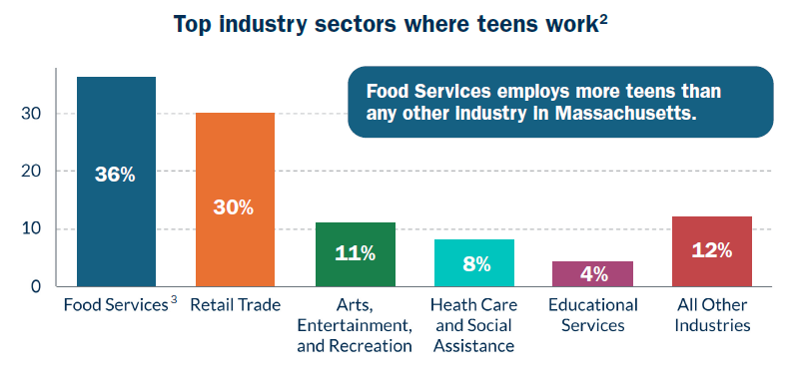
Bar graph showing the top industry sectors where teens work in Massachusetts. Industry and Percentage:
Food Services 36%
Retail Trade 30%
Arts, Entertainment, and Recreation 11%
Health Care and Social Assistance 8%
Educational Services 4%
All Other Industries 12%
The label for Food Services has a 3 next to it. You can find the meaning of it in the endnotes at the end of this document.
Text in figure: Food Services employs more teens than any other industry in Massachusetts.
Demographics of teen workers in Food Services (Sex)
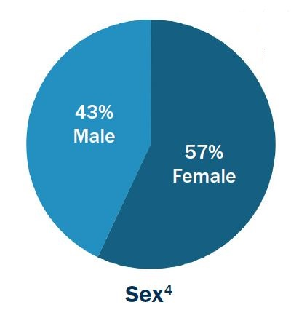
Pie chart showing the demographics of teen workers in food services by sex.
Male 43%
Female 57%
The label for Sex has a 4 next to it. You can find the meaning of it in the endnotes at the end of this document.

Demographics of teen workers in Food Services (Race/Ethnicity)

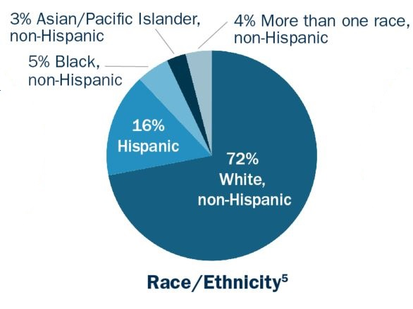
Pie chart showing the demographics of teen workers in food services by race/ethnicity.
White, non-Hispanic 72%
Hispanic 16%
Black, non-Hispanic 5%
More than one race, non-Hispanic 4%
Asian/Pacific Islander, non-Hispanic 3%
The label for Race/Ethnicity has a 5 next to it. You can find the meaning of it in the endnotes at the end of this document.

Demographics of teen workers in Food Services (Age)
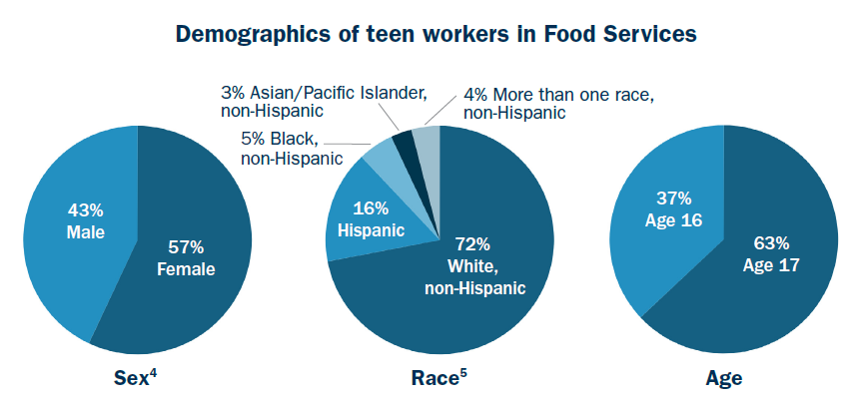
Pie chart showing the demographics of teen workers in food services by age in years.
Age 16 37%
Age 17 63%

Injuries among Teen Workers in Massachusetts⁶

How did we get data on teen worker injuries?
The data below came from workers’ compensation data. Between 2017 and 2021, 442 claims were filed on behalf of teen workers. Each claim represents a work-related injury and/or illness that resulted in five or more lost workdays. This means the data in this report account for the most severe injuries, not all injuries.

Note: A majority (over 91%) of claims filed were injuries. Therefore, we refer to these claims as injuries, but that does also include illnesses (1.5%) and claims that could not be classified (6.6%).

Top industry sectors among teens with work-related injuries
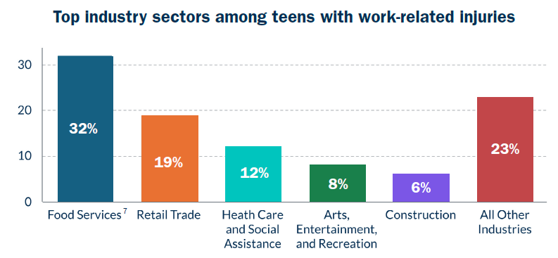
Bar graph showing the top industry sectors among teens with work-related injuries. Industry and Percentage:
Food Services 32%
Retail Trade 19%
Health Care and Social Assistance 12%
Arts, Entertainment, and Recreation 8%
Construction 6%
All Other Industries 23%
The label for Food Services has a 7 next to it. You can find the meaning of it in the endnotes at the end of this document.
Top occupations among teens in Food Services with work-related injuries⁸
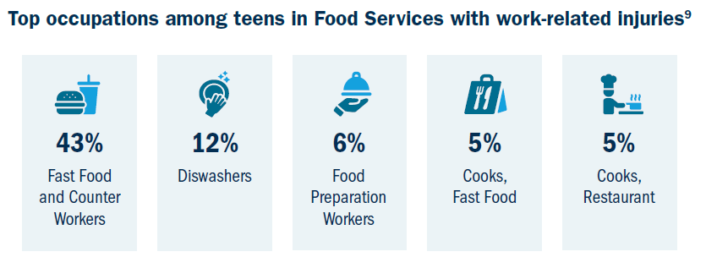
This figure is a set of graphics representing the top 5 occupations among teens in food services with work-related injuries. Each graphic has the name of the occupation under it and the percentage of teen work-related injuries in that occupation.
Graphic with hamburger and cup with straw
Fast Food and Counter Workers 43%
Graphic with hand on a plate with bubbles
Dishwashers 12%
Graphic of hand holding tray with lid
Food Preparation Workers 6%
Graphic of fork and knife
Cooks, Fast Food 5%
Graphic of cook with chef’s hat with pot with steam over it on a stove
Cooks, Restaurant 5%

Demographics of teens in Food Services with work-related injuries (Sex)⁹
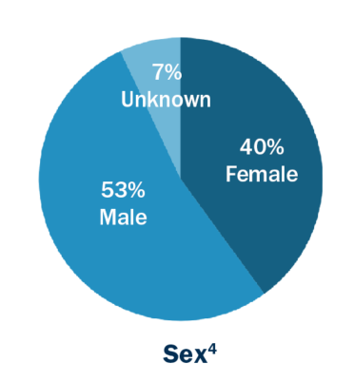
Pie chart showing the demographics of teens in food services with work-related injuries by sex.
Male 53%
Female 40%
Unknown 7%
The label for Sex has a 4 next to it. You can find the meaning of it in the endnotes at the end of this document.

Demographics of teens in Food Services with work-related injuries (Age)⁹
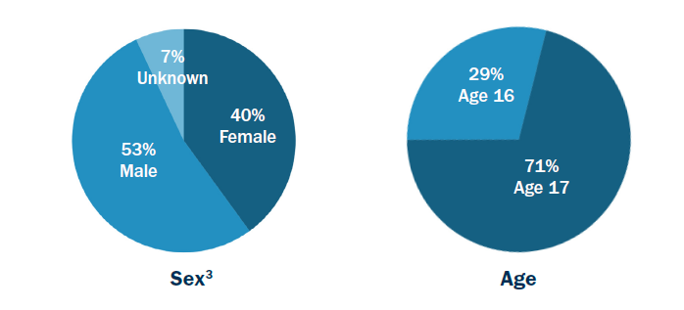
Pie chart showing the demographics of teens in food services with work-related injuries by age in years.
Age 16 29%
Age 17 71%

Types of work-related injuries among teens in Food Services
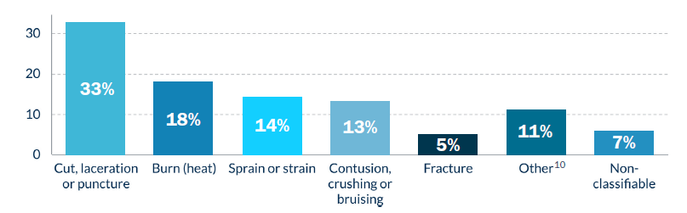
Bar graph showing the types of work-related injuries among teens in food services. Injury type and Percentage:
Cut, laceration or puncture 33%
Burn (heat) 18%
Sprain or strain 14%
Contusion, crushing or bruising 13%
Fracture 5%
Other 11%
Non-classifiable 7%
The label for Other has a 10 next to it. You can find the meaning of it in the endnotes at the end of this document.

Endnotes

- Source for industry and demographic data: American Community Survey (ACS), 2017-2021.

- Percentages in the figure and those that follow may not add up to 100 due to rounding.

- The Food Services industry includes family or fine dine restaurants, pizzerias, fast food, and catering, among other sub-groups. It also includes Accommodations (e.g., hotels), which accounts for less than 2% of the overall workforce in this industry.

- Sex is captured as a binary variable.

- Due to unstable estimates, “Other, non-Hispanic” is not reported. Hispanic includes people who identify as being of Hispanic, Latino, or Spanish origin.

- Source for claims data: Workers’ Compensation data, 2017-2021, Massachusetts Department of Industrial Accidents.

- The Food Services industry includes family or fine dine restaurants, pizzerias, fast food, and catering, among other sub-groups. It also includes Accommodations (e.g., hotels), which accounts for only 9% of the claims filed in this industry.

- Occupations were coded using the Standard Occupational Classification (SOC) System:
  - Fast Food and Counter Workers: SOC 35-3023
  - Dishwashers: SOC 35-9021
  - Food Preparation Workers: SOC 35-2021
  - Cooks, Fast Food: SOC 35-2011
  - Cooks, Restaurant: SOC 35-2014

- While Workers’ Compensation data has information on age and sex of claimants, it lacks information on race/ethnicity, limiting our ability to examine racial disparities in injuries.

- Other injury types include concussions, dislocations, multiple injuries, non-classifiable injuries, and illnesses.

