**WORKING IN INET WITH WINDOWS 10\IE11**

We know that a lot of the facilities have already upgraded to Windows 10/IE11 but the Health Safety Net wanted to let you know that you can use all of the functions in INET with Windows 10/IE11 with the compatibility mode settings. ***(Please note: It is not mandatory that you upgrade to Windows 10/IE11. INET will continue to work with the Windows version/Internet Explorer version you have presently..***

**Below is the information you will need In order to add the compatibility mode settings:**

***Provider Portal Tips – IE11 Browser Compatib*ility**

Open IE11 and navigate to INET at <https://dhcfpinet.hcf.state.ma.us/inetn/Login.aspx> .

In the IE11 settings, choose **Tools >> Compatibility View Settings**.

In the Compatibility View Settings dialog, Type “state.ma.us” and click the Add button to add “state.ma.us” to the Compatibility View Websites List.

See next page for additional information.

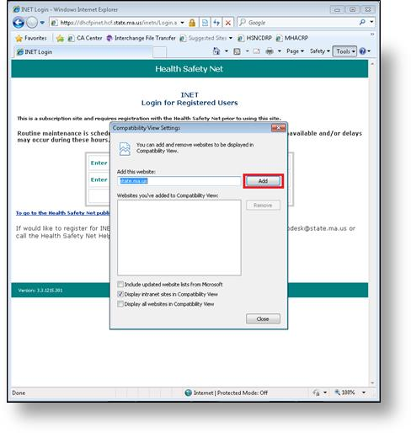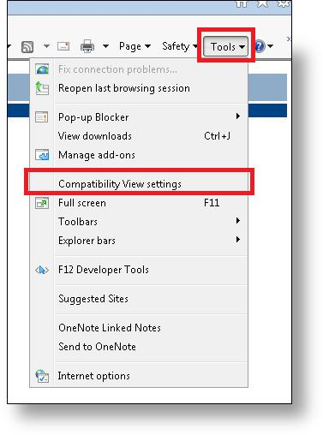

***Enable TLS 1.0, 1.2 and 1.2 – Follow the below steps***

Open Internet Explorer E11

In the IE11 Toolbar - Choose **Tools >> Internet Options>>Advanced**.

Scroll to bottom

Make sure that **TLS 1.0, 1.1 and 1.2** are checked off (See below)

Click “**OK**”

**Please clear the cache on your computer by deleting the history files and also delete the old INET website/icon from your computer and**

**GO TO:** **Health Safety Net website>>Providers>>HSN-INET Information>>INET website**

**Click on INET website and save as your new Health Safety Net link**

