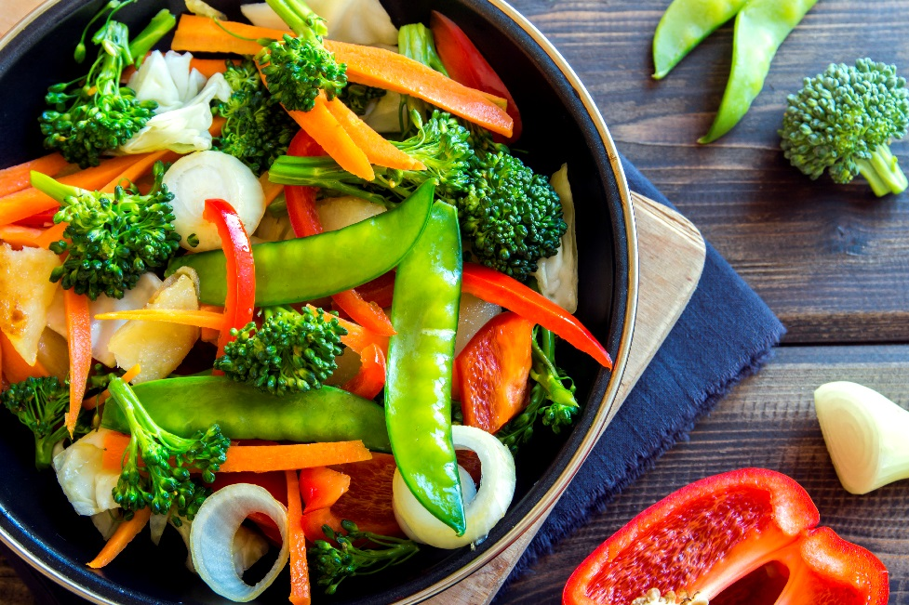

CHAPTER IX:
WORKING WITH THE STATE
PUBLIC HEALTH LABORATORY

IMPORTANT RESOURCES

State Public Health Laboratory (SPHL) –Main 617-983-6201
BioThreat & Chemical Threat 24/7 Emergency 617-590-6390
Enteric Laboratory 617-983-6609
Environmental Microbiology Laboratory 617-983-6610
Chemical Terrorism Laboratory 617-839-1283
(24 hours/7 days)
Environmental Chemistry Laboratory 617-983-6657
To Obtain Enteric Kits 617-983-6603
To Obtain Norovirus Kits 617-983-6441
Food Protection Program (FPP) 617-983-6712
Epidemiology Program 617-983-6800

Manual of Lab Tests and Services: http://www.mass.gov/eohhs/gov/departments/dph/programs/state-lab/services/manual-of-lab-tests-and-services.html

Submission Forms http://www.mass.gov/eohhs/gov/departments/dph/programs/state-lab/services/specimen-submission-forms.html

June 2017

About the State Public Health Laboratory

The Massachusetts Department of Public Health (MDPH) Bureau of Infectious Disease and Laboratory Sciences (BIDLS) is located at the William A. Hinton State Laboratory Institute, at 305 South St. in Jamaica Plain, MA. Comprehensive public health laboratory services are provided for diagnosis, surveillance, investigation and prevention. Hospitals and other laboratories send specimens or isolates for confirmation and serotyping to the State Public Health Laboratory.

The following are the core functions of the State Public Health Laboratory:
- Diagnostic testing
- Reference testing
- Laboratory-based surveillance
- Consultation for laboratory test interpretation and use
- Environmental chemical analysis and diagnosis of chemical illness in humans due to chemical exposure
- Infectious disease outbreak identification, surveillance and response
- Food safety
- Emergency response testing for biological and chemical terrorism, foodborne illness, and emerging infectious diseases
- Health studies
- Partnerships with the U.S. Centers for Disease Control and Prevention (CDC), the National Laboratory Response Network (LRN), Food Emergency Response Network (FERN), Federal Food and Drug Administration (FDA), U. S. Department of Agriculture (USDA) and other federal and state agencies
- Training and outreach in laboratory science and related subject matter expertise

Enteric (Stool) Samples

A. What Is Accepted for Testing? The Enteric Lab is one of two labs that conduct foodborne illness-related testing. Boards of Health (LBOHs) should coordinate through the Food Protection Program (FPP) or Epidemiology Program if enteric testing is necessary. Laboratory identification of a pathogen can validate the hypothesis and perhaps allow easier implementation of control and preventive measures. Increased certainty results if statistical association is combined with isolation of a pathogen from the ill person and the implicated food. This evidence is almost certain to be irrefutable. Therefore, time is of the essence when requesting and collecting clinical specimens and food samples.

Figure 9-1: Bacterial Tests Performed on Fecal (Stool) Specimens

Routine cultures:
Campylobacter species
Salmonella species
Shigella species
Vibrio species
Yersinia species
Shiga Toxin-producing E. coli

B. Collection Kits for Bacterial Stool Specimen Collection and Submission.
The Enteric Laboratory provides pre-made enteric stool specimen collection kits, called "Para-Paks" consisting of an outer cardboard canister with a metal top, an inner metal canister with the specimen submission form wrapped around it, and a clear plastic container with a white label on it inside the metal container. A collection paddle is connected to the top of the plastic specimen bottle, which holds clear ORANGE fluid.

Enteric culture kits now provided by the Laboratory usually have an expiration date on them. Older kits had a date stamped on the outer container, which was the date the kit was made. Kits have an eighteen-month shelf life, but can be used as long as the liquid remains clear orange. If the fluid is cloudy or yellow, it cannot be used, regardless of the date on the container. Please return kits no longer usable to the Laboratory; certain parts can be recycled.

C. Collection Kits for Norovirus Stool Specimen Collection and Submission.
Attachment 9-1 (SI-MO-1-13) has a description of the contents of the Norovirus Collection Kit and complete instructions for collection.

D. When to Collect Clinical Specimens. Diagnosis of most foodborne diseases can be made more easily when etiologic agents are isolated from clinical specimens of ill persons.
a. Encourage ill persons to submit stool specimens while they are still experiencing symptoms or as soon as is practical thereafter. Pathogens or toxins may remain in the intestinal tract for only a short time after illness onset.
b. Collect stool specimens prior to antibiotic treatment if at all possible. All stool specimens taken for return to work clearance by a food employee must be taken at least 48 hours after antibiotic treatment has been completed.

E. How Much to Collect.
a. A sample, the size of a dime, should be placed on the paddle in the transport medium. The medium stabilizes the specimens and prevents overgrowth of normal flora, which is flora usually found in the intestinal tract. If the stool is liquid, transfer no more than 4 ml of specimen to the container. Do not overfill!
b. Take care to not contaminate feces with urine.
c. A larger container such as a disposable plastic container or plastic wrap placed over the toilet are methods to make collection easier. The sample for the transport kit can then be taken from the middle of the larger sample, to decrease contamination when preparing the specimen.

F. Label each Specimen Bottle with:
a. Patient's name
b. Date of Birth
This information is essential for the lab to identify the specimen and complete testing!

Figure 9-2: Sample Specimen Bottle Label

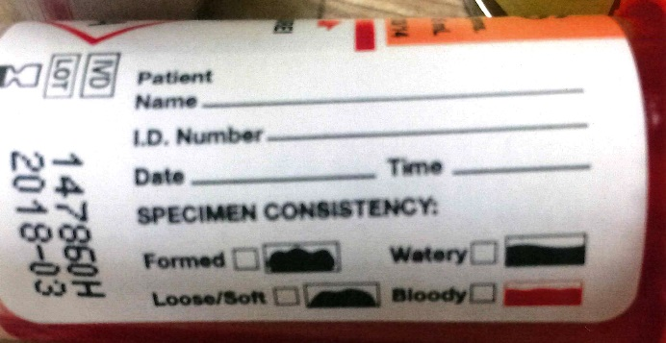

G. Complete the General Specimen Submission Form (SS-SLI-1-13 or current form available online). As described above, the form is found inside the container, usually wrapped around the outer metal container, but the form may have changed even though the specimen kit is still good. The form must include (a) and (b) from the following list:
a. Patient's name, address, date of birth, sex
b. Name and address of LBOH
c. Occupation (e.g. food employee, day care provider, etc.)
d. History of recent travel outside the U.S.
e. History of shellfish consumption
f. Whether patient is a "contact" to a known case, or whether this is a "release" or "clearance" specimen for someone to return to work
g. Note whether a particular food establishment is involved or if part of a known outbreak; (c) through (g) are extremely helpful.

Health Department staff, who have responsibility for requesting these specimens of anyone, should assist the individual with the completion of the SS-SLI-1-13 form and the label on the specimen bottle. The Date of Specimen Collection can be left blank at the time of completing all the additional information. Warn the patient to complete the date of collection before closing the specimen container for transport. Less than half of the specimens submitted to the State Public Health Laboratory are completed properly and some specimens cannot be tested for that reason. The SS-SLI-1-13 form is Attachment 9-2 at the end of this chapter.

It is highly recommended that LBOHs, either pick up specimens at the food service establishment (in an outbreak situation,) or ask everyone to deliver their specimens to the Health Department, so that they can be delivered by staff or courier. LBOHs should coordinate with the Epidemiology Program regarding any specimen collection. The results are extremely important and it is in the best interest of the Health Department to assist in every possible way to get the specimens collected, labelled properly and delivered to the Laboratory as soon as possible.

REJECTION CRITERIA:

SPECIMENS WITHOUT THE PATIENT'S NAME, DATE OF BIRTH, SEX,
AND NAME AND ADDRESS OF THE LBOH
WILL NOT BE TESTED!

H. Packaging.
a. To prevent leakage, tighten cover of transport bottle completely.
b. Place transport bottle into inner metal container
c. Wrap SS-SLI-1-13 form around the metal container holding the specimen and put both in the
cardboard outer container.
d. See slightly different instructions on Attachment 9-1 for Norovirus specimens.

I. Delivery
Coordinate delivery between the facility involved, the LBOH and the SPHL. Specimens have a short shelf-life and delivery coordination is extremely important. Bacterial specimens are stored and delivered at room temperature. Norovirus specimens are stored and delivered per Attachment 9-1.

J. Reporting Results
Written or electronic reports on all positive results are sent to:
a. The CDC in Atlanta
b. The LBOH where the patient lives (always)
c. Other submitters as noted on the SS-SLI-1-13 form
d. The LBOH handling the outbreak
e. Office of Integrated Surveillance and Informatics Services (ISIS)
f. State Public Health Laboratory files (Electronic - LIMS and ELR)

Written or electronic reports on all negative results are sent to:
a. LBOH where patient lives (if the patient is a release or contact; if LBOH is listed as the submitter
on the requisition; or if the LBOH requests the result.)
b. Other submitters as noted on the requisition (e.g., hospital or physician)
c. LBOH handling the outbreak
d. State Public Health Laboratory files (LIMS)

It is important to note that the Massachusetts Virtual Epidemiologic Network
(MAVEN) will not register negative specimen results.

K. Stool Specimen Testing Turnaround Times
Testing results for bacterial samples such as Campylobacter, Salmonella, Yersinia, Shigella, Vibrio and Shiga Toxin-producing E. coli, as well as Norovirus, take a minimum of 24 hours for positive or negative results.

L. Culture-Independent Diagnostic Tests (CIDT)
These tests can identify the general type of bacteria causing illness within hours, without having to culture, or grow the bacteria in a laboratory. These tests allow doctors to quickly determine the cause of the patient's illness and start treatment sooner. However, without the standard culture, public health is left not knowing the organism's strain or subtype (DNA fingerprint), resistance pattern and other important characteristics. This information is necessary to detect and prevent outbreaks, to track antibiotic resistance and monitor disease trends to know whether prevention measures are working.

As a short-term solution, CDC is encouraging clinical laboratories to work with public health laboratories to continue to culture and isolate the harmful bacteria from ill people with positive CIDTs. They are also trying to make the follow-up cultures easier and less expensive for clinical laboratories. The CDC is working with the Association of Public Health Laboratories (APHL), public health officials, regulatory agencies, diagnostic laboratories, CIDT kit manufacturers, and clinicians to make sure that cultures are obtained when CIDTs are positive, or that the positive specimen is provided to the public health laboratory so it can be cultured.

The long-term solution is believed to be creating more advanced testing methods so that obtaining a bacterial isolate from the culture process is no longer necessary to obtain the information so important to public health officials. These long-term solutions, however, will be years in the making. Culture-derived bacterial isolates from ill individuals will be necessary for the foreseeable future. (1)

In Massachusetts, laboratories are required by regulation to also perform standard cultures on specimens that have a positive CIDT. Shiga Toxin-producing E. coli specimens can be sent to the SPHL. All others should be done at the laboratory at which the CIDT was conducted.

M. Special Testing
1. Ova and Parasites (e.g. Giardia lamblia, Cryptosporidium parvum, Cyclospora cayetanensis.) The State Public Health Laboratory does not examine specimens for ova and parasites. If there is a need for this testing, due to food employees or individuals without health insurance, arrangements can be made through the SPHL for the specimens to be sent to a contract laboratory.

2. Viral Isolation. The SPHL also does not perform viral isolation on stool specimens. In special circumstances, the CDC may be able to offer laboratory assistance and conduct viral testing on fresh stool specimens. Contact the Epidemiology Program and/or the SPHL for assistance.

3. Urine. Urine is not a usual specimen for culture, although the Enteric Lab does receive isolates (usually from hospital labs) from urine specimens of Salmonella, Shigella and Shiga Toxin-producing E.coli for identification or serotyping. If the LBOH receives notification from the Enteric Lab of a positive pathogen from a urine specimen, follow-up should include a stool specimen. If the case is a food employee, that individual still must submit negative stool specimens in accordance with the reinstatement guidelines in the Food Code as outlined in the Employee Health Guidance Document, Attachment 8-1, in Chapter VIII: When There Are Sick Food Employees.

4. Blood. When typhoid fever and botulism are suspected, blood is an acceptable specimen, or a clinician can request blood testing for another reason. Blood tests for hepatitis A are usually performed through the individual's private medical provider, and are not performed at the SPHL.

5. Botulism Testing. Requests for botulism testing should go directly to the Epidemiology Program where a clinical history, food history, and discussion of symptoms takes place prior to a determination whether or not botulism testing is appropriate. If a decision to test is made, the other members of the Working Group on Foodborne Illness Control (WGFIC) will be contacted to coordinate specimen collection and laboratory preparation.

FOOD SAMPLES

All food sample submissions must be coordinated through the FPP and require pre-approval before delivery to the SPHL. All pertinent paperwork such as sample submission forms, foodborne illness complaint worksheets and investigation reports must accompany samples.

A. Collect Samples Aseptically; Temperature range 32 to 45 degrees F
  - Use sterile containers or Whirl-pak bags.
  - Make sure caps are tight, to prevent leakage.
  - Do not handle or touch the inside of the container.
  - Use sterile utensils, tongs, spoons, etc.
  - Use polypropylene containers. Try not to use Whirl-pak bags for liquids, which can leak and spill easily; if unavoidable, place in a second sterile bag.
  - Whirl-pak bags may be used for solid foods, such as dry milk, meat, etc.
  - Collect adequate amount of sample - at least 100-150 grams or milliliters, (4 to 6 oz.)
  - For liquids, fill containers no more than 3/4 full, to allow for proper mixing of the sample.
  - When collecting water from spigots, let the water run for 2 minutes, before collecting sample.

B. Transportation
a. Use dry ice for ice cream or frozen food samples.
b. Use plenty of ice cubes or crushed ice in a well-insulated cooler for time/temperature control
for safety foods.
c. If possible, wrap sample in a plastic bag before putting in the cooler.
d. Place sample container in cooler so that cover or lid is just above the ice level.
e. Pre-frozen ice packs may be used for food samples.

C. Labels
a. Write clearly with waterproof marker or use waterproof labels with a ball-point pen.
b. Tags may be used, especially on glass bottles.
c. Be careful to number each container, watch the sequence, be careful not to skip any numbers
or double up on the numbers.
d. Clearly state contents of container, e.g., raw milk, pasteurized, bulk, cultured, etc.
e. Include as much information as possible, lot numbers, expiration dates, manufacture's dates, etc.

D. Delivery
a. Make sure that all samples are kept at the same temperature they were at when collected; either room
temperature, refrigerated, or frozen.
b. Deliver food samples to the Specimen-Receiving area at the State Laboratory.
c. Coordinate arrival times with the Laboratory so someone is available to receive the food samples,
especially if the anticipated arrival is after 5 PM.

Figure 9-3: Food Sampling Equipment to Have On-hand

1. Sterile Sample Containers: plastic bags (disposable or Whirl-Pak), 2 oz., 18 oz., and 24 oz. and wide mouth plastic and glass jars with screw caps (6 oz. to 1 qt.)
2. Sterile and Wrapped Sample Collection Implements: spoons, scoops, tongue-depressor blades, spatula, swabs
3. Supporting Equipment: fine-point felt-tip marking pen, roll of adhesive or masking tape, waterproof labels/tags, sample submission forms
4. Sterilizing and Sanitizing Agents: 95% ethyl alcohol, sodium or calcium hypochlorite, test papers and alcohol wipes
5. Refrigerants: Insulated cooler; thermometer (0 to 220 degrees F); pre-frozen cold packs, heavy duty plastic bags to be filled with ice
6. Clothing: Hair restraint and disposable plastic gloves; laboratory coat and disposable plastic or paper shoe covers are highly recommended

In the preparation of this manual, there has been much discussion about how health departments should obtain the above equipment, how much they should have, etc. In general, the FPP is prepared to assist health departments, especially in collecting food samples. Since time is of the essence in the collection of these samples, however, there has been discussion of how the necessary supplies could be perhaps stored in the MDPH regional offices or some other scenario that would assist in better preparedness for foodborne illness outbreaks. No decisions have been made as of this writing, but a solution is being considered.

Chemical Illness/Poisoning
The Environmental Chemistry Laboratory may be involved in situations of suspected chemical poisonings or for the testing of naturally occurring toxins. In outbreak situations, LBOHs can coordinate food sample and clinical specimen submissions with the SPHL to ensure that all specimens, (e.g., food employees, patrons, and implicated foods) are handled in a coordinated fashion.

Clinicians and consumers should report food and beverage chemical contaminant incidents to their LBOH. Healthcare facilities, public safety officials and businesses are told to contact the MDPH FPP at 617-983-6712. The LBOH and FPP will initiate an investigation with those reporting the incident and coordinate any laboratory analysis needed with the Environmental Chemistry Laboratory depending on the suspected agent and/or assay methodology.

INTERPRETING THE REPORT RESULTS

A. Bacterial Test Results
All specimens are screened using a molecular pathogen panel. Negative specimens are reported as being negative for the specific DNA in question, by PCR. In accordance with regulation, 105 CMR 300.000, specimens which are positive will be confirmed via culture. It is possible to have a specimen which screens as PCR positive for the presence of DNA but the organism is unable to be grown in culture. This can be due to:
1) the presence of bacterial DNA from a non-viable organism (i.e. an old infection), or
2) the bacterial pathogen is present in quantities below the limit of detection for bacterial culture.
B. Norovirus Test Results
Specimens are tested by RT-PCR following CDC Guidelines. Negative for Norovirus by RT-PCR interpreted as Norovirus RNA not detected by RT PCR. Positive for Norovirus by RT-PCR interpreted as Norovirus RNA Detected by RT PCR. RT PCR Norovirus positive sample will be sequenced for surveillance purposes.

C. Chemical Test Results
Specimens are tested by various analytical techniques such as, GC/MS, ICPMS, FTIR for toxic heavy metals or chemicals (e.g. pesticides, drugs, and other harmful chemicals). The results are checked against chemical libraries for identification and if standards are available they will be used for confirmation.

Refer to attachment 9-5 for examples of reports.

References:

MA State Public Health Laboratory Manual of Laboratory Tests and Services (MLTS)

Council to Improve Foodborne Outbreak Response (CIFOR). Guidelines for Foodborne Disease Outbreak Response. 2nd edition. Atlanta: Council of State and Territorial Epidemiologists; 2014.

(1) Centers for Disease Control and Prevention website: cdc.gov; A to Z index; Food Safety; Challenges in Food Safety; "Culture-Independent Diagnostic Tests."

Attachments:

Attachment 9-1: Instructions for Stool Collection for Norovirus Testing
Attachment 9-2: SS-SLI-1-13 (Bacterial Stool Specimen)
Attachment 9-3: Environmental Sample Submission Form
Attachment 9-4: Chemical Exposure Clinical Specimen Submission Form
Attachment 9-5: Sample Laboratory Reports

Attachment 9-1: Instructions for Stool Collection for Norovirus Testing

MASSACHUSETTS DEPARTMENT OF PUBLIC HEALTH

WILLIAM A. HINTON STATE LABORATORY INSTITUTE

MOLECULAR DIAGNOSTICS LABORATORY

305 SOUTH STREET, JAMAICA PLAIN, MA 02130

INSTRUCTIONS FOR STOOL COLLECTION FOR NOROVIRUS TESTING

Norovirus Kit Components: a white plastic stool collection container in a large plastic bag, a plastic spoon, a vial with a spoon attached to the lid, a small plastic bag, a pre-labeled canister, an ice pack, and a specimen submission form.

Kit Storage prior to Collection: The canister and its contents should be stored in the freezer before specimen collection to keep the ice pack frozen until the specimens have been collected and the kit is ready for transport to the Hinton State Laboratory Institute.

Specimen Collection:
- The Specimen Submission form should be completed before entering the restroom.
- Label stool vial with name, date of birth, date of stool collection.
- Remove the white plastic stool collection container from the plastic bag, lift the toilet seat, and place the collection device towards the back of the toilet lower seat down for use. The container should collect stool only. Do not mix urine or water from the toilet with the sample.
- Open the empty vial, set the lid with the attached spoon upright on the counter.
  - For liquid stool: Unwrap the plastic spoon to transfer liquid stool into the empty vial. Collect enough liquid stool to fill the vial about half way, or to the line indicated. DO NOT FILL TO THE TOP. Recap the vial and firmly secure the cap.
  - For loose or semi-solid stool: Use the spoon attached to the lid of the cap to transfer approximately 10mL (or the equivalent of a ping pong ball) of stool into the vial. Recap the vial and firmly secure the cap.
- Wash your hands thoroughly.
- Place the closed vial into the small plastic bag with the biohazard label and seal the bag. Place the specimen submission form in the outer pocket of the small plastic bag and insert into the aluminum canister with the cold pack. Wash your hands thoroughly.
- Please refrigerate the specimen until it is transported for testing. Do not freeze.
- Slide the emptied white stool collection container and any trash including the used plastic spoon into the large ziplock bag and discard in regular trash. Wash your hands thoroughly.

Transport: Transport specimens without delay.

Deliver to: Attention: Molecular/ CaliciNet Laboratory (Rm. 869)
Hinton State Laboratory Institute
305 South Street
Jamaica Plain, MA 02130

Questions: Contact Massachusetts Epidemiology Program at (617) 983-6800.
For stool collection:

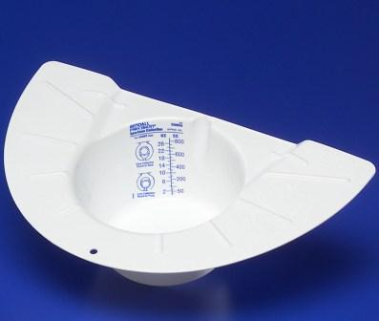  White stool collection container | 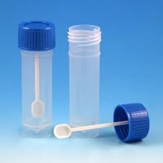 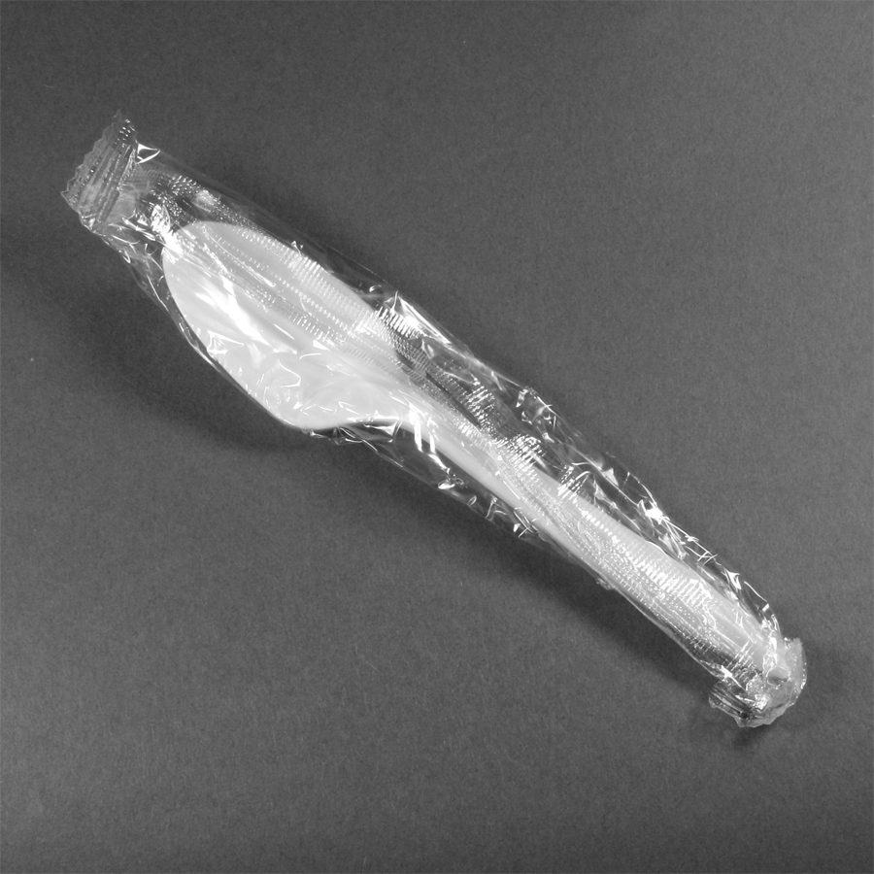 Vial with spoon Individually Wrapped Plastic Spoon

For specimen packaging and submission:
Cardboard canister | 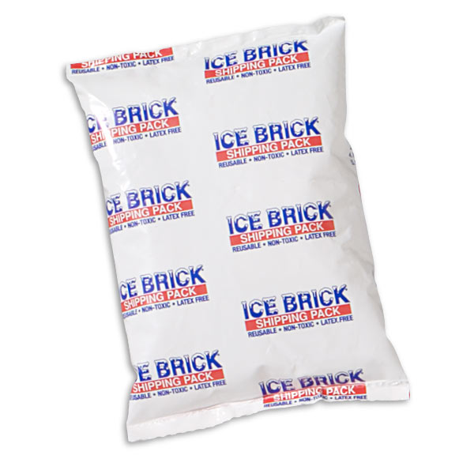  Ice pack | 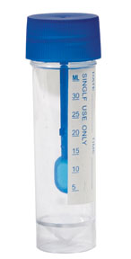  Secured Cap with Sample
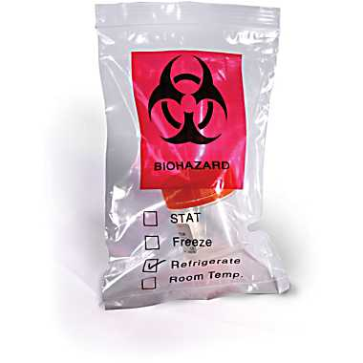
Small Biohazard bag with Exterior Pocket Completed Specimen Submission form

Place Cardboard canister, collection vial and ice pack as received, in freezer prior to stool collection.
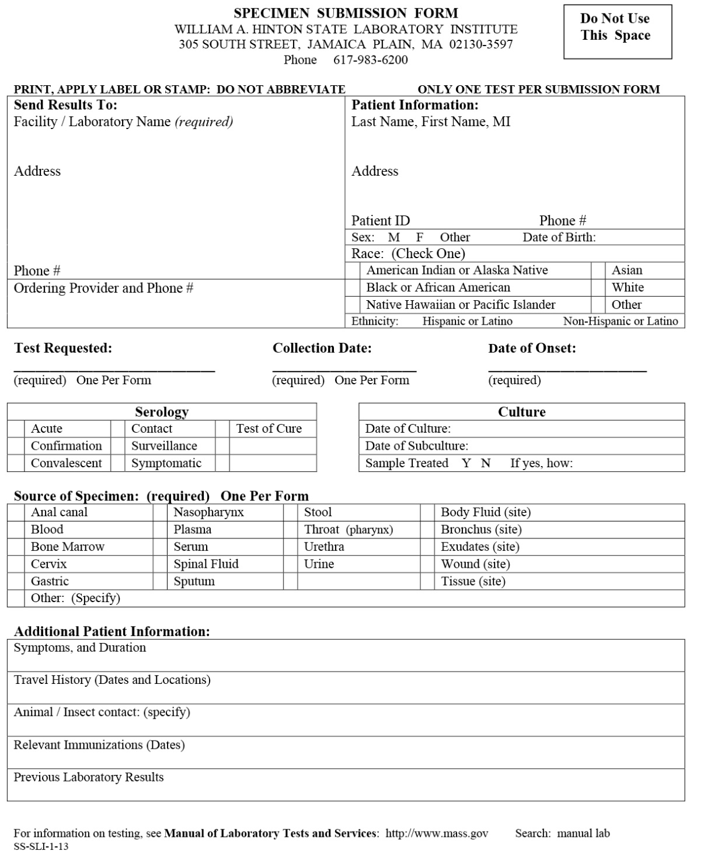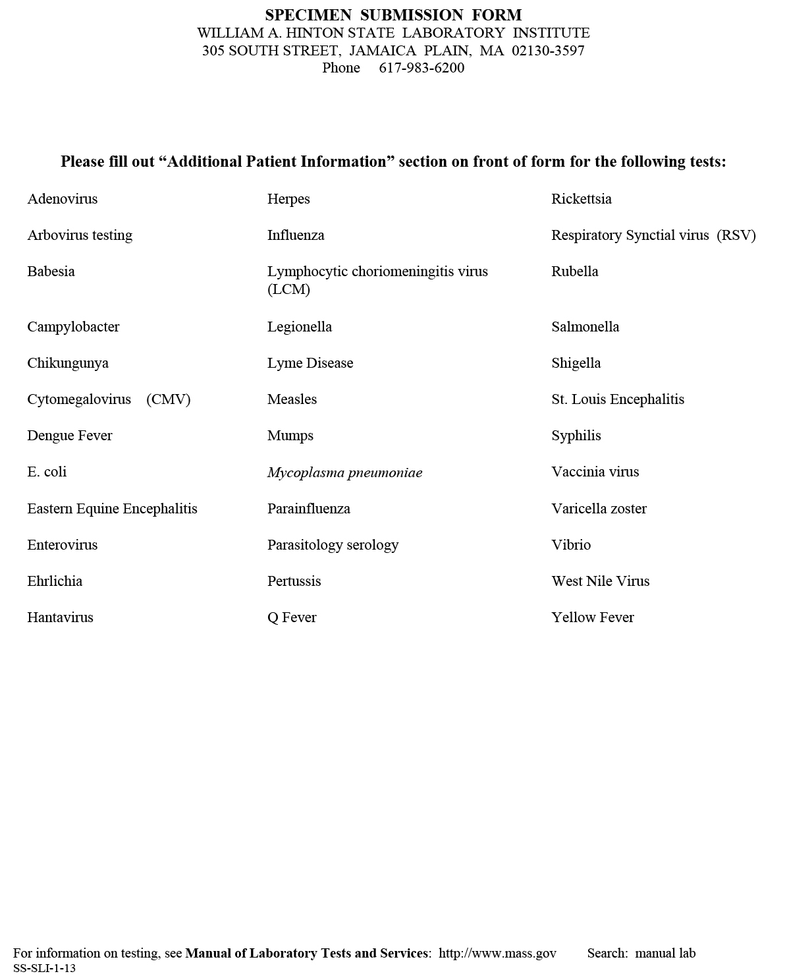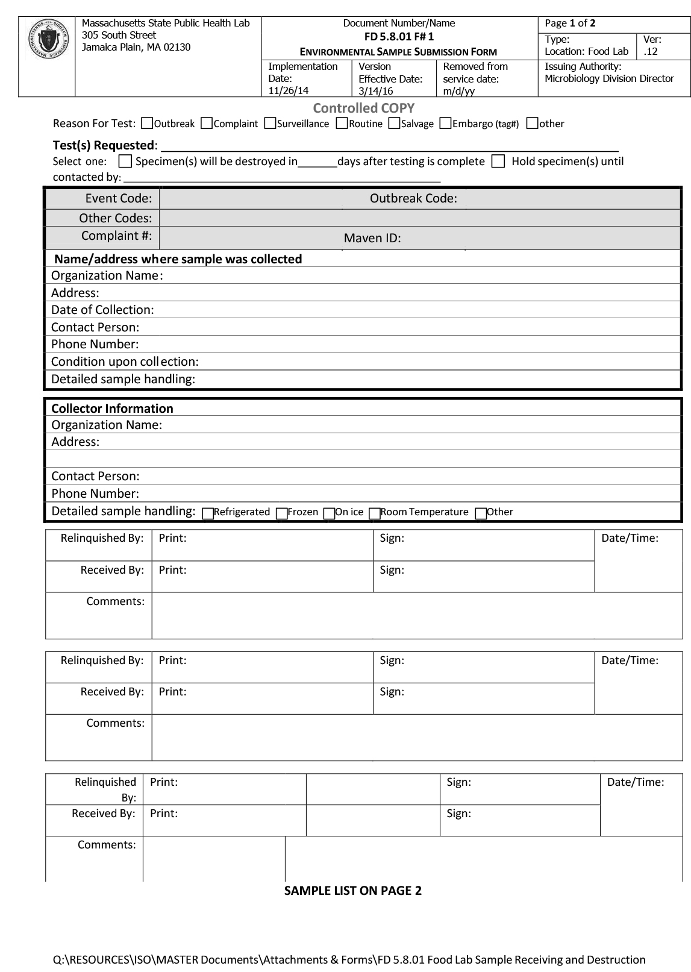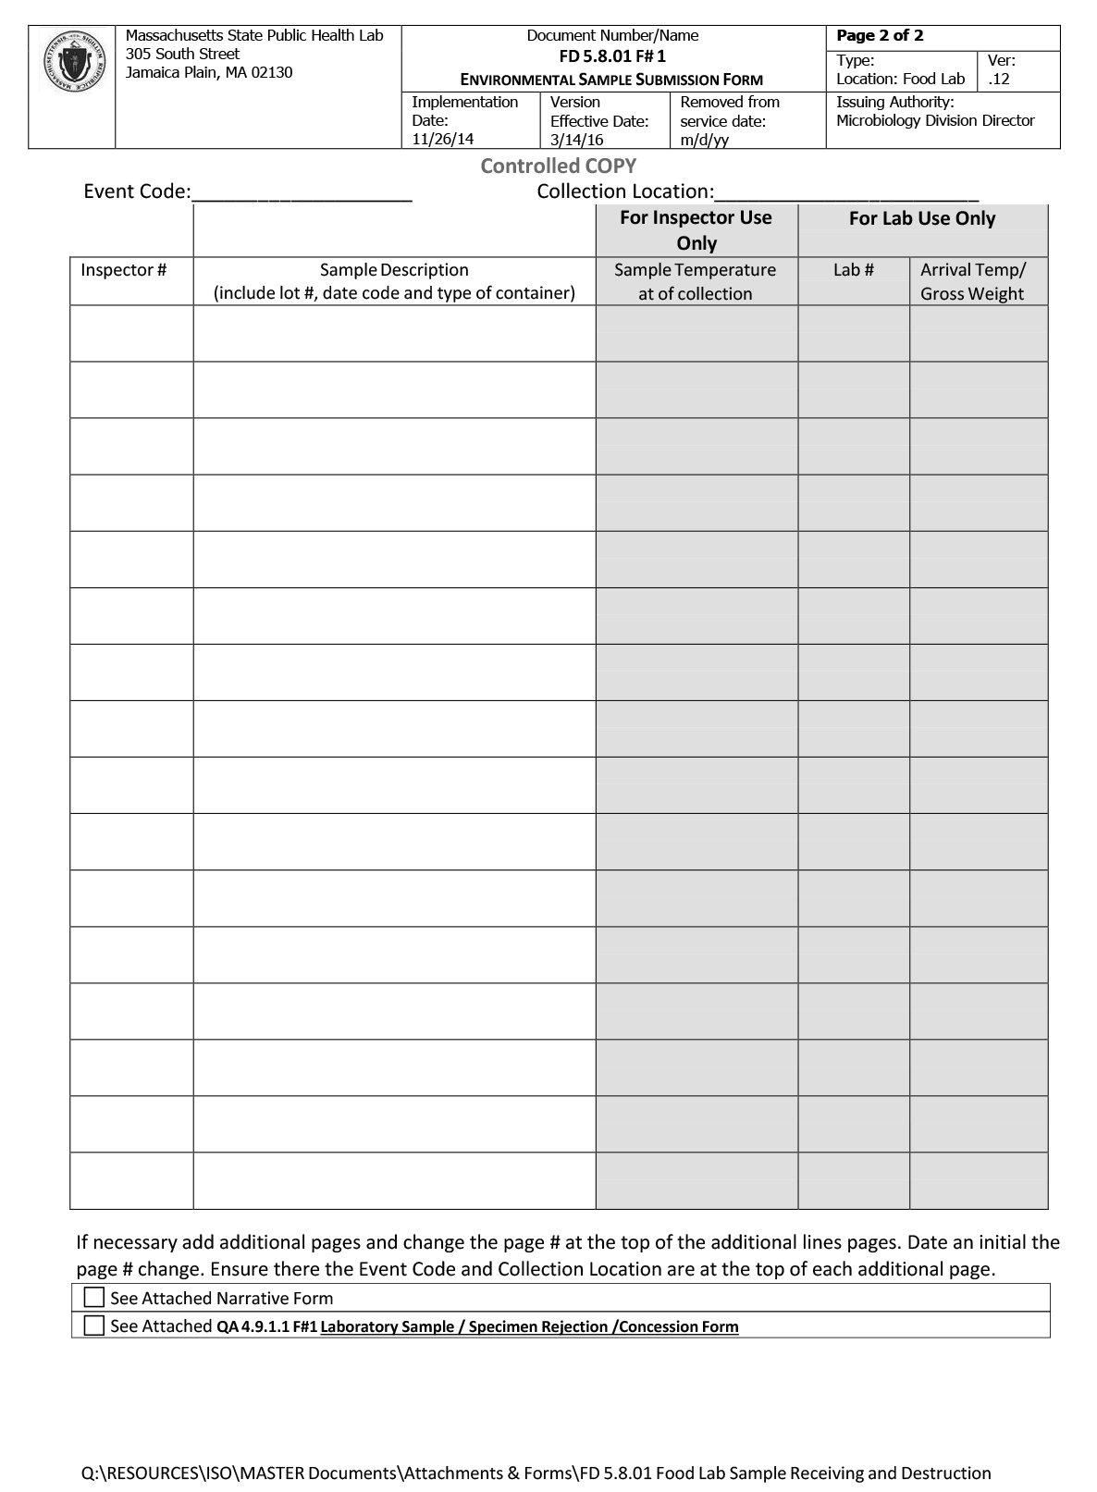
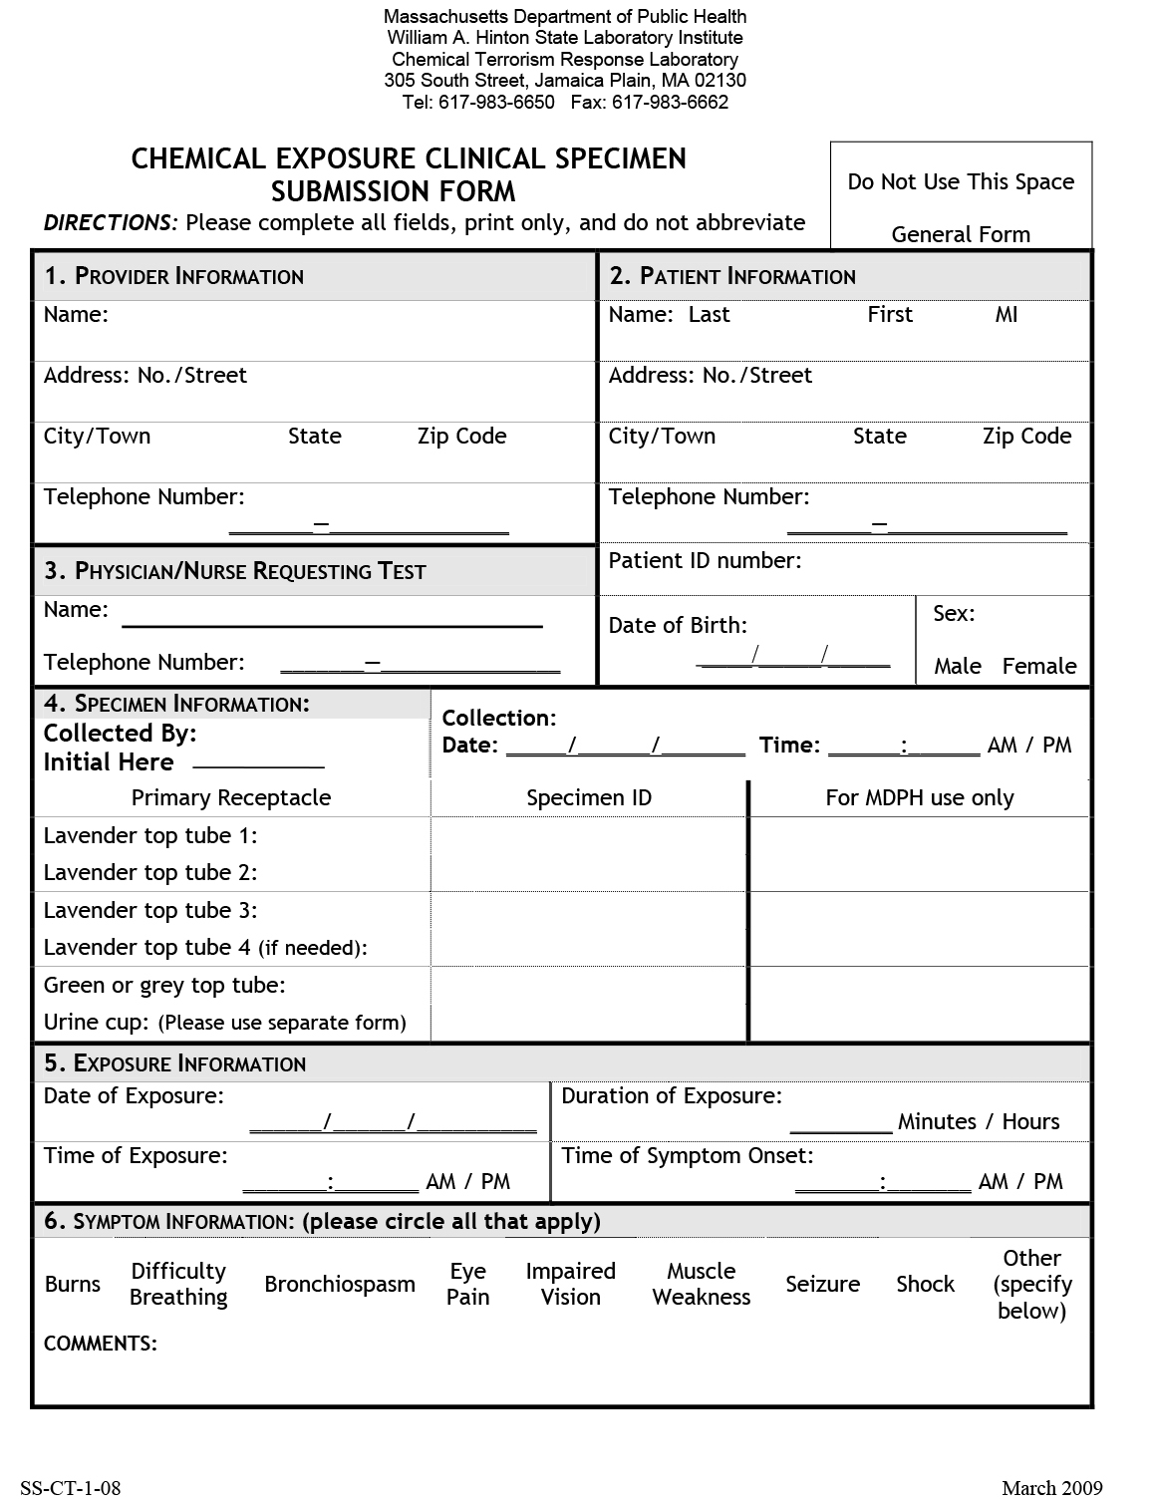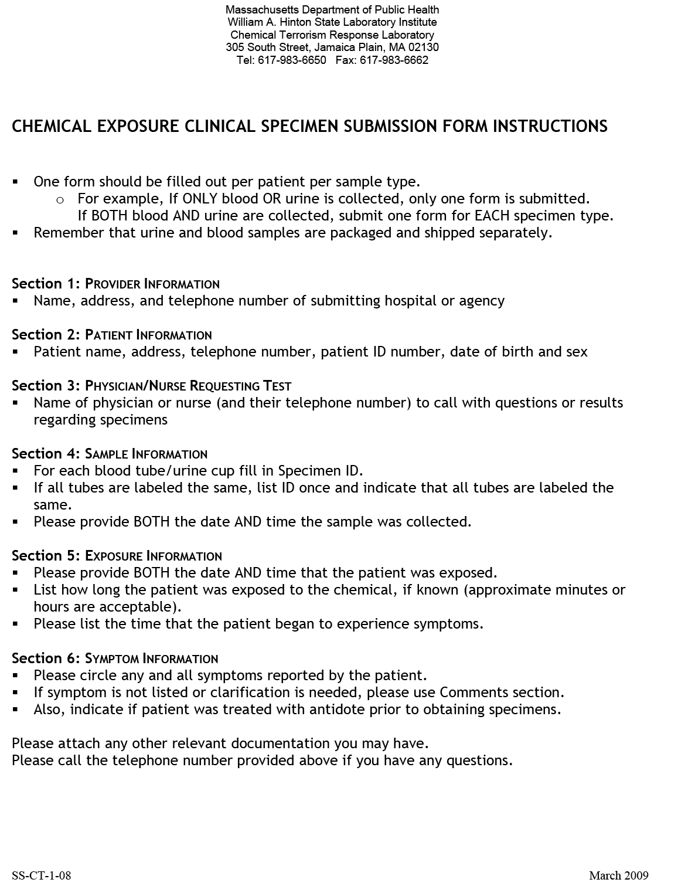
Attachment 9-5: Sample Laboratory Reports

