**INDOOR AIR QUALITY ASSESSMENT**

**Wrentham District Court**

**60 East Street**

**Wrentham, MA**



Prepared by:

Massachusetts Department of Public Health

Bureau of Climate and Environmental Health

January 2025

# BACKGROUND

|  |  |
| --- | --- |
| Building: | Wrentham District Court (WDC) |
| Address: | 60 East Street, Wrentham, MA |
| Assessment Requested by: | Michael Lane, Administrative Office of the Trial Court (AOTC) |
| Reason for Request: | Reports of mold concerns in an office |
| Date of Assessment: | November 15, 2024 |
| Massachusetts Department of Public Health/Bureau of Climate and Environmental Health (MDPH/BCEH) Staff Conducting Assessment: | Michael Feeney, Senior Bureau Advisor, BCEH |
| Building Description: | Two-story brick/masonry building with occupied basement constructed in 1955. |
| Building Population: | Approximately 50-60 employees, with up to several hundred members of the public visiting daily |
| Windows: | Openable |

# METHODS

Please refer to the IAQ Manual for methods, sampling procedures, and interpretation of results (MDPH, 2015).

# RESULTS AND DISCUSSION

## Ventilation

A heating, ventilating and air conditioning (HVAC) system has several functions. First it provides heating and, if equipped, cooling. Second, it is a source of fresh air. Finally, an HVAC system will dilute and remove normally-occurring indoor environmental pollutants by not only introducing fresh air, but by filtering the airstream and ejecting stale air to the outdoors via exhaust ventilation. Even if an HVAC system is operating as designed, point sources of respiratory irritation may exist and cause symptoms in sensitive individuals.

A variety of HVAC systems exist in the WDC that were installed at various times since the building was opened in 1955.

* The attic contains two air handling units (AHUs) (Picture 1). Date of installation of these could not be determined. These AHUs likely provide conditioned air for courtrooms or other areas that may have a significant number of occupants due to court trials and hearings.
* Courtrooms and some offices have unit ventilators (univents) installed inside ornate wooden cabinets (Picture 2). Date of installation of these could not be determined.
* A number of locations have window-mounted air-conditioners (WAC) of an undetermined age.
* One office has equipment that was retrofitted into the building, likely in the 1970s, that are labelled “Ra-Matic” (Picture 3). An examination of louver cover vents outside these devices shows significant spaces around a metal case (Picture 4). This equipment appears to use coils similar to those found in window air conditioners (Picture 5). No information regarding the design or function of the Ra-Matic units could be located.
* Several areas have wall-mounted ductless heating/cooling devices, sometimes referred to as mini-splits (Picture 6). Of note is the second-floor hallway which had an operating mini-split next to a window that has an open passive vent that allows for unconditioned outdoor air to be drawn into the building.
* Bathrooms in several areas have metal radiators connected to uninsulated heating pipes (Picture 7). Some of these radiators had measurable temperatures over 200°F (Picture 8) which appear to be heating the sink drain trap (Picture 9).
  + The temperature of restroom radiators indicates a lack of control of heating from the WDC furnace. In addition, these temperatures may play a role in drying out sink drain traps and allowing water vapor and sewer odor into the restrooms.
* Some areas are equipped with ceiling-mounted ductless air-conditioning units (DACUs) which are similar in function to mini-splits. When operating, DACUs recirculate room air, which may include pollutants. DACUs are equipped with filters that remove visible dust, but do not likely filter respirable dust. As reported by AOTC staff, individuals experienced possible symptoms potentially attributed to airborne pollutants particularly in locations that have Ra-Matic units. Since Ra-Matic units do not appear to have adequate air filters, it is possible that DACUs are drawing outdoor pollutants through or around the Ra-Matic units.

In general, MDPH recommends that HVAC system have filters. Use of filters with a Minimum Efficiency Reporting Value (MERV) of 8 is recommended, which are adequate in filtering out pollen and mold spores (ASHRAE, 2012).

Note that many locations do not appear to be equipped with exhaust ventilation. Lack of air exchange/circulation can lead to the build-up of naturally occurring pollutants in the space, which can result in IAQ/comfort complaints. Based on observation, the locations where mold and IAQ concerns were expressed does not have functioning HVAC equipment that filters airborne particles.

It is also important to note that the many components of the HVAC system are at least 40 years old. Efficient function of equipment of this age is difficult to maintain since compatible replacement parts are often unavailable. According to the American Society of Heating, Refrigeration and Air-Conditioning Engineering (ASHRAE), the service life[1] for a unit heater, hot water or steam is 20 years, assuming routine maintenance of the equipment (ASHRAE, 1991). Despite attempts to maintain the equipment, the optimal operational lifespan of this equipment has been exceeded.

Basement areas have no mechanical HVAC system. Fresh air is supplied by opening windows that exist in below grade window wells. Cooling in some areas is provide by window-mounted air conditioners.

## Microbial/Moisture Concerns

MDPH staff conducted temperature and relative humidity testing in areas with reported mold odors. Temperature and relative humidity conditions at the time of the visit were not at levels that would be likely to lead to mold growth in building materials. However, bowing ceiling tiles were found. If a building experiences high relative humidity (+70%) indoors over an extended period, moisture exposure may cause ceiling tiles to bow. According to American Society of Heating, Refrigerating and Air-Conditioning Engineers (ASHRAE), if relative humidity exceeds 70%, mold growth may occur due to wetting of building materials (ASHRAE, 1989). It is recommended that porous material be dried with fans and heating within 24 to 48 hours of becoming wet (US EPA, 2008, ACGIH, 1989). Bowed ceiling tiles without discoloration/stains are not mold colonized but are a sign of water vapor exposure causing the sagging due to the weight of water in the ceiling tile and its effect on binders that hold the tile intact.

Bowing ceiling tiles are often found in rooms with sink or floor drains where the trap has dried. A trap is a section of pipe below the drain opening that fills with water to form an airtight seal. The airtight seal prevents combustible sewer gas, odors, and water vapor from the drain systems from backup up the drain to enter occupied space. Water evaporates from the trap if a plumbing device is not used for several days. Heating from radiators as shown above may accelerate the drying of drain traps.

Wetting drain traps regularly to maintain the airtight water seal is particularly important when heavy rains occur, which can pressurize sewer systems and force water vapor, sewer odors, and other pollutants into occupied space; this would be prevented by a wet drain trap.

Basement windows open into cement-lined window wells (Picture 10). To prevent water accumulation, the floors of window wells will be equipped with drains. Window wells were found to contain significant amounts of leaves and plant debris that would block drains and serve as a source of water vapor and mold.

### HVAC system components and water vapor in hot, humid weather

Various HVAC components that cool air, require a fixed maximum room volume in order to properly function, to main comfort, and to prevent the generation of condensation on cold surfaces. If this volume is exceeded, air heating and chilling devices will not maintain comfort and reduce humidity sufficiently to prevent mold growth.

If a building has a centralized HVAC system, the volume of outdoor air to be conditioned is fixed. The WDC does not have a centralized HVAC system that serves the entire building. Several devices have been retrofitted to operate independent of centralized temperature control. Because of the limited ability of the HVAC units in the WDC to remove humidity, the amount of hot, moist air introduced into the building should be eliminated or reduced. The following conditions allow for hot, moist air to enter occupied space:

* The elevator pressurization equalization vent (Picture 11) has no means to limit outdoor air entry into the WDC. A large vent with a fixed louver exists at the top of the elevator that faces southeast. Under certain wind and weather conditions hot, moist air can enter the WDC to be distributed through hallways.
* Open vent to the outdoors shown in Picture 6.
* Dry drain traps, including floor drains.
* Custodial closets that have utility sinks with no mechanical exhaust ventilation.
* Open windows.
* Open flexible duct in the attic (Picture 12).
* Unsealed seams between wood and brick structures. Of note were roof structures attached to the exterior wall which do not appear to have sealant between the roof and brick wall seam. Without sealant, wind driven moist air may enter the roof structure to penetration into the building interior.

Each of these water vapor sources may allow water vapor into interior space, which may then moisten building materials and contents.

### Extreme weather conditions

Hot humid summers are becoming more frequent due to climate change. Massachusetts has experienced hot, humid, and rainy summers in 2018, 2021, 2023 and 2024. As an example, July of 2021 was the wettest ever recorded in Massachusetts, and the three-month period from June through August, known as the meteorological summer, was the fourth wettest on record, according to the National Oceanic and Atmospheric Administration’s (NOAA) Centers for Environmental Information (NOAA, 2021). The summer of 2023 was also hot, and wet, being measured as the second rainiest on record (WBUR, 2023). The summer of 2024 has also had significant stretches of hot, humid weather. These conditions are challenging for buildings, particularly those without central air conditioning.

Under these weather conditions, public buildings experienced extended periods of water vapor exposure from high relative humidity. When exposed to these conditions, porous materials such as gypsum wallboard, cardboard, carpeting and other materials may become moistened and colonized with mold, particularly if located in areas that are prone to developing condensation, such as floors and walls in contact with the ground (e.g., below grade space).

The guideline “Preventing Mold Growth In Schools During Hot, Humid Weather” <https://www.mass.gov/info-details/preventing-mold-growth-in-massachusetts-schools-during-hot-humid-weather> should be used to minimize the impact of such weather on room materials. This includes use of air conditioning and dehumidifiers, ensuring exhaust vents are on and operable, keeping windows closed, and ensuring air can circulate around porous materials.

## Other Concerns

In some areas, items were observed on the floor, windowsills, tabletops, counters, bookcases, and desks. The large number of items stored provides a source for dusts to accumulate. These items (e.g., papers, folders, boxes) make it difficult for custodial staff to clean. Items should be relocated and/or be cleaned periodically to avoid excessive dust build up. In addition, these materials can accumulate on flat surfaces (e.g., desktops, windowsills, and carpets) in occupied areas and subsequently be re-aerosolized causing further irritation.

Many areas contained carpeting that appeared to be past its useful life. The Institute of Inspection, Cleaning, and Restoration Certification (IICRC), recommends that carpeting be cleaned annually, or semi-annually in high-traffic areas (IICRC, 2012). Since the average lifespan of carpeting is approximately eleven years (Bishop, 2002), consideration should be given to planning the installation of new flooring. In general, carpeting is not recommended in basement areas, especially if exposed to chronic moisture.

## Mold Testing Recommendations

The presence of mold does not necessarily indicate a problem. Visual evidence of mold growth and/or the presence of musty odors are reliable indicators of mold problems that are correlated with health risks in buildings where indoor environmental complaints have been made. Mold spores waft through the indoor and outdoor air continually. There is no practical way to eliminate all mold and mold spores in the indoor environment; the way to control indoor mold growth is to control moisture (U.S. EPA, 2024).

There is no means by which to determine whether an individual’s symptoms or reactions were caused by mold by conducting environmental air testing for mold. While mold, spores, and other associated materials can make allergies and asthma symptoms worse, different people react differently to mold and mold spores. In addition to mold, reactions experienced by individuals could be caused by bacteria, other compounds in the air caused by the breakdown of wet building materials, or something different altogether (NIOSH, 2024; California DPH, unknown; Mendell, M. J., Mirer, A. G., Cheung, K., & Douwes, J. 2011; WHO. 2009).

The U.S. Environmental Protection Agency (EPA) does not recommend testing. MDPH follows the guidelines contained in the U.S. EPA Mold Remediation in Schools and Commercial Buildings report for cleaning and removing water-damaged materials. US EPA’s guidelines recommend, in most cases, that if visible mold growth is present, mold sampling is not necessary. A number of international, US Federal, and state agencies either do not have or recommend against conducting mold testing as part of mold remediation (see References with headings of: Agencies with guidelines recommending against mold testing and References from government agencies, industrial hygiene groups and/or other environmental professional guidelines that denote that no mold exposure limits have been established for mold in workplaces, government buildings, or residences). For example, the U.S. Department of Housing and Urban Development (HUD) does not recommend conducting environmental mold testing.

*“No matter what kind of mold you have, you need to get rid of it and fix the moisture problems that made it grow. Most experts think it’s better to spend your time and money on cleaning up the problem than testing* (HUD, 2024).

In addition, multiple worker safety agencies and organizations have no worker safety air levels established for exposure to species of mold. The following agencies and professional industrial hygiene agencies have not established mold exposure levels in the workplace that would justify air testing. The following industrial safety guidelines do not list any mold species and air level concentrations:

* US Occupational Safety and Health Administration has not established any mold Permissible Exposure Limits (PELs) for mold air levels.
* American Conference of Governmental Industrial Hygienists (ACGIH) has no established Threshold Limit Values (TLVs) for mold air levels.
* National Institute of Occupational Safety and Health (NIOSH) has no established Recommended Exposure Limits (RELs) for mold air levels.
* American Industrial Hygiene Association (AIHA) has no established Workplace Environmental Exposure Levels (WEELs) for mold air levels.

In addition, even if worker safety exposure limits existed for mold, such guidelines **would not apply** to non-employees in a building. These individuals include students in primary education schools; students in secondary education facilities; adults outside worker ages as defined by OSHA; individuals with chronic health conditions; patients in any medical facility; adults who are invitees, customers, or visitors to the workplace and other members of the general public.

For non-employees, there are **no established mold exposure limits** (international, Federal, or state regulations, building standards or guidelines) on how much mold can exist in air before health impacts are expected for the general population. In addition, no international, Federal, state, or building standards agency have established mold remediation clean-up levels that must be achieved after mold remediation efforts are completed.

This means that even if tests are conducted, there is no way to compare results or determine whether the measured level could cause health effects or meet clean-up levels. Multiple Federal agencies, including the US EPA, US Department of Housing and Urban Development and the US Federal Emergency Management Agency (FEMA) have not established mold exposure standard or recommend environmental mold testing in any water damage/flood recovery guidelines. With no established worker or general public safety exposure limits, air testing will not influence how mold remediation efforts would be conducted.

In order to remove mold from buildings, of primary importance is to identify, repair and/ or limit the moisture source causing damage in the building. Once the moisture source is remediated, then discarding and/or cleaning of mold contaminated materials can be completed.

# CONCLUSIONS/RECOMMENDATIONS

Based on observations at the time of assessment, the WDC has various heating and cooling equipment that appears to have minimal control and operate independently. Heat control in the building appears to be minimal, as demonstrated by radiator temperatures. Based on these observations, consideration should be given to have a building engineer comprehensively evaluate all components of the HVAC systems in WDC to advise on control and coordination of heating and cooling in the building.

It is important to note that no location assessed had visible mold or had musty odors. The office area that has the Ra-Matic equipment may be a source of uncontrolled outdoor air or accumulated pollutants. Each of these units should be cleaned by a professional HVAC servicing contractor who can also determine the nature of this equipment. If the Ra-Matic equipment is not part of the WDC heating system, wrapping these units in plastic and tape to render each airtight is recommended until decisions concerning replacement, repair or removal is made.

Based on observations made, the following is recommended:

## Ventilation Recommendations

1. Determine the purpose of the Ra-Matic units. If devices only provide air-conditioning during summer month, consider removing these devices. If removed, seal openings permanently with an appropriate material to render these exterior wall openings airtight.
2. If Ra-Matic equipment remains, consider placing one HEPA filter air purifier in front of each Ra-Matic.
3. Ensure that all univents are equipped with appropriately sized air filters. If installation of filters of at least a MERV rating of 8 is not feasible, consider using HEPA filter-equipped air purifier near each univent.
4. Clean univents and change filters 2 to 4 times a year.
5. Have all HVAC system components cleaned by a professional HVAC contractor.
6. Operate mechanical ventilation, where available, continuously in all areas during occupied periods.
7. Repair and operate all mechanical exhaust vents for restrooms and custodial closets
8. Have an HVAC engineering firm evaluate univents for proper operation and future replacement, including the addition of exhaust vents in rooms containing univents.
9. Ensure univents, supply vents, and personal fans are cleaned periodically to prevent buildup and re-circulation of dust and debris.

## Water Damage Recommendations

1. Seal ends of flexible vents in the attic to render airtight.
2. Examine the feasibility to prevent humid air penetration into the elevator pressurization equalization vent in Picture 11.
3. Repair radiator valves in restrooms to provide control. Consider insulating supply pipe and consider installing a cover over restroom radiators to prevent occupant contact with hot pipes.
4. Consider installing insulation over sink drains next to radiators to reduce heating that would dry drain trap.
5. Ensure traps on all drains are wetted periodically. If fixtures are not used regularly, pour water into drains at least once a week to maintain the trap seal.
6. Remove passive vents from the window in the second-floor hallway and replace with glass or other appropriate material.
7. Remove all plant debris from window wells periodically to allow drainage.
8. Do not open windows during hot, humid weather when any air chilling device is operating.

## Other Recommendations

1. Replace old/stained/worn carpeting throughout the building; consider non-porous flooring such as tile for below-grade areas.
2. Clean existing carpeting annually (or semi-annually in soiled high traffic areas) as per the recommendations of the Institute of Inspection, Cleaning and Restoration Certification (IICRC).
3. For buildings in New England, periods of low relative humidity during the winter are often unavoidable. Therefore, scrupulous cleaning practices should be adopted to minimize common indoor air contaminants whose irritant effects can be enhanced when the relative humidity is low. To control for dusts, a high efficiency particulate arrestance (HEPA) filter equipped vacuum cleaner in conjunction with wet wiping of all surfaces is recommended. Drinking water during the day can help ease some symptoms associated with a dry environment (e.g., throat and sinus irritations).
4. Refer to resource manual and other related IAQ documents located on the MDPH’s website for further building-wide evaluations and advice on maintaining public buildings. These documents are available at: <http://mass.gov/dph/iaq>.

# REFERENCES

## Report references

ACGIH. 1989. Guidelines for the Assessment of Bioaerosols in the Indoor Environment. American Conference of Governmental Industrial Hygienists, Cincinnati, OH.

ASHRAE. 1991. ASHRAE Applications Handbook, Chapter 33 “Owning and Operating Costs”. American Society of Heating, Refrigeration and Air Conditioning Engineers, Atlanta, GA.

ASHRAE. 2012. American Society of Heating, Refrigeration and Air Conditioning Engineers (ASHRAE) Standard 52.2-2012 -- Method of Testing General Ventilation Air-Cleaning Devices for Removal Efficiency by Particle Size (ANSI Approved). 2012.

Bishop. 2002. Bishop, J. & Institute of Inspection, Cleaning and Restoration Certification. A Life Cycle Cost Analysis for Floor Coverings in School Facilities.

IICRC. 2012. Institute of Inspection Cleaning and Restoration Certification. Institute of Inspection, Cleaning and Restoration Certification. Carpet Cleaning: FAQ.

MDPH. 2015. Massachusetts Department of Public Health. Massachusetts Department of Public Health Indoor Air Quality Manual: Chapters I-III. Available at: <http://www.mass.gov/eohhs/gov/departments/dph/programs/environmental-health/exposure-topics/iaq/iaq-manual/>.

NOAA. 2021. Summer 2021 neck and neck with Dust Bowl summer for hottest on record. National Oceanic and Atmospheric Administration, 1401 Constitution Avenue NW, Room 5128, Washington, DC 20230 <https://www.noaa.gov/news/summer-2021-neck-and-neck-with-dust-bowl-summer-for-hottest-on-record>.

WBUR. 2023. “It's been a summer of rain and flooding misery in Mass.” WBUR local news. September 12, 2023. <https://www.wbur.org/news/2023/09/12/summer-flooding-rain-massachusetts>.

US EPA. 2008. “Mold Remediation in Schools and Commercial Buildings”. Office of Air and Radiation, Indoor Environments Division, Washington, DC. EPA 402-K-01-001. September 2008. Available at: http://www.epa.gov/mold/mold-remediation-schools-and-commercial-b

## Mold Testing References

ACGIH, 1989. Guidelines for the Assessment of Bioaerosols in the Indoor Environment. American Conference of Governmental Industrial Hygienists, Cincinnati, OH

ASHRAE, 1985. ASHRAE Transactions. Optimum Relative Humidity Ranges for Health. American Society of Heating, Refrigeration and Air Conditioning Engineers. Vol. 91, Part 1B.

CA DPH, unknown. California Department of Public Health Statement on Building Dampness, Mold, and Health. [California Department of Public Health Statement on Building Dampness Mold and Health](https://www.cdph.ca.gov/Programs/cls/dehl/ehl/CDPH%20Document%20Library/MoldDampStatement2017_ENG.pdf)

HUD. 2024. Help Yourself to a Healthy Home. US Department of Housing and Urban Development. Washington, DC. PAGES and Cover002.indd (hud.gov).

IICRC, 1997. IICRC S001 Standards Reference Guide for Professional On-location Cleaning of Installed Textile Floor Covering Materials. 3rd ed. The Institute of Inspection, Cleaning and Restoration Certification, Vancouver, WA.

Mendell, M. J., Mirer, A. G., Cheung, K., & Douwes, J. 2011. Respiratory and allergic health effects of dampness, mold, and dampness-related agents: a review of the epidemiologic evidence. Environmental Health Perspectives 119(6):748. <https://pubmed.ncbi.nlm.nih.gov/21269928/>

NIOSH, 2024. [Mold, Testing, and Remediation | Workplace Mold | CDC](https://www.cdc.gov/niosh/mold/testing-remediation/index.html)

US EPA, 2008. “Mold Remediation in Schools and Commercial Buildings”. Office of Air and Radiation, Indoor Environments Division, Washington, DC. EPA 402-K-01-001. September 2008. Available at: <http://www.epa.gov/mold/mold-remediation-schools-and-commercial-buildings-guide>

U.S. EPA, 2024, Frequent Questions on Mold and Moisture, Updated: October 14, 2024. [Mold Frequently Asked Questions | US EPA](https://www.epa.gov/mold/mold-frequently-asked-questions)

WHO, 2009. WHO Guidelines for Indoor Air Quality: Dampness and Mould. World Health Organization Copenhagen: WHO Europe. WHO guidelines for indoor air quality: dampness and mould <https://www.who.int/publications/i/item/9789289041683>

**Agencies with guidelines recommending against mold testing**

APHC. Residential Indoor Mold and Residential Mold Air Sample Results What Do They Mean? FACT SHEET 55-026-0319. U.S. Army Public Health Center, Industrial Hygiene Field Services Program, Aberdeen Proving Ground, Maryland. [Microsoft Word - IAQ and Mold Sample Result Fact Sheet_Version 4 HRCD 28 Mar](https://ph.health.mil/PHC%20Resource%20Library/IAQandMoldSampleResultFactSheet.pdf)

CA HESIS. 2005. Molds in Indoor Workplaces. California Hazard Evaluation System and Information Service. P.2 Molds in Indoor Workplaces: Fact Sheet for Workers and Employers (ca.gov) Nov. 2005 <https://www.cdph.ca.gov/Programs/CCDPHP/DEODC/OHB/HESIS/CDPH%20Document%20Library/molds.pdf>

CDC. 2024. Mold. Centers for Disease Control. Atlanta, GA. [Mold | Mold | CDC](https://www.cdc.gov/mold-health/about/index.html).

CTDPH. 2012. Get the Mold Out: Mold Clean-Up Guidance for Residences Fact Sheet. Connecticut Department of Public Health Environmental & Occupational Health Assessment Program Environmental Health Secon 410 Capitol Avenue, MS # 11EOH. [Get The Mold Out_ fact sheet082012](https://portal.ct.gov/-/media/departments-and-agencies/dph/dph/environmental_health/eoha/pdf/getthemoldoutpdf.pdf)

FEMA, 2015. Homeowner’s and Renter’s Guilder to Mold Cleanup after Disasters. <https://www.fema.gov/sites/default/files/documents/fema_hm-cdc-homeowners-and-renters-mold-guide_english.pdf>

Health Canada. Guide to addressing moisture and mould indoors. <https://www.canada.ca/en/health-canada/services/publications/healthy-living/addressing-moisture-mould-your-home.html>

MDHHS. 2010. Mold Fact Sheet. Maine Department of Health and Human Services, Bangor, ME. <https://www.maine.gov/dhhs/mecdc/infectious-disease/epi/disease/documents/pdf/mold.pdf>

MNDPH. 2024. Testing for Mold. [Testing For Mold - MN Dept. of Health (state.mn.us)](https://www.health.state.mn.us/communities/environment/air/mold/moldtest.html)

NHDHHS. 2013. Mold and moisture. New Hampshire Department of Health and Human Services, Concord, NH. <https://www.dhhs.nh.gov/sites/g/files/ehbemt476/files/documents/2021-11/holu-dphs-mold-policy-letter.pdf>

NIOSH. 2024. Mold, Testing, and Remediation. National Institute of Occupational Safety and Health, Cincinnati, OH.

NYDOL. Mold Assessment and Remediation in New York State. Mold Assessment and Remediation in New York State. New York Department of Labor. [p227.pdf (ny.gov)](https://dol.ny.gov/system/files/documents/2021/03/p227.pdf)

ODHS. Unknown. FAST FACTs: Household Mold. Oregon Department of Human Services, Public Health Division, Office of Environmental Public Health: Toxicology Consulting Services. [Moldfactsheet.pdf (oregon.gov)](https://www.oregon.gov/oha/ph/HealthyEnvironments/TrackingAssessment/EnvironmentalHealthAssessment/Documents/Moldfactsheet.pdf)

OSHA. Mold. US Occupational Safety and Health Administration. [Mold - Recognize Mold Hazards | Occupational Safety and Health Administration (osha.gov)](https://www.osha.gov/mold/hazards)

USAPHC. 2018. Technical Guide 278 Industrial Hygiene Public Health Mold Assessment Guide. US Army Public Health Center, Public Health 6582 Magrath Ave BLDG 2059 Fort Carson, Colorado. <https://ph.health.mil/PHC%20Resource%20Library/TG278.pdf> .

VTDH. 2024. Mold Inside Home and Other Buildings. <https://www.healthvermont.gov/sites/default/files/document/env-hh-mold-indoors.pdf>

WSDH. Unknown. Mold. Washington State Department of Health, [Mold | Washington State Department of Health](https://doh.wa.gov/community-and-environment/contaminants/mold)

**References from government agencies, industrial hygiene groups and/or other environmental professional guidelines that denote that no mold exposure limits have been established for mold in workplace, government buildings or residences.**

AIHA. 2019. FAQs About Spore Trap Air Sampling for Mold for Direct Microscopical Examination Mold Analysis Document. American Industrial Hygiene Association, Falls Church, VA. <https://aiha-assets.sfo2.digitaloceanspaces.com/AIHA/resources/FAQs-About-Spore-Trap-Air-Sampling-for-Mold-for-Direct-Examination-Guidance-Document.pdf>

APHC. Residential Indoor Mold and Residential Mold Air Sample Results What Do They Mean? FACT SHEET 55-026-0319. U.S. Army Public Health Center, Industrial Hygiene Field Services Program, Aberdeen Proving Ground, Maryland. [Microsoft Word - IAQ and Mold Sample Result Fact Sheet_Version 4 HRCD 28 Mar](https://ph.health.mil/PHC%20Resource%20Library/IAQandMoldSampleResultFactSheet.pdf)

FEMA, 2015. Homeowner’s and Renter’s Guilder to Mold Cleanup after Disasters. <https://www.fema.gov/sites/default/files/documents/fema_hm-cdc-homeowners-and-renters-mold-guide_english.pdf>

MDHHS. 2010. Mold Fact Sheet. Maine Department of Health and Human Services, Bangor, ME. <https://www.maine.gov/dhhs/mecdc/infectious-disease/epi/disease/documents/pdf/mold.pdf>

OHHN. 2023. Mold Basics. Ohio Healthy Homes Network, Columbus, Ohio. [Mold Basics | Ohio Healthy Homes Network (ohhn.org)](https://www.ohhn.org/mold-basics/)

WDHS. 2021. Controlling Mold and Moisture Household Mold Guidance for Local Health Professionals Wisconsin Department of Health Services, Indoor Air and Radon Program Division of Public Health, Bureau of Environmental and Occupational Health. <https://www.dhs.wisconsin.gov/publications/p02069.pdf>

WHO, 2009. WHO Guidelines for Indoor Air Quality: Dampness and Mould. World Health Organization Copenhagen: WHO Europe. WHO guidelines for indoor air quality: dampness and mould <https://www.who.int/publications/i/item/9789289041683>

**Picture 1**

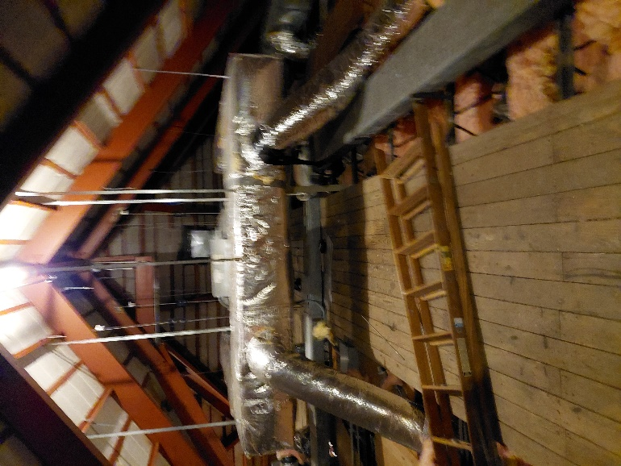

**Attic AHU**

**Picture 2**

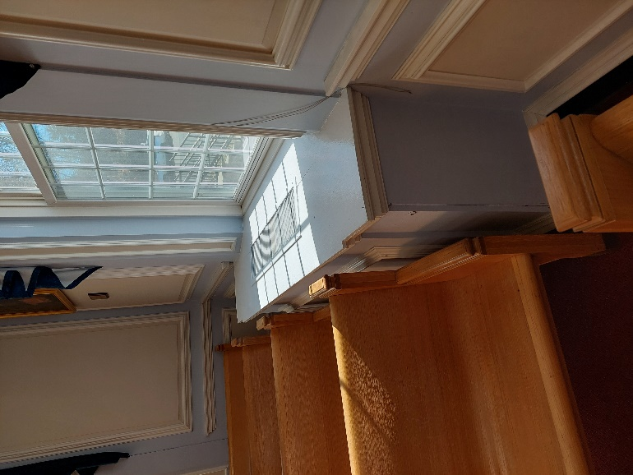

**Courtroom univent inside wooden cabinet**

**Picture 3**

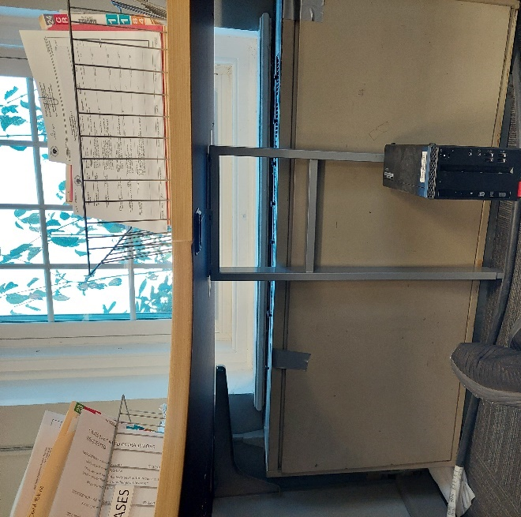

**Retrofitted HVAC unit; note desk support leg blocking front panel which prevents inspection of the interior**

**Picture 4**

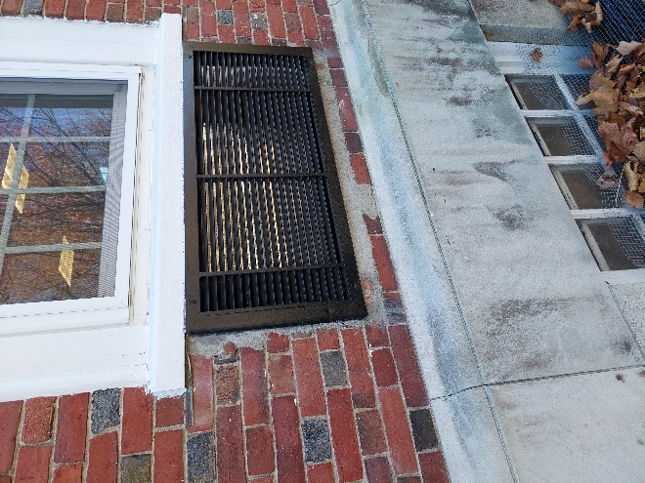

**Outdoor vent outside of Ra-Matic unit; note spaces around case, which would not be consistent with installation of a univent fresh air intake. Additionally, note cement and brick around the exterior grill, which likely indicates that this opening was created after this building was constructed,**

**Picture 5**

** Close up view of metal case that show vanes of a coil typically found in WAC 
**

**Close up view of metal case that show vanes of a coil typically found in WAC**

**Picture 6**

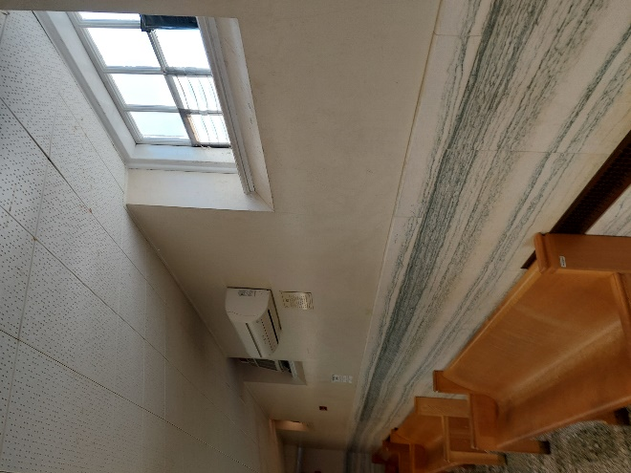

**Mini-split in 2nd floor hallway; note passive vent open to the outdoors**

**Picture 7**

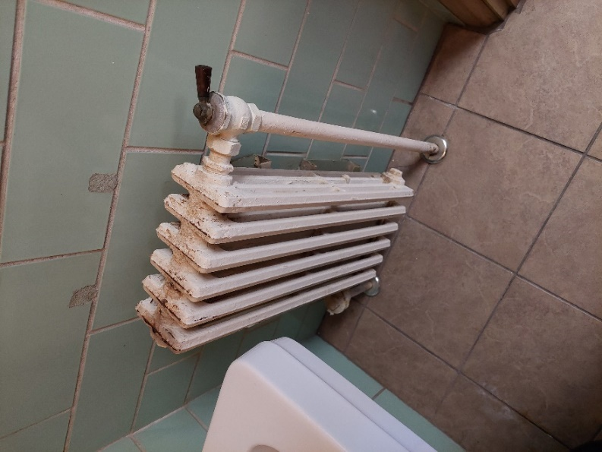

**Example of restroom radiator**

**Picture 8**

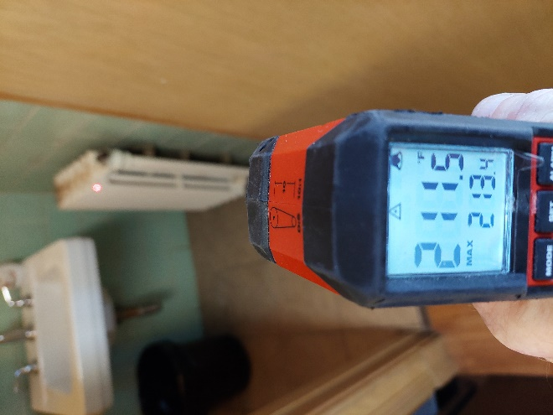

**Surface temperature of restroom radiator taken with a laser thermometer**

**Picture 9**

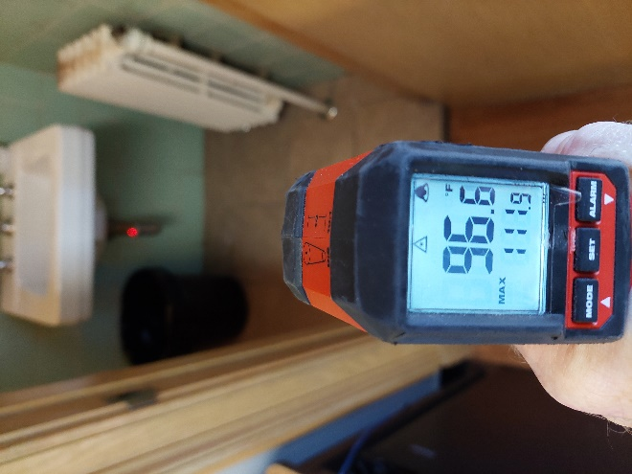

**Surface temperature of sink drain trap taken with a laser thermometer**

**Picture 10**

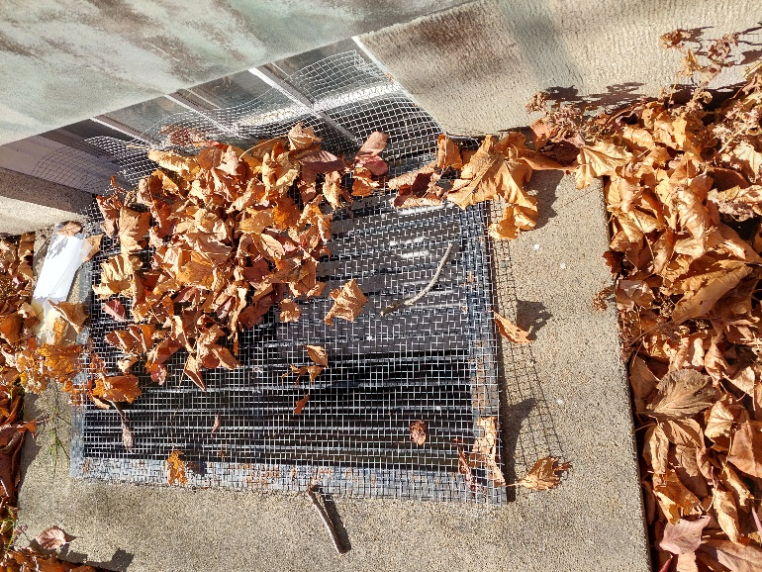

**Window well covered by leaves**

**Picture 11**

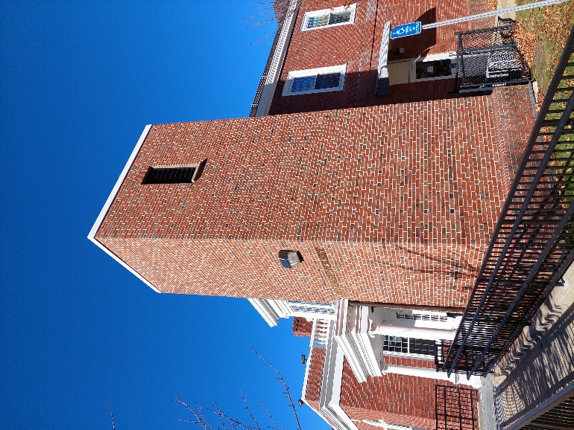

**Elevator pressure equalization vent with open-fixed louver**

**Picture 12**

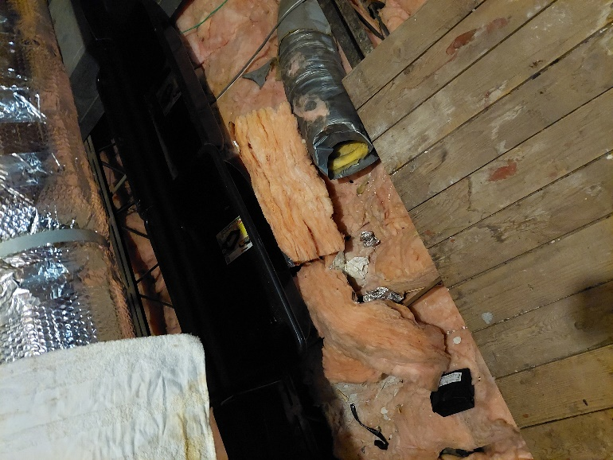

**Open flexible ductwork**

1. The service life is the median time during which a particular system or component of …[an HVAC]… system remains in its original service application and then is replaced. Replacement may occur for any reason, including, but not limited to, failure, general obsolescence, reduced reliability, excessive maintenance cost, and changed system requirements due to such influences as building characteristics or energy prices (ASHRAE, 1991).