COMMONWEALTH OF MASSACHUSETTS

DEPARTMENT OF ENVIRONMENTAL PROTECTION

STANDARD REFERENCES FOR MONITORING WELLS

SECTION 2.1 RECONNAISSANCE SURVEYS

Section 2.1
Page i
January 1991

SECTION 2.1
RECONNAISSANCE SURVEYS

TABLE OF CONTENTS

Section Title Page No.

2.1-1 PURPOSE 1

2.1-2 METHODOLOGY 2

2.1-2.1 Literature Search 2

2.1-2.1.1 Published Bibliographies 3

(a) Annotated Groundwater Bibliography
Covering the Northeast 3
(b) Massachusetts Hydrologic Matrix 3

2.1-2.1.2 Geologic Maps 3

(a) Bedrock Geologic Maps . 3
(b) Surficial Geologic Maps 4

2.1-2.1.3 Hydrologic Information 4

- U.S.G.S. Hydrologic Atlases and Basic Data Reports 4
(b) DEP Water Supply Protection Atlas 4
(c) Zone of Contribution (Zone II), as defined by DEP 4

2.1-2.1.4 Other Sources of Information 4

(a) Soil Conservation Service (SCS) Soil Surveys 4
(b) DEP Files and Reports 5
(c) Environmental Protection Agency (EPA) Library 5
(d) Aerial Photographs 5
(e) Bridge Borings 5
(f) HUD Flood Insurance Maps 6
(g) Sanborn Fire Insurance Maps 6

2.1-2.2 Map and Remote Sensing Interpretation 6

2.1-2.2.1 U.S.G.S. Topographic Maps 6
2.1-2.2.2 Remote Sensing 6

2.1-2.3 Historical Review (see 2.2-4.1.1) 7

Section 2.1
Page ii
January 1991

SECTION 2.1
RECONNAISSANCE SURVEYS

TABLE OF CONTENTS
(continued)

Section Title Page No.

2.1-2.4 Physical Characterization of a Location (see 2.2-4.1.2) 7

2.1-2.5 Base Map Preparation 7

2.1-2.5.1 Site Visit 8

(a) Site Access 8
(b) Site Topography and Drainage 8
(c) Significant Cultural Features 8
(d) Vegetation 8
(e) Geology 8
(f) Hydrologic Features 9
(g) Wetlands. .9
(h) Waste Information 9
(i) Facility Operation 9
(j) Land Use 9

2.1-2.5.2 Map Revision 9

2.1-3 PROBLEMS AND POSSIBLE SOLUTIONS 10

2.1-3.1 Restricted Site Access and Uncooperative
Landowners 10
2.1-3.2 Lack of Available Data 10
2.1-3.3 Weather Conditions 10

REFERENCES 11

Section 2.1
Page iii
January 1991

LIST OF FIGURES

Figure Title Page No.

2.1-1 Elements of a Reconnaissance Study 13

2.1-2 Organization Chart of Massachusetts Department of
Environmental Protection (DEP) 14

LIST OF TABLES

Table Title Page No.

2.1-1 A Guide to Map Scales 15

2.1-2 Forms of Remote-sensing Imagery 16

2.1-3 Uses of Remote-sensing for Engineering Geologic
Mapping and Environmental and Natural Resource
Studies 17

2.1-4 General Procurement of Publications from
U.S. Geological Survey, U.S. Department of
Interior 18

2.1-5 Procurement of Remote-sensing Imagery 19

2.1-6 General Sources of Information: USGS and Others 20

2.1-7 Sources of Geologic Information, State Agencies 21

APPENDICES

Appendix Title Page No.

A Site Assessment Checklist for Use During a Site
Reconnaissance Visit 24

B Site Reconnaissance Field Summary 29

SECTION 2.1
RECONNAISSANCE SURVEYS

2.1-1 PURPOSE

Reconnaissance surveys are carried out for a number of environmental reasons:

- To assess the suitability of the ground water or surface water at a site as a source of water supply for human consumption, fighting fires, non-contact cooling or other industrial process water, irrigation or other agricultural purposes.

- To assess the suitability of a site for the storage, treatment or disposal of solid waste, sludges, or hazardous materials.

- To assess the impact of an existing or proposed development upon a wetland area or a marine estuary.

- To determine whether or not contamination of air, soil, ground water or surface water at the site is attributable to past or present waste disposal practices.

- To determine whether or not a site is located within the Aquifer Protection Zone (Zone II) of a public water supply.

- To determine the natural quality of ground water as a baseline reference in case of future contamination problems.

The purpose of a reconnaissance survey is to collect and synthesize the available historical, environmental, physical, and chemical information about a location to be studied prior to undertaking an exploratory field program. A thorough survey can usually develop a useful amount of information about a site, including: its geology, ground water and surface water hydrology, drainage patterns, topography, past and present land use, location of underground and aboveground utilities, buildings, and storage areas. Collection of this information can identify data gaps and assist in the development of a cost-effective field program.

On-site subsurface investigations using test pits, boreholes or monitoring wells generally are not part of a site reconnaissance program. However, if the results of previous sampling efforts are available, they should be utilized. All of this information can assist in the development of a more focused investigation at the start of an exploratory field program, potentially eliminating duplication of effort and identifying specific problem areas.

At locations where contamination is suspected or known to be present, the reconnaissance survey should be carried out in such a way that there is minimal risk of exposure to the personnel conducting the investigation. A preliminary Health and Safety Plan should be prepared which emphasizes the importance of precautionary and preventative measures. Most of the investigation should be conducted off-site or in the areas where the risk of exposure is minimal. A good health and safety training program should distinguish between the low-risk nature of a reconnaissance investigation and the higher-risk nature of a full-scale program of exploration with drill rigs, monitoring wells and collection of environmental samples (see Section 2.3).

Under the Massachusetts Contingency Plan (310 CMR 40.000), two types of reconnaissance investigations are listed: a Preliminary Assessment (Sec. 40.541) and a Phase I - Limited Site Investigation and Report (Sec. 40.543). A Preliminary Assessment is described as an initial evaluation to determine whether or not the location is a disposal site, whether a short-term measure is necessary, and whether further remedial response is necessary. It includes researching and assembling existing data and conducting at least one reconnaissance visit. A Phase I - Limited Site Investigation and Report is intended to confirm whether or not the location is a disposal site, if this was not established in the Preliminary Assessment. If it is a disposal site, the report must provide information necessary for DEP to classify the site as a priority or a non-priority disposal site. The Phase I - Limited Site Investigation Report, therefore, must include a detailed history and description of the location. Site characterization of waste sources is expected to be investigated using field screening techniques, geophysical methods, and field sampling of various media and subsequent laboratory analysis.

Depending on the scope of the project, a reconnaissance survey may involve some or all of the following elements:

- A field visit to the site to confirm or refine the preliminary map(s); to familiarize the project team with the site conditions, including topography, drainage, and vegetation; to evaluate site access; to locate overhead and underground utilities; to determine if land use activities have changed; and to evaluate other factors that might affect the field program.

- Literature search of available data on the geology, hydrology, historical land-use, and information obtained during previous investigations.

- Terrain analysis based on a review of topographic maps, aerial photos, and, if possible, remotely-sensed imagery.

- Construction of a preliminary base map for the site and/or the region.

- Compilation of available geologic, topographic, and hydrologic data onto the base map(s).

- Assessment of on-site hazards for development of a site specific Health and Safety Plan, if necessary.

- Field observation of on-site and adjacent industrial processes, and/or hazardous material use, storage, treatment, or disposal.

- Development of a field investigation program based on the observed and anticipated hydrogeologic conditions and other site-specific factors.

Figure 2.1-1 is a flow chart of the elements of a reconnaissance investigation.

2.1-2 METHODOLOGY

2.1-2.1 Literature Search

A literature search involves identifying available published information for a specific area, including maps, reports, and theses. There are numerous sources of information, including the United States Geological Survey (U.S.G.S.), state agencies, local agencies, universities, and public libraries. At the present time, there is no central statewide repository in the Commonwealth of Massachusetts for information on 21E site assessments, RCRA permits, NPDES discharge permits, ground water discharge permits, and other regulated activities. Consequently, the investigator may have to seek out several different sources of information to compile a comprehensive database on a specific project. Information that may be useful for a reconnaissance investigation includes topographic, geologic, and hydrologic data; aerial photos; data from geotechnical projects; bridge borings; permits for former or existing activities; previous investigations; and historical land use. Potential sources for much of this information are presented below. Figure 2.1-2 is a flow chart depicting the present organizational structure of the Massachusetts' DEP, which may be helpful in identifying where certain files, records and information may be located within the department.

Information can be obtained from the following sources:

2.1-2.1.1 Published Bibliographies.

(a) Annotated Groundwater Bibliography Covering the
Northeast

Published in 1982 by the Massachusetts Audubon Society, Lincoln, Massachusetts. References on general and technical ground water issues, including books, reports, journals, technical articles, and conference proceedings.

(b) Massachusetts Hydrologic Matrix

Published in 1982 by the Massachusetts Department of Environmental Quality Engineering, (now DEP), Division of Water Supply, Boston, Massachusetts. Summarizes many sources of information available from the U.S.G.S. on subsurface geology and hydrogeology in Massachusetts. Includes geologic quadrangle maps, project bulletins, and miscellaneous investigations. Also contains some references to municipal, industrial, and academic reports on aquifers.

2.1-2.1.2 Geologic Maps.

Geologic maps of interest in reconnaissance investigations include surficial soils, bedrock maps, and hydrologic atlases. Geologic maps depict, in plan view, contacts between the surface exposures of various soil deposits or rock formations. The scale, detail, and accuracy of geologic maps will vary depending on the intensity of the field investigation and the amount of exposure. Geologic maps are available in a wide range of scales. Table 2.1-1 is a guide to common map scales and related information. Tables 2.1-4 and 2.1-6 contain a list of sources of information that may be used in compiling geologic maps; Table 2.1-7 contains a list of Geoscience Agencies for 50 states and the territory of Puerto Rico.

(a) Bedrock Geologic Maps

Bedrock maps contain information on rock types, ages, and structural features such as faults, joints, and foliation. Bedrock maps are available from several sources including the U.S.G.S., graduate theses, and miscellaneous publications available at university and public libraries. A map of the bedrock geology of the Commonwealth of Massachusetts, at a scale of 1:250,000, has been published by the U.S.G.S. Additionally, U.S.G.S. has published maps of the bedrock geology of numerous quadrangles in Massachusetts.

(b) Surficial Geologic Maps

Surficial geologic maps show the distribution of unconsolidated materials on the ground surface. Surficial maps depict the types of soil materials, as well as directions of glacial movement, locations of borrow pits, and areas where bedrock is exposed or located within approximately 10 feet of the ground surface. The mapped soil units may include outwash deposits, glacial till, marine clays, organic deposits, and man-made fills. An official, regional surficial map for Massachusetts is not presently available, but surficial geologic maps of numerous quadrangles in Massachusetts have been completed by the U.S.G.S. As with bedrock maps, additional sources of information include graduate theses and miscellaneous publications available at local universities and public libraries.

2.1-2.1.3 Hydrologic Information.

(a) U.S.G.S. Hydrologic Atlases and Basic Data Reports

The Water Resources Division of the U.S.G.S. has published a series of atlases for most of the major river basins in Massachusetts. These reports present information on the surface and ground water resources in the basin. The Hydrologic Atlas includes information on the following items:

- Basin boundaries
- Precipitation
- Ground water levels
- Basic data well locations
- Location of low, moderate, and high yield zones in surficial aquifers

(b) DEP Water Supply Protection Atlas

A water supply protection atlas has been compiled by DEP's Division of Water Supply. The atlas consists of a series of four acetate overlays to be used with the 1:25,000-scale U.S.G.S. topographic quadrangle maps. The overlays depict the following information:

- Public water supplies: ground water and surface water sources

- Aquifer information: location and characterization of yield of known aquifers

- Drainage divides: major rivers and sub-basins

- Waste sources: surface impoundments, landfills, auto junkyards, road salt storage areas, and NPDES discharge locations.

(c) Zone of Contribution (Zone II), as Defined by DEP

As these zones of contribution are officially mapped and approved, they will provide significant information about the protected area of contribution around a public water supply.

2.1-2.1.4 Other Sources of Information

(a) Soil Conservation Service (SCS) Soil Surveys

Some consultants attempt to use SCS information in environmental assessments. However, in the opinion of the Department, the SCS classification system is not suitable for use in hydrogeologic studies. Soil survey maps produced by the Soil Conservation Service of the U.S. Department of Agriculture are generally plotted on an aerial photo base. These surveys are usually prepared on a county basis and contain information on soil drainage conditions, slopes, and shallow ground water.

(b) DEP Files and Reports

Other significant sources of hydrogeologic information are the reports prepared by consultants for municipalities, DEP, and the private sector in connection with development of public water supplies, sewerage systems, building construction, and contamination investigations. Many of these reports are available at the regional DEP offices or the DEP office in Boston. Individuals interested in reviewing these files must make an appointment in advance with the respective DEP office. Reports relating to sites on the National Priorities List are put on file at local libraries and are available for review at these locations. There is no central bibliography of these reports at this time.

(c) Environmental Protection Agency (EPA) Library

The regional office of EPA has a well-stocked reference library of U.S. Government environmental publications and reports. The library is located at One Congress Street, 11th floor, Boston, Massachusetts, Tel. (617) 918-1990.

(d) Aerial Photographs

Inspection of aerial photos is an effective and economical way to become familiar with a site. Stereo pairs of aerial photos can be viewed with a stereoscope to produce a three-dimensional image of the ground surface; the view is similar to flying over the site in an airplane. Various aspects of site geology, vegetation, hydrology, and landforms may be interpreted from aerial photos. The Massachusetts Department of Public Works maintains a library of stereo pair aerial photos with coverage of most of the state at 10-year intervals. Individuals who wish to view the photos must make an appointment with the Office of Transportation. They are located in the Photogrametric Section, Geodetic Survey, Massachusetts Department of Public Works, 10 Park Plaza, Boston. Photos cannot be removed from the premises. Aerial photo coverage is also available from some municipalities.

(e) Bridge Borings

Bridge boring information is available for inspection at the office of the Massachusetts Department of Public Works, 10 Park Plaza, Boston. Individuals wishing to view the borings must call ahead for an appointment.

(f) HUD Flood Insurance Maps

These maps have been prepared for almost all communities. They show flood-prone areas.

(g) Sanborn Fire Insurance Maps

These maps are compiled periodically by a private firm. Where available they can provide a historical record of facility layouts.

2.1-2.2 Map and Remote Sensing Interpretation

A review of a series of historical photographs and maps can be used to observe how land use activities have changed over time and to locate old lagoons, dumps, and other waste disposal areas.

2.1-2.2.1 U.S.G.S. Topographic Maps

Topographic maps display landforms, drainage, man-made features, vegetation, and contour lines. Contour lines connect points of equal elevation above sea level. In addition, spot elevations are depicted at the tops of hills, road intersections, and survey points. On U.S.G.S. topographic maps, specific colors are used on all maps to depict various features:

Brown contour lines
Blue drainage, water bodies
Black boundaries, bench marks, roads, and mines
Green trees, brush, and crops
Red highways, fences, and survey lines
Pink closely spaced buildings in urban areas
Purple revisions made from aerial photographs that have not been field checked

U.S.G.S. topographic maps for Massachusetts are available at various scales including 1:24,000, 1:25,000, and 1:62,500. Exact positions of latitude and longitude are shown along the map margins. Each map or quadrangle has a name that is unique to that quadrangle, generally corresponding to a town located in the quadrangle. In Massachusetts the U.S.G.S. has recently published a series of metric 7.5-minute maps at a scale of 1:25,000 for the entire state. Very recently, double quads (7.5 minutes x 15 minutes) have been published for certain parts of the state. At the base of the map is a graphic scale in feet, miles, meters, and kilometers. If the map is photocopied, enlarged, or reduced, the graphic scale should also be copied to maintain the accuracy of the scale of the reproduction of the original map.

2.1-2.2.2 Remote Sensing

Remote sensing can be used in the interpretation of site geology and drainage. Infrared and multi-spectral imagery can be used to identify thermal gradients, which may be indicative of surface water pollution, subsurface seepage, or stressed vegetation. Table 2.1-2 lists the common forms of remote sensing imagery. Table 2.1-3 summarizes the uses of remote sensing imagery used in hydrogeologic and site
investigations. Conclusions drawn from photo interpretation should be verified on the ground during a site visit. Sources of remote sensing imagery are listed in Table 2.1-5.

2.1-2.3 Historical Review

A historical review can provide information about the suitability of a site for its intended purpose or the potential degree of contamination that might be associated with the land and the ground water. Potential sources of historical information should be consulted. These include, but are not limited to, previous owners and employees, neighbors, municipal records and officials, newspaper articles and photographs. Section 2.2-4.1.1 lists the MCP requirements for the history of a location.

2.1-2.4 Physical Characterization of a Location

It is extremely important that the location of the reconnaissance investigation be identified on plans, both regionally and specifically. A U.S.G.S. topographic quadrangle is usually sufficient to provide the general locus of the area being investigated. Geographical coordinates (latitude and longitude or UTM grid coordinates) will provide a universally accepted description of the precise area under investigation. The amount of detail included in the physical characterization will depend on the objective(s) of the investigation and the type of information needed to plan the next phase of a hydrologic investigation. Physical features that might be significant during a reconnaissance investigation include:

- Site access
- Site topography and drainage
- Significant cultural features
- Vegetation
- Geology
- Hydrologic features
- Wetlands
- Adjacent land use
- Utility locations and easements

Section 2.2-4.1.2 lists the MCP requirements for the physical characterization of a location.

2.1-2.5 Base Map Preparation

A fundamental part of a reconnaissance program is the preparation of a preliminary base map. The extent of area covered by this base map will depend on the nature of the investigation. The scale of the map will be dependent upon the size of the area and the type and detail of available information. A regional map may have a scale on the order of a mile to the inch, while a site-specific map may have a scale of 100 or 200 feet to the inch. The base map can be prepared from an air photo, an enlarged U.S.G.S. topographic map, a local assessor's map, or a site survey. If possible, the base map should contain the following information:

- graphic scale
- north arrow, indicating true north
- source(s) of map base
- significant cultural features
- site features including drainage, topography
- property boundaries
- site boundaries
- underground and overhead utilities
- existing wells, drains, and other underground features
- legend
- notes

Following the preparation of a base map, it may be helpful to compile the existing geologic and hydrologic information onto various base maps, depending upon the detail and accuracy of the existing information. During a subsequent site visit, it is helpful to have geologic and hydrologic maps available so that information shown on the base map can be easily confirmed or refined.

2.1-2.5.1 Site Visit

A site visit should be performed after the compilation of available information and preparation of the preliminary base map. The primary purpose of a site visit is to confirm, supplement, or modify the existing information about the site. The following items should be considered during a site visit.

(a) Site Access

Fences, roads, topography, vegetation, subsurface or overhead utilities, wet areas, and other factors that may affect a subsurface exploration programs.

(b) Site Topography and Drainage

General topography and drainage as they relate to site hydrogeology and access.

(c) Significant Cultural Features

Presence of buildings, overhead and underground utilities, storm drains, buried tanks, parking lots, or roads that would influence access for a subsurface boring program.

(d) Vegetation

Describe surface vegetation (i.e., wooded, grassy, or marshy) and how it relates to access for a filed investigation program. Determine if the pattern of vegetation is consistent with hydrogeologic interpretations (i.e., wetland vegetation where ground water discharge occurs). Look for evidence of stressed vegetation that might relate to contamination of the surface water, ground water, or soil.

(e) Geology

Assess whether landforms, soil characteristics, and rock outcrops are consistent with available data. Look for sinkholes, gullies, and excavations for information on subsurface conditions. Locate outcrops and note the rock type, degree of weathering, and structure. Describe the surficial geology, frequency and size of boulders, presence and character of artificial fill, and the presence of organic soils.

(f) Hydrologic Features

Locate surface water bodies, wells, springs, and wetlands. Estimate surface and subsurface flow directions. Estimate elevation of water surface in streams, below bridges, and in ponds. Estimate the depth to the water table.

(g) Wetlands

Look for wetland areas that will be subject to the jurisdiction of the local Conservation Commission under M.G.L. c131, sec. 40, or the U.S. Army Corps of Engineers under Section 404 of the Clean Waters Act, as amended.

(h) Waste Information

Describe the presence and condition of drums, barrels, other storage containers, and disposal areas. Record evidence of spills, soil discoloration, leachate breakout, seeps, fill materials or odors. Locate and describe the condition of tanks, waste water systems, pits, lagoons, and disposal areas.

(i) Facility Operations

If the site includes an operating facility, the site reconnaissance should include an interview with individuals responsible for operation of this facility, followed by an evaluation of the status of the existing operation of the site.

(j) Land Use

Obtain as much information as possible about past and present land use activities at and near the site. If possible, obtain the names of employees or neighbors knowledgeable about the site. Verify that the use of adjacent land is consistent with available data. Evaluate the relative significance of abutting up-gradient and down-gradient environmental receptors. Determine if adjacent land uses or activities might alter ground water flow directions or present possible sources of contamination. Identify sensitive environmental receptors.

It is important to maintain good notes during a site visit. Examples of site reconnaissance checklists that can be used during a site visit are included in Appendix A and B. It is most useful to make notations directly on a site base map. Geologic contacts can also be confirmed during a site visit.

A pocket tape recorder may be useful for dictating notes and recording conversations with individuals associated with the site. If a tape recorder is used, the notes should be transcribed immediately upon return to the office to avoid accidental data loss.

2.1-2.5.2 Map Revision

Existing data should be revised and updated following the completion of a reconnaissance site investigation. If not already completed, the pertinent geologic, hydrologic, cultural, and land use information should be compiled onto the various base maps. Once this is complete, a site-specific investigation program can be developed based on a review of all accurate, available data.

    - PROBLEMS AND POSSIBLE SOLUTIONS

2.1-3.1 Restricted Site Access and Uncooperative Landowners

Frequently, landowners become increasingly wary or uncooperative during a field investigation program. It is important to obtain as much detailed information as possible during a preliminary site visit in case future access is restricted. Additionally, areas critical to understanding the site should be investigated as early as possible in the program in case access is eventually restricted.

In some cases, it may not be possible to perform a thorough site investigation due to limited or prohibited access. A file review of local sites and field visit to adjacent sites may be helpful in evaluating the available data. In cases where landowners are uncooperative, local and state officials may be of some assistance in persuading landowners to permit site access.

2.1-3.2 Lack of Available Data

In some areas, little or no data are available about a site, making a preliminary assessment of geologic and hydrologic conditions extremely difficult. In this case, a thorough review of the regional data and a detailed site visit are recommended. Assistance from experienced geologists and engineers during a site visit may be helpful in identifying the actual site conditions. If the available data are very sparse and the site visit is limited, it will be advisable to perform a phased investigation program consisting of surface geophysical investigations and/or preliminary test pits and borings before planning
the full-scale site investigation.

2.1-3.3 Weather Conditions

Snow cover, high water and rain may significantly hamper a thorough site visit. Outcrops, excavations, man-made features, and even odors may be obscured by adverse weather conditions, severely limiting the effectiveness of a preliminary site visit. If possible, site visits should be planned for a time when all the significant features are fully accessible.

REFERENCES

American Geological Institute, 1990, Directory of Geoscience Organizations-U.S. State Surveys: in Geotimes, October, 1990, V. 35, n.10.

Hunt, R.E., 1984, Geotechnical engineering investigation manual: New York, N.Y., McGraw-Hill, 683 p.

SECTION 2.1
RECONNAISSANCE SURVEYS

LIST OF FIGURES

Figures Title Page No.

2.1-1 Elements of a Reconnaissance Study 15

2.1-2 Organization Chart of Massachusetts Department of
Environmental Protection (DEP) 16

LIST OF TABLES

Section Title Page No.

2.1-1 A Guide to Map Scales 17

2.1-2 Forms of Remote-sensing Imagery .18

2.1-3 Uses of Remote-sensing for Engineering Geologic
Mapping and Environmental and Natural Resource
Studies 19

2.1-4 General Procurement of Publications from U.S.
Geological Survey, U.S. Department of Interior 20

2.1-5 Procurement of Remote-sensing Imagery 21

2.1-6 General Sources of Information: USGS and Others 22

2.1-7 Sources of Geologic Information, State Agencies 23

APPENDICES

Appendix Title Page No.

A Site Assessment Checklist for Use During a Site
Reconnaissance Visit 26

B Site Reconnaissance Field Summary 31

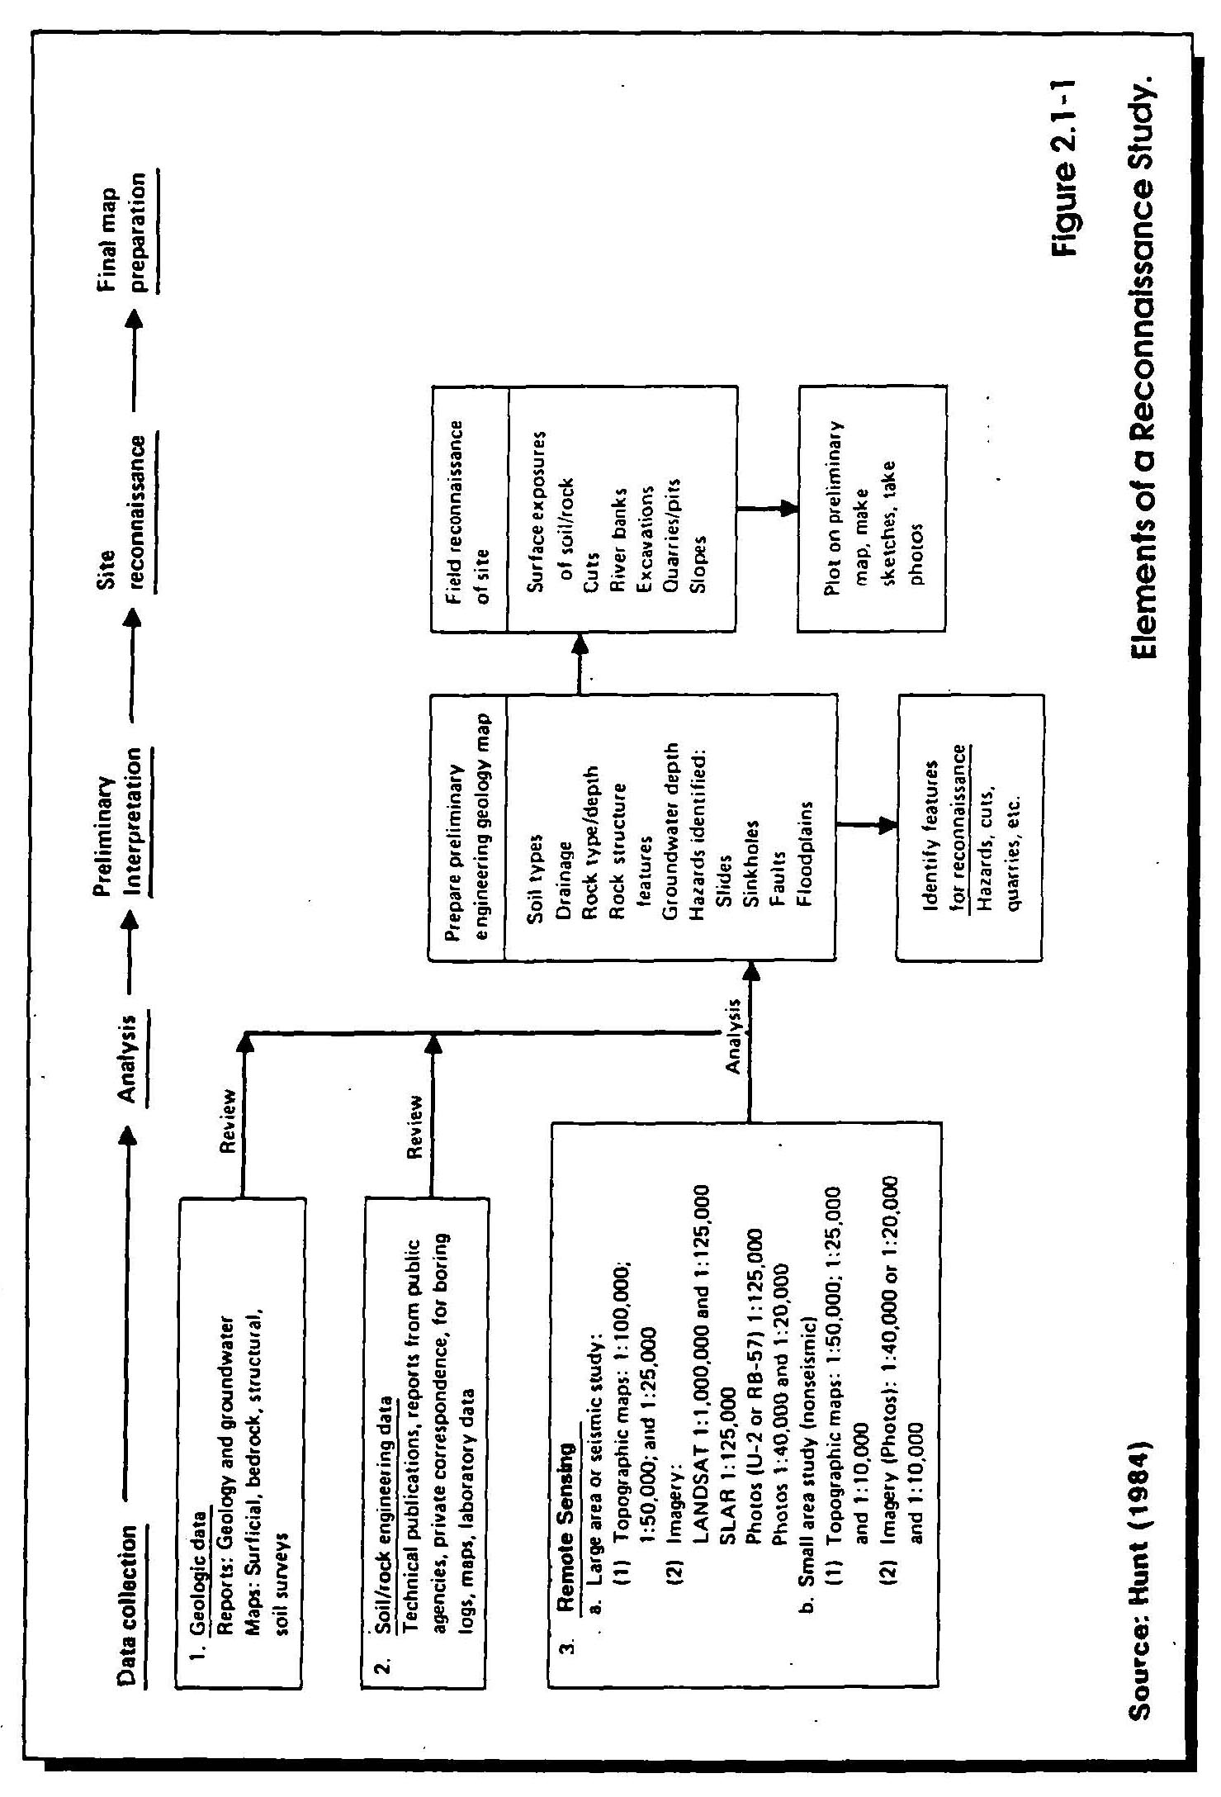

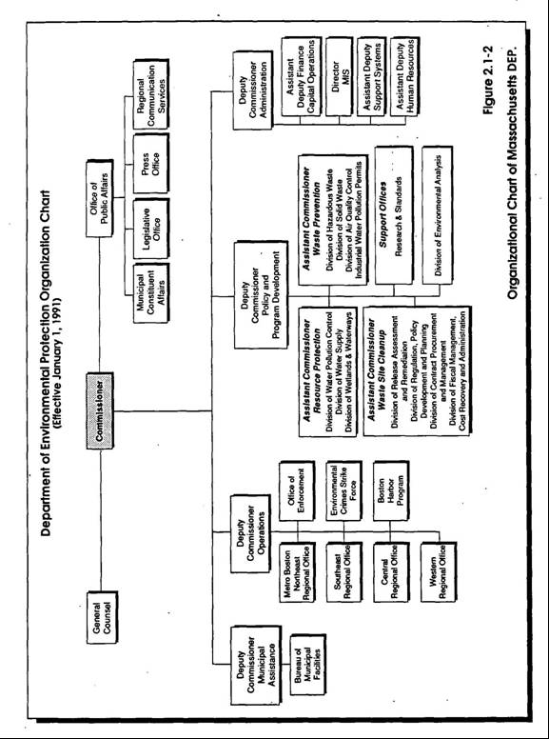
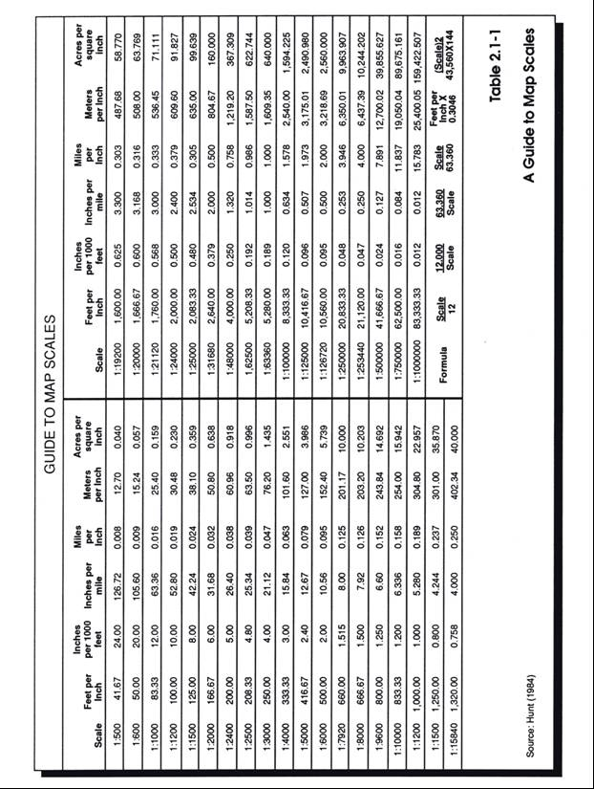

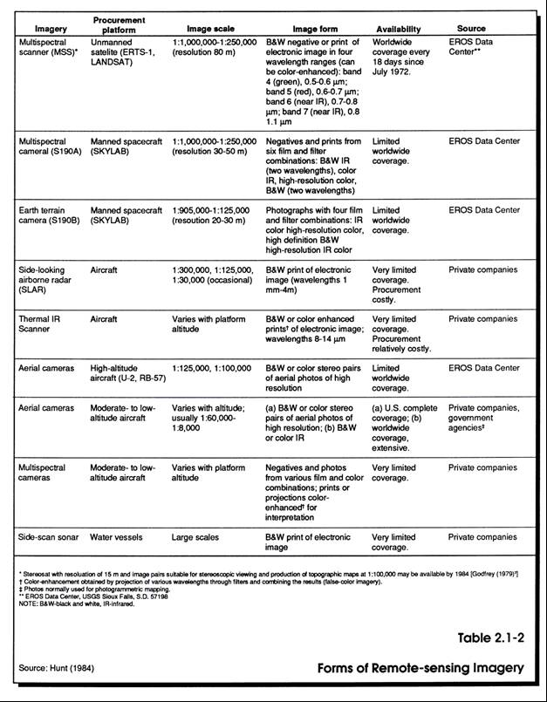

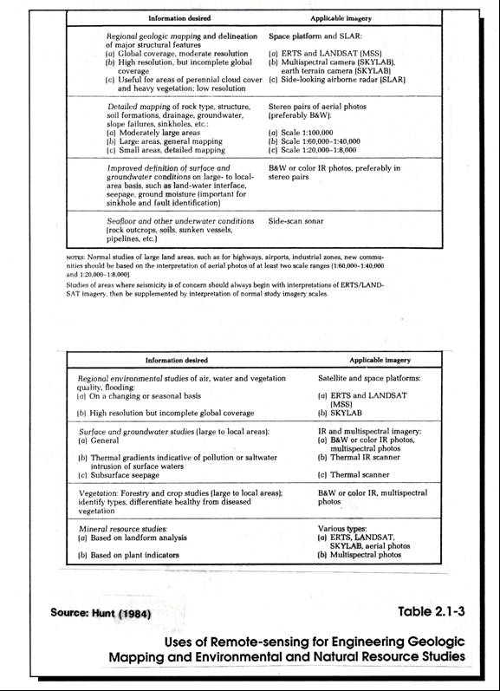

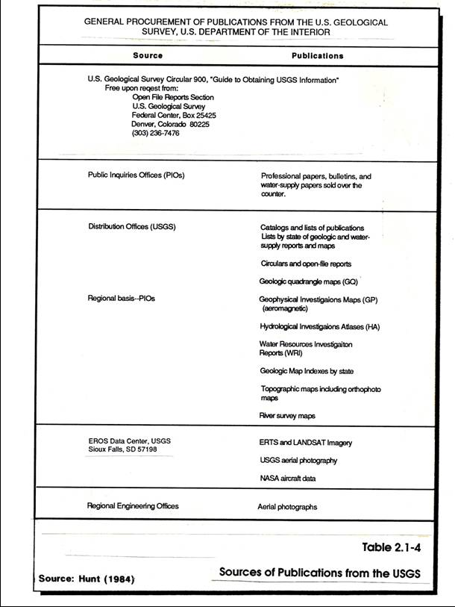

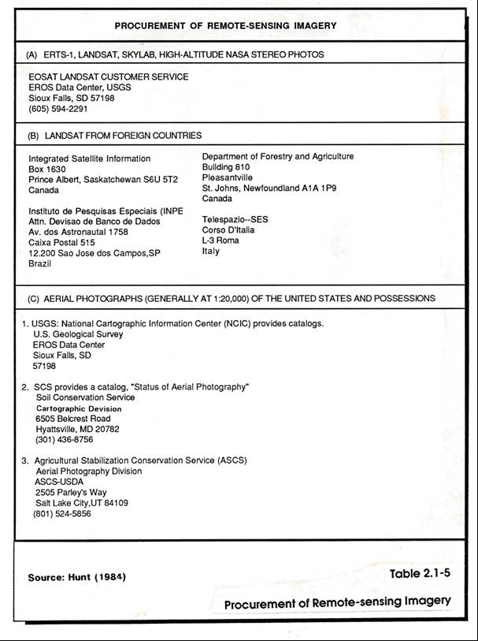

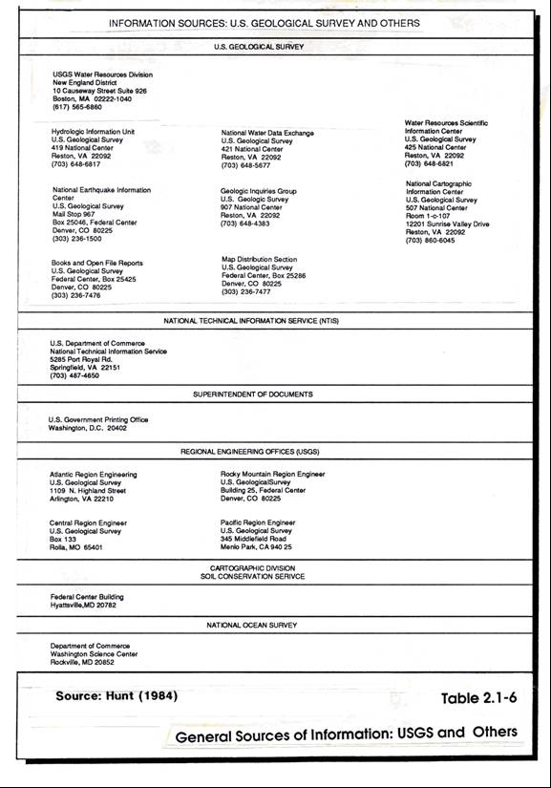

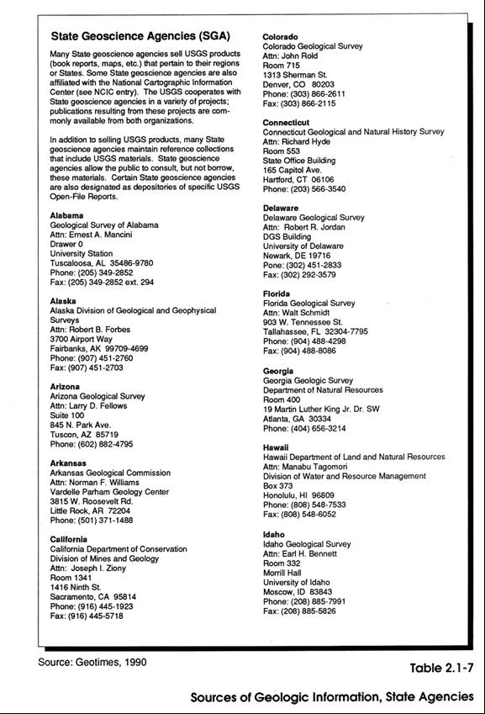

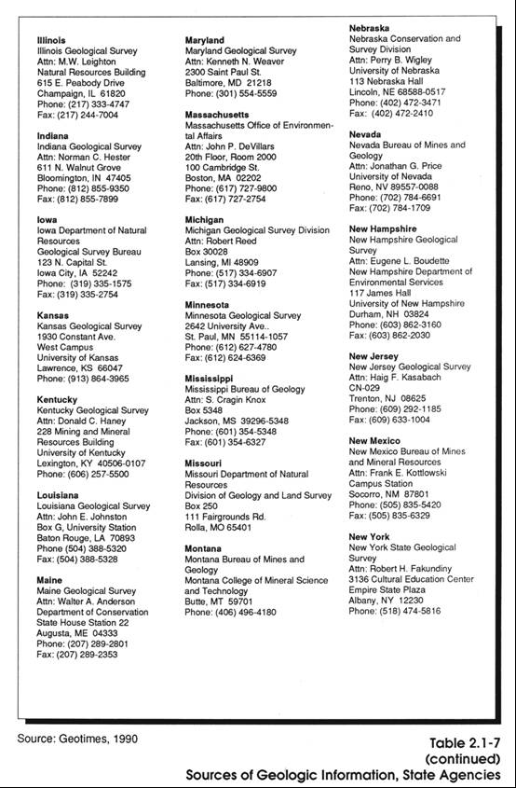

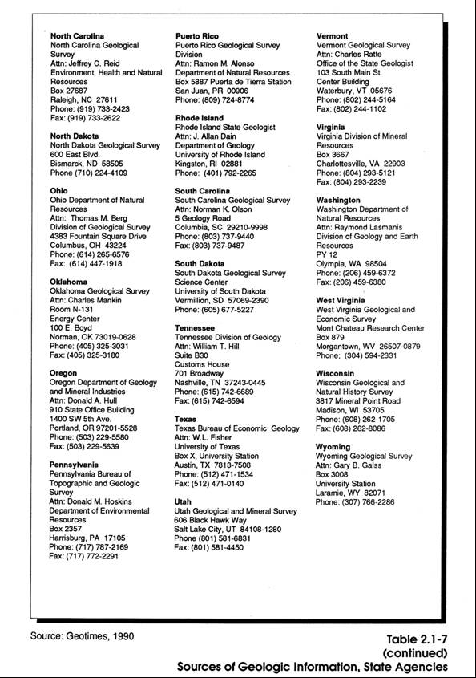

APPENDIX A

SITE ASSESSMENT CHECKLIST FOR USE
DURING A SITE RECONNAISSANCE VISIT

SITE ASSESSMENT CHECKLIST Job No.________________
FOR USE DURING A SITE RECONNAISSANCE VISIT Site Name______________
Client_________________
Date___________________
Completed by___________

MANMADE AND RELATED FEATURES

1. Buildings
Number, location, size
Type of construction
Age _
General Condition
Flooring Materials
Floor drains; to where?
Spill evidence; cleaned up?

2. Utilities
Electricity
Natural Gas
Oil
Telephone
Sewers
Water
Storm drains _

3. Physical Features
Parking areas (paved or under roof?)
Roads
Power lines
Dwellings
Structures/improvements
Rights-of-way

4. Security Features
Access roads
Fencing and gates
Vegetation barriers
Bike trails
Camp fire/party remains
Boat launching areas

5. Adjacent Land Use (Past and Present)
Surface water/groundwater use
Roads/utilities
Residential/industrial/commercial/agricultural
SITE ASSESSMENT CHECKLIST Job No.________________
FOR USE DURING A SITE RECONNAISSANCE VISIT Site Name______________
Client Client_________________
Date Date___________________
Completed by Completed by___________
Page 2 of 4

Vacant land
Vegetation types
Drainage patterns

NATURAL FEATURES

1. Vegetation Features and Condition
Type
Maturity
Density
Condition (stressed)

2. Water Features
Wells
Springs/seeps
Wetlands (swamps, meadows, bogs)
Ponds/lakes
Streams
Direction of runon and runoff
Surface erosion_
Evidence of flooding
Water body use

3. Geologic Features
Topography and slope
Soil characteristics
Rock outcrops
Sinkholes
Excavations
Spoil piles
Mining activity
Quarries or pits
Diversion ditches
Soil stockpiles
Aquifer characteristics
Erosion
Boulders

SITE ASSESSMENT CHECKLIST Job No.________________
FOR USE DURING A SITE RECONNAISSANCE VISIT Site Name______________
Client_________________
Date___________________
Completed by___________
Page 3 of 4

POTENTIALLY HAZARDOUS FEATURES
1. Waste Evidence
Drums, barrels, containers
Waste materials
Construction/demolition debris
Discolored soil
Odors
Leachate seeps
Discolored surface water
"Unnatural soil"
Ash or blackened area

2. Chemical/Fuel/Drum/Storage Area

Materials stored
Type of construction
Age _
General condition
Security and access
Spill control berms
Spill evidence

3. Manholes/Catch Basins/Drains/Fill Pipes
Where
What for
Description
Unusual appearance or odors

4. Process Tanks/Wastewater Tanks
Size
Materials of construction
Purpose
Inside/outside appearance
Above/below grade
Lined/unlined
Contents
General condition
Leaks/spills-evidence or incidents
Connecting piping secure?
Chemical feed/pump system ok?

SITE ASSESSMENT CHECKLIST Job No.________________
FOR USE DURING A SITE RECONNAISSANCE VISIT Site Name______________
Client_________________
Date___________________
Completed by___________
Page 4 of 4

5. Pits/Ponds/Lagoons
Size/location
Materials and construction
Purpose/contents
Above/below
Lined/unlined _
General condition
Freeboard
Leaks
Fill/drainpipes

6. Disposal Areas
Size
Location
Age
Contents _
General condition
Debris
Drums
Sludge/residue/rubble
Discoloration
Odors
Monitoring wells
Cover material
Vegetation
Equipment condition
Surface contours
Erosion
Leachate (analytical results)

7. Chemical Transfer Points
Where, when
What chemicals
Inside/outside)
Paved/unpaved
Spill evidence

APPENDIX B

SITE RECONNAISSANCE FIELD SUMMARY

Job No.________________
SITE RECONNAISSANCE FIELD SUMMARY Site Name______________
Client_________________
Date___________________
Completed by___________
Page 1 of 3

1. GENERAL
Client
Name of project
Location of sit
USGS Quadrangle_____________________Size of site
Description of proposed development

Available site plans and other drawings (Dwg. No., Title, Author, Date) (if no plans are available, prepare sketch and attach to report)

Available photographs
Available bedrock or surficial geology maps

2. SITE ACCESS
Sketch location of roads and trails not shown on site plan and note type and condition.
Describe type of exploration equipment which can be moved into site, e.g., small or large backhoe, either rubber-tired or tracked, truck mounted or skid-mounted drill rigs, small portable rigs, water availability for drilling, overhead utility restrictions, etc.

3. TOPOGRAPHY (Level - Rolling - Hilly - Mountainous, etc.)
Describe

Degree of slopes, approx.
Max. elevation__________________Min. elevation
Reference datum (USGS MLS, Boston City Base, etc.)

4. GEOMORPHOLOGY
(Tidal marsh - Drumlin - Flood Plain - Valley Floor, etc.)
Describe

___________________________Is the site virgin?
Character of erosion gullies (steep, moderate, or gently inclined)

Job No.________________
SITE RECONNAISSANCE FIELD SUMMARY Site Name______________
Client_________________
Date___________________
Completed by___________
Page 2 of 3

5. SURFACE VEGETATION (Wooded - Brush - Grass - Cleared - Fill, etc.)
Describe

Size and type trees

6. DRAINAGE (Locate features on sketch)
Natural Streams and Springs (Estimate gradient and discharge)

Man-made Drainage ditches and Culverts (describe type and estimate size, lined or unlined, headwalls, presence of water)

Probable groundwater elevation (from observations in pits, wells)

Evidence on history of flooding
Max. flood el.

7. EXISTING STRUCTURES ON SITE OR NEARBY
(Describe and locate on sketch)
Buildings (Type, size owner, foundation, available borings)

8. SOIL AND ROCK FEATURES (Show applicable information on sketch)
Bedrock Type Rock (outcrops, cuts)

Joining and Fissility (Degree and angle)
Surface boulders (Size, number, type rock)
Stone walls (None, few, many)

Soil Exposures (Describe types of materials and vertical sequence noted in each
exposure, e.g. in open pits, roadway cuts, trenches, erosion gullies, etc.

Artificial Fill (Granular, rubbish, cinders, etc.)

Job No. _______________
SITE RECONNAISSANCE FIELD SUMMARY Site Name______________
Client__________________
Date___________________
Completed by___________
Page 3 of 3

Topsoil Thickness and Type _
Organic Materials (Peat depths, limits, etc.)
_
Probable Subsoil Conditions (Describe as completely as possible)

Previous Subsurface Explorations

9. SOURCES OF BORROW (Where applicable, give name and location of pit, name, address and telephone of owner, distance from site, type of soil, sample taken, price, estimated resources, etc.)

10. ADDITIONAL INVESTIGATIONS (If applicable to investigation, check public works department and town engineer for location of sewer lines, water lines, buried cables, septic tanks, etc. Include name and telephone numbers of people contacted)

11. ADDITIONAL COMMENTS AND NOTES

COMMONWEALTH OF MASSACHUSETTS

DEPARTMENT OF ENVIRONMENTAL PROTECTION

STANDARD REFERENCES FOR MONITORING WELLS

SECTION 2.2 WORK AND COST PLANS (RESERVED)

COMMONWEALTH OF MASSACHUSETTS

DEPARTMENT OF ENVIRONMENTAL PROTECTION

STANDARD REFERENCES FOR MONITORING WELLS

SECTION 2.3 HEALTH AND SAFETY PLANS

Section 2.3
Page i
January 1991

SECTION 2.3
HEALTH AND SAFETY PLANS

TABLE OF CONTENTS

Section Title Page No.

2.3-1 PURPOSE 1

2.3-2 APPLICABILITY 1

2.3-3 REQUIREMENTS 2

2.3-4 PERSONAL PROTECTIVE 4

2.3-4.1 Level A 5
2.3-4.2 Level B 5
2.3-4.3 Level C 5
2.3-4.4 Level D 6

2.3-5 QUESTIONS AND SUGGESTED SOLUTIONS 6

REFERENCES 10

Section 2.3
Page ii
January 1991

APPENDICES

Appendix Title Page No.

A Example of Site-specific HASP Format 12

Attachment 1 - Confined Space entry procedures 45
Attachment 2 - Health and Safety Audit
Checklist 55

B Effectiveness of Protective Materials Against
Chemical Degradation .62

C Risk/Hazard Analysis Calculations 64

Section 2.3
Page iii
January 1991

LIST OF FIGURES

Figure Title Page No.

A-1 OSHA Job Safety and Health Protection Poster 42

A-2 Confined Space Entry Checklist: General Entry 49

A-3 Confined Space Entry Log 50

A-4 Manhole/Sewer Entry Log 54

LIST OF TABLES

Table Title Page No.

A-1 Sample of CHRIS Data Sheet/Material Safety Data
Sheet for Contaminants of Concern 44

A-2 Confined Space Classification 61

SECTION 2.3
HEALTH AND SAFETY PLANS

2.3-1 PURPOSE

Workers at hazardous waste sites may be exposed to a variety of known and unknown physical and chemical hazards. To control worker exposure to these hazards, the Occupational Health and Safety Administration (OSHA), as required by Congress in the Superfund Amendments and Reauthorization Act (SARA) of 1986, developed the Hazardous Waste Operations and Emergency Response standard-interim final rule, 29 CFR 1910.120, to regulate employee safety and health at hazardous waste operations. One portion of this standard addresses site-specific Health and Safety Plans (HASPs).
The purpose of this Standard Reference is to present guidelines and a methodology for developing HASPs. A site-specific HASP is necessary to address the health and safety hazards anticipated at a particular site, and to describe the means that will be used to eliminate or control hazardous exposure in order to reduce the risk of bodily injury. The HASP must be developed in a systematic manner so that all hazards and necessary protective actions are addressed. A well developed HASP should provide all the information needed for site personnel to work in safety, and respond to emergencies in a quick, safe, and efficient manner.

The Health and Safety Plan guidelines outlined in these Standard References pertain to hazardous waste sites and any emergency response actions that may occur at a site. Specific guidelines for emergency response actions at uncontrolled releases of oil or hazardous materials may differ.

2.3-2 APPLICABILITY

All hazardous waste sites covered by 29 CFR 1910.120 are required to develop site-specific HASPs. In Sections (a)(1) and (2) of the Hazardous Waste Operations and Emergency Response rule, the scope of coverage is described. To summarize this section, employers and employees engaged in the following operations are required to comply with the regulation:

- Operations involving hazardous substances that are conducted under the Comprehensive Environmental Response, Compensation, and Liability Act (CERCLA) of 1980

- Clean-up operations involving major corrective actions conducted under the Resource Conservation and Recovery Act (RCRA) of 1976

- Operations at hazardous waste sites that have been designated for cleanup by state or local governmental authorities

- Operations at treatment, storage, and disposal (TSD) facilities involving hazardous wastes regulated under 40 CFR Parts 264 and 265, pursuant to RCRA

- Emergency response operations for release of, or substantial threats of, hazardous substances without regard to the location of the hazard

2.3-3 REQUIREMENTS

The Hazardous Waste Site and Emergency Response rule (29 CFR 1910.120) also specifies certain items that must be addressed in the HASP. (See Appendix A.) In addition to pertinent site information, all HASPs, at a minimum, must contain the following information, although the level of detail provided should be dependent upon the anticipated risk and exposure:

- Personnel:

Key health and safety personnel are those who either have health and safety responsibilities on-site or are utilized as a backup if an emergency occurs. These personnel include: (1) at the corporate level, the Health and Safety Manager (HSM), who is responsible for implementing all health and safety programs within the corporation; (2) at lower corporate levels, the Health and Safety Supervisor (HSS) and the Health and Safety Officer (HSO), who are responsible for designing site-specific HASPs and auditing compliance with the HASP; (3) at a site level, the Health and Safety Designee (HSD), if one is so designated, who assists the HSO when multiple operations are conducted that require air monitoring; (4) the Industrial Hygienist; and (5) other relevant individuals.

- Risk or Hazard Analysis:

The purpose of the risk or hazard analysis is to determine the extent of worker exposure during the conduct of various operations at the site. The analysis is conducted by reviewing all available data on the potential hazards at the site, both chemical and physical. It is necessary to determine the potential for worker exposure, based on the levels and types of contaminants known or suspected to be on-site, as well as the site conditions and the work to be done. The analysis must include an evaluation of the potential risks or hazards from accidents or major catastrophes.

- Training Requirements:

All site personnel who may potentially be exposed to hazardous materials at a hazardous waste site must have first received a minimum of 40 hours of initial health and safety instruction, and a minimum of three days of field experience under the direct supervision of a trained, experienced health and safety specialist. See Table 2.3-1. Site personnel must also receive eight hours of refresher training each year. On-site management and supervisors directly responsible for employees engaged in hazardous waste operations must receive an additional eight hours of supervisory training.

- Personal Protective Equipment (PPE):

Selection of the appropriate PPE is a complex process that must consider a variety of factors, including the identification of known or suspected hazards, their routes of entry into the body (i.e., skin absorption, inhalation, or ingestion), and the performances of the PPE. Before selecting PPE, engineering controls must be taken into account. If it is feasible to use engineering controls and work practices to limit or reduce the exposure, they must be given priority over the use of PPE. Types of engineering controls that may be feasible include the use of pressurized cabs or control booths on equipment, the use of remotely operated material handling equipment, wetting down soil to control dust, and ventilating a confined space.

- Medical Monitoring:

Any employees exposed or potentially exposed for 30 days or more per year to hazardous substances or health hazards, at levels that equal or exceed the exposure levels established by OSHA, the National Institute for Occupational Safety and Health (NIOSH), or the American Conference of Governmental Industrial Hygienists (ACGIH), or who wear respirators for 30 days or more a year, must be enrolled in a medical surveillance program.

- Monitoring:

The frequency and types of air monitoring, personnel monitoring, and environmental sampling techniques and instrumentation to be used should be described. The methods of maintenance and calibration of monitoring and sampling equipment to be used should also be included.

- Site Control Measures:

Appropriate site control procedures must be implemented before work begins. To control employee exposure to hazardous substances, the site control program must include, at a minimum, a site map, site work zones (i.e., Exclusion Zone, Contamination Reduction Zone [CRZ], and Support Zone - see Figure 2.3-1), the use of a "buddy system," site communications, the standard operating procedures for safe work practices, and identification of the nearest medical assistance, including written directions and a map showing the most direct route to the facility.

- Decontamination:

A decontamination procedure must be developed, discussed with all on-site employees, and implemented before any work may be undertaken in areas on-site where a potential for exposure to hazardous substances exists.

- Emergency Response:

An emergency response plan must be developed to cover all anticipated emergencies prior to the commencement of work on-site.

- Confined Space Entry Procedures:

If employees will be required to enter a confined space, entry procedures must be developed and communicated to the employees before the commencement of work. If entry into a confined space will not be required, a statement stating this must be included in the HASP.

The HASP should always be regarded as a dynamic document, subject to revision as more information becomes available or as site conditions change. The initial development, subsequent revisions, and implementation of the HASP are the responsibility of the HSO assigned to the site. When developing a HASP, the HSO will gather the necessary information about the site from past records, including what was disposed of; complaints from the public on odors, illnesses, or injuries that may be site related; any previous agency action (e.g., prior investigations, response to spills or leaks, fires, or response to complaints of contaminated water); worker or non-worker injury that may have occurred on-site while the site was in operation or when prior investigations were underway; and prior sampling episodes.

A preliminary HASP must then be developed to beused for the site reconnaissance. This important preliminary work step sets the framework for the execution of the remainder of the project HASP. It enables the HSO to develop a layout of the site, identify site hazards, establish the appropriate level of personal protection, verify information about the site, and provide additional information for use in other work-related matters (e.g., locating future monitoring wells and test pits).

All information gained is later incorporated into a site-specific HASP. As additional information relative to the site becomes available, or work conditions change, revisions to the HASP must be made. These changes must be communicated to all affected personnel.

2.3-4 PERSONAL PROTECTION LEVELS

Levels of personal protection were first developed by the U.S. Environmental Protection Agency (USEPA) and later adopted by OSHA in the Hazardous Waste Operations and Emergency Response rule. This section summarizes the protection levels appropriate for various conditions. Appendix B lists the OSHA-recommended equipment per level of protection.

2.3-4.1 Level A

Level A personal protection provides the highest level of protection for the skin, eyes, and respiratory system. It is appropriate for conditions where there are potential or actual high concentrations of atmospheric vapors, gases, or particulates. It should be used if site operations or work functions involve a high potential for splash, immersion, or exposure to unexpected vapors, gases, or particulates of materials that are harmful to the skin or capable of being absorbed through the intact skin. Level A is primarily used for emergency situations or when the following conditions exist: (1) vapors/mists of strong acids; (2) known or probable "Immediately Dangerous to Life and Health" (IDLH) atmospheres with dermally active compounds; (3) high atmospheric concentrations of compounds that can be absorbed through the skin; and (4) operations that must be conducted in a confined, poorly ventilated area, where conditions requiring Level A have not yet been eliminated. The key PPE in Level A personal protection are the fully encapsulating suit and the positive pressure/pressure demand self-contained breathing apparatus (SCBA) or hoseline respirators.

2.3-4.2 Level B

Level B personal protection should be used when the type and atmospheric concentration of substances have been identified and require a high level of respiratory protection; however, the atmospheric contaminant, splashing liquid, or other direct contact will not adversely affect or be absorbed through any exposed skin. This includes atmospheres with IDLH concentrations of specific substances that do not represent a severe skin hazard, or that do not meet the criteria for use of air purifying respirators. Level B has the same respiratory protection criteria as Level A, but the dermal exposure is not as severe. Level B is also required where cartridge-type respirators are not available for the contaminant of concern.

2.3-4.3 Level C

Level C personal protection should be used when the atmospheric contaminant, liquid splashes, or other direct contact will not adversely affect or be absorbed through any exposed skin. In addition, the types of air contaminants must have been identified, the concentration measured, and an air-purifying respirator made available that can remove the contaminants. Air-purifying respirators can only be used if the oxygen content in the air is at least 19.5 percent, the contaminant has adequate warning properties (e.g., odor, taste, and irritating effect thresholds within two to three times the Threshold Limit Values [TLVs]), the concentration of the contaminant does not exceed the IDLH, and the worker has been fit tested. Level C has the same splash protection as Level B, but cartridge respirators are used instead of SCBAs.

2.3-4.4 Level D

Level D personal protection requires a work uniform affording minimal protection; it is used only for nuisance contamination. This level of protection should only be used when the atmosphere contains no known hazard; all potential airborne contaminants can be monitored for; and work functions preclude splashes, immersion, or the potential for unexpected inhalation of or contact with hazardous levels of any chemical.

2.3-5 QUESTIONS AND SUGGESTED SOLUTIONS

This section presents some problems that may be encountered when developing a HASP and suggests possible methods for developing solutions.

PROBLEM: How to ensure that a preliminary HASP is developed prior to site reconnaissance.

DISCUSSION: Frequently, to get a project moving, preliminary site walk-overs occur without first taking the time to develop a preliminary HASP. A preliminary HASP is required by OSHA; it is the same as the regular HASP except it is based solely on information gathered off-site (e.g., from background checks, complaints from the public, previous agency action, and prior injuries or illnesses). This document should be as complete as possible, based on all the information available at the time. If the preliminary off-site assessment does not produce sufficient information to identify the hazards or suspected hazards at a site, OSHA requires that initial site entry be conducted in Level B PPE. Therefore, the preliminary HASP enables workers to conduct the initial reconnaissance in a safe manner, whether it be in Level B, C, or D PPE.

POSSIBLE SOLUTIONS: Training is important. Ensure that all personnel, from management down, know of the requirements and the reasons for the preliminary HASP. Establish a communication network between Project Managers and health and safety personnel to review the information found during the preliminary site evaluation and determine an adequate level of protection.

PROBLEM: How to determine the level of personal protection to be used on-site.

DISCUSSION: When determining the proper level of personal protection, the more information that is available about the site, the better. If in doubt, the level of protection selected should be conservative so as to protect the health of the workers. However, if a greater level of personal protection is selected than needed, problems inherent with the equipment could not only increase the cost of the project (due to the costs associated with the equipment and the reduction in work efficiency associated with wearing the equipment), but also make it more hazardous than the hazard itself.

For example:

Respirators

- reduce visibility
- affect communication
- increase breathing resistance
- are bulky and heavy (SCBAs)
- sometimes impair mobility (air-line)
- reduce endurance, especially in a hot environment

Chemical Protective Clothing

- cause heat stress, a very serious consideration; worker tolerance level can be reduced as much as 56 percent when working in a hot environment

Steel-toe, Steel-shank, Chemical-resistant Boots

- are hot in the summer (heat stress)
- are cold in the winter (frostbite)

Gloves

  - reduce dexterity, especially if multiple pairs are used
  - are hot in the summer (heat stress)

POSSIBLE SOLUTIONS: Conduct a hazard analysis, using all available information, and estimate the potential for exposure. The more information available, the better the evaluation. If no or very little information is available about the contaminants and the site, a higher level of protection must be selected. If data are available on the types, concentrations, and locations (aboveground or below ground) of contaminants, and the type of work to be done, a lower level of protection may be safely selected.

Once the level of PPE is chosen, the type of glove, boot, and chemical-resistant clothing can be selected. This selection is based on the contaminants found on-site and on how well the material resists degradation or permeation by the contaminant. See Appendix B for a table on the Effectiveness of Protective Materials Against Chemical Degradation (by Generic Class).

PROBLEM: How to go about conducting a risk or hazard analysis.

DISCUSSION: A risk or hazard analysis is required by OSHA when developing a HASP. The purpose of the risk/hazard analysis is to evaluate all the information available, identify the hazards, and develop controls.

POSSIBLE SOLUTION: When conducting a risk/hazard analysis, the more information available, the better the analysis. If available information is limited, a higher degree of hazard must be assumed until enough data are compiled to determine otherwise.

To conduct a chemical risk/hazard analysis, the first step is to identify the types of contaminants on-site. How hazardous are they? Are they in high enough concentration to pose a health hazard? What type of work is to be conducted? Where are the contaminants found? If found only in the groundwater, and the work is non-invasive, the risk of exposure may be low or nonexistent. If the contaminants are found at the surface and the concentrations are high, the risk of exposure may be high. What are the routes of entry into the body (i.e., inhalation, ingestion, skin absorption, or injection)? Evaluate the contaminant's physical properties. For example, is it a solid, liquid, or gas? If it is a solid, the exposure route will be primarily dermal, with some possibility of particulate inhalation. If the contaminant is a gas or a volatile liquid, inhalation is the route of most concern. What is the contaminant's vapor pressure? Vapor pressure is an indicator of the chemical's volatility. All this information should be analyzed to determine the risk of exposure.

When conducting risk/hazard analyses, care must be taken when determining which established exposure limit (EEL) to use. OSHA has developed permissible exposure limits (PELs), which are legally enforceable.

Neither the ACGIH TLVs nor the NIOSH Recommended Exposure Limits (RELs) are enforceable, because they are recommended limits only. However, the TLVs and RELs are based on current experimental and epidemiologic data and are updated regularly. Therefore, except when the OSHA PELs are lower, prudence recommends the use of TLVs or RELs when determining EELs. See Appendix D for calculations that can be used in the analysis.

Although chemical exposures are first in order of concern, physical hazards must also be evaluated. Physical hazards are represented by rough or uneven terrain, test pits, ditches, or inadequate stairs for the trailer. Such hazards may cause slips, trips, or falls. Improper materials handling may lead to back, shoulder, or arm strain; working around drilling rigs can cause injury due to the hammer, rods, augers, or similar equipment falling and striking personnel. Also, heat stress, cold stress, and noise exposure may occur. In addition to physical hazards, biological, radiological and electrical hazards must be evaluated.

PROBLEM: How to determine if there is a confined space exposure on-site.

DISCUSSION: Confined spaces can be categorized generally as areas where air circulation is minimal or restricted, and where the potential exists for concentration or stratification of gases. Test pits, trenches, ditches, depressions, diked areas around a tank, and certain types of storage tanks may be classified as open-top confined spaces. If the contaminant is heavier than air (i.e., butane, propane, and other hydrocarbons), it flows to the lowest point, where it is difficult to remove.

Other confined spaces (e.g., sewers, casings, tanks, basements, silos, vaults, and compartments of ships) usually have limited access. The problems arising in these areas are similar to those that occur in open-top confined spaces. However, the limited access increases the risk of injury. Gases that are heavier than air (e.g., carbon dioxide and propane) may lie in a tank or vault for hours, or even days, after the container is opened.

Gases that are lighter than air (e.g., hydrogen and methane) may also be trapped within an enclosed-type confined space, especially those with access from the bottom or side.

POSSIBLE SOLUTIONS: Ensure that personnel are trained in how to recognize a confined space. Monitoring equipment should be employed prior to entry into any confined or semi-confined area. Analyze the confined space for oxygen content. Analyze the contaminants suspected and known to be on-site. Determine which are heavier and lighter than air. When conducting the initial reconnaissance, instruct field personnel to be on the lookout for any low-lying terrain where heavier-than-air contaminants could be trapped during work activities. Be careful of any work done inside buildings, especially basements, which can be considered confined spaces if not well ventilated. Confined spaces should never be entered alone. A backup is always required.

PROBLEM: How to deal with the press, politicians, vandals, and others who want to enter an unauthorized zone.

DISCUSSION: OSHA regulations are very specific on the training and health monitoring requirement for hazardous waste sites. If on-site more than 30 days per year, personnel must have received all the required training and must be enrolled in a medical surveillance program.

POSSIBLE SOLUTION: To prevent unauthorized access and thereby exposure of unauthorized, unprotected people, plan to have and maintain good site security in the Support Zone and at the Access Control Points. Assign a person responsibility for enforcing authority for entry and exit requirements. Have the Project Team Leader approve all visitors to the site. If possible, erect a fence or other physical barrier around the site. If the site is not fenced, post signs around the perimeter and use guards to patrol. Enlist public enforcement agencies (e.g., the local police department) if needed. Have a public relations person assigned to deal with the press and politicians, as well as the public. Have this person assigned to the site or refer the press and politicians to the telephone number where this person can be reached.

PROBLEM: How to obtain local emergency numbers (e.g., for hospitals, police, fire department, and poison control) in the easiest possible way.

DISCUSSION: Emergency numbers as well as the route to the hospital are required as part of the emergency response plan.

POSSIBLE SOLUTIONS: When first in the area of the site, acquire a local telephone book from the telephone company and/or contact the local police and fire departments. Police and fire departments are a good source for emergency numbers, as well as getting the best route to the hospital. These sources should provide most of the information needed.
REFERENCES

American Conference of Governmental Industrial Hygienists, 1986, Documentation of threshold limit values and biological exposure indices and BEIs, 5th edition: Cincinnati, OH.

American Conference of Governmental Industrial Hygienists, 1987, Threshold limit values and biological exposure indices for 1988-1989: Cincinnati, OH, American Conference of Governmental Industrial Hygienists.

Guide to portable instrumentation for assessing airborne pollutants arising from hazardous wastes, draft international document: in International Organization of Legal Metrology, American Conference of Governmental Industrial Hygienists, Cincinnati, OH.

Haz-mat Consultants, Inc., Guidelines for HAZWOPER, 154 W. Park Street, Lee, MA 01238.

National Institute of Occupational Safety and Health, 1985, NIOSH Pocket guide to chemical hazards: Washington, DC, U.S. Government Printing Offices.

Occupational Safety and Health Administration (U.S. Dept of Labor), 1986, Hazardous waste operations and emergency response: Washington, DC, U.S. Government Printing Office, 29 CFR 1910.120.

Sax, N., 1984, Dangerous properties of industrial materials, 6th edition: New York, NY, Van Nostrand Reinhold Company.

Schwope, A.D., Costas, P.P., Jackson, J.O., Stull, J.O., and Weitzman, 1987, Guidelines for the selection of chemical protective clothing, 3rd edition: Cincinnati, OH, American Conference of Governmental Industrial Hygienists, Inc.

U.S.Department of Transportation and U.S. Coast Guard, 1984, CHRIS hazardous chemical data, manual II.: Washington, DC, U.S. Government Printing Office.

U.S.Department of Health and Human Services, 1985, Centers for Disease Control, National Institute for Occupational Safety and Health, 1985, NIOSH/OSHA/OSCG/EPA Occupational safety and health guidance manual for hazardous waste site activities: Washington, DC, U.S. Government Printing Office.

U.S.Environmental Protection Agency, 1984, Standard operating safety guides: Office of Emergency and Remedial Response, Hazardous Support Division, Environmental Response Team.
SECTION 2.3 HEALTH AND SAFETY PLANS

APPENDICES

A EXAMPLE OF SITE-SPECIFIC HASP FORMAT

Attachment 1 - Confined space entry procedures
Attachment 2 - Health and Safety Audit Checklist

B EFFECTIVENESS OF PROTECTIVE MATERIALS AGAINST CHEMICAL DEGRADATION

C RISK/HAZARD ANALYSIS CALCULATIONS

APPENDIX A

EXAMPLE OF SITE-SPECIFIC HASP FORMAT

HEALTH AND SAFETY PLAN (HASP)

Prepared for:

(identify the site)

(identify city, county, and state)

Prepared by:

ABC ENGINEERING CO.
ANYTOWN, MASSACHUSETTS

(enter date as month and year prepared/revised)

(NOTE: Do not leave blanks in the HASP!
If sections are not considered necessary or
applicable, state this.)

The attached sample HASP contains all elements required by OSHA, but the format used is only one of many acceptable versions. DEP does not require use of a particular format; as long as the HASP conforms to OSHA and other applicable regulations, format is at the discretion of the preparer.

The sample HASP can and should be adapted as necessary to address site- and project- specific details and concerns. For example, when a HASP is submitted in conjunction with a work and cost plan, sections that are common to both (such as scope of work and site history) need not be repeated.
APPENDIX A
EXAMPLE OF SITE-SPECIFIC HASP FORMAT

TABLE OF CONTENTS

Section Title Page No.

A.1 GENERAL . 17

A.1.1 Scope and Purpose 17
A.1.2 Health and Safety Personnel 17

A.1.2.1 Health and Safety Manager 17
A.1.2.2 Health and Safety Supervisor 17
A.1.2.3 Health and Safety Officer 17

A.1.3 Training 18
A.1.4 Medical Surveillance 18

A.2 SITE CHARACTERIZATION AND ANALYSIS 18

A.2.1 Site Name, Location, and Size 18
A.2.2 Scope of Work 19
A.2.3 Site History 19
A.2.4 Hazardous Substances/Conditions 19
A.2.5 Initial Site Entry 19

A.2.5.1 Initial Level of Personal Protection 19
A.2.5.2 Initial Monitoring 19

A.2.6 Site Risks 20

A.2.6.1 Health Hazards 20
A.2.6.2 Safety Hazards 20
A.2.6.3 Conclusions/Risk Assessment 20

A.3 SITE CONTROL 20

A.3.1 Zonation 20

A.3.1.1 Exclusion Zone 20
A.3.1.2 Contamination Reduction Zone 21
A.3.1.3 Support Zone 21
A.3.2 Medical Assistance 22

A.4 ENGINEERING CONTROLS, WORK PRACTICES, AND PERSONAL
PROTECTIVE EQUIPMENT 22
APPENDIX A
EXAMPLE OF SITE-SPECIFIC HASP FORMAT

TABLE OF CONTENTS
(continued)

Section Title Page No.

A.4.1 Engineering Controls 22
A.4.2 Work Practices 22
A.4.3 Personal Protective Equipment 24

A.4.3.1 Levels of Protection 24
A.4.3.2 Other Personal Protection Equipment 26
A.4.3.3 Operational Levels of Protection 26

A.5 MONITORING 26

A.5.1 Air Sampling, Equipment, Maintenance, and Calibration 26
A.5.2 Personal Monitoring: Equipment, Maintenance, and Calibration 28
A.5.3 Other 29

A.6 DECONTAMINATION/DISPOSAL 29

A.6.1 Personnel Decontamination 29
A.6.2 Small Equipment Decontamination 30
A.6.3 Heavy Equipment Decontamination 31
A.6.4 Disposal of Decontaminated Materials 31

A.7 EMERGENCY/CONTINGENCY PLAN 31

A.7.1 Personnel Roles, Lines of Authority, and Communication 32
A.7.2 Evacuation 32

A.7.2.1 Withdrawal Upwind 32
A.7.2.2 Site Evacuation 32
A.7.2.3 Evacuation of Surrounding Area 33

A.7.3 Emergency Medical Treatment/First Aid 33

A.8 OTHER 33

A.8.1 Illumination 33
A.8.2 Sanitation 33
A.8.3 Excavation 34
A.8.4 Confined Space Entry 34
A.8.5 OSHA Poster 34

APPENDIX A
EXAMPLE SITE-SPECIFIC HASP FORMAT

TABLE OF CONTENTS
(continued)

Section Title Page No.

A.9 ADMINISTRATIVE 35

A.9.1 Personnel Authorized Downwind 35
A.9.2 HASP Approvals 36
A.9.3 Emergency Telephone Numbers 37
A.9.4 Routes to Emergency Medical Facilities 38
A.9.5 Emergency Signals 39
A.9.6 Field Team Review 40
A.9.7 Medical Data Sheet 41

ATTACHMENT 1 - CONFINED SPACE ENTRY PROCEDURES 45
ATTACHMENT 2 - HEALTH AND SAFETY AUDIT CHECKLIST 55

LIST OF FIGURES

Figure Title Page No.

A-1 OSHA Job Safety and Health Protection Poster 42

A-2 Confined Space Entry Checklist: General Entry 49

A-3 Confined Space Entry Log 50

A-4 Manhole/Sewer Entry Log 54

LIST OF TABLES

Table Title Page No.

A-1 Sample of CHRIS Data Sheet/Material Safety Data
Sheet for Contaminants of Concern 43

A-2 Confined Space Classification 61

APPENDIX A EXAMPLE OF SITE-SPECIFIC HASP FORMAT

A.1 GENERAL

A.1.1 Scope and Purpose

This Health and Safety Plan (HASP) was prepared in conform with the ABC Engineering Co. Health and Safety Program, and is intended to meet the requirements found in 29 CFR 1910.120. As such, the HASP addresses all activities associated with field operations at the (* identify the site). Compliance with this HASP is required of all ABC Engineering Co. personnel, contractor's personnel, or third parties entering the site.

A.1.2 Health and Safety Personnel

The following paragraphs briefly describe the health and safety designations and general responsibilities that will be employed for the (* identify the site) project. Other personnel without specific safety designations (e.g., the Project Manager, Field Operations Leader [FOL], and the field crew) should remember that safety is everyone's responsibility and should tailor their actions and decisions accordingly.

A.1.2.1 Health and Safety Manager

The Health and Safety Manager (HSM) for ABC Engineering Co., J.A. Smith, can be reached at (617) 123-4567, in Anytown, Massachusetts. The HSM has final authority to resolve health and safety issues that are not resolved at the site or through the Health and Safety Supervisor (HSS), and has overall responsibility for ensuring that the policies and procedures of this HASP are implemented by the Health and Safety Officer (HSO). In the various regions, the HSM may delegate additional functions to the Regional HSS.

A.1.2.2 Health and Safety Supervisor

The HSS for ABC Engineering Co., D.E. Jones, can be reached at (617) 123-4567, in Anytown, Massachusetts. The HSS is the health and safety professional serving as the ABC Engineering Co. HSM's designee for this project. As such, the HSS will be responsible for (1) approval of the individual chosen to serve as the site HSO for this field operation; (2) review and approval of site-specific HASPs developed by the HSO, as well as any significant changes made over time to the site HASP; (3) oversight of the daily efforts of the HSO; (4) resolution of site disputes involving health and safety issues; (5) implementation of the HASP by the HSO; and (6) conduct of health and safety audits at the site (see Attachment 2). The HSS will notify the HSM of any Stop Work Orders issued by an HSO.

A.1.2.3 Health and Safety Officer

(* Enter name of HSO) has been approved as the HSO for the (* identify the site) by the ABC Engineering Co. HSS. The HSO is responsible for developing and implementing this site-specific HASP in accordance with the ABC Engineering Co. Health and Safety

Program. The HSO will conduct safety inspections and investigate all accidents, illnesses, and incidents occurring on-site. The HSO will also conduct safety briefings and site-specific training for on-site personnel. As necessary, the HSO will accompany all U.S. Environmental Protection Agency (USEPA), Occupational Safety and Health Administration (OSHA), or other governmental agency personnel visiting the site in response to health and safety issues. The HSO, in consultation with the HSS, is responsible for updating and modifying this HASP as site or environmental conditions change.

The HSO is vested with the authority to stop site operations (STOP WORK AUTHORITY) if he/she determines that an imminent health or safety hazard or other potentially dangerous situation exists. The HSO is to immediately notify the HSS of any Stop Work Orders issued. The HSO may also recommend to the HSS or HSM that the downwind authorization of individual site personnel be revoked for health and/or safety reasons.

The HSO, through the HSS, ensures that all personnel entering the (* identify the site) are qualified for downwind deployment, in accordance with the ABC Engineering Co. Health and Safety Program requirements. If the HSO is responsible for a large number of sites, some of these sites may be delegated to Health and Safety Designees (HSDs).

A.1.3 Training

All personnel working on an ABC Engineering Co. site, who may potentially be exposed to toxic substances or hazardous materials, must participate in a 40-hour initial, eight-hour annual (and/or supervisory as appropriate), and site-specific training program in accordance with 29 CFR 1910.120, prior to commencement of their on-site assignment. See Table 2.3-1. Personnel without the required training will not be permitted in a downwind position.

A.1.4 Medical Surveillance

All personnel entering potentially contaminated areas of this site must be medically qualified for site assignment as determined by a medical surveillance program, such as that outlined in the ABC Engineering Co. Health and Safety Program. This program consists of an initial medical examination to establish the employee's baseline, with follow-up examinations conducted on an annual or biennial basis or more frequently if project assignments warrant testing. Personnel without medical clearance will not be permitted in a downwind position.

A.2 SITE CHARACTERIZATION AND ANALYSIS

A.2.1 Site Name, Location, and Size

(*Enter information that identifies the site: its location, city, county, and state; U.S. Geological Survey [USGS] quadrangle; and size. A figure showing the site on a USGS quadrangle or other suitable map would be appropriate.)

A.2.2 Scope of Work

(*Enter information regarding the scope of work as it relates to the types of field activities in which ABC Engineering Co. or subcontractor personnel would be engaged. Particular attention should be given to actual work activities of field personnel to identify where and how they might encounter health and safety hazards.)
A.2.3 Site History

(*Enter information on site use, as it relates to the types of material that could be expected to be encountered during site operations. Information on any site-related incidents, actions, spills, or complaints about the site would be appropriate. A description of existing facilities should be included; a figure of the facility layout, both current and historic, should be inserted, if available.)

A.2.4 Hazardous Substances/Conditions

(*Enter information that would identify those hazardous substances and/or conditions known or suspected to be present on-site. The information could be the result of direct evidence from past environmental actions, or supposition based on historic use of the site. In addition to identifying the hazardous substances that may be present, exposure limits for the substances should be noted along with the sources of the limits. [See Table A-1, Guidelines for Assessing Chemical and Physical Hazards]. It is recommended that the most conservative numbers be used when there is more than a single limit. Other hazardous conditions [e.g., structural instability of site buildings, unstable ground conditions, or explosives] should also be identified). See Table A-2 for Sample of CHRIS Data Sheet/Material Safety Data.

A.2.5 Initial Site Entry

A.2.5.1 Initial Level of Personal Protection

(*Enter information on the selection of the initial level of protection that will be employed for the initial reconnaissance. The selection of this level of protection will be based on the preliminary data collected. If quite a bit is known about the site and its potential hazards, a lower level of personal protection can be selected, if applicable. If little or nothing is known about the site, at a minimum, Level B personal protection must be used [according to OSHA 29 CFR 1910.120(c)]. If this is not a preliminary HASP, this section should be used to discuss the level of protection to be worn initially by site personnel for the proposed site operations.)

A.2.5.2 Initial Monitoring

Where the development of site information either shows the potential for or is unable to rule out the possibility of ionizing radiation or "Immediately Dangerous to Life or Health" (IDLH) conditions, initial monitoring will consist (at a minimum) of an ionizing radiation survey and air monitoring, using devices such as a combustible gas indicator, oxygen

meter, or photoionization detector (PID). It is intended that real-time monitoring instrumentation will be used to assist in the determination of the appropriate level of protection for the initial site entry team.

A.2.6 Site Risks

A.2.6.1 Health Hazards

(*Enter information that identifies health hazards that site personnel can expect to encounter as a result of site conditions or operations. This information will be used to support the conclusions in the "Conclusions/Risk Assessment" section, which will be used to select levels of protection identified in Section A.4.3.)

A.2.6.2 Safety Hazards

(*Enter information that identifies safety hazards that site personnel can expect to encounter as a result of site conditions or operations. This information will be used to support the conclusions in the "Conclusions/Risk Assessment" section, which will be used to select levels of protection identified in Section A.4.3.)

A.2.6.3 Conclusions/Risk Assessment

(*Enter the conclusions regarding risk assessment for site personnel, identifying the measures necessary to protect their safety. Areas to consider include the known or suspected contaminants and their potential for additive or synergistic responses, the physical hazards that may be encountered, and the potential for such exposures or encounters to occur.)

A.3 SITE CONTROL

A.3.1 Zonation

(*Insert site layout map showing site zonation.)

The site itself will normally be divided into three zones: the majority of the work area will be considered the Exclusion Zone, with limited areas serving as the Support Zone, and an area for decontamination called the Contamination Reduction Zone (CRZ). See Figure 2.3-1.

A.3.1.1 Exclusion Zone

The Exclusion Zone isolates the area of contaminant generation and restricts (to the extent possible) the spread of contamination from active areas of the site to support areas and off-site locations. The Exclusion Zone is demarcated by the Hot Line (i.e., a tape line or physical barrier). Personnel entering the Exclusion Zone must (1) enter through the CRZ; (2) wear the prescribed level of protection (see Section A.4.3); and (3) be otherwise authorized to enter the Exclusion Zone (see Sections A.1.3, A.1.4, and A.9.1). Any personnel, equipment, or materials exiting the Exclusion Zone will be considered contaminated. Personnel will be subject to decontamination; equipment and materials will be subject to either decontamination or containerization in uncontaminated devices.

Within the Exclusion Zone, specific locations or restricted areas (clearly marked or identified) will be established as necessary for particular locations or around specific site operations. In the case of well drilling or excavation operations, a restricted area will be established that includes a minimum 30-foot radius from the drill rig or excavation operation. Other restricted areas may include drum staging areas, active site areas, sources of combustible gases or air contaminants, or other dangerous areas as they are identified. Specific access for emergency services to areas of specific site operations will be established.

A.3.1.2 Contamination Reduction Zone

Moving out from the Exclusion Zone, starting at the Hot Line and continuing to the Contamination Control Line, is the CRZ. The CRZ is a transition zone between contaminated and uncontaminated areas of the site. When "hot" or contaminated personnel, equipment, or materials cross the Hot Line, they are assumed to be as "hot" or contaminated as they are going to be from site operations. Being subjected to the decontamination process, they become less contaminated; when they reach the Contamination Control Line, they are clean and can exit this zone without spreading contamination.

Within the CRZ is the Contamination Reduction Corridor (CRC), where materials necessary for full personnel and portable equipment decontamination are kept. A separate facility will be established for heavy equipment decontamination. In addition, certain safety equipment (e.g., emergency eye wash, fire extinguisher, stretcher, and first aid kit) is staged in this zone.

A.3.1.3 Support Zone

The Support Zone is the outermost zone of the site, separated from the CRZ by the Contamination Control Line; it is considered a clean area. Movement of personnel and materials from this zone into the CRZ is generally unrestricted, except as required through access points controlled for administrative purposes. However, only uncontaminated/decontaminated personnel or materials may enter this zone from the CRZ.

The Support Zone contains the necessary support facilities (including personal hygiene facilities) for site operations. It also serves as the communications center and source of emergency assistance for operations in the Exclusion Zone and CRZ. A log of all persons entering the site will be maintained by the HSO, the FOL, or the site designee.

A.3.2 Medical Assistance

The primary source of medical assistance for the (*identify the site) is:

(*identify medical facility)

(*insert address of medical facility)

(*insert telephone number to contact the medical facility or emergency transport to the facility)

The alternate source of medical assistance is:

(*identify alternate medical facility)

(*insert address of alternate facility)

(*insert telephone number to contact the medical facility or emergency transport to the facility)

A.4 ENGINEERING CONTROLS, WORK PRACTICES, AND PERSONAL

PROTECTIVE EQUIPMENT

A.4.1 Engineering Controls

(*Enter a description of the engineering controls that will be employed to deal with the health and safety hazards identified in Section A.2.6. For example, exhaust ventilation systems for fixed work stations, and enclosed, ventilated cabs of heavy equipment and remote-operated equipment.)

A.4.2 Work Practices

(*Enter specific work practices that will be used for this site and site-specific operations. Use the words provided herein, as appropriate.)

Workers are expected to adhere to established safe work practices for their respective specialties (e.g., drilling, laboratory analysis, or construction). The need to exercise caution in the performance of specific work tasks is made more acute due to (1) weather conditions; (2) restricted mobility and reduced peripheral vision caused by the protective gear itself; (3) the need to maintain the integrity of the protective gear; and (4) the increased difficulty in communicating caused by respirators. Work at the site will be conducted according to established protocol and guidelines for the safety and health of all involved. Among the most important of these principles for working at a hazardous waste site are the following:

  - In any unknown situation, always assume the worst conditions and plan responses accordingly.

  - Use the buddy system. Under no circumstances will any person be permitted to enter the Exclusion Zone alone. Establish and maintain communication. In addition to radio communications, it is advisable to develop a set of hand signals, because conditions may greatly impair verbal communications.

  - Because no personal protective equipment (PPE) is 100-percent effective, all personnel must minimize contact with excavated or contaminated materials. Plan work areas, decontamination areas, and procedures accordingly. Do not place equipment on drums or the ground. Do not sit on drums or other materials. Do not sit or kneel on the ground in the Exclusion Zone or CRZ. Avoid standing in or walking through puddles, stained soil, or other obvious sources of contamination.

  - Smoking, eating, or drinking in the work area and before decontamination will not be allowed. Oral ingestion of contaminants is the second most likely means of introducing toxic substances into the body (inhalation being the first).
  - Avoid heat and other work stresses related to wearing protective gear. Work breaks should be planned to prevent stress-related accidents or fatigue.

  - To the maximum extent feasible, handling of contaminated materials should be done remotely, particularly when drummed or other containerized hazardous waste materials are found on-site. Every effort should be made to identify the contents of containers found on-site before they are subject to material-handling applications.

  - Personnel must be observant of not only their own immediate surroundings, but also those of others. Everyone will be working under constraints; therefore, a team effort is needed to notice and warn of impending dangerous situations. Extra precautions are necessary when working near heavy equipment and while utilizing PPE because vision, hearing, and communication can be restricted.

  - Contact lenses should not be worn on-site; if corrosive or tear-producing substances enter the eyes, proper flushing would be impeded.

  - Personnel with any facial hair that interferes with the proper fit of the respirator will not be allowed to work on sites requiring Level C or B protection.

  - Rigorous contingency planning and dissemination of plans to all personnel mimimizes the impact of rapidly changing safety protocols in response to changing site conditions.

  - Personnel must be aware that chemical contaminants may mimic or enhance symptoms of other illnesses or intoxication. Avoid excess use of alcohol or working while ill during field investigation assignments.

  - The FOL, HSO, and sampling personnel will maintain project records in a bound notebook (e.g., daily activities, meetings, incidents, and data). Notebooks will remain on-site for the duration of the project so that replacement personnel can add information, thereby maintaining continuity. These notebooks and daily records should become part of the permanent project file.

A.4.3 Personal Protective Equipment

A.4.3.1 Levels of Protection. The following descriptions provide the basic composition of the generally recognized protective ensembles to be used for site operations. Specific components for any level of protection are site specific and will be selected based on hazard assessment with the ability to upgrade as necessary. Additional elements will be added as necessary. Disposable protective clothing, gloves, and other equipment, exclusive of respirators, should be used when feasible to minimize risks during decontamination, and possible cross-contamination during sample handling. For example, all joints between sleeves and gloves, pant legs and boots, and face mask and hood, should be sealed with duct tape to prevent contaminants from accidentally coming in contact with the skin at these points.

Level A

  - Atmosphere Supplying Respirator (full-facepiece) - either positive pressure Self-Contained Breathing Apparatus [SCBA] or positive pressure Supplied Air Respirator [SAR] (airline) with escape-only positive pressure SCBA.

  - fully-encapsulating, chemical-resistant suit

  - inner chemical-resistant gloves

  - chemical-resistant safety boots/shoes

  - two-way radio (intrinsically safe)

  - cooling unit*

- coveralls*

- hardhat*

- long cotton underwear*

*optional

Level B

  - Atmosphere Supplying Respirator (full-facepiece) - either positive pressure Self-Contained Breathing Apparatus [SCBA] or positive pressure Supplied Air Respirator [SAR] (airline) with escape-only positive pressure SCBA.

  - chemical-resistant clothing (i.e., coveralls and long-sleeved jacket; hooded, one- or two-piece chemical-splash suit; and disposable chemical-resistant one-piece suit)

  - inner and outer chemical-resistant gloves

  - chemical-resistant safety boots/shoes

  - hardhat

  - two-way radio (intrinsically safe)

  - coveralls*

  - disposable boot covers*

  - face shield*

  - long cotton underwear*

Level C

  - full facepiece, air-purifying respirator with appropriate sorbent canisters

  - chemical-resistant clothing (i.e., coveralls and long-sleeved jacket; hooded, one- or two-piece chemical-splash suit; and disposable chemical-resistant one-piece suit)

  - inner and outer chemical-resistant gloves

  - chemical-resistant safety boots/shoes

  - hardhat

  - two-way radio (intrinsically safe)

  - coveralls*

  - disposable boot covers*

  - face shield*

*optional

  - escape mask*

  - long cotton underwear*

Level D

  - coveralls*

  - safety boots/shoes

  - safety glasses or chemical-splash goggles

  - hardhat

  - gloves*

  - escape mask*

  - face shield*

  - boot cover – chemical resistant*

* Optional

A.4.3.2 Other Personal Protective Equipment

(* Enter information that identifies other PPE to be used on-site. Examples include lifelines and harness, personal flotation devices, and body armor for blast protection.)

A.4.3.3 Operational Levels of Protection

(* Enter detailed information regarding the levels of protection that will be employed for each site operation under various site conditions, emphasizing the points or factors that will necessitate a higher level of protection. The information developed in Sections A.2.2 through A.2.6 should be used to determine the levels of protection needed for the proposed site operations. NOTE: The protection described in this section must be supported by the conclusions in the "Conclusions/Risk Assessment" section.)

A.5 MONITORING

The work environment will be monitored to ensure that IDLH or other dangerous conditions are identified. At a minimum, monitoring will include evaluations for combustible atmospheres, oxygen-deficient environments, hazardous concentrations of airborne contaminants, and radioactivity.

A.5.1 Air Sampling: Equipment, Calibration, and Maintenance

To the extent feasible, the presence of airborne contaminants will be evaluated through the use of direct-reading instrumentation. Information gathered will be used to ensure the adequacy of the levels of protection being employed at the site, and may be used as the basis for upgrading or downgrading levels of protection, at the discretion of the site HSO.

(*Identify the air sampling equipment to be used at the site, and the frequency at which it will be employed [i.e., during initial site visit, daily at the start-up of operations, constantly during operations, or some combination thereof]. Examples of the types of air monitoring equipment currently available for site operations follow.)

  - ISD Dual Detector:

This meter monitors for combustible gases and oxygen. It can be used to determine (1) if an area contains concentrations of combustible gases with readings in percentage of the lower explosive limit; and (2) the percentage of oxygen. This equipment will be calibrated in accordance with the manufacturer's instructions.

  - NMS MX-241 (Explosimeter):

This instrument, which is calibrated to methane, monitors combustible gases in the percentage of the lower explosive limit. It will be calibrated in accordance with the manufacturer's instructions.

  - ISD HS267:

This instrument monitors for the presence of hydrogen sulfide in parts per million (ppm). This instrument will be calibrated in accordance with the manufacturer's instructions.

- Photovac Organic Vapor Analyzer (OVA) 10S50:

The OVA is a total organic vapor analyzer capable of detecting volatile organic compounds (VOCs) that can be ionized by ultraviolet (UV) light. Model 10S50 is commonly used on-site to estimate the presence of VOCs for purposes of crew protection, well screen placement, and selection of samples for further analysis. The principle of operation is twofold: (1) the ambient temperature gas chromatograph (GC), which resolves mixtures of VOCs into individual components identified by retention time; and (2) detection accomplished by ionization in UV light. The charged component then moves to an electrode, which, in turn, results in a meter deflection proportional to the concentration of the contaminant. This instrument does not read out directly in ppm unless calibrated against the material being measured; therefore, results must be interpreted carefully and conservatively. Calibration and maintenance will be performed in accordance with the manufacturer's instructions.

  - HNU PI101 and Photovac TIP Photoionization Detector (PID):

Like the OVA, the PID operates on the basis of ionization of the contaminant, which results in a meter deflection proportional to the concentration of the contaminant. In the PID, ionization is caused by a UV light source. The strength of the UV light (measured in electron volts [eV]) determines which contaminants can be ionized. The HNU can use three different-strength UV sources: 9.6, 10.2, and 11.7 eV. Only the 10.2- and 11.7-eV probes are currently available for field use. The TIP operates using a UV light source of 10.6 eV. Calibration and maintenance will be performed in accordance with the manufacturer's instructions.

  - Detector Tubes (MSA and Draeger):

A colorimetric detector tube is a direct-reading instrument that consists of a glass tube impregnated with an indicating chemical, which is connected to a piston cylinder or bellows-type pump. A known volume of air is drawn through the glass tube. The contaminant in the air reacts with the indicator chemical, producing a stain, the length of which is proportional to the contaminant's concentration. Care must be taken when using the detector tubes because reliability of the results depends on proper calibration, the degree of stability of the reacting chemical, and the ambient temperature. Interfering gases or vapors can also positively or negatively affect measured results. Calibration should be carried out according to the manufacturer's instructions.

A.5.2 Personal Monitoring: Equipment, Maintenance, and Calibration

Personal monitoring will be undertaken to characterize exposure of high-risk employees to hazardous substances encountered on-site. The designation of an employee as high-risk will be the responsibility of the HSO in consultation with the HSS and or HSM.
(*Identify the personal monitoring equipment to be used on-site, and the frequency that it will be employed [i.e., during initial site visit, daily at the start-up of operations, constantly during operations, or some combination thereof]. Examples of the types of personal monitoring equipment currently available for site operations follow.)

  - Gilian Personal Sampling Pumps: These devices can be worn by an employee to draw air samples through appropriate collection media. The units can be used to draw volumes from 2 to 3 liters per minute. Calibration will be conducted using standard industrial hygiene protocols before and after each sampling session (i.e., each day's use).

  - Passive Dosimeters or Gas Badges: These devices are non-mechanical collection devices used to monitor for organic vapors and various gases. They

are worn by an employee and sent to an industrial hygiene laboratory for analysis.

  - Thermoluminescent Dosimetry (TLD) Body Badges: These devices are non-mechanical collection devices used to monitor for x-ray, beta, and gamma radiation exposure. They are worn by an employee and sent to a qualified laboratory for analysis.

A.5.3 Other

(*Identify any other sampling equipment that will be used to evaluate potential employee exposures on-site.)

A.6 DECONTAMINATION/DISPOSAL

All personnel and/or equipment leaving contaminated site areas are subject to decontamination, which occurs in the CRZ (see Section A.3.1).

A.6.1 Personnel Decontamination

(*Enter information regarding the personnel decontamination equipment and requirements for the site based on the level of protection used. A figure showing the decontamination line layout should be included; examples of figure types can be found in Appendix 1 of the USEPA Standard Operating Safety Guides. The following words can be used as is or adjusted to the site.)

Decontamination procedures must be followed by all personnel leaving hazardous waste sites. When using Level A or B personal protection, decontamination will be a team effort, with the decontamination team at a level of protection equal to or one level lower than the work crew. Under no circumstances (except emergency evacuation) will personnel be allowed to leave the site prior to decontamination. Generalized procedures for removal of protective clothing are as follows:

1. Drop tools, monitors, samples, and trash at designated drop stations (i.e., plastic containers or drop sheets).

2. Step into the designated shuffle pit area and scuff feet to remove gross amounts of dirt from outer boots. Wash down boots with clear water in the designated wash pit area. If non-disposable clothing is used, wash down outer protective garments.

3. Remove tape from boots and remove boots; discard in disposal container.

4. Remove outer gloves and place in container.

5. Remove hardhat and respirator and place or hang in the designated area.

- Remove outer garment and discard in container.

7. Remove inner gloves and discard in container.

8. If the site requires use of a decontamination trailer, all personnel must shower before leaving the site at the end of the work day.

NOTE: Disposable items (i.e., Tyvek coveralls, inner gloves, and latex overboots) will be changed on a daily basis unless there is reason to change sooner. Dual respirator canisters will be changed daily, unless more frequent changes are deemed appropriate by site surveillance data or personnel assessment.

Pressurized sprayers or other designated equipment will be available in the decontamination area for wash down and cleaning of personnel, samples, and equipment.

Respirators will be decontaminated daily and taken from the drop area. The masks will be disassembled, the cartridges set aside, and all other parts placed in a cleansing solution. Parts will be pre-coded (e.g., #1 on all parts of Mask #1). After an appropriate time in the solution, the parts will be removed and rinsed with potable water. Old cartridges will be marked to indicate length of usage (i.e., if means to evaluate the cartridges' remaining utility are available) or will be discarded in the contaminated trash container for disposal. In the morning, the masks will be reassembled and new cartridges installed, if appropriate. Personnel will inspect their own masks and readjust the straps for proper fit.

A.6.2 Small Equipment Decontamination

(*Enter information that establishes decontamination procedures for small equipment [e.g., hand tools, radios, instruments, or other small non-disposable items the field crew might use downrange]. This could include bagging or wrapping of equipment prior to sending it downrange. The following words can be used, as appropriate.)

Small equipment will be protected from contamination as much as possible by draping, masking, or otherwise covering the instruments with plastic (to the extent feasible) without hindering operation of the unit. For example, the HNU meter should be placed in a clear plastic bag to allow reading the scale and operating the knobs. The HNU sensor should be partially wrapped, keeping the sensor tip and discharge port clear.

The contaminated equipment will be taken from the drop area and the protective coverings removed and disposed of in appropriate containers. Any dirt or obvious contamination will be brushed or wiped with a disposable paper wipe. The units can then be taken inside in a clean plastic tub, wiped off with damp disposable wipes, and dried. The units will be checked, standardized, and recharged as necessary for the next day's operation, and then prepared with new protective coverings.

A.6.3 Heavy Equipment Decontamination

(*Enter information that defines how heavy equipment used on-site will be decontaminated before being permitted to leave the site. This must include the mechanism for controlling and/or collecting the fluids used for heavy equipment decontamination. A figure showing the layout of a heavy equipment decontamination station can be used. The following words can be used, as appropriate.)

It is anticipated that drilling rigs/backhoes will be contaminated during borehole/test-pitting activities. They will be cleaned with high-pressure water or steam, followed by a soap-and-water wash and rinse. Loose material will be removed with a brush. The person performing this activity will usually be at least at the level of protection utilized during the personnel and monitoring equipment decontamination.

A decontamination pad will be constructed to allow collection and storage of contaminated decontamination fluids in Department of Transportation (DOT)-approved 55-gallon drums.
A.6.4 Disposal of Decontaminated Materials

(*All contaminated disposable clothing and decontamination fluids must be properly handled on-site. For those sites where disposal has not yet occurred, these fluids and materials may be left on-site, when properly containerized. At other sites, it may be necessary to containerize and dispose of the materials as Hazardous Wastes Solids or Hazardous Wastes Liquids not otherwise stated (n.o.s.). As a result of the need to do something with these materials, this section must state how they will be handled and disposed of. The following words can be used, as appropriate.)

All protective gear, decontamination fluids (for both personnel and equipment), and other disposable materials will be disposed of at each site. Decontamination fluids (i.e., methylhydrate [ethanol:methanol 9:1 v/v], used to decontaminate sampling equipment [e.g., split spoons and groundwater sampling pump]) will be stored in DOT-approved 55-gallon drums. Disposable materials (e.g., gloves and Tyveks) will be double-bagged and stored as is, or placed in DOT-approved 55-gallon drums.

A.7 EMERGENCY/CONTINGENCY PLAN

(*As now envisioned, this HASP would be used for operations at sites for Remedial Investigations/Feasibility Studies [RIs/FSs] or remediation efforts. As such, the emergency/contingency plan required under 29 CFR 1910.120 would be for "on-site emergency response" only. Much of the information required by 1910.120[i] is found in other sections of the HASP; therefore, only those items not previously addressed are included in this section. In the event that such information is not considered necessary, specifically indicate this. DO NOT LEAVE BLANKS IN THE HASP.)

This section identifies the emergency contingency planning undertaken for operations at this site. Other sections provide further information to be used under emergency conditions.

A.7.1 Personnel Roles, Lines of Authority, and Communications

The site HSO is the primary authority for directing site operations under emergency conditions. All communications both on- and off-site will be directed through the HSO.

A.7.2 Evacuation

(*The need to evacuate, and the location where site workers will be safe if an evacuation is necessary, will depend on the type of emergency [i.e., fire, explosion, chemical release, or personal injury]. Therefore, include information that identifies the contingency being planned for. For example, in the event of a FIRE, when the decision to evacuate is made, personnel will evacuate upwind to location "X" and await further instruction. In the event of a CHEMICAL RELEASE, when the decision to evacuate is made, personnel will move to an upwind position [as noted by a windsock] relative to the release. The following words can be used, as appropriate.)

A.7.2.1 Withdrawal Upwind

The work party will continually note general wind directions while on-site. (A windsock may be set up near the work site for visual determinations.) When conditions warrant moving away from the work site, the crew will relocate upwind a distance of approximately 100 feet or farther, as indicated by site monitoring instruments. Donning a SCBA and a safety harness and line, the HSO or a member of the crew may return to the work site to determine if the condition noted was transient or persistent. If persistent, an alarm should be raised to notify on-site personnel of the situation and the need to leave the site or don a SCBA. An attempt to decrease emissions should be made only if greater respiratory protection is donned. The HSO and client will be notified of conditions. When site access is restricted, thus hindering escape, the crew may be instructed to evacuate the site rather than move upwind, especially if withdrawal upwind moves the crew away from escape routes.

A.7.2.2 Site Evacuation

When conditions warrant site evacuation, the work party will proceed upwind of the work site and notify the security force, HSO, and field office of site conditions. If the decontamination area is upwind and greater than 500 feet from the work site, the crew will pass quickly through decontamination to remove contaminated outer suits. If the hazard is toxic gas, respirators will be retained. The crew will proceed to the field office to assess the situation. If instrumentation indicates an acceptable condition, respirators may be removed. As more information is received from the field crew, it will be relayed to the appropriate agencies. The advisability and type of further response action will be coordinated and carried out by the HSO.

A.7.2.3 Evacuation of Surrounding Area

When the HSO determines that conditions warrant evacuation of downwind residences and commercial operations, local agencies will be notified and assistance requested. Designated on-site personnel will initiate evacuation of the immediate off-site area without delay.

A.7.3 Emergency Medical Treatment/First Aid

(*Provisions must be made for adequate numbers of site personnel, trained to render first aid and CPR; these persons should be identified in this section. Additionally, specific pages of the HASP, found in Section A.9, are designed as pull-outs for posting information [e.g., emergency telephone numbers and routes to medical services].)

First aid will be rendered to any person injured on-site, as appropriate. The injured person will then be transported to medical personnel for further examination and/or treatment. The preferred transport method is a professional emergency transportation service; however, when this is not readily available or would result in excessive delay, other transport is authorized. Under no circumstances will injured persons transport themselves to a medical facility for emergency treatment.

When an injury occurs in a downrange position, provisions for decontamination of the victim will be made. However, life-threatening conditions may preclude normal decontamination procedures. In such cases, arrangements will be made with the medical facility and transporter to provide for the situation.

A.8.0 OTHER

(*Enter information on other site topics that are not appropriately discussed in separate sections of the HASP. All sections must be addressed. If not applicable, state this. DO NOT LEAVE BLANKS IN THE HASP.)

A.8.1 Illumination

Site operations will not be permitted without adequate lighting. Therefore, unless provisions are made for artificial light, downrange operations must halt in time to permit personnel and equipment to exit the Exclusion Zone and proceed through decontamination before dusk. Conversely, operations will not be permitted to begin until lighting is adequate.

(*If artificial light is to be used, information about the types and deployment should be included.)

A.8.2 Sanitation

(*Provisions must be made for sanitation facilities for the site work force. At a minimum, the provision of toilet facilities must meet the requirements of 29 CFR 1910.120(n), which include one facility for less than 20 employees; or one toilet and one urinal for every 40 employees, up to 200; then one of each for every 50 employees. If it is a mobile crew and they have transport readily available, the requirements do not apply.)

A.8.3 Excavation

Site excavations created during site operations will be shored or sloped to prevent accidental collapse, and otherwise conducted in accordance with 29 CFR 1926 (Subpart P). Under no circumstances will site personnel enter excavations that are not adequately shored or sloped. When entry into an excavation does occur, and the excavation is considered a confined space, such an entry will be done in accordance with the confined space entry program (see Section A.8.4).

A.8.4 Confined Space Entry

Confined space entry presents special problems and substantial risks to involved personnel (*including those who might be called upon to attempt a rescue of initial entrants). Therefore, entry into a confined space is a MEANS OF LAST RESORT, and will only be permitted where no other mechanism is feasible to achieve the desired goal. If confined space entry is necessary, it will be conducted under provisions outlined in Attachment 1.

A.8.5 OSHA Poster

OSHA requires employers to post the "Job Safety and Health Protection" poster in a conspicuous place where notices to employees are customarily posted. This includes trailers at job sites. The purpose of the poster is to inform employees of their rights under the Occupational Safety and Health Act. Figure A-1 contains a copy of this poster.

A.9 ADMINISTRATIVE

A.9.1 Personnel Authorized Downrange

Personnel authorized to participate in downrange activities at this site have been reviewed and certified for site operations by the Site Manager and HSS. Certification involves the completion of appropriate training, a medical examination, and a review of this site-specific HASP. All persons entering the site must utilize the buddy system, and check in with the Site Manager and/or HSO before proceeding downrange.

Certified ABC Engineering Co. Team Personnel:

________________________________ ________________________________
________________________________ ________________________________
________________________________ ________________________________
________________________________ ________________________________
________________________________ ________________________________
________________________________ ________________________________
________________________________ ________________________________
________________________________ ________________________________

Other Certified Personnel
________________________________ ________________________________
________________________________ ________________________________
________________________________ ________________________________
________________________________ ________________________________
________________________________ ________________________________
________________________________ ________________________________

* Current First Aid Training
+ Current CPR Training

A.9.2 Health and Safety Plan Approvals

By signature, the undersigned approve this HASP for applicability in the protection of the health and safety of all persons entering the (identify the site).

_________________________________________ _________________
Health and Safety Officer Date

_________________________________________ _________________
Project Manager Date

_________________________________________ _________________
ABC Engineering Co. Health and Safety Date
Manager/Supervisor
A.9.3 Emergency Telephone Numbers

(Local) Police Department ( ) -

(Local) Rescue Service ( ) -

(*insert name of primary) hospital ( ) -

(*insert name of secondary) hospital ( ) -

(Local) Fire Department ( ) -

Off-site Emergency Services ( ) -

National Poison Control Center (800) 492-2414

Massachusetts Poison Control Center (800) 682-9211

National Response Center (800) 424-8802

Regional USEPA Emergency Response ( ) -

Chemical Manufacturers Association

Chemical Referral Center (800) 262-8200

Site Health and Safety Officer:
(* enter name of HSO) ( ) -

Site Manager: (*insert name) ( ) -

Regional Health and Safety Supervisor:
(*insert name) ( ) -

ABC Environmental Co. Health and Safety Manager: ( ) -
(*insert name)
A.9.4 Routes to Emergency Medical Facilities

Primary source of medical assistance for the (* identify the site):

(* identify medical facility)

(* insert address of medical facility)

(* insert telephone number to contact the medical facility for emergency transport to the facility)

Directions to primary source of medical assistance:

(* insert directions to primary medical facility)

Alternate source of medical assistance:

(* identify alternate medical facility)

(* insert address of alternate facility)

(* insert telephone number to contact the medical facility or emergency transport to the facility)

Directions to alternate source of medical assistance:

(* insert directions to alternate medical facility)

(* Insert area map showing routes to primary and alternate medical facilities, on a separate page if necessary.)

A.9.5 Emergency Signals

In most cases, field personnel will carry portable radios for communications. If this is the case, a transmission that indicates it is of an emergency nature will take priority over all other transmissions. All other site radios will yield the frequency to the emergency transmissions.

Where radio communication is not available, the following air-horn signals will be used:

HELP three short blasts (. . .)

EVACUATION three long blasts (___ ___ ___)

ALL CLEAR alternating long and short blasts (___.___.___)

(* Enter any other site-specific emergency signals deemed necessary.)
A.9.6 Field Team Review

I have read and reviewed the HASP for the (* identify the site), understand the information contained, and agree to comply.

Site/Project: ________________________________________________

Name: ________________________________ Date: ______________
(Please Print)

Signature: ___________________________________________________
A.9.7 Medical Data Sheet

This Medical Data Sheet will be completed by all on-site personnel and will be kept in the Support Zone during site operations. It is in no way a substitute for the Medical Surveillance Program requirements consistent with the ABC Engineering Co. Health and Safety Program for Hazardous Waste Sites. This data sheet will accompany any personnel when medical assistance or transport to hospital facilities is required. If more information is required, use the back of this sheet.

Project:

Name:

Address:

Home Telephone: ( )_______________________

DOB: ______________ Height: _________ Weight: _____________

In case of emergency, contact:
(print name)

Address:

_________________________________________________________

Telephone (Day): ( )

Telephone (Night): ( )

Do you wear contacts? ( ) Yes ( ) No

Allergies:

List medication taken regularly:

Particular sensitivities:

Previous/recent illnesses or exposures to hazardous chemicals:
______________________________________________________________

Name of Personal Physician

Telephone: ( )

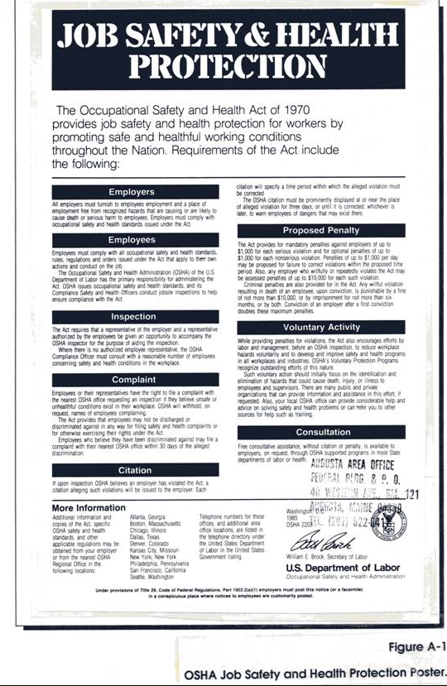

Table A-1

CHRIS DATA SHEETS/MATERIAL SAFETY DATA SHEETS
FOR CONTAMINANTS OF CONCERN

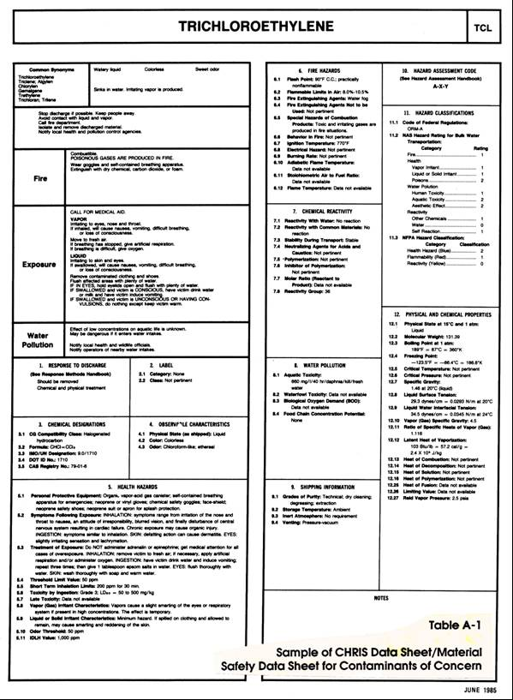

ATTACHMENT 1

CONFINED SPACE ENTRY PROCEDURES

Refer to
"Confined Space Entry Program" for further information

(TO BE INCLUDED WITH THE HASP FOR
ALL CONFINED SPACE ENTRY WORK)
CONFINED SPACE CLASSIFICATION

Confined spaces are classified according to their existing or potential chemical and physical hazards. Classification is based on characteristics of the confined space, oxygen level, flammability, and toxicity. The following table defines the parameters of each classification. If any of the hazards present a situation that is "Immediately Dangerous to Life and Health" (IDLH), the confined space is classified as Class A. Classification is determined by the most hazardous condition of entering, working in, and exiting a confined space. Class B confined spaces have the potential for causing injury and illness but are not IDLH. Class C entry is one in which the chemical hazard potential is minimal and does not require any special modification in work procedures. (See Table A-2)

ENTRY PROCEDURES

Team Size. A minimum of three workers is required for each confined space activity: two entry and one standby; or one entry, one rescue, and one standby. If the former is used, all three must be ABC Engineering Co. employees. If the latter is used, the standby could be a non-ABC Engineering Co. team member, assuming he/she has comparable training, is proficient in the assigned duties, and is capable of using all safety equipment.

The one entry/one rescue/one standby arrangement should only be used when the confined space is relatively small and/or the entry person will be in the line of sight at all times. In this instance, the rescue person acts as the second person in the "buddy system."

The two entry/one standby arrangement is used when the area of the confined space is larger, and the tasks may take the worker away from the entryway. Again, care must be taken with this arrangement because the standby person cannot enter the confined space and attempt rescue unless adequately protected (i.e., respiratory and dermal) and replaced by another qualified standby person.

This number of workers is the minimum required for these activities and, in most cases, should only be used for relatively nonhazardous confined spaces. Additional crew may be needed if entering a Class A or B confined space. Additional crew could include rescue, decontamination, and line-of-sight personnel.

General Entry

1. Inspect all pieces of equipment to ensure they are in good working order. DO NOT ENTER A CONFINED SPACE WITH DEFECTIVE EQUIPMENT.

2. Conduct a background check to identify all potential hazards that may be encountered in the confined space. Determine if there is a potential for fire/explosion hazards, as well as a potential for a toxic or oxygen-deficient atmosphere.

3. Test the atmosphere inside the confined space before entry. An attempt should be made to test the atmosphere without opening the entryway (i.e., through a vent line or a small opening). If the entryway must be opened to test, and only low levels are expected in the confined space, crack open entryway, test breathing zone first, and then test the confined space. If potentially high levels are expected in the breathing zone, respiratory protection should be worn prior to opening the entryway cover.

4. Purge or ventilate the confined space prior to entry, if explosive, toxic, or oxygen-deficient atmosphere is detected. Retest the atmosphere three times at 5-minute intervals. A person can enter the confined space without respiratory protection only if all three test results are below the Permissible Exposure Limit/Threshold Limit Value (PEL/TLV), 10 percent of the Lower Explosive Limit (LEL), and above 19.5-percent oxygen (all three conditions must be met).

(NOTE: Any downward deflection of the readings on the oxygen meter from background (i.e., 20.9 percent) should be viewed as a potential for an IDLH atmosphere. Unless contaminants are known to be nontoxic, do not enter the confined space without respiratory protection if the oxygen level is below background.)

5. Blank, block, or otherwise isolate, lockout, and tag all chemical, physical, and/or electrical hazards wherever possible.

6. Monitor the air on a continuous basis, if using an air-purifying respirator or if an IDLH and/or explosive atmosphere exists. If respiratory protection is not used and there is potential for atmospheric conditions to change due to work practices or conditions, air monitoring should be done periodically. In all these cases, a 5-minute escape pack must be used.

7. Record all results of the tests for hazardous conditions including the location, time, date, weather (if applicable), and readings on the PID, combustible gas meter, oxygen deficiency meter, Draeger tubes, and any other equipment used on the "Confined Space Entry Checklist-General Entry" form. Send a copy of the completed form to the Health and Safety Supervisor (HSS).

8. Wear appropriate clothing for site conditions, as determined by the Health and Safety Officer (HSO).

9. Wear a safety belt or harness with lifeline if hazardous conditions exist. If the diameter of the entryway is less than 18 inches, the wrist-type harness must be used and special provisions made if a supplied-air respirator is necessary.

10. One person (standby) must remain at the entryway at all times and must keep continuous contact with the person entering the confined space. Contact can be maintained by line of sight, listening for sounds, the safety line, and/or radio. The standby person must not enter the confined space unless another trained person

is available to act as standby, and he/she is equipped with adequate respiratory and dermal protection. (In most cases, respiratory protection would be an airline respirator or self-contained breathing apparatus [SCBA].)

11. Do not smoke when working in or near confined spaces and do not take flash-lighted photographs when explosive gases are known or suspected to be present.

12. Do not rely on permanent ladders because they are often in poor condition. If they must be used, be sure of footing. Inspect permanent ladders for deterioration before entering and while descending. Try each step with one foot, while standing on the step above. When in doubt, use a portable ladder of adequate height to reach 3 feet above opening, or a rope ladder, or lower the entry person using the tripod. If a portable ladder is used, it should be tied off, if possible; otherwise, it should be held in place by the standby person.

13. Do not work with inadequate lighting. Use only "explosion-proof" lights or hand lamps.

14. The entry person must not remain in the confined space if he/she becomes even slightly drowsy, faint, dizzy, or otherwise uncomfortable. Many of the gases that cause the most problems are odorless, tasteless, and invisible.

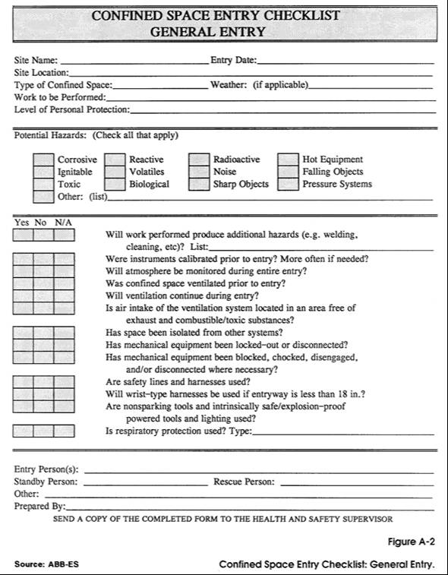

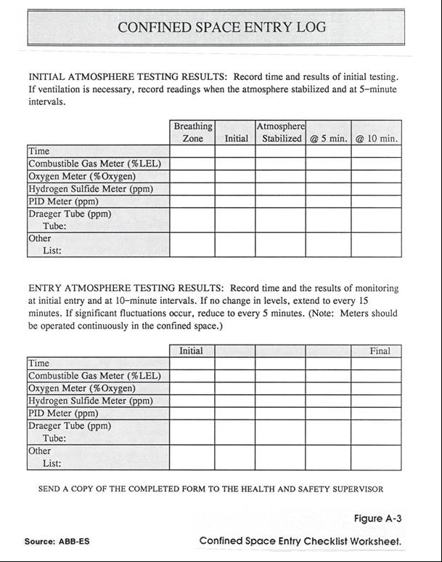

Manhole/Sewer Entry

When preparing to enter a manhole/sewer, the following safety measures must be taken:

1. Inspect all pieces of equipment to ensure they are all in good working order. DO NOT ENTER CONFINED SPACE WITH DEFECTIVE EQUIPMENT.

2. Park the vehicle near the manhole (do NOT leave the vehicle running). If the manhole is in the street, it is best to park so as to detour oncoming traffic around the manhole. The vehicle's emergency flashers and portable yellow warning beacon must be ON. The vehicle serves as protection from oncoming traffic, can be used to store emergency equipment (e.g., SCBA and first aid kit), and can be used in an extreme emergency to slowly pull an injured person from the confined space if a tripod with hoist attachment is unavailable or inoperative.

3. Erect portable barricades or cones around the manhole and in front of the vehicle to divert traffic and prevent pedestrians from falling in. Reflective vests should be worn so that workers are visible to approaching traffic.

4. If there are openings large enough to admit sampling tubes, test for the presence of explosive and toxic gases before removing each manhole cover. Otherwise, raise one side of the cover using the cover hook or pick, prop it slightly open, and conduct the tests.

5. If toxic or explosive gases are detected in the sewer, report this immediately to the local fire department and/or department of public works.

6. Record the results of tests for hazardous conditions, including location, manhole number (if applicable), time and date, weather (if applicable), and the readings on the photoionization detector (PID), combustible gas meter, oxygen deficiency meter, and Draeger tube on the Manhole/Sewer Entry Log Form. Send a completed copy of the form to the HSS.

7. Remove manhole covers with a cover hook or pick; do not improvise. Be careful of fingers and toes; covers are usually heavy and difficult to handle. Unless the cover is extremely heavy, it is safer for only one worker to handle it.

8. Test the atmosphere; if toxic, flammable, or oxygen-deficient, ventilate the sewer. Depending on the hazard, ventilation can be accomplished in a variety of ways: for example (1) remove and vent the adjoining upstream and downstream manhole covers, as soon as possible, and well in advance of entering the manhole (high hazard); and (2) vent the manhole in which entry will occur (very low hazard). If a blower is used, it is desirable to establish a flow of air in the sewer, in one manhole and out another. Ensure that the air intake is well away

from automobile exhaust, and combustible and/or toxic atmospheres. Appropriate traffic control measures must be taken by barricading or otherwise marking the open manholes.

9. After ventilating, test for explosive and toxic gases and oxygen deficiency in the manhole at ground level and at the bottom; record results. If entering the sewer itself, make the same tests at the manholes at either end. If ventilation is necessary, monitor the atmosphere in the manhole while work progresses, or continue operation of the blower. Continuous monitoring (i.e., equipment ON during entire entry) is imperative because conditions within the sewer may change rapidly. Do not enter a manhole while there is an oxygen deficiency without a pressure-demand, air-supplied breathing apparatus. If the oxygen level is lower than 20.9 percent of background, caution must be taken because an IDLH atmosphere may exist.

10. When entering manholes or tanks, wear a hardhat, protective clothing, and, when required, appropriate respiratory protection and safety belt or harness with lifeline. If the manhole is less than 18 inches in diameter, a wrist-type harness must be used and special provisions made if air-supplied respirators are necessary. When working in manholes greater than 12 feet deep, in the sewer itself, or where potential exists for gases to appear unexpectedly, a 5-minute emergency egress air supply is required (unless the time required to don the emergency respirator is greater than what would be needed to exit the manhole).

11. At least one person (i.e., standby) must remain at the manhole at all times and must keep continuous contact with the person entering the sewer. Contact can be maintained by line of sight, listening for sounds, and the safety line and/or radio. The standby person must not enter the manhole unless another trained person is available to act as standby and has adequate respiratory and dermal protection available. (In most cases, respiratory protection will be an airline respirator or SCBA.) The standby/rescue person should be suited up (but not yet on air) before the work crew enters the confined space.

12. Do not smoke when working in or near manholes. Do not take flash-lighted photographs when explosive gases are known or suspected to be present.

- Do not rely on the manhole ladders because they are often in poor condition. If they must be used, be sure of footing. Inspect manhole ladders for deterioration before entering and while descending. Try each step with one foot, while standing on the step above. When in doubt, use a portable ladder of adequate height to reach 3 feet above the manhole opening, or lower the entry person using the tripod. If a portable ladder is used, it should be tied off if possible; otherwise, it should be held in place by the standby person.

14. Do not work without adequate lighting. Use only "explosion-proof" lights or hand lamps in the manhole or sewer.

15. The entry person must not remain in the manhole or sewer if he/she becomes even slightly drowsy, faint, dizzy, or otherwise uncomfortable. Remember that carbon monoxide, carbon dioxide, methane, and hydrogen sulfide, which cause the most trouble, are odorless, tasteless, and invisible. Hydrogen sulfide has a distinct odor only during initial exposure.

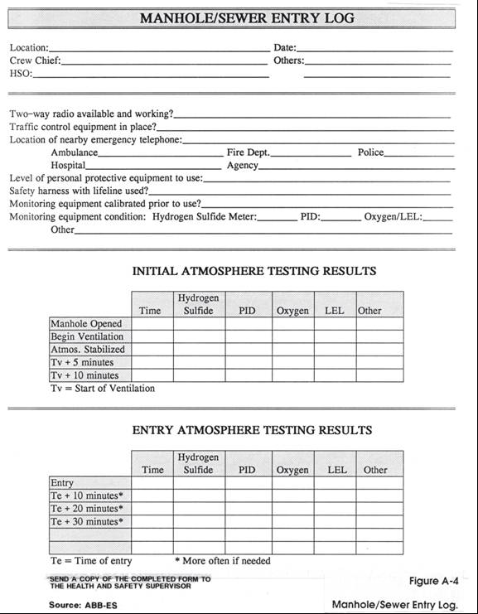

ATTACHMENT 2

HEALTH AND SAFETY AUDIT CHECKLIST

HEALTH AND SAFETY AUDIT CHECKLIST

Site Name __________________________________ Date _________

GENERAL YES NO COMMENTS

HASP on-site? ___ ___ ______________

Completely signed off and ___ ___ ______________
approved?

Only employees listed and approved ___ ___ ______________
in HASP on-site?

All personnel properly trained? ___ ___ ______________
All personnel in health monitoring? ___ ___ ____________

Zones established? ___ ___ ______________

Unusual situations on-site, not ___ ___ ______________
listed in HASP?

What?___________________________________________________

Action taken?______________________________________________

Hasp revised?____________________________________________

Are daily tool-box meetings held? ___ ___ ____________

OSHA poster posted in trailer? ___ ___ ______________

If night work is to be conducted, ___ ___ ______________
adequate illumination?

Proper sanitation facilities? ___ ___ ______________

PERSONAL PROTECTIVE EQUIPMENT

Proper PPE being worn as specified ___ ___ ______________
in the HASP?

PPE adequate for work conditions? ___ ___ _______________

If no, reason? ______________________________________________

up/down grade to PPE level__________________________________

PERSONAL PROT. (cont.) YES NO COMMENTS

Facial hair which would interfere ___ ___ _______________
with fit of respirators?

If Level B, backup/emergency person ___ ___ _______________
suited up (except for air)?

HSO periodically inspects PPE & ___ ___ _______________ equipment?

PPE not in use properly stored? ___ ___ _______________

EMERGENCY RESPONSE

Emergency response plan part of ___ ___ _______________
HASP?

Emergency procedures discussed ___ ___ _______________
during tool-box meetings?

Vehicle available on-site for ___ ___ _______________
transportation to the hospital?

Fire extinguishers on-site? ___ ___ _______________

At least two persons trained in CPR ___ ___ _______________
and first aid on-site at all times?

All personnel know who is trained? ___ ___ _______________

Emergency evacuation conducted? ___ ___ _______________

Reason______________________________________________________

Level of evacuation:

Withdrawal upwind ___ ___ _______________

Site evacuation ___ ___ _______________

Evacuation of surrounding ___ ___ _______________
area

First-aid kit on-site? ___ ___ _______________

Adequately stocked? ___ ___ _______________

Inspected weekly? ___ ___ _______________

EMERGENCY RES. (cont.) YES NO COMMENTS

Emergency eye-wash on-site? ___ ___ _____ ___

Emergency shower on-site? ___ ___ ______________

Stretcher on-site? ___ ___ ______________

Emergency numbers posted in trailer? ___ ___ ______________

DECONTAMINATION

Decontamination line set up properly? ___ ___ ______________

Proper cleaning fluid used for known ___ ___ ______________
or suspected contaminants?

Proper decontamination procedures used? ___ ___ ______________

Decontamination personnel wearing ___ ___ _____________
proper PPE?

Equipment decontaminated? ___ ___ _____________

Disposable items changed at least ___ ___ ______________
daily and more often if needed?

Proper collection and disposal of ___ ___ ______________
contaminated PPE?

Proper collection and disposal of ___ ___ ______________
decontamination fluid?

Water available for decontamination? ___ ___ ______________

MONITORING EQUIPMENT

All equipment listed in HASP on-site? ___ ___ ______________

Properly calibrated? ___ ___ ______________

In good condition? ___ ___ ______________

Used properly? ___ ___ ______________

Other equipment needed? ___ ___ ______________

List________________________________________________________

Monitoring equipment covered with
plastic to minimize contamination? ___ ___ ______________

WORK PRACTICES YES NO COMMENTS

Buddy system used? ___ ___ _________

Equipment kept off drums and ground? ___ ___ __________

No kneeling or sitting on drums or ___ ___ __________
ground?

Personnel avoid standing or walking ___ ___ ___________
through puddles or stained soil?

No smoking, eating, or drinking in ___ ___ ___________
the Exclusion Zone or CRZ?

To the extent feasible, contaminated ___ ___ ____________
materials handled remotely?

No contact lenses allowed on-site? ___ ___ ____________

No entry into excavations unless ___ ___ ____________
properly shored or sloped?

CONFINED SPACE ENTRY

All confined spaces identified? ___ ___ ____________

If not, list______________________________________________

All appropriate equipment available ___ ___ ____________
and in good working order?

Equipment properly calibrated? ___ ___ ____________

Confined Space Checklists used? ___ ___ _____________

Checklists completely and ___ ___ _____________
correctly filled out?

DOCUMENTATION AND RECORDKEEPING YES NO COMMENTS

Daily field records kept by the ___ ___ _____________
Site Manager?

Site surveillance records kept by HSO? ___ ___ ______________

Daily safety log kept by HSO? ___ ___ ______________

___________________________________ __________________________
Health and Safety Supervisor Date

___________________________________ ___________________________
Health and Safety Officer Date

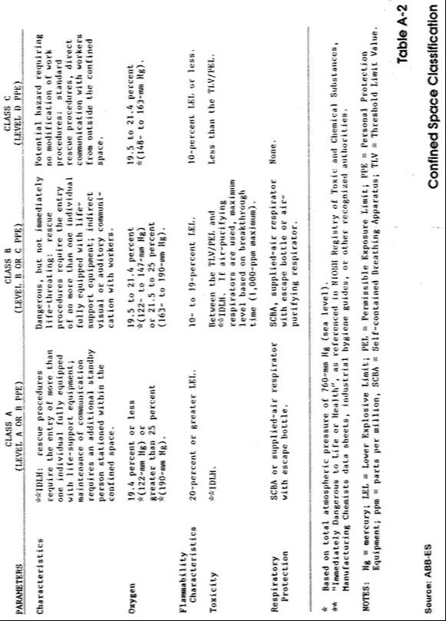

APPENDIX B

EFFECTIVENESS OF PROTECTIVE MATERIALS AGAINST
CHEMICAL DEGRADATION (BY GENERIC CLASS)

EFFECTIVENESS OF PROTECTIVE MATERIALS AGAINST
CHEMICAL DEGRADATION (BY GENERIC CLASS)¹

______________________________________________________________________

Butyl Polyvinyl Natural
Generic Class rubber Chloride Neoprene rubber

Alcohols E E E E

Aldehyde E-G G-F E-G E-F

Amines E-F G-F E-G G-F

Esters G-F P G F-P

Ethers G-F G E-G G-F

Fuels F-P G-P E-G F-P

Halogenated
hydrocarbons G-P G-P G-F F-P

Hydrocarbons F-P F G-F F-P

Inorganic
acids G-F E E-G F-P

Inorganic bases
and salts E E E E

Ketones E P G-F E-F

Natural fats
and oils G-F G E-G G-F

Organic acids E E E E

____________________________________________________________________

¹ E - Excellent F - Fair
G - Good P - Poor

Source: Survey of Personal Protective Clothing and Respiratory Apparatus. DOT, USGS, Office of Research and Development (September 1974).

APPENDIX C

RISK/HAZARD ANALYSIS CALCULATIONS

