Middlesex County
Restoration Center Commission
Year Three Findings and Recommendations



Appendix A

Materials from Meeting April 28, 2020

Middlesex County Restoration Center Commission
Tuesday, April 28, 2020
3 – 5 pm
Virtual – Zoom

AGENDA

3:00PM – 3:05PM Welcome and Introductions
Co-Chairs, Sheriff Koutoujian and Danna Mauch

3:05PM – 3:15PM Legislative Update
Senator Friedman and Representative Gordon

3:15PM – 3:20PM Approval of Minutes from Last Meeting
Co-Chairs, Sheriff Koutoujian and Danna Mauch

3:20PM – 4:45PM Discussion of Consultant Report

4:45PM – 4:55PM SFY 2021 Budget Request

4:55PM – 5:00PM Next Steps and Closing
Co-Chairs, Sheriff Koutoujian and Danna Mauch

Middlesex County Restoration Center
Tuesday, April 28, 2020
3 – 5 pm
Zoom


MINUTES

Attendees: Sheriff Peter J. Koutoujian, co-chair; Danna Mauch, Massachusetts Association for Mental Health, co-chair; Senator Cindy Friedman; Representative Kenneth Gordon; Judge Rosemary Minehan; Nancy Connolly, Department of Mental Health; Jim Cremer (representing Jennifer Barrelle), Department of Public Health; Deirdre Calvert, Bureau of Substance Addiction Services; Mandy Gilman, Association for Behavioral Health; Eliza Williamson, National Alliance on Mental Illness (NAMI) Massachusetts; Tim Burton, NAMI Massachusetts; David Ryan, Middlesex Sheriff’s Office (MSO); Catia Sharp, MSO.

3:00 PM: WELCOME AND INTRODUCTION

Sheriff Koutoujian called the meeting to order and reviewed the agenda.

3:05 PM: LEGISLTIVE UPDATE

Representative Gordon gave a legislative update. The first formal session is coming up on Thursday. People who want to go in person can, but it is discouraged. Otherwise, formal session will vote by phone relay. The budget from the House won’t happen until July, with budget amendments happening after that. Sessions will be streamed internally among members.

3:15 PM: APPROVING THE MINUTES FROM THE LAST MEETING

Sheriff Koutoujian motioned to approve the minutes from the last meeting.

Representative Gordon seconded.

Sheriff Koutoujian asked for all of those in favor, and then all of those opposed. The vote was unanimous in favor of approving the minutes from the last meeting.

3:20 PM: DISCUSSION OF CONSULTANT REPORT

Mandy Gilman asked whether the costs will ramp up, and over what period of time, given the likelihood of a challenging state budget year.

Danna Mauch said that the task was to create an annual operational budget. We can assume a startup budget that is phased in from there.

Catia gave a refresher on the overview of the considerations around geographic regions of the state included in the report.

Danna Mauch talked about putting the restoration center into a region that doesn’t have robust resources.

Sheriff Koutoujian asked the group if they might narrow it down to 2 regions as options.

Danna Mauch thought the group could eliminate one region.

Jim Cremer added that potential bidders will help to pick a specific site – you want the procurement to be more general.

Danna Mauch said that we want to develop selection criteria based on the regions.

Mandy Gilman added that ABH doesn’t have an opinion on the location, but would support a strong relationship with ESP being a major factor in the procurement.

Scott Taberner said that the ESP system must be re-procured in the next couple of years. He suggested the group speak with Dan Tsai at MassHealth in order to not miss any connections to the work they are doing on the broader delivery system. He also thought there would be some value in narrowing down to two regional options, and suggested that Lowell has a lot of appeal with there being significant need in the Merrimack Valley.

Sheriff Koutoujian added that Lowell is the biggest contributor to those incarcerated/detained at the jail.

Judge Minehan added that the Lowell numbers are extremely high from a court perspective as well.

Danna Mauch said she appreciates the need to take a broader approach, and wants to narrow in on the procurement criteria. Danna asked Nancy Connolly and Deirdre Calvert if they had any thoughts on that.

Nancy Connolly said that the Lowell court clinic is overwhelmed, and that the community is clearly underserved and desperately in need of services. Lowell has the highest number of fatal drug overdoses of any drug court in the state. She added that, at this point, DMH is COVID-focused, and they haven’t been able to bring this up internally. She agreed that it would be important to have a discussion with leadership at EOHHS and DMH.

Deirdre Calvert added that overdose data shows that Lowell is an important area to explore. She thought the procurement should emphasize partnership with the ESP/city/etc.

Eliza Williamson said that in general, families that NAMI works with are thrilled to hear about the restoration center and want to know more. She has less to say about a particular geography or region – each identified area has a strong NAMI affiliate organization, which could be an asset. NAMI wants to do what they can to help get funding approved.

Tim Burton added that the decision about where to place the center should be where it has the greatest chance for success. Lowell has the potential to be very successful.

Danna Mauch asked Representative Gordon if he has been hearing from constituents or colleagues about the restoration center.

Representative Gordon responded that the legislature is very interested, as are Middlesex County colleagues. But he emphasized that we are headed into fiscally perilous times. Lowell seems to have a lot of need; the costs are higher in the Southeast part of the county. He sees no particular reason not to focus on Lowell, especially since we might get more for our dollar there.

Danna Mauch asked Sonya Khan if there was anything to add.

Sonya Khan said that the Data-Driven Justice Project is still working on their analyses, and hope to have more to say in the coming months.

Mandy Gilman said that a narrow geography limits the potential bidders for the project, and to keep that in mind.

Danna Mauch said we might not get to the procurement this year due to the budget situation.

Scott Taberner said that would provide more time to work with MassHealth and others to change the ESP program, and align this resource through the re-procurement. Scott recommends seeking an opportunity ASAP to talk to the Commissioners, Secretary, etc.

Danna Mauch said that coming out of COVID, we are going to see even more clearly the need to manage people’s behavioral health outside of jail settings. We have to make diversion from jail a priority.

Sheriff Koutoujian said that the world will be a very different place after this.

Eliza Williamson asked if it was too soon to know if there would be recidivism from COVID?

Sheriff Koutoujian responded that the Middlesex Sheriff’s Office has been decarcerating and is now down to 605 in total population – they haven’t been below 800 in years. They put some people out on bracelets, which is completely within his discretion as Sheriff. Otherwise, the Supreme Judicial Court and the District Attorneys have to change bails and other things to release people. It is too soon to know the effect of this, but he is hearing about people overdosing upon release, which is unfortunate. The biggest challenge is finding placements for people – they are having people assault officers on their way out because they are frightened and agitated about having nowhere to go (maybe their mom doesn’t want to take them in because of the virus, for example). We need to wait to find out how decarceration is affecting people and the public safety of the community.

Nancy Connolly added that the police aren’t looking as hard for Section 35’s because it is harder to get evaluations now.

Sheriff Koutoujian thought there was a commonality of opinion about Lowell as a potential region for a restoration center.

Danna Mauch said that the sense from the group is that Lowell is a priority, but that perhaps the procurement could cast a broader net.

Scott Taberner thought there would be an opportunity to recommend that this resource interact with MassHealth reforms that are ongoing. This is even more important now than we thought a year ago. People are going to be looking for a solution at the legislative and Governor’s levels.

Jim Cremer said that DPH regulations are being looked at as part of a behavioral health redesign process at EOHHS. They are looking at flexibility for ATS and CSS step-down, and looking to align with larger developments in the system.

Mandy Gilman thought that it would not make sense to make administrative and regulatory changes until we know what the program looks like. She warned of overreach.

Danna Mauch asked Catia Sharp to review the transportation proposals.

Catia Sharp reviewed the transportation options from the Advocates report and the pros and cons of each.

Danna Mauch thought we would need a combination of options to do diversion effectively. On the front end, we should be working to minimize the use of police vehicles and ambulances. She thought we might wait to decide on the use of Via to see what the unique needs and preferences are in a particular region.

Scott Taberner said that in Tucson, they continuously emphasized that police are supportive of bringing people to care specifically because of the limited amount of time officers have. Police saw the value in using the center. Would some of the police concern about cruiser dropoff go away if we could prove that this would be a speedy dropoff? There also might be a lack of understanding generally among officers of the potential in a restoration center.

Representative Gordon agreed about Tucson. He said that in the beginning, there was reluctance, but it melted away as they see the no wrong door attitude.

Danna Mauch agreed. She added that the police chief indicated agreement in Arizona with the way the crisis services people were characterizing the relationship. Here, police would need to understand reliability better to get on board.

4:45 PM: SFY 2021 BUDGET REQUEST

Catia Sharp presented three options for budget requests for the next state fiscal year, which were designed to provide our legislative partners with flexibility given the COVID-related fiscal challenges and uncertainty.

Representative Gordon noted that SFY 2022 might also be challenging – we just don’t know yet.

Danna Mauch noted that the Commission can ramp up doing some useful things in the meantime.

Catia Sharp shared that Arnold Ventures has finally released its report on crisis centers, which Sonya Khan was kind enough to share.

5:00 PM: NEXT STEPS AND CLOSING

Danna Mauch thanked everyone for a good meeting, and added that in the midst of a pandemic and a related behavioral health pandemic, she was thankful for what each Commission member is doing to help people in the Commonwealth. The meeting was adjourned.

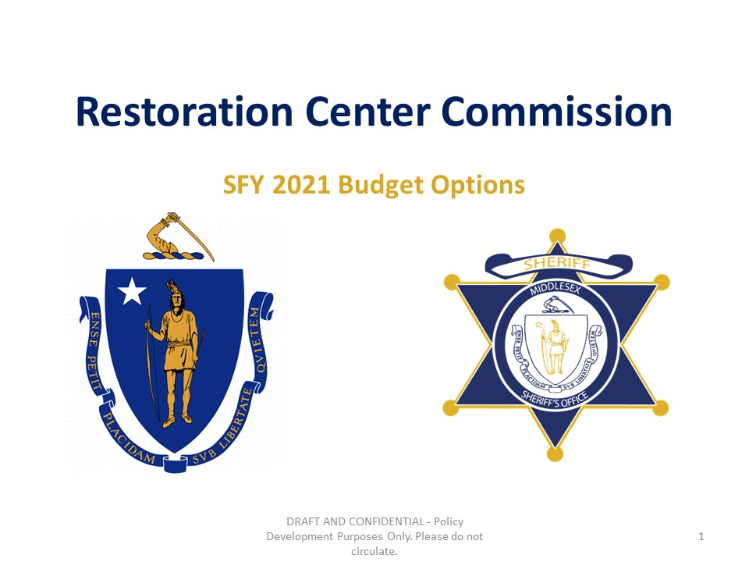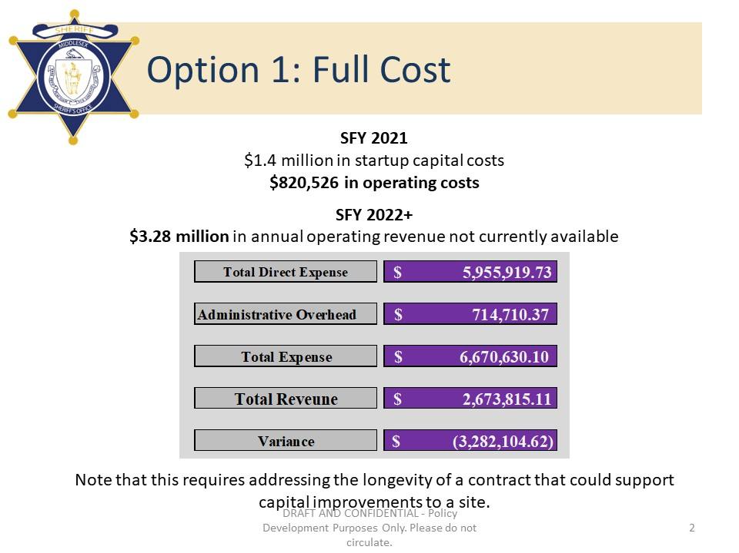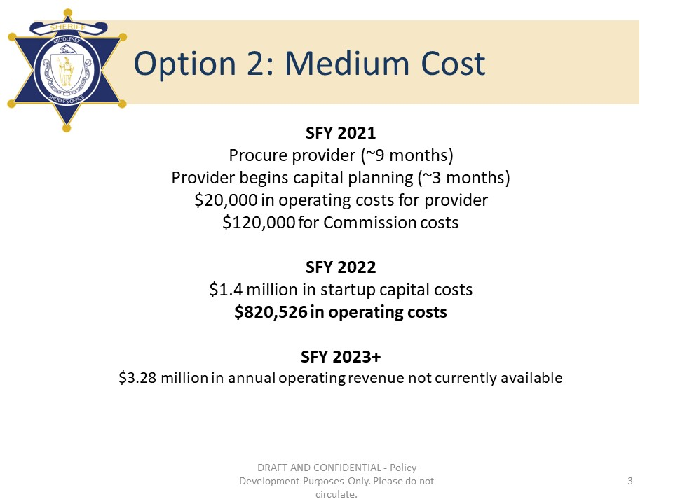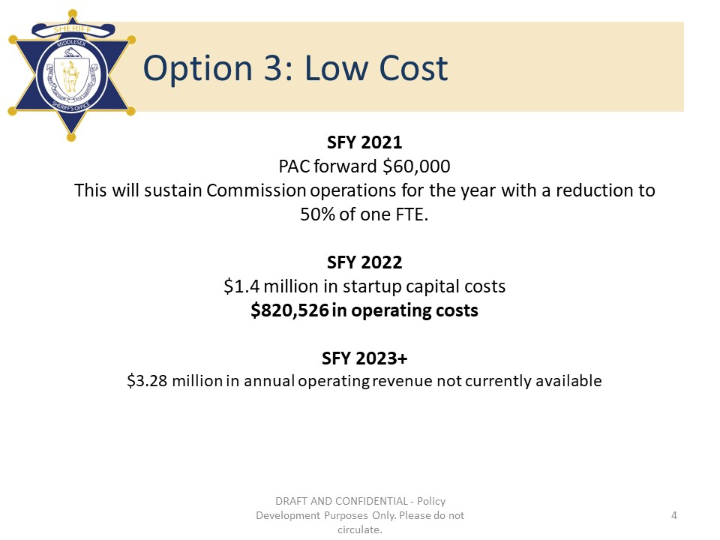
Materials from Meeting September 22, 2020

Middlesex County Restoration Center Commission
Tuesday, September 22, 2020
10 AM – 12 PM
Virtual

AGENDA

10:00AM – 10:05AM Welcome and Introductions
Co-Chairs, Sheriff Koutoujian and Danna Mauch

10:05AM – 10:30AM Legislative and Budget Update
Senator Friedman and Representative Gordon

10:30AM – 10:45AM Approval of Minutes from Last Meeting
Co-Chairs, Sheriff Koutoujian and Danna Mauch

10:45AM – 11:45AM Leveraging Commission Research and Experience to Contribute to the Police and Justice Reform Conversations – Discussion
All Commission members

11:45AM – 12:00PM Next Steps and Closing
Co-Chairs, Sheriff Koutoujian and Danna Mauch

Middlesex County Restoration Center
Tuesday, September 22, 2020
3 – 5 pm
Zoom

MINUTES

Attendees: Sheriff Peter J. Koutoujian, co-chair; Danna Mauch, Massachusetts Association for Mental Health, co-chair; Senator Cindy Friedman; Representative Kenneth Gordon; Judge Minehan; Nancy Connolly, Department of Mental Health; Deirdre Calvert, Bureau of Substance Addiction Services; Lydia Conley, Association for Behavioral Health; Eliza Williamson, National Alliance on Mental Illness (NAMI) Massachusetts; Robert Bongiorno, Chief of Bedford Police Department; Marisa Hebble, Ma Trial Court; Dave Swanson, MA Senate; Cody Case, MA General Court; Catia Sharp, MSO; June Binney, member of the public; Richard Sheola, member of the public.

10:00 AM: WELCOME AND INTRODUCTION

Sheriff Koutoujian called the meeting to order.

10:05 AM: LEGISLTIVE UPDATE

Senator Friedman talked about how hard everyone (the Governor, House, and Senate) is working to minimize the cuts and try to maintain a level budget, including by creatively using the CARES Act money. There are some hopeful signs that this will be doable, but 2022 is expected to be difficult. The goal is to not go into the Stabilization Fund next year, but also not make a contribution either. This was as of a conversation last week. The confidence that there will be more money from the federal government in the next three months is quickly diminishing, but legislators are holding out hope for more stimulus in January. COVID has clearly exacerbated the problem the Commission is trying to solve – CHA has no partial hospitalization programs going on right now; SUD beds are closing. It makes what we are doing that much more important.

Representative Gordon added that this is consistent with what he has heard in the House of Representatives as well.

10:15 AM: APPROVING THE MINUTES FROM THE LAST MEETING

Sheriff Koutoujian motioned to approve the minutes from the last meeting.

Sheriff Koutoujian asked for all of those in favor, and then all of those opposed. The vote was unanimous in favor of approving the minutes from the last meeting.

10:20 AM: PUBLICITY

Sheriff Koutoujian shared that he plans to talk to the Boston Globe editorial board about a story highlighting the ways in which the Restoration Center Commission has been working on solutions to the problem of police dealing with problems that aren’t their job for a while now to promote programs like this as a response to ongoing efforts in police reform.

Danna Mauch added that COVID is hitting these people hard; people who have mental health conditions who are likely to be justice involved are also more likely than the general population to be unhoused, which exacerbates the challenges of COVID. Racial disparities in all three of these areas are stark, and racial justice is a topic of national interest currently. This Commission and the stakeholders at the table here have been talking about the needs of people who are justice-involved for a long time; we have something not only constructive to offer in the current conversations, but that is fact-based, that has some research and analysis behind it. It is worthy of the Commission’s consideration to offer what we have learned to the conversation that is going on. Danna asked “how can we make a helpful contribution to that conversation?”

Senator Friedman thought that was a good point, and asked Nancy and Scott as the representatives of the administration/people who are doing things in a greater context to describe how the administration and people who are doing the work can engage the Restoration Center Commission in a more overt way so that we make those connections in a greater context than only the pilot. Danna is talking about a conversation that is broader than just this commission.

Danna added that one of the things about our “pilot” is that it depends on close collaboration and alignment with a number of other elements in the system. This isn’t stepping outside of our box so much as talking more fully about what we have been looking at. What we have learned would be helpful to others who are now looking at criminal justice and policing reform.

Senator Friedman agreed. What are we doing and how does that fit into whatever else is going on out there. We want to be coordinated, share our contribution, and get feedback too.

Danna added that it’s important for people to know what we have been working on so that they can use it when they are working on things to for example take things off the plates of police that don’t need to be there.

Scott Taberner agreed. We should bring the work of the Commission into bigger things that are going on. During COVID, EOHHS has a concerted effort to work on healthcare and racial equity within MassHealth. MassHealth is now examining all of the initiatives/options that should be included in the 115 waiver that must be re-submitted to CMS in a year. One of the key issues that has been discussed for inclusion would be to use the waiver to increase access and quality of care for persons of color in the state, including how coverage intersects with law enforcement and the criminal justice system. For example, this will include CSP-JI. Also talking about doing in-reach in other ways for services to get around the Medicaid inmate exclusion. Also, can we leverage dollars up-front for diversion? Scott mentioned a related commission that he co-chairs, the policing and behavioral health commission. Scott asked Senator Friedman and Representative Gordon what’s going on with the conference committee for the policing bill? The intersection of this commission and several other major initiatives is something we should be taking on, bringing the right people together.

Sheriff Koutoujain said that COVID was thrown on us so quickly; there is probably no better time than COVID to have engaged in that program [CSP-JI]. We are decarcerating so quickly, which causes a lot of anxiety for people not having community connections. Thought of using that program in a different way at that time because people were going back out on the street with nothing – no mental health services, no substance use services, no housing.

Senator Friedman said this brings up a really important point. What the program is designed to do and what happens on the ground is often very different. It is important for the people designing programs and the people on the ground to be constantly checking in with each other. We always have to going back and forth and making sure that the policy fits the practice, and that the barriers people are facing on the ground are addressed. Senator Friedman thought that next steps should include having Scott, Nancy, Marisa, the people doing the work on the ground present at the next meeting on the 115 waiver, the SIM report, and other ongoing work. Then the Commission can discuss what specific needs are out there that we should address as part of the restoration center. How we can fill gaps, be most effective.

Nancy Connolly responded that, if anything, this COVID crisis has shaken things up and forced us to intensify interagency collaborations because people weren’t being served and they needed to be served right away and it wasn’t clear who was going to serve them. There were many people who were released to homelessness and had never sought services before and became visible for the first time to DMH. Also been dealing with the racial equity issues as well. Marisa’s work on mapping has been important here. Just coming out with research on psychological testing and whether there is racial bias in that – for example, a risk factor of arrest is a history of arrest, but there is racial bias in the arrest history, which artificially bumps up the risk score for people of color. This is a time for reexamining a lot of things. When the courts were shut down, almost none of their programs were going on; but now they are back up to the same numbers as pre-COVID despite the courts not being back to full capacity yet. Interagency services comes into play here to reduce redundancy in services. The criminal justice and behavioral health worlds have never been separate at DMH, but now people are seeing this too. We are identifying a mass of people now who have long been under-served.

Sheriff Koutoujian added that something to watch is whether the people with mental health conditions are still getting stuck even while we massively decarcerate.

Nancy Connolly added that the needs/complexity level is going up with this group – it will be more difficult to design services around people who are more complex.

Sheriff Koutoujian said that his facility had a person who for years was very violent and always hurting people. They can’t send that person to Bridgewater anymore because they don’t want to do restraints or deal with person who is more violent. The person is very complex. Nancy really helped. Thinking about a class action about how these people shouldn’t be in a jail, but need to be in a secure facility.

June Binney raised her hand and said that as jail populations decrease, the percentages of people with mental health conditions increase – we know this across jurisdictions around the country. She offered to connect the Commission with presenters on new ESP-like crisis services in NYC, as well as their 2 restoration centers, the health homes, their work to decarcerate and close Rikers Island as well (all of this is interrelated).

Danna Mauch noted that program capacity that has been lost because of health requirements due to social distancing, and asked Deirdre Calvert what she has been seeing at DPH.

Deirdre Calvert responded that they have tried to keep all programs open, but they have to reduce by 50% because of public health requirements plus the added cost of PPE and cleaning and sick time. Telehealth flexibility has been a life saver. Flexibility around OTPs and their ability to distribute methadone in higher quantities, allowing people to take home 30 days worth, have been a life saver to help ensure people don’t have to stand in line every day. Many OTPs didn’t exercise the flexibility to its fullest extent unfortunately – aren’t letting people they consider “unstable” to take home, which is causing problems in Melnea Cass area. Worried about increases in alcohol use – seen an increase in number of people contemplating treatment for alcohol use.

Lydia Conley added that, depending on the service modality, their members have had a slightly different experience. SOAP has huge variability in whether those programs have been able to open. Some are open with reduced capacity; some are closed. Variability in whether telehealth has been working for them.

Deirdre Calvert said that there is telehealth inequality: people can’t go to support meetings who don’t have good internet. AA/NA are anonymous so can’t use technology.

Marisa Hebble said that she had heard that providers are seeing decreases in missed appointments because of telehealth

Deirdre Calvert said that no-show rates have gone down to 5% in some cases, especially for methadone at OTPs (don’t have to take 3 buses and leave your kids everyday to get it). But there is variability between people, programs, and services.

Danna Mauch added that even though we have reduced no-show rates and more participation in OP treatment, for those people who need more structure or need services that are more challenged due to COVID, she speculates that is feeding the uptick in presentations to the court for evaluations. What are the police seeing in terms of calls for help? Without support and structure around these programs it is hard to keep up the heroics of the telehealth and workarounds – leads to more pressure on criminal justice and public safety.

Senator Friedman said she hears about the tenuousness of these programs. What could we be doing to shore up those programs over the next year? What are some concrete things? Our reason for being here is to stop people from going to jail in the first place. We really want to focus on stopping that pipeline. What are our next steps? What should we be focused on in the short-term? At some point it would be great to talk to NY and find out how their restoration centers are going and what’s working/what’s not.

Sheriff Koutoujian responded that the first next step is an op-ed with Globe editorial board. The Sheriff apologized, and said he needed to step off the call.

Dann Mauch welcomed judge Minehan, who joined the meeting late. She then suggested that a few of the members can put together updates for the committee and structure the agenda so we can make recommendations on some actions. What time frame would be most helpful for the legislative side? What are the time frames inside the administration? Map the agenda accordingly.

Scott Taberner said that preparation for the 115 waiver renewal development is happening this fall. Within the next month/month and a half, MassHealth will be issuing a roadmap for the 5 year waiver. The opportunity for input into that process will be a series of meetings across the state. Scott welcomed the opportunity to sit down with a small group and try to capture many of the topics we have discussed here and see if we could weave together a proposal for the waiver. Scott said he is working with BSAS to see if BH-JI can take on an MAT component, and proposed a small group and come up with the handful of major initiatives that are going on and how this fits in. Chief Bongiorno and some of the police agencies we are working with have a very enlightened view of how to use these services.

Senator Friedman said she is interested in having a general roadmap/conversation about where the largest pieces are in MassHealth, the courts, how that can inform what we do next.

Danna asked Chief Bongiorno if he had additional items to add to the agenda.

Chief Bongiorno added that calls for service are down about 1,000, but when we look at key metrics, domestic calls and mental health calls are all up dramatically. Restraining orders and noise complaints are also up. Complexity and needs for services are doing up.

Nancy Connolly asked why is the complexity going up? Is it a failure of the system, or is it a success of the interventions that we are having that we are able to better identify people? For example, having a jail diversion coordinator helps to better identify people. Has the system failed us, or are we getting better at identifying people?

Danna Mauch responded that these people have always been there, but the pandemic has thrown it into stark relief because of the need to de-congregate things. It presents an opportunity to re-assess people’s needs.

Senator Friedman noted that these are good questions to keep in our minds as we look at what services are needed. She also suggested saving the NY presentation until the meeting after next in order to prioritize hearing about the MassHealth work and other local work to inform the budget.

Scott Taberner asked where the police reform bill stands.

Senator Friedman said that can’t tell us where it is in conference.

Scott responded that he is anxiously awaiting news on this because it is so relevant to this discussion.

Catia Sharp mentioned that telehealth successes and challenges can be another topic for discussion at the next Commission meeting.

Deirdre Calvert said that DPS is doing a survey that she can tell us more about.

Nancy Connolly also offered to join.

Danna Mauch asked how the meeting schedule should look going forward.

Catia Sharp proposed going back to monthly meetings.

There was unanimous agreement to do so.

12:00 PM: NEXT STEPS AND CLOSING

Danna Mauch took a motion to adjourn; the group voted unanimously to adjourn.


Restoration Center Commission Brief

The summer of 2020 has brought deep reflection and opportunity for action on a fundamental problem: too many people are not well served by our health and social services systems, and as a result interact with police, often with harmful outcomes like institutionalization and physical harm or even death.

The Middlesex County Restoration Center Commission was created in S. 225 of Chapter 69 of the Acts of 2018, “An Act Relative to Criminal Justice Reform” to divert people with mental health and substance use conditions from arrest and/or unnecessary hospitalization. The goal is to invest in social services to prevent unnecessary law enforcement interactions.

The Commission is co-chaired by Danna Mauch, President and CEO of the Massachusetts Association for Mental Health, and Middlesex Sheriff Peter Koutoujian. Representation on the Commission comes from mental health stakeholders like the Association for Behavioral Healthcare and the National Alliance on Mental Illness of Massachusetts; relevant government agencies like MassHealth, the Department of Mental Health, and the Bureau of Substance Addiction Services; criminal justice entities, like a police chief and a judge with deep knowledge of the mental health commitment laws; and legislators Senator Cindy Friedman and Representative Ken Gordon.

In its first year, the Commission reviewed the mental health system and the criminal justice diversion programs that exist in Middlesex County and produced a report containing a gaps analysis. The report found that people with mental health and substance use conditions (collectively referred to as “behavioral health conditions”) are disproportionately involved with the criminal justice system, caused in part by underinvestment in behavioral health and social services and a lack of a coordinated system for diversion from the criminal justice system. Insufficient mental health and substance use treatment and conditions of poverty and homelessness leave individuals and their families desperately seeking care through a last resort: 911. They found that a restoration center could provide behavioral health urgent care and related social services programming that could prevent criminalization of people with social service needs.

In its second year, the Commission contracted a behavioral health provider organization to develop a service model and budget for a restoration center in Middlesex County, which it published in its second annual report. The model includes: a sober support unit, which can provide short-term detoxification and real-time linkage into the substance use treatment continuum; crisis stabilization services to provide urgent psychiatric support; respite, which provides a medically-monitored place to stay while explicitly planning for follow-up housing and healthcare arrangements; and social services navigation and placement to ensure that people using the center have a coordinated plan for the future that can prevent future police involvement.

The model proposed in the report is estimated to cost $3.28 million annually to operate. In state fiscal year 2021, the Commission seeks $140,000 in funding for planning purposes. The Commission’s Year One Findings and Recommendations also include related recommendations that would help further the goal of social service investments as an alternative to criminal justice systems, like commercial coverage of Emergency Services Providers.

Materials from Meeting October 20, 2020

Middlesex County Restoration Center Commission
Tuesday, October 20, 2020
3:30 PM – 5 PM
Virtual

AGENDA

3:30PM – 3:35PM Welcome and Introductions
Co-Chairs, Sheriff Koutoujian and Danna Mauch

3:35PM – 3:45PM Legislative and Budget Update
Senator Friedman and Representative Gordon

3:45PM – 3:50PM Approval of Minutes from Last Meeting
Co-Chairs, Sheriff Koutoujian and Danna Mauch

3:50PM – 3:55PM Media Update
Sheriff Koutoujian

3:55PM – 4:25PM Massachusetts 1115 Waiver Update
Scott Taberner

4:25PM – 4:55PM Massachusetts Telehealth Successes and Challenges Discussion
Deirdre Calvert, Lydia Conly, Nancy Connolly

4:55PM – 5:00PM Next Steps and Closing
Co-Chairs, Sheriff Koutoujian and Danna Mauch

Middlesex County Restoration Center
Tuesday, October 20, 2020
3:30 – 5 pm
Zoom
MINUTES

Attendees: Sheriff Peter J. Koutoujian, co-chair; Danna Mauch, Massachusetts Association for Mental Health, co-chair; Representative Kenneth Gordon; Judge Minehan; Nancy Connolly, Department of Mental Health; Deirdre Calvert, Bureau of Substance Addiction Services; Lydia Conley, Association for Behavioral Health Scott Taberner, MassHealth; Marisa Hebble, MA Trial Court; Dave Ryan, MSO; Catia Sharp, MAMH; June Binney, member of the public; Richard Sheola, member of the public; Sarah Waldron, member of the public.

3:30 PM: WELCOME AND INTRODUCTION

Sheriff Koutoujian called the meeting to order.

3:35 PM: LEGISLTIVE UPDATE

Senator Friedman could not attend the meeting.

Danna Mauch noted that the state fiscal year 2021 budget is now under consideration by the legislature and reminded Commissioners about the budget proposal that the Commission discussed earlier this year.

Representative Gordon said that he has advocated for the $140,000 option to House Ways and Means. The House expects to consolidate a full season of budget negotiations into a few weeks, which might mean more of a unified approach where House and Senate budgets are developed on collaboration rather than as a way to establish negotiating positions.

June Binney, member of the public, asked if the Commission will be weighing in on policing reform, given the conference committee that is reviewing House and Senate versions of a police reform bill.

Sheriff Koutoujian responded that the mission of the Commission is to look at a Restoration Center, and that as a body we probably should not be advocating on police reform.

June Binney responded that the Commission is so far advanced in terms of what the state is doing that it could be establishing the blueprint for emergency response to social service needs. It would behoove the Commission be a leader in this space. The Restoration Center is inextricably linked to how policing works.

Sheriff Koutoujian suggested that he could talk to Cindy Friedman about this.

Ken Gordon added that the police reform bill is already in conference committee, so the current legislation has to stay within the parameters of the Senate and House bills going into conference committee.

June Binney added that it is hard to tell from the press what the remaining issues are and what are the specifics that are holding up the bills.

Ken Gordon noted the limited mission of the Commission, which might not make sense to advocate on that bill.

Sheriff Koutoujian added that his understanding is that behavioral health components of the bills are not the point of contention between the House and Senate versions of the police reform bill.

3:45 PM: APPROVING THE MINUTES FROM THE LAST MEETING

Sheriff Koutoujian mentioned that Catia Sharp sent out the minutes from last meeting.

Catia Sharp introduced members of the public in attendance who have never attended before. Sarah Waldron works for Eliot Human Services at the Medford courthouse on behavioral health diversion and is working to reduce Section 35s.

Sheriff Koutoujian motioned to approve the minutes from the last meeting. Under the auspices of new guidance for virtual public meetings in light of COVID-19, a roll call vote was taken. Results of the roll call vote are as follows:

Sheriff Koutoujian: yes
Danna Mauch: yes
Representative Gordon: yes
Judge Minehan: yes
Scott Taberner: yes
Deirdre Calvert: yes
Nancy Connolly: yes
Lydia Conley: yes

3:50 PM: MEDIA UPDATE

Sheriff Koutoujian shared that he had a Zoom call with members of the Boston Globe editorial board. He and Danna will have a meeting with them soon about the Restoration Center.

June Binney, member of the public, told the Commission about conversations she has had with the sister of Juston Root, who is also talking to the Globe editorial board. Her family’s story highlights the need to keep people healthy and safe in the community before they get to the point of crisis like Juston Root. The Restoration Center is one of the solutions to this.

Eliza Williamson noted that NAMI has also been meeting with her. The case is complicated in a number of ways and using Juston’s case as an example of someone who could have been diverted using a Restoration Center is complicated because he did have a weapon, even if it was a BB gun. We should consider that when we think about using certain people’s experiences to elevate the need for a Restoration Center.

3:55 PM: TELEHEALTH

Sheriff Koutoujian noted that we will be swapping the order of the next two agenda items because of some presenter’s need to get to another meeting.

Sheriff Koutoujian said that the jail is doing some telehealth. He then handed the floor over to Lydia Conley from the Association for Behavioral Healthcare.

Lydia Conley shared preliminary data from an ABH telehealth survey. Members had served ~57,000 individuals via telehealth. Most cannot tell based on current recordkeeping whether telehealth services were rendered telephonically or using video, but of those who did collect that information, 50% were audio and 50% were video. No-shows were reduced by 25.8%. Wait time went from 34 days to 22 days (36% reduction in wait time). Access gains for individuals who speak a language other than English went from 43 days to 20 days (50% reduction in wait times).

Deirdre Calvert said that the BSAS telehealth survey went out yesterday. The most important thing that BSAS is looking at is the implementation of the federal waiver which allows buprenorphine to be prescribed by phone, as well as telehealth more broadly. BSAS provided telephones and data services to many OBOTs to ensure that telehealth was happening. BSAS is hearing anecdotally that no-show rates went down with the implementation of telehealth (one particular provider had their no-show rate go down to 5% at one point). Deirdre opined that telehealth not a panacea but certainly has increased access for parents who have to stay home with kids, those who struggle with transportation, etc.

Nancy Connolly stepped in to talk about some challenges in implementing telehealth that she has seen. DMH court clinics have implemented teleconferencing during the pandemic, and Nancy reported that it has been a massive uphill battle to get minimally adequate services for court-based mental health evaluations. Nancy stated that in-person evaluations/assessments are best, and video is much better than audio in terms of the quality of the evaluation since body language is important in behavioral health. Video is also the most challenging method of telehealth to implement because you need hardware and software on both sides. Many evaluations were being done by telephone for a while at the court clinics as well, which is according to Nancy completely inadequate for this purpose – “it’s not clinically sound to do initial interviews not in person for this purpose.” Video is adequate in Nancy’s opinion for the most part, but a telephone interview is not. The problem is that people’s liberty is at stake because court clinic assessments are used to commit people to the hospital against their will. The best video conferencing experience that court clinics have had is for people housed in jail settings using video. You need staff on both sides of the screen to make it work well. Privacy is also a concern, because you do not know who is in the house with the person.

Sheriff Koutoujian though it was very helpful to understand the challenges related to telehealth. In the jail, there are a lot of staff around which helps to get the session up and running and functional (to the point about needing staff on both sides of the screen to be successful). Sheriff Koutoujian said he would check what makes a productive telehealth engagement work in the jail.

Nancy Connolly said you need clinical people present, but you also want to reduce other people being there for privacy reasons. But if telehealth can reduce the need for transportation, it is good.

Sheriff Koutoujian said that we should be factoring in the extra body or two that need to be there as part of the cost of the telehealth call.

Nancy Connolly added that it is not in anybody’s job description to sit through a clinical interview currently.

Deirdre Calvert noted that there is a difference between Section 35 assessments, where people’s liberty is at stake, and an OTP where the telehealth engagement can help people keep up with the program from home. Telephonic telehealth is never going to be the preferred method over in-person or video-based, but it can expand access to critically needed services like MAT.

Marisa Hebble asked Deirdre if anything will be changing with take-home methadone going forward?

Deirdre Calvert responded that she was not aware of any impending changes. She explained that the federal government expanded the ability of providers to send methadone home with people during COVID who were previously considered too unsafe for take-home. BSAS providers went up to 52% multiple-day methadone take-home. They are seeing that people are more responsive to clinical conversations and keeping up with it better.

Sheriff Koutoujian added that he is in touch with the acting director of DEA, and that SAMHSA is also involved in regulating MAT. If there are other ways to continue the discussion with DEA and/or SAMHSA, the Sheriff would like to know in order to pursue those options. He added that he recently received interesting information about Portugal’s complete legalization, where they have mobile vans doing methadone. He said this fit into people’s lives rather than them needing to fit into the methadone system.

Deirdre Calvert said that methadone treatment has not been changed in 40 years. There is no thought to the psycho-social parts of treatment, even though MAT is an evidence-based program. The Sheriff is correct that the waiver she mentioned earlier is through SAMHSA in conjunction with the DEA. SAMHSA has been clear that relaxing methadone restrictions requires federal law changes to allow for this (expanded take-home prescriptions of methadone) long-term. We have had less illicit substance use in Massachusetts during the pandemic, and we have had NO overdoses with this program. We have had a very small number of people need to have their take home allowance reversed. We find that when you treat people like adults, they behave like adults most of the time.

Sheriff Koutoujian asked Deirdre to talk more about this on the law enforcement side. How do you know illicit substance use is down?

Deirdre Calvert said that BSAS providers still call people in for tox screens randomly through the methadone programs.

Scott Taberner asked how should we think about these successes/challenges in the context of the Advocates model for a Restoration Center documented in the Commission’s Year Two Report?

Judge Minehan added that what Nancy is talking about is a real issue: in the courts, people end up committed because a judge put them there. That is a significant curtailment of their liberty. Judge Minehan noted that it is one thing for telehealth to help you keep up with your methadone. Modifying court processes is harder.

Catia Sharp said she would share a set of guided questions with Commission members to chew on before next meeting to Scott’s point of thinking about telehealth successes and challenges in the context of our proposed Restoration Center model.

4:25 PM: 1115 WAIVER UPDATE

Scott Taberner discussed the basic structure of the state’s work to design its 1115 waiver update, which is due to the federal government next year. He described the problem statement as being in alignment with the Restoration Center Commission mission. BH-JI is ongoing and is one part of the answer to that problem statement. A procurement to expand BH-JI statewide will go out later this year, with services beginning in FY22. The 1115 waiver could allow MassHealth to expand our ability to collect FMAP for the community services component of this, but not for the in-reach component (because of the Medicaid Inmate Exclusion Policy (MIEP)). Deirdre from BSAS is also working with MassHealth and the Sheriffs to expand MAT to HOCs – up to 9 HOCs. A key target population for this 1115 waiver update is the justice-involved population with behavioral health needs. MassHealth is looking to improve eligibility and plan enrollment for individuals who are in state and county correctional facilities. Third, MassHealth is looking at an MIEP exemption to help coordinate care better, reduce costs, improve billing, and improve outcomes. Two states have done preliminary efforts to put something like this in front of CMS, but it is only for the last 30 days of an incarceration. CMS has not approved these yet, but indications are that they are open to this even under the Trump administration. EOHHS is looking at options for this that go beyond the 30 days, but conversations are still very preliminary. Scott specifically thanked Sheriff Koutoujian and others on the Commission for their support of and engagement in these efforts – the process would not be possible nor successful without it.

Sheriff Koutoujian proposed that the Commission have a further discussion when we have more information, and asked Scott to please keep us updated.

Scott Taberner underscored the importance of the partnerships between corrections and healthcare to get this done and noted that the Restoration Center model should be an adjacent piece of the puzzle.

Danna Mauch commented that the EOHHS criminal justice initiative is a tremendous piece of work and noted that several people on the Commission have worked hard on this, so congratulations to them. She added that the ambulatory care redesign roadmap is coming out soon, and she has been doing her best to keep the Restoration Center in that conversation, as well as the conversation about the 1115 waiver update and MassHealth services to justice-involved people.

Marisa Hebble asked who are the two other states?

Scott Taberner responded that the other two states who proposed MIEP exclusions are New York and Utah, but it is a little bit clouded where their applications sit and what level of approval they have received.

Sheriff Koutoujian asked what are the next steps?

Scott Taberner said that he will be talking to Carrie Hill and Andy Peck about this soon. He wants to get Sheriff Koutoujian and Secretaries Turco and Sudders together to discuss this list of priorities. He wants to accomplish that before Thanksgiving.

4:55 PM: NEXT STEPS AND CLOSING

Danna Mauch thanked everyone for another very productive meeting. She asked Commission members and observers to stay tuned in and engaged in the next few weeks on budget advocacy, because the people we serve have a lot at stake.

Sheriff Koutoujian adjourned the meeting.

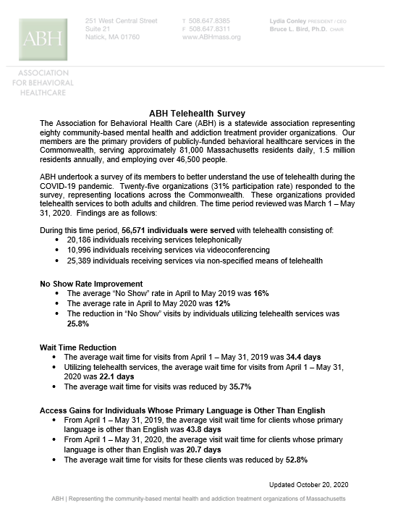

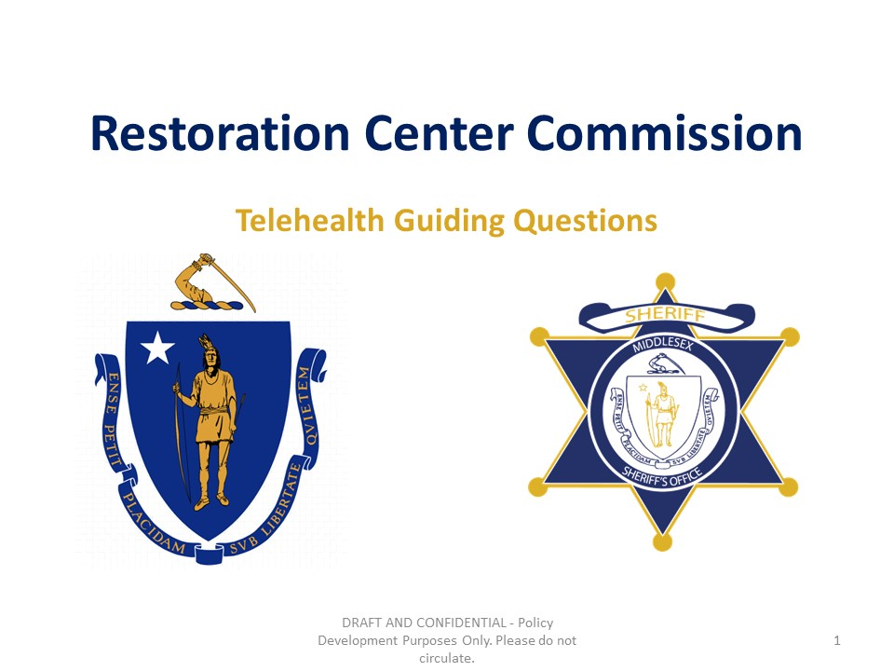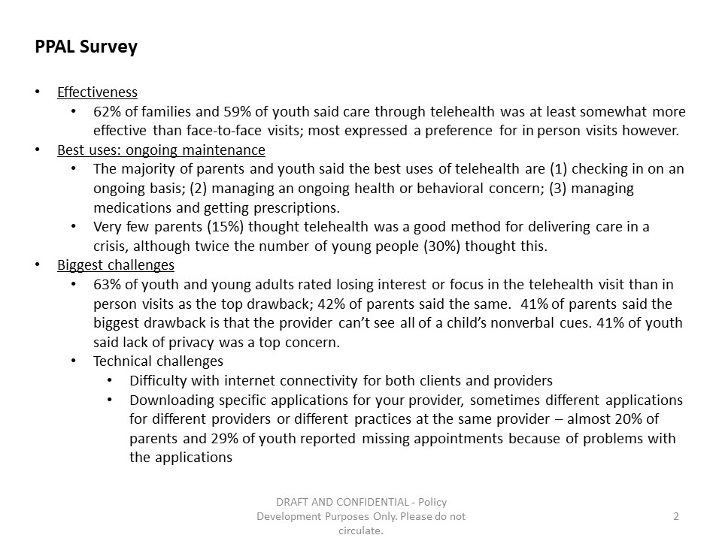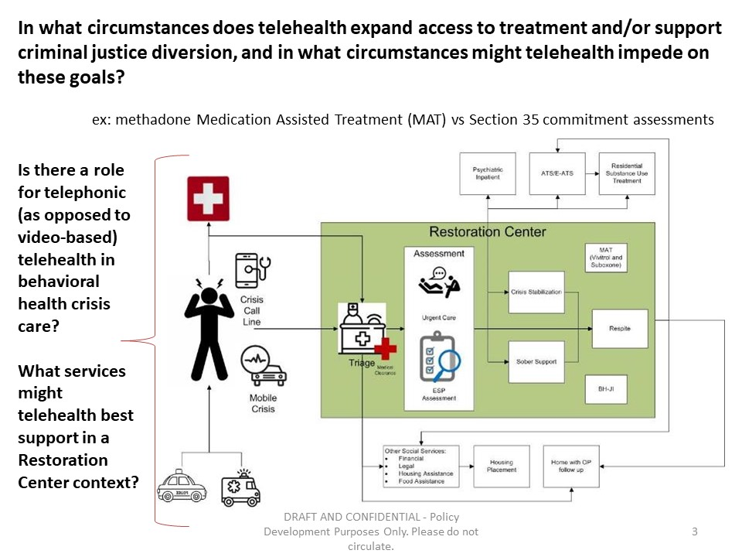

Materials from Meeting December 17, 2020

Middlesex County Restoration Center Commission
Thursday, December 17, 2020
10:00 AM – 11:30 PM
Virtual

AGENDA

10:00AM – 10:05AM Welcome and Introductions
Co-Chairs, Sheriff Koutoujian and Danna Mauch

10:05AM – 10:10AM Legislative and Budget Update
Senator Friedman and Representative Gordon

10:10AM – 10:15AM Approval of Minutes from Last Meeting
Co-Chairs, Sheriff Koutoujian and Danna Mauch

10:15AM – 10:20AM Media Update
Sheriff Koutoujian

10:20AM – 10:50AM Update on Sequential Intercept Mapping
Marisa Hebble

10:50AM – 11:15AM Massachusetts 1115 Waiver Update
Scott Taberner

11:15AM – 11:25AM Brief Plan for FY21
Co-Chairs, Sheriff Koutoujian and Danna Mauch

11:25AM – 11:30AM Next Steps and Closing
Co-Chairs, Sheriff Koutoujian and Danna Mauch

Middlesex County Restoration Center
Thursday, December 17, 2020
10:00 – 11:30 am
Zoom
MINUTES

Attendees: Sheriff Peter J. Koutoujian, co-chair; Danna Mauch, Massachusetts Association for Mental Health, co-chair; Judge Minehan; Chief Robert Bongiorno, Bedford Police Department; Nancy Connolly, Department of Mental Health; Deirdre Calvert, Bureau of Substance Addiction Services; Scott Taberner, MassHealth; Marisa Hebble, MA Trial Court; Dave Ryan, MSO; Catia Sharp, MAMH; June Binney, member of the public; Richard Sheola, member of the public; Danielle Allen, member of the public.

10:00 AM: WELCOME AND INTRODUCTION

Sheriff Koutoujian called the meeting to order.

10:05 AM: LEGISLATIVE AND BUDGET UPDATE

Representative Gordon could not attend the meeting.

Senator Friedman noted that the final SFY2021 budget passed, and included $250,000 for the Restoration Center Commission.

10:10 AM: APPROVING THE MINUTES FROM THE LAST MEETING

Sheriff Koutoujian motioned to approve the minutes from the last meeting. The vote was unanimous in favor of approving the minutes.

10:15 AM: MEDIA UPDATE

Sheriff Koutoujian shared that he, Danna, and Senator Friedman had a meeting with the Globe Editorial Board to talk about the Restoration Center work. The Board was very interested in the topic and asked for the Commission to keep them appraised of any current events that would be supported by a timely article in the future.

10:20 AM: UPDATE ON SEQUENTIAL INTERCEPT MAPPING

Marisa Hebble provided a presentation updating the Commission on the status of the Massachusetts Community Justice Project using a powerpoint presentation. There have been 29 workshops to date, encompassing 155 cities, towns and neighborhoods. Below are some interesting cross-workshop conclusions from the data:

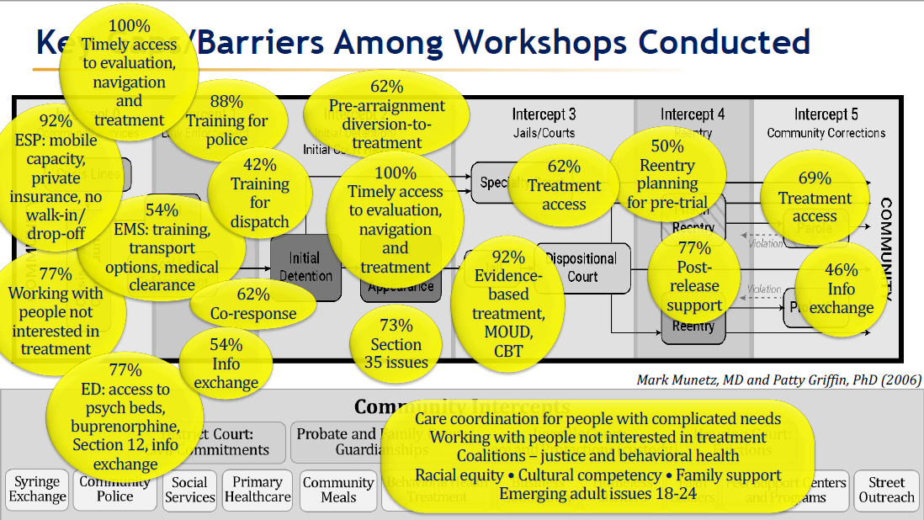

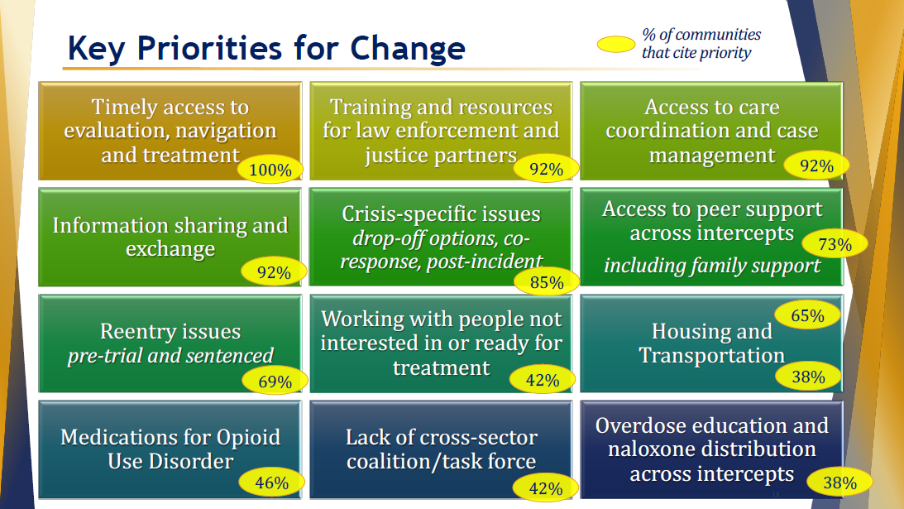

The primary challenge that communities cited post-workshop is finding champions to move key outcomes of the workshops forward.

Looking ahead, the Trial Court is currently planning three workshops tailored to specific target populations: child welfare, commercial sexual exploitation, and perinatal. Marisa also noted additional interesting work being done at the Trial Court, including the in-development Supreme Judicial Court Standards on Substance Use and Mental Health, which will be issued this spring; and Project NORTH (Navigation Outreach Recovery Treatment and Hope) to provide recovery support navigation, transportation, sober housing support, and virtual support.

Senator Friedman noted that this work is very important and is very informative to the work of the Commission.

Danielle Allen, community member, asked whether the Restoration Center Commission has been looking into the use of the Police-Assisted Addiction and Recovery Initiative (PAARI) and whether the Center will work with such programs.

Danna Mauch responded that the Commission is aware of PAARI programs and documented the police departments in Middlesex County who participate in its Year One Findings and Recommendations report. She noted the importance of such programs to divert individuals with substance use conditions away from police involvement and jail.

10:50 AM: MASSACHUSETTS 1115 WAIVER UPDATE

Scott Taberner provided more detail on the Massachusetts 1115 waiver update, including the choice to maximize the number of prisoners who might benefit from scaling back the Medicaid Inmate Exclusion Policy (MIEP).

11:15 AM: BRIEF PLAN FOR FY21

Sheriff Koutoujian asked Catia Sharp to briefly review the work plan for FY21, now that the state budget has been signed.

Catia Sharp reviewed the following components of the FY21 work plan, to be completed by a contracted provider entity:
- Selecting a site and capital planning
- Developing a hiring plan to ramp up services in FY22
- Work with DMH, DPH, and MassHealth to nail down licensure and leverage existing funding streams like respite and CSS, including taking into account 1115 waiver renewal development and EOHHS Roadmap to Reform
- Search for non-state sources of funds, including federal funds and private charitable sources
- Develop any subcontractors or contractual relationships with other providers, including other ESPs and outpatient providers, as needed
- Develop transportation services
- Work with Restoration Center Commission staff to identify a FY22 launch plan with an expected $250,000 budget
- Refine the budget produced in Year 2 taking into account the above listed work

11:25 AM: NEXT STEPS AND CLOSING

Danna Mauch thanked everyone for another very productive meeting.

Sheriff Koutoujian adjourned the meeting.

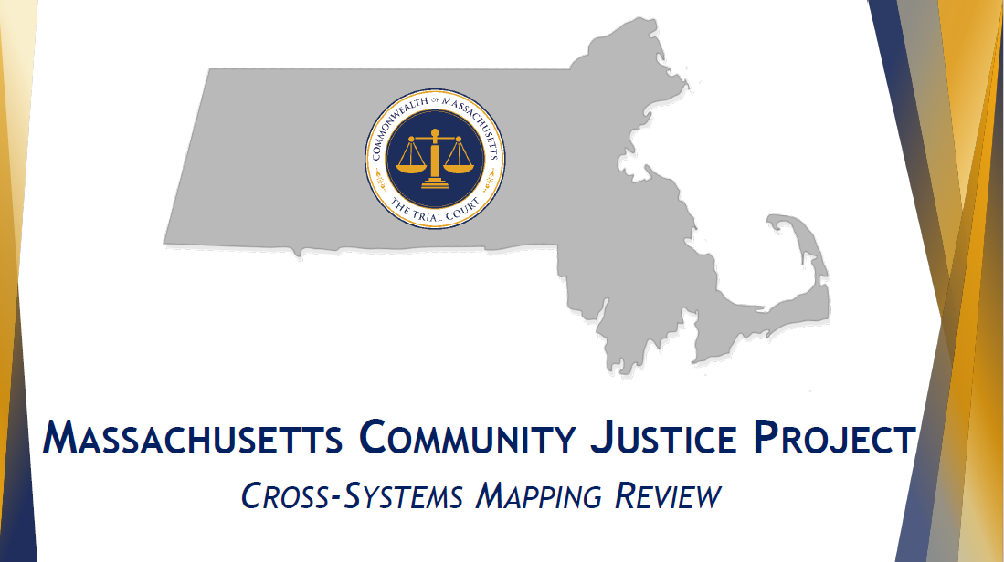

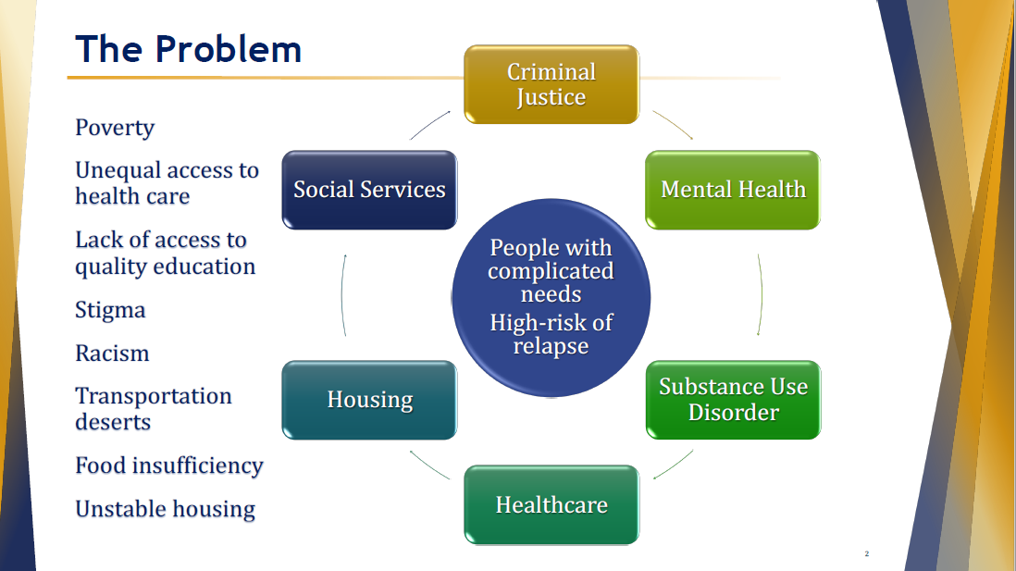

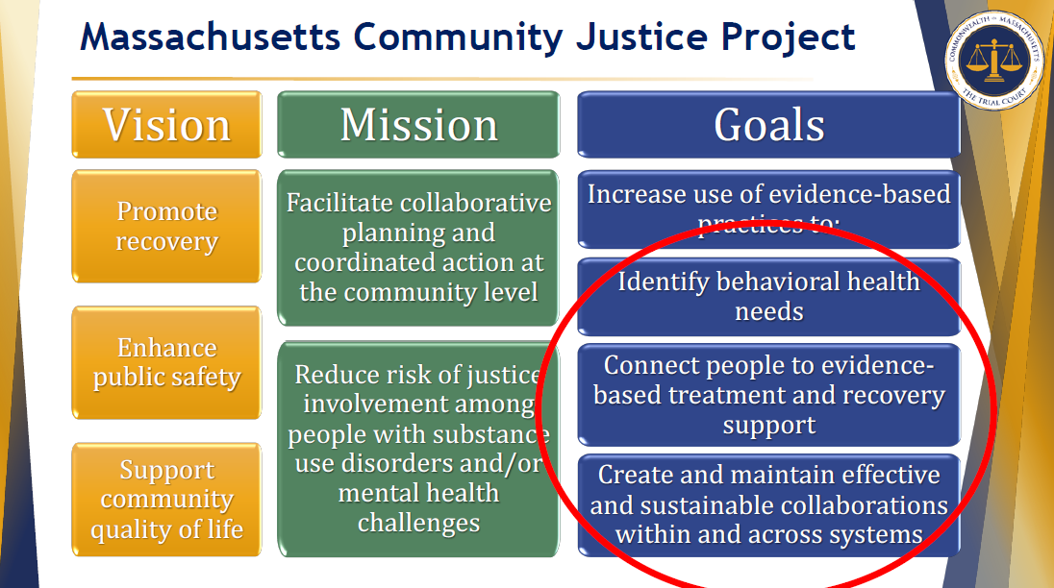

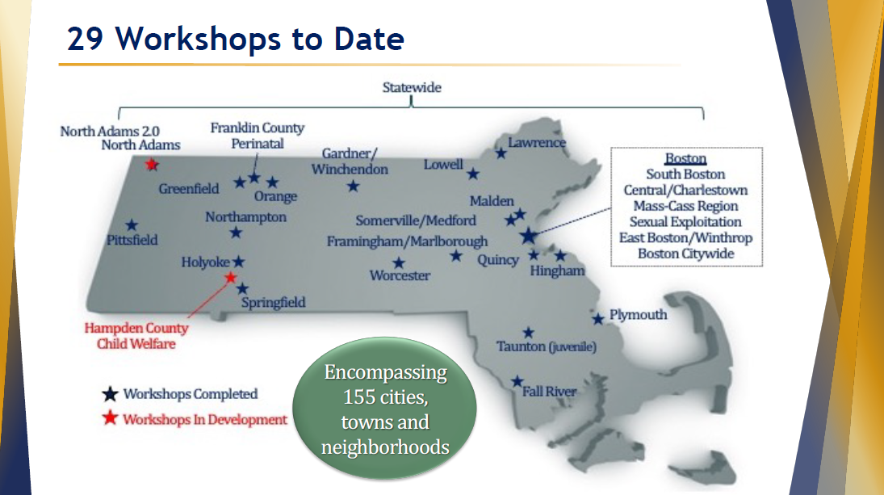

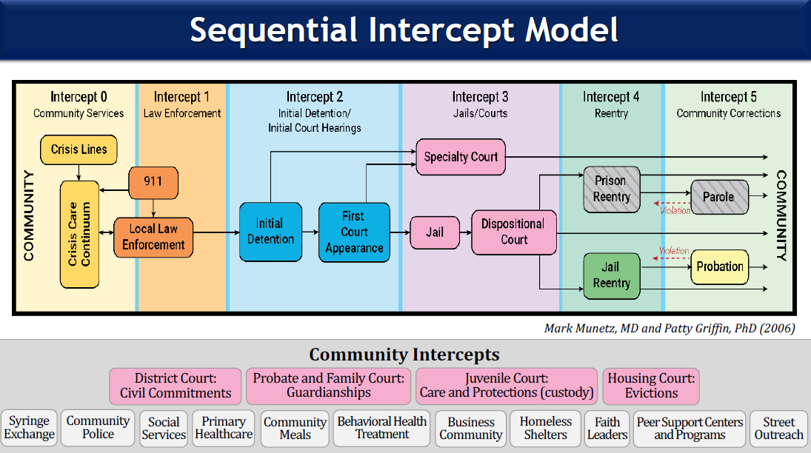

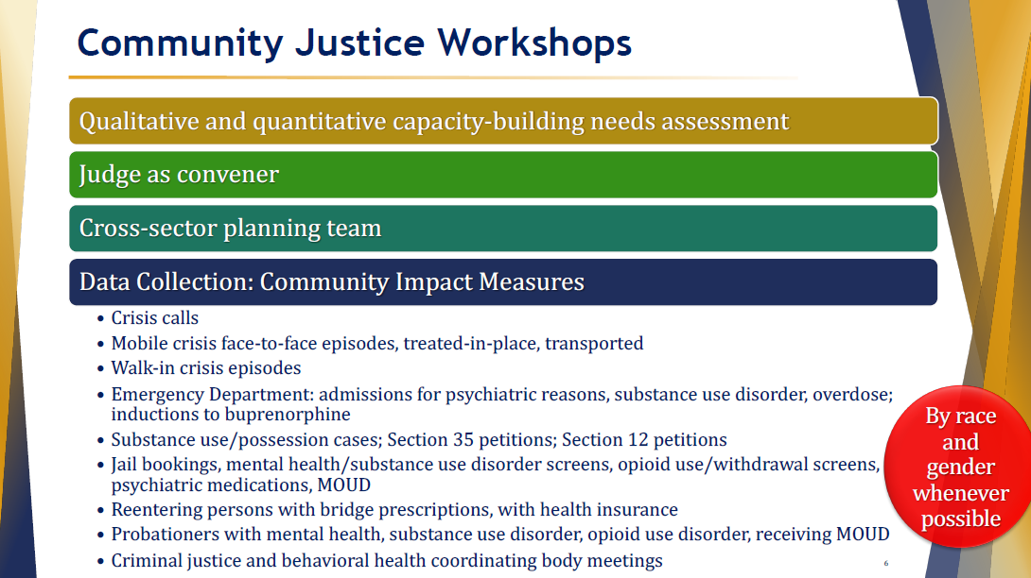

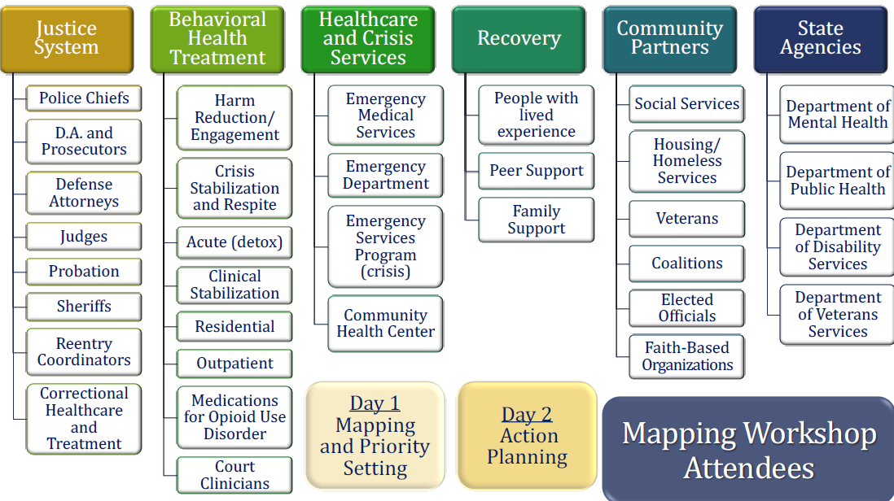

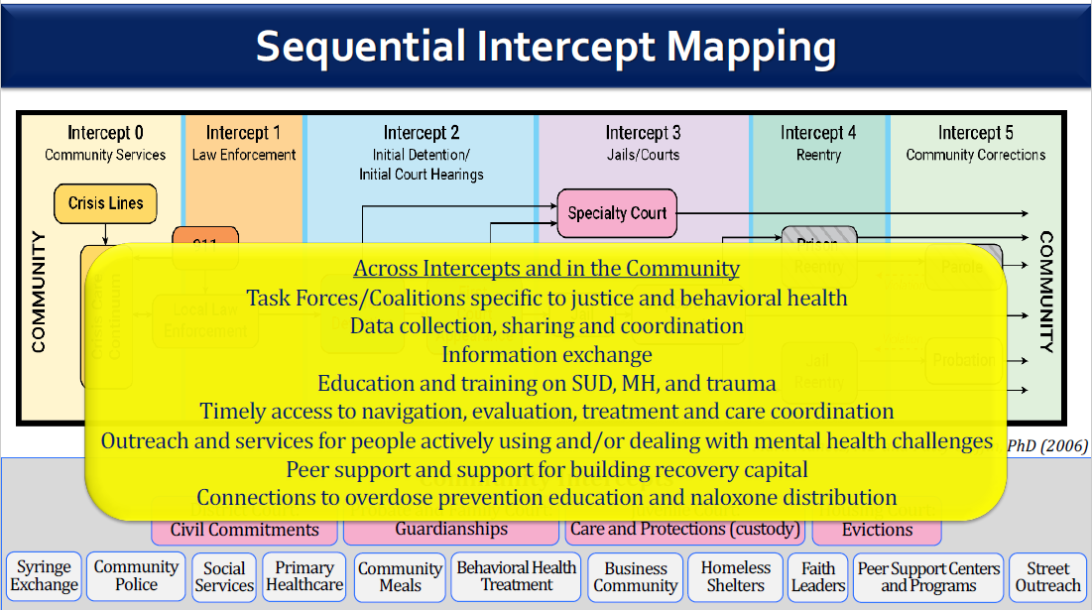

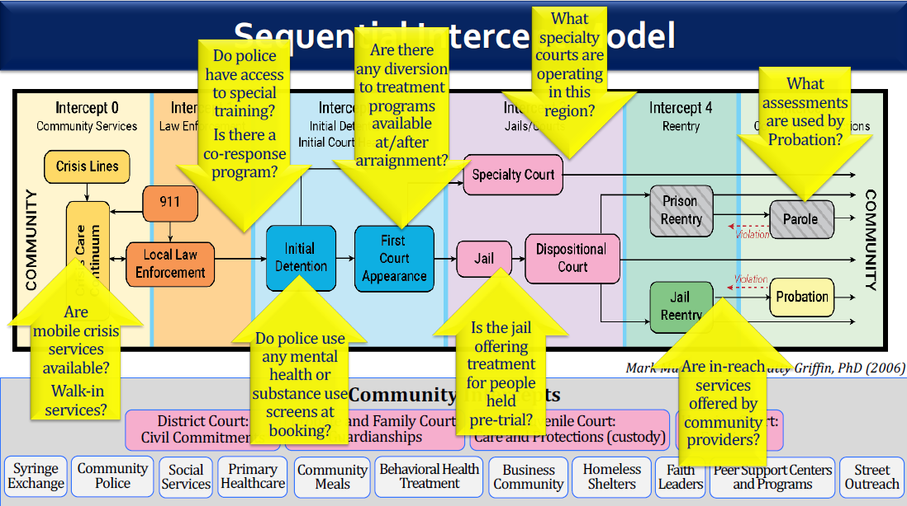

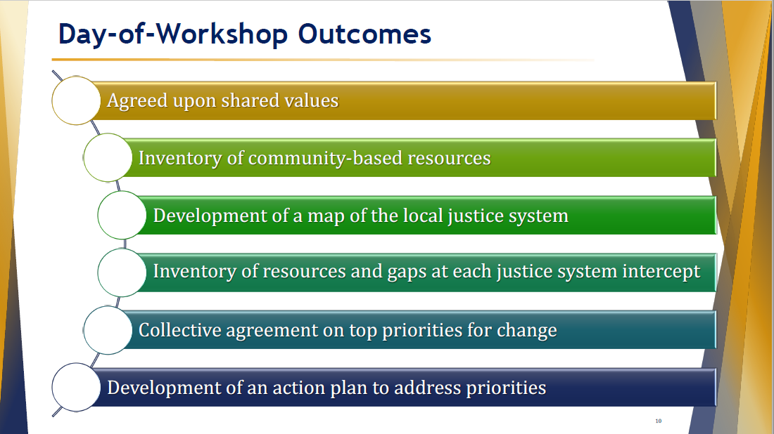

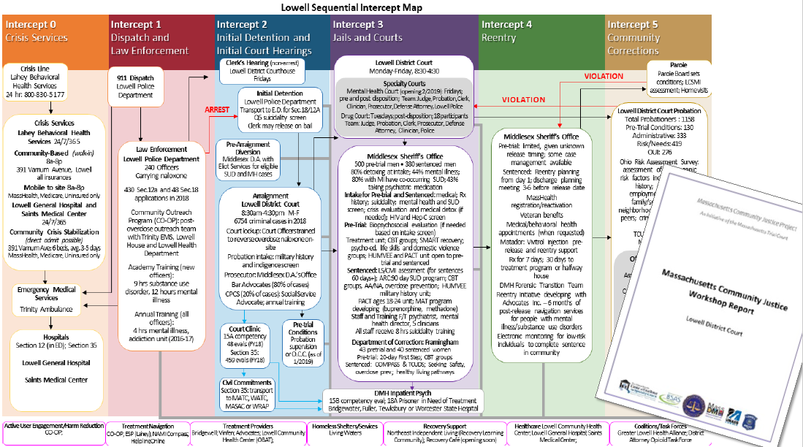

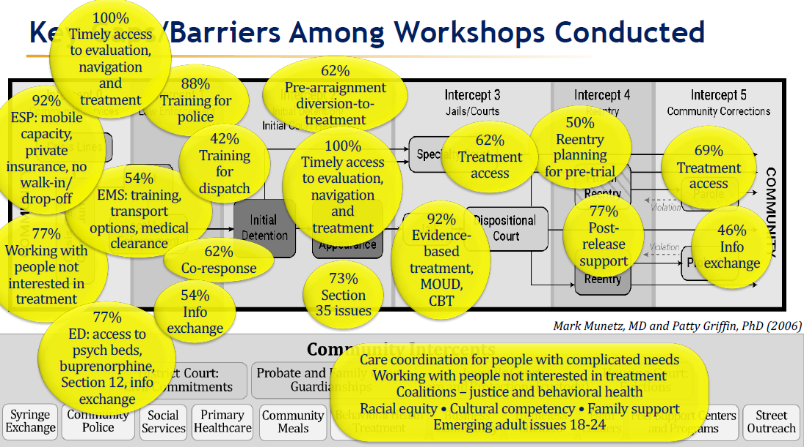

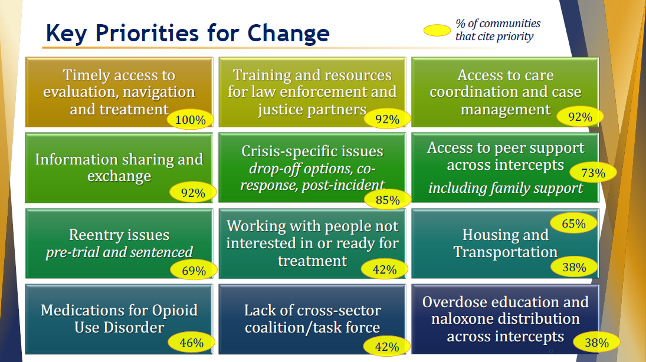

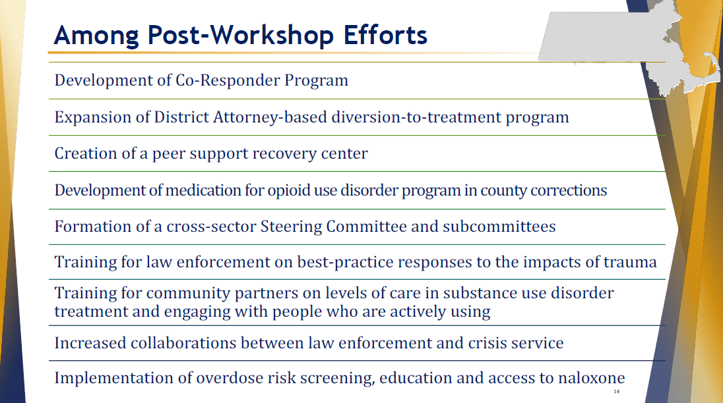

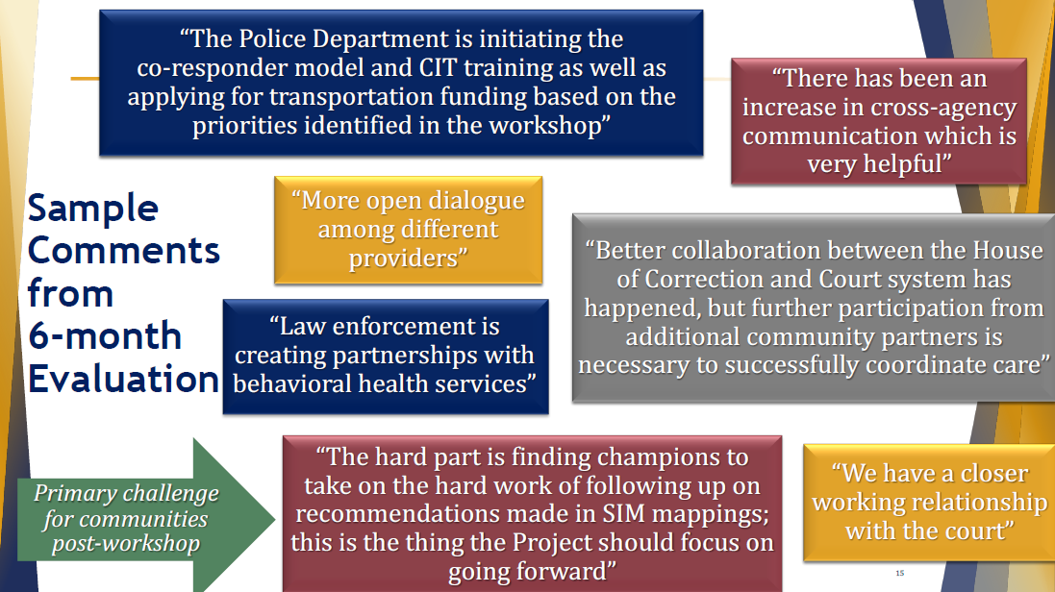



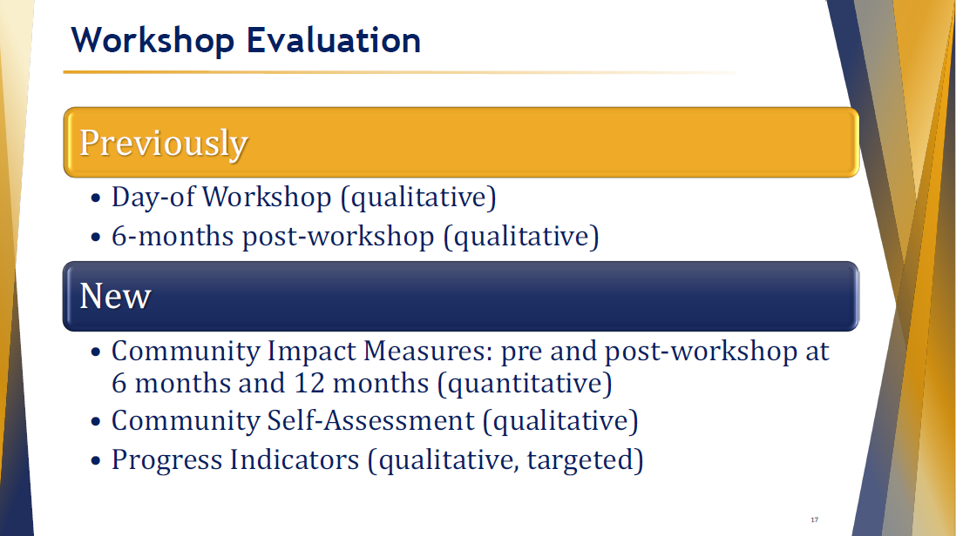

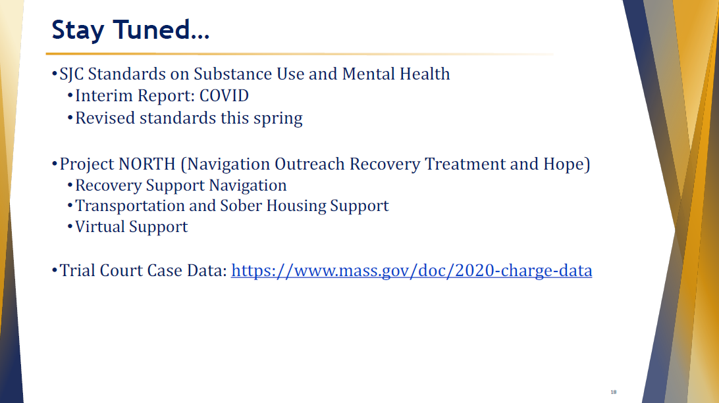

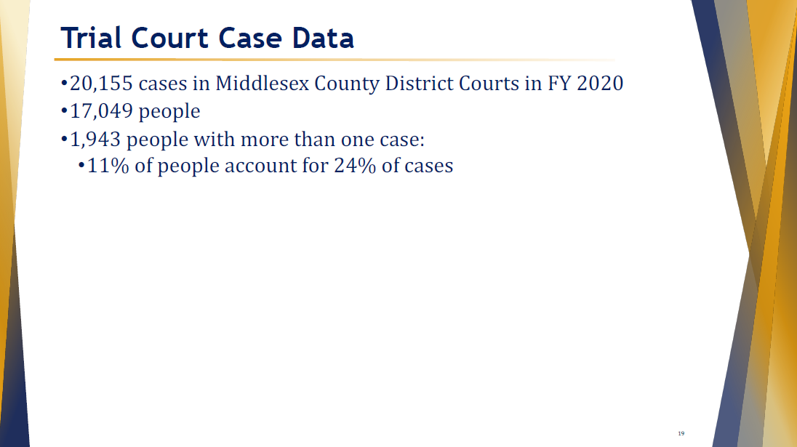

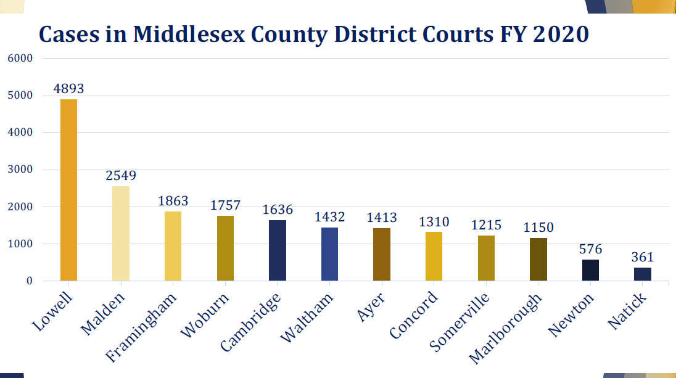

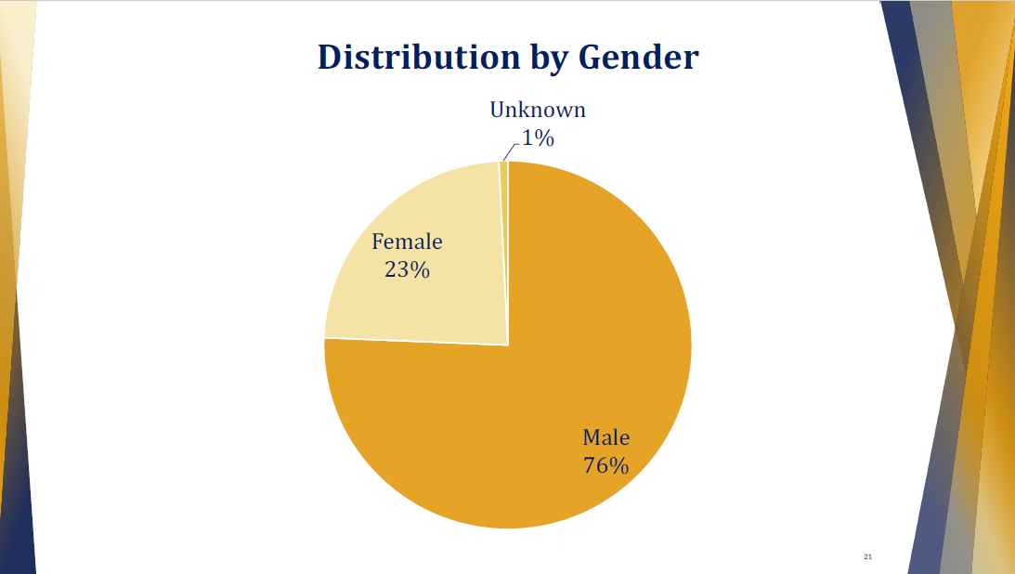

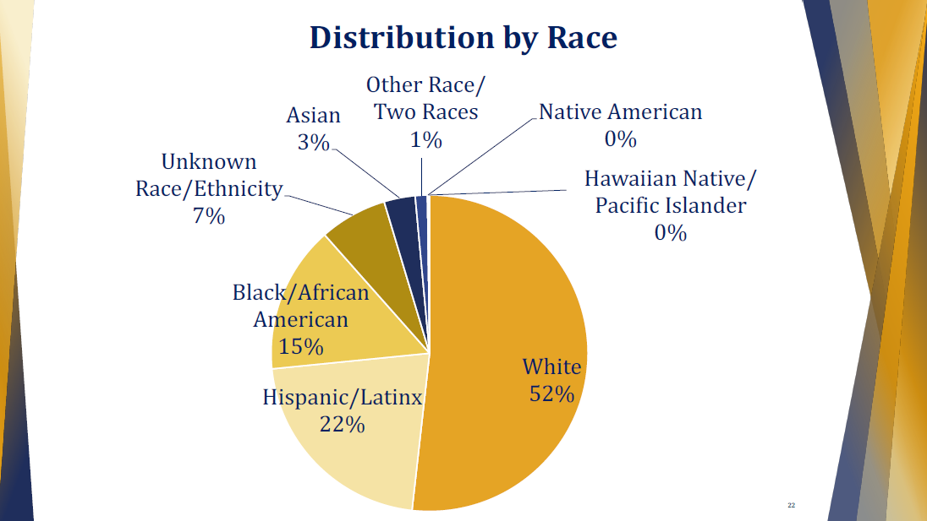

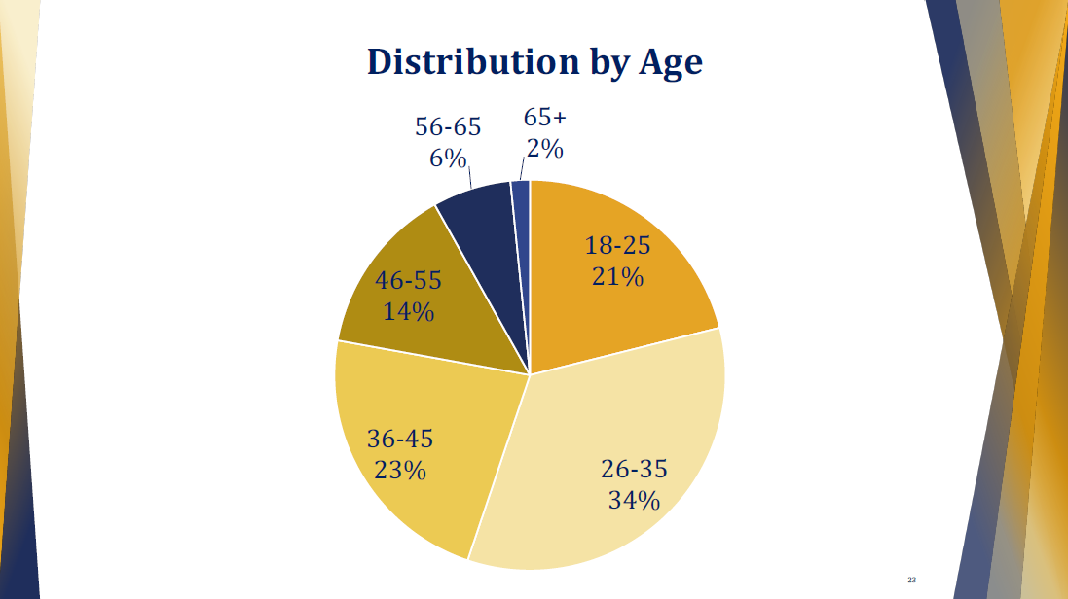

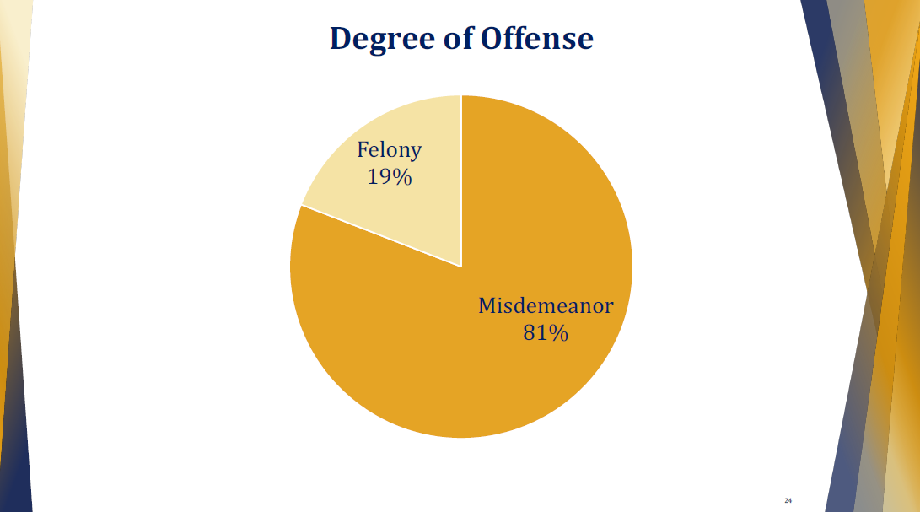

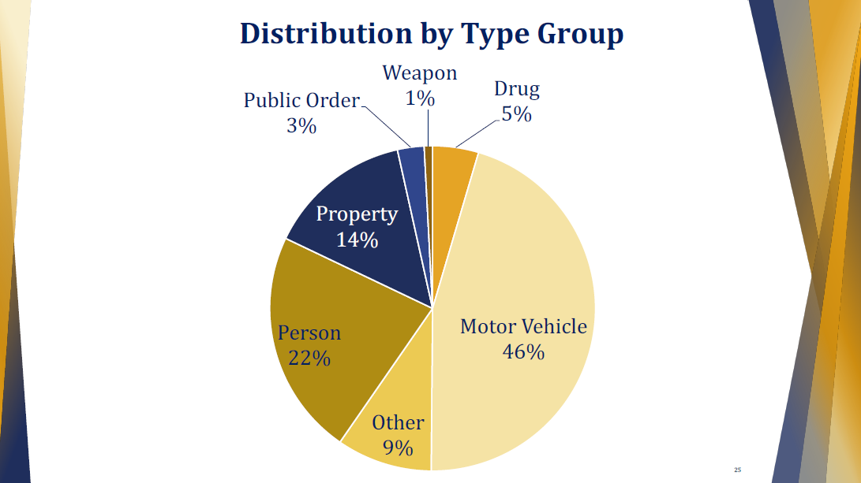

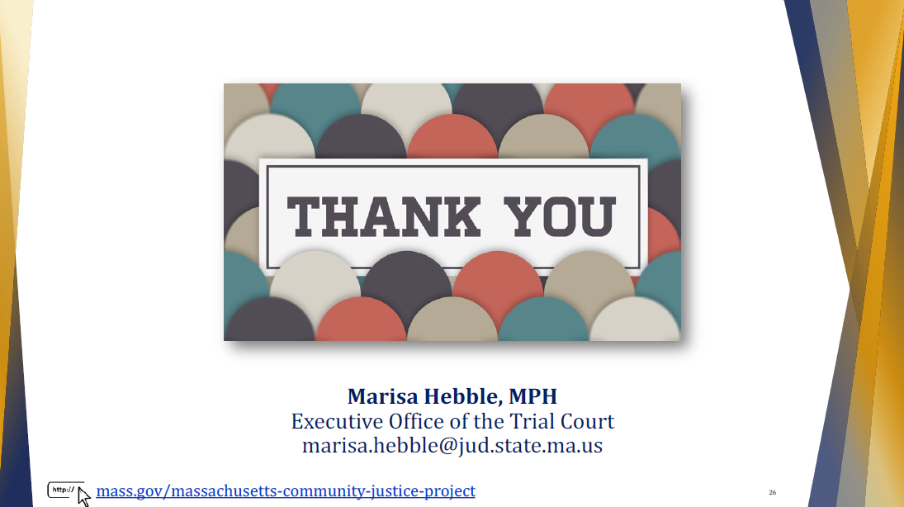

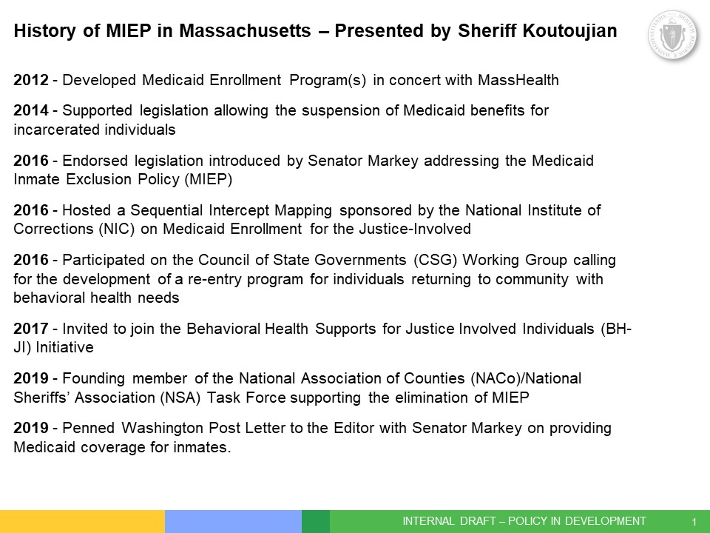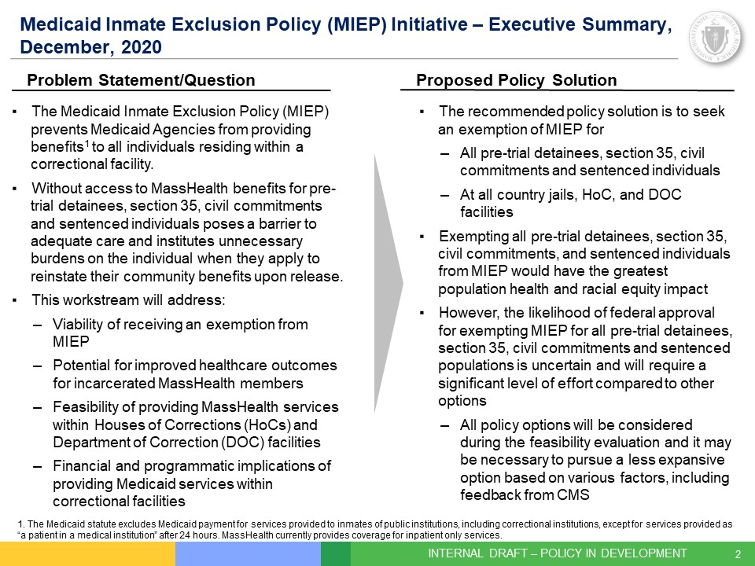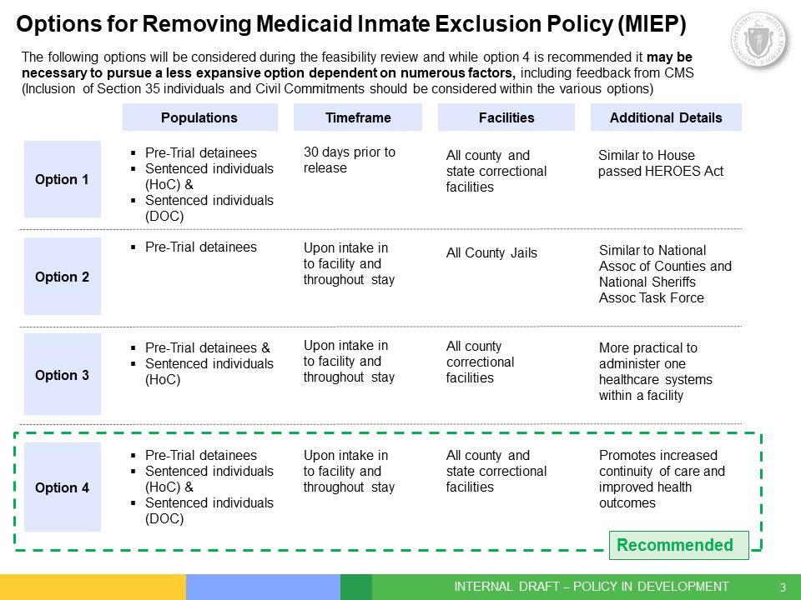

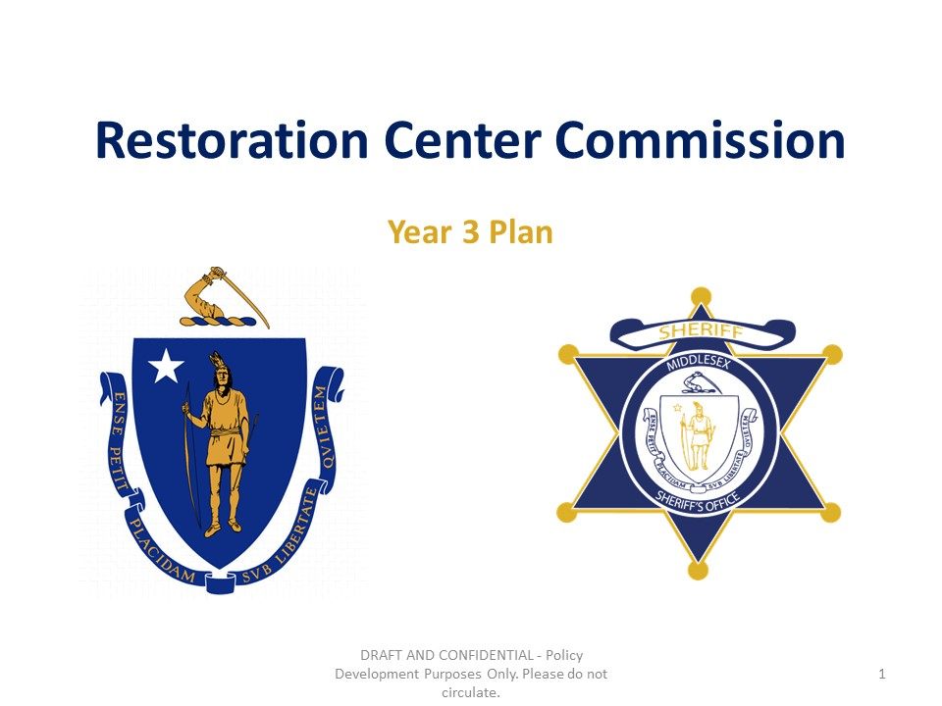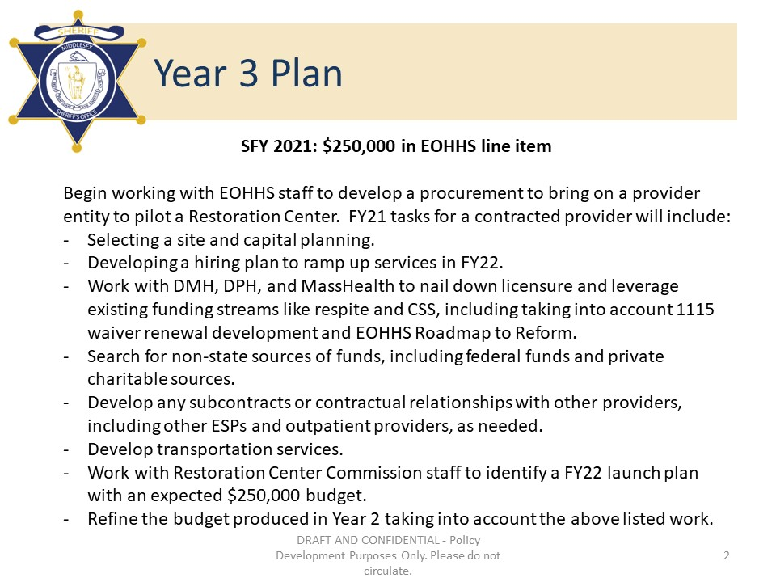
Materials from Meeting January 28, 2021

Middlesex County Restoration Center Commission
Thursday, January 28, 2021
2:00 PM – 3:00 PM
Virtual

AGENDA

2:00PM – 2:05PM Welcome and Introductions
Co-Chairs, Sheriff Koutoujian and Danna Mauch

2:05PM – 2:10PM Legislative and Budget Update
Senator Friedman and Representative Gordon

2:10PM – 2:15PM Approval of Minutes from Last Meeting
Co-Chairs, Sheriff Koutoujian and Danna Mauch

2:15PM – 2:35PM Work Plan for FY21, including subcommittee structure
Co-Chairs, Sheriff Koutoujian and Danna Mauch

2:35PM – 2:40PM Next Steps and Closing
Co-Chairs, Sheriff Koutoujian and Danna Mauch

2:40PM – 3:00PM Executive Session:
Guests from Project Citizen – individuals currently at Billerica House of Correction participating in a civic engagement project
Sheriff Koutoujian

Middlesex County Restoration Center
Thursday, January 28, 2021
2:00 – 3:00 pm
Zoom
MINUTES

Attendees: Sheriff Peter J. Koutoujian, co-chair; Danna Mauch, Massachusetts Association for Mental Health, co-chair; Senator Cindy Friedman; Chief Robert Bongiorno, Bedford Police Department; Nancy Connolly, Department of Mental Health; Deirdre Calvert, Bureau of Substance Addiction Services; Scott Taberner, MassHealth; Marisa Hebble, MA Trial Court; Lydia Conley, Association for Behavioral Healthcare; Tim Burton, National Alliance for Mental Illness Massachusetts; Bridget Cook, MSO; Sonya Khan, MSO; Morgan Rumpf, MSO; Dave Ryan, MSO; David Swanson, Office of Senator Cindy Friedman; Catia Sharp, MAMH; June Binney, member of the public; Richard Sheola, member of the public; Caroline Bays, member of the public; Jennifer Honig, member of the public from Mental Health Legal Advisors Committee (MHLAC); Kate Nemens, member of the public from MHLAC; Megan Mauskapf, member of the public from MHLAC; Phil Kassel, member of the public; Rebecca Leaf, member of the public.

2:00 PM: WELCOME AND INTRODUCTION

Sheriff Koutoujian called the meeting to order.

2:05 PM: LEGISLATIVE AND BUDGET UPDATE

Representative Gordon could not attend the meeting.

Senator Friedman said that she has been all-consumed by vaccine distribution, and has not had a chance to look at the Governor’s budget that was released yesterday to check to see if it included $250,000 for the Restoration Center Commission.

Danna Mauch confirmed that the Governor’s budget does not include funding for the Commission.

Sheriff Koutoujian suggested that the co-chairs work with Senator Friedman and Representative Gordon to get funding into the House and Senate versions of the budget.

2:10 PM: APPROVING THE MINUTES FROM THE LAST MEETING

Sheriff Koutoujian motioned to approve the minutes from the last meeting. The vote was unanimous in favor of approving the minutes.

2:15 PM: WORK PLAN FOR FY21

Sheriff Koutoujian proposed creating a subcommittee structure for the Commission, beginning with a subcommittee on procurement.

The group was unanimous in agreeing to create a subcommittee on procurement. Commission members can join the subcommittee voluntarily, and Catia Sharp will set it up.

Sheriff Koutoujian particularly urged members of the Commission who work in the administration or have procurement experience to join the subcommittee on procurement.

2:35 PM: NEXT STEPS AND CLOSING

Sheriff Koutoujian announced that the rest of the meeting would be in an Executive Session to protect the privacy of the presenters, and asked all members of the public to sign off. The presenters would be participants in the People Achieving Change Together (PACT) unit at the Billerica Jail and House of Corrections who participated in Project Citizen, a civics course. The young men would present their final project for the course related to reentry services. Sheriff Koutoujian announced that the open session of the meeting would not reconvene.

2:40 PM: EXECUTIVE SESSION

Materials from Meeting February 22, 2021

Middlesex County Restoration Center Commission
Monday, February 22, 2021
10:00 AM – 12:00 PM
Virtual

AGENDA

10:30AM – 10:35AM Welcome and Introductions
Co-Chairs, Sheriff Koutoujian and Danna Mauch

10:35AM – 10:40AM Legislative and Budget Update
Senator Friedman and Representative Gordon

10:40AM – 10:45AM Approval of Minutes from Last Meeting
Co-Chairs, Sheriff Koutoujian and Danna Mauch

10:45AM – 11:15AM Discussion: Project Citizen Findings
All

11:15AM – 11:30AM Update on Establishing a Subcommittee on Procurement
Co-Chairs, Sheriff Koutoujian and Danna Mauch

11:30AM – 11:50AM FY21 Work Plan
Co-Chairs, Sheriff Koutoujian and Danna Mauch

11:50AM – 12:00PM Next Steps and Closing
Co-Chairs, Sheriff Koutoujian and Danna Mauch

Middlesex County Restoration Center
Monday, February 22, 2021
10:30 am – 12:00 pm
Zoom
MINUTES

Attendees: Danna Mauch, Massachusetts Association for Mental Health, co-chair; Senator Cindy Friedman; Representative Ken Gordon; Chief Robert Bongiorno, Bedford Police Department; Nancy Connolly, Department of Mental Health; Deirdre Calvert, Bureau of Substance Addiction Services; Scott Taberner, MassHealth; Marisa Hebble, MA Trial Court; Lydia Conley, Association for Behavioral Healthcare; Eliza Williamson, National Alliance for Mental Illness Massachusetts; Tim Burton, National Alliance for Mental Illness Massachusetts; Senator John Cronin; Kevin Bowe, member of the public; Dave Ryan, MSO; David Swanson, Office of Senator Cindy Friedman; Catia Sharp, MAMH; June Binney, member of the public.

10:30 AM: WELCOME AND INTRODUCTION

Danna Mauch called the meeting to order.

10:35 AM: LEGISLATIVE AND BUDGET UPDATE

Senator Friedman announced that she filed the bill to create a Trust Fund for the Commission this session, and the bill number is 585 on the Senate side.

Representative Gordon let the Commission know that the House is preparing for the budget.

10:40 AM: APPROVING THE MINUTES FROM THE LAST MEETING

Senator Friedman motioned to approve the minutes from the last meeting, as well as the minutes from the Executive Session. The vote was unanimous in favor of approving the minutes.

10:45 AM: DISCUSSION OF PROJECT CITIZEN PRESENTATION

Danna Mauch opened the discussion on the Project Citizen presentation from the January meeting by remarking that it was an inspiring presentation.

Scott Taberner asked if there are any other PACT-like programs in other Houses of Correction or at the Department of Correction in Massachusetts.

Dave Ryan responded that the Suffolk County House of Correction does, but that he is not aware of any others.

Marisa Hebble asked if the Suffolk County unit is run the same as PACT.

Dave Ryan responded that Vinny Schiraldi from the Columbia Justice Lab worked with Suffolk in the design of their unit, while Vera worked with the Middlesex Sheriff’s Office.

Senator Friedman said that she thought it was a really excellent presentation. These are people who wouldn’t necessarily benefit from the Restoration Center because they are already incarcerated, but the Commission shouldn’t forget about them and needs to support them on their road to recovery. This falls outside the Commission’s purview but provides good ides about the Commission needs to be doing to support people – housing, community services, etc.

Danna Mauch asked the Commission members what they learned in that presentation that might inform how the Commission focuses on that younger age group in the design and implementation of the Restoration Center. She asked how the Restoration Center can most effectively be an alternative for these young men?

Scott Taberner let the Commission know that MassHealth has issued a procurement for the Community Support Program for Behavioral Health for Justice-Involved individuals last week. The program is modeled off the pilot MassHealth ran with Middlesex House of Corrections. COMMBUYS - Bid Solicitation

Danna Mauch asked Nancy Connolly if she had any comments about diversion programs at DMH and other places that might help these young men.

Nancy Connolly responded that the things these young men needed were not specifically behavioral health services – housing for example seemed to be the primary issue. What is the Commission looking to provide to people for diversion services. Is it only behavioral health services, or would it include wrap-around social services?

Danna Mauch said that the Restoration Center is targeted at people with behavioral health conditions, but the conversation with those young men reminded her that the needs for housing, community supports, and other things are central to diversion, and so the Restoration Center will need to do linkages to those critical support services.

Senator Friedman added that for the young men who spoke to the Commission in January, their life stories are steeped in trauma, and the Commission can’t ignore that. We ignore the mental health needs of people when doing social services and vice cersa. It’s critical what we do for people to address the full spectrum of needs for people with trauma. If we just detox someone and send them on their way it isn’t enough. The Commission has to tackle the housing and other support needs.

Danna Mauch asked Deirdre Calvert about her work with trauma as an underlying need of people with substance use conditions.

Deirdre said that the Department of Public Health has an RFR that closed on Friday for black and Latino men being released from prison – this is a population that is dying at an increased rate from opioid overdose. It is based on the Uplifting Fathers program. She also described a Housing First initiative at the Department of Public Health. She said that this is the first time they are supporting housing. Many people who are chronically relapsing are being excluded form housing. 60 beds are coming online, and sobriety is not a requirement. They are hoping to add more beds. This is currently targeted in Suffolk County in the Melnea Cass Boulevard area. They are also looking to start doing more preventative work before people are housing unstable.

Danna Mauch asked Eliza about the needs for housing for the people who call the Compass Helpline. What role can the Restoration Center play in connecting people to housing?

Eliza Williamson said that housing is the number one call type on the Compass Helpline. Beyond access to mental health services, there is a problem accessing services for social determinants of health. Eliza doesn’t have a clear sense of what to do about that, but the Restoration Center will need to have people who are better able to facilitate support and access to housing because in addition to having not enough housing supports, people don’t know how to access the supports that exist – how to get the forms, who to talk to, etc.

Danna Mauch responded that this is confirming that housing is an important unmet need and a high-volume need.

Marisa Hebble added that when the Commission went out to Bexar County to look at their services there was not only the Haven for Hope housing complex but a multi-service center where community navigators and service providers could come and provide services to people at the crisis center. We know that all these other issues are so interwoven into the needs of this population. The Commission will need to co-locate other services like housing, food security, financial services, etc.

Danna Mauch agreed, adding that at a minimum the Restoration Center will need case managers who can do these connections. One of the tasks in the next stage of implementation planning might be to define the landscape of multi-service and targeted service providers who have cooperative agreements with the Restoration Center provider to help do this navigation.

Senator Friedman said what a luxury it would be to have that kind of multi-service center co-located. She asked what the core, fundamental resources are that need to be in place right at the beginning. She noted that clearly housing support is one. But also how to become a DMH client, because that process is very difficult and very opaque. She wondered if there is a way to say how to access existing state resources for people, and how to identify the services and resources and then help people navigate into those systems. DMH services for DMH clients are very comprehensive. How does the Restoration Center help people get that.

Nancy Connolly said that the forensic transition team works in correctional facilities to help people get services before release. Maybe the Restoration Center can model off of that.

Senator Friedman said that she hears a lot about the challenges with access that service. She thought the Commission should think about how it can change that or how to access it most efficiently.

Danna Mauch mentioned that she had been helping someone get DMH services over the weekend. She noted that what is in the regulations is data points that are criteria for getting SMH services like that the client has to have serious mental illness. The type of information that isn’t in the written regulations is what you really need to do to qualify, like how long you have to be diagnosed, etc. We need to make those pieces more accessible for people so that can take those initial steps of getting access to services. It isn’t clear when you’re going through the process how the judgment will be made. The restoration Center will also be seeing people who don’t qualify for DMH services and those people need their needs met too.

Lydia Conley added that most people don’t meet the DMH criteria. She also asked how to weave in housing. She asked what the Behavioral Health Roadmap to Reform being released by the Executive Office for Health and Human Services is going to look like, and how this fits into that.

Danna Mauch added that for DMH clients, there is DMH Rental Subsidy Program (RSP) for housing. For non-DMH clients, there are traditional forms of housing supports like the Massachusetts Rental Voucher Program (MRVP). But many people aren’t able to navigate those programs. ABH member Advocates is great at it; how do others meet that need. How does the Restoration Center do that.

Lydia Conley mentioned that there are supposed to be community-based locations in the Behavioral Health Roadmap to Reform. What will these locations be able to provide? How do they integrate into the Restoration Center.

Danna Mauch responded that she thinks they are expected to have crisis services, which will make it key to integrate a Restoration Center with these locations. She also said it is key to integrate mental health and substance use into a single space because so many people have overlapping diagnoses. Also homelessness will be a big issue from an integration perspective. Danna asked Chief Bongiorno if he has comments on this.

Chief Bongiorno said that there are large parts of the county where homelessness is a major challenge. The Restoration Center will be a great addition to the county to handle those kinds of problems.

Danna Mauch agreed. She said some amount of linkage with shelters is therefore needed as well to facilitate services.

Chief Bongiorno said that the Senator hit it spot-on earlier. He said we shouldn’t focus on the reentry program because it is out of scope. But the Restoration Center could be more proactive. His question was if the resources were available, would we be in the situation we are in now. The services should be front-loaded into the Restoration Center to prevent incarceration so we don’t have to worry as much about reentry.

Senator Friedman added that this is why housing is so important – if you don’t have a place to live, that won’t send you back to jail/prison again.

Representative Gordon said that the investigative trips the Commission has been taking have all had examples of programs with wrap-around housing supports. It isn’t necessarily the core service function we are looking at, but it is a critical element.

Chief Bongiorno added that the Restoration Center would have been a great stop for clients who need vaccinations.

Senator Friedman noted that this might bring more equity to vaccine distribution.

Marisa Hebble noted that she hoped that this would not be the last time the Commission hears from people with lived experience of the type the Commission is trying to address, because it is so important.

Marisa also noted that for people who have children, that’s a unique set of needs that the Commission hasn’t talked much about. The Restoration Center should connect with the family resource centers, The thing that often prevents people from getting into care is that they have kids, so the Commission should think about how that impacts people’s decisions.

Danna Mauch said that this was an excellent point.

Senator Friedman thought that this is why there needs to be a list of critical elements of a Restoration Center. Bexar County was amazing – even the part where you could just come in and be homeless and receive services. We need the list of things we are focusing on, even through partnerships. We ought to use this list for the procurement because the need is enormous on every level and it can be overwhelming.

Danna Mauch said that one of the tasks that should be a first order of business is to go back into the reports and studies and tease out those critical elements that would represent a very comprehensive program. Then determine which will happen inside the Center, and which will happen through affiliation. Then the Commission can establish those elements of service that will happen out the gate through the procurement.

11:15 AM: UPDATE ON ESTABLISHING A SUBCOMMITTEE ON PROCUREMENT

Catia Sharp provided a list of Commission members who had expressed interest in participating in a subcommittee on procurement, which included Marisa Hebble, Eliza Williamson, and Scott Taberner.
Lydia Conley asked about the rules, and whether ABH could participate given that their members are likely to bid on the procurement.

Catia Sharp asked Scott Taberner to follow up on this, and told Lydia they would circle back with an answer from the lawyers.

Senator Friedman said that someone who knows what this looks like on the front-lines should participate, like Chief Bongiorno.

Chief Bongiorno agreed to join the subcommittee.

Nancy Connolly said she would find a DMH staff person to join the subcommittee.

Tim Burton from NAMI Mass volunteered to participate in the subcommittee as well.

11:30 AM: UPDATE ON WORK PLAN FOR FY21

Danna Mauch asked Catia Sharp to provide an update on the work plan.

Catia Sharp asked Scott Taberner to describe the flow of funds under the new line item for the Commission funding.

Scott Taberner said that EOHHS is working on an Intergovernmental Service Agreement (ISA) with Commonwealth Medicine to find a home for the resources that are named in the line item for the Restoration Center. He said that these entities are working to understand the timeline for procurement, given that there are only 4 months left in the fiscal year to spend the funds. Speed will be of the essence to get a design together and get the actual procurement out.

Danna Mauch said that the subcommittee can meet a couple of times over the next few weeks to tee up documents and drafts for Commonwealth Medicine’s review and refinement. If the subcommittee can refine the list of priority activities for the scope of work and key criteria for evaluation of bids, that could be turned over to EOHHS and Commonwealth Medicine and plunked into a procurement document. This would create a solid starting point for action.

Scott Taberner thought this was an excellent idea.

Danna Mauch said that the Commission can target taking action on the recommendations of the subcommittee at the next Commission meeting.

Scott Taberner noted that Katharine London at Commonwealth Medicine would be getting involved in the project.
Danna Mauch said that she has worked extensively with Katharine London, and she is incredibly knowledgeable and cares deeply about the people we are trying to divert, so she will be a great support in this effort. She noted that Katharine is also working on the Behavioral Health Roadmap to Reform, so to the extent that the Restoration Center can be linked to that effort, she will be able to help with that.

Scott Taberner added that Commonwealth Medicine brings a lot more people who are doing work on these other projects – the behavioral health Roadmap, Medicaid Inmate Exclusion Policy, etc. – and it is an impressive array of work to divert people from justice involvement so this will provide a lot of synergy.

Chief Bongiorno advocated for comfort dogs in this type of work. His department recently got a comfort dog, and when the dog is in their building, it has a very calming effect on the employees. It’s used for therapeutic sessions in police departments, correctional settings, etc. Long-range, one of those comfort animals might be a good fit for the Restoration Center.

Danna Mauch said this was a great idea. She added that the Framingham women’s prison has a program where the women train comfort dogs.

Eliza Williamson added that in the 90’s she worked with adolescents on the North Shore who were court-involved in group living settings, and had a service dog. She mentioned it was unbelievable the impact the dog had on these people’s ability to function. She was asked to bring the dog to court with people so they could remember to breathe and so on. She thought this was an excellent idea as well.

Chief Bongiorno wondered aloud if a person from the correctional institute could come talk about the impact of comfort dogs at a meeting.

Danna Mauch said she would be happy to try and track that down.

Dave Ryan added that the MSO has a service dog, and he could talk to Sheriff Koutoujian about having someone from the MSO come talk about it at a meeting.

Chief Bongiorno said that during COVID, access to pets has really changed employee morale in the Bedford Police Department.

11:50 AM: NEXT STEPS AND CLOSING

Danna Mauch adjourned the meeting.

Materials from Meeting March 22, 2021

Middlesex County Restoration Center Commission
Monday, March 22, 2021
10:00 AM – 11:00 AM
Virtual

AGENDA

10:00AM – 10:05AM Welcome and Introductions
Co-Chairs, Sheriff Koutoujian and Danna Mauch

10:05AM – 10:10AM Legislative and Budget Update
Senator Friedman and Representative Gordon

10:10AM – 10:15AM Approval of Minutes from Last Meeting
Co-Chairs, Sheriff Koutoujian and Danna Mauch

10:15AM – 10:55AM Update on Subcommittee on Procurement
Co-Chairs, Sheriff Koutoujian and Danna Mauch

10:55AM – 11:00AM Next Steps and Closing
Co-Chairs, Sheriff Koutoujian and Danna Mauch

Middlesex County Restoration Center
Monday, March 22, 2021
10:00 am – 11:00 pm
Zoom
MINUTES

Attendees: Sheriff Peter J. Koutoujian; Danna Mauch, Massachusetts Association for Mental Health, co-chair; Senator Cindy Friedman; Representative Ken Gordon; Chief Robert Bongiorno, Bedford Police Department; Nancy Connolly, Department of Mental Health; Deirdre Calvert, Bureau of Substance Addiction Services; Scott Taberner, MassHealth; Marisa Hebble, MA Trial Court; Lydia Conley, Association for Behavioral Healthcare; Tim Burton, National Alliance for Mental Illness Massachusetts; Karin Orr, DMH; Dave Ryan, MSO; David Swanson, Office of Senator Cindy Friedman; Catia Sharp, MAMH; Katharine London, Commonwealth Medicine; June Binney, member of the public; Richard Sheola, member of the public.

10:00 AM: WELCOME AND INTRODUCTION

Sheriff Koutoujian called the meeting to order.

10:05 AM: LEGISLATIVE AND BUDGET UPDATE

Senator Friedman mentioned that the big things of interest to the Commission right now are the state budget process and the EOHHS Roadmap to Reform, where she is looking at the budget for the Roadmap and trying to best align the Restoration Center with that. She also talked about getting the Restoration Center plugged into the discussions on the opioid settlement trust fund and ensuring that the language of the trust fund allows for things like the Restoration Center to be funded.

Chief Bongiorno asked about cannabis tax revenue and whether it can go toward a Restoration Center.

Sheriff Koutoujian asked where we stand on the opioid settlement which the Attorney General is pursuing, and whether there are any specific settlement agreements yet.

Senator Friedman responded that the marijuana tax revenue is mostly spoken for with strict guidelines for how it is spent, but that the opioid settlement revenues are certainly something the Restoration Center Commission should be able to tap into because it is treating similar problems.

Sheriff Koutoujian added that Arnold Ventures is looking across the country at how similar monies are getting utilized. He also mentioned Sheriff Gleason who was just elected in Williamson County, Texas, and is doing interesting, similar work, and he might be an interesting speaker at our Commission. It would be good to reconnect on national models and how they are going. Also, it might be good to partner with the Massachusetts Hospital Association.

Senator Friedman mentioned that the hospitals are very busy right now with COVID.

Representative Gordon let the Commission know that the House is preparing for the budget in the next month, and he will be requesting full funding for the Restoration Center for launching services next year. He is working to socialize the Restoration Center Commission work with Ways and Means Chairman Michlewitz to support this.

Senator Friedman asked to clarify whether full funding is still the $250,000 or if it is more than that and requested to have a meeting with co-chair Mauch and Representative Gordon to discuss the funding amount.

10:10 AM: APPROVING THE MINUTES FROM THE LAST MEETING

Sheriff Koutoujian moved to adopt the minutes from the last meeting. Danna Mauch seconded.

10:15 AM: PROCUREMENT SUBCOMMITTEE UPDATE

Sheriff Koutoujian asked Catia Sharp to report to the Commission on the findings of the procurement subcommittee.

Catia Sharp thanked the members of the procurement subcommittee for their diligent work, letting the Commission know that the following individuals participated: Tim Burton from NAMI Mass, Chief Bongiorno, Scott Taberner, Marisa Hebble, Dave Ryan, and Karin Orr. Catia Sharp introduced Karin Orr to the Commission members; she represents Nancy Connolly on the subcommittee and is an Area Director of Forensic Services at the Department of Mental Health.

Catia Sharp also introduced Katharine London from Commonwealth Medicine, who will be supporting the Commission’s work due to the shift of funds into the EOHHS budget in fiscal year 2021.

Katharine London introduced herself, having a long career working on issues related to behavioral health and criminal justice.

Catia Sharp shared that the document the procurement subcommittee had created would provide recommendations for components of a scope of work and evaluation criteria to Commonwealth Medicine for the procurement.

Scott Taberner asked whether the Commission needed to enter Executive Session to protect materials supporting the development of a procurement from improper public view.

Sheriff Koutoujian thought this was a good suggestion and recommended wrapping up the rest of the Commission’s agenda prior to entering Executive Session where the Commission members could more extensively review the procurement recommendations.

Sheriff Koutoujian brought up the idea of reaching out to the federal delegation about obtaining an earmark or other funding for the Restoration Center.

Senator Friedman asked about the Roadmap to Reform.

Danna Mauch shared a staff-level meeting between EOHHS staff and Commission staffers to learn more about the Roadmap. Throughout the Commission’s deliberations, it has been clear that the Restoration Center would need to be integrated into the behavioral health system of care in order to function well. When earlier reports came out, the Commission did not have the benefit of knowing what was in the Roadmap, and thus analyzed the fit of the planned center in the existing system of care.

Senator Friedan asked who was present at the meeting.

Danna Mauch responded that the meeting included Commonwealth Medicine team members, Commissioner Doyle of the Department of Mental Health, Director Deirdre Calvert of the Department of Public Health BSAS, Behavioral Health Director Christie Hager of MassHealth, and staff of the Commission including Dave Ryan and Catia Sharp.

Scott Taberner added that it was a helpful discussion of the CBHC model and where areas of alignment may exist between CBHCs and the Restoration Center.

Deirdre Calvert added that areas of alignment include induction to MAT, for example.

Sheriff Koutoujian referenced the plan in the Roadmap to select community behavioral health centers (CBHCs) along county lines and noted while it might not make any more sense than EOHHS service areas, at least using county lines aligns CBHCs with the Restoration Center and with diversion from the justice system.

Senator Friedman expressed concern that the legislative leaders are not fully aware what is in the Roadmap, and finds it challenging to support the Roadmap in the budget process and in legislation without that level of detail.

Scott Taberner shared that the administration is expecting to brief key stakeholders on the contents of the Roadmap, including the co-chairs and legislative members of the Restoration Center Commission. They are working on scheduling that meeting now.

10:45 AM: NEXT STEPS AND CLOSING

Sheriff Koutoujian adjourned the meeting.

10:45 AM: EXECUTIVE SESSION

The Commission entered Executive Session to discuss the procurement.

Materials from Meeting April 7, 2021

Middlesex County Restoration Center Commission
Wednesday, April 7, 2021
10:00 AM – 12:00 PM
Virtual

AGENDA

10:00AM – 10:05AM Welcome and Introductions
Co-Chairs, Sheriff Koutoujian and Danna Mauch

10:05AM – 10:10AM Legislative and Budget Update
Senator Friedman and Representative Gordon

10:10AM – 10:15AM Approval of Minutes from Last Meeting
Co-Chairs, Sheriff Koutoujian and Danna Mauch

10:15AM – 10:30AM Update on Subcommittee on Fundraising
Co-Chairs, Sheriff Koutoujian and Danna Mauch

10:30AM – 11:55AM Annual Report Discussion
All Commission members

11:55AM – 12:00PM Next Steps and Closing
Co-Chairs, Sheriff Koutoujian and Danna Mauch

People Achieving Change Together, the name of the specialized unit in the Billerica Jail and House of Corrections which houses young men and is managed using restorative justice techniques and offers specialized programming.

