**Massachusetts Violent Death Reporting System**

**Massachusetts Department of Public Health**



**DATA BRIEF**

**A Closer Look – Youth Suicide (Ages 10-24 years), 2011-2015**

**BACKGROUND**

Suicide is a significant and preventable public health issue in Massachusetts and across the nation. For every suicide completion, it is conservatively estimated that 18 loved ones are left behind to experience the profound and challenging grief stemming from such a loss.[1] For youth suicide, the impact of the death on parents, friends, and the community is even greater.

In this publication, youth suicides are defined as suicides occurring between the ages of 10-24 years. Youth represent an important risk group for suicide prevention. In addition to being the age group with the potential to give up the largest number of healthy years of life, suicide is the 2nd leading cause of death among 10-24 year olds in the United States.[2]

The Massachusetts Suicide Prevention Program (SPP) funds providers who have implemented several suicide prevention strategies targeting youth throughout the state. These include:

* The distribution of SOS (Signs of Suicide) kits by Screening for Mental Health (SMH)
* The presentations of Families for Depression Awareness, Coping with Stress and Depression webinars, regular podcasts and peer-to-peer programming in schools
* In-service training of school staff and workshops for middle and high school students
* The provision of postvention services to schools who experience a suicide loss
* Production of a free training tool for educators – The “S” Word: The Role of Schools in Preventing Suicide

**Key Findings, 2011-2015**

* 401 youth in Massachusetts were lost to suicide between 2011 and 2015.
* An average of 80 young individuals died by suicide each year between 2011 and 2015 in Massachusetts.
* The highest average annual youth suicide rate overall was among White, non-Hispanic youths (n=299, 6.4 deaths per 100,000).

**MA YOUTH SUICIDE OVERVIEW, 2011-2015**

* Between 2011 and 2015, 401 youth died by suicide in Massachusetts.[3]
* 77% of youth suicide victims were between the ages of 18-24 yrs. (n=309).
* 2012 had the highest overall youth suicide rate at 6.6 deaths per 100,000 persons and the highest rate for youth 18-24 yrs. at 10.4 deaths per 100,000 persons.
* The average annual rate of youth suicide in Massachusetts between 2011 and 2015 was 5.9 deaths per 100,000 persons. This was lower than the average annual U.S. youth suicide rate between 2011 and 2015 (8.4 deaths per 100,000 persons).[4]

Source: MA Violent Death Reporting System

* Franklin County had the highest average annual rate of youth suicide at 10.0 deaths per 100,000 persons.

0.0

n < 6

n < 6

**n=15**

**n=9**

**n=8**

**n=21**

**n=9**

**n=16**

**n=11**

n < 6

n < 6

n < 6

n < 6

Source: MA Violent Death Reporting System

**AGE AND SEX OF MA YOUTH SUICIDE VICTIMS, 2011-2015**

* Males accounted for 71% of youth suicides that occurred in MA during 2011-2015 (n=286).

**Male**

* The highest male youth suicide rate occurred in 2015 (9.1 deaths per 100,000 persons, n=62)

**Female**

Source: MA Violent Death Reporting System

**RACE AND ETHNICITY OF MA YOUTH SUICIDE VICTIMS, 2011-2015**

* White, non-Hispanic youth had the highest average annual suicide rate (6.4 deaths per 100,000 persons).[5]
* Hispanic youth had the lowest average annual suicide rate (3.5 deaths per 100,000 persons).
* 32% (n=11) of Hispanic youth victims were born outside of the U.S.[6]
* 50% (n =13) of Asian, Non-Hispanic youth victims were born outside of the U.S. 62% (n=8) of which were female.
* 13% (n = 50) of youth suicide victims were born outside of the U.S. and its territories.

Source: MA Violent Death Reporting System

**METHODS OF MA YOUTH SUICIDES, 2011-2015**

* Hanging was the most prevalent method of youth suicide, for both males and females, from 2011-2015 (66%, n=264).
* Firearms were the second most prevalent method (13%, n=51). Of these, 96% were male (n=49).

Source: MA Violent Death Reporting System

|  |  |  |  |
| --- | --- | --- | --- |
| **Table 1. Method of Suicide Youth Victims (Ages 10-24 yrs.) by Sex, MA 2011-2015 (n=401)** | | | |
|
| **Method** | **Male** | **Female** | **Total** |
| Hanging, strangulation, suffocation | 178 | 86 | 264 |
| Firearm | 49 | 2 | 51 |
| Poisoning | 29 | 16 | 45 |
| Other transport vehicle, e.g., trains, planes, boats | 10 | 1 | 11 |
| Fall | 8 | 2 | 10 |
| Drowning | 6 | 4 | 10 |
| Other method | 6 | 4 | 10 |
| **Total** | **286** | **115** | **401** |

Source: MA Violent Death Reporting System

**CIRCUMSTANCES OF MA YOUTH SUICIDES, 2011-2015**

The circumstances surrounding youth suicides provide information on the trends and contributing factors that may lead to suicide. As such, they are an important resource for informing prevention efforts. Note that the circumstances presented here are not mutually exclusive. More than one circumstance can be attributed to a victim. It is also important to note that certain circumstances are more likely to be known/reported on than others.

n<6

Source: MA Violent Death Reporting System

* 73% of male Hispanic victims tested positive for alcohol and/or drugs at the time of their death.[7] This is in comparison to 45% of white, non-Hispanic male victims, 42% of black, non-Hispanic male victims and 38% of Asian, non-Hispanic male victims who tested positive at the time of their death.

Source: MA Violent Death Reporting System

**LOCATION OF INJURY OF YOUTH SUICIDES IN MA, 2011-2015[8]**

For youth 10-17 yrs., the highest annual rate of suicides occurred in Hampden (4.4 deaths per 100,000 persons) and Worcester (4.0 deaths per 100,000 persons) counties.

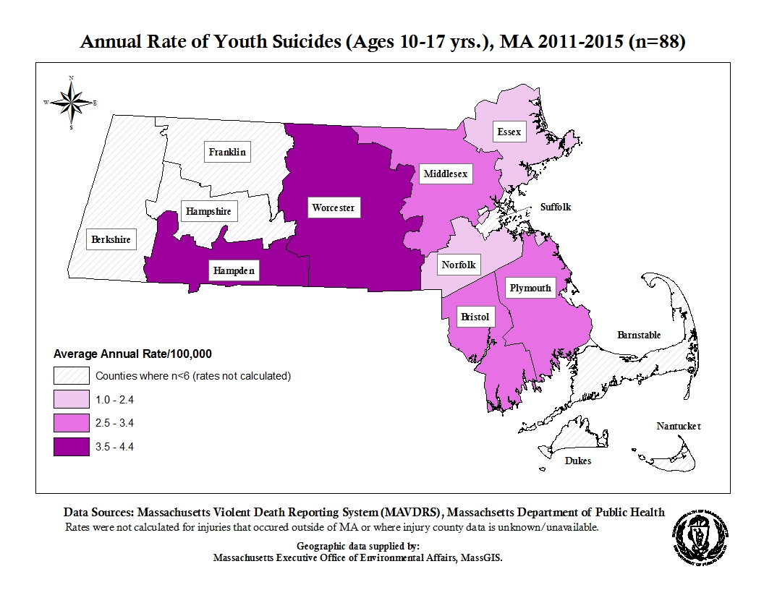

**Places of Injury: Youth 10-17 yrs.**

* The majority of suicides (83%, n=73) in this age group occurred in a house, apartment, or in its surroundings (e.g. porch, driveway, garage, yard).
* Approximately 8% (n=7) of suicides in this age group occurred in a natural area including fields, rivers, beaches and woods.

For youth 18-24 yrs., the highest annual rate of suicides occurred in Barnstable (13.2 deaths per 100,000 persons), Bristol (10.5 deaths per 100,000 persons), and Worcester (10.2 deaths per 100,000 persons) counties.

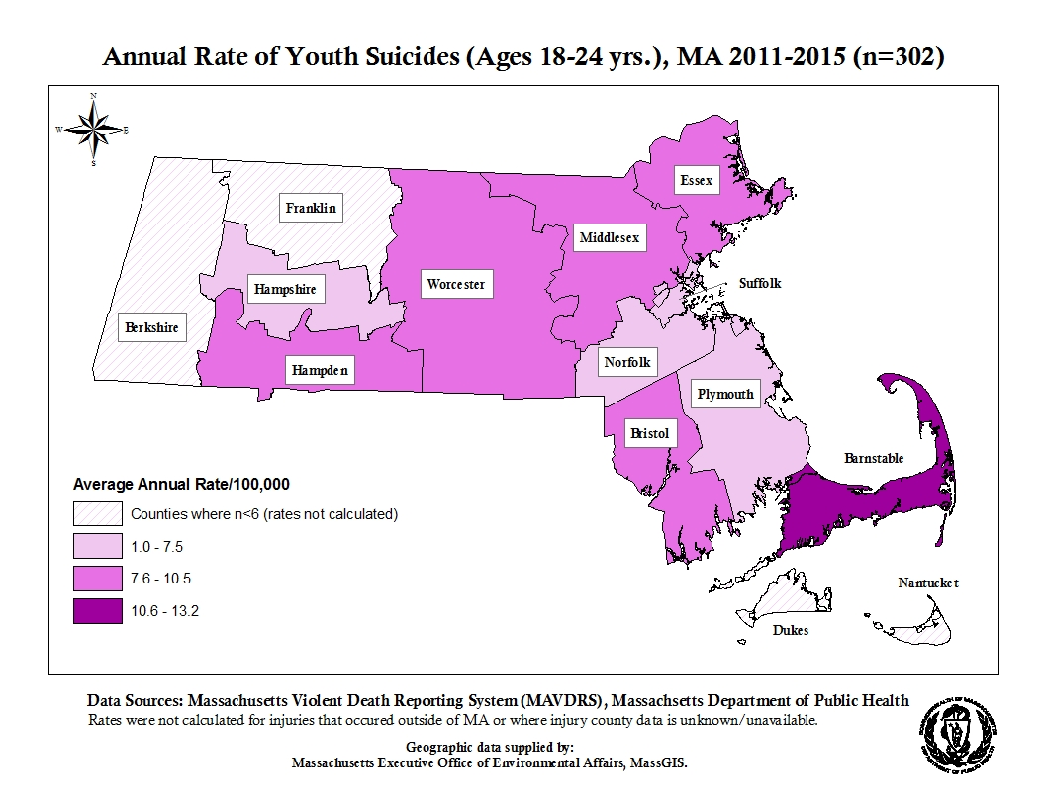

**Places of Injury: Youth 18-24 yrs.**

* The majority of suicides (60%, n=180) in this age group occurred in a house, apartment, or in its surroundings (e.g. porch, driveway, garage, yard).
* Approximately 10% (n=30) of suicides in this age group occurred in a natural area including fields, rivers, beaches and woods.
* Approximately 10% (n=30) of suicides in this age group occurred at a college or university, elementary or middle school (including dormitories and residential schools).

**FOR MORE INFORMATION:**

**Injury Surveillance Program (ISP)**

Bureau of Community Health and Prevention (BCHAP)

(617) 624 - 5664 (MAVDRS)

(617) 624 - 5648 (General injury information)

<http://www.mass.gov/dph/isp>

**Suicide Prevention Program (SPP)**

Bureau of Community Health and Prevention (BCHAP)

(617) 624 – 6076

<http://www.mass.gov/dph/suicideprevention>

**Bureau of Substance Abuse Services (BSAS)**

(800) 327 – 5050   
TTY: (888) 448 – 8321

<http://www.mass.gov/dph/bsas>

**Where to go for *help***

**__________________**

MA Coalition for Suicide Prevention

(617) 297 – 8774

[info@masspreventssuicide.org](mailto:info@masspreventssuicide.org)

**__________________**

***24 hour* help lines**

**SAMARITANS … call or text**

**(877) 870 – HOPE (4673)**

**NATIONAL LIFELINE**

**(800) 273 – TALK (8255)**

**TTY: (800) 799 - 4TTY (4889)**

**'**

**METHODOLOGY**

All suicide and self-inflicted injury data were ascertained using guidelines recommended by the Centers for Disease Control and Prevention (CDC) and are based upon the International Classification of Disease codes (ICD-10) for morbidity and mortality. Rates were not calculated for counts less than 6 and are considered unstable for counts less than 20. Rates were calculated using the National Center for Health Statistics postcensal estimates of the Massachusetts resident population of the United States for July 1, 2011-July 1, 2015, by year, county, age, bridged race, Hispanic origin, and sex.

**Data Sources:**

* *Death Data:* MA Violent Death Reporting System (MAVDRS), MA Department of Public Health (DPH). The National Violent Death Reporting System (NVDRS) is a CDC-funded system in 42 states that links data from death certificates, medical examiner files, and police reports to provide a more complete picture of the circumstances surrounding violent deaths. MAVDRS operates within the Injury Surveillance Program (ISP) at DPH. MAVDRS captures all violent deaths (homicides, suicides, deaths of undetermined intent, and all firearm deaths) occurring in MA, regardless of residency, and has been collecting data since 2003. Data reported are for calendar year and were analyzed by ICD-10 code.
* *U.S. injury rates and U.S. population*wereaccessed fromCDC, National Center for Injury Prevention and Control (NCIPC), and the Web-based Injury Statistics Query and Reporting System (WISQARS)**.**

1. American Association of Suicidology. (2014). *USA Suicide: 2014 Official Final Data;* <http://www.suicidology.org/Portals/14/docs/Resources/FactSheets/2014/2014datapgsv1b.pdf>
2. 10 Leading Causes of Death by Age Group, United States - 2014*:* *National Vital Statistics System , National Center for Health Statistics (NCHS), CDC*
3. Victims with injuries that initially occurred out of MA were not included in calculating the rates (n=11). Additionally, rates are not calculated for counts less than 6 and are considered unstable for counts less than 20.
4. Data Source: WISQARS - Centers for Disease Control and Prevention, [National Center for Injury Prevention and Control,](http://www.cdc.gov/injury) Statistics, Programming and Economics Branch. Accessed: August 2017.
5. Because n<6, the rate of American Indian victims was not calculated. Additionally, the rate of victims who identified as “Other Race/Ethnicity” was also not calculated due to the lack of population data.
6. The birth countries are located in Central America, South America and the Caribbean.
7. Drug classes tested for are, amphetamines, anticonvulsants, antidepressants, antipsychotics, barbiturates, benzodiazepines, cocaine, marijuana, muscle relaxants and opiates.
8. This section only contains information on injuries that occurred in MA (n= 390). The remaining 11 victims that died of youth suicide in MA were initially injured outside of the state.