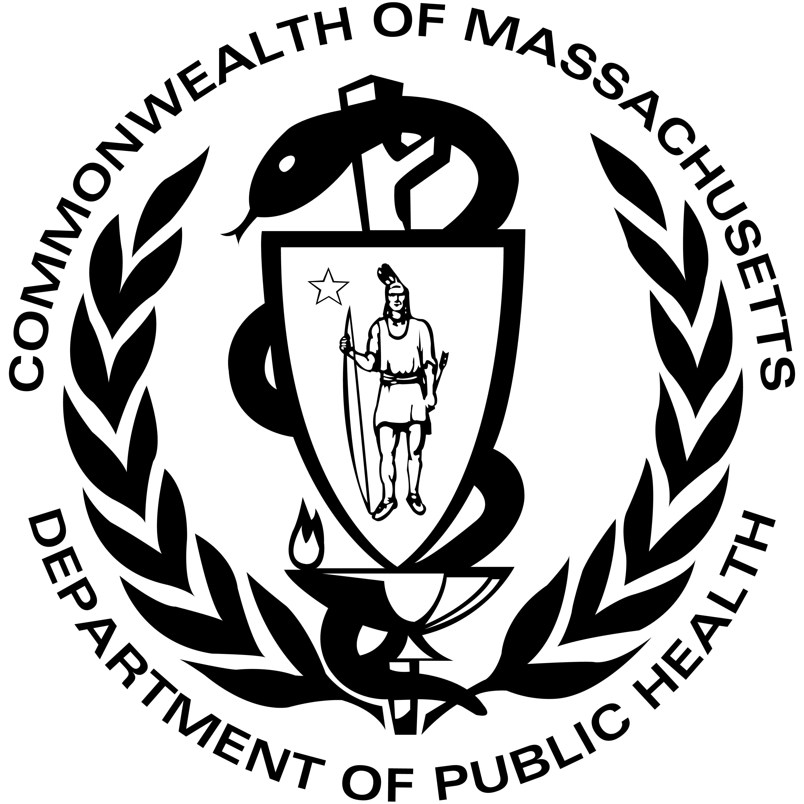
DATA BRIEF: SUICIDES, SUICIDE ATTEMPTS, AND SUICIDAL IDEATION AMONG YOUTH IN MASSACHUSETTS, 2015-2019

Summer 2022
Injury Surveillance Program, Massachusetts Department of Public Health
Suicides are a significant yet largely preventable public health problem. The purpose of this data brief is to provide information for practitioners and prevention specialists on the magnitudes, trends, and risk factors of suicides, self-inflicted injuries, and suicidal ideation among youth in Massachusetts. While suicide refers to those who die by suicide, nonfatal self-inflicted injuries can include both suicide attempts and non-suicidal self-injury. Suicidal ideation refers to thinking about, considering, or planning to end one’s own life. In this publication, youth are defined as those between the ages of 10 and 24 years, inclusive. The Massachusetts Department of Public Health’s Suicide Prevention Program works in collaboration with state, national, and local partners to reduce deaths and injuries among this age group.

YOUTH SUICIDES IN MA: KEY FINDINGS
10-18 yrs

- Between 2015 and 2019, 415 youth died by suicide in Massachusetts, representing 12% of all suicides.
19-24 yrs

- 71% of youth suicide decedents were between the ages of 19 and 24 (n=294).
All Youth

- 76% of youth suicide decedents were male (n=314).

- 2016 had the highest overall youth suicide rate at 6.8/100,000 persons. Between 2016 and 2019, youth suicide rates in Massachusetts decreased 23%.
Source: MA Violent Death Reporting System

- The average annual rate of youth suicide in Massachusetts between 2015 and 2019 was 6.0/100,000 persons. This was significantly lower than the average annual U.S. youth suicide rate of 10.0/100,000 persons (based on a p-value of 0.05).

- The highest suicide rate for youth aged 10-18 years was in 2016 (3.8/100,000 persons, n=29) as was the case for youth aged 19-24 years (10.4/100,000 persons, n=64) (see Figure 1).

- The highest male youth suicide rate was in 2017 (10.7/100,000 persons, n=74), and the highest female youth suicide rate was in 2016 (3.5/100,000 persons, n=24) (see Figure 2).
Source: MA Violent Death Reporting System
- See Methods section at the end of this document for additional details on data collection concerning sex.
Source: MA Violent Death Reporting System
*Rates not calculated when counts are less than six. Rates based on counts less than 20 are considered unstable and should be interpreted with caution.

- Asian, non-Hispanic youth had the highest average annual suicide rate between 2015 and 2019 (8.0/100,000 persons, n=40). This represents a shift in youth suicide trends because historically, White, non-Hispanic youth have had the highest suicide rates.

- While suicide rates for White, non-Hispanic youth were significantly lower in Massachusetts compared to the country as a whole (6.5/100,000 persons vs. 12.0/100,000 persons, respectively), the suicide rate for Asian, non-Hispanic youth in Massachusetts was almost identical to the national rate (8.0/100,000 persons vs. 8.3/100,000 persons, respectively).

- Overall, 12% of youth suicides between 2015 and 2019 in Massachusetts were among those born outside of the U.S. However, this statistic overlooks the wide ranges seen when this data is broken down by race/ethnicity. While just 3% of suicides among White, non-Hispanic youth were from those born outside of the U.S., a significant portion of suicide deaths among youth of color came from those born outside of the U.S., including:
  - 41% of Black, non-Hispanic youth,
  - 40% of Asian, non-Hispanic youth, and
  - 23% of Hispanic youth.

- Non-white youth were less likely to have a diagnosed mental health problem or have treatment for a mental health problem compared to White, non-Hispanic youth.

- In particular, Black, non-Hispanic youth were significantly less likely to have a diagnosed mental health problem compared to White, non-Hispanic youth.

- Lower rates of mental health problems among non-White youth may not necessarily mean that such issues were less prevalent among these groups; this might also indicate that these groups were less likely to receive care and/or diagnoses for mental health issues.
Source: MA Violent Death Reporting System

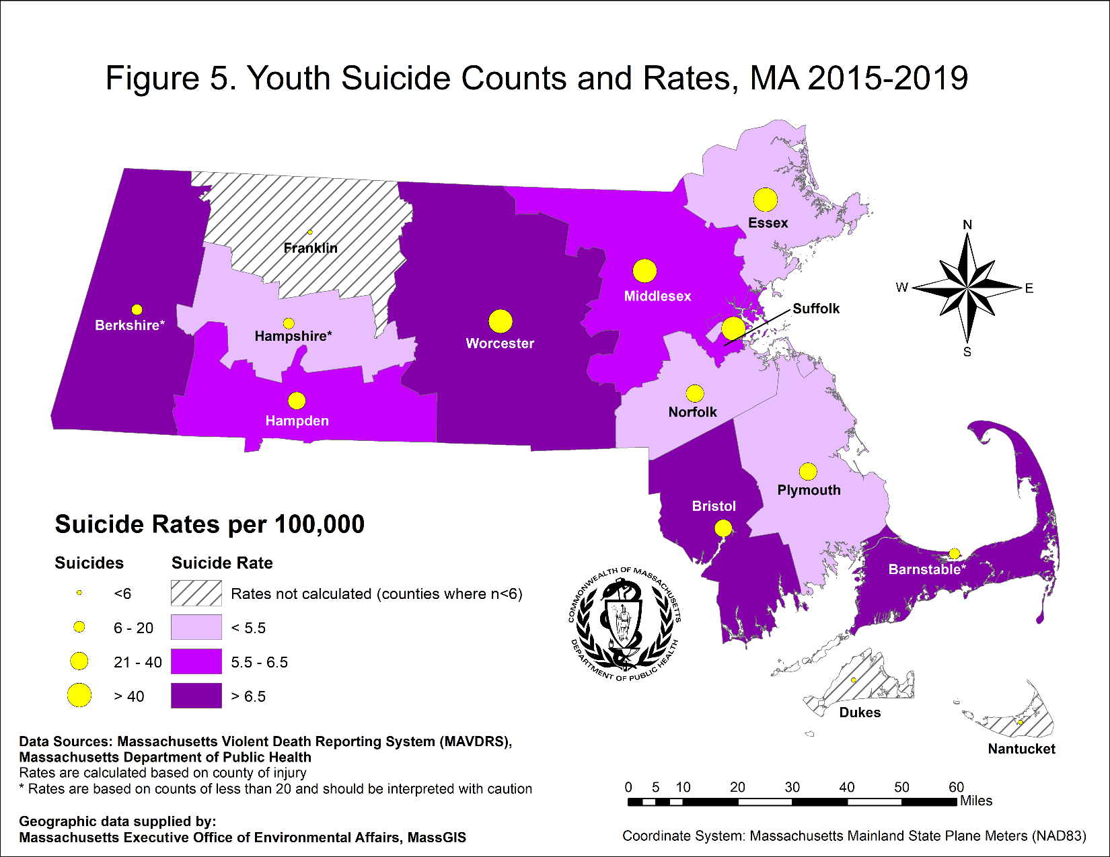

- The counties with the highest annual rates of youth suicide between 2015 and 2019 were:
  - Berkshire County (13.9/100,000 persons, n=16),
  - Barnstable County (7.5/100,000 persons, n=12), and
  - Bristol County (7.1/100,000 persons, n=39).
  - Note that due to the low counts of suicides in Berkshire and Barnstable counties (n < 20), the rates here are considered unstable and should be interpreted with caution.

- The following counties had youth suicide rates greater than the overall youth suicide rate of 6.0/100,000 persons between 2015 and 2019:
  - Berkshire County (13.9/100,000 persons, n = 16),
  - Barnstable County (7.5/100,000 persons, n = 12),
  - Bristol County (7.1/100,000 persons, n = 39), and
  - Worcester County (6.6/100,000 persons, n = 56).

- The county with the lowest measurable youth suicide rate was Plymouth County (4.5/100,000 persons, n=23).

- The county with the highest number of youth suicides between 2015 and 2019 was Middlesex County (5.6/100,000 persons, n = 88).

- Between 2015 and 2019, half of the cities and towns in Massachusetts (51%, n=178) had at least one youth suicide.

MECHANISMS OF INJURY AMONG MA YOUTH SUICIDES, 2015-2019
Firearm
Hanging/Suffocation
Fall
Train
Poisoning/Overdose
Other Mechanism
Source: MA Violent Death Reporting System
- Hanging/strangulation/suffocation was the most prevalent mechanism of injury in youth suicides for both males and females between 2015 and 2019 (57%, n=238).

- Firearms were the second most prevalent mechanism of injury for all youth (17%, n=69) as well as for males (19%, n=61). Among females, poisonings/overdoses were the second most prevalent mechanism of injury (23%, n=23).

- The most common classes of substances used in youth poisoning/overdose suicides were antidepressants, alcohol, antihistamines, and opiates.

- There were some differences in the most common mechanism of injury among youth suicides by sex. Some of the differences observed include the following:

  - Male youth were significantly more likely to die by firearm compared to female youth.
  - Male youth were significantly less likely to die by poisoning/overdose compared to female youth.

- There were also several differences in the most common mechanisms of injury among youth suicides compared to other age groups. Compared to adults 25 years of age or older, youth were:

  - Significantly less likely to die by firearm,
  - Significantly less likely to die by poisoning/overdose,
  - Significantly more likely to die by hanging/suffocation, and
  - Significantly more likely to die by train.

- Compared to other age groups, suicides by train were much more prevalent among youth. Youth were four times more likely to die by train compared to adults. Among all suicides by train in Massachusetts between 2015 and 2019, 37% of those suicides were among youth. By comparison, 14% of all hanging/strangulation/suffocation suicides, 10% of all firearm suicides, and just 8% of all poisoning/overdose suicides were among youth.

CIRCUMSTANCES OF MA YOUTH SUICIDES, 2015-2019
The circumstances surrounding youth suicides provide information on the trends and contributing factors that may lead to suicide. They can also highlight opportunities for future prevention efforts. Note that the circumstances presented below are not mutually exclusive; more than one circumstances can be attributed to a suicide decedent. It is important to remember that some circumstances are more likely to be known and documented than others, and if a circumstance is not identified, that does not necessarily mean it was not present in the decedent’s life.

- Diagnosis and treatment for mental health problems were among the most commonly reported circumstances for youth suicides.

- Several differences in circumstances surrounding youth suicides were found when comparing data by sex. Some of these differences include the following:

  - Female youth were significantly more likely to have a diagnosed mental health problem, have a history of treatment for a mental illness, and be currently treated for a mental illness at the time of death, compared to male youth.
  - Female youth were significantly more likely to have a history of past suicide attempts compared to male youth, with 1 in 3 female youth having evidence of such history.

- Please note that these differences do not necessarily mean that females were significantly more likely to have mental health issues. Because circumstances related to mental health are based on having a diagnosis from a provider, it will miss those who either did not seek care or who were unable to access care. Therefore, some of the discrepancies found may be due to differences in how female youth were able to access mental and behavioral health care compared to male youth.

YOUTH HOSPITALIZATION DATA, 2016-2019

Emergency Department (ED) Visits
- Although male youth had higher rates of suicide deaths, female youth had higher rates of hospitalization for self-inflicted injuries.
Females

- The emergency department visit rate for self-inflicted injuries among female youth was a little over two times higher than what it was for male youth.
Males
All Youth

- Between fiscal years 2016 and 2019, there were modest declines in emergency department visit rates. Rates declined 11% for males and 9% for females.

- Note: Fiscal years run from October 1st of the previous year to September 30th of the current year (e.g. fiscal year 2016 runs from October 1, 2015 – September 30, 2016).

Hospital Stays
Females
- As with emergency department visits, female youth had higher rates of hospital stays for self-inflicted injuries. Female youth had hospital stay rates between two and two and a half times higher than male youth.
All Youth
Males

- Between fiscal years 2016 and 2019, hospital stay rates declined 9% for male youth and 6% for female youth.

Mechanisms of Injury
- The mechanisms of injury seen in ED visits and hospital stays differed than what occurred in suicide deaths. Among ED visits, the most prevalent mechanisms of injury for both male (40.3%) and female (47.3%) youth were cutting/piercing injuries.
Unspecified
Other
Specified
- Among hospital stays, most self-inflicted injuries for both male youth (78.2%) and female youth (87.9%) were from poisonings (either drug or non-drug).
Poisoning

- Note: “self-inflicted injuries” in this data includes non-suicidal self-injuries (NSSI). While not all of the injuries and visits analyzed here may be directly related to suicide attempts, NSSI can be a strong predictor of future suicide attempts.
Hospital Stays

Cut/Pierce
Sources: MA Emergency Department Discharges Database, MA Inpatient Hospital Discharge and Outpatient Observation Stay Databases, Center for Health Information and Analysis (CHIA)

YOUTH SUICIDAL THINKING AND BEHAVIOR AMONG MA HIGH SCHOOL STUDENTS, 2017-2019

MA Youth Risk Behavior Survey (YRBS)
- The MA Youth Risk Behavior Survey (YRBS) is an anonymous, written self-report survey of students in public high schools in Massachusetts. In 2017 and 2019, results showed that during the past year:
  - 1 in 7 students (15%) reported non-suicidal self-injury,
  - 1 in 7 students (14%) seriously considered suicide,
  - 1 in 8 students (12%) made a plan to attempt suicide, and
  - 1 in 16 students (6%) attempted suicide.

MA YRBS Data by Sex
- Female students were significantly more likely to report non-suicidal self-injury and seriously considering suicide compared to male students.

- While female students were also more likely to make a suicide plan and attempt suicide compared to males, those results were not statistically significant.

MA YRBS Data by Race/Ethnicity
- Black, non-Hispanic students were significantly less likely to report non-suicidal self-injury compared to all other students.

- Hispanic students were significantly more likely to report attempting suicide compared to White, non-Hispanic students.

- Hispanic students were also more likely to report non-suicidal self-injury and making a suicide plan compared to other race/ethnicity groups, although those results were not statistically significant.

MA YRBS Data by Lesbian, Gay, Bisexual and/or Transgender (LGBT) Status
- LGBT students were significantly more likely to report all suicidal thoughts and behaviors compared to heterosexual students.

- LGBT students were also significantly more likely to report all suicidal thoughts and behaviors compared to all other groups represented on this page (i.e. male; female; White, non-Hispanic; Black, non-Hispanic, and Hispanic students).
Source: MA Youth Risk Behavior Survey 2017 and 2019, weighted data

OVERVIEW AND PROGRAM ACTIVITIES
Suicide Prevention Resources for Youth
- Youth.gov: https://youth.gov/youth-topics/youth-suicide-prevention
- The Jed Foundation (College Students): www.jedfoundation.org/
- The Trevor Project (LGBTQ+ Support): www.thetrevorproject.org/
- Trans Lifeline: https://translifeline.org/
DPH Initiatives Addressing Youth Suicide
The Massachusetts Suicide Prevention Program (SPP) funds providers who have implemented several suicide prevention strategies targeting youth throughout the state. Some of these strategies include:
- Offering Signs of Suicide (S.O.S.), a suicide prevention curriculum for middle and high school students at no cost to any school in Massachusetts
- Working with the Department of Mental Health to offer Zero Suicide Learning Collaboratives across the state
- Providing postvention services to schools who experience a suicide loss
- Receiving the Garrett Lee Smith Grant from SAMHSA, which focused on youth suicide prevention work and implemented Zero Suicide in selected health care and behavioral health care systems from 2015-2021
- Receiving a Comprehensive Suicide Prevention Grant from the CDC aimed to reduce suicides, suicide attempts, and suicidal ideation among high-risk populations, including youth
- Implementing a Youth Suicide Prevention Task Force along with six other state agencies, including the Department of Children and Families (DCF), Department of Youth Services (DYS), Department of Elementary and Secondary Education (DESE), Office of the Child Advocate (OCA), MassHealth, and the Department of Mental Health (DMH), with the goal to create a structure and guidelines for how each agency and their providers can support youth at risk for suicide
Key Findings, 2015-2019
- While youth suicide rates have been declining since 2016, suicide is still the 2nd leading cause of death among youth aged 10-24 years in both Massachusetts and the country overall².
- 415 youth died by suicide in Massachusetts between 2015 and 2019. The youth suicide rate during these years was 6.0/100,000 persons.
- An average of 83 youth died by suicide each year between 2015 and 2019, with half of the cities and towns in Massachusetts having at least one youth suicide during this time.
- 57% of youth who died by suicide had a diagnosed mental health issue and is likely an underestimate of the true number. 34% of female youth who died by suicide had a history of prior suicide attempts.
- Asian, non-Hispanics had the highest youth suicide rate of any race/ethnicity group (8.0/100,000 persons, n=40). This represents a shift because historically, White, non-Hispanic youth had the highest suicide rates.
- LGBT high school students were significantly more likely to report suicidal ideation and suicide attempt compared to all other groups analyzed.
- While male youth had suicide rates two to three times higher than female youth, conversely, female youth had self-injury hospitalization rates two to three times higher than male youth.
- The most common mechanism of injury in youth suicide deaths was hanging/suffocation, followed by firearms. Restricting access to certain means, such as firearms or medications, when a person is in a suicidal crisis can reduce the chances that a person will attempt suicide.
For more information, contact these programs at
Massachusetts Department of Public Health,
250 Washington Street,
Boston, MA 02018
Where to go for help
__________________

MA Coalition for Suicide Prevention
(617) 297-8774
info@masspreventssuicide.org
__________________

24 hour help line
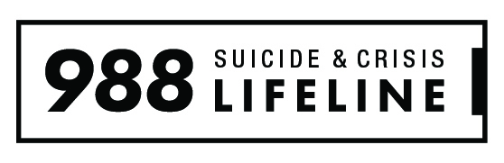
Over 150 languages offered
Press 1 for Veterans
TTY: (800) 799-4TTY (4889)

INJURY SURVEILLANCE PROGRAM (ISP)
Bureau of Community Health and Prevention (BCHAP)
(617) 624-5664 (MAVDRS)
(617) 624-5648 (General injury information)
http://mass.gov/injury-surveillance-program

SUICIDE PREVENTION PROGRAM (SPP)
Bureau of Community Health and Prevention (BCHAP)
(617) 624-5460
http://mass/gov/suicide-prevention-program

BUREAU OF SUBSTANCE ADDICTION SERVICES (BSAS)
(800) 327-5050
TTY: (888) 448-8321
http://mass.gov/orgs/bureau-of-substance-addiction-services

METHODS

General Notes: All data were ascertained using guidelines recommended by the Centers for Disease Control and Prevention (CDC) and are based upon the International Classification of Disease codes (ICD-10) for morbidity and mortality. The most recently available years of data for each data source were used for this data brief. Rates reported in this bulletin are crude rates. Rates are not calculated on counts of less than six, and rates based on counts less than 20 are considered unstable.

Notes on Data Collection Concerning Sex: The sex of an individual who died by suicide is based on information provided in the individual’s death certificate, which may or may not reflect their sex at birth. Additionally, data is separately collected to ascertain whether or not the decedent was transgender, although data on whether or not the decedent was nonbinary is not captured. Data on transgender youth was too small to be able to report.

Data Sources:
- Death Data: MA Violent Death Reporting System (MAVDRS), MA Department of Public Health (DPH). The National Violent Death Reporting System (NVDRS) is a CDC-funded system in all 50 states, the District of Columbia, and Puerto Rico that links data from death certificates, medical examiner files, and police reports to provide a more complete picture of the circumstances surrounding violent deaths. MAVDRS operates within the Injury Surveillance Program (ISP) at DPH. MAVDRS captures all violent deaths (homicides, suicides, deaths of undetermined intent, and all firearm deaths) occurring in MA, regardless of residency, and has been collecting data since 2003. MA residents who died out-of-state are excluded from this analysis. As a result of these data collection and analysis methodologies, results here may differ from what is provided by the MA Registry of Vital Records and Statistics (RVRS). Data reported are by calendar year and were analyzed by ICD-10 code.
- MA Youth Risk Behavior Survey: MA Department of Education and CDC MMWR Vol. 69, No. 1, August 2020
- Statewide Emergency Department Discharges at Acute-Care Hospitals: MA Emergency Department Discharge Database, MA Center for Health Information and Analysis. Data are reported by fiscal year (October 1 – September 30). Deaths occurring during treatment or those admitted to the hospital were excluded from the counts presented. All discharge diagnoses were analyzed to ascertain injury.
- Statewide Acute-Care Hospital Stays: MA Inpatient Hospital Discharge and MA Outpatient Observation Stay Databases, MA Center for Health Information and Analysis. Data are reported by fiscal year (October 1 – September 30). Deaths occurring during the hospital stay and transfers to another acute-care facility were excluded from the counts presented. All discharge diagnoses were analyzed to ascertain injury.
- Population Data: University of Massachusetts Donahue Institute Estimates
- U.S. injury rates and U.S. population were accessed from CDC, National Center for Injury Prevention and Control (NCICP), and the Web-based Injury Statistics Query and Reporting System (WISQARS).

Statistical Significance: A statistically significant p-value indicates strong evidence against the null hypothesis. For example, if your null hypothesis is that Group A is equal to Group B, and you obtain a small p-value (<0.05), that indicates that Group A likely does not equal Group B. These tests can tell you if groups differ in an outcome (for example, men versus women dying by suicide) or if a factor if associated with an outcome (for example, are financial circumstances associated with dying by suicide). Statistical significance does not necessarily imply importance and should not be the only consideration when exploring an issue. Because a rate is not “statistically significant” does not mean that there is not a real problem that could or should be addressed.

Source: CDC, WISQARS Fatal Injury Reports, National, Regional and State, 1981-2019
See Methods section at the end of this document for an explanation of how Statewide Acute-Care Hospital Stays were defined.
Source: CDC, WISQARS Fatal Injury Reports, National, Regional and State, 1981-2019

