**Youth Tobacco Use in Massachusetts**

Survey Results from 1995 to 2017

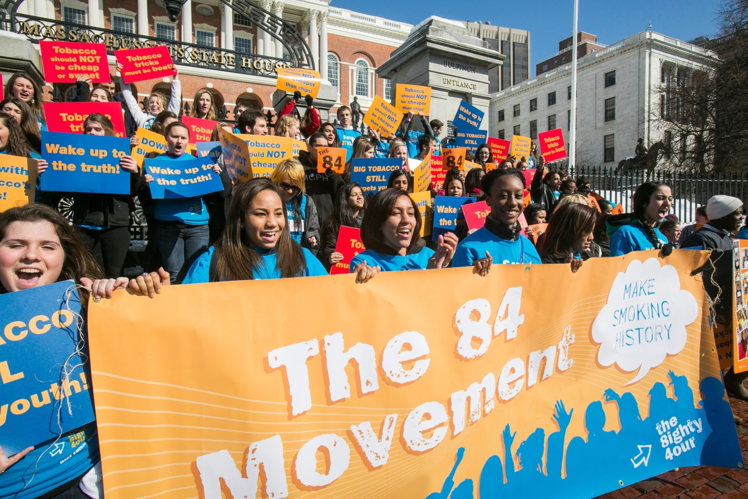



**The Commonwealth of Massachusetts**

Department of Public Health

**March 2019**

# Table of Contents

Executive Summary3

**High School Students6**

Cigarettes6

Smokeless Tobacco11

Cigars13

Other Conventional Tobacco15

Any Conventional Tobacco16

Electronic Nicotine Products17

All Tobacco Products20

Flavored Tobacco21

Tobacco Access22

**Middle School Students23**

Cigarettes23

All Tobacco Products24

Tobacco Access25

**Conclusions26**

**Resources27**

**Appendices28**

Appendix A: Youth Survey Methods28

Appendix B: Youth Data30

**References31**

# Executive Summary

Statewide and nationally, tobacco continues to be the leading cause of preventable death and disease, causing approximately 8,000 deaths in Massachusetts each year.[1] Eighty-two percent of adult smokers in Massachusetts smoked their first cigarette before age 19.[2] Research shows that the earlier young people begin to smoke, the more likely they are to become addicted to cigarettes and smoke heavily.[3]

In Massachusetts, data on youth tobacco use come primarily from two statewide surveys: the Massachusetts Youth Risk Behavior Survey (MYRBS) and the Massachusetts Youth Health Survey (MYHS).

Since 1995, current cigarette use among Massachusetts high school students has declined by over 80%. Current use of conventional tobacco products overall (cigarettes, cigars, or smokeless tobacco-also called chewing tobacco, snuff, or dip- combined) has declined by 68%; from 35.1% in 1999 to 11.4% in 2017. When considered separately from cigarette use, this downward trend has been observed for use of cigars and smokeless tobacco as well.

However, new challenges have emerged. The tobacco industry intentionally targets flavored tobacco products, which include attractive fruit and candy flavors, towards younger users.[4] Among youth who use tobacco, the majority use flavored products.

In 2017, among high school youth who currently use tobacco:

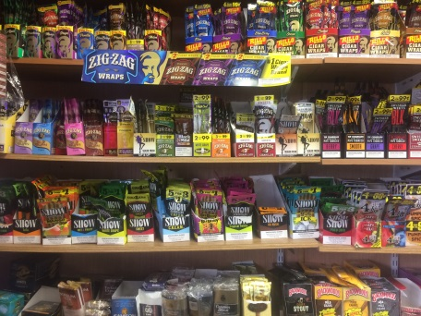

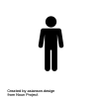

**4** in **5** ***currently*** ***use*** flavored products

Source: MYHS

In addition, many youth are using electronic nicotine products. Electronic nicotine products[5] are battery-operated products which deliver aerosolized flavorings and chemicals, including nicotine, that are inhaled by the user.[6] Nicotine is harmful to the developing adolescent brain and can increase risk of other drug use and addiction, lead to impairments in impulse control, and increase risk of anxiety disorders and depression. Other chemicals in these products, such as diacetyl, and some heavy metals, are linked to lung disease and other conditions.[7]

There are many types of electronic nicotine products, including, but not limited to: JUUL, e-cigarettes, e-cigars, e-pipes, mods, personal vaporizers, vape pipes, vaping pipes, e-hookahs, and hookah pens. These products are increasing in popularity among youth, commensurate with their wide availability, attractive flavors, and pervasive marketing.[8] There is also some evidence to suggest that electronic nicotine product use may increase the risk of conventional cigarette use.[9]

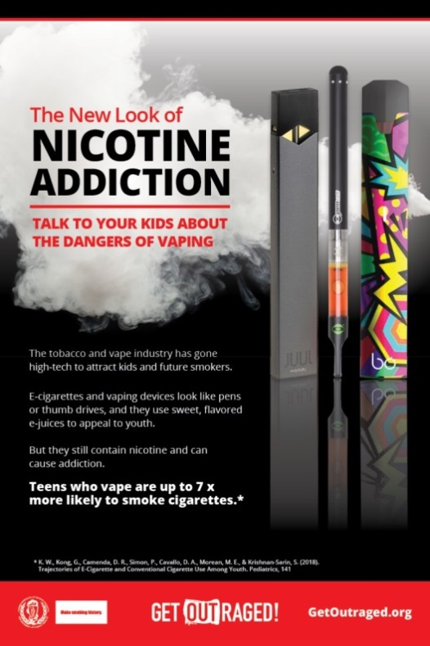 In 2017, among all high school youth:



**2** in **5** ***ever tried*** electronic nicotine products



**1** in **5** ***currently use*** electronic nicotine products

Source: MYRBS

Though 2017 rates of electronic nicotine product use (41.1% ever use, 20.1% current use) decreased slightly from 2015 rates (44.8% ever use and 23.7% current use), current use of electronic nicotine products is still over

**3x**

**2x**

the rate of current cigarette smoking (6.4%), and almost the rate of cigarette, cigar, or smokeless use combined (11.4%).

Similar trends are seen amongst middle school students; in 2017, 1 in 10 middle school students had ever tried an electronic nicotine product, which was significantly higher than any other tobacco product (cigarettes, cigars, or smokeless).

While tobacco use among youth in Massachusetts is generally trending downward, many young people are still becoming addicted (see Appendix B for current rates of tobacco product use among high school students). Massachusetts is fortunate to have a strong group of committed youth, professionals, volunteers, businesses, and organizations who are working diligently to achieve an environment where all people can live tobacco-free. Together, we can make smoking history in Massachusetts.

# Cigarette Smoking- High School Students

***Lifetime Use***

The percentage of high school students who have ever tried smoking cigarettes (lifetime use) was 19.6% in 2017 – a significant decrease from 27.8% in 2015. Since 1995, lifetime use of cigarettes has decreased by 73% percent.

***First Smoked a Whole Cigarette***

The percentage of high school students who smoked a whole cigarette before age 13 (when smoking initiation most often occurs)[10] was 5.7% in 2017- a slight (non-significant) increase from 4.3% in 2015. However, since 1995, the percentage of students who have reported smoking a whole cigarette before age 13 has decreased by 76%.

***Current Use***

Current cigarette smoking has also declined significantly among high school students in Massachusetts. Since 1995, cigarette use within the past 30 days (current use) has decreased by 82%. In recent years, the downward trend has continued with the percentage of current smokers decreasing significantly from 10.7% in 2013 to 6.4% in 2017.



***Gender***

Current cigarette smoking varies by gender. In 2017, the rate of current smoking was significantly lower among female high school students (3.9%), compared to male high school students (8.7%).

***Race/Ethnicity***

Due to small sample sizes, smoking rates cannot be reported by individual race/ethnic categories (eg. non-Hispanic Black, Hispanic, Asian). National data suggests that non-Hispanic Blacks have significantly lower smoking rates than non-Hispanic Whites in high school.[11] However, non-Hispanic Blacks tend to initiate tobacco use at a later age compared to non-Hispanic White youth, and experience inequities in smoking-related outcomes and disease later in life.[12] Both non-Hispanic Black youth and adults smoke menthol cigarettes at higher rates than non-Hispanic Whites and menthol cigarettes are more addictive and harder to quit.[13] Advertising for menthol products is more prevalent in areas with greater proportions of Black and low-income residents.[14],[15],[16]

***Grade Level***

The percentage of current smokers increases as grade level increases. Among twelfth grade students, current cigarette smoking was 10.3%, which is significantly higher than current smoking among 9th and 10th graders.

***Frequent Smoking***

Frequent cigarette smoking (smoking at least one cigarette on at least 20 of the last 30 days) among high school students was 1.0% in 2017 - a significant decrease from 3.2% in 2013. Since 1997, the percentage of frequent smokers has decreased by 95%.

***Youth More Likely to Smoke Cigarettes***

Studies have found that some youth subgroups report higher smoking rates compared to the population as a whole, including LGBTQ youth, youth with poor academic performance, youth with disabilities, and youth with poor mental health or those who have considered suicide.[17],[18],[19],[20][21]The graph below presents the prevalence of current smoking among these groups compared to the state average, in descending order of prevalence. In 2017, smoking rates were significantly higher for high school students who considered suicide (13.9%), or who have a learning disability (12.8%), compared to the state average (6.4%).

The percentage of high school students who live with a smoker has decreased slightly over time; 29% of students reported living with a smoker in 2013, compared to 26% in 2017 (non-significant difference). Nevertheless, high school students who live with a smoker are significantly more likely to smoke themselves – 12.3% compared to 4.4% of those who do not live with a smoker.

# Smokeless Tobacco- High School

***Current Use***

Current smokeless tobacco use among high school students was 4.8% in 2017– a significant decrease from 7.9% in 2009. Smokeless tobacco use is defined as use of chewing tobacco, snuff, or dip (such as Skoal, Grizzly, or Copenhagen) within the past 30 days.

***Gender***

In 2017, current smokeless tobacco use was significantly lower among female high school students (2.2%) compared to male high school students (7.3%).

***Race/ethnicity***

In 2017, smokeless tobacco use was highest among Hispanics (6.2%) compared to non-Hispanic Whites and non-Hispanic Blacks (4.7% and 3.4% respectively), however this difference was not statistically significant. Due to small samples sizes, smokeless use cannot be reported for other race/ethnic groups. National data suggests that use of smokeless tobacco among high school students is highest among non-Hispanic Whites, compared to non-Hispanic Blacks and Hispanics.[22] Current research does not address reasons for these differences.

# Cigars- High School

***Current Use***

Current cigar use (cigars, cigarillos, or little cigars) was first asked on the MYRBS in 1999. Current cigar use among high school students was 6.7% in 2017 – a significant decrease from 14.9% in 2009.



***Gender***

In 2017, current cigar use was significantly lower among female high school students (2.6%) compared to males (10.5%).

***Race/Ethnicity***

Due to small sample sizes, cigar use cannot be reported by individual race/ethnic categories. However, national data suggests that cigar use is higher among non-Hispanic Black students compared to students of other race/ethnicities (National Youth Tobacco Survey, 2016).[23] Studies have found that availability and advertising for little cigars and cigarillos is higher in areas with greater proportions of non-Hispanic Black youth. [24],[25]

# Other Conventional Tobacco- High School

***Current Use***

To compare cigarettes to other conventional tobacco products, a measure of other tobacco product (OTP) use was used. Current use of OTPs (cigars and/or smokeless tobacco) among high school students was 8.8% in 2017, significantly lower than 17.6% in 2009.

***Gender***



In 2017, current use of OTPs was significantly lower among female high school students (4.0%) compared to males (13.5%).

# Any Conventional Tobacco – High School

***Current Use***

Current use of any conventional tobacco products (cigarettes, cigars, and/or smokeless tobacco) decreased from 1999 to 2017. Current tobacco use among high school students was 11.4% in 2017 – a significant decrease from 23.9% in 2009.



***Gender***

In 2017, current use of any conventional tobacco product was significantly lower among female high school students (6.6%) compared to males (16.0%).

# Electronic Nicotine Products– High School

***Lifetime Use***

Use of electronic nicotine products (which include: JUUL, e-cigarettes, e-cigars, e-pipes, mods, personal vaporizers, vape pipes, vaping pipes, e-hookahs, and hookah pens) is very prevalent both nationally, and in Massachusetts.

In 2017, significantly more high school students had ever tried electronic nicotine products (41.1%) than cigarettes (19.6%). This represents a small decline from the students who reported ever trying electronic nicotine products in 2015 (44.8%), though this decrease was not significant.

***Gender***

In 2017, rates of electronic nicotine product ever-use were similar for female (40.1%) and male (42.2%) high school students.

***Current Use***

In 2015, 23.7% of high school students reported currently using electronic nicotine products, which was significantly greater than the use of any other type of tobacco product. In 2017, the percentage of Massachusetts high school students who reported using electronic nicotine products, decreased slightly, but non-significantly, to 20.1%, and remains significantly higher than use of all other tobacco products combined (11.4%). Furthermore, 12.7% of youth currently use electronic nicotine products **exclusively**.

Current

***Gender***

In 2017, current use of electronic nicotine products was lower among female high school students (18.4%), though this difference was not significant. However, many studies suggest that adolescent e-cigarette users are more likely to be male than female.[26]m (21.9%), though this difference was not significant.

***Race/Ethnicity***

In 2017, electronic nicotine product use was higher among non-Hispanic Whites (23.2%) compared to non-Hispanic Blacks (11.8%) and Hispanics (17.7%) (but only significantly higher than the rate for non-Hispanic Blacks). Due to small samples sizes, electronic nicotine product use cannot be reported for other race/ethnic groups. These use rates are consistent with the literature which suggests that electronic nicotine product use is higher among non-Hispanic Whites, compared to students of other race/ethnicities. [27]

**All Tobacco Products- High School**

In 2017, the majority of students who currently use tobacco products reported using electronic nicotine products, followed by cigars, cigarettes, and smokeless tobacco.

Similar subgroups of youth who consistently report higher smoking rates compared to the state average, also report higher tobacco use rates (current use of electronic nicotine products, cigars, cigarettes, or smokeless tobacco combined). In addition to subgroups of youth with significantly higher smoking rates compared to the state average (those who have considered suicide, and those with a learning disability), among all tobacco users, youth with poor academic performance, and youth who report feeling sad or hopeless for two weeks or more, also have higher tobacco use rates compared to the state average. These estimates are presented in the graph below in descending order of prevalence.

# Flavored Tobacco Products- High School

In 2009, the Family Smoking Prevention and Tobacco Control Act banned the sale of flavored cigarettes (excluding menthol and mint flavors). However, this legislation did not extend to non-cigarette products. Since this time, the availability of these non-cigarette products (cigars, smokeless tobacco, and electronic nicotine products) in the retail environment has increased, coinciding with increases in youth use of these products.[28]

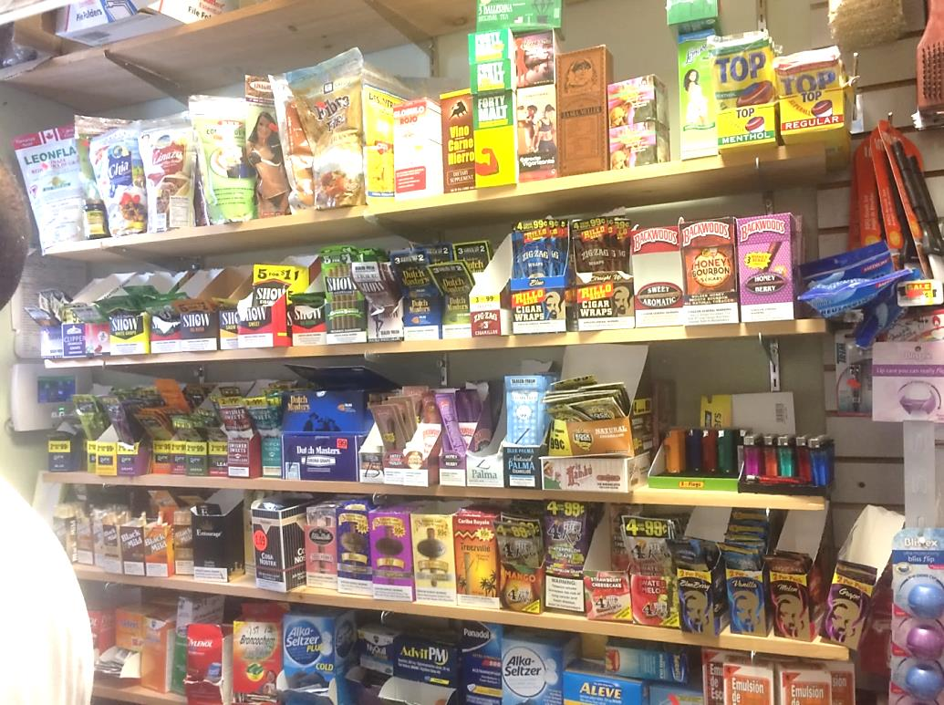

Currently, the majority of high school students who use tobacco products report using flavors. In 2017, the first time flavored tobacco use was captured by the MYHS, 80% of current tobacco users (cigarettes, cigars, smokeless, or electronic nicotine products) in high schools reported using a flavored product (excluding menthol or mint flavors) in the past 30 days. When stratifying by product type, electronic nicotine product users report using flavored products at the highest rate (83%), followed by cigar users (69%), and then smokeless users (40%).

**Tobacco Access- High School**

Students obtain tobacco products from a variety of sources. 2017 was the first year that students were asked about where they accessed their tobacco products (including cigarettes, cigars, smokeless tobacco, and electronic nicotine products). Among high school students who currently use tobacco, about 1 in 3 reported borrowing their products from someone else, or purchasing them from a store (including supermarket, convenience stores, gas station/mini-marts, and vape stores).

Almost 1 in 5 students also reported that they got their tobacco “some other way,” which may include purchasing products online (this will be included as a response option in the 2019 survey).

# Cigarette Smoking- Middle School

# *Lifetime Use*

The percentage of middle school students (6th, 7th, and 8th graders) who ever tried cigarette smoking (lifetime use) was 4.3% in 2017- a significant decrease from 15.5% in 2007. Since 2007, lifetime use of cigarettes has decreased by 72%.

***Current Use***

Current cigarette use (past 30 day use) among middle school students was 0.8% in 2017- a significant decrease from 4.8% in 2007. Since 2007, current smoking has decreased by 71%.

# All Tobacco Product- Middle School

Among middle school students, current use of most tobacco products is very low. For example, in 2017, current use rates of cigarettes, cigars, and smokeless tobacco were all under 1%. Therefore ever-use rates of these products in 2017 are presented below. Similar to high school students, middle school students are significantly more likely to have tried cigars than smokeless tobacco.

2017 was the first year middle school students were asked about electronic nicotine product use. In 2017, ever-use of electronic nicotine products (9.9%) was significantly higher than ever use of any other tobacco product (cigarettes, cigars, or smokeless).

***Gender and Race/Ethnicity***

Though differences in tobacco-ever use may exist by gender and race/ethnicity among middle school students, in general, sample sizes in this age group are too small to present rates by subgroup.

**Tobacco Access- Middle School**

Among middle school students who currently use tobacco, about 2 in 5 reported getting their tobacco products “some other way”, which may include getting products from friends (this will be included as a response option in the 2019 survey). In addition, 1 in 4 students reported borrowing their products from someone else. Significantly fewer middle school students reported getting products from a store compared to high school students (13.1% vs. 32.9%).

# Conclusions

Overall, current (30-day) tobacco use among high school youth in Massachusetts is trending downward.

|  |  |  |  |
| --- | --- | --- | --- |
| **Product** | **2015 (%)** | **2017 (%)** | **Change** |
| Cigarettes | 7.7 | 6.4 | Decrease |
| Smokeless | 5.5 | 4.8 | Decrease |
| Cigars | 10.4 | 6.7 | Significant  Decrease |
| Electronic Nicotine Products | 23.7 | 20.1 | Decrease |

However, youth tobacco use is still a critical issue. For most products, males have significantly higher use rates compared to females. Although comparisons by race/ethnicity are generally not possible due to small sample sizes, national data suggest differences in use rates may exist for some products by race/ethnicity, such as cigars. Future reports will explore the possibility of assessing use rates by race/ethnicity using a combined YRBS/YHS dataset.

In addition, youth in both middle and high school use **electronic nicotine products** at higher rates than any other type of tobacco, and the majority of youth who use tobacco use products that are **flavored**.

The latest figures from 2017 show that even though cigarette smoking among Massachusetts high school students has decreased to the lowest level ever recorded (6.4%), the rate of electronic nicotine product use is over **three times higher** (20.1%). Electronic nicotine product use is also higher than the rate of any conventional tobacco product use combined (cigarettes, cigars, or smokeless) (11.4%). Electronic nicotine product use is also decreasing at a slower rate over time compared to other types of tobacco; from 2015 to 2017 conventional tobacco use decreased significantly by 28%, while electronic nicotine product use only decreased by 15% during the same time frame (and this difference was not significant).

Furthermore, in 2017 (the first year data on flavored tobacco use was captured), 79.8% of high school youth who currently use tobacco reported using a flavored product in the past 30 days. This has important implications for youth prevention efforts, as research suggests that the majority of youth who use flavored tobacco products would stop using tobacco altogether if flavored tobacco products no longer existed.[29]

Current youth prevention efforts in Massachusetts include media/education campaigns, the 84 youth engagement movement, and local tobacco control regulations.

Resources

**Data**: For more data on youth tobacco use in Massachusetts, visit [mass.gov/info-details/tobacco-statistics-in-massachusetts-and-how-tobacco-use-impacts-your-health](https://www.mass.gov/info-details/tobacco-statistics-in-massachusetts-and-how-tobacco-use-impacts-your-health). For more information on electronic nicotine products, visit [makesmokinghistory.org/dangers-of-vaping/](http://makesmokinghistory.org/dangers-of-vaping/).

**Youth Engagement**: For more information on the youth-led movement to prevent youth tobacco use in Massachusetts, visit the84.org. The 84 represents the 84% of youth who did not smoke when this movement began (today, 93% of youth do not smoke).

**Policies:** Municipalities can pass policies aimed at changing the tobacco retail environment, which can decrease youth exposure to tobacco, and in turn, help prevent youth initiation. These policies include restricting flavored tobacco products to adult-only retailers, and raising the minimum price of cigars. For more information on local tobacco regulations in Massachusetts, visit [makesmokinghistory.org/my-community/local-priority-policies/](http://makesmokinghistory.org/my-community/local-priority-policies/).

# Appendix A: Youth Survey Methods

To monitor youth health and risk behaviors, Massachusetts conducts two coordinated statewide surveys in public schools: 1) the Massachusetts Youth Risk Behavior Survey (MYRBS); and 2) the Massachusetts Youth Health Survey (MYHS).

# *Massachusetts Youth Risk Behavior Survey*

The MYRBS is a high school survey conducted every two years since 1993 by the Massachusetts Department of Elementary and Secondary Education (DESE) with funding from the Centers for Disease Control and Prevention (CDC). The survey monitors adolescent risk behaviors related to the leading causes of morbidity and mortality among youth and adults. These behaviors include tobacco, alcohol, and other drug use; behaviors related to intentional and unintentional injuries; high-risk sexual behaviors; poor dietary patterns; and lack of physical activity.

***Massachusetts Youth Health Survey***

The MYHS is the Massachusetts Department of Public Health’s (MDPH) surveillance system to monitor the health of public school students in grades 6 through 12. It is conducted by MDPH in collaboration with the DESE. The survey contains health status questions in addition to questions about risk behaviors and protective factors. MDPH created reports for the Youth Health Survey for data collected in 2007, 2009, 2011, and 2013, and a joint Youth Risk Behavior Survey and Youth Health Survey report for 2015.

In this report on youth tobacco use, the MYRBS is used as the primary data source for high school students, because the CDC considers the state YRBS as the standard survey for high school student risk behaviors. For results on middle school students and questions not available on the MYRBS, the MYHS is used as the data source. All estimates were weighted to the grade, sex, and race/ethnicity distribution of the state, so that they are representative of all students across Massachusetts.

***Statistical Analyses***

As changes in the tobacco landscape and available products occur, questions in the youth surveys have been added to reflect these changes. For some graphs, the starting year reflects the year the question was added to the survey.

To describe trends in cigarette use, data from 1995 is often used as the baseline comparison year, since this was the year that youth smoking rates hit a peak, both in Massachusetts and nationally. To describe trends in use of non-cigarette tobacco product s, data from 2009 is often used as the baseline comparison year, since this was the year that availability and use of these products increased, both in Massachusetts and nationally, after the Family Smoking Prevention and Tobacco Control Act banned the sale of flavored cigarettes.[30]

To determine whether prevalence estimates are statistically different from each other, two statistical tests are used. If the 95% confidence intervals do not overlap, then the prevalence estimates are considered statistically significant. However, this only detects large differences in prevalence estimates. To detect smaller differences, a chi-square analysis with a p-value less than 0.05 is used to determine statistical significance. If not otherwise noted, all differences discussed in the narrative are statistically significant.

Limitations

This report has several limitations. First, all data were self-reported by youth, so the extent of underreporting and overreporting of behaviors cannot be determined. That said, all survey questions demonstrate good reliability.[31] Additionally, as the tobacco industry is consistently changing, examples of tobacco products listed in survey questions may not accurately reflect products available to and used by youth (eg. JUUL), and use rates may be underreported.

Second, the data presented in the report is not representative of all persons in middle and high school in Massachusetts. The data only represent youth who attend public schools; students in private schools, state custody, or alternative educational settings are not represented. Students who are frequently absent from school, such as those with severe disabilities, may also be underrepresented.[32] In addition, sample sizes for students of color (students who do not identify as non-Hispanic White) are small, so in general, data cannot be stratified by race/ethnic categories.

Finally, while the survey analyses accounted statistically for cluster effects, it is possible that tobacco use can have larger than expected cluster effects. That is, students in a classroom who interact with each other on a daily basis can have more similarities on behaviors such as tobacco use, which could limit the representativeness of these results to all Massachusetts youth.

Nevertheless, despite limitations, these surveys provide high-quality trend data on tobacco use among Massachusetts youth.

# Appendix B: 2017 Youth Data

**Current Tobacco Use (use within past 30 days), 2017** (% of high school students)

**Appendix**

|  |  |  |  |  |  |  |  |  |  |  |  |  |  |  |  |  |  |
| --- | --- | --- | --- | --- | --- | --- | --- | --- | --- | --- | --- | --- | --- | --- | --- | --- | --- |
|  | **High school** | **Male** | **Female** | **LGBT** | **White** | **Black** | **Hispanic** | **9th** | **10th** | **11th** | **12th** | **Suicide\*** | **Grades C, D,or F** | **Physical**  **Disability** | **Learning Disability** | **Felt Sad or Hopeless (2 or more weeks)** | **Lives with smoker\*\*** |
| **Cigarettes** | 6.4 | 8.7 | 3.9 | 7.6 | 6.8 | -- | 6.5 | 3.1 | 4.3 | 7.8 | 10.3 | 13.9 | 11.2 | 9.8 | 12.8 | 9.2 | 12.3 |
| **Cigars** | 6.7 | 10.5 | 2.6 | 6.8 | 6.9 | -- | 7.3 | 2.4 | 4.9 | 7.8 | 11.7 | 8.4 | 12.4 | 8.8 | 12.1 | 7.1 | 8.9 |
| **Smokeless** | 4.8 | 7.3 | 2.2 | 4.9 | 4.7 | 3.4 | 6.2 | 1.9 | 3.9 | 7.0 | 6.8 | 5.5 | 8.6 | 9.1 | 9.1 | 5.1 | 5.4 |
| **Other Tobacco\*\*\*** | 8.8 | 13.5 | 4.0 | 8.5 | 8.9 | 5.2 | 10.5 | 3.3 | 6.9 | 10.0 | 15.3 | 10.8 | 15.9 | 13.9 | 16.3 | 9.4 | 10.9 |
| **Any Conventional Tobacco†** | 11.4 | 16.0 | 6.6 | 12.8 | 11.7 | 6.0 | 12.9 | 5.4 | 8.8 | 12.8 | 18.8 | 18.3 | 19.6 | 17.9 | 21.1 | 14.0 | 16.7 |
| **Any**  **Tobacco‡** | 24.6 | 27.8 | 21.2 | 29.4 | 26.9 | 15.5 | 25.0 | 15.4 | 22.5 | 28.4 | 32.4 | 35.8 | 37.4 | 32.4 | 38.0 | 31.7 | 30.8 |
| **Electronic Nicotine Products** | 20.1 | 21.9 | 18.4 | 23.5 | 23.2 | 11.8 | 17.7 | 12.8 | 19.2 | 23.3 | 25.9 | 31.3 | 32.3 | 23.7 | 30.4 | 26.7 | 24.1 |

Source: MYRBS

*Seriously considered attempting suicide in the past 12 months

** Data from MYHS (question not asked on MYRBS)

***Use of smokeless tobacco and/or cigars

†Use of cigarettes, smokeless tobacco, and/or cigars

‡Use of cigarettes, smokeless tobacco, cigars, and/or electronic nicotine products

Note: Due to small sample sizes, some tobacco use rates for race/ethnicity subgroups are suppressed, and use rates for additional race/ethnicity categories cannot be reported. In addition, small sample sizes also prevent reporting of tobacco use rates by sexual orientation and transgender subgroups individually.

# Endnotes

1. Massachusetts Department of Public Health, Tobacco Cessation and Prevention Program. Smoking-Attributable Mortality, Morbidity, and Economic Costs: Massachusetts 2006. Available at: <http://www.mass.gov/eohhs/docs/dph/tobacco-control/economic-costs-of-smoking.pdf>.
2. Massachusetts Department of Public Health, 2007 Massachusetts Behavioral Risk Factor Surveillance System (BRFSS).
3. Everett SA, Warren CW, Sharp D, et al. Initation of Cigarette Smoking and Subsequent Smoking Behavior among U.S. High School Students. Preventive Medicine. Preventive Medicine. 1999; 29(5): 327-333.
4. Kostygina G, Glantz SA, Ling PM. Tobacco industry use of flavours to recruit new users of little cigars and cigarillos. Tobacco Control*.* Published Online First: 29 October 2014.
5. The term “electronic nicotine products” is used in this report to be consistent with other documents. However, survey questions use the term “electronic vapor products.”
6. U.S. Food and Drug Administration. Vaporizers, E-Cigarettes, and other Electronic Nicotine Delivery Systems (ENDS). 2016.
7. U.S. Department of Health and Human Services. E-Cigarette Use Among Youth and Young Adults. A Report of the Surgeon General. 2016. Atlanta, GA: U.S. Department of Health and Human Services, Centers for Disease Control and Prevention, National Center for Chronic Disease Prevention and Health Promotion, Office on Smoking and Health
8. Campaign for Tobacco Free Kids, Electronic Cigarettes and Youth (2015). Available at: <https://www.tobaccofreekids.org/research/factsheets/pdf/0382.pdf>.
9. U.S. Department of Health and Human Services, 2016.
10. Miech RA, Johnston LD, O’Malley PM, et al. Monitoring the Future National Survey Results on Drug Use, 1975-2015: Volume 1, Secondary School Students, Ann Arbor, Institute for Social Research, The University of Michigan, 2016. <http://www.monitoringthefuture.org/pubs/monographs/mtf-vol1_2015.pdf>.
11. CDC, “Tobacco Use Among Middle and High School Students—United States, 2011-2017,” MMWR, 67(22): 629-633, June 7, 2018, <https://www.cdc.gov/mmwr/volumes/67/wr/pdfs/mm6722a3-H.pdf>.
12. Roberts ME, Colby SM, Lu B, Ferketich AK. Understanding tobacco use onset among African Americans. Nicotine & Tobacco Research. 2016;18(suppl 1):S49–S56. 
13. Fagan P, Pohkrel P, Herzog T, et al. Comparisons of three nicotine dependence scales in a multiethnic sample of young adult menthol and non-menthol smokers. Drug and Alcohol Dependence. 2015; 149: 203-211.
14. Lee, J. G., Henriksen, L., Rose, S. W., Moreland-Russell, S., & Ribisl, K. M. (2015). A systematic review of neighborhood disparities in point-of-sale tobacco marketing. American journal of public health, 105(9), e8-e18;
15. Rodriguez, D., Carlos, H. A., Adachi-Mejia, A. M., Berke, E. M., & Sargent, J. D. (2012). Predictors of tobacco outlet density nationwide: a geographic analysis. Tobacco Control, tobaccocontrol-2011
16. Moreland-Russell, S., Harris, J., Snider, D., Walsh, H., Cyr, J., & Barnoya, J. (2013). Disparities and menthol marketing: additional evidence in support of point of sale policies. International journal of environmental research and public health, 10(10), 4571-4583.
17. Corliss HL, Wadler BM, Jun HJ, et al. Sexual-orientation disparities in cigarette smoking in a longitudinal cohort study of adolescents. Nicotine & Tobacco Research. 2013; 15: 213-222.
18. Morin AJ, Rodriguez D, Fallu JS, et al: Academic achievement and smoking initiation in adolescence: a general growth mixture analysis. Addiction. 2012, 107 (4): 819-28.
19. Nagarajan VD and Okoli CT. A systematic review of tobacco use among adolescents with physical disabilities. Public Health. 2016; 133: 107–115
20. McNamara JK, and Willoughby T. A longitudinal study of risk-taking behavior in adolescents with learning disabilities. Learning Disabilities Research & Practice. 2010; 25(1): 11-24
21. DeHay T, Morris C, May MG, et al. Tobacco use in youth with mental illnesses. Journal of Behavioral Medicine. 2012; 35(2), 139–148.
22. Centers for Disease Control and Prevention. Smokeless Tobacco Use in the United States (2016). Available at: <https://www.cdc.gov/tobacco/data_statistics/fact_sheets/smokeless/use_us/index.htm>.
23. Jamal A, Gentzke A, Hu SS, et al. Tobacco Use Among Middle and High School Students—United States, 2011-2016. MMWR Morb Mortal Wkly Rep. 2017; 66: 597-603.
24. Kirchner, T, et al., “Tobacco retail outlet advertising practices and proximity to schools, parks and public housing affect Synar underage sales violations in Washington, DC,” Tobacco Control 24: e52-e58, 2015.
25. Cantrell J, et al., “Marketing Little Cigars and Cigarillos: Advertising, Price, and Associations with Neighborhood Demographics,” American Journal of Public Health, published online ahead of print August 15, 2013.
26. # Perikleous EP, Steiropoulos P, Paraskakis E, et al. E-Cigarette Use Among Adolescents: An Overview of the Literature and Future Perspectives. Fronteirs in Public Health. 2018; 6:86.

   
27. Dutra  LM and Glantz  SA.  Electronic cigarettes and conventional cigarette use among U.S. adolescents: a cross-sectional study. *JAMA Pediatr*. 2014;168(7):610-617.
28. Courtemanche CJ, Palmer MK, Pesko MF. Influence of the Flavored Cigarette Ban on Adolescent Tobacco Use. American Journal of Preventive Medicine. 2017; 52(5):e139-e146.
29. Harrell MB, Loukas A, Jackson CD, Marti CN, Perry CL. Flavored Tobacco Product Use among Youth and Young Adults: What if Flavors Didn't Exist? Tobacco Regulatory Science. 2017; 3(2): 168-173.
30. Courtemanche et al., 2017.
31. Kann L, McManus T, Harris WA, et al. Youth Risk Behavior Surveillance- United States, 2017. MMWR Surveill Summ 2018; 67(8):1-114.
32. Health & Risk Behaviors of Massachusetts Youth, 2015. Massachusetts Department of Elementary and Secondary Education and Massachusetts Department of Public Health. Available at: <http://www.doe.mass.edu/sfs/yrbs/2015report.pdf>.