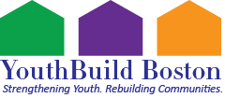
Are you between the ages of 18-24?
Do you have a high school diploma?
Did you leave high school without graduating and need to obtain a HiSET?
Are you interested in architecture and design and between the ages of 14-18 yrs old?
Interested in the trades and or construction industry?
Do you want to apply to the Trades Unions?
Want to get paid while receiving hands on training?
If you have answered “Yes” to any of these questions,
SCAN THE QR CODE BELOW TO REGISTER FOR OUR ZOOM MEETINGS EVERY 1st and 3rd THURSDAY OF THE MONTH at 7PM

