Getting started on EEC's "Provider Portal" in "LEAD"

EEC's "Provider Portal" in "LEAD" is an online interface which allows you, as a provider, to digitally work with EEC. It is a place for you to manage your provider information, submit incidents, or respond to EEC about a visit. In the future, it will also act as a place for you to have access and to keep track of all the documentation and records created while working with EEC, such as licensing applications.

Step One:

To get started on the EEC Provider Portal in LEAD, your first step is contact your Licensor (or EEC regional office) and request that they create an account for you on the EEC Provider Portal. Please note: to have an EEC Provider Portal account, you must have a valid email address, preferably one you are checking regularly.

Step Two:

EEC personnel will create an account for you, and you will receive an email welcoming you to the EEC Provider Portal in LEAD with instructions about how to connect. Here is an example of the type of email you will receive:

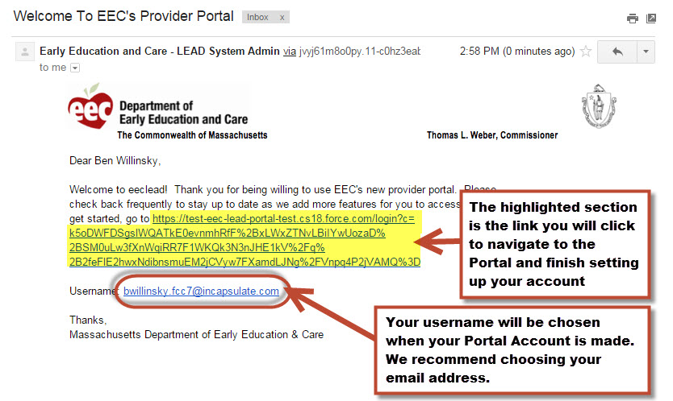

You will notice that the email has a link that you will use to activate your account and your chosen username. To activate your account you will follow the link in the email.

Step Three:

This will navigate you to the EEC Provider Portal in LEAD where you will set up a password: You will select a password, type it into “New Password” and “Verify New Password”, then click “Change Password. Your password must be at least eight (8) characters lone and have a mix of numbers, uppercase and lowercase letters, and at least one of these special characters: !#$%-_=+<>

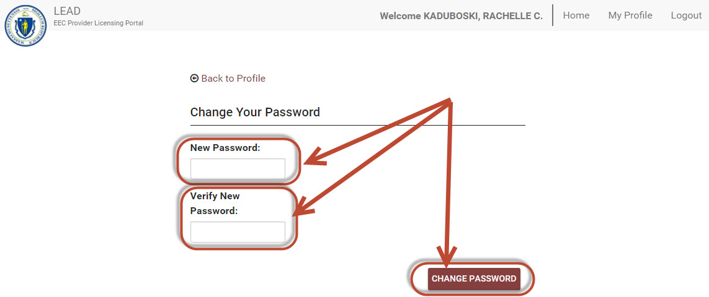
You are now set on the EEC Provider Portal!

(If you forget your password in the future, you can use these same steps to reset it).

See "Navigating the EEC Provider Portal in LEAD" for further instructions and/or follow this link to a You Tube video to help you log on for the first time and navigate the EEC Provider Portal in LEAD.

https://youtu.be/3Yp5mMIXMII

