Navigating the EEC Provider Portal in LEAD

The EEC Provider Portal in LEAD can be accessed from any computer or mobile device with internet connectivity. Navigating to the EEC Provider Portal is easy, you can get there by going to the website eeclead.force.com.

The EEC Provider Portal in LEAD works best in the most recent versions of Chrome, Firefox, Safari, or Internet Explorer (version 10 or higher). For optimal performance, please ensure that your browser is fully updated to its most recent version.

The Home Page

When you first log into the EEC Provider Portal, you will be on the Home Page. This page has several sections. The Latest News section is an area that will be periodically updated by EEC and provide you with important information. The "Provider" link will navigate you to a page with all of your provider information. The New Incident /Injury Link will let you log a new incident or injury. There is also a section at the bottom of the page which has links to a number of useful websites.

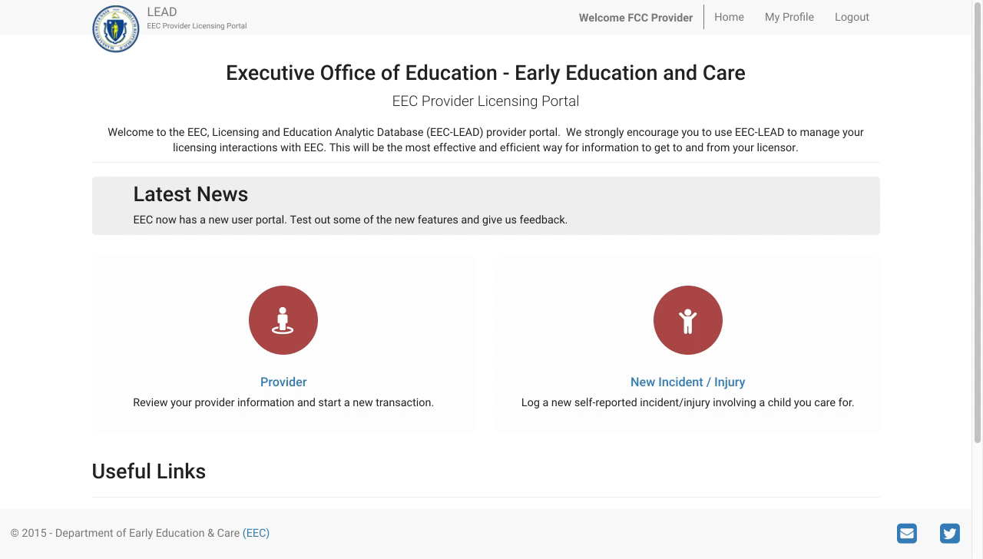

The Provider Page

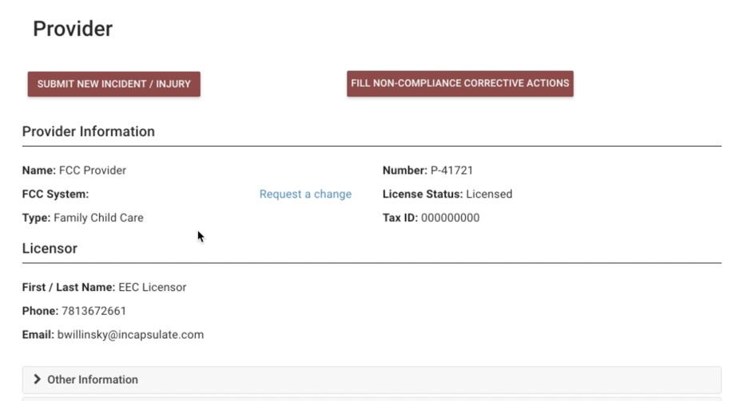

All information about the Provider will be included in one of the dropdown related lists on the Provider page. Some of the related lists will contain basic information about the Provider, such as:
- Contact Phone number and email address
- Address information
- Information about the license

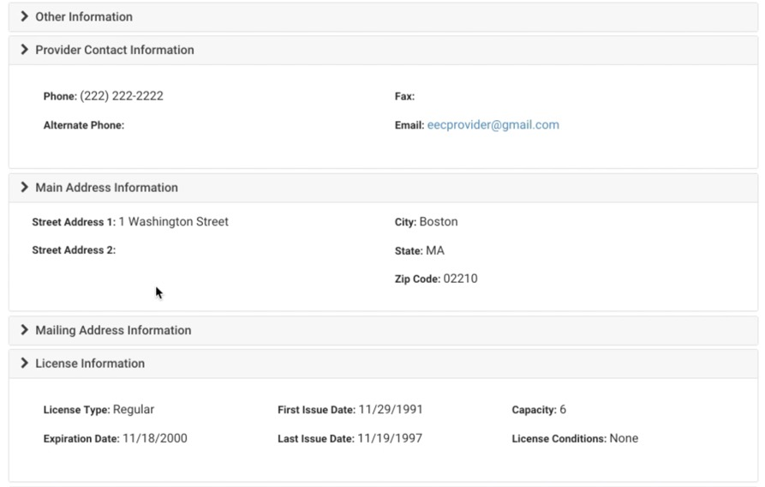
Other related lists will contain detailed information on all of the interactions between you and EEC. As you use the EEC Provider Portal over time you will see a comprehensive list of:
- Visits
- Reported Injuries and Incidents
- Investigation reports
- Internal Investigations (as applicable)

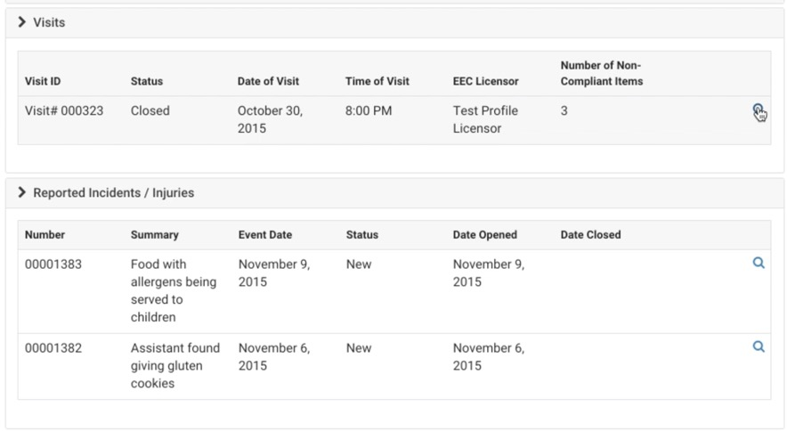

By clicking the magnifying glass, you can see a more detail about a record. The records will be on the EEC Provider Portal for you to access at any time. As an example, you can click the magnifying glass next to a Visit which you want to view more detail.
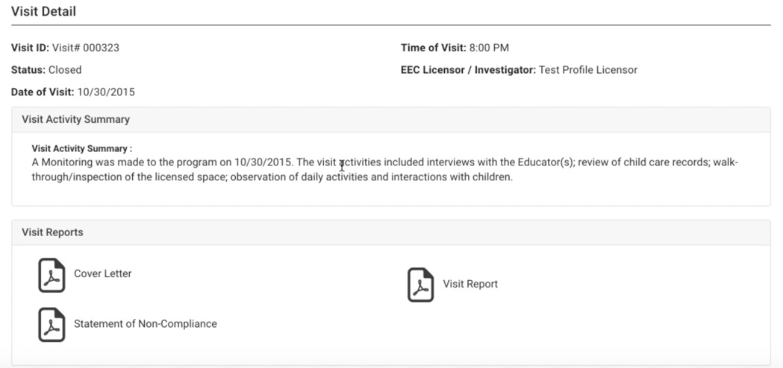

On the visit page you will be able to view all relevant information about this visit. this includes:

- PDFs of generated reports that can be open with a click and then saved or downloaded
- Breakouts of non-compliant visit items

Similarly, if you go to view Incident or Injury you can a view the complete record, of what was submitted.
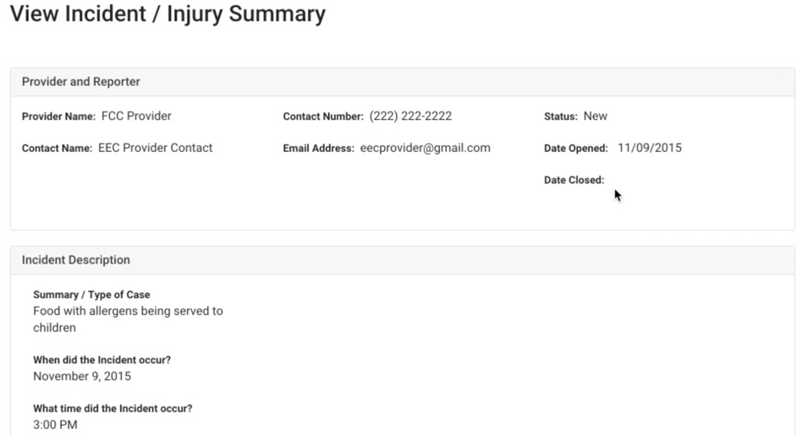

On the investigation page, you can see all of the investigation details including::
- PDFs of generated reports
- Identified Noncompliance items and associated visits

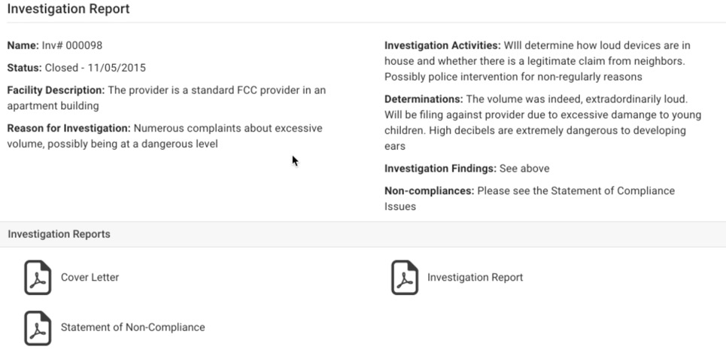

When visit Items are found to be non-compliant, the Licensor will submit them to the EEC Provider Portal for you to document your corrective action plans. You will be notified by EEC via email if you have any pending corrective actions. The EEC Provider Portal in LEAD will allow you fill out the corrective action plan directly and submit it back to EEC.

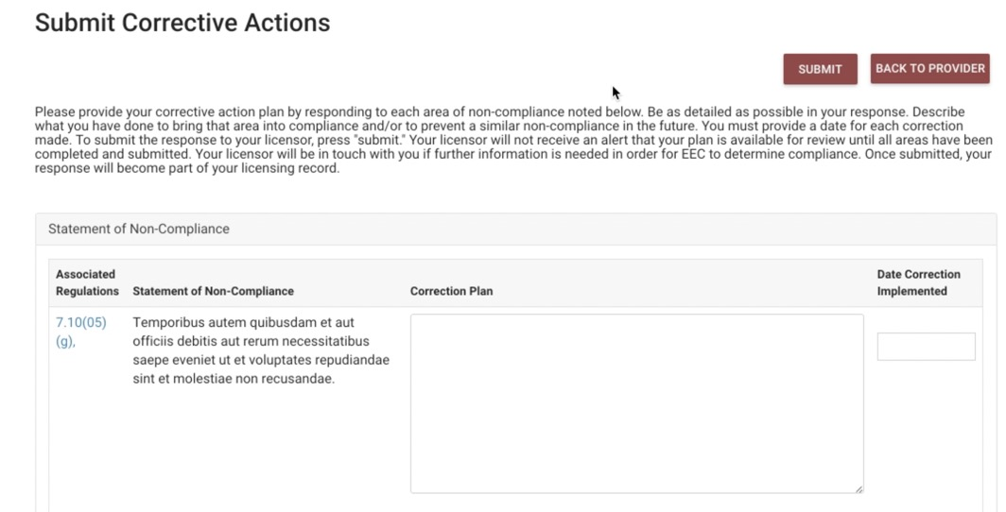

New Incident / Injury will allow you, as a Provider, to submit a self-reported Incident / injury. Clicking on the link will bring you to a series of web pages that will instruct you on what information is needed.

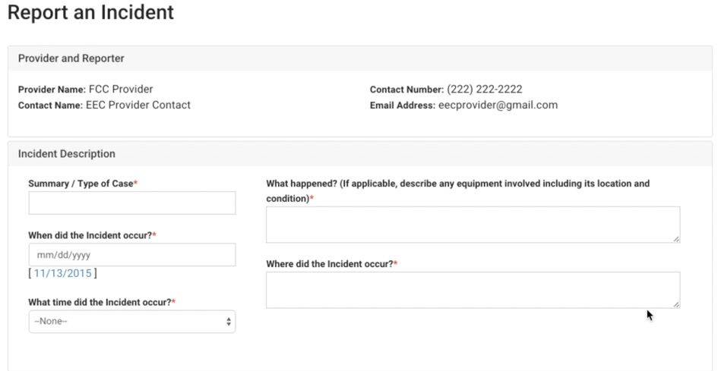
Additional features for Residential and Placement providers:

Quarterly restraint reports and internal investigation reports can be submitted through the EEC Provider Portal in LEAD. Stay tuned, further training will be offered regarding restraint reports.

Reporting issue to EEC regarding the EEC Provider Portal in LEAD:

Technology or technology support issues should not be reported to your EEC licensor. Please use the web form from the URL below to submit support or technical issues for the EEC Provider Portal.

http://eoe.state.ma.us/contactus.aspx
You should be able to see the dropdown for applications listed on the “Subject” line of the form and should select “Licensing Education Analytic data (LEAD)” to submit any request.
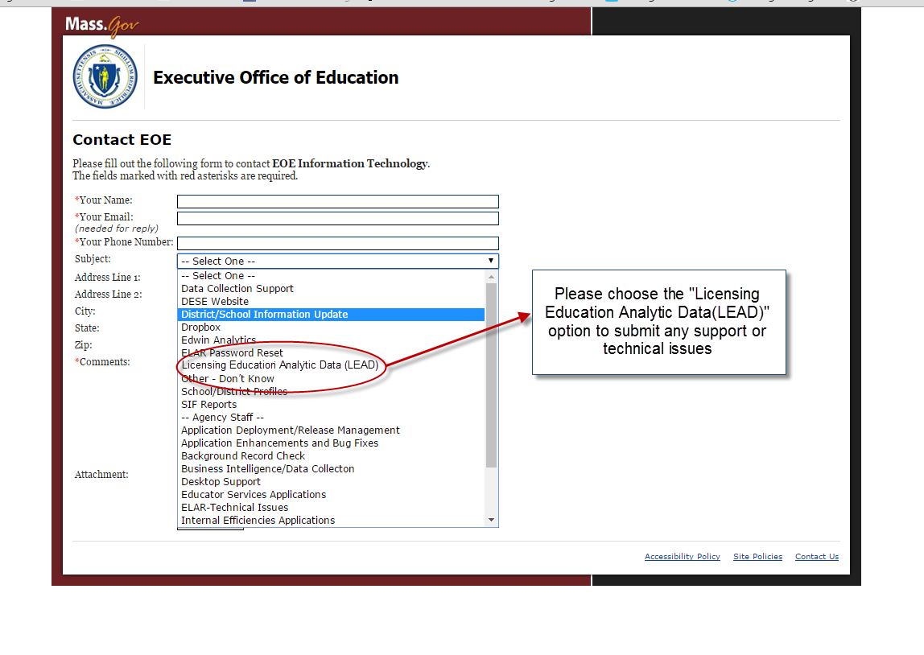
Submitting a form will trigger a COMiT ticket in an email format. This email will be sent to the group responsible for attending to this issue. Please do not use any other EEC helpdesk for reporting matters related to the EEC Provider Portal in LEAD.

Future Features of the EEC Provider Portal coming later this year:

As the EEC LEAD system expands, more features will be added to the EEC Provider Portal in LEAD, such as:

Licensing applications; new, renewal, upgrade etc.
Requests for license changes; change of address, name changes etc.

Thank you for using the EEC Provider Portal in LEAD:

This information should help you get started using the EEC Provider Portal in LEAD. If you have not already done so, please also watch the You Tube video in this link to review this information in a video format https://youtu.be/3Yp5mMIXMII

Captioning may be turned on within the video by clicking on the CC button at the bottom of the video screen.

Thank you in advance for using the EEC Provider Portal in LEAD.

