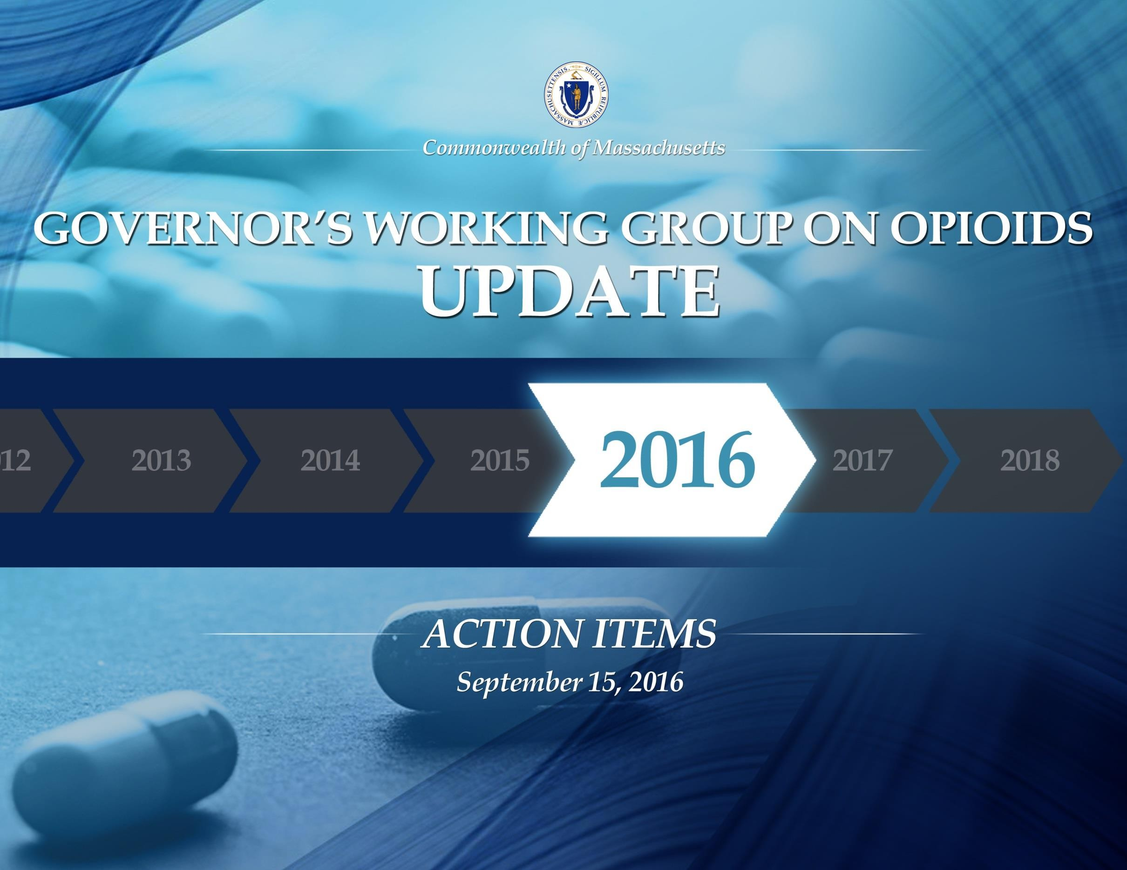

1
Progress to date . . .

2

To date, 93% of the action items, announced by Governor Baker on June 22, 2016, are either in progress or completed. A
few highlights include:

Prevention:
• In March 2016, we implemented a first in the nation 7-day limit on opioid prescriptions to limit first time exposure to opioids.
• We created three public awareness campaigns – State Without Stigma, Stop Addiction, and promotion of the Good Samaritan Law – to reduce stigma and raise awareness.
• We worked with medical schools, dental schools, advanced practice nursing (APRN) programs and professional organizations,
physician assistant programs, the Massachusetts Association of Physician Assistants, the Massachusetts League of Community Health Centers, and all affiliated community health centers to implement a set of core competencies related to the prevention and management of prescription drug misuse for medical professionals.

Intervention:
• We launched a completely new and improved Prescription Monitoring Program on August 22, 2016.
• We improved data collection and the timeliness of releasing data about the impact opioids are having on our communities, issuing a quarterly report.

Treatment:
• Since January of 2015, we have added 455 substance use treatment beds to the system.
• In April 2016, we ended the practice of sending women who are civilly committed because of the risk they pose to themselves or others,
as a result of a substance use disorder, to MCI-Framingham.

Recovery:
• As of September 1, 2016, 83 Sober Homes have been certified by the Massachusetts Association of Sober Houses.

2
Prevention Initiatives

3

Public Awareness
• Create a public awareness campaign focused on reframing addiction as a medical disease
• Foster public-private partnerships to leverage public awareness activities
• Promote drug take-back days
• Partner with a chain pharmacy to pilot a drug-take-back program in the Commonwealth

Education – Parents and Students
• Educate parents, students, and faculty about the risks of opioid use and misuse during mandatory athletic meetings
• Provide state funding for evidence-based opioid prevention programs in schools
• Develop targeted educational materials for parents about the risks of opioid use and misuse

Prescriber Practices
• Mandate prescriber education as a condition of licensure by working with boards of registration to enforce continuing education requirements related to: effective pain management; identification of patients at high risk for a SUD; and counseling patients on the side effects, addictive nature, and proper storage and disposal of prescription medications
• Appoint an addiction specialist to the Board of Registration in Medicine, Board of Registration in Nursing, Board of Registration of
Physician Assistants, and Board of Registration in Dentistry
• Appoint members to the drug formulary commission and commence the first meeting prior to August 1
• Outreach to prenatal and postpartum care providers to increase training about screening, intervention, and care for women with a substance use disorder (SUD)
• Increase and improve educational offerings about safe prescribing practices by engaging in private-public partnerships
• Encourage the American College of Graduate Medical Education to adopt requirements for pain management and substance use disorder education for all medical and residency programs, through a partnership with federal leaders

complete in progress not in progress

3
Intervention Initiatives

4

Prescription Monitoring Program
• Improve the prescription monitoring program (PMP)
• Ensure data compatibility of the PMP with other states, Memorandum of understanding with other states required
• Require PMP data to be submitted within 24 hours by pharmacies, Legislation required

Data
• Require timely reporting of overdose death data to the public
• Amend Department of Public Health regulations to require that emergency medical service providers report opioid overdose data
• Utilize overdose reports to identify geographical hot spots for targeted intervention and alert law enforcement, public health entities, community coalitions, and the public

Other Intervention Action Items
• Develop and distribute educational materials for prescribers to increase co-prescribing of naloxone with opioid prescriptions
• Implement a training program about neonatal abstinence syndrome and addiction for Department of Children and Families’ staff
• Promote the Good Samaritan law
• Amend the civil commitment statute, section 12 of chapter 123 of the General Laws, to allow for the involuntary transport and assessment of an individual with a substance use disorder (SUD), Legislation required
• Improve affordability of naloxone through bulk purchasing, Legislation required

complete in progress not in progress

4
Treatment Initiatives

5

MassHealth
• Develop a statewide database of available treatment services, accessible by phone and internet
• Expand mobile emergency service programs to support individuals with a substance use disorder (SUD) in crisis
• Provide case management services to MassHealth fee-for-service members who have a SUD
• Remove fail-first requirements for medication-assisted treatment and ensure naltrexone is categorized as a pharmacy benefit within all MassHealth plans
• Review SUD treatment prior authorization policies across MassHealth to ensure consistency and remove barriers to treatment
• Enroll uninsured patients receiving acute treatment services or clinical stabilization services in MassHealth or other insurance

Department of Public Health
• (Pilot) Create walk-in access to a trained clinician in community-based outpatient provider settings who can provide an emergent/urgent addiction assessment and direct referral to the appropriate level of care
• (Pilot) Make recovery coaches available in emergency departments and hot spots
• Increase the number of office-based opioid treatment programs in community health centers
• Integrate medication-assisted treatment into the clinical stabilization services (CSS) care setting
• Add 100 new treatment beds by July 2016 and expand access to patient navigators

complete in progress not in progress

5
Treatment Initiatives

6

Department of Corrections
• Bulk purchase opioid agonist and naltrexone therapies for correctional facilities
• Improve SUD treatment services for men and women committed under section 35 of chapter 123 of the General Laws:
• Transfer women from the correctional facility at MCI-Framingham to a new facility run by the Executive Office of Health and
Human Services (EOHHS)
• Develop a feasibility plan to transfer responsibility for the Massachusetts Alcohol and Substance Abuse Center at Bridgewater to EOHHS, Legislation required
• Increase treatment beds and ensure a continuum of care for patients who are civilly committed under section 35

Division of Insurance
• Review existing Division of Insurance bulletins regarding parity oversight and enforcement
• Issue guidance on the implementation of the substance use disorder recovery law before October 1, 2015

Group Insurance Commission
• Ensure that all Group Insurance Commission (GIC) plans provide coverage for naltrexone, naloxone, buprenorphine, and methadone
• Review GIC insurance plans, removing fail-first policies and prior authorization protocols that may impede access to treatment

Partnering with Federal Leaders
• Change Drug Enforcement Agency (DEA) rules to permit medical residents to prescribe buprenorphine under an institutional DEA
registration number, through a partnership with federal leaders
• Change federal law and regulations to increase access to buprenorphine by: increasing the cap - the number of patients a physician can treat with buprenorphine - or removing it entirely; and permitting nurse practitioners and physician assistants to prescribe buprenorphine, through a partnership with federal leaders

complete in progress not in progress

6
Recovery Support Initiatives

7

Department of Public Health
•Enforce and strengthen the requirement that all licensed addiction treatment programs accept patients who are on methadone or buprenorphine medication
•Implement a process to certify alcohol and drug-free housing to increase accountability and credibility
•Establish revised rates for residential recovery homes, effective July 1, 2015
•Leverage community coalitions to address the opioid epidemic
•Open Recovery High School in Worcester

Executive Office of Health and Human Services
• Create a consistent public behavioral health policy through a review of all DPH and DMH licensing regulations for outpatient
primary care clinics, outpatient mental health clinics, and BSAS programs removing all barriers to integration
• Ensure MassHealth coverage is reinstated on an accelerated basis for individuals upon release from incarceration
• Establish a single point of accountability for addiction and recovery policy within the Executive Office of Health and Human
Services
• Amend the composition of the Interagency Council on Substance Abuse, Legislation required
• Report publicly on the progress and challenges of implementing the working group’s recommendations
• Increase federal support for substance use prevention, intervention, treatment, and recovery efforts uniquely tailored for our
Veterans, through a partnership with federal leaders

complete in progress not in progress

7
Budget and Legislation

8

• Supplemental Budget (Ch. 119 of the Acts of 2015): Appropriated $27.8 million to curb the opioid epidemic ($3 M to expand SUD treatment for MassHealth members, $5.8 M to support the opening of the Women’s Recovery from Addictions Program at Taunton State Hospital, $14 M to support treatment of individuals in a residential recovery setting, $5 M to support SUD prevention efforts).
• FY 2016 Budget (Ch. 46 of the Acts of 2015): Appropriated $134 million for substance use treatment, prevention, intervention, and recovery efforts. Included a strong investment in developing new clinical stabilization beds, funded a public awareness campaign about the Good Samaritan Law, invested in community coalitions, invested in
improving access to medication assisted treatment, and authorized a bulk purchase trust fund to support the purchase of Narcan by first responders in our cities and towns.
• Criminalizing Fentanyl Trafficking (Ch. 136 of the Acts of 2015): Mandates that trafficking fentanyl is a felony and institutes mandatory minimums on the charge.
• Ended the practice of civilly committing women under Section 35 to MCI-Framingham (Ch. 8 of the Acts of 2016): Eliminates the possibility that women can be committed to MCI-Framingham under Section 35 of Chapter 123 of the General Laws. Ensures that women with a substance use disorder who are civilly committed will now receive substance use treatment at an appropriate facility.
• STEP Act (Ch. 52 of the Acts of 2016): limits a first-time opioid prescription to seven days; requires practitioners to check the PMP before prescribing opioids; requires student prevention education training during concussion safety training for athletes; increases prescriber education requirements; expands Good Samaritan protections by shielding individuals administering Narcan to a person during an opiate overdose from civil liability; and requires a substance use disorder evaluation for individuals presenting in the emergency room because of an apparent opiate overdose.
• FY 2017 Budget (Ch. 133 of the Acts of 2016): Appropriated $173 million for substance use treatment, prevention, intervention, and recovery efforts. Including a $24 million increase ,over FY 16 GAA, in support for residential recovery beds, continued support for 19 community coalitions, support for 32 office based opioid treatment programs,
41 outpatient treatment programs, and 10 recovery support centers.

8
Public Awareness Campaigns and Improved Treatment Locator Services

Launched 3 public awareness campaigns:
• Stop Addiction in its Tracks, providing information on
how to prevent and identify opioid misuse and where
to go for help http://www.mass.gov/eohhs/gov/departments/dph/stop-
addiction/
• #StateWithoutStigMA, changing the way we think
about, talk about and treat people with addiction
http://www.mass.gov/eohhs/gov/departments/dph/stop-addiction/state-without- stigma/
• MakeTheRightCall, to improve public awareness about
the Good Samaritan Law
http://www.mass.gov/eohhs/gov/departments/dph/programs/substance- abuse/make-the-right-call-public-information-campaign.html

450,000

400,000

350,000

300,000

250,000

200,000

150,000

18,329

264,123

Make the Right Call unique web hits

Stop Addiction unique web hits

#StateWithoutStigMA
unique web hits

Helpline calls

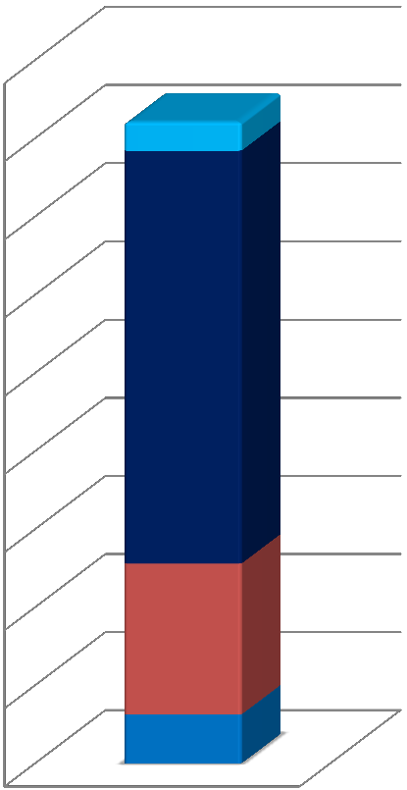
Improved Treatment Locator Services, including:
• BSAS Helpline, (800) 327-5050
• The MBPH treatment locator
http://www.mabhaccess.com/
100,000

50,000

0
96,650

31,363
New PMP System: MassPAT

10

• The new Massachusetts Prescription Awareness Tool (MassPAT): provides an enhanced user experience; improves data collection and timeliness; expand interstate connectivity; and allows for integration with electronic medical records systems.

• Response times to query prescription data is significantly reduced to 1.7 seconds.

• To date, MassPAT can send and receive prescription data from RI, CT, VT, VA, GA, NY, AZ, CO, ID, and TX.

• Massachusetts pharmacies are required to report data within 24-hours or no later than the next business day.

• 80% of individuals who were registered on the old system have registered for
MassPAT.
Summary of Treatment Service Expansion for Psychiatric
and Substance Use Services in the Commonwealth
(As of September 1, 2016)

Program Type | Total Operational Licensed Capacity as of January 1, 2015 | Total Operational Licensed Capacity as of January 1, 2016 | Total Operational Licensed Capacity as of September 1, 2016 | Change Since  January 1, 2015
DPH Acute Treatment Services (ATS) (level 4.0 & 3.7), Adult | 846 beds | 902 beds | 953 beds | 107 beds
DPH Clinical Stabilization Services (CSS) | 297 beds | 340 beds | 454 beds | 157 beds
DPH Transitional Support Services (TSS) | 339 beds | 312 beds | 342 beds | 3 beds
DPH Adult Residential Recovery | 2300 beds | 2375 beds | 2,405 beds | 105 beds
DPH Youth Stabilization Beds | 48 beds | 48 beds | 48 beds
DPH Second Offender Residential | 58 beds | 58 beds | 58 beds
DPH Adolescent / Transitional Youth Residential Beds | 144 beds | 111 beds | 86 beds | -40 beds*
DPH Family Residential | 110 families | 110 families | 110 families
DMH Adult Psychiatric | 1782 beds | 1854 beds | 1,904 beds | 122 beds
DMH Geriatric Psychiatric | 399 beds | 399 beds | 453 beds | 54 beds
DMH Adolescent & Child Psychiatric | 252 beds | 266 beds | 266 beds | 14 beds
Section 35 Men's Beds | 258 beds | 308 beds | 308 beds | 50 beds
Section 35 Women's Beds | 90 beds | 90 beds | 163 beds | 73 beds
DPH Outpatient Treatment Program (OTP) - Medication Assisted  Treatment (MAT) Programs (Methadone) | 39 programs | 41 programs | 41 programs | 2 programs
DPH Outpatient Counseling and Outpatient Detox Programs | 190 programs | 190 programs | 192 programs | 2 programs
DPH Office-Based Outpatient Treatment (OBOT) (buprenorphine) – MAT Sites funded by DPH | 14 programs | 17 programs | 30 programs | 16 programs
Sober Homes Certified by the Mass Association of Sober Houses | 0 | 0 | 83 homes  1,082 beds | 83 homes  1,082 beds
* DPH has awarded contracts to providers to add 60 new beds across 4 programs, these beds are not included in this number

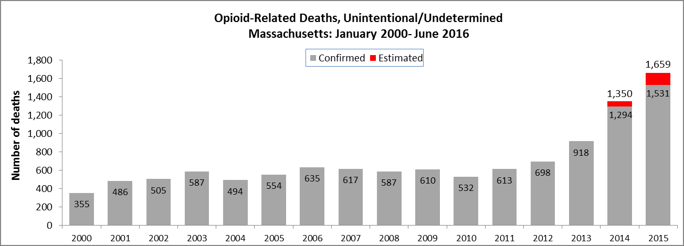Opioid-Related Deaths, Unintentional / Undetermined, (Massachusetts 2000-2015)

12

Source: DPH. http://www.mass.gov/eohhs/docs/dph/quality/drugcontrol/county-level-pmp/data-brief-overdose-deaths-may-2016.pdf
In 2015, 57% of opioid-related deaths with toxicology screen tested positive for fentanyl. During the first six months of 2016, that number rose to 66%
Opioid-related Deaths, All Intents by Month
Massachusetts Residents: January 2015 - June 2016

200
180
160
Number of deaths
140 17
120 19
100
80

Confirmed Estimated
Opioid-Related Deaths by Month

11 18

156

46 95

150 171
60 135 119 140
40
20
0
107 111 97 100 122 120 124 126 97
136

108
82

20 2
January March May July September November January March May

2015 2016

754

565
Opioid-Related Deaths with a Positive
Toxicology Screen for Fentanyl

Negative for fentanyl

289

150

January 2015 – December 2015

Positive for fentanyl

January 2016 – June 2016

13

Using predictive modeling techniques and multiple data sources, DPH is able to estimate opioid-related deaths month-to-month with minimal delay in reporting, http://www.mass.gov/eohhs/docs/dph/quality/drugcontrol/county-level-pmp/data-brief-overdose-deaths-may-2016.pdf

13
Unintentional Opioid-related Overdose Deaths vs. Motor Vehicle-related Injury Deaths, (Massachusetts 2000-2015)

Unintentional Opioid-related Overdose Motor Vehicle-related Injury

1,800

1,600

1,659

1,400
Number of Deaths

1,200

1,000

800

600

493

200
338
315

14
0
2000 2001 2002 2003 2004 2005 2006 2007 2008 2009 2010 2011 2012 2013 2014 2015

Source: DPH. Note: 2015 motor vehicle data and 2014/2015 overdose data are based on DPH estimates
State Spending to Support Substance Use Prevention, Treatment, Intervention, and Recovery Efforts has increased steadily over the past six fiscal years

15

Agency | FY12 GAA | FY13 GAA | FY14 GAA | FY15 GAA | FY16 GAA & Supp Budget | FY17 Projected
Department of Public Health | $83,110,802 | $85,464,595 | $92,258,094 | $101,877,333 | $136,321,803² | $143,695,567
Department of Mental Health |  |  |  |  | $3,500,000³ | $13,212,701
MassHealth Substance Abuse Disorders Services (including  Methadone) | $150,243,844¹ | $145,943,598¹ | $158,797,616¹ | $185,329,771¹ | *
Medication Assisted Treatment (e.g. Buprenorphine, Naltrexone) | $21,827,729¹ | $29,947,101¹ | $24,586,518¹ | $20,536,840¹ | *
Health Policy Commission |  |  |  |  | $600,000
Attorney General's Office |  |  |  |  |  | $1,000,000
Department of Correction |  |  | $10,521,022 | $11,909,800 | $13,326,130 | $13,326,130
District Attorney's Association |  |  |  | $500,000 | $500,000 | $495,000
Massachusetts State Police |  |  |  |  |  | $1,200,000

*MassHealth’s finalized claims data will be available in November 2016
¹ Denotes actual spending
² The FY16 GAA appropriated $119,487,403 to DPH; the Supplemental Budget (Ch. 119 of the Acts of 2015) appropriated $16,834,400
³ The Supplemental Budget (Ch.119 of the Acts of 2015) appropriated $5.8M to DMH to support the opening of the Women’s Recovery from Addictions
Program (WRAP) at Taunton State Hospital
The FY16 GAA appropriated $500,000 to DESE; the Supplemental Budget (Ch. 119 of the Acts of 2015) appropriated $3.8M to DESE
Emergency Medical Services (EMS) Naloxone Statistics
(2013-2015)

12,000

10,000

8,000

6,000

4,000

2,000

0

7,002

10,720
12,982

Incidents in which naloxone was administered more
than once
Incidents in which naloxone was administered once

administrations
2013 2014 2015

16

Source: DPH data
Opioid Overdose Deaths by Demographic
(2015)

Unintentional/undetermined opioid-related deaths by gender, 2015
1,500

1,000

500

400

300
Unintentional/undetermined opioid-related deaths by age, 2015

437

350
302
Unintentional/undetermined opioid-related deaths by race, 2015

1,400 1,162
1,200
1,000
800
600

500

0

Male Female
200

100

0
142

1

132

15

400
200
0

63 6 125 23

17

Source: DPH. http://www.mass.gov/eohhs/docs/dph/quality/drugcontrol/county-level-pmp/opioid-demographic-may-2016.pdf

17
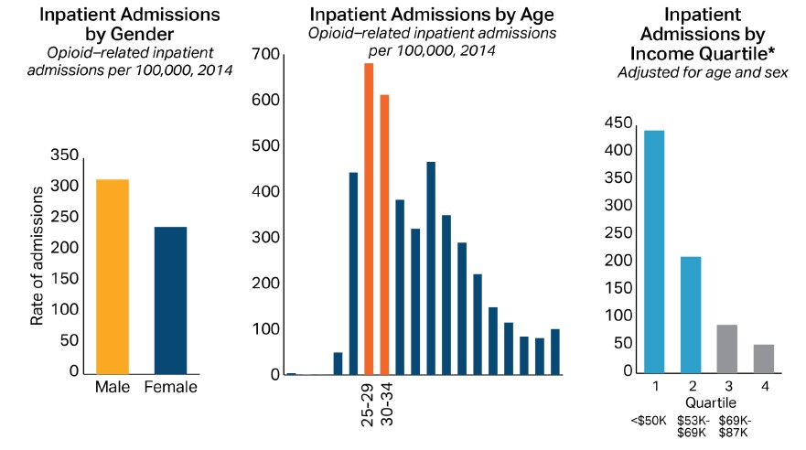Opioid-related Inpatient Hospital Admissions by Demographic

18
(2014)

Source: HPC analysis, CHIA Data

18
Opioid-Related Deaths in Massachusetts by Category of Insurance
(2013-2015)

2% 2% 10%
12%

50%

2013
9%

1%

14%

1% 0%

15%

2015

12%

4% 1%

14%

Commercial Insurance

Medicare

Medicare + HSN

Medicare + MassHealth (Duals)

1% 1% 11%

2014

13%

6%
1%

13%

53%
2015

MassHealth & CommCare
Health Safety Net Other Public* Unknown/Uninsured

19

53%

Source: DPH, MassHealth, and CHIA data
Number of Substance-Exposed Newborns (SEN) Reports to DCF (March 2014 to July 2016)

260

240

244

246

225

232 235

228

180

160

133

200

169

151

184
220

214

206

195

174

201

181

Total
SEN Reports

Screen-In
Total

120
132

20

100

Source: DCF data
2014 2015 2016
January  February  March April May June July August  September October November  December | 177 232
 | 203 197
 | 133 208 235
 | 142 207 213
 | 157 208 199
 | 159 193 228
 | 168 230 201
 | 206 236
 | 244 246
 | 219 221
 | 160 225
 | 200 211

Medication-Assisted Treatment Re-Entry Initiative (MATRI)
in the Correctional System
(January 2015 – June 2016)

94 participants received pre-release Vivitrol injection
61 received first post- release injection + 3 more remained
engaged in treatment

47 received a second post-release injection

21

• Provides pre-release treatment and post-release referral for inmates with alcohol or opioid use disorder at participating sites in the Department of Correction (DOC)
• Offers inmates a pre-release injection of Vivitrol and connects inmates to
community-based clinics for aftercare treatment
• Vivitrol shot provided at no cost to the Commonwealth

Source: DOC data

