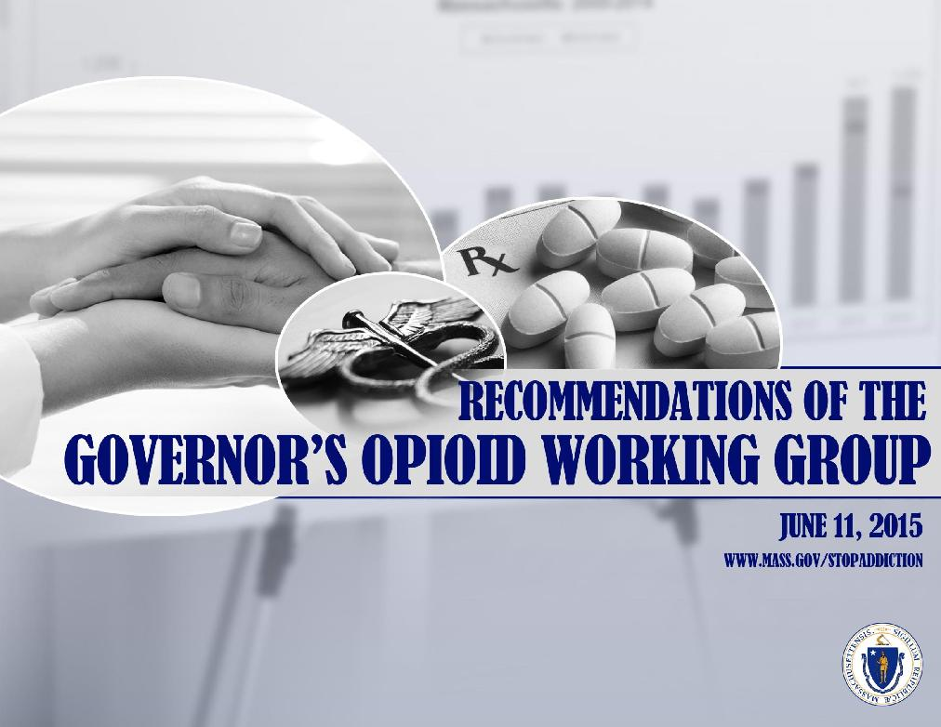

Overview

The Commonwealth has a long history of trying to combat addiction. We began to address the harm of opioids in 2004, when 456 individuals died of an opioid overdose. Since 2004, more than 6,600 members of our community have died, and behind those deaths are thousands of hospital stays, emergency department visits, and unquantifiable human suffering.

We are in the midst of an epidemic. Our response requires a strong partnership between the medical community, law enforcement, the judiciary, insurers, providers, health and human services agencies, elected officials, and the public. Our law enforcement agencies are a critical part of the opioid solution; however, we cannot arrest our way out of this epidemic. These recommendations aim to ensure access to pain medication for individuals with chronic pain while reducing opportunities for individuals to access and use opioids for nonmedical purposes.

The Commonwealth must build upon and accelerate the prevention, intervention, treatment, and recovery support strategies recommended by prior task forces and commissions and acted upon by the legislature. Equally important, we must implement BOLD NEW STRATEGIES. To that end, the working group developed more than 65 actionable recommendations for the administration to consider for implementation.

The challenge is great. Addiction is a complex disease. There are no easy or quick solutions, nothing short of a comprehensive approach to this opioid epidemic will turn the tide of overdose deaths and reduce the harms that opioids are inflicting upon individuals, families and our communities.

2

Objective

Produce actionable recommendations to address the opioid epidemic in the Commonwealth

Goals

- Reduce the magnitude and severity of harm related to opioid misuse and addiction

- Decrease opioid overdose deaths in the Commonwealth

To Meet the Objective the
Working Group

- Hosted 4 listening sessions in Boston, Worcester, Greenfield, and Plymouth

- Held 11 in person meetings

- Received and examined documents and recommendations from more than 150 organizations

- Heard from more than 1,100 individuals from across the Commonwealth

- Reviewed academic research, government reports, and reports of previous task forces and commissions

3

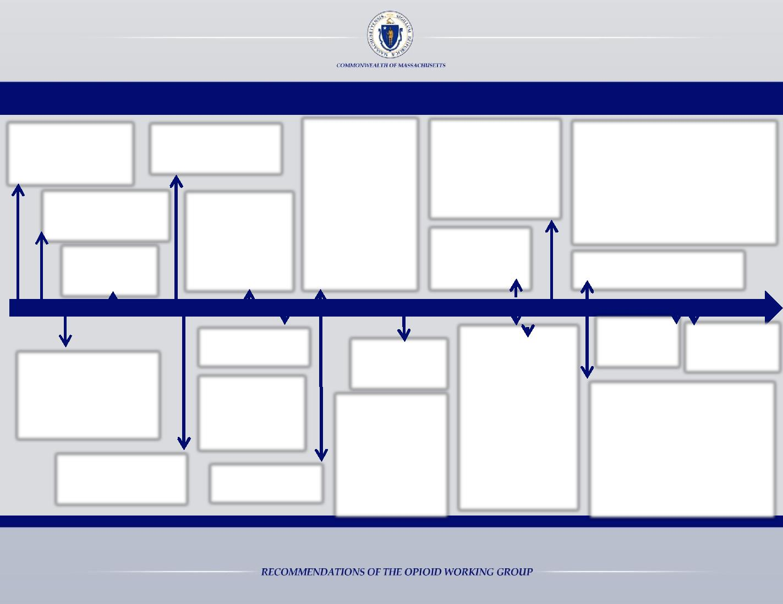
30 Years of Combatting Addiction in the Commonwealth

1987: Commonwealth announces to halt sending civilly committed women to the correctional facility in Framingham ¹

2004: Legislature:
Establishes Massachusetts
OxyContin and Other Drug

Abuse Commission⁶

2010: Legislature: Requires practitioners to receive training on:
• Pain management;

• Identifying patients
as high risk for

2013: Legislature:

• Requires practitioners to
utilize the PMP prior to
issuing a schedule II or
III drug to a patient for
the first time

2014: Legislature:
• Mandates minimum insurance coverage
 | for ATS/CSS – effective October 1, 2015
• | Requires | pharmacists to dispense
 | interchangeable abuse deterrent drugs
• | Requires | hospitals to report incidents of

 |  | 1992: Commonwealth |  | 2008: Legislature:
 |  | establishes the |  | Establishes
 |  | prescription monitoring |  | commission to
 |  | program (PMP) |  | investigate the impact
 |  | 2000: Legislature: |  | of OxyContin and
 |  |  |  | Heroin on state and
 |  | Mandates parity for
1987 | 1992 |  | 2004 | municipal
 |  | behavioral health
 |  |  |  | government⁸
 |  | treatment⁴
substance abuse;
• Counseling patients
about the side
effects, addictive
nature, and proper
storage and disposal
of prescription

medications ¹¹

• Funds expansion of § 35

services ¹⁶

2012: Substance Use | 2013
Prevention
Education: A cost

analysis report issued ¹⁵

substance exposed newborns
• Requires regulations that mandate
coordination of care and discharge

planning for BSAS licensed facilities ¹⁸

2014: Findings of the Opioid Task Force and DPH Recommendations released ¹⁹

1996 2000

2008 2009 2010 2011

2012 2014

2015

2006

1996: SJC Chief Justice Liacos states that substance abuse programs prevent crime; estimating that between 85% and 90% percent of criminals have a substance abuse problem³

2006: Massachusetts OxyContin and Other Drug Abuse Commission issues report⁷

2009: Legislature: Authorizes recovery high schools ⁹

2009: Recommendations of the OxyContin and Heroin Commission submitted to the legislature¹⁰

2010: Commonwealth issues Substance Abuse Strategic Plan²

2011: DPH issues report on Alcohol & Drug Free Housing¹²

2011: Legislature:

- Reforms §35 civil commitment statute, increasing the maximum time that a person may be held from 30 days to 90 days

- Funds expansion of §35 services¹³

2012: Legislature: Reforms prescribing practices, requiring:

- Automatic enrollment into the PMP for practitioners

- Tamper resistant prescription forms

- Dissemination of educational materials when a pharmacist dispenses a schedule II or III drug

- Prescription lock boxes be sold at pharmacies¹⁴

February 2015: | June 2015:
Governor Baker
 | Working group
appoints opioid
 | submits
working group²⁰
 | recommendations²¹

2014: Legislature:

- Establishes trust fund to increase access to treatment

- Requires BSAS to establish a helpline and website for consumers to be informed of available treatment

- Authorizes pharmacists to dispense Narcan (naloxone)

- Requires DPH to certify Alcohol and Drug Free Homes that meet specific guidelines¹⁷

Sources listed in Appendix A

4

Number of deaths

Opioid-Related Deaths, Unintentional/Undetermined
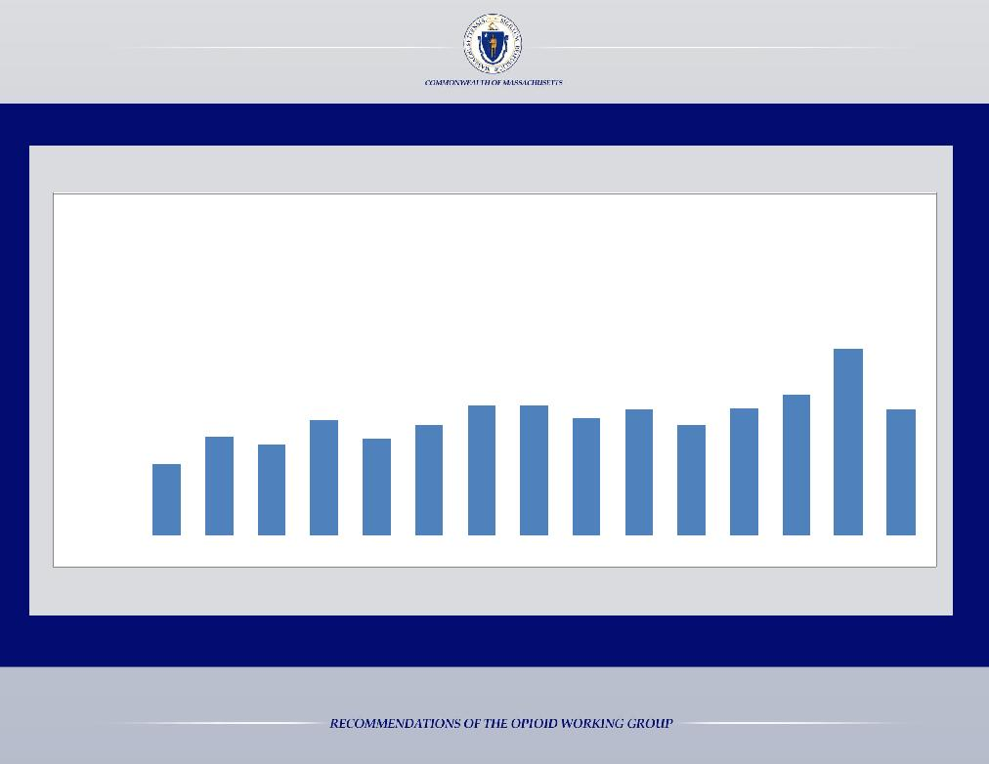
Massachusetts: 2000-2014

1,200 |  |  |  |  |  |  |  |  |  |  |  |  |  |  |  |  | Confirmed |  |  |  |  | Estimated
 |  |  |  |  |  |  |  |  |  |  |  |  |  |  |  |  |  |  |  |  |  |  |  |  |  |  |  |  |  |  |  |  |  |  | 967 |  |  |  | 1,008
1,000
800 |  |  |  |  |  |  |  |  |  |  |  |  |  |  |  |  |  |  |  |  |  |  |  |  |  |  |  |  |  |  | 668 |  |  |  | 888
600 |  |  |  |  |  |  |  |  |  |  |  |  |  | 615 |  |  |  | 614 |  |  |  |  |  |  | 599 |  |  |  | 603
 |  |  |  |  |  |  | 549 |  |  |  |  |  |  |  |  |  |  |  |  |  |  | 561 |  |  |  |  |  |  |  |  |  |  |  |  |  |  |  |  | 600
 |  |  |  |  |  |  |  |  |  |  | 525 |  |  |  |  |  |  |  |  |  |  |  |  |  |  |  | 526
 |  |  | 468 |  |  |  |  |  | 456
400 |  |  |  |  | 429
200 |  | 338
0
2000 |  |  | 2001 |  | 2002 |  | 2003 |  | 2004 |  | 2005 |  |  | 2006 |  |  |  | 2007 |  |  |  | 2008 |  |  | 2009 |  | 2010 |  | 2011 |  | 2012 |  |  |  | 2013 |  |  |  | 2014

MA Department of Public Health Data Brief, April 2015 http://www.mass.gov/eohhs/docs/dph/quality/drugcontrol/county-level-pmp/data-brief-apr-2015-overdose-county.pdf

5

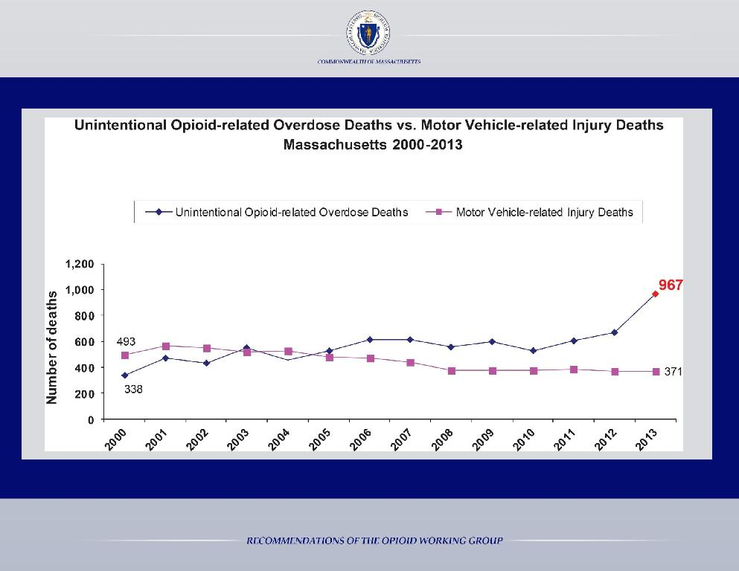

MA Department of Public Health Data, February 2015

6

The Working Group’s KEY STRATEGIES:

- Create new pathways to treatment

Too many individuals seeking treatment utilize acute treatment services (ATS) as their entry point, even when a less acute level of treatment may be appropriate. By creating new entry points to treatment and directing individuals to the appropriate level of care, capacity will be managed more efficiently and the Commonwealth will be better able to meet the demand for treatment.

- Increase access to medication-assisted treatment

Medication-assisted treatment for opioid use disorder (e.g. methadone, buprenorphine, naltrexone) has been shown to reduce illicit opioid use, criminal activity, and opioid overdose death. Increasing capacity for long-term outpatient treatment using medications as well as incorporating their use into the correctional health system, can be a life-saving intervention.

- Utilize data to identify hot spots and deploy appropriate resources

By the time DPH receives overdose death data from the medical examiner, the data is stale. The Commonwealth should partner with law enforcement and emergency medical services to obtain up-to-date overdose data, which can be used to identify hot spots in a timely manner and allocate resources accordingly.

- Acknowledge addiction as a chronic medical condition

Primary care practitioners must screen for and treat addiction in the same way they screen for and treat diabetes or high blood pressure. This will expedite the process for timely interventions and referrals to treatment.

- Reduce the stigma of substance use disorders

The stigma associated with a substance use disorder (SUD) is a barrier to individuals seeking help and contributes to: the poor mental and physical health of individuals with a SUD; non-completion of substance use treatment; higher rates of recidivism; delayed recovery and reintegration processes; and increased involvement in risky behavior.

7

The Working Group’s KEY STRATEGIES:

- Support substance use prevention education in schools

Early use of drugs increases a youth’s chances of developing addiction. Investing in the prevention of youth’s first use is critical to reducing opioid overdose deaths and rates of addiction.

- Require all practitioners to receive training about addiction and safe prescribing practices

Opioids are medications with significant risks; however, safer opioid prescribing practices can be accomplished through education.

- Improve the prescription monitoring program

The Commonwealth’s prescription monitoring program (PMP) is an essential tool to identify sources of prescription drug diversion. By improving the ease of use of the PMP and enhancing its capabilities, it will no longer be an underutilized resource.

- Require manufacturers and pharmacies to dispose of unused prescription medication

Reducing access to opioids that are no longer needed for a medical purpose will reduce opportunities for misuse.

10. Acknowledge that punishment is not the appropriate response to a substance use disorder

Arrest and incarceration is not the solution to a substance use disorder. When substance use is an underlying factor for

criminal behavior, the use of specialty drug courts are effective in reducing crime, saving money, and promoting retention in drug treatment. It is important that treatment occur in a clinical environment, not a correctional setting, especially for patients committed civilly under section 35 of chapter 123 of the General Laws.

11. Increase distribution of Naloxone to prevent overdose deaths

Naloxone saves lives. It should be widely distributed to individuals who use opioids as well as individuals who are likely to witness an overdose.

12. Eliminate insurance barriers to treatment

Removing fail first requirements and certain prior authorization practices will improve access to treatment. By enforcing parity laws, the Commonwealth can ensure individuals have access to behavioral health services.

8

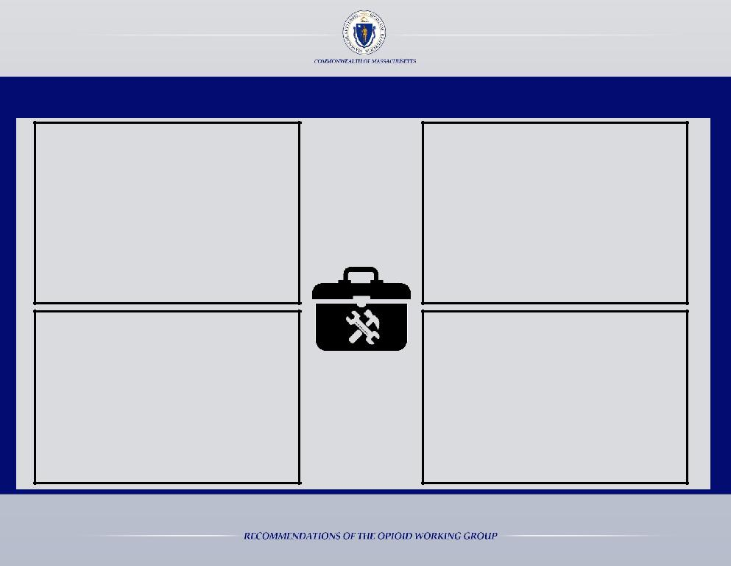

In order to reduce opioid deaths, the Commonwealth must use all the tools in the toolkit

Prevention

- School based prevention education

- Parent education about signs of addiction

- Community coalition initiatives

- Local drug-free school initiatives

- Prescriber and patient education

- Drug take-back programs

- Public awareness

Treatment

- Continuum of treatment from acute inpatient services to outpatient services

- Civil commitment: court-ordered SUD treatment

- Medication assisted treatment

- Outpatient counseling

- Emergency services

- Central database of treatment resources

Intervention

- Evidence-based screening for risk behaviors and appropriate intervention methods

- Prescription monitoring program

- Civil commitment

- Utilization of data to identify hot spots

- Access to naloxone

- Recovery coaches in Emergency Departments

Recovery Support

- Residential rehabilitation programs

- Alcohol and drug free housing

- Family and peer support

- Recovery high schools

- Resource navigators and case management

9

FINDINGS AND

RECOMMENDATIONS

**Recommendations appearing in red are included in the Governor’s action plan

10

The Working Group’s Findings:

1. | Individuals in crisis cannot access the right level of treatment at the right time | 12
2. | Youth drug use and addiction trends must be addressed through prevention education | 18
3. | Pregnant women and mothers with a substance use disorder need specialized care | 21
4. | Opioid medications must be safely managed by prescribers, pharmacists, and patients | 23
5. | The stigma associated with a substance use disorder is a barrier to treatment and recovery | 28
6. | Lack of transparency and accountability hinder our ability to respond to the opioid crisis | 29
7. | Courts and Jails should not be the primary mode of accessing long-term treatment | 30
8. | Recovery resources are insufficient and difficult to access | 31
9. | Increasing access to Naloxone will save lives | 32
10. | Insurance barriers prevent individuals from receiving treatment | 33
11. | The opioid crisis is a national issue that requires both state and federal solutions | 34

11

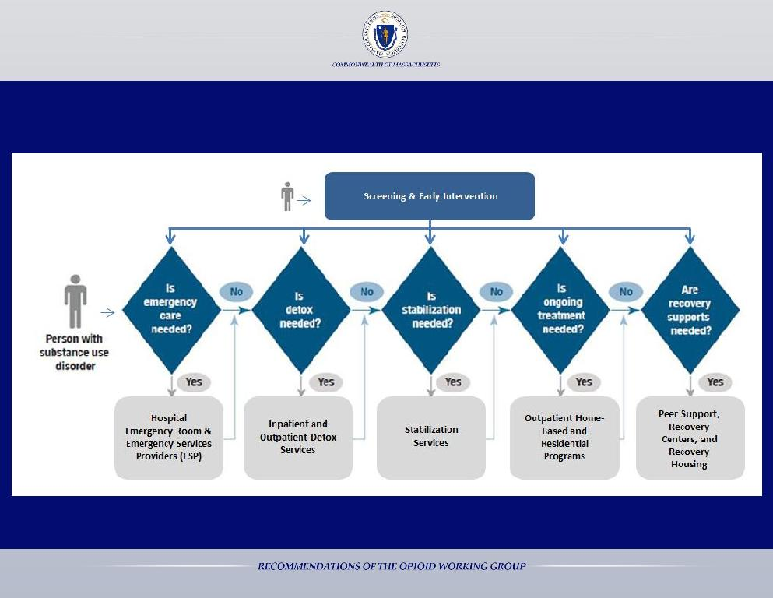

The Commonwealth must realign the treatment system to reflect the nature of opioid use disorder as a chronic disease to allow for multiple entry points to treatment

Revised figure from Center for Health Information and Analysis, Report: Access to substance use disorder treatment in Massachusetts, 2015

Finding 1: Individuals in crisis cannot access the right level of treatment at the right time

12

Focusing on patient care can increase access without having to

Recidivism Rates of Individuals receiving Acute Treatment Services (ATS) in a Single Year
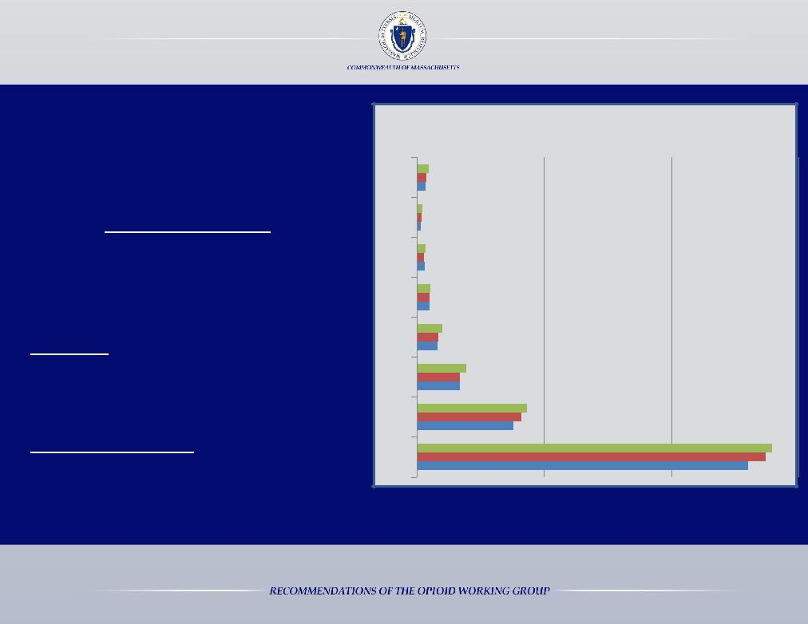
add beds

In 2014, 4,524 individuals utilized
ATS services 3 or more times

Two individuals utilized ATS services
23 times

In 2014, if these individuals had received ongoing treatment, at least

16,000 additional individuals could have received ATS services

- 7

7

6

5

4

3

2

1
464
377
337

224
183
152

328
276
295

542
498
488

1,014
861
812

1,952
1,688
1,696

2014

2013

2012

4,322
4,104
3,805

13,957
13,703
13,028
Data from DPH licensed ATS providers

Finding 1: Individuals in crisis cannot access the right level of treatment at the right time

13

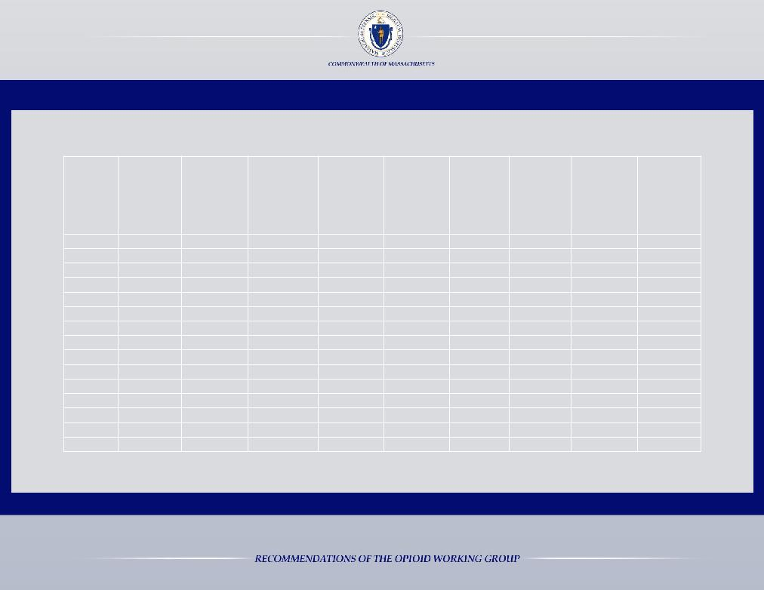

Number of Adult Treatment Beds & Licensed Programs for a Substance Use Disorder

 | Acute | Section 35: | Clinical | Section 35: | Transitional |  |  | Opioid
 |  | Acute |  | Clinical |  |  | Outpatient |  | Outpatient
County | Treatment |  | Stabilization |  | Support | Residential |  | Treatment
 | Service Beds | Treatment | Service Beds | Stabilization | Service Beds | Beds | Detox | Programs | Counseling
 |  | Service Beds |  | Service Beds |  |  | Programs |  | Programs
 | (ATS) | (ATS) | (CSS) | (CSS) | (TSS) |  |  | (Methadone)
Barnstable | 35 | 0 | 55 | 0 | 0 | 61 | 1 | 1 | 2
Berkshire | 21 | 0 | 13 | 0 | 0 | 24 | 0 | 2 | 2
Bristol | 52 | 24 | 30 | 66 | 80 | 333 | 0 | 5 | 8
Dukes | 0 | 0 | 0 | 0 | 0 | 0 | 0 | 0 | 1
Essex | 86 | 0 | 23 | 0 | 25 | 137 | 0 | 7 | 15
Franklin | 0 | 0 | 0 | 0 | 0 | 70 | 0 | 1 | 2
Hampden | 60 | 0 | 30 | 0 | 27 | 224 | 0 | 4 | 11
Hampshire | 0 | 0 | 0 | 0 | 0 | 0 | 0 | 1 | 1
Middlesex | 79 | 40* | 0 | 0 | 0 | 347 | 0 | 5 | 23
Nantucket | 0 | 0 | 0 | 0 | 0 | 0 | 0 | 0 | 1
Norfolk | 75 | 0 | 62 | 0 | 60 | 52 | 0 | 0 | 5
Plymouth | 89 | 132** | 64 | 76 | 0 | 43 | 0 | 3 | 6
Suffolk | 188 | 0 | 22 | 0 | 80 | 690 | 0 | 6 | 30
Worcester | 207 | 0 | 30 | 0 | 72 | 377 | 1 | 5 | 15
Total | 892 | 196 | 329 | 142 | 344 | 2358 | 2 | 40 | 122

Bed & Program data, May 2015 *MCI Framingham has 40 infirmary beds, 12 designated as detoxification beds, for its entire population **Department of Correction beds included

Finding 1: Individuals in crisis cannot access the right level of treatment at the right time

14

- 61 of the 122 adult outpatient counseling programs in the Commonwealth treat adolescent patients

- There are 4 recovery high schools in the Commonwealth, with 1 additional planned in Worcester

Number of Licensed Youth & Family Treatment Beds
 | Family | Adolescent | Transitional | Youth
 |  |  | Aged Youth
 | Residential | Residential |  | Stabilization
County |  |  | Residential
 | (# of Families | Beds |  | Beds
 |  |  | Beds
 | Served) | (13-17) |  | (ATS/CSS)
 |  |  | (16-21)
Barnstable | 13 | 0 | 0 | 0
Berkshire | 0 | 0 | 0 | 0
Bristol | 0 | 0 | 0 | 0
Dukes | 0 | 0 | 0 | 0
Essex | 0 | 15 | 0 | 0
Franklin | 0 | 0 | 0 | 0
Hampden | 0 | 16 | 0 | 0
Hampshire | 14 | 0 | 0 | 0
Middlesex | 37 | 26 | 0 | 0
Nantucket | 0 | 0 | 0 | 0
Norfolk | 0 | 0 | 0 | 0
Plymouth | 0 | 0 | 0 | 24
Suffolk | 34 | 15 | 30 | 0
Worcester | 12 | 33 | 0 | 24
Total | 110 | 105 | 30 | 48
 |  |  | Bed & Program data from May, 2015

Finding 1: Individuals in crisis cannot access the right level of treatment at the right time

15

Recommendations Related to Treatment

- Realign Treatment System to Reflect Nature of Opioid Use Disorder as a Chronic Disease with Periods of Acute Needs and Periods of Stability

  - Increase points of entry to treatment, eliminating the need for individuals to access other levels of care only through acute treatment services (ATS) and clinical stabilization services (CSS)

  - Establish and promote a longitudinally based treatment system and continuum of care

- Increase Treatment Access by Matching Demand and Capacity

  - Develop a real-time, statewide database of available treatment services, making information available via phone and the internet

  - Increase the number of post-ATS/CSS beds (transitional support service, residential recovery homes)

  - Fund patient navigators and case managers to ensure a continuum of care

  - Pilot a program that provides patients with access to an emergent or urgent addiction assessment by a trained clinician and provides direct referral to the appropriate level of care

  - Establish revised rates for recovery homes, effective July 1, 2015

Finding 1: Individuals in crisis cannot access the right level of treatment at the right time

16

Recommendations Related to Treatment

- Increase Access to Evidence-Based Medication-Assisted Treatment

  - Increase the number of office-based opioid treatment programs and the number of practitioners prescribing buprenorphine and naltrexone

  - Enforce and strengthen the requirement that all licensed addiction treatment programs accept patients on an opioid agonist therapy

- Promote Integration of Mental Health, Primary Care, and Opioid Treatment

  - Create a consistent public behavioral health policy by conducting a full review of all DPH and DMH licensing regulations for outpatient primary care clinics, outpatient mental health clinics, and BSAS programs removing all access barriers

  - Explore state mechanisms to establish opioid treatment programs as Health Homes

  - Conduct a review of the license renewal process for programs accredited by The Joint Commission or Commission on Accreditation of Rehabilitation Facilities (CARF) and evaluate whether Massachusetts should implement a “deemed status” for BSAS license renewals

  - Permit clinicians to hold an individual with a substance use disorder involuntarily in order to conduct an assessment of whether release poses a likelihood of serious harm

Finding 1: Individuals in crisis cannot access the right level of treatment at the right time

17

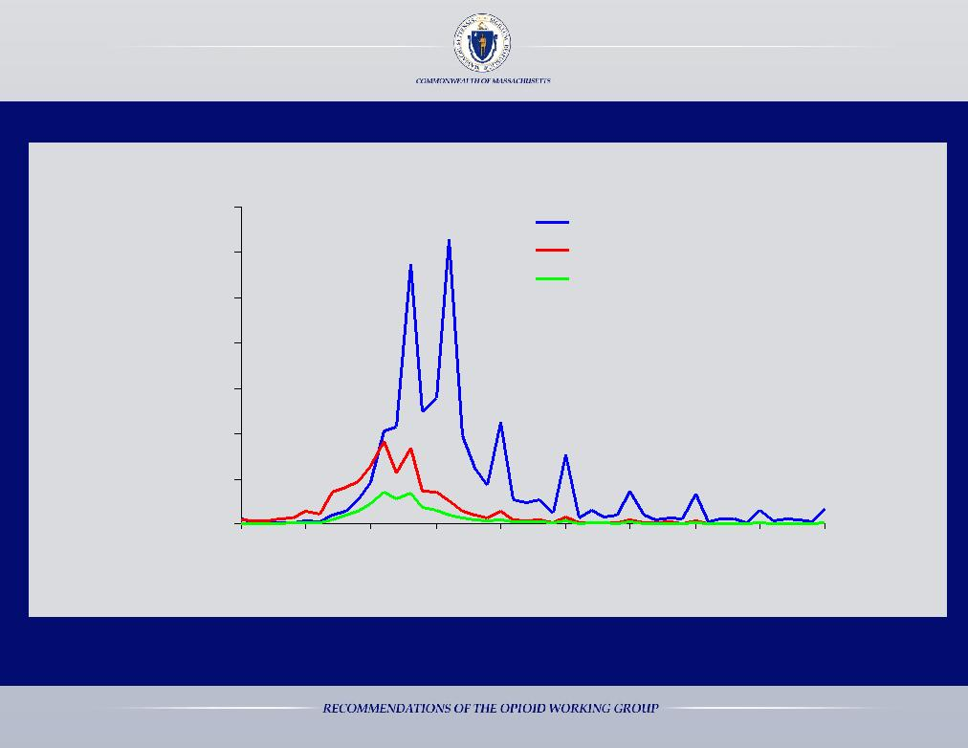

Studies demonstrate that youth begin to use alcohol and drugs as early as 10 years old

Addiction is a Developmental Disease

age group who | alcohol
Percentage in each | begin using

35%

30%

25%

20%

15%

10%

5%

0%

Age of First Alcohol Use

Age at first Nicotine Use

Age of First Cannabis Use

5 10 15 20 25 30 35 40 45 50

Age

Source: Li, Ting-Kai, Alcohol Use, Abuse, and Dependence , National Institute on Alcohol Abuse and Alcoholism, National Institutes of Health, U.S. Department of Health and Human Services, p.30, citing NIAAA National Epidemiologic Survey on Alcohol and Related Conditions, 2003, retrieved from: Retrieved from: www.pitt.edu/~super7/25011-26001/25521.ppt

Finding 2: Youth drug use and addiction trends must be addressed through prevention education

18

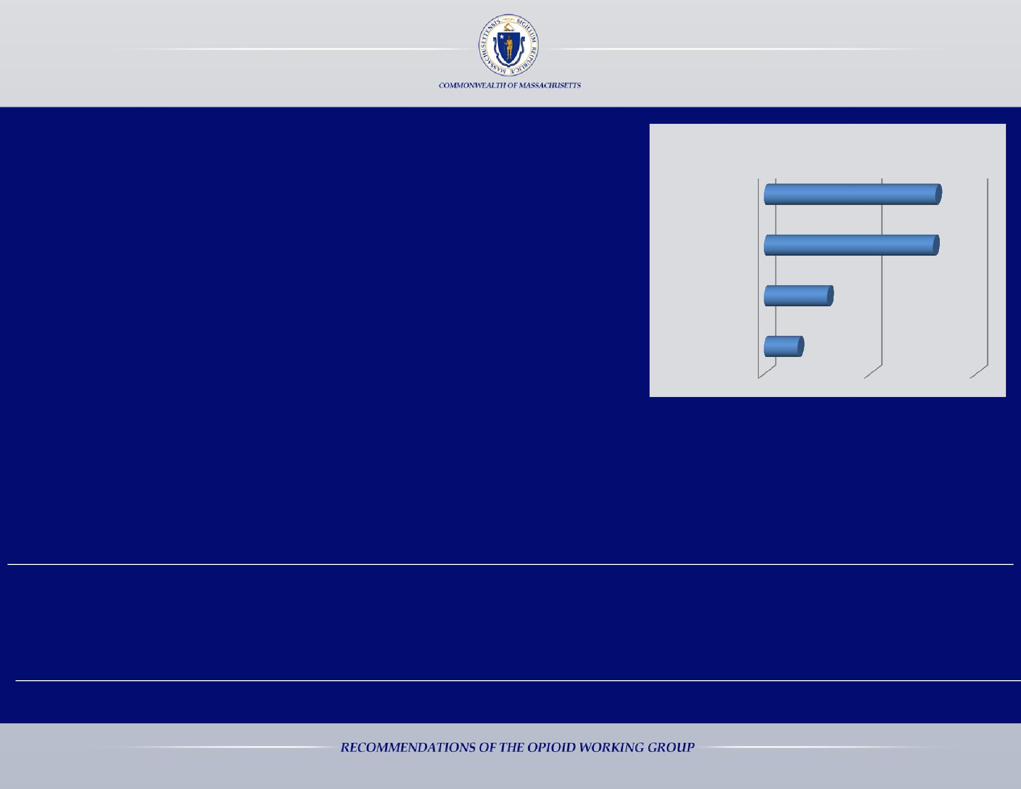

- Universal evidence-based preventive interventions can effectively and efficiently reduce nonmedical prescription opioid use¹

- According to a 2012 National Survey, parents generally do not discuss the dangers of prescription pain relievers with their teens²

- 74% of individuals with a substance use disorder began substance use at the age of 17 or younger; 10.2% initiated use at the age of 11 or younger ¹

2012 National Survey on Parent/Teen Conversations about Substance Misuse²

Marijuana | 81%
Alcohol | 80%
Crack/Cocaine | 30%
Prescription | 16%
Pain Relievers

- 40% of kids who begin drinking at age 15 will become alcoholics, while only 7% of those who begin drinking at age 21 become alcoholics³

- Adolescent males who participate in sports may have greater access to opioid medication, which puts them at greater risk to misuse these controlled substances ⁴

- Crowley, D. M., Jones, D. E., Coffman, D. L., & Greenberg, M. T. (2014). Can we build an efficient response to the prescription drug abuse epidemic? Assessing the cost effectiveness of universal prevention. Preventive Medicine, 62, 71-77. doi: 10.1016/j.ypmed.2014.01.029. PMCID: PMC4131945 .

- 2012 Partnership Attitude Tracking Study (2013). MetLife Foundation. Retrieved from: http://www.drugfree.org/newsroom/full-report-and-key-findings-the-2012-partnership-attitude-tracking-study-sponsored-by-metlife-foundation/

- Substance Abuse and Mental Health Services Administration, Center for Behavioral Health Statistics and Quality. (July 17, 2014). The TEDS Report: Age of Substance Use Initiation among Treatment Admissions Aged 18 to 30. Rockville, MD. Retrieved from: http://www.samhsa.gov/data/sites/default/files/WebFiles_TEDS_SR142_AgeatInit_07-10-14/TEDS-SR142-AgeatInit-2014.htm

- Veliz, P, Epstein-Ngo, Q.M., Meier, E., Ross-Durow, P.L., McCabe, S.E., Boyd, C.J., (2014). Painfully obvious: a longitudinal examination of medical use and misuse of opioid medication among adolescent sports participants. J Adolescent Health, 2014 Mar;54(3), 333-40.

Finding 2: Youth drug use and addiction trends must be addressed through prevention education

19

Recommendations Related to Youth & Parent Education & Interventions

- Support the implementation of substance use prevention curricula in schools. School districts should have the autonomy to choose the evidence-based curricula and the grade level that it is implemented in their district. Programs must be proven to reduce nonmedical opioid use. Examples of programs include: LifeSkills and All Stars

- Integrate information about the risks of opioid use and misuse into mandatory athletic meetings and trainings for parents, students, and faculty

- Increase the use of screenings in schools to identify at-risk youth for behavioral health issues

- Develop targeted educational materials for school personnel to provide to parents about closely monitoring opioid use if their child is prescribed opioids after an injury, as well as, signs and symptoms of drug and alcohol use

- Partner with state universities that have strong education programs to develop substance use prevention curricula for school districts throughout the Commonwealth

- Require state universities that educate teachers to integrate screening and intervention techniques as well as substance use prevention education into the curriculum

Finding 2: Youth drug use and addiction trends must be addressed through prevention education

20

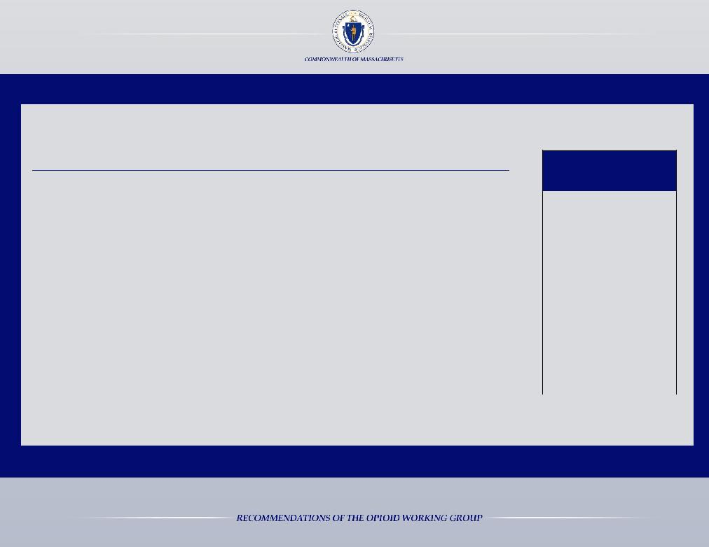

The Department of Children and Families (DCF) received 2,376 reports of a substance exposed newborn (SEN) between March, 2014 and March, 2015

A SEN designation is given when 1 or more of the following occurs:
- A positive toxic screen on the newborn;

- A positive toxic screen on the mother during her pregnancy or at delivery;

- A newborn has been diagnosed with Neonatal Abstinence Syndrome (NAS);

- Evidence of withdrawal symptoms from alcohol or drugs on the mother or the baby;
- A newborn shows signs of Fetal Alcohol Syndrome (FAS);

- A newborn tests positive for methadone, buprenorphine (Subutex), or buprenorphine with naloxone (Suboxone); or

- A self report by the mother or a verifiable report from a treatment provider that during pregnancy the mother used illicit drugs.

SEN reports to DCF

Mar, 2014 | 133
Apr, 2014 | 142
May, 2014 | 157
Jun, 2014 | 159
Jul, 2014 | 168
Aug, 2014 | 206
Sep, 2014 | 244
Oct, 2014 | 219
Nov, 2014 | 160
Dec, 2014 | 200
Jan, 2015 | 177
Feb, 2015 | 203
Mar, 2015 | 208
Total | 2,376

Finding 3: Pregnant women and mothers with a substance use disorder need specialized care

21

Recommendations Related to Neonatal Abstinence

Syndrome, Prenatal Care & Neonatal Care

- Outreach to prenatal and postpartum providers to increase training about: screening, intervention, and care for women with a substance use disorder

- Promote early identification and proper treatment, raise awareness of NAS within the public health and medical communities

- Review the costs and benefits of mandating testing for in utero exposure to alcohol and drugs at every birth
- Ensure adequate capacity for pregnant women in the treatment system

- Develop and institute a training program focused on NAS and addiction for Department of Children and Families staff

- Work with health care providers to ensure all infants with NAS are referred to early intervention by the time of hospital discharge

- Partner with early intervention (EI) leadership and developmental experts to study the value of increasing automatic EI eligibility for infants with NAS from one year to two years

Finding 3: Pregnant women and mothers with a substance use disorder need specialized care

22

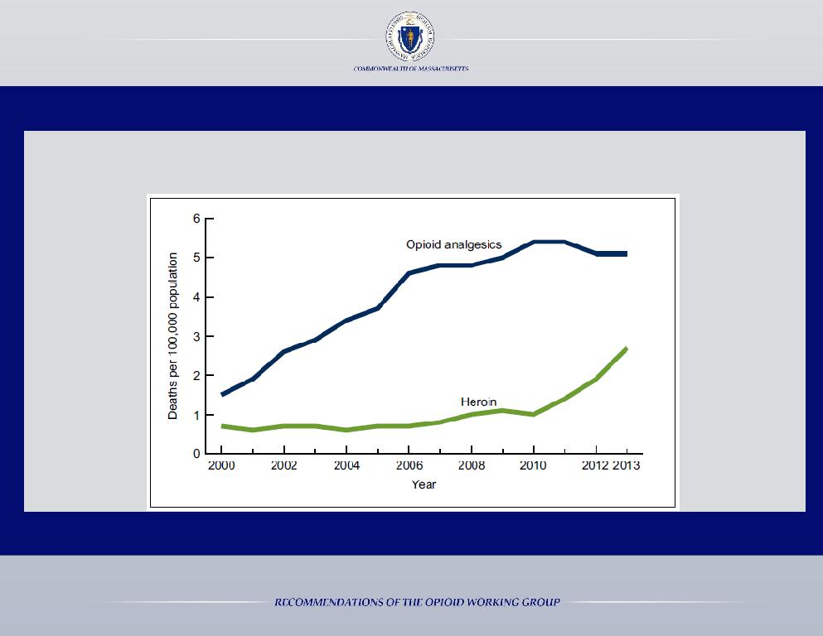

RATES OF OVERDOSE DEATH FROM PRESCRIPTION PAINKILLERS & HEROIN

UNITED STATES, 2000-2013

Hedegaard H, Chen LH, Warner M. Drug-poisoning Deaths Involving Heroin: United States, 2000-2013. NCHS Data Brief. 2015 Mar;(190):1-8.

Finding 4: Opioid medications must be safely managed by prescribers, pharmacists, and patients

23

SOURCE, AMONG THOSE AGED 12 OR OLDER, WHO USED PAIN RELIEVERS NONMEDICALLY (2012-2013)

Internet, 0.1%
Got from a | Other,
drug dealer or
 | 10.8%
stranger, 4.3%

Prescribed | Obtained
 | free from
by 1 doctor, | friend or
21.2% | relative,
 | 53.0%

Bought from a friend or relative, 10.6%

Source: Results from the 2013 National Survey on Drug Use and Health: Summary of National Findings, U.S. Department of Health and Human Services, Substance Abuse and Mental Health Services Administration, Center for Behavioral Health Statistics and Quality

SURVEY: REASON FOR PRESCRIPTION
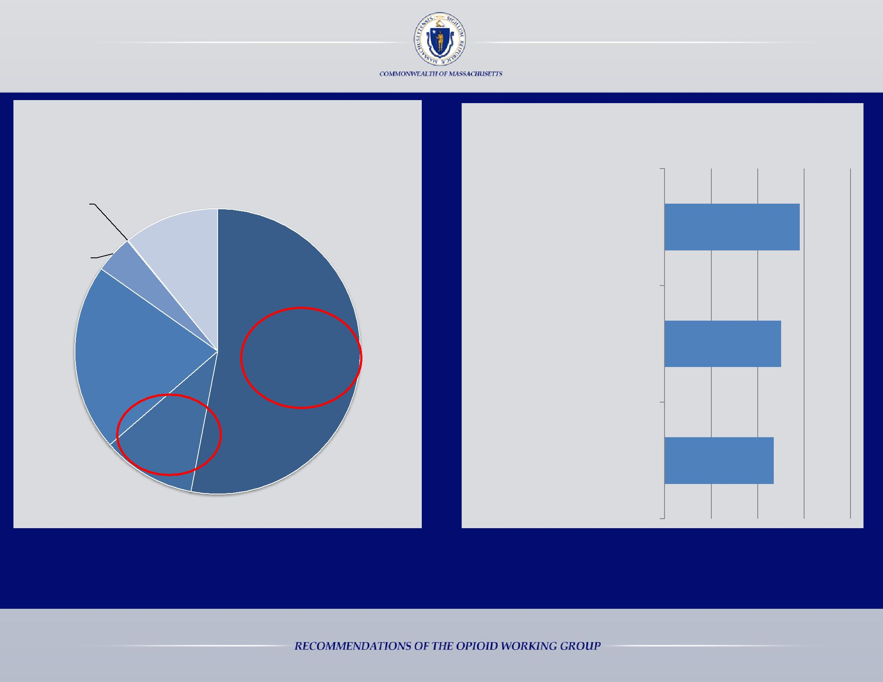
PAINKILLER MISUSE

% of Massachusetts residents who say each of the following is a major cause of prescription painkiller misuse

Too easy to buy

prescription painkillers 58% illegally

Painkillers are prescribed

too often or in doses that 50% are bigger than necessary

Too easy to get painkillers | 47%
from those who save pills

Source: Boston Globe and Harvard T.H. Chan School of Public Health, Prescription Painkiller Abuse: Attitudes among Adults in Massachusetts and the United States

Finding 4: Opioid medications must be safely managed by prescribers, pharmacists, and patients

24

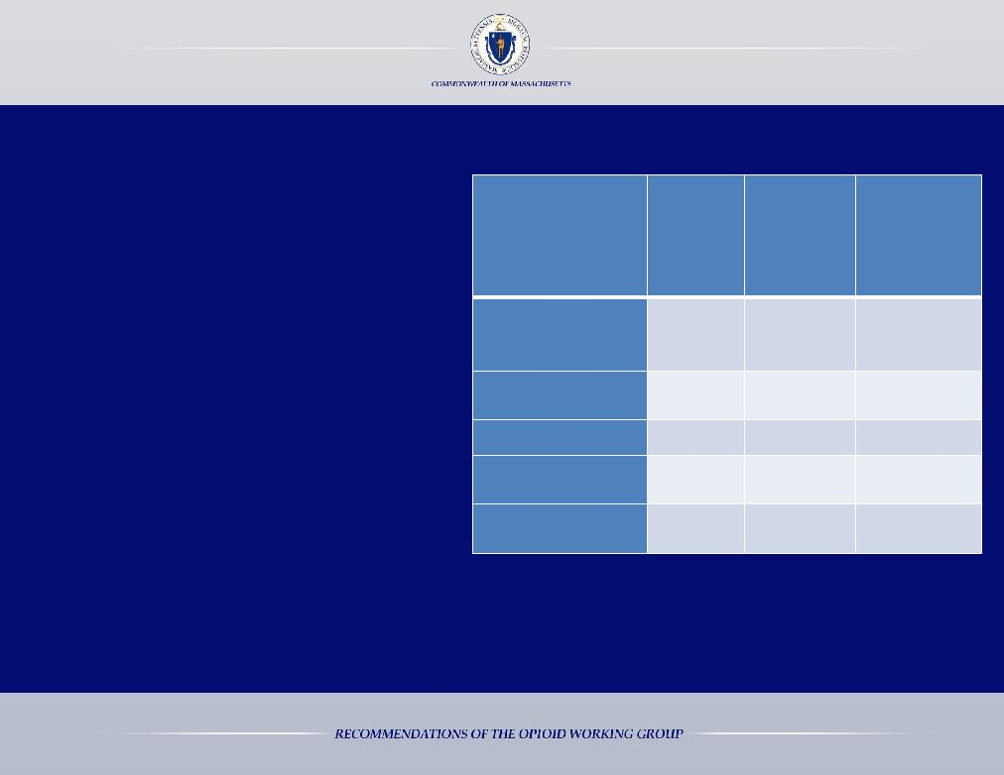

Enrollment of Providers and Delegates in the MA Online PMP (March, 2015)

- 25% of enrolled prescribers have logged into the PMP and searched for a patient at least 1 time in the past year

- Over 50% of enrolled prescribers have never logged into the system

- 58% of prescribers enrolled in the PMP issued more than 10 Schedule II-V prescriptions during 2014

 |  | Estimated |  | Total
 |  |  | Percentage
 | Total | Number
 |  |  | Enrolled
 | Enrolled | Practicing
 |  |  | (of | Eligible
 |  | in MA
 |  |  | Providers)
Practitioners
(MD / DO / Dentist | 25,977 | 34,173 |  | 76%
/ Podiatrist)
Mid-Levels | 2,671 | 8,626 |  | 31%
(APRN / PA)
Pharmacists | 3,521 | 12,000* |  | 29%
Total Provider | 32,169 | 54,799 |  | 51%
Enrollment
Delegates | 139 | N/A |  | N/A
(New Entry)

* This number represents an estimate of all registered pharmacists that are licensed in MA. Many licensed pharmacists do not work in retail pharmacy settings and are not dispensing controlled substances; therefore, the percentage enrolled for this provider category will be biased on the low side.

Finding 4: Opioid medications must be safely managed by prescribers, pharmacists, and patients

25

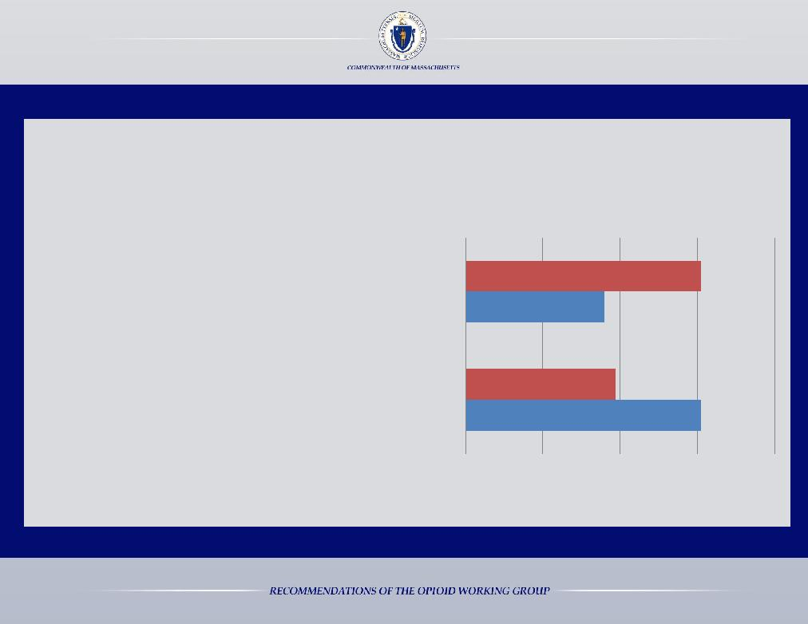

MASSACHUSETTS DOCTORS DISCUSS THE RISKS OF PRESCRIPTION PAINKILLERS WITH PATIENTS LESS THAN DOCTORS IN OTHER PARTS OF THE COUNTRY

In a 2015 survey, individuals who, in the past 2 years, HAD taken a strong prescription painkiller, such as Percocet, OxyContin, or Vicodin that was prescribed by a doctor for more than a few days, were asked the following question:

“Before or while you were taking these strong prescription painkillers, did you and your doctor talk about the risk of prescription painkiller addiction, or haven’t you talked about that?”

Only 36% of Massachusetts residents said “yes”, compared to 61% nationally

Yes

No

Did your doctor discuss the risks of addiction with you?

U.S., Mass., ^{61%}
36%

U.S.,
^{39%} Mass.,

61%

Source: Boston Globe and Harvard T.H. Chan School of Public Health, Prescription Painkiller Abuse: Attitudes among Adults in Massachusetts and the United States

Finding 4: Opioid medications must be safely managed by prescribers, pharmacists, and patients

26

Recommendations Related to Prescriber & Safe Disposal Practices

- Mandate pain management, safe prescribing training, and addiction training for all prescribers as a condition of licensure (physician assistants, nurses, physicians, dentists, oral surgeons, and veterinarians)
- Allow partial refills across all payers with a one-time co-payment

- Eliminate prescription refills by mail for schedule II medications

- Improve the Prescription Monitoring Program (PMP):

  - Increase utilization by improving ease of use and expanding abuse alerts from the PMP to prescribers

  - Ensure data compatibility of the PMP with other states & interface the PMP with electronic health records

  - Enforce mandatory use of the PMP

  - Require PMP data to be submitted within 24 hours by pharmacies
  - Improve data analytics and educate prescribers about how to utilize the information

- Implement electronic prescribing for opioids

- Partner with the medical and provider community to improve and increase educational offerings for prescribers and patients to promote safe prescribing
- Promote awareness and support for alternate pain therapies

- Appoint individuals with expertise in addiction to the medical profession licensing boards

- Develop universal distribution of easy to read materials at pharmacies on the safe use of medications

- Expand and promote drug take-back days and permanent drug take-back locations, financed by pharmacies and manufacturers

- Require practitioners, including dentists, to educate patients on the risks and side effects associated with opioids and document such discussions at the point of prescribing
- Increase screening for substance use at all points of contact in the medical system

- Appoint members to the drug formulary commission established under Chapter 258 of the Acts of 2014

Finding 4: Opioid medications must be safely managed by prescribers, pharmacists, and patients

27

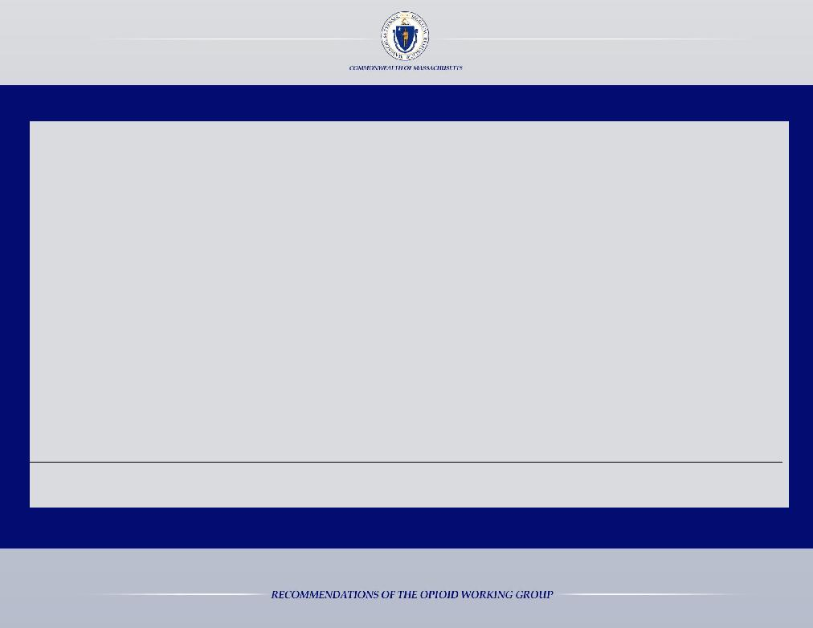

The Harms of Stigma Associated with a Substance Use Disorder:

- Stigma is a barrier to individuals seeking help¹
- Stigma contributes to the poor mental and physical health of individuals with a SUD²
- Stigma contributes to non-completion of substance use treatment²
- Stigma delays recovery and reintegration processes²

- Stigma increases involvement in risky behavior (e.g. needle sharing) ²

Recommendations Related to Reframing Addiction as a Disease

- Create a public awareness campaign, with messaging that targets various ages, focused on:

  - Reframing addiction as a medical disease

  - Promoting medication safety practices
- Promote the Good Samaritan law

- Reduce stigma among medical and treatment professionals ¹

- Kelly, J. F., Wakeman, S. E., & Saitz, R. (2015). Stop Talking ‘Dirty’: Clinicians, Language, and Quality of Care for the Leading Cause of Preventable Death in the United States. The American Journal of Medicine, Vol. 128, Issue 1, 8-9. Retrieved from: http://www.amjmed.com/article/S0002-9343(14)00770-0/pdf.

- Livingston, J. D., Milne, T., Fang, M. L., & Amari, E. (2012). The effectiveness of interventions for reducing stigma related to substance use disorders: a systematic review. Addiction (Abingdon, England), 107(1), 39–50.

Finding 5: The stigma associated with a substance use disorder is a barrier to treatment and recovery

28

Recommendations Related to Enhancing the Utilization of Data to Improve Transparency

- Require and support universal and timely reporting of overdose deaths, through a partnership between the

Department of Public Health, the Attorney General’s Office, the Massachusetts State Police, the District Attorneys, local police departments, emergency medical services, hospitals, and others
- Make EMS overdose data available

- Utilize overdose reports to identify geographical hot spots for targeted intervention and to alert law enforcement, public health entities, community coalitions, and the public
- Create a unified EOHHS privacy policy and implement a process for sharing confidential data

Recommendations Related to Government & Provider Accountability

- Establish a single point of accountability for the Commonwealth, Director of Addiction and Recovery Policy

- Enhance provider accountability by requiring treatment programs at all levels (inpatient and outpatient) to report on outcomes
- Incentivize and support providers to develop and test innovative treatment approaches

- Create provider accountability for the successful transition from one level of care to the next and incentivize providers to reduce re-admissions; the current "system" inadvertently "rewards" providers for repeat detoxes and rehabs

- Require the Department of Public Health to advance standards of care by establishing industry benchmarks

Finding 6: Lack of transparency and accountability hinder our ability to respond to the opioid crisis

29

Recommendations Related to the Courts

- Increase drug and specialty court capacity

- Increase access to beds for patients who are civilly committed under section 35 of chapter 123 of the General Laws and provide a roster of currently available beds to judges for section 35 commitments

- Review and revise discharge policies for section 35 patients; facilities must be required to follow the law and issue a written determination that release will not result in a likelihood of serious harm when individuals are discharged from the facility

- Improve the continuum of care for patients committed under section 35

- Ensure notification to the Court when a section 35 patient escapes from treatment

Recommendations Related to Policing & Correctional Institutions

- Transfer responsibility for civil commitments from the Department of Corrections to the Executive Office of Health and Human Services
- Suspend, rather than terminate, MassHealth coverage during incarceration
- Partner correctional facilities with community health centers to ensure individuals can access treatment upon release

- Analyze treatment spending in correctional facilities

  - Inmates should be able to continue medication-assisted treatment while incarcerated

  - Inmates should be able to begin treatment while incarcerated and be connected to treatment upon release

- Encourage and support alternatives to arrest, making police a partner in obtaining treatment for individuals

- Bulk purchase opioid agonist and naltrexone therapies for county corrections

Finding 7: Courts and Jails should not be the primary mode of accessing long-term treatment

30

Recommendations Related to Recovery & Support

- Leverage and increase support for community coalitions to address the opioid crisis

  - Create an online repository of resources and best practices for community coalitions

  - Improve statewide coordination and information sharing among coalitions

- Expand peer and family support organizations such as Learn to Cope

- Pilot recovery coaches in emergency rooms and hot spots

- Implement a process to certify alcohol and drug free housing to bring accountability and credibility to this recovery support system

- Partner with businesses to remove employment barriers that recovering individuals experience, specifically review regulations related to CORI checks

- Incentivize employers to hire individuals in early recovery

- To improve outcomes for recovery, explore the benefits and costs associated with issuing certificates of recovery

Finding 8: Recovery resources are insufficient and difficult to access

31

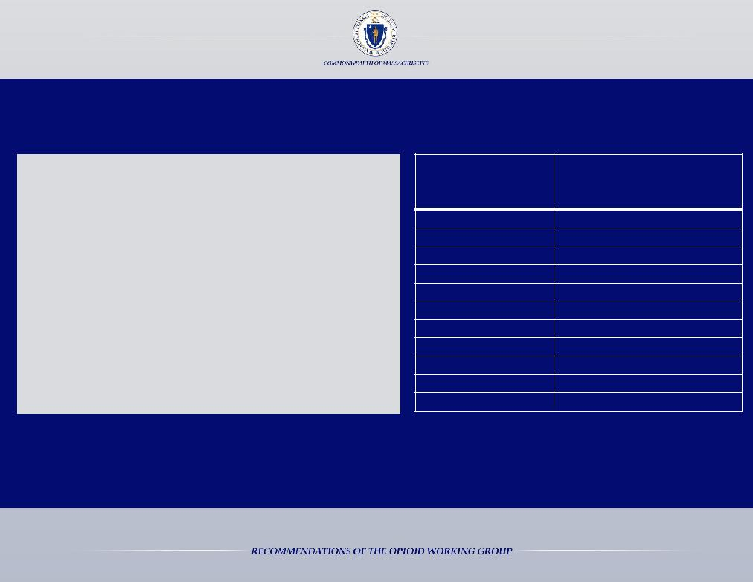

Recommendations Related to Naloxone

- Investigate the feasibility of having Naloxone in public spaces

- Improve affordability of Naloxone

  - Through bulk purchasing agreements

  - By eliminating all copayment requirements

- Encourage Naloxone to be co-prescribed with opioids

 | Price Per Naloxone “Kit”
Date | 2 Naloxone Doses and 2
 | Atomizers
November 2007 | $22.98
March 2008 | $31.55
January 2009 | $31.87
September 2009 | $31.49
June 2011 | $31.77
March 2012 | $32.35
May 2012 | $40.56
January 2014 | $42.82
July 2014 | $41.69
November 2014 | $74.06
May 2015 | $74.06

Finding 9: Increasing access to Naloxone will save lives

32

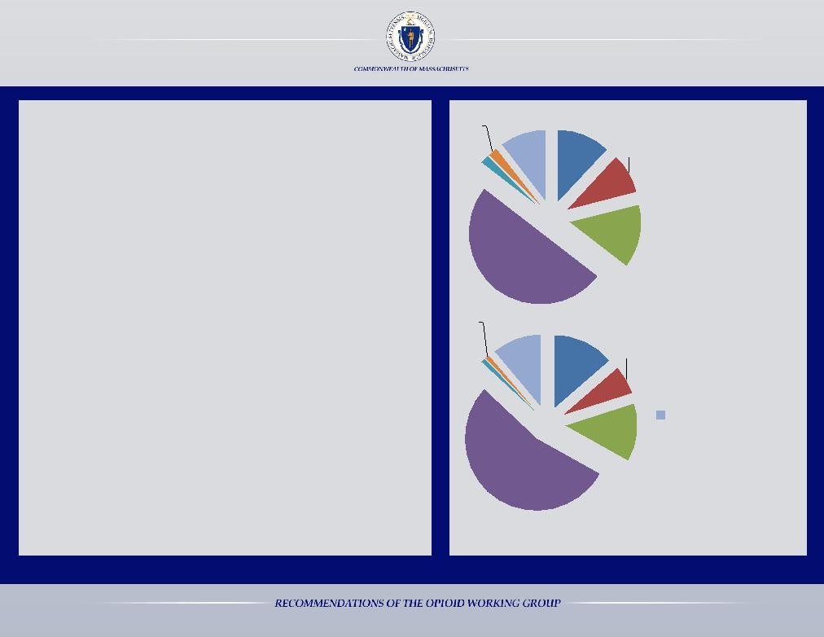

Recommendations Related to Insurance

• Require the Division of Insurance to implement
guidance for commercial insurers about the
implementation of chapter 258 of the acts of 2014
prior to October 1, 2015
• Eliminate insurance barriers that impede integration
of addiction and mental health care into the primary
care setting
• Require consistent coverage and prior authorization
practices and policies throughout all MassHealth
programs
• Bring meaning to federal and state behavioral health

2% 11%
^{2%} 12%

2013

50%

^{1%} 11%

Opioid Related Deaths

9% in MA by Category of Insurance

Commercial Insurance

14% |  | Medicare
 |  | Medicare and
 |  | MassHealth (Duals)
 |  | MassHealth

parity laws through enforcement actions to remove
inappropriate barriers to treatment
• Encourage insurers to support non-opioid pain
therapies
1%

14%

6% |  | Health Safety Net
 |  | Other
 |  | Unknown/Uninsured

• Prepare a public report on what non-

pharmacological treatments for pain are covered by
all private and public insurers
• Encourage insurers to support recovery coaches for
individuals with a substance use disorder
• Encourage insurers to support new pathways to
treatment
2014

54%

13% | at Time of Death

Data provided by the Center for Health Information and
Analysis, the Department of Public Health, and MassHealth

Finding 10: Insurance barriers prevent individuals from receiving treatment

33

Recommendations Related to Federal-State Partnerships

- Partner with federal leaders to recommend that the American College of Graduate Medical Education adopt requirements for pain management and substance use disorder education for all medical and residency programs (i.e. surgical, pediatrics, internal medicine, family medicine, obstetrics, and gynecology)

- Partner with federal leaders to recommend that the Commission on Dental Accreditation adopt requirements for education on safe opioid prescribing practices for all dental programs

- Partner with federal leaders to recommend that the American Veterinary Medical Association adopt requirements for education on safe opioid prescribing practices for all veterinary programs

- Partner with federal leaders to increase support for substance use prevention, intervention, treatment, and recovery efforts uniquely tailored for our Veterans

Finding 11: The opioid crisis is a national issue that requires both state and federal solutions

34

Recommendations Related to Federal-State Partnerships

- Request the Drug Enforcement Agency (DEA) to permit medical residents to prescribe buprenorphine under an institutional DEA registration number, thus allowing residents to learn how to manage patients with an opioid addiction

- Implement nationwide standards for pharmaceutical take back programs

  - Require manufacturers and pharmacies nationwide to finance the disposal of unused prescription medication
- Change the laws and regulations related to prescribing buprenorphine

  - Increase the cap - the number of patients a physician can treat - or remove it entirely

  - Permit nurse practitioners and physician assistants to prescribe buprenorphine

- Facilitate the interoperability of prescription monitoring programs nationwide

- Review 42 CFR Part II to ensure that it facilitates integrated care and the use of electronic health records and does not exacerbate the stigma associated with a substance use disorder

- Request that the Pain Management Question from the HCAHPS not be linked to hospital reimbursement

Finding 11: The opioid crisis is a national issue that requires both state and federal solutions

35

Summary of Short-Term Action Items (6 months to 1 year)

Prevention Intervention Treatment Recovery

• | Increase educational offerings | • | Improve the PMP | • Develop a central statewide
 | for prescribers and patients to | • | Outreach to prenatal and | database of available treatment
 | promote safe prescriber |  | postpartum providers to | services
 | practices |  | increase screening for women | • Transfer section 35 civil
• | Develop targeted educational |  | with a substance use disorder | commitment responsibility
 | materials for schools | • | Improve reporting of overdose | from DOC to EOHHS
• Appoint members to the drug |  |  | death data | • Increase the number of office
 | formulary commission | • | Enhance data transparency, | based opioid treatment
• Integrate information about the |  |  | including EMS data | programs
 | risks of opioid use and misuse | • | Encourage naloxone to be co- | • Require DOI to issue bulletins
 | into school athletic programs |  | prescribed with opioids | on chapter 258 of the Acts of
• | Conduct a public awareness | • | Amend civil commitment | 2014 prior to Oct. 2015
 | campaign |  | process | • Pilot recovery coaches in
 |  | • Identify hot spots for targeted |  | emergency rooms and hot spots
 |  |  | intervention, using EMS, | • Bulk purchase opioid agonist
 |  |  | hospital, and police data | and naltrexone therapies for
 |  | • Promote the Good Samaritan |  | correctional facilities
 |  |  | law | • Add 100 new ATS/CSS beds
 |  | • Consider mandating testing for |  | • Open Recovery High School in
 |  |  | in utero exposure to alcohol and | Worcester
 |  |  | drugs at every birth | • Review capacity in the treatment
 |  | • | Encourage and support | system for women/families
 |  |  | alternatives to arrest | • Analyze treatment spending in
 |  | • | Expand availability of Naloxone | correctional facilities
 |  |  |  | • Increase the number of
 |  |  |  | stepdown beds and services

- Promulgate chapter 257 rates for recovery homes effective July 2015

- Establish a single point of accountability for addiction and recovery policy at EOHHS

- Suspend rather than terminate MassHealth coverage during incarceration

- Certify alcohol and drug free housing

- Enforce the requirement that BSAS treatment programs accept patients on an opioid agonist therapy

- Strengthen connections between law enforcement and community providers for individuals upon release

- Explore issuing certificates of recovery

- Review and revise discharge/court notification policies for section 35

36

Summary of Mid-Term Action Items (1 year to 3 years)

Prevention

Intervention Treatment Recovery

- Support substance use prevention curricula in schools

- Mandate pain management, safe prescribing and addiction training for all prescribers

- Partner with federal government regarding graduate medical education

- Require manufacturers and pharmacies to dispose of unused prescription medication

- Require prescribers to discuss opioid side effects at point of prescription

- Allow partial refills across all payers

- Eliminate prescription refills by mail for schedule II medications

- Amend the curriculum for teachers as state universities to include training on screening and intervention techniques

- Have state universities develop substance use prevention curricula for schools

- Improve the PMP to ensure data compatibility with other states

- Develop training on neonatal abstinence syndrome and addiction for DCF staff

- Improve affordability of Naloxone

- Increase access to beds for section 35 patients

- Implement electronic prescribing for opioids

- Increase screening for substance use at all points of contact in the medical system

- Increase the use of screenings in schools to identify at-risk youth for behavioral health issues

- Create a consistent public behavioral health policy through licensing reforms

- Pilot providing patients with access to an emergent/urgent addiction assessment by a trained clinician and direct referral to the appropriate level of care

- Increase points of entry to treatment

- Ensure section 35 patients receive a continuum of care

- Enhance provider accountability by requiring treatment programs to report on outcomes

- Reform purchasing of substance use disorder treatment services

- Require DPH to advance standards of care by establishing industry benchmarks

- Add new non-ATS/CSS treatment beds

- Fund patient navigators and case managers

- Leverage community coalitions to address opioids

- Ensure all infants with NAS are referred to early intervention by time of hospital discharge

- Increase drug and specialty court capacity
- Expand peer/family support

- Partner with businesses to remove employment barriers that recovering individuals experience

37

Summary of Long-Term Action Items (3+ years)

Prevention Intervention Treatment Recovery

- Support alternate pain therapies through commercial and public insurers & prepare a public report on what non-pharmacological treatments for pain are covered by all private and public insurers

- Improve the PMP by interfacing the PMP with electronic health records

- Establish and promote a longitudinally based system of addiction care

- Integrate primary care into substance use treatment programs

- Reduce stigma among medical and treatment professionals

38

Opioid Working Group Members

Marylou Sudders, Chair, Secretary of the Executive Office of Health and Human Services Maura Healey, Attorney General
George Bell, General Catalyst Partners

Monica Bharel, MD, MPH, Commissioner of the Department of Public Health Hon. Paula M. Carey, Chief Justice of the Trial Court
Bill Carpenter, Mayor of Brockton
Alan Ingram, Ed.D., Deputy Commissioner of the Department of Elementary and Secondary Education
Colleen Labelle BSN, RN-BC, CARN, Boston Medical Center

Judy Lawler, Chelsea District Drug Court Joseph D. McDonald, Sheriff, Plymouth County John McGahan, The Gavin Foundation
Hon. Rosemary B. Minehan, Plymouth District Court
Fred Newton, Hope House, Inc.

Robert Roose, MD, MPH, Sisters of Providence Health System Cindy Steinberg, Massachusetts Pain Initiative, U.S. Pain Foundation
Raymond V. Tamasi, Gosnold on Cape Cod
Steve Tolman, Massachusetts AFL-CIO
Sarah Wakeman, MD, Massachusetts General Hospital

39

Organizations that Submitted Information to the Working Group

AdCare Hospital of Worcester, Inc.

AIDS Action Committee of Massachusetts, Inc. AIDS Project Worcester

Alkermes, Inc. Alosa Foundation

American Academy of Addiction Psychiatry American Academy of Pain Management American Round Table to Abolish Homelessness

Associated Industries of Massachusetts Mutual Insurance Company

Association for Behavioral Healthcare Barnstable County Human Services
Barnstable County Sheriff’s Office

Baystate Mary Lane Hospital Baystate Wing Hospital
Berkshire District Attorney’s Office

Berkshire Opioid Abuse Prevention Collaborative Berkshire Public Health Alliance

Berkshire Regional Planning Commission

Beth Israel Deaconess Hospital – Plymouth Blake Works
Blue Cross Blue Shield of Massachusetts

Boston Homeless Solidarity Committee Boston Medical Center

Boston Municipal Court

Boston Public Health Commission

Boston University School of Medicine: Continuing Medical Education Program

Boston University School of Public Health Boston Warm

Boys and Girls Club Massachusetts Alliance

Brockton Area Multi-Services, Inc. (BAMSI) Brook Retreat

Cambridge Health Alliance
Cambridge Needle Exchange
Cape and Islands District Attorney’s Office

Carlson Recovery Center Casa Esperanza, Inc.
Center for Early Relationship Support at Jewish Family &
Children’s Service
Center for Human Development, Inc.
Children’s Mental Health Campaign

Christian Service and Outreach Committee Clean Slate Centers

Collaborative for Educational Services Commission on the Status of Grandparents Raising
Grandchildren

Committee for Public Counsel Services Communities United For A Drug Free Environment Community Catalyst

40

Organizations that Submitted Information to the Working Group

 | Community Substance Abuse Centers | High Point Treatment Center
 | Cordant Health Solutions | Holyoke Recovery Support Center
 | Covectra | Hope Health / Hope Hospice
 | Coverys | Hope House, Inc. – Boston - Residents
 | Education Development Center, Inc. | Hyde Park Pain Management
 | Emerson Hospital | Imprivata
 | EvansCutler | Inflexxion
 | Families Against Mandatory Minimums | Institute for Health and Recovery
 | Family Health Center of Worcester | Journal of Opioid Management
 | Franklin County Home Care Corporation | Learn to Cope
 | Franklin County House of Corrections – Residents | Locke Lord, LLP
 | Franklin County Sheriff’s Office | Lowell House, Inc.
 | Franklin Regional Council of Governments | Main South Alliance for Public Safety
 | Gate House | March of Dimes Massachusetts
 | Gosnold on Cape Cod | Massachusetts Association of Behavioral Health Systems, Inc.
 | Granada House | Massachusetts Association of Health Plans
 | Greenfield Health Center | Massachusetts Attorney General’s Office
 | Greenfield Public Schools | Massachusetts Behavioral Health Partnership
 | Hampden County Sheriff’s Department | Massachusetts Chiropractic Society, Inc.
 | Harvard Pilgrim Health Care | Massachusetts Council of Human Service Providers, Inc.
 | Health Care For All | Massachusetts Department of Children and Families
 | Health Innovations, Inc. | Massachusetts Dept. of Elementary and Secondary Education
 | Healthy Gloucester Collaborative | Massachusetts Department of Mental Health
 | Healthy Streets Outreach Program | Mass. Dept. of Mental Health: Franklin/North Quabbin Area
 | Heroin Education Awareness Task Force | Massachusetts Department of Public Health

41

Organizations that Submitted Information to the Working Group

Massachusetts Division of Insurance Massachusetts Health Council Massachusetts Hospital Association Massachusetts Medical Society

Massachusetts Organization for Addiction Recovery Massachusetts Pain Initiative

Mass Society for the Prevention of Cruelty to Children Mass Technical Assistance Partnership for Prevention Massachusetts Trial Court

MassHealth
MCI-Norfolk Project Youth Program
Medford Substance Abuse Task Force

Melrose Substance Abuse Prevention Coalition Meridian House

Merrimack Valley Prevention and Substance Abuse Project Middlesex County Opioid Task Force

Middlesex District Attorney’s Office
Monson HEARS
Mystic Valley Public Health Coalition’s Opioid Abuse

Prevention Collaborative Narcotics Anonymous Never Another Death

New Beginnings Peer Recovery Center
Norfolk County Sheriff’s Office
Norfolk District Attorney’s Office

North Adams Mayor’s Office
Northern Berkshire Community Coalition
Northwestern District Attorney’s Office
Number 16

Opioid Task Force of Franklin County and North Quabbin Ostiguy School

Partnership for Drug-Free Kids Peabody Police Department Pfizer

Phoenix Multisport
Pioneer Valley Regional School District

Plymouth County Correctional Facility Plymouth Fire Department

Plymouth Police Department Plymouth Public Schools Project Cope

Project NESST (Newborns Exposed to Substances: Support and Therapy)
Project Youth

Quaboag Hills Community Coalition Quincy Community Action Programs, Inc. Real You Revolution

Recovery Homes Collaborative RW Massage Therapy
SAS Solutions

42

Organizations that Submitted Information to the Working Group

 | Scituate FACTs | Victory Programs, Inc.
 | SEIU Local 509 | WellCrest
 | Shrewsbury High School | Wellesley College Health Service
 | Shilts Chiropractic Offices | Western Mass Recovery Learning Community
 | Somerville Overcoming Addiction | Wicked Sober Inc.
 | South Bay Mental Health | Worcester District Attorney’s Office
 | South Hadley High School | Worcester Sheriff’s Office
 | Spectrum Health Systems, Inc.
 | Square Medical Group
 | State Representative Joseph McKenna, 18th Worcester District
 | State Representative Kay Khan, 11th Middlesex District
 | State Senator Eric Lesser
 | Suffolk County Sheriff’s Office
 | Team Morrison
 | The Alex Foster Foundation
 | The Alliance of Massachusetts YMCA’s
 | The Brien Center
 | The Carson Center for Human Services, Inc.
 | The Herren Project
 | The New Testament Church, Plymouth
 | The Social-Emotional Learning Alliance for Massachusetts
 | (SAM), Inc.
 | Town of Greenfield
 | Tufts Medical Center
 | U.S. Pain Foundation

43

Additional Resources Reviewed by the Working Group

- Harik, V., El Ayadi, A., Kossow, S., Albert, B. (2015). Analysis of Substance Abuse on Cape Cod: A Baseline Assessment. Barnstable County Human Services, March 2015. Retrieved from: http://www.bchumanservices.net/library/2015/03/RSAC-Baseline-Report-FULL-REPORT-3-11-15-Final.pdf.

- Alford, D. P., LaBelle, C. T., Kretsch, N., Bergeron, A., Winter, M., Botticelli, M., & Samet, J. H. (2011). Five Year Experience with Collaborative Care of Opioid Addicted Patients using Buprenorphine in Primary Care. Archives of Internal Medicine, Vol. 171, No. 5, 425-431. Retrieved from: http://www.ncbi.nlm.nih.gov/pmc/articles/PMC3059544/pdf/nihms240250.pdf.

- Beacon Health Options (June, 2015). Confronting The Crisis Of Opioid Addiction, A Beacon Health Options White Paper. Retrieved from: http://beaconlens.com/wp-content/uploads/2015/06/Confronting-the-Crisis-of-Opioid-Addiction.pdf

- Clark, R. E., Samnaliev, M., Baxter, J. D., & Leung, G. Y. (2011). The Evidence Doesn’t Justify Steps By State Medicaid Programs To Restrict Opioid Addiction Treatment With Buprenorphine. Health Affairs, 30, No. 8, 1425-1433. Retrieved from: http://content.healthaffairs.org/content/30/8/1425.long.

- Coffin, P. O., & Sullivan, S. D. (2013). Cost-Effectiveness of Distributing Naloxone to Heroin Users for Lay Overdose Reversal. Annals of Internal Medicine, Vol. 158, Issue 1, 1-9. Retrieved from: http://annals.org/article.aspx?articleid=1487798,

- Connery, H. S. (2015). Medication-Assisted Treatment of Opioid Use Disorder: Review of the Evidence and Future Directions. Harvard Review of Psychiatry, Vol. 23, Issue 2, 63-75. Retrieved from: http://journals.lww.com/hrpjournal/Fulltext/2015/03000/Medication_Assisted_Treatment_of_Opioid_Use.2.aspx#.

- Cunningham, Courtney (2015). Opioid Addiction Treatment: Evidence-Based Medicine, Policy, and Practice. Massachusetts Association of Health Plans, OnPoint: Health Policy Brief, Vol. II, March 2015. Retrieved from: http://www.mahp.com/unify-files/MAHPOnPoint_March2015_Opioid.pdf.

- D’Onofrio, G., O’Connor, P. G., Pantalon, M. V., Chawarski, M. C., Busch, S. H., Owens, P. H., Bernstein, S. L., & Fiellin, D. A. (2015). Emergency department-initiated buprenorphine/naloxone treatment for opioid dependence: a randomized clinical trial. The Journal of the American Medical Association, Vol. 313, Issue 16, 1636-1644. Retrieved from: http://jama.jamanetwork.com/article.aspx?articleid=2279713.

- Dart, R. C., Surratt, H. L., Cicero, T. J., Parrino, M. W., Severtson, S. G., Bucher-Bartelson, B., & Green, L. L. (2015). Trends in Opioid Analgesic Abuse and Mortality in the United States. The New England Journal of Medicine,Vol. 372, 241-248. Retrieved from: http://www.nejm.org/doi/full/10.1056/NEJMsa1406143.

- Dennis M., & Scott, C. K. (2007). Managing Addiction as a Chronic Condition. Addiction Science & Clinical Practice, Vol. 4, Issue 1, 45–55. Retrieved from: http://www.ncbi.nlm.nih.gov/pmc/articles/PMC2797101/pdf/ascp-04-1-45.pdf.

- Depew, B., Esiobu, C., Gabrieli, J., Ojeaburu, S., He, C., Moon, J., Chen, E., Agabalogun, T., & Rahman, A. (2014). Involuntary Commitment for Substance Abuse Treatment in Massachusetts: Problems and Proposed Solutions. Harvard Institute of Politics, Policy Brief, May 2014. Retrieved from: http://www.iop.harvard.edu/sites/default/files_new/research-policy-papers/Section35HealthcarePolicyPaper.pdf.

- Franklin, G., Sabel, J., Jones, C. M., Mai, J., Baumgartner, C., Banta-Green, C. J., Neven, D., & Tauben, D. J. (2015). A comprehensive approach to address the prescription opioid epidemic in Washington State: milestones and lessons learned. American Journal of Public Health, Vol 105, Issue 3, 463-469. Retrieved from: http://ajph.aphapublications.org/doi/abs/10.2105/AJPH.2014.302367?url_ver=Z39.88-2003&rfr_id=ori%3Arid%3Acrossref.org&rfr_dat=cr_pub%3Dpubmed&.

- Haegerich, T. M., Paulozzi, L. J., Manns, B. J., & Jones, C. M. (2014). What we know, and don't know, about the impact of state policy and systems-level interventions on prescription drug overdose. Drugs and Alcohol Dependence, December 1, 2014, Vol 145, 34-47. Retrieved from: http://www.drugandalcoholdependence.com/article/S0376-8716(14)01846-8/fulltext.

- Hedegaard, H., Chen, L. H., & Warner, M. (2015). Drug-poisoning Deaths Involving Heroin: United States, 2000–2013. NCHS Data Brief, No. 190, March 2015, 1-7. Retrieved from: http://www.cdc.gov/nchs/data/databriefs/db190.pdf.

- Kelly, J. F., Wakeman, S. E., & Saitz, R. (2015). Stop Talking ‘Dirty’: Clinicians, Language, and Quality of Care for the Leading Cause of Preventable Death in the United States. The American Journal of Medicine, Vol. 128, Issue 1, 8-9. Retrieved from: http://www.amjmed.com/article/S0002-9343(14)00770-0/pdf.

- Kolodny, A. K., Courtwright, D. T., Hwang, C. S., Kreiner, P., Eadie, J. L., Clark, T. W., & Alexander, G. C. (2015). The Prescription Opioid and Heroin Crisis: A Public Health Approach to an Epidemic of Addiction. Annual Review of Public Health, Vo. 36, 559-574. Retrieved from: http://www.annualreviews.org/doi/full/10.1146/annurev-publhealth-031914-122957?url_ver=Z39.88-2003&rfr_id=ori:rid:crossref.org&rfr_dat=cr_pub%3dpubmed&.

- Legal Action Center (2015). Confronting an Epidemic: The Case for Eliminating Barriers to Medication-Assisted Treatment of Heroin and Opioid Addiction. Retrieved from: http://lac.org/wp-content/uploads/2014/07/LAC-The-Case-for-Eliminating-Barriers-to-Medication-Assisted-Treatment.pdf.

44

Additional Resources Reviewed by the Working Group

- Liebschutz, J. M., Crooks, D., Herman, D., Anderson, B., Tsui, J., Meshesha, L. Z., Dossabhoy, S., Stein, M. (2014). Buprenorphine Treatment for Hospitalized, Opioid-Dependent Patients: A Randomized Clinical Trial. The Journal of the American Medical Association: Internal Medicine Vol. 174, Issue 8, 1369-1376. Retrieved from: http://archinte.jamanetwork.com/article.aspx?articleid=1885989.

- Livingston, J. D., Milne, T., Fang, M. L., & Amari, E. (2012). The effectiveness of interventions for reducing stigma related to substance use disorders: a systematic review. Addiction (Abingdon, England), 107(1), 39–50. Retrieved from: http://www.ncbi.nlm.nih.gov/pmc/articles/PMC3272222/.

- Magura, S., Lee, J. D., Hershberger, J., Joseph, H., Marsch, L., Shropshire, C., & Rosenblum, A. (2009). Buprenorphine and methadone maintenance in jail and post-release: a randomized clinical trial. Drug and Alcohol Dependence, 99(1-3), 222–230. Retrieved from: http://www.ncbi.nlm.nih.gov/pmc/articles/PMC2658719/pdf/nihms90814.pdf.

- Marshall, B. D. L., Milloy, M. J., Wood, E., Montaner, J. S. G., & Kerr, T. (2011). Reduction in overdose mortality after the opening of North America's first medically supervised safer injecting facility: a retrospective population-based study. The Lancet , Volume 377, Issue 9775, 1429-1437. Retrieved from: http://www.thelancet.com/journals/lancet/article/PIIS0140-6736(10)62353-7/fulltext.

- Massachusetts Center for Health Information and Analysis (2015). Access to Substance Use Disorder Treatment in Massachusetts. Retrieved from: http://chiamass.gov/assets/Uploads/SUD-REPORT.pdf.

- Massachusetts Department of Public Health (2015). Data Brief: Fatal Opioid-related Overdose Among MA Residents. Retrieved from: http://www.mass.gov/eohhs/docs/dph/quality/drugcontrol/county-level-pmp/data-brief-apr-2015-overdose-county.pdf.

- Massachusetts Department of Public Health (2014). Findings of the Opioid Task Force and Department of Public Health Recommendations on Priorities for Investments in Prevention, Intervention, Treatment and Recovery. Retrieved from: http://www.mass.gov/eohhs/docs/dph/substance-abuse/opioid/report-of-the-opioid-task-force-6-10-14.pdf.

- Massachusetts Health Council (2015). Local Approaches to the Opioid Overdose Epidemic: How Massachusetts Communities are Responding Today. Retrieved from: http://c.ymcdn.com/sites/www.mahealthcouncil.org/resource/resmgr/Member_Distribution/MHC_Community_Opioid_Coaliti.pdf

- Massachusetts Hospital Association (2015). MHA Guidelines for Emergency Department Opioid Management. Retrieved from: https://www.mhalink.org/AM/Template.cfm?Section=Substance_Abuse&Template=/CM/ContentDisplay.cfm&ContentID=49021.

- Massachusetts Joint Policy Working Group (2014). Response to the Massachusetts Opioid Prescription Drug Epidemic. Retrieved from: http://www.mass.gov/eohhs/docs/dph/quality/drugcontrol/best-practices/best-practices-workgroup-report.pdf.

- Massachusetts Medical Society (2015). Massachusetts Medical Society Opioid Therapy and Physician Communication Guidelines. Retrieved from: http://www.massmed.org/Patient-Care/Health-Topics/Massachusetts-Medical-Society-Opioid-Therapy-and-Physician-Communication-Guidelines/#.VXHlBNJViko.

- Massachusetts Office of the Attorney General (2014). Examination of Health Care Cost Trends and Cost Drivers. Retrieved from: http://www.mass.gov/ago/docs/healthcare/2014-hcctd.pdf.

- Massachusetts OxyContin and Heroin Commission (2009). Recommendations of the OxyContin and Heroin Commission. Retrieved from: http://archives.lib.state.ma.us/bitstream/handle/2452/46748/ocn466141823.pdf?sequence=1&isAllowed=y.

- National Association of State Alcohol and Drug Abuse Directors, Inc. (2015). Opioids. Retrieved from: http://nasadad.wpengine.com/wp-content/uploads/2015/05/Opioids-Final.pdf.
- National Institute on Drug Abuse (2014). Drug Facts: Lessons from Prevention Research. Retrieved from: https://d14rmgtrwzf5a.cloudfront.net/sites/default/files/drugfacts_lessonsfromprevention.pdf.

- Report to the Legislature, Substance Use Prevention Education: A Cost Analysis (2012). Retrieved from: http://www.mass.gov/edu/docs/eoe/publication-reports/20121001-substance-use-prevention-edu-rpt.pdf.

- Saitz, R., Larson, M. J., LaBelle, C., Richardson, J., & Samet, J. H. (2008). The Case for Chronic Disease Management for Addiction. The Journal of Addiction Medicine, Vol. 2, Issue 2, 55-65. Retrieved from: http://www.ncbi.nlm.nih.gov/pmc/articles/PMC2756688/pdf/nihms-123835.pdf.

- Schwartz, R. P., Gryczynski, J., O’Grady, K. E., Sharfstein, J. M., Warren, G., Olsen, Y., Mitchell, S. G., & Jaffe, J. H. (2013). Opioid Agonist Treatments and Heroin Overdose Deaths in Baltimore, Maryland, 1995–2009. American Journal of Public Health, Vol. 103, Issue 5, 917–922. Retrieved from: http://www.ncbi.nlm.nih.gov/pmc/articles/PMC3670653/pdf/AJPH.2012.301049.pdf.

- Shanahan, C. W., Beers, D., Alford, D. P., Brigandi, E., & Samet, J. H. (2010). A Transitional Opioid Program to Engage Hospitalized Drug Users. Journal of General Internal Medicine, Vol. 25, Issue 8, 803-
  - Retrieved from: http://www.ncbi.nlm.nih.gov/pmc/articles/PMC2896583/pdf/11606_2010_Article_1311.pdf.

45

Additional Resources Reviewed by the Working Group

- The Boston Globe and Harvard T. H. Chan School of Public Health. Prescription Painkiller Abuse: Attitudes among Adults in Massachusetts and the United States. May 2015. Retrieved from: https://s3.amazonaws.com/s3.documentcloud.org/documents/2082835/prescription-painkiller-poll-report-the-boston.pdf.

- United Nations Office on Drugs and Crime and the World Health Organization. Opioid overdose: preventing and reducing opioid overdose mortality. Discussion paper, UNODC/WHO, 2013. Retrieved from: http://www.who.int/substance_abuse/publications/opioid_overdose.pdf?ua=1.

- United States Department of Health and Human Services Office of the Assistant Secretary for Planning and Evaluation (2015). Opioid Abuse in the U.S. and HHS Actions to Address Opioid-Drug Related Overdoses and Deaths. ASPE Issue Brief, March 26, 2015. Retrieved from: http://aspe.hhs.gov/sp/reports/2015/OpioidInitiative/ib_OpioidInitiative.pdf.

- Vermont Agency of Human Services (2012). Integrated Treatment Continuum for Substance Use Dependence “Hub/Spoke” Initiative—Phase 1: Opiate Dependence. Retrieved from: http://www.healthvermont.gov/adap/documents/HUBSPOKEBriefingDocV122112.pdf.

- Vermont Department of Health (2015). Report to the Vermont Legislature: The Effectiveness of Vermont’s System of Opioid Addiction Treatment. Retrieved from: http://legislature.vermont.gov/assets/Legislative-Reports/Opioid-system-effectiveness-1.14.15.pdf.

- Volkow, N. D., Frieden, T. R., Hyde, P. S., & Cha, S. S. (2014). Medication-Assisted Therapies — Tackling the Opioid-Overdose Epidemic. The New England Journal of Medicine, Vol. 370, 2063-2066. Retrieved from: http://www.nejm.org/doi/pdf/10.1056/NEJMp1402780.

- Walley, A. Y., Xuan, Z., Hackman, H. H., Quinn, E., Doe-Simkins, M., Sorensen-Alawad, A., Ruiz, S., & Ozonoff, A. (2013). Opioid overdose rates and implementation of overdose education and nasal naloxone distribution in Massachusetts: interrupted time series analysis. The Boston Medical Journal, 346: f174, 1-12. Retrieved from: http://www.bmj.com/content/346/bmj.f174.full.pdf+html.
- White House’s Office of National Drug Control Policy. 2014 National Drug Control Strategy. Retrieved from: https://www.whitehouse.gov/sites/default/files/ndcs_2014.pdf.

46

Appendix A

- Lehr, G. (1987). Program Targets Alcoholic Women Care, Not Jail, Is New Policy. The Boston Globe, May 5, 1987, pp. 21.

- Commonwealth of Massachusetts (2010). Substance Abuse Strategic Plan Update FY 2011 – FY 2016. July 2010. Retrieved from: http://www.dmahealth.com/pdf/ICSAP%20Strategic%20Plan%20Update%20July%202010.pdf.
- Unknown (1996). Liacos. State House News Service, June 19, 1996.
- Chapter 80 of the Acts of 2000.
- Beardsley, E. J. (2000). New Data Profiles Recipients, Addresses The Success Of Drug Treatment. State House News Service, July 18, 2000.
- Chapter 189 of the Acts of 2004.

- Massachusetts OxyContin and Other Drug Abuse Commission (2005). Final Report. Retrieved from: https://www.ok.gov/odmhsas/documents/MA%20RX.pdf.
- Chapter 302 of the Acts of 2008.
- Chapter 27 of the Acts of 2009.

- Massachusetts OxyContin and Heroin Commission (2009). Recommendations of the OxyContin and Heroin Commission. Retrieved from: http://archives.lib.state.ma.us/bitstream/handle/2452/46748/ocn466141823.pdf?sequence=1&isAllowed=y.

- Chapter 283 of the Acts of 2010.
- Massachusetts Department of Public Health (2011). Study Regarding Sober (Alcohol and Drug Free) Housing

In response to Chapter 283, Section 10, of the Acts of 2010. Retrieved from: http://www.mass.gov/eohhs/docs/dph/substance-abuse/adf-housing-study.pdf
- Chapter 142 of the Acts of 2011.
- Chapter 244 of the Acts of 2012.

- Report to the Legislature, Substance Use Prevention Education: A Cost Analysis (2012). Retrieved from: http://www.mass.gov/edu/docs/eoe/publication-reports/20121001-substance-use-prevention-edu-rpt.pdf.

- Chapter 38 of the Acts of 2013.
- Chapter 165 of the Acts of 2014.
- Chapter 258 of the Acts of 2014.

- Massachusetts Department of Public Health (2014). Findings of the Opioid Task Force and Department of Public Health Recommendations on Priorities for Investments in Prevention, Intervention, Treatment and Recovery. Retrieved from: http://www.mass.gov/eohhs/docs/dph/substance-abuse/opioid/report-of-the-opioid-task-force-6-10-14.pdf.

47

