Violent Crime in Massachusetts: A 25-Year Retrospective

Annual Policy Brief

Issued October 2012

Report prepared by:
Massachusetts Executive Office of Public Safety and Security
Office of Grants and Research
Research and Policy Analysis Division

Author:
Brittany Peters, Research Analyst

HIGHLIGHTS

In calendar year 2011, the volume of violent crime (27,747 offenses) within the Commonwealth fell to its lowest point in the past 25 years, to levels not seen since the early 1980’s.

During the 25-year period from 1987 to 2011, the rate of violent crime per 100,000 persons in Massachusetts dropped 19% from 523.24 offenses per 100,000 persons to 421.21 offenses.

The statewide volume of violent crime decreased 10% from calendar year 2010 to calendar year 2011,
with a decline in each of the four major offense categories: murder (-10%); forcible rape (-10%); robbery (-3%); and aggravated assault (-12%).

The rate of violent crime per 100,000 persons in Massachusetts decreased 10% between calendar years 2010 and 2011, with a decline in each of the four major offense categories: murder (-11%); forcible rape (-11%); robbery (-4%); and aggravated assault (-12%).

OVERVIEW

The purpose of this Annual Policy Brief is to increase public awareness of the nature and prevalence of violent crime in the Commonwealth by analyzing data over a 25-year period from 1987 to 2011. The state data presented in this report is also examined within the context of national trends during the same timeframe. The four major offense classifications that are used to measure violent crime are murder, forcible rape, robbery, and aggravated assault. Aggravated assault includes all assault sub-categories (assault; assault by gun; assault by knife; assault by blunt object; and assault by hands/fist) except simple assault. These classifications are based upon the Massachusetts Department of State Police Crime Reporting Unit’s (CRU) Massachusetts Part I Offense Data Uniform Crime Report Codebook, modeled after the Federal Bureau of Investigation’s (FBI) Uniform Crime Reporting Handbook.

This 2012 Policy Brief will examine the volume and rates of these violent crime categories utilizing data from 375 law enforcement agencies that voluntarily submitted crime statistics during calendar years 2010 and 2011. The 375 agencies are comprised of 308 municipal police departments (representing 88% of the 351 cities and towns within Massachusetts), 38 campus police departments, 21 state police barracks, seven counties patrolled by transit police, and one hospital police department. Of these reporting agencies, 302, or 81%, utilized the National-Incident Based Reporting System (NIBRS) and the remaining 73 agencies provided summary data to the CRU via the Uniform Crime Reporting (UCR) Program.

DATA COLLECTION, METHODOLOGY, AND INTERPRETATION

The data presented in this report comes from three primary sources – local agency and cumulative state violent crime statistics were provided by the CRU; national violent crime data was obtained through the FBI’s website; and population data (both decennial counts and annual estimates, where available) was retrieved from the United States Census Bureau’s website. Figures prior to calendar year 2010 that are presented in this document were drawn from trends reported in previous Annual Policy Briefs. The Appendix provides annual data of violent crime in Massachusetts from 1987 to 2011 by volume and rate.

The volume of violent crime refers to the raw number or total count of offenses. Rates, on the other hand, produce the number of offenses divided by the population of a given jurisdiction. Rates allow for the comparison of the volume of crime within the state and nation over a period of time by controlling for population change. Examinations of crime rates also allow for the comparison of municipalities of varying sizes that would not otherwise be possible. All of the crime rates presented in this Annual Policy Brief are calculated per 100,000 persons.

Crime count estimates were generated for 52 agencies that submitted at least three months of statistics during calendar year 2011 but reported less than 12 full months of data, utilizing the following formula: Number of Crimes/Number of Months Reporting x 12. This practice was followed for all classifications of violent crime except murder. This process is, however, inherently flawed because it, “…implicitly assumes that the crime rate for non-reporting months is the same as for the reporting months.” In addition, 52 agencies (43 municipal departments, eight campus departments, and the Environmental Police) were excluded from our examination altogether as they reported fewer than three months of data, making a reliable estimation of crime counts over time all but impossible.

HISTORY OF NATIONAL CRIME DATA COLLECTION

The UCR was established in 1930 by the International Association of Chiefs of Police (IACP) as a means of quantifying national crime data within the context of periodic fluctuations in the volume of crime at the local, state and national levels. The Federal Bureau of Investigation (FBI) was tasked by the IACP with oversight of the UCR and began collecting crime statistics from a modest number of law enforcement agencies across the country. This process remained constant until 1958, when it was determined that there was sufficient participation by law enforcement agencies throughout the nation to aggregate the data and produce annual crime estimates. Shortly thereafter, individual states began to collect crime data from law enforcement agencies within their jurisdiction and these numbers were then tallied and forwarded on to the FBI.

In the 1980’s, the FBI, in conjunction with the Bureau of Justice Statistics, created NIBRS as a supplement to the UCR to parse out specific subsets of data related to the offense, victim and offender that are not otherwise captured within the summary datasets. NIBRS data, much like UCR data, is submitted on a voluntary basis and as such, the method and degree of reporting by individual law enforcement agencies varies greatly. In addition, the FBI has implemented a crime estimation system to account for data that is omitted or submitted after the deadline, which further compromises the validity of official figures. The CRU serves as the repository for those Massachusetts law enforcement agencies that submit monthly UCR summary data or NIBRS data and this information is then, in turn, reported to the FBI.
VOLUME OF VIOLENT CRIME IN MASSACHUSETTS

The most recent year of complete available data – 2011 – revealed that the volume of violent crime within
the Commonwealth (27,747) had fallen 10% from the previous year and 8% over the course of the 25-year
period examined in this Policy Brief. In addition, violent crimes declined 31% from the peak of 40,239
offenses in 1993 and are currently on par with levels not seen since 1983. These trends are displayed in
Figure 1 below.

Figure 1.
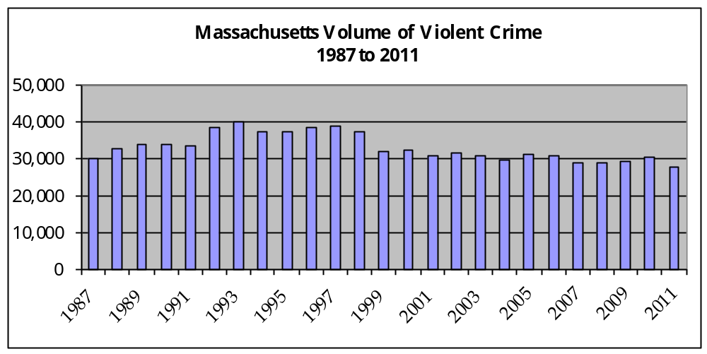

The changes seen in Massachusetts are not unique. The FBI published preliminary data for 2011
that reveals a similar pattern; the total volume of national crime fell 19% from 1,484,000 to 1,196,398
over the 25-year period and declined a notable 38% from the peak of 1,932,270 offenses in 1992.
One-year violent crime counts from 2010 to 2011 were also down 4%. This information is presented below in Figure 2.

Figure 2.
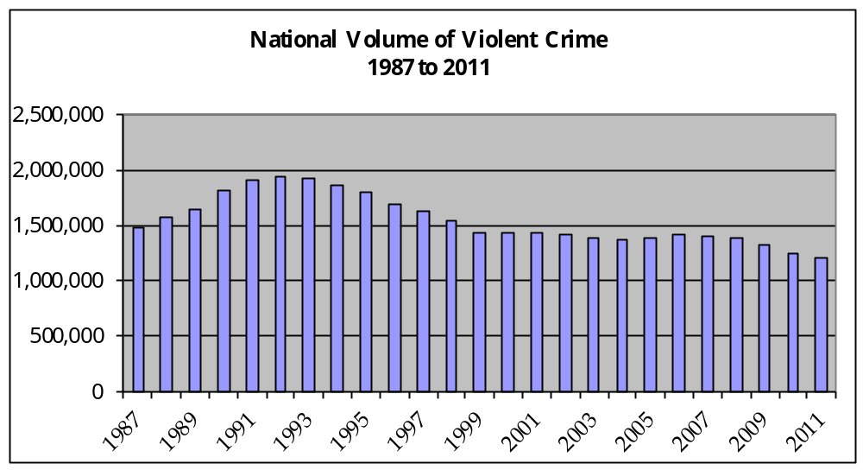

Of the 27,747 violent offenses committed in Massachusetts during 2011, the overwhelming majority were aggravated assaults (19,286.01), followed by robberies (6,673.51), forcible rapes (1,604.93), and
murders (183.00). These values are displayed as percentages in Figure 3 and closely resemble the
proportion of offenses to the overall number of violent crimes in the nation in 2010. Moreover, while the raw numbers and percentage shares of each of the four offense categories have changed from one year to the next, the ranking has remained consistent over time; aggravated assaults are the most frequently occurring violent crime, followed distantly by robberies, then forcible rapes, and murders.

Figure 3.
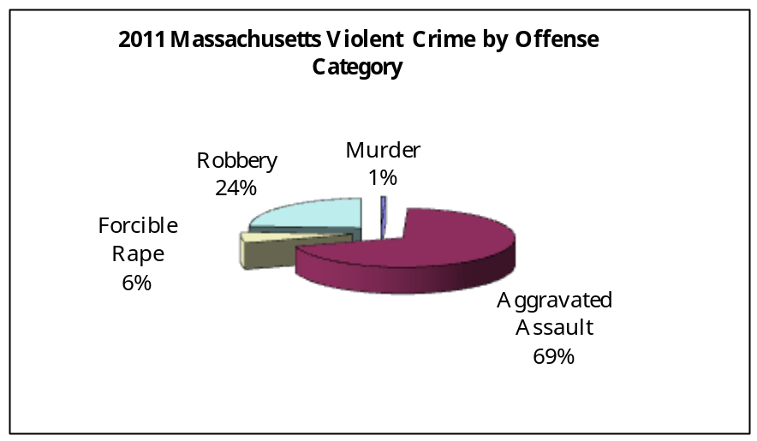

In the one year period from 2010 to 2011, the volume of violent crime in Massachusetts decreased 10%, with a drop in each of the four crime categories; the number of murders and forcible rapes each fell by 10%; robberies fell 3%; and the number of aggravated assaults declined 12%.

Figure 4.
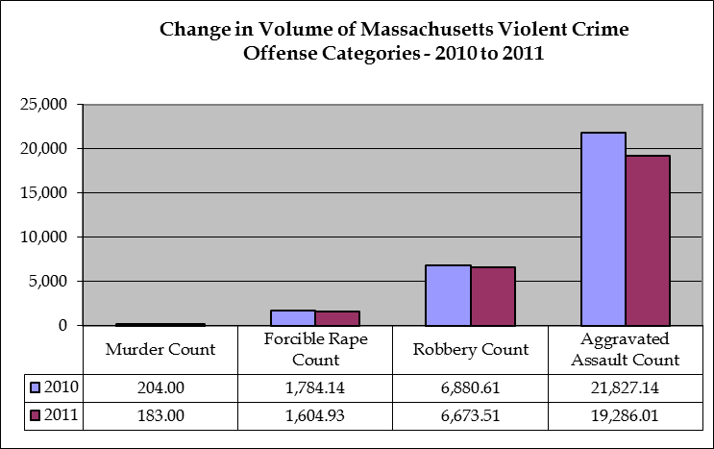
RATE OF VIOLENT CRIME IN MASSACHUSETTS

Over the 25-year period examined in this Policy Brief, the rate of violent crime in Massachusetts dropped 19% from 523.24 offenses per 100,000 persons to 421.21 offenses. By comparison, during this same period of time, the national rate of violent crime fell 37%, nearly twice that of the statewide rate. Data released by the FBI for calendar year 2010 ranks the violent crime rate for Massachusetts (466.60) as thirty-eighth among the nation in ascending order, with the highest rate among all New England States. The most currently available data reveals that the rate of violent crime in Massachusetts decreased 10% between calendar years 2010 and 2011, with a decline in each of the four major offense categories. Preliminary figures suggest that the national violent crime rate continued to fall during 2011, but at a rate of half (5%) that of the reduction seen in the Commonwealth. As noted in the Data Collection, Methodology, and Interpretation Section of this Report (see page 2), crime rates provide a more accurate picture of the changes in crime patterns within the state and the nation over time, as the statewide population grew 15% from 1987 to 2011 and the national population increased 28% during those same years.

Figure 5.
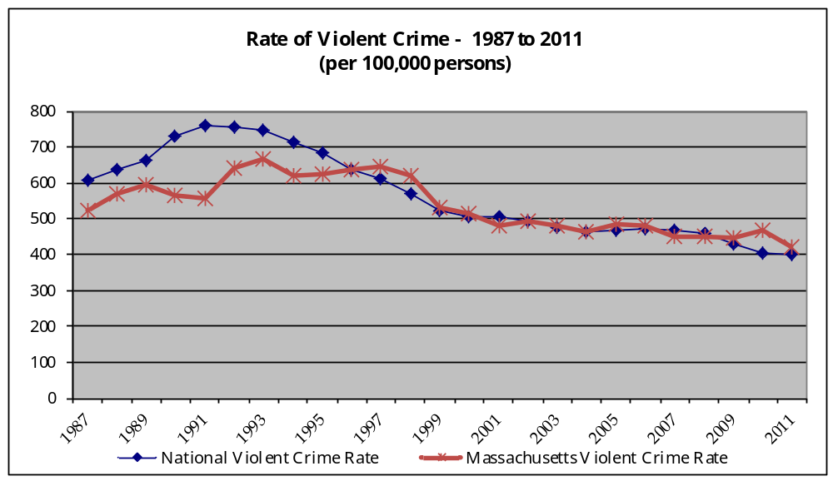

In addition to illustrating the overall decline in Massachusetts violent crime rates, Figures 6 and 7 display the changes in the rates for each of the four major violent crime offense categories. Although the violent crime rate in Massachusetts peaked in 1993 and has fallen progressively since then, there does not appear to be any clearly defined pattern between annual changes in the overall rate and fluctuations in the categories of murder, forcible rape, and robbery. The aggravated assault rate changes do however appear to be closely related to the annual shifts in the violent crime rate in the Commonwealth. Between 1987 and 2011, the murder rate declined 9%, the rate of forcible rape dropped 17%, the robbery rate fell 40%, and the rate of aggravated assault fell 9%. From 2010 to 2011, the rates for those same offense categories decreased 11%, 11%, 4%, and 12%, respectively.

Figure 6.
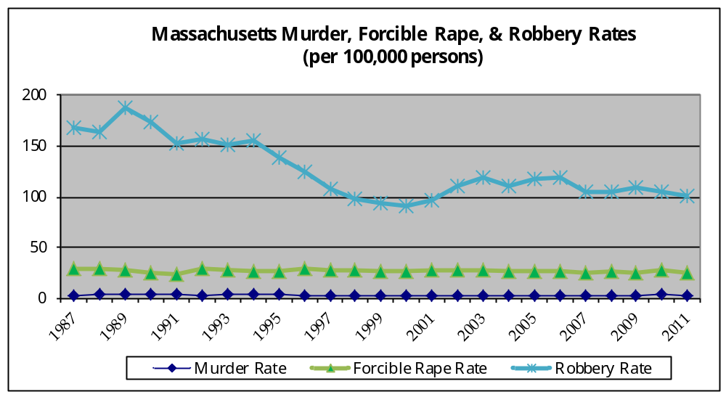

Figure 7.
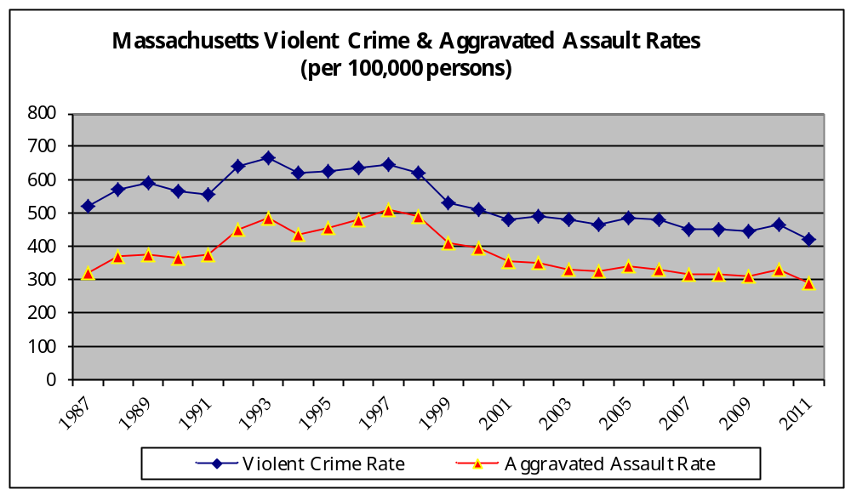

LOCATION OF VIOLENT CRIME

The ten Massachusetts communities with the highest volume of violent crime in 2011 (in declining order) are as follows: Boston, Worcester, Springfield, Brockton, New Bedford, Fall River, Lynn, Lowell, Lawrence, and Chelsea. Not surprisingly, the majority of these communities are the most populous cities within the Commonwealth and also have poverty levels that exceed both the state and national averages (10.5% and 13.8%, respectively). An overview of the population ranking for each municipality is presented below in Table 1, along with the volume of violent crimes. In addition, Map 1 provides a visual display of these ten communities and thus, an illustration of the concentration of violent crime, by volume, throughout the Commonwealth.

Table 1.
Top Ten Communities in Massachusetts by Volume of Violent Crime
City | 2011 Volume of Violent Crime | 2010 Population | Population Ranking (out of 308 reporting municipalities)
Boston | 5,252 | 617,594 | 1
Worcester | 1,804 | 181,045 | 2
Springfield | 1,581 | 153,060 | 3
Brockton | 1,160 | 93,810 | 7
New Bedford | 1,093 | 95,072 | 6
Fall River | 1,089 | 88,857 | 10
Lynn | 804 | 90,329 | 9
Lowell | 795 | 106,519 | 4
Lawrence | 764 | 76,377 | 12
Chelsea | 619 | 35,177 | 44

Map 1.
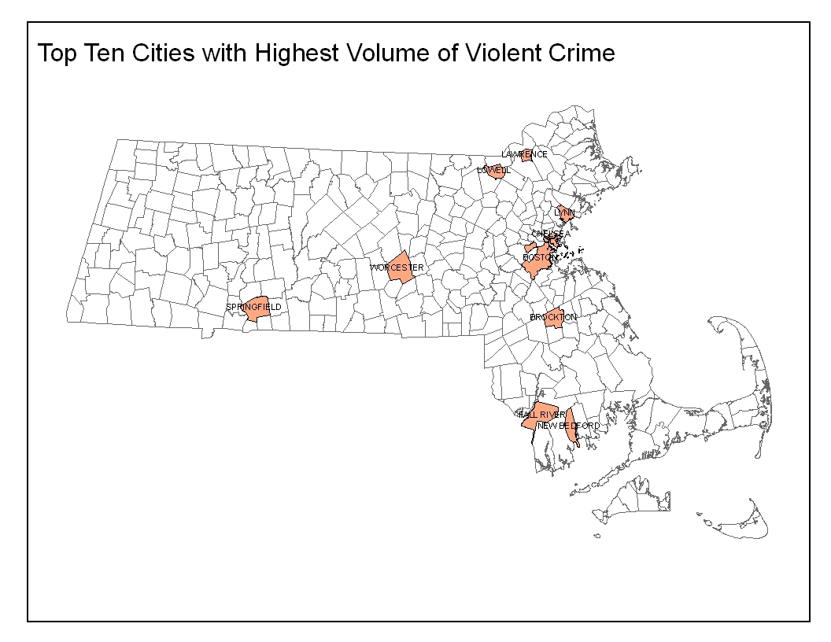
When the rates of violent crime are further explored, taking into account the population of the community, it becomes evident that an analysis based solely upon the volume of crime, as conducted in Table 1, is insufficient to fully understand the extent of the problem. Consider, for example, that Boston and Lowell are listed in Table 1 but no longer appear in Table 2, whereas two additional communities – Holyoke and North Adams – have now been incorporated into the analysis. In addition, the city of Chelsea appears in both lists, but jumped considerably from the tenth community with the highest violent crime count (Table 1) to the community with the highest violent crime rate (Table 2) in the state. Map 2, therefore, provides another depiction of the distribution of violent crime, by rate, for these ten communities that are located across the state.
Table 2.
Top Ten Communities in Massachusetts by Rate of Violent Crime
City | 2011 Rate of Violent Crime (per 100,000 persons) | 2010 Population | Population Ranking (out of 308 reporting municipalities)
Chelsea | 1,759.67 | 35,177 | 44
Brockton | 1,236.54 | 93,810 | 7
Fall River | 1,225.56 | 88,857 | 10
New Bedford | 1,149.65 | 95,072 | 6
Springfield | 1,032.93 | 153,060 | 3
Holyoke | 1,013.04 | 39,880 | 37
Lawrence | 1,000.30 | 76,377 | 12
Worcester | 996.44 | 181,045 | 2
North Adams | 897.29 | 13,708 | 142
Lynn | 890.08 | 90,329 | 9

Map 2.
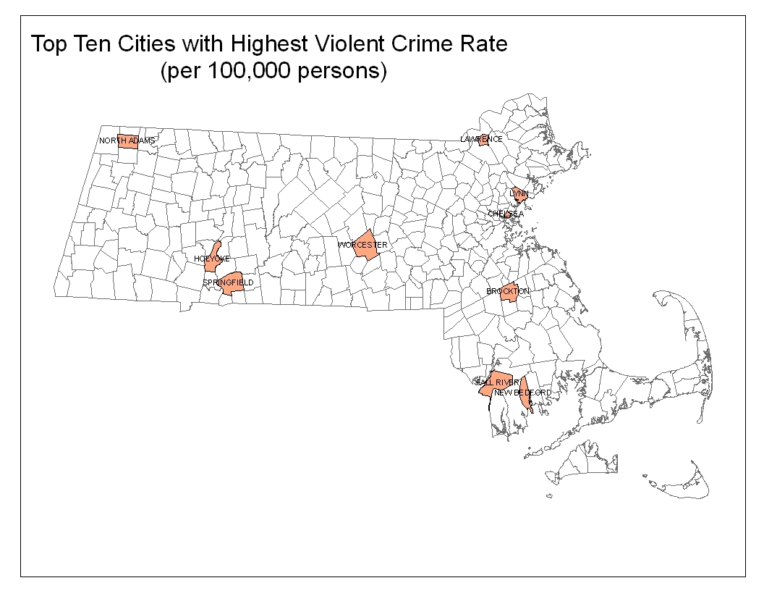

Where the two preceding maps displayed information for only the ten most violent communities, by volume and rate, Map 3 illustrates the distribution of the volume of all reported violent crime in the Commonwealth during 2011.

Map 3.
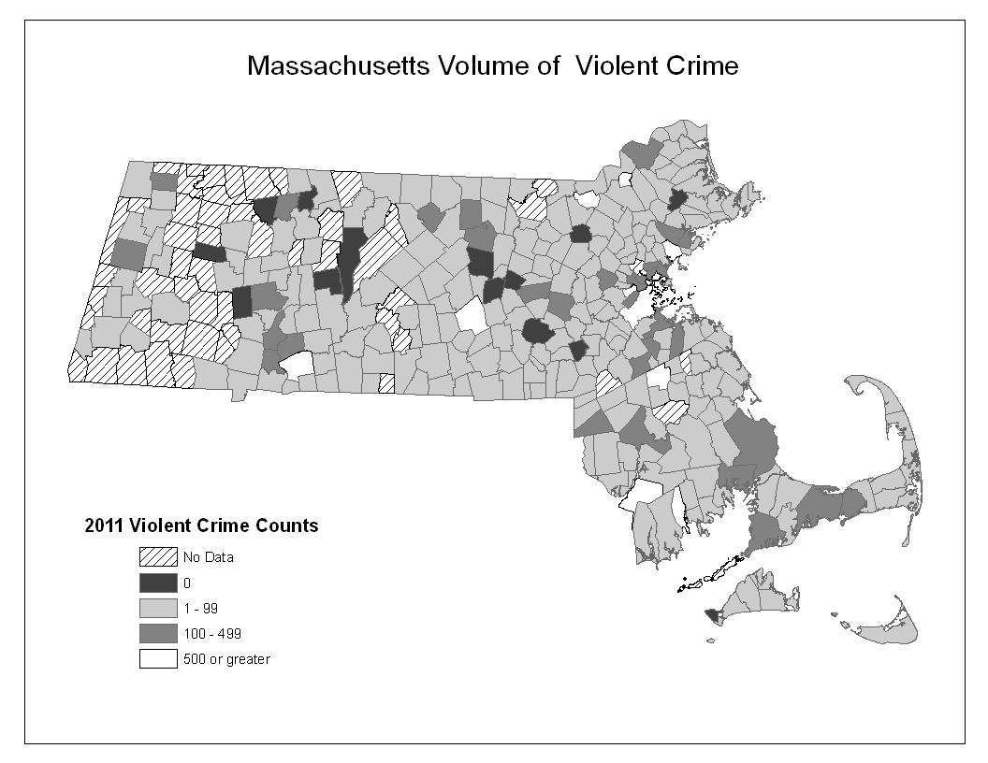

CONCLUSION

Violent crime in the Commonwealth, as measured by the cumulative number of murders, forcible rapes, robberies, and aggravated assaults, has followed a pattern not unlike the national figures; most notably, violent crime declined over the one-year period from 2010 to 2011, reflecting an overall downward trend during the past quarter century. This reduction is reflected in the volume, or raw counts of crimes, as well as the rates of crime, which accounts for population adjustments over time.

This document was prepared by the Research and Policy Analysis Division of the Massachusetts Executive Office of Public Safety and Security (EOPSS). This project was supported by the U.S. Department of Justice, Office of Justice Programs federal grant number 2008-DJ-BX-0044 as awarded by EOPSS.

The opinions, findings, conclusions and recommendations expressed in this publication are those of the author and do not necessarily reflect the views of the state or the U.S. Department of Justice, Bureau of Justice Assistance.

SOURCES

Federal Bureau of Investigation, Crime in the United States, 2010. Data Accessed July 23, 2012 and September 10, 2012.
http://www.fbi.gov/about-us/cjis/ucr/crime-in-the-u.s/2010/crime-in-the-u.s.-2010/summary

Federal Bureau of Investigation, Crime in the United States, 2011. Data Accessed July 23, 2012.
http://www.fbi.gov/about-us/cjis/ucr/crime-in-the-u.s/2011/preliminary-annual-ucr-jan-dec-2011

Maltz, Michael D., Bridging Gaps in Police Crime Data. Bureau of Justice Statistics, A Discussion Paper from the BJS Fellow Program, September 1999, 1 – 41.

Massachusetts Department of State Police, Crime Reporting Unit. NIBRS and UCR Summary Data, 2010 and 2011. Data received July 6, 2012.

U.S. Census Bureau, State & County QuickFacts. Massachusetts. Data Accessed July 23, 2012 – July 25, 2012. http://quickfacts.census.gov/qfd/states/25000.html

Please see the Executive Office of Public Safety and Security’s website for additional research publications:
http://www.mass.gov/eopss

APPENDIX A

APPENDIX: Massachusetts Violent Crime Data, 1987 – 2011

Volume Rate (per 100,000 persons)

Year | Census Population | Violent Crime | Murder | Forcible Rape | Robbery | Aggravated Assault | Violent Crime | Murder | Forcible Rape | Robbery | Aggravated Assault
1987 | 5,737,037 | 30,019 | 175.00 | 1,677.06 | 9,620.05 | 18,546.22 | 523.24 | 3.05 | 29.23 | 167.68 | 323.27
1988 | 5,737,037 | 32,674 | 184.00 | 1,687.47 | 9,424.40 | 21,376.39 | 569.52 | 3.21 | 29.41 | 164.27 | 372.60
1989 | 5,737,037 | 34,062 | 182.00 | 1,559.76 | 10,750.11 | 21,560.65 | 593.72 | 3.17 | 27.19 | 187.38 | 375.82
1990 | 6,016,425 | 34,132 | 212.00 | 1,500.00 | 10,502.43 | 21,914.34 | 567.31 | 3.52 | 24.93 | 174.56 | 364.24
1991 | 6,016,425 | 33,440 | 213.00 | 1,443.91 | 9,172.28 | 22,605.69 | 555.81 | 3.54 | 24.00 | 152.45 | 375.73
1992 | 6,016,425 | 38,692 | 171.00 | 1,793.65 | 9,443.34 | 27,283.93 | 643.11 | 2.84 | 29.81 | 156.96 | 453.49
1993 | 6,016,425 | 40,239 | 209.00 | 1,705.46 | 9,089.71 | 29,231.87 | 668.82 | 3.47 | 28.35 | 151.08 | 485.87
1994 | 6,016,425 | 37,394 | 199.00 | 1,620.76 | 9,325.96 | 26,247.12 | 621.52 | 3.31 | 26.94 | 155.01 | 436.26
1995 | 6,016,425 | 37,594 | 207.00 | 1,624.79 | 8,321.18 | 27,441.29 | 624.86 | 3.44 | 27.01 | 138.31 | 456.11
1996 | 6,016,425 | 38,449 | 161.00 | 1,753.15 | 7,540.96 | 28,993.53 | 639.06 | 2.68 | 29.14 | 125.34 | 481.91
1997 | 6,016,425 | 38,974 | 126.00 | 1,689.29 | 6,450.20 | 30,705.88 | 647.79 | 2.09 | 28.08 | 107.21 | 510.37
1998 | 6,016,425 | 37,355 | 113.00 | 1,640.13 | 5,883.17 | 29,713.86 | 620.88 | 1.88 | 27.26 | 97.79 | 493.88
1999 | 6,016,425 | 32,038 | 119.00 | 1,558.63 | 5,605.75 | 24,754.56 | 532.51 | 1.98 | 25.91 | 93.17 | 411.45
2000 | 6,349,097 | 32,642 | 122.00 | 1,674.73 | 5,738.22 | 25,105.65 | 514.11 | 1.92 | 26.38 | 90.38 | 395.42
2001 | 6,395,585 | 30,785 | 167.00 | 1,780.03 | 6,177.96 | 22,656.50 | 481.35 | 2.61 | 27.83 | 96.60 | 354.25
2002 | 6,412,549 | 31,543 | 171.00 | 1,813.55 | 7,116.36 | 22,440.05 | 491.90 | 2.67 | 28.28 | 110.98 | 349.94
2003 | 6,420,289 | 30,783 | 136.00 | 1,778.00 | 7,691.84 | 21,176.90 | 479.46 | 2.12 | 27.69 | 119.81 | 329.84
2004 | 6,416,553 | 29,838 | 166.00 | 1,730.67 | 7,125.95 | 20,814.76 | 465.01 | 2.59 | 26.97 | 111.06 | 324.39
2005 | 6,398,743 | 31,145 | 175.00 | 1,675.61 | 7,492.36 | 21,802.06 | 486.74 | 2.73 | 26.19 | 117.09 | 340.72
2006 | 6,437,193 | 30,998 | 185.00 | 1,670.66 | 7,704.73 | 21,437.40 | 481.55 | 2.87 | 25.95 | 119.69 | 333.02
2007 | 6,449,755 | 28,992 | 184.00 | 1,583.45 | 6,755.28 | 20,469.85 | 449.51 | 2.85 | 24.55 | 104.74 | 317.37
2008 | 6,497,967 | 29,204 | 162.00 | 1,664.86 | 6,784.53 | 20,592.30 | 449.43 | 2.49 | 25.62 | 104.41 | 316.90
2009 | 6,593,587 | 29,522 | 172.00 | 1,657.00 | 7,167.00 | 20,526.00 | 447.74 | 2.61 | 25.13 | 108.70 | 311.30
2010 | 6,547,629 | 30,696 | 204.00 | 1,784.14 | 6,880.61 | 21,827.00 | 468.81 | 3.12 | 27.25 | 105.09 | 333.36
2011 | 6,587,536 | 27,747 | 183.00 | 1,604.93 | 6,673.51 | 19,286.01 | 421.21 | 2.78 | 24.36 | 101.31 | 292.77

Four municipal police departments submitted data only in 2011; and 13 agencies (eight municipal police departments; four campus police departments; and one hospital police department) submitted data only in 2010.
State and municipal crime data was provided by Dan Bibel, from the CRU. Maps were provided by Bob Kearney, from the Office of Grants and Research.
Maltz, Bridging Gaps in Police Crime Data, 11.
Ibid, 4.
Ibid, IV.
Ibid, 12.
Ibid, 1.
The volume of violent crime in Massachusetts in 1983 was 27,776.
The violent crime figures presented in this section are carried out to two decimal places due to the use of estimates for those law enforcement agencies that did not report data for the full 12 months of 2011.
The volume of violent crime in the nation in 2010, the most recent year of data available, was 1,246,248. Aggravated assaults = 778,901 (62%); robberies = 367,832 (30%); forcible rapes = 84,767 (7%); and murders = 14,748 (1%).
The rate of violent crime in the nation in 1987 was 609.70 offenses per 100,000 persons; that number fell to 383.96 offenses per 100,000 persons in 2011, based on preliminary figures.
The figure published by the FBI differs from the violent crime rate provided by the CRU (421.20) and presented in the Appendix of this Brief, likely due to variations in the estimation methodology utilized by the FBI and the author.
ME = 122.00; VT = 130.20; NH = 167.00; RI = 256.60; and CT = 281.40.
The national population figures climbed from 243,400,000 in 1987 to 311,591,917 in 2011.
Percentage of Persons below the Poverty Level (2006 – 2010), as reported on the Census Bureau’s website: Boston = 21.2%; Worcester = 18.3%; Springfield = 27.6%; Brockton = 14.6%; New Bedford = 22.7%; Fall River = 20.2%; Lynn = 19.3%; Lowell = 17.5%; Lawrence = 26.5%; and Chelsea = 24.2%.
Percentage of Persons below the Poverty Level (2006 – 2010), as reported on the Census Bureau’s website: Holyoke = 31.7%; and North Adams = 16.1%.

