LEAD POISONING
Call for free: 1-800-532-9571
Assistance available in other languages.

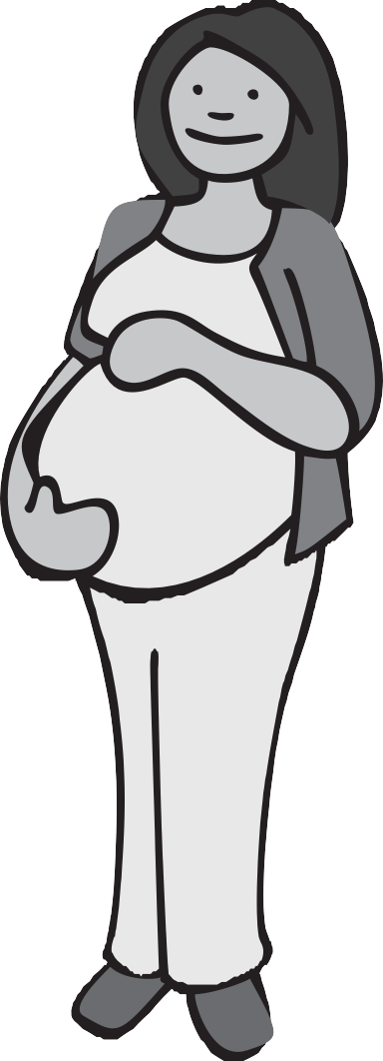Pregnant?
Get the Facts on Lead

Lead poisoning is caused by too much lead in the body. Lead is a metal that hurts the brain, kidneys and nervous system of children.

Lead can pass from a mother to her unborn child. High levels of lead can increase the risk of miscarriage. It can also cause the baby to be born too small or too early. Low levels of lead can cause learning and behavior problems.

How Can I Protect My Baby Before Birth?

Stay away from peeling paint and repair work.
Scraping paint creates lead dust. Cleaning, painting, or remodeling in a room with lead paint can hurt you and your baby.

Talk to your doctor about dietary supplements and home remedies. They may contain bone meal or shells with lead. Tell your doctor about any cultural practices where you eat soil or clay.

Eat foods high in Iron, Calcium, and Vitamin C.
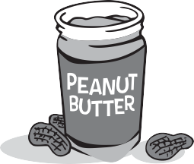These foods may help you and your unborn baby.

Iron can be found in meats, fish, peanut butter, cereals, beans and dried fruit.

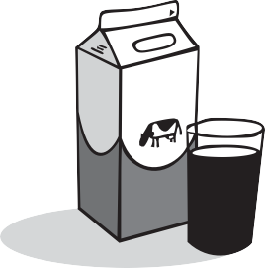Calcium can be found in milk, yogurt, cheese, and green leafy vegetables.

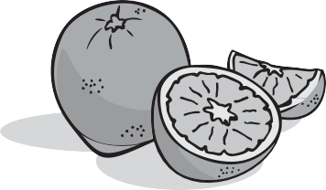Vitamin C can be found in oranges, mangos, green peppers, and juices.

www.mass.gov/dph/clppp

How Can I Protect My Baby After Birth?

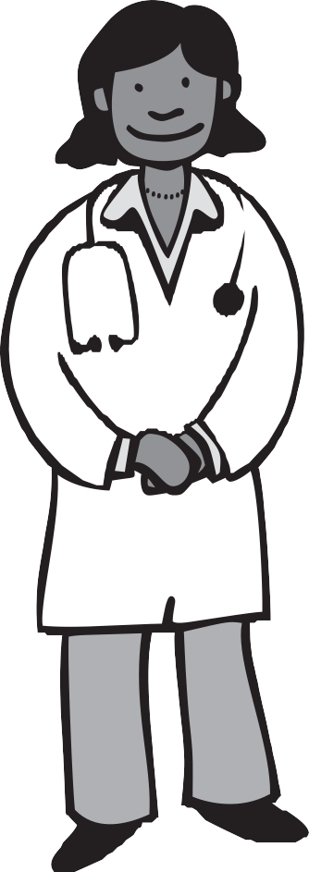Have Your Home Tested for Lead.
The Massachusetts Lead Law protects children under 6 who live in a home built before 1978. If there is lead paint in your home, the landlord must fix it. Ask your landlord to test your home for lead.

Have Your Child Tested for Lead.
A blood test is the only way to tell if your child has
lead poisoning. Children are required to have their first lead test when they are between 9 and 12 months old. Children must be tested again at ages 2, 3, and sometimes 4 depending on where they live.
Ask a doctor to test your child for lead.

Be Aware of Lead Paint Hazards in Your Home.
Lead dust and lead paint can be found in or around painted areas. It can also be breathed in during home repairs.

Did You Know?
Children can get lead poisoning from sources other than lead paint. These sources include water, soil, pottery, and products from other countries. Do not use handmade dishes or pots for food or drinks. They may contain lead.

Childhood Lead Poisoning
Prevention Program (CLPPP)
Call: 1-800-532-9571 or 1-617-624-5757
TTY: 1-617-624-5286
Email: clppp@state.ma.us
On the web: www.mass.gov/dph/clppp

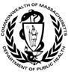Massachusetts Department of Public Health
Bureau of Environmental Health 2015

