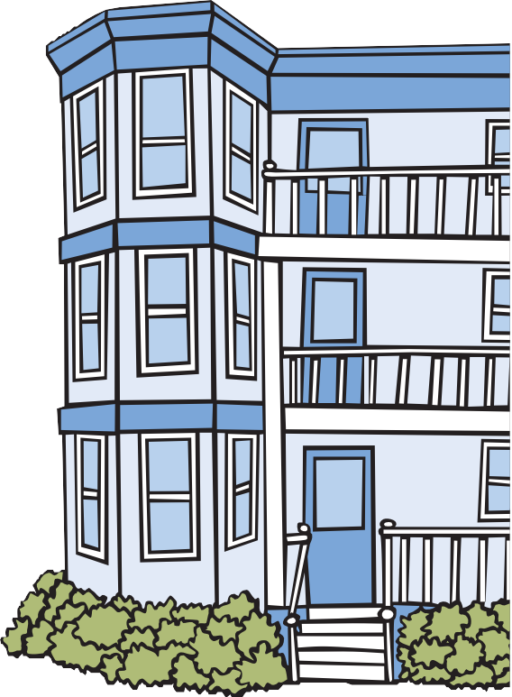

Lead can make your child sick.
Lead can hur t the brain, kidneys, and ner vous system of children. Even low levels of lead can make it hard to learn, pay attention, and behave.
If you are pregnant, lead can harm your baby.
Most children who have lead poisoning do not look or act
sick. A blood test is the only way to tell if your child has
lead poisoning.
Call the CLPPP Helpline! We have free information for:
Parents who want to learn how to protect their kids from lead.
Tenants who have questions about lead paint in their homes.
Property Owners with questions about the Lead Law or renovating safely.
You! Call us today.

1-800-532-9571
Monday-Friday 9am to 5pm

Childhood Lead Poisoning Prevention Program (CLPPP) Bureau of Environmental Health
Massachusetts Department of Public Health
250 Washington St., Seventh Floor
Boston, MA 02108
2015
www.mass.gov/dph/clppp
Protect Your Family.
Stay Ahead of Lead!

Childhood Lead Poisoning Prevention Program (CLPPP)
1-800-532-9571

How do children get lead poisoning?
Lead dust and lead paint in older homes can poison children. When old paint peels and cracks, it makes lead dust. Lead dust can also come from:
- opening and closing old windows, and
- repair work or renovation on older homes.
Children can breathe in lead dust. Some lead dust falls on the floor and toys. It gets into a child’s body when he puts his hands and toys in his mouth.

Lead can also be found in:
- Water and Soil
- Toy jewelry
- Pots, dishes, home remedies, and candy from other countries
What can I do to protect my child?
Test your child for lead. Children should
be tested at ages 1,2,3, and sometimes 4. Ask your doctor to test your child for lead.
Give your child healthy foods. Foods with calcium, iron, and vitamin C can help prevent lead poisoning. Always wash
your child’s hands before eating.
Clean up lead dust. Wet wipe often to get rid of dust. Wash hands and toys.
Test your home for lead. CLPPP can
check to see if your home has
ever been tested for lead. If you
rent your home, ask your landlord to hire a licensed lead inspector.

Are families with
children protected by law?
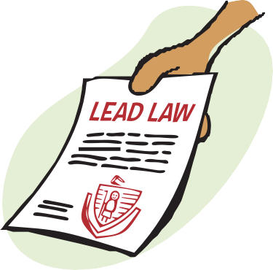Yes. The Lead Law protects children under 6 years old who live in a home built before 1978. If there is lead paint in the home, the owner (or landlord) must fix it.

Test your child. Test your home.
Protect your family!

Call us! We can help. 1-800-532-9571

