Data Brief:
Health Professions Data Series –
Physicians 2014
Massachusetts Department of Public Health April 2016
The Massachusetts Health Professions Data Series: Physicians 2014 Report provides data on workforce characteristics of Physicians licensed to practice in Massachusetts. This report is part of the Department of Public Health’s Health Professions Data Series, which currently reports on seven licensed health professions: dentists, dental hygienists, pharmacists, physicians, physician assistants, registered nurses, and licensed practical nurses.
The Massachusetts Health Professions Data Series: Physicians 2014 Report represents data provided by the Board of Registration in Medicine. This database contains demographic, education, and employment information on all physicians licensed to practice in the Commonwealth of Massachusetts in 2014.
The data series responds to the need for quality and timely data on demographics and employment characteristics of the Commonwealth’s healthcare workforce.
Chapter 224 of the Acts of 2012: An Act Improving the Quality of Health Care and Reducing Costs Through Increased Transparency, Efficiency and Innovation continues and expands the work of the Health Care Workforce Center established initially in the Acts of 2008. The publication of this data series is a significant step toward fulfilling the mandates of Chapter 224. It complements and contributes to ongoing health care access and payment reform initiatives in the Commonwealth, and federal efforts including the National Center for Health Workforce Analysis Assessment.
The data series characterizes the workforce from a supply perspective. It enhances the Commonwealth’s ability to identify trends and patterns in its healthcare workforce that will impact access to health care professionals and the services they provide. The data is integral to current and future decisions about healthcare workforce development, education, training, recruitment, and retention. It will also help to ensure the availability of a highly qualified, diverse, and culturally and linguistically competent workforce to meet the current and future needs of all Massachusetts residents.
¹ Chapter 224 of the Acts of 2012: An Act Improving Quality of Health Care and Reducing Costs Through Increased Transparency, Efficiency and Innovation: http://malegislature.gov/Laws/SessionLaws/Acts/2012/Chapter224

Background
The physician workforce data in this report is derived from Massachusetts physician license data maintained by the Board of Registration in Medicine (BORIM). As of October 2014, a total of 40,884 physicians were included in this database. Of these, 27,845 physicians possessed a full, active license and a business address in Massachusetts. This equates to 413 physicians per 100,000 residents in Massachusetts, the highest of any state in the country². The following data represents 27,845 physicians with a full, active license and business address in MA.
Demographics n=27,845
Figure 1: Gender

There are currently over 5,500 more male physicians than female physicians working in Massachusetts. Despite the disparity, the percentage of female physicians is the highest of any state in the country. In 2015, the national percentage of active, female physicians was 33.3%².
In Massachusetts, 26.5% physicians are age 60 or older, compared to the national average of 29.4% in 2015².
Education n=27,845
Figure 3: Medical Degree Obtained
Figure 4: Graduation School Location

The large majority (97%) of physicians in Massachusetts have a Doctor of Medicine (M.D.) degree (figure 3). Only 3% of physicians have a Doctor of Osteopathic Medicine (D.O.) degree, compared to the national percentage of 7.4%².
The percentage of Massachusetts physicians that obtained their medical degree from an international medical school (20%) is smaller than the national percentage of 24.2%² (figure 4).

² National data presented in this report is from the 2015 State Physician Workforce Data Book produced by the Association of American Medical Colleges (AAMC)
Most Massachusetts physicians graduated from medical school between the ages of 25 and 29 (figure 5). The mean and median age of graduation was 26 years. About 16% of physicians in Massachusetts graduated within the past 10 years.
Over 22% of physicians working in Massachusetts received their medical degree from one of the four medical schools in the state: Boston University, Harvard University, Tufts University, and University of Massachusetts.
The American Board of Medical Specialties (ABMS) is comprised of 24 Member Boards that certify physicians in a number of specialties. Figure 6 represents the reported physician specialties certified by ABMS.
Tables 1 and 2 below show the ABMS specialties with the highest percentage of male and female physicians, respectively. As earlier reported in Figure 1, male physicians represent 60% of the total physician workforce in Massachusetts.
Table 1: ABMS Specialties with
the Most Male Representation
ABMS Specialty | % Male
Orthopedic Surgery | 90.7%
Urology | 89.7%
Neurological Surgery | 87.7%
Thoracic and Cardiac Surgery | 87.4%
Nuclear Medicine | 79.5%
Otolaryngology | 78.0%
Plastic Surgery | 77.5%
General Surgery | 73.7%
Colon and Rectal Surgery | 71.2%
Table 2: ABMS Specialties with
the Most Female Representation
ABMS Specialty | % Female
Obstetrics and Gynecology | 62.5%
Pediatrics | 58.9%
Dermatology | 53.8%
Family Medicine | 52.0%
Clinical Genetics | 47.5%

* Some reported specialties were combined into broader categories that are seen in Figure 6.
³ Percentages do not add up to 100%. Not all specialties are listed here and not all physicians have a reported specialty. Many physicians reported multiple specialties.
Employment Characteristics n=27,845
Figure 7. Physician License Status
27,845 – Business Address in MA
4,672 - Limited or Temporary License
39,115 - Active License
40,884 Total Physicians with a MA License
1,769 - Inactive, Resigned, Revoked, or Suspended License

34,443 - Full License
6,598 – Business Address in Other State or Unreported Address

Figure 7 breaks down the license status of
all 40,884 physicians that were included in the licensure database. There are 27,845 physicians that have a full, active license and a business address in MA.
Figure 8 displays the five most frequently reported physician work settings. All other work settings received less than 1% of responses. They include: business establishments, government facilities, HMOs, medical research organizations, medical societies, mental health centers, nursing homes, preferred provider organizations, school health services, and urgent care centers.
A greater percentage of female physicians (8.5%) work in clinics compared to male physicians (4.8%). A greater percentage of male physicians (41.3%) work in hospitals compared to female physicians (33.4%).
There were also differences in work settings by age groups. A higher percentage of physicians over the age of 35 work in private offices (18.3%) compared to physicians under the age of 35 (2.4%).
Physicians, on average, are providing 22.8 outpatient hours and 13.9 inpatient hours per week. The median number of combined inpatient and outpatient hours provided per week is 40.
Approximately 2 out of 3 physicians reported that their practice is accepting new patients and accepting Medicaid (Figures 9 and 10).
Primary Care Physicians (PCPs) n=5,661
Figure 11. Primary Care Physician Criteria⁴
Physicians were categorized as PCPs
using the following criteria:
20% of Fully Licensed Physicians
in Massachusetts are categorized
as Primary Care Providers

5,661 Physicians with reported Outpatient Hours
15,797 with Work Settings in one of the following categories:
27,845 Total Physicians with a Full License and a Business Address in MA
6,549 with reported Specialties only in one of the following categories:

Work Settings
Business Establishment | Clinic
Government Employee | HMO
Partnership or Group Practice | Preferred Provider Organization
Private Office | Other or Not Reported

Specialties
Adolescent Medicine | Internal Medicine
Family Medicine | Obstetrics and Gynecology
General Practice | Pediatrics
General Preventive Medicine | Preventive Medicine
Geriatric Medicine | Unspecified Specialty or Not Reported

Figure 12 above shows that there are various differences between PCPs and other providers. PCPs are more frequently female, more likely to accept Medicaid, and spend more time on average on outpatient care compared to other providers. Physicians with a D.O. degree more frequently practice primary care than physicians with an M.D. (32% versus 20%).
⁴ The criteria used for primary care in this report are consistent with that of the Primary Care Office of the Massachusetts Department of Public Health. Comparisons to national data from AAMC are not made, however, due to differences in criteria
Figure 13 displays the age distributions of primary care providers compared to other providers. Approximately 1 in 5 PCPs are under the age of 40 (20.6%), compared to 1 in 4 non-PCPs (25.8%).
Geographic Distribution n=27,845
Figure 14. Physician Practice Location Distribution by County
Berkshire
1.7%
Hampshire
1.4%
Essex
6.4%
Suffolk
37.9%
Norfolk
8.9%

Hampden
5.4%
Franklin
0.5%
Worcester
9.3%
Middlesex
18.5%
Plymouth
3.3%
Bristol
4.1%

Barnstable
2.2%
Dukes
0.2%

Nantucket
0.1%

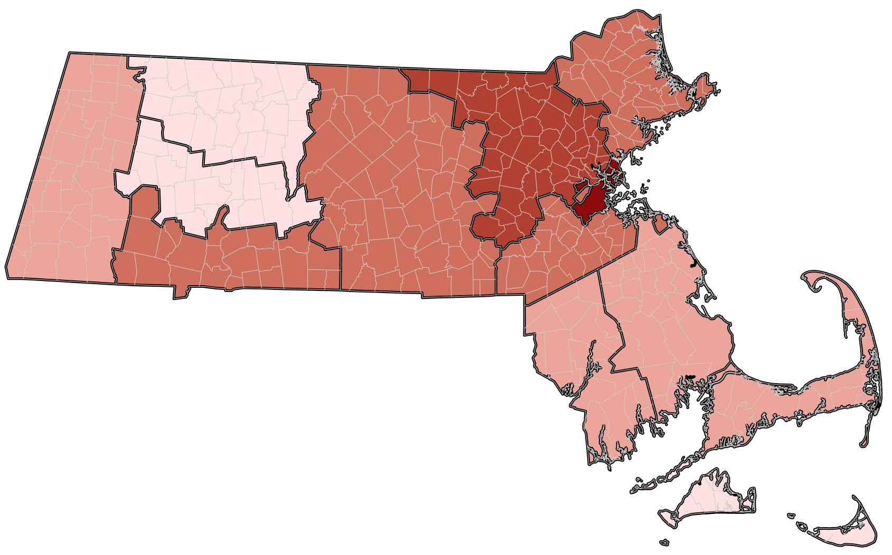

<2%
2 – 4.9%
5 – 9.9%
10 – 19.9%
20 - 38%

Figure 14 displays the distribution of reported physician practice location by county. Over a third of physicians in Massachusetts are practicing in Suffolk County, which contains 11.4% of the Massachusetts population⁵.

⁵ US Census 2014 Estimates of the Resident Population: April 1, 2010 to July 1, 2014

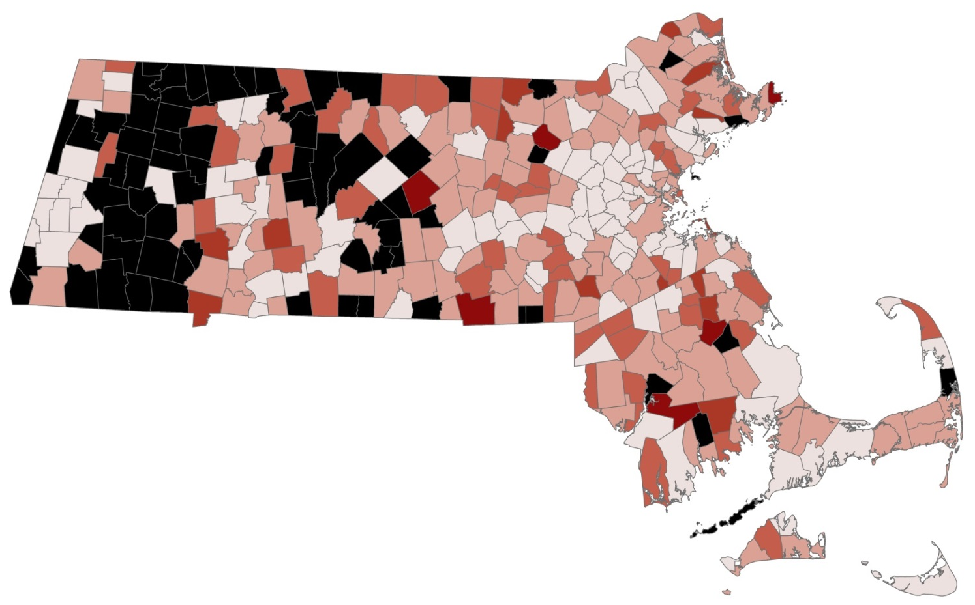
Figure 15. Residents per Physician Ratio by City/Town
Residents per
Physician
No Physicians
1 - 499
500 - 1499
1500 - 3499
3500 - 6499
6500+

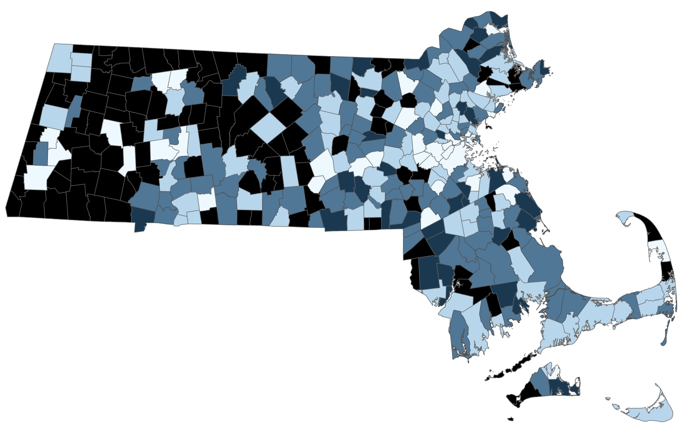
Figure 16. Residents per Primary Care Physician Ratio by City/Town
Residents per
PCP
No PCPs
1 - 749
750 - 1499
1500 - 3499
3500+

Figures 15 and 16 display the ratio of residents to physicians and primary care physicians at the city/town level. The Health Resources and Services Administration (HRSA) uses a PCP to population ratio of 1:3500 or greater as one criterion to define primary care health professional shortage areas (HPSAs). Areas in black represent towns and cities where no physicians reported practicing. Towns and cities with more favorable physician to population ratios are more prevalent in the Boston and Metro West regions, while those with no physicians are more prevalent in the western and central portions of the state.

This report was developed by the
Massachusetts Department of Public Health

Bureau of Community Health and Prevention
Health Care Workforce Center

Board of Registration in Medicine

For additional information about the
Health Professions Data Series or this Physician Report
Please contact the
Massachusetts Health Care Workforce Center
at the
Massachusetts Department of Public Health

Website: mass.gov/dph/hcworkforcecenter
Email: HCWorkforceCenter@state.ma.us

