**Massachusetts Department of Public Health | Bureau of Environmental Health**

# Pet Waste and Bathing Beaches

## This brochure will educate pet owners on environmentally sound waste disposal practices to protect the recreational waters of Massachusetts.

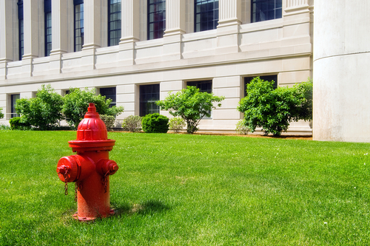

Health Risks Possibly Associated with Pet Waste

Pet waste can contain bacteria and parasites, causing infections such as the following:

• **Campylobacteriosis**: A bacterial infection that causes diarrhea in humans.

• **Giardiasis**: A protozoan infection of the small intestine that can cause diarrhea, cramping, fatigue, and weight loss.

• **Salmonellosis**: Symptoms include   
fever, muscle aches, headache,   
vomiting, and diarrhea.

• **Toxocariasis**: An animal-to-human infection that is caused by roundworms found in the intestines of dogs. The parasite can cause vision loss, rash, fever, or cough, and is a particular threat to children exposed to parasite eggs in sand and soil.

Why is Pet Waste A Concern?

There are a lot of pets, producing a lot of waste, and while pet waste is not the most significant pollutant, it can contribute to pollution over time.

Why pick up after my dog? won't the tide wash it away?

Dog waste may pose a health threat to swimmers, wildlife, surfers, and other dogs. It can pollute the water and lead to beach closures and closure of shellfish beds.

I only have a small dog; it can't really harm the water, can it?

It can be hard to picture how a single dog depositing a small amount of waste can result in water pollution. However, studies have shown that the combined impact of all pets and wildlife within a watershed can be significant when it comes to water quality and human health.

Be Aware

• When animal waste ends up in the water, it decomposes, using up oxygen. During summer months, low dissolved-oxygen levels harm fish and other aquatic life.

• Beaches and shellfish beds may be closed if evidence that disease-causing bacteria and viruses might be present is found on routine water testing. Pet waste can be a cause of test results that close beaches and shellfish beds.

• The majority of water pollution comes   
from small sources, especially at the household level.

• Many towns have "pooper scooper" ordinances that require pet owners to pick up and remove fecal matter from public property. Fines can be imposed on those caught violating these laws.

Pet Waste is Natural

• However, efficient drainage systems and roads now make it easy for pet waste to reach beach waters.

• Waste left on the ground either passes through storm sewers untreated or washes directly into oceans, lakes, and streams.

• Pet waste is unpleasant and can pose health risks when left on beaches or in other recreational areas.

• To make sure your pet isn't contributing   
to the problem, always clean up after   
your pet and deposit waste in an appropriate manner.

Quick Tips

• Reuse old bags (e.g. grocery, sandwich, newspaper, produce, or bread bags) to pick up and contain pet waste.

• Keep a supply of bags near your dog's leash.

• Tie bags onto the leash if you don't have a pocket or pack.

Do More to Protect the Shore

• Always carry a plastic bag to pick up your pet's waste.

• Do not throw pet waste near a storm drain; use a trash can. Pet waste can also be flushed down a toilet, but please don't   
flush the bag.

• Make sure to dispose of pet waste in   
a sealed bag, so it doesn't spill during   
trash collection.

• Do not flush pet or wildlife waste from your deck or dock into the water.

• Obey local leash laws and seasonal bans   
at beaches.



line seperating footer

For More Information:

Bureau of Environmental Health   
MA Department of Public Health   
250 Washington Street, 7th Floor, Boston, MA 02108   
Phone: 617-624-5757 | Fax: 617-624-5777 | TTY: 617-624-5286  
[www.mass.gov/eohhs/gov/departments/dph/programs/environmental-health/exposure-topics/beaches-algae/pet-waste-and-bathing-beaches.html](http://www.mass.gov/eohhs/gov/departments/dph/programs/environmental-health/exposure-topics/beaches-algae/pet-waste-and-bathing-beaches.html)

Reviewed May 2017