FLUORIDE MOUTHRINSE MONITORS'

TRAINING PROGRAM





MASSACHUSETTS DEPARTMENT OF PUBLIC HEALTH
Office of Oral Health

FLUORIDE MOUTHRINSE TRAINING PROGRAM

Table of Contents

Page

Welcome:
Overview Fluoride Mouthrinse (FMR) Training Program 3
Supplies Needed 4
Pre Test 5
Background 7
Introduction 9
Program Objective 9

Funding: 9

Fluoride:
Physiology of Fluoride 10
Systemic 10
Topical 11
Fluorosis: 11

Kindergarten: 12

Administration:
Records 13
Staffing 13

Demonstration:
Storage 14
Preparation 14
Dispensation 15
Practice Session 15
Distribution 15
Safety 16

Appendices: 17
A – Arrival Notice 18
B – Parents Permission Slip 19
C – Classroom Roster 20
D – Client Participation Reports 21
E – Fluoride Retention Following Mouthrinsing by Preschoolers 22
F – Physician/Dentist Signature 23
G – Systemic/Non-systemic Fluoride 24
H – Fluoride Toxicity Guide 25
I – Post Test 26

Revised 2008 Massachusetts Department of Public Health Office of Oral Health

FLUORIDE MOUTHRINSE TRAINING PROGRAM

Title: Fluoride Mouthrinse (FMR) Certification Training

Brief
Description: This course is made available to persons involved with the dental health care of students. The statewide FMR program depends on trained individuals who will correctly conduct and monitor the week-to-week activities. This course is designed to develop the skill level of the individual to correctly conduct and monitor this program.

Course

Objectives: The primary objective of the training program is to develop competent
skills for the persons serving as FMR monitors.

Behavioral Objectives:

Recognize the most effective measure to prevent dental caries (tooth decay);

- State the correct percent reduction in dental caries by the use of fluoride mouthrinses;

- Identify and complete the records utilized within the program;

- State the physiologic effects of fluoride;

- Demonstrate the correct method in storing, mixing, and dispensing the fluoride mouthrinse;

- State the toxic and fatal dosage of fluoride mouthrinse; and

- Describe appropriate emergency procedures for toxic and fatal dosages of the fluoride mouthrinse.

Evaluation: 1. Pre and Post Testing

2. Skills demonstration

Teaching

Methodologies: PowerPoint Presentation, Discussion and Hands-on Activity

LIST OF SUPPLIES NEEDED:


Bottle

Pump

NaF packets (3 grams)

Pre and Post tests

Cups

Napkins

Certificates

12 oz and 5 oz can of Evaporated Milk

Can opener

Handouts

Trash bags

PRE TEST

- What is the most effective measure to prevent dental caries (tooth decay)?

- regular visits to a dentist
- topical fluoride mouthrinses
- community water fluoridation
- good diet and regular tooth brushing

- Topical fluoride mouthrinses can reduce dental decay:

- 10% - 20%
- 20% - 40%
- 50% - 60%
- 60% - 70%

- What records must be kept to monitor the fluoride mouthrinse program?

- a parental consent or permission slip
- a classroom treatment roster
- participation reports
- a supply inventory
- all of the above

- What solution will a 3-gram packet of sodium fluoride make when properly diluted?

- 2%
- 0.2%
- 0.02%
- 0.12%

- A pump is provided to dispense the sodium fluoride solution, what is the correct ratio?

- 5ml = 1 teaspoons
- 10ml = 2 teaspoons
- 15ml = 3 teaspoons
- 20ml = 4 teaspoons

- What range is a toxic dosage?

- 20 mg - 40 mg or 1-2 dispensations
- 40 mg - 120 mg or 2-6 dispensations
- 200 mg - 800 mg or 10-40 dispensations
- 800 mg - 1,000 mg or 40-50 dispensations

- What range is a fatal dosage?

- 20 mg - 40 mg or 1-2 dispensations
- 40 mg - 120 mg or 2-6 dispensations
- 200 mg - 800 mg or 10-40 dispensations
- 800 mg - 1,000 mg or 40-50 dispensations

- What is the first emergency procedure you would follow with a toxic
and/or fatal dosage?

- give child 1 quart of milk
- give child 1 quart of fruit juice
- call Poison Control Center
- call the school physician

- Unused fluoride mouthrinse solution should be:

- discarded
- refrigerated
- stored in a locked cabinet
- left in the classroom for the following week

- Fluoride mouthrinse should be scheduled:

- 10 minutes before recess
- 15 minutes before recess
- 20 minutes before recess
- at least 30 minutes before eating or drinking is likely to occur.

- Dental Caries (decay):

- are an infectious, communicable disease
- are almost entirely preventable
- can lead to pain, loss of teeth and infection
- all of the above

BACKGROUND

In 1978, the Massachusetts Department of Public Health (MDPH) initiated a school-based fluoride mouthrinse program for elementary school children. In the 2008 school year, approximately 53,000 school children will be participating in this program, more than six times the participation rate in 1978, when the program began.

GOAL

The major goal of MDPH Office of Oral Health is to prevent and control dental
disease through organized community prevention efforts. Over the past few years, the principle community effort has been to adopt fluoridation in communities with public water supplies. In addition to community water fluoridation, one of the state’s major concerns has been to improve the oral health of school-aged children, particularly children with high-unmet dental needs. In 2000 a Special Legislative Commission released a report on oral health. Recommendations in the report included monitoring of the oral health status of school children and promotion of statewide individual and population-based preventive services and programs, especially for children.
In collaboration with the Department of Education, Massachusetts Dental Society, Massachusetts Dental Hygiene Association and the Oral Health Foundation of Massachusetts, the Massachusetts Department of Public Health coordinated and implemented the 2003 Give Kids A Smile Oral Health Survey of Third Grade School Children in Massachusetts. In 2007, this survey was again implemented and although the Commonwealth has seen a slight reduction in caries experience and untreated tooth decay since 2003, disparities still exist and oral health is still a crisis for many school-aged children statewide.
In 2006, the Office of Oral Health surveyed school nurses statewide and found that only 8% of public schools had a school-based dental sealant program with a noticeable falloff in services occurring in seventh grade, when most students are in middle school, and by twelfth grade, nearly 80% of respondent schools report that no oral health services are provided.
Of the 351 cities and towns in Massachusetts, 139 communities participate in the Massachusetts Community Water Fluoridation Program serving almost 4 million of our state’s residents. Along with community water fluoridation, a number of additional fluoride measures are promoted and available to reduce dental decay among the school children of Massachusetts, including the Fluoride Mouthrinse Program and school-based sealant programs.

REASONS FOR SCHOOL PROGRAMS

School programs are successful because children attend school daily and therefore are accessible to weekly scheduled programs. This assures regularity and continuity for the fluoride mouthrinse program. Continuity of a program makes a school setting most appropriate for implementing prevention programs for school-age children. The primary goal of educational institutions is to maximize the learning potential of its students through various educational methods. Implementation of school health services directly in schools has become an important component of education, based on the premise that a healthy child, free of illness and disease, will be a more effective learner than a child in ill health. Most state laws mandate that children have immunizations and health examinations or screenings before entering into a public school.
The state of Massachusetts mandates physical examinations, which include vision and hearing tests, height and weight screening and scoliosis screening for all school children before entering into the public school system. Although dental disease affects about half of the school-age population, currently there is no statewide mandate for dental examinations as part of the health requirements for children entering Massachusetts' public schools. Massachusetts Department of Public Health assists local cities and towns in adopting alternative preventive measures for caries control. One measure is the school-based Fluoride Mouthrinse Program. Weekly mouthrinsing with fluoride reduces caries by 20-40% in high risk children. Since 1978, the Massachusetts Department of Public Health has supported the Fluoride Mouthrinse Program through the purchase of fluoride mouthrinse kits for schools. The cost of this program is about $1.11 per child.
A number of school districts and local boards of health have implemented fluoride mouthrinse programs in their communities. Approximately 267 public and private schools participate in the statewide program. The program is dependent on school nurses, teachers, health aides, volunteers, dental hygienists and dental assistants to serve as Program Monitors; without their collective efforts the program could not be conducted. This course is designed to provide the basic skills necessary to serve as a FMR Program Monitor.

INTRODUCTION

Dental caries (tooth decay) is the most common chronic disease of childhood. The use of fluoride and sealants significantly reduces the risk of decay. Community water fluoridation is the most cost effective measure; however, about two million residents do not receive this health and economic benefit. Topical fluoride is very effective in reducing the decay rate in communities with and without fluoridation. Studies indicate a 20% to 40% reduction in the rate of caries for a school-based fluoride mouthrinse program.

PROGRAM OBJECTIVE

The primary objective of a public health school-based fluoride mouthrinse program is to provide school-age children with an inexpensive program that will reduce the incidence of dental caries by 20% to 40%.

FUNDING FOR FLUORIDE MOUTHRINSE PROGRAMS

The Massachusetts Department of Public Health provides materials for fluoride mouthrinse programs to eligible agencies and communities. The materials are: fluoride concentrate, plastic cups, napkins, pumps, bottles and plastic trash bags. The school or agency undertakes the following responsibilities in the program: promotion and outreach, administration, necessary support staff, and required progress reports. For precautionary/safety reasons, a 12 oz. can of evaporated milk and a can opener must be readily available.

FLUORIDE

Fluoride was first added to U.S. drinking water in 1945 in Grand Rapids, Michigan. According to the U.S. Centers for Disease Control and Prevention (CDC), approximately 69% of individuals on public water systems in the US now receive fluoride in their drinking water. The optimal concentration of fluoride in drinking waters has been set at 0.7 to 1.2 parts per million by the CDC and is dependant on the average local temperature and based on the assumption that in warmer climates people drink more water. That range provides a balance between effective cavity prevention and the incidence of dental fluorosis. Fluoride prevents tooth decay by enhancing the remineralization of enamel that is under attack and inhibiting the production of acid by decay-causing bacteria in dental plaque. Fluoride is also a normal constituent of the enamel itself, incorporated into the crystalline structure of the developing tooth and enhancing its resistance to acid dissolution.
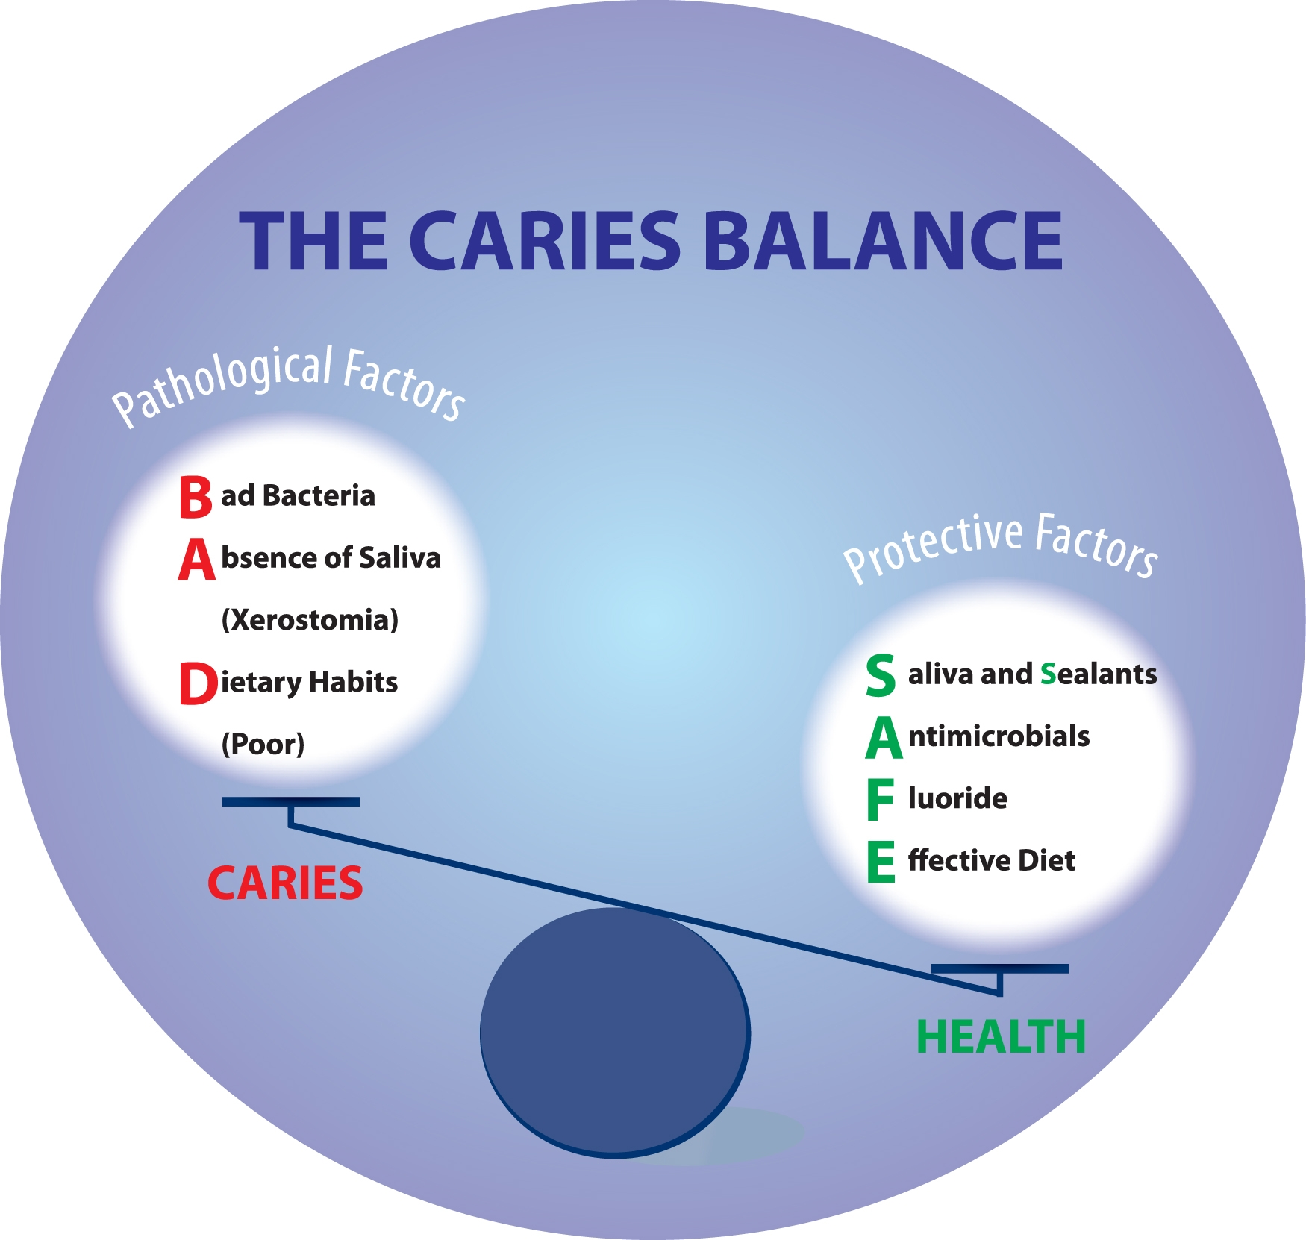

SOURCES OF FLUORIDE

In addition to ingesting fluoride in water, people receive fluoride from a large number of other sources such as toothpaste, mouthrinses, soft drinks, tea, processed foods, and vegetables. Fluoride is also consumed in food when fluoridated water is used during cooking. Fluoride intake from sources other than drinking water can be significant for some individuals, especially very young children who frequently swallow toothpaste or mouthrinse containing fluoride. We do not recommend fluoride mouthrinse in Kindergarten children due to their underdeveloped swallow reflex. (Appendix E).

I. SYSTEMIC

When fluoride is ingested by means of drops, tablets or drinking water, its absorption is systemic. When fluoride is ingested, fluoride ions are quickly absorbed into the bloodstream from the stomach and small intestine. The absorbed fluoride is distributed throughout the body via the circulatory system. Fluoride becomes incorporated systemically into the saliva, which continuously releases trace amounts of fluoride to the outer surfaces of erupted teeth. Some becomes incorporated in the unerupted teeth; and excess fluoride is excreted in the urine. Once deposited into the developing unerupted teeth, fluoride is not readily released. It is the incorporation and storage of systemically administered fluoride into the enamel of unerupted teeth that imparts a degree of caries resistance and results in a lower incidence of dental decay after the teeth erupt. The presence of fluoride in and on the teeth strengthens them against acid attacks from within the oral cavity.

II. TOPICAL
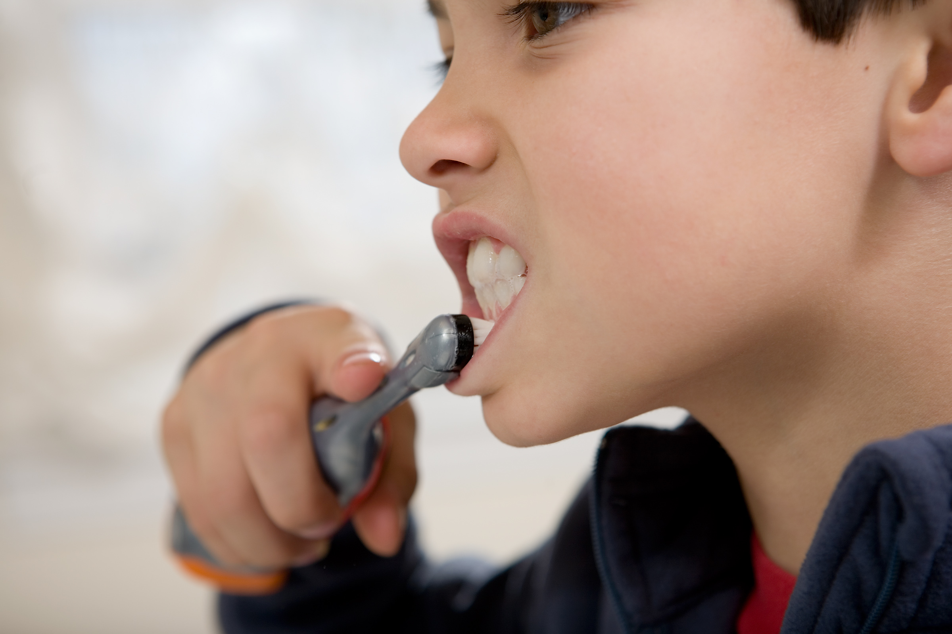
Fluoride is also available to the teeth via a topical mechanism. The self-application of a fluoridated mouthrinse is an example of a topical fluoride. Other topical fluoride prevention methods include fluoride dentifrices (toothpaste), or professionally applied fluorides. Topical fluoride is applied to erupted teeth and is therefore not incorporated within the developing tooth structure.

DENTAL FLUOROSIS

Dental fluorosis, sometimes referred to as mottled enamel, occurs when excessive amounts of fluoride are ingested. Fluorosis affects the enamel, the most outer layer of the tooth. The enamel fails to crystallize properly leading to defects that range from barely discernible white speckling to severe brown stains, surface pitting, and brittleness. Fluorosis may only occur during the development of the unerupted tooth, usually before the age of eight. School-age children, beginning in grade one or later, who participate in the Massachusetts Fluoride Mouthrinse Program are not at risk for developing dental fluorosis, as their anterior (front) teeth are fully developed by this age.
The most effective approach to controlling the prevalence and severity of dental fluorosis, without jeopardizing the benefits of fluoride to oral health, is likely to come from a more judicious use of fluoride in over-the-counter dental products, such as children not using more than a pea-sized amount of toothpaste regularly when brushing.

KINDERGARTEN CHILDREN

As noted previously, fluoride mouthrinses are not recommended for use by kindergarten and preschool-age children because most children this age may not adequately control their swallow reflex.



ADMINISTRATION OF THE PROGRAM

All programs must have a dentist or physician to serve as program consultant.

Records
All participants in the Fluoride Mouthrinse Program shall maintain the following records for a period of two years:
- A parental consent or permission slip allowing a child to be enrolled in the FMR Program. Consent should describe the nature, dose, and effects of fluoride tablets or mouthrinse. (Appendix B)
- A classroom treatment record roster sheet. (Appendix C)
- Participation reports. (Appendix D)
- Supply inventory records.

Staffing

There must be one identified individual who has overall responsibility for the coordination of the program and the submittal of progress reports and supply verification. The individual may be a school nurse, dental hygienist, teacher, local health officer or school administrator.
There must be sufficient staff trained in program methodology to manage the program.
These individuals, who serve as fluoride program monitors, may be school nurses, teachers, dental hygienists, dental assistants, teacher aides, health aides and volunteers.
Their responsibilities may include distributing fluoride supplies, ensuring participation by eligible students only, and supervising the mixing and dispensing of the fluoride materials. All persons who serve in this capacity must complete a training program offered annually by the Massachusetts Department of Public Health, Office of Oral Health.

TECHNICAL DEMONSTRATION

- Storage


Fluoride powder/packets must be kept in a locked storage area that is located in an area with normal room temperature. There must be an accurate inventory of records which details the management of the fluoride supplies.

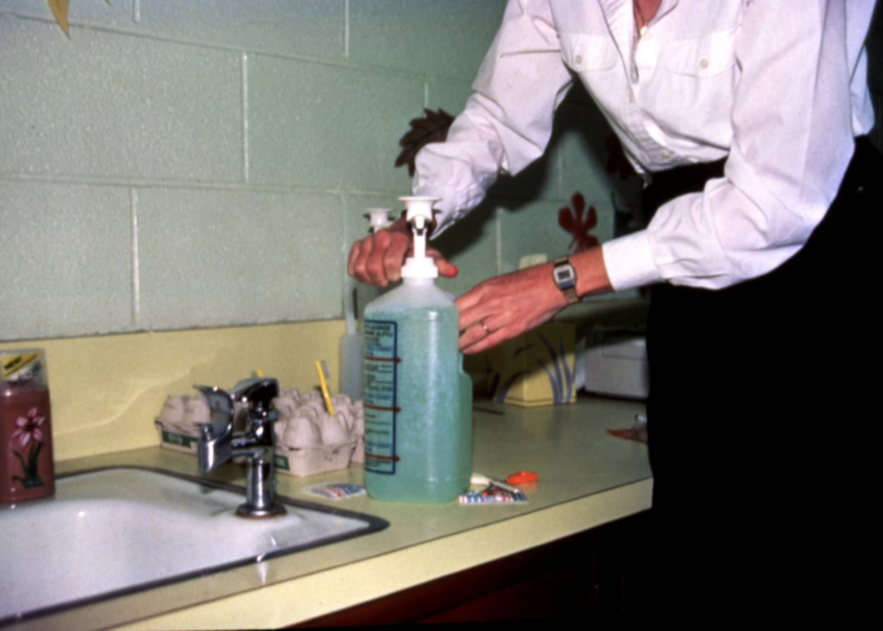
2. Preparation of Fluoride Solution

Sodium fluoride powder is the concentrate used to make the fluoride mouthrinse solution. The powder comes in packets, weighing 3 grams. The powder should
NEVER be dispensed in its concentrated form.

- Sodium fluoride powder MUST ALWAYS be mixed with the appropriate amount of water before a child is permitted to ‘swish and spit.’

- The FMR solution should be mixed in the plastic container that comes with the FMR kit.
The FMR solution should NEVER be made up day(s) in advance; and all un-used solution should be discarded by the end of the day.

- The FMR concentrate should NEVER be mixed or stirred in a glass bottle, as it will become alkaline rather than remain neutral.

The following instructions will assure the correct and safe preparation of the sodium fluoride mouthrinse. Also, read carefully the manufacturer’s instructions and the instructions on the plastic bottle. When mixed to the exact proportion, the sodium fluoride powder and water will yield a 0.2% neutral fluoride rinse. The water must be measured carefully and the solution mixed thoroughly.

Preparation Steps

- Remove the cap of the polyethylene container.

- Empty the 3-gram neutral sodium fluoride powder into the container.

- Fill the container with lukewarm tap water up to the level of the water line indicated on the container. Replace the cap securely and shake container to dissolve all the powder thoroughly. This process makes a 0.2% solution.

- Remove the cap and insert pump; tighten pump cap.

- The recommended amount dispensed is 10 ml equivalent or 2 teaspoons for grades 1-8.

- Prime the pump by pushing the plunger up and down a few times until the solution flows freely. Discard this fluoride rinse immediately.

- The pump will now dispense the correct amount of solution for each student’s use with each stroke of the pump.

3. Dispensing of Fluoride Solution

A workable schedule is to be developed and adhered to. It is recommend that the fluoride program be conducted at least 30 minutes prior to eating as food particles left on the teeth may hinder the effectiveness of the mouthrinse.

4. Practice Session

Prior to implementing the fluoride program, there should be a practice session, using plain water, to orient students to the proper procedures and to identify program management problems (timing, classroom distribution procedures).
Repeat the practice session if necessary.

5. Distribution

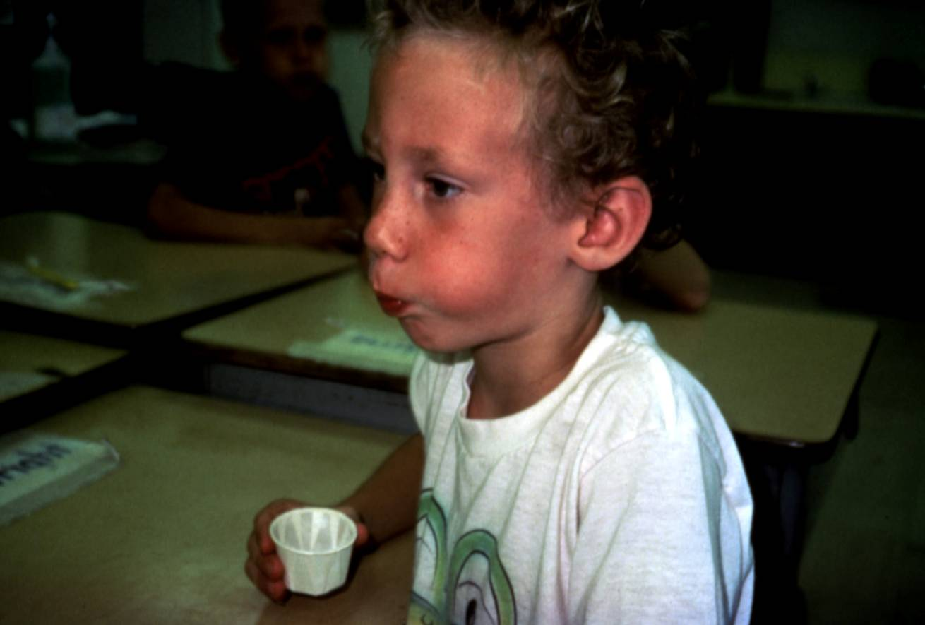
- After each participating student and fluoride program coordinator or monitor has a cup containing fluoride solution and a paper napkin, the monitor reminds the students not to swallow the solution and to forcefully strain the solution between their teeth until a signal is given to stop.
- All participants empty the contents of the cups into their mouths at the same time. The one minute timing begins at this point. During this time, the monitor can discuss the importance of toothbrushing, diet, etc. to enhance oral health education. The solution must reach all surfaces of the teeth. This is accomplished by puffing the cheeks and lips rhythmically. The monitor should watch for children who have little cheek and lip movement. A child may occasionally resort to shaking his head back and forth rather than using a cheek and lip motion. The monitor should correct these inappropriate actions.
- When 60 seconds have elapsed, the students are directed to empty the solution back into the cup, blot their lips with the napkin, and gently stuff the napkin into the paper cup to absorb the liquid.
- The cups are then placed into a plastic waste bag for proper disposal.
- Participation is recorded on the Weekly FMR Classroom Roster.

- Safety

There have been no reports of undesirable effects from the Massachusetts Fluoride Mouthrinse Program.

If a student is suspected of swallowing any dosage of sodium fluoride solution, or has ingested any portion of the dry fluoride powder, Poison Control Center should be called for further instructions.
1-800-222-1222
- If a student swallows his/her portion of the weekly mouthrinse solution, this amount is not toxic.
- A student could swallow up to 6 of the mouthrinse (120 mg of sodium fluoride) and only receive an insignificant dosage.
- If a student accidentally swallows a quantity of 10 (200 mg) of mouthrinse solution, or up to 40 (800 mg), he/she has received a toxic dosage.
- If a student ingests 50 or more, the equivalent of one-third of the total solution held in the plastic container, the student has received a fatal dose.
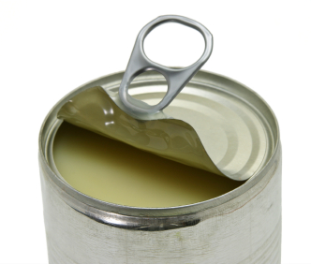
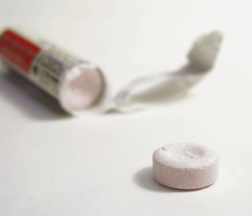
At least one 12 oz. and one 5 ounce can of evaporated milk and a can opener should be kept readily available. The Poison Control Center may recommend the use of milk in an overdosing emergency. To make one pint of milk, mix 8 oz. of evaporated milk with 8 oz. of water.

For children who are allergic to milk Poison Control may recommend either a calcium supplement or antacid tablet.

APPENDICES

APPENDIX A………………………………………………………….Arrival Notice

APPENDIX B………………………………………………………….Parents Permission Slip

APPENDIX C………………………………………………………….Classroom Roster

APPENDIX D………………………………………………………….Client Participation Reports

APPENDIX E……………………………………………………Fluoride Retention of Preschoolers
APPENDIX F………………………………………………………….Physician/Dentist Signature

APPENDIX G………………………………………………………….Systemic/Non-systemic Fluoride

APPENDIX H………………………………………………………….Fluoride Toxicity Guide

APPENDIX I…………………………………………………………...Post Test

APPENDIX A

Notice of Arrival of Fluoride Mouthrinse Materials

Name of Agency or Program:______________________________________________________
Address:___________________________________________________________________
City/Town:____________________________________State:_________ Zip:____________
Telephone: (_______)__________________________________

Date Materials Arrived: ____________________________________________________________

Condition of Shipment: (please check)

Excellent Satisfactory Poor

Number of Kits

Please list missing items:________________________________________________________

Comments (if any) on materials received:____________________________________________________

_____________________________________________________________________________________

I hereby certify that these materials have been received by______________________________________
Person in receipt of materials

on__________________.
Date

_________________________________________
Signature

Please complete and forward to:

Lynn Bethel, RDH, BSDH, MPH
Director, Office of Oral Health
Massachusetts Department of Public Health
250 Washington Street, 5th Floor
Boston, MA 02108-4619
(617) 624-5942
(617) 624-6062 Fax

APPENDIX B

WEEKLY FLUORIDE MOUTHRINSE PROGRAM SAMPLE PARENT PERMISSION SLIP

Dear Parent or Guardian:

Our school has an opportunity to participate in the Weekly Fluoride Mouthrinse Program this year. The program will be coordinated and funded by the Massachusetts Department of Public Health Office of Oral Health.

The Food and Drug Administration has approved the 0.2% weekly sodium fluoride mouthrinse as a safe and effective means of preventing tooth decay. This simple method of applying fluoride has been demonstrated to be safe and effective in reducing tooth decay 20% - 40%. Under supervision, participating students will rinse their mouths in school with 10ml (2 tsp.) of 0.2% neutral sodium fluoride solution for one minute each week. The solution is not swallowed. There are no known adverse effects associated with this procedure.

This program will help improve the dental health of your child, although it will not take the place of regular dental check-ups and proper tooth care at home.

FLUORIDE MOUTHRINSE IS BENEFICIAL. IT IS NOT MEANT AS A SUBSTITUTE FOR ANY OTHER FLUORIDE YOUR CHILD MAY BE GETTING, EITHER BY FLUORIDATED WATER, FROM YOUR DENTIST, OR BY PRESCRIPTION.

Participation in the mouthrinse program is voluntary and there is not cost to you. We encourage you to allow your child to participate in this valuable health program. Your child can participate in this program only if you give your permission by signing and returning the bottom half of this letter to your child’s teacher. Please return the slip whether you check “YES” or “NO”

If at any time you have a question about the program, you may call ___________________________
Program Coordinator

or____________________________________________at_________________________________
Principal Phone Number

Please sign the form below and return it to your child’s teacher by ____________________________

Sincerely, ________________________________________________________________________
Signature and Title
***************************************************************************************************************
_____ Yes, I want my child to participate in the weekly fluoride mouthrinse program.
_____ No, I do not want my child to participate in the weekly fluoride mouthrinse program.

___________________________________________ _____________________________________
Name of Student Signature of Parent/Guardian

________________________________ ______ ___________
Teacher Room Date

I would like to volunteer approximately 1 hour per week with the Fluoride Mouthrinse Program.

Yes _____ No _____

Signature: __________________________________________

APPENDIX C
INSTRUCTIONS: Weekly mark (+) YES when child participates and (-) NO when child does not participate

Weekly Fluoride Mouthrinse Classroom Roster

Fluoride Mouthrinse Record
200__ - 200__  School Session |  |  |  |  |  |  |  |  |  |  |  |  |  |  |  |  |  |  |  |  |  | School:
200__ - 200__  School Session |  |  |  |  |  |  |  |  |  |  |  |  |  |  |  |  |  |  |  |  |  | Teacher:
200__ - 200__  School Session |  |  |  |  |  |  |  |  |  |  |  |  |  |  |  |  |  |  |  |  |  | Grade:
PARTICIPANTS | SCHOOL WEEK RINSE YES(+) NO(-)
------ | 1 | 2 | 3 | 4 | 5 | 6 | 7 | 8 | 9 | 10 | 11 | 12 | 13 | 14 | 15 | 16 | 17 | 18 | 19 | 20 | 21 | 22 | 23 | 24 | 25 | 26 | 27 | 28 | 29 | 30 | 31 | 32 | 33 | 34 | 35
1.
2.
3.
4.
5.
6.
7.
8.
9.
10.
11.
12.
13.
14.
15.
16.
17.
18.
19.
20.
21.
22.
23.
24.
25.
26.
27.
28.
29.

APPENDIX D
Due in December and June

CLIENT PARTICIPATION REPORT

Massachusetts Department of Public Health

Office of Oral Health

Program Monitoring System

Year:_______ Period Ending:___________________ Grantee:______________________________

Program Weeks: __________________

Address: ______________________________ Report Prepared by:_____________________

Program | Class Location | # Eligible | # Participating | % Participation | % School Free/Reduced Lunch

TOTAL

Appendix E

The Commonwealth of Massachusetts
Executive Office of Health and Human Services
Department of Public Health
250 Washington Street, Boston, MA 02108-4619

920 Fluoride Retention Following Mouthrinsing by Preschool Children. M. Kanellis*, S.H.Y. Wei, D. Krell, W.C. Warren, R. Louie. University of Iowa, IA City, DHHS OMCH Rockville, MD and U.S.P.H.S., San Francisco, CA.

Currently, fluoride rinses are not recommended for use by preschool-aged children because of the belief that they cannot adequately control their swallow reflex. The purpose of this study was to determine the amount of fluoride retained by preschool children rinsing with a solution of 0.025% NaF. 465 children, ages 3(n=115), 4(n=250) and 5(n=109) years participated in the study. One group of children (n=98) were from a fluoridated area and had no experience with mouthrinsing. Another group (n=378) were experienced mouthrinsers participating in a weekly mouthrinse program with 10 ml of a 0.2% NaF solution. Volumes of 5, 7 and 10ml were tested, as were rinsing times of 30 seconds and 1 minute. The expectorated volumes were measured and the fluoride recovered was analyzed with an Orion fluoride ion electrode to determine the amount that may be ingested by each child. Analysis of the samples revealed that the amount of fluoride retained by all rinsers was significant. When rinsing for 30 seconds with 7 ml, 3 year-olds retained 23.0% and 5 year-olds retained 16.6%. The experienced rinsers did not swallow significantly less than those with no experience and a “practice” rinse had no significant effect on a child’s ability to rinse. A small number of children ingested the entire amount at each age group and these children should be excluded in a rinse program. Because the percent retention of all three age groups was high in this experiment, weekly fluoride rinses with currently available concentrations cannot be recommended for use by preschool-aged children.

Supported by USPHS (Grant BRSH # 500) RR 5313.

Journal of Dental Research March 1982, Volume 61, p.281. Program and Abstracts of IADR/AADR Annual Session, March 18-21, 1982, New Orleans, LA

Appendix F

PHYSICIAN/DENTIST ORDER FOR FLUORIDE MOUTHRINSE

PROGRAM YEAR _______________

I hereby request the Massachusetts Department of Public Health Office of Oral Health to provide fluoride mouthrinse for participating children in this School System or District. I also require the fluoride mouthrinse to be administered according to the protocols developed by the Department of Public Health.

Name of School System or District:_______________________________________________

Address:_____________________________________________________________________

_____________________________________________________________________

____________________________________________
Signature of Dentist or Physician Consultant to School System

_____________________
License Number

_____________________
Date

APPENDIX G

RECOMMENDED USE OF SYSTEMIC AND NON-SYSTEMIC FLUORIDES

MASSACHUSETTS DEPARTMENT OF PUBLIC HEALTH

Systemic: The ingestion of a substance that affects the body as a whole. An internal method for
obtaining fluorides by swallowing fluoridated water, some fluoride mouths rinse or
dietary fluoride supplements in the form of tablets, pills or drops that have been
prescribed by a physician or dentist.

Non-Systemic: The local or topical use of a substance. The direct application of professionally
applied fluorides to the teeth, the use of a fluoride paste, a fluoride mouth piece and most fluoride mouth rinses. None of these topical methods for obtaining
fluoride are meant for internal use and thus are not to be swallowed.

- Use of Fluoride in Communities WITHOUT Public Water Supply Fluoridation

Type of Fluoride Systemic/ Recommendation
Non-Systemic for Use

Fluoride mouthrinse Non-Systemic Yes

Fluoride toothpaste Non-Systemic Yes

Topical applications of Non-Systemic Yes
fluoride

- Dietary fluoride supplements

in the form of tablets, pills Systemic Yes
or drops taken internally

- Use of Fluoride in Communities WITH Public Water Supply Fluoridation

Type of Fluoride Systemic/ Recommendation
Non-Systemic for Use

Fluoride mouthrinse Non-Systemic Yes

Fluoride toothpaste Non-Systemic Yes

Topical applications of Non-Systemic Yes
fluoride

Dietary fluoride supplements Systemic No
in the form of tablets, pills,
or drops taken internally

APPENDIX H
Guideline of Fluoride Toxicity

Levels for Use in School Fluoride Mouthrinse Programs

Toxic levels of fluoride if swallowed | Milligrams of Sodium Fluoride | Milliliter of water | Number of Dispensations | Antidote
Recommended dosage for rinsing once weekly | 20 mg | 10 ml of water | 1 *dispensation | None- trivial amount, no harm if swallowed. Call Poison Control Center and inform school nurse.
Not recommended but not likely to be toxic | 40 mg  100 mg  120 mg  140 mg  160 mg  180 mg | 20 ml of water  50 ml of water  60 ml of water  70 ml of water  80 ml of water  90 ml of water | 2 dispensations  5 dispensations  6 dispensations  7 dispensations  8 dispensations  9 dispensations | None –Call Poison Control Center and inform school nurse.
Toxic- never recommended  Toxic- never recommended  Toxic- never recommended  Toxic- never recommended | 200 mg  400 mg  600 mg  800 mg | 100 ml of water  200 ml of water  300 ml of water  400 ml of water | 10 dispensations  20 dispensations  30 dispensations  40 dispensations | - Call Poison Control Center. Have available if needed: 12 oz can of evaporated milk and can opener  - (8 oz of evaporated milk mixed with  8 oz of water makes appropriate of  milk)  DO NOT GIVE JUICE
Can be fatal-Immediately follow directions for antidote | 1000 mg | 500 ml = 1/3 of plastic jug | 50 dispensations | - CALL POISON CONTROL CENTER  - FOLLOW WITH RECOMMENDED AMOUNT OF MILK – IF UNAVAILABLE, GIVE SAME AMOUNT OF LIQUIDS.  DO NOT GIVE JUICE
* Dosage received in a once weekly mouthrinse program Grades 1-6.  3-grams of Sodium Fluoride powder is mixed with 1500 ml of water to produce a 0.2% neutral sodium fluoride solution. |  |  | SUPPLIES NEEDED:  - 1 can each (5 oz & 12 oz evaporated milk).  - 8 oz of evaporated milk mixed with 8 oz of water makes one pint of milk.  - Can opener

Poison Control
1-800-222-1222
Appendix I

POST TEST

- What records must be kept to monitor the fluoride mouthrinse program?

- A parental consent or permission slip
- A classroom treatment roster
- Participation reports
- A supply inventory
- All of the above

- What is the most effective measure to prevent dental caries (tooth decay)?

- Regular visits to a dentist
- Topical fluoride mouthrinses
- Community water fluoridation
- Good diet and regular tooth brushing

- Unused fluoride mouthrinse solution should be:

- Discarded
- Refrigerated
- Stored in a locked cabinet
- Left in the classroom for the following week

- What range is a toxic dosage?

- 20 mg – 40 mg or 1-2 dispensations
- 40 mg – 120 mg or 2-6 dispensation
- 200 mg – 800 mg or 10-40 dispensations
- 800 mg – 1,000 mg or 40-50 dispensations

- What range is a fatal dosage?

- 20 mg – 40 mg or 1-2 dispensations
- 40 mg – 120 mg or 2-6 dispensation
- 200 mg – 800 mg or 10-40 dispensations
- 800 mg –1,000 mg or 40-50 dispensations

- Fluoride mouthrinse should be scheduled:

- 10 minutes before recess
- 15 minutes before recess
- 20 minutes before recess
- At least 30 minutes before eating or drinking is likely to occur.

- A pump is provided to dispense the sodium fluoride solution, what is the correct ratio?

- 5 ml = 1 teaspoon
- 10 ml = 2 teaspoons
- 15 ml = 3 teaspoons
- 20 ml = 4 teaspoons

- What solution will a 3-gram packet of sodium fluoride make when properly diluted?

- 2%
- 0.2%
- 0.02%
- 0.12%

- What is the first emergency procedure you would follow with a toxic and/or fatal dosage?

- Give child 1 quart of milk
- Give child 1 quart of fruit juice
- Call the poison center
- Call the school physician

- Topic fluoride mouthrinses can reduce dental decay:

- 10% - 20%
- 20% - 40%
- 50% - 60%
- 60% - 70%

- Dental caries (decay):

  - is an infectious, communicable disease
  - is almost entirely preventable
  - can lead to pain, loss of teeth and infection
  - all of the above

