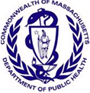
Data Brief: Massachusetts Adolescent Health Sexual Health, Experiences, and Behaviors

Health Survey Program, Office of Data Management and Outcomes Assessment Spring 2016
Massachusetts Department of Public Health | www.mass.gov/dph/hsp
Overview

Promoting healthy sexual behaviors continues to be a national and statewide public health priority. Six of the 15 Healthy People 2020’s Family Planning objectives target adolescents; these health indicators include delaying the age of first intercourse, reducing pregnancy, increasing contraceptive use, and increasing instruction about reproductive health topics before age 18 in formal settings (e.g. school, community center, etc.) and from parents and guardians¹.

This data brief presents descriptive statistics on sexual risk behaviors and experiences, pregnancy, pregnancy prevention, and education and screening for HIV and other sexually transmitted diseases (STDs) among public high school students in the Commonwealth. Additionally, selected disparities in sexual health are compared by race/ethnicity, gender, sexual orientation, and disability status.

Massachusetts Surveys of Youth Health Risks
Since 1993, Massachusetts (MA) Department of Elementary and Secondary Education (ESE) has administered a biennial survey entitled Youth Risk Behavior Survey (YRBS) on health and risk behaviors of MA high school youth. Since 2007, MA Department of Public Health (DPH) and ESE began to collaborate on the administration of YRBS and a second biennial survey entitled Youth Health Survey (YHS), which asks additional questions about health and risk behaviors of MA middle and high school youth. In 2013, 5,519 students from 57 public high schools participated in both surveys. Statistics presented are based on data from 2003-2013.

Data limitations: YHS and YRBS data are self-reported and from a sample of MA public school students. Students in private schools, state custody, or other educational settings are not represented. Students who have severe limitations or disabilities, or who are often absent from school may be under-represented. Data are voluntary and cross-sectional, and so should not be used to determine causation.

In this data brief:
Teen Sexual Risk Behaviors and
Experiences ……………………………….. 2
Teen Pregnancy ………..……………….… 3
Teen Pregnancy Prevention Methods .…. 4
Teen Sexual Health Disparities ..……… 5-7
HIV/STD Screening and Education ..…… 7
Community Partners ..…………................ 8

2013 Key Findings in MA:
- High school students in 9th and 10th grades have been consistently less likely to report having sex in the last three months than high school students in higher grades (Fig. 2).

- Of those who have ever had sex, 9th graders were least likely to use a pregnancy prevention method at last sex (Fig. 5) and to ever be screened for HIV/other STDs (Fig. 13).

- Survey results showed disparities by race/ethnicity, sexual orientation, and disability status:
- Male and Lesbian, Gay, and Bisexual (LGB) students were more likely to report alcohol and drug use prior to last sex than females and non-LGB students, respectively (Fig. 9, 11).
- Female and LGB students were less likely to report condom use at last sex than males and non-LGB students, respectively (Fig. 9, 11).
- Students reporting any disability were more likely to have had sex with 4 or more people and were more likely to ever have been or gotten someone pregnant (Fig. 12).

Teen Sexual Risk Behaviors and Experiences
A number of risk and protective factors are known to affect teen sexual behavior. For example, drug and alcohol use, physical abuse, and depression are associated with increased sexual risk behaviors, while protective factors such as positive family dynamics, positive peer norms, and connectedness to school and community are associated with decreased sexual risk behaviors². Earlier onset of sexual experiences, including consensual and/or non-consensual sexual contact, is associated with a higher number of sexual partners and inconsistent condom and contraceptive use. Adolescents who experience these types of high-risk situations have an increased incidence of STDs and/or unintended pregnancies^{2-6,20}. DPH programs aim to address both risk and protective factors, as well as risky sexual behaviors, to delay the onset of first sexual intercourse and increase condom and birth control use.

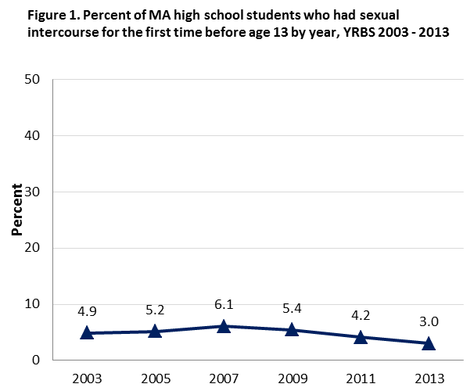
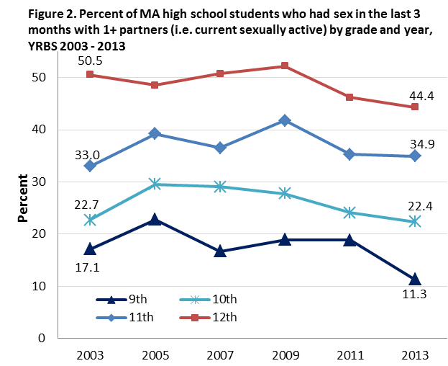
MA YRBS Survey: Since 2003, MA high school students were asked: “Have you ever had sexual intercourse?”, “How old were you when you had sexual intercourse for the first time?”, “During the past 3 months, with how many people did you have sexual intercourse?”, “Did you drink alcohol or use drugs before you had sexual intercourse the last time?” and “The last time you had sexual intercourse, did you or your partner use a condom?”

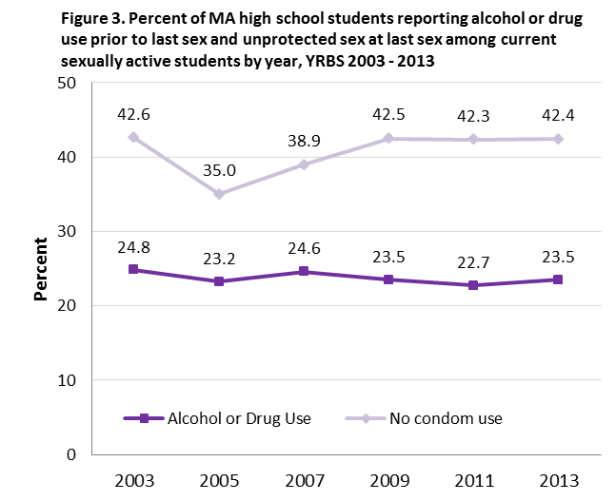
Findings in Massachusetts:
- The percent of high school students reporting having sex for the first time before age 13 has not significantly changed since 2003. Although the percent in 2013 was lower than in 2011, more years of data are needed to determine if there will be a statistically significant downward trend (Fig. 1).
- Since 2003, high school students in older grades were consistently more likely to report current sexual intercourse (in the last 3 months) compared to those in 9th grade (Fig. 2).
- Among students who had sex in the last 3 months, the percentages reporting drinking alcohol or using drugs prior to last sex (42.4%) and not using a condom at last sex (23.5%) in 2013 were similar to percentages in 2011 and 2009 (Fig. 3).

Teen Pregnancy
Teen pregnancy is often associated with poor outcomes for families and children. Nationally, an estimated 30% of teen girls who drop out of high school do so because of pregnancy. Children born to mothers less than 18 years of age are less likely to demonstrate school readiness, have more behavioral issues, and have higher rates of becoming teen parents themselves compared to children born to older mothers^{2,7}. Nationally, nearly 67% of teen mothers living on their own live below the poverty line⁷. In 2012, publicly funded family planning services in MA provided by safety-net health centers helped to prevent 22,900 unplanned pregnancies⁸.

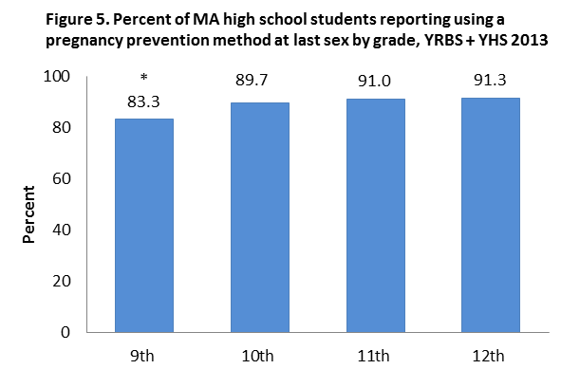
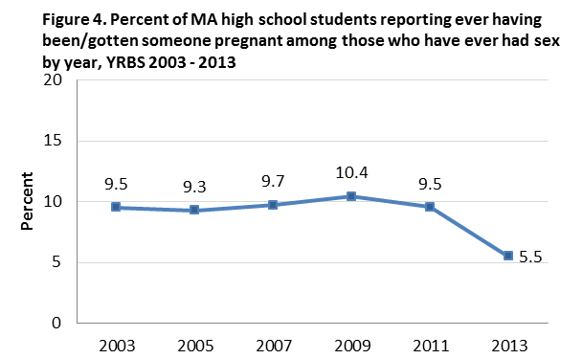
MA YRBS + YHS Surveys: MA high school students were asked, “How many times have you been pregnant or gotten someone pregnant?” (YRBS) and “The last time you had sexual intercourse, what one method did you or your partner use to prevent pregnancy?” (YRBS + YHS)

Findings in Massachusetts:

- In 2013, 5.5% of students who have ever had sex also reported ever having been or having gotten someone pregnant. This percent has not significantly changed since 2003. Although the percent in 2013 was lower than in 2011, more years of data are needed to determine if there will be a statistically significant downward trend (Fig. 4).
- Among those who have ever had sex, 9th graders were least likely to report using a pregnancy prevention method at last sex (83.3%) compared to students in older grades (≥89.7%) (Fig. 5).

DPH Spotlight: Adolescent Health and Youth Development Program

- DPH’s Adolescent Health and Youth Development Program (AHYD) implements teen pregnancy prevention and youth development programs in communities with high teen birth rates to prevent or reduce teen pregnancy, STDs including HIV/AIDS, and sexual activity among youth ages 10-24. AHYD also aims to increase protective factors, such as connection to school and community, among high-risk youth. (See map of AHYD’s funded communities on page 8).
- Teen Pregnancy Prevention (TPP) program funds 13 agencies to serve 15 high teen birth rate communities. TPP provides evidence-based curricula, adolescent sexual health, and youth development programming. Programming takes place in schools, after-school programs, community-based agencies, and housing developments. In FY13, TPP served 2,418 youth in ongoing programming (i.e. evidence-based, 3+ session programming) and 17,908 youth and community members in one or two-time workshops.
- Personal Responsibility Education Program (PREP) is a federally-funded collaboration between DPH and ESE to provide evidence-based teen pregnancy prevention curricula that include adulthood preparation topics such as financial literacy and healthy relationships. In FY13, PREP reached 2,439 youth (1,773 in middle schools and 666 in community-based agencies).
- Massachusetts Pregnant and Parenting Teen Initiative (MPPTI) provides a comprehensive support model for pregnant and parenting teens with the goals of increasing academic achievement, delaying subsequent pregnancy, and enhancing family stability through increasing social/emotional support systems and healthy parenting practices. MPPTI supported 433 adolescent parents and 394 children in FY13.

For more info: www.mass.gov/eohhs/gov/departments/dph/programs/community-health/primarycare-healthaccess/adolescent-health * Statistically significant at 95% confidence level.

Pregnancy Prevention Methods

Since 2003, the Massachusetts birth rate among teens age 15-19 has dropped overall and for all racial/ethnic groups statewide. The 2013 teen birth rate of 12.0 births per 1,000 women was a historic low (although certain communities continue to see high rates). Observed declines in the state’s teen birth rate may be attributed to increased availability of a wide range of contraceptives including highly-effective long-acting reversible contraceptives, implementation of evidence-based programs that provide information about contraceptive access and use, youth development programs focused on increasing protective factors and decreasing risk factors associated with teen pregnancy, and targeting resources to communities with the highest teen birth rates and other associated risk factors⁹.

Examples of…
- Long-acting reversible contraceptive (LARC) methods: contraceptive implant and intrauterine devices (IUDs).
- Short-term contraceptive methods: male and female condoms, birth control pills, diaphragms and cervical caps, contraceptive injections, contraceptive patches, and vaginal contraceptive ring.

Figure 6. Pregnancy prevention methods that MA high school students reported using at last sex, YRBS + YHS 2013*

Findings in Massachusetts:
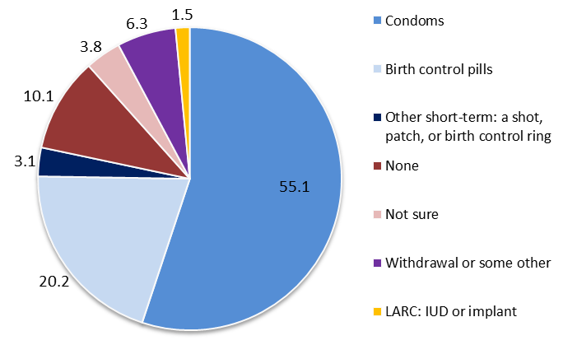
- Among students who have ever had sex, 10.1% reported that neither they nor their partner used any method to prevent pregnancy at last sex, while 3.8% were not sure if any method was used (Fig. 6).
- Condoms were the most common method of pregnancy prevention used at last sex (55.1%), followed by birth control pills (20.2%). Only 1.5% of respondents used any LARC method (Fig. 6).

DPH Spotlight: Sexual and Reproductive Health Program

DPH’s Sexual and Reproductive Health Program (SRHP) seeks to prevent unintended pregnancy and STDs throughout the Commonwealth. SRHP contracts with 12 community-based agencies to offer comprehensive family planning services to low-income MA residents at over 90 locations statewide. The majority of these agencies are funded to provide direct clinical services to eligible clients, predominantly those who are low-income, uninsured, and those who need access to confidential family planning care. (See map of SRHP-funded agencies on page 8).

In FY13, community-based agencies provided SRHP-funded services to 5,928 adolescents ages 13-19, amounting to 10,954 clinical visits. Of these visits, 263 included the provision of a LARC method and approximately 5,413 of these visits included the provision of short-term contraceptive methods.

For more info: www.mass.gov/dph/familyplanning

* Sums > 100 are due to rounding.

Teen Sexual Health Disparities

Disparities in teen sexual behaviors and experiences, birth rates, and adverse health outcomes by race/ethnicity, gender, sexual orientation, and disability status are well-documented^{2,3,10-15}. Nationally, Black non-Hispanic adolescents have higher rates of STDs like chlamydia, gonorrhea, and HIV/AIDS than other races/ethnicities^{2,3,16}. Both Hispanic and non-Hispanic Black females age 15-19 have greater risks of experiencing sex at an early age and of becoming pregnant¹⁶. Adolescent boys and youth from low-income households also have a greater risk of experiencing sex at an early age².

Lesbian, gay, and bisexual (LGB) youth are more likely to report experiencing sex before age 13, having more lifetime and current sexual partners, higher alcohol use before last sex, and a history of pregnancy than heterosexual youth^{15,16}. Adolescents with a developmental disability have greater risks of physical and sexual abuse, unplanned pregnancy, and STDs, and are less likely to receive adequate sexual health education, than those without a disability^{15,17}.

MA YRBS Survey: MA high school students were asked: “Have you ever had sexual intercourse?”, “During your life, with how many people have you had sexual intercourse?”, “Have you ever been taught about AIDS or HIV infection in school? “, and “During the past 12 months, how often did you talk with your parents or other adults in your family about sexuality or ways to prevent HIV infection, other sexually transmitted diseases (STDs), or pregnancy?”

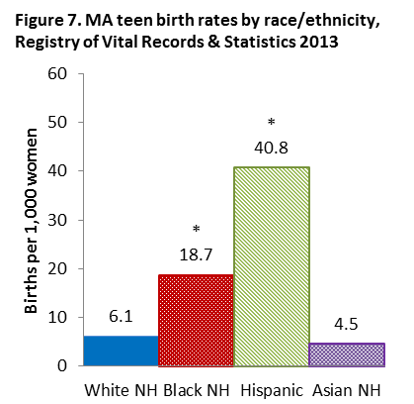
Race/Ethnicity**:
- Compared to non-Hispanic (NH) White students in Massachusetts:
- The teen birth rate for Hispanics was almost 7 times higher and the rate for Black NH was close to three times higher (Fig. 7).
- Hispanic students (52.8%) were more likely and Asian NH students (18.2%) were less likely to report ever having had sex (Fig. 8).
- Black NH students (23.7%) were more likely and Asian NH students (3.2%) were less likely to report having had 4+ sexual partners (Fig. 8).
- Asian NH students (23.2%) were less likely to discuss sexuality and prevention methods for pregnancy, HIV, or STDs with their parents or other family adults (Fig. 8).
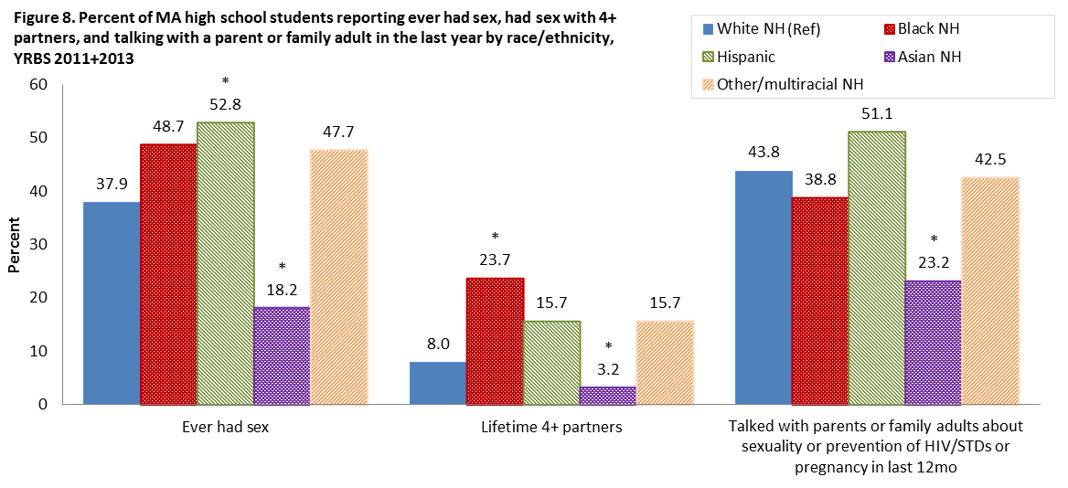

* Statistically significant at 95% confidence level.
**Race categories are mutually exclusive (White, Black, Asian, and Other/Multiracial are non-Hispanic).

Teen Sexual Health Disparities (cont’d)
..
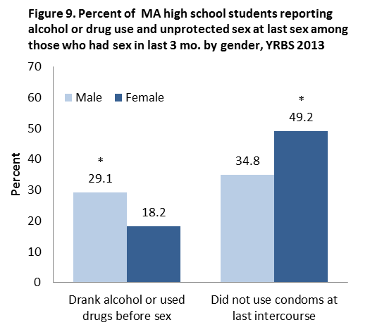
Gender:

- In Massachusetts among students who had sex in the past 3 months, males were 1.6 times more likely to report drinking or using drugs prior to last sex than females (Fig. 9).
- Female students were 1.4 times more likely to report that a condom was not used at last sex than males (Fig. 9).
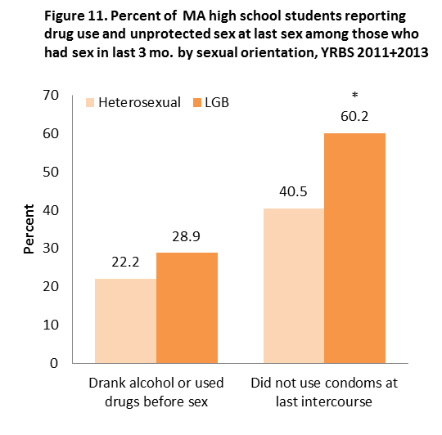
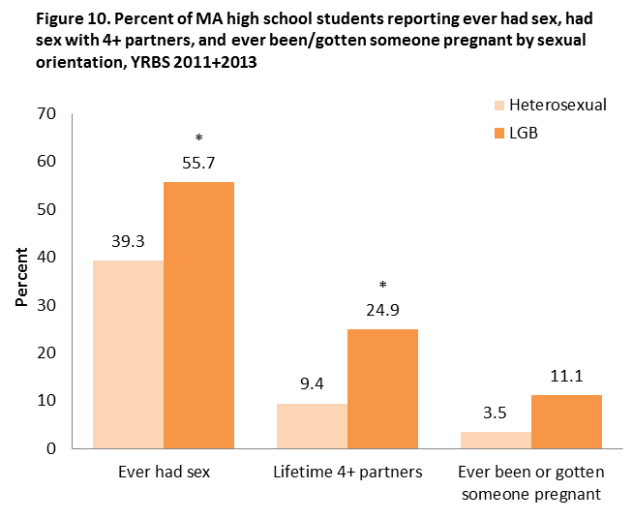
- The percent of students who reported they’ve ever had sex were similar among males and females (figure not shown).
Sexual Orientation:

- In Massachusetts, compared to heterosexual students, lesbian, gay, and bisexual (LGB) students were 1.4 times more likely to report ever having had sex, 2.6 times more likely to report having had sex with 4+ partners, and 3.2 times more likely to report ever having been or having gotten someone pregnant (Fig. 10).
- LGB students were also 4.1 times less likely to report using a method to prevent pregnancy at last sex, 34.0% vs. 8.3% (figure not shown).
- Among students who had sex in the past 3 months, LGB students were 1.5 times more likely to report no condom use at last sex (Fig. 11).
- The percent of students who reported using alcohol or drugs prior to last sex were similar among LGB and heterosexual students (Fig. 11).

DPH Youth Program Outcomes: Sixteen percent of youth served by community agencies in DPH’s PREP program self-identified as LGBTQ. Youth identifying as LGBTQ and youth identifying as straight reported comparable, positive experiences and outcomes in PREP. At least 75% of youth in both groups reported feeling respected in the program and at least 68% of youth in both groups rated program materials as useful. At program completion, 85% of straight youth and 93% of LGBTQ youth reported having at least one teacher or other adult to talk to about a problem compared to 80% among both groups at program initiation. At program completion, 77% of straight youth and 79% of LGBTQ youth reported condom use at last sex compared to 60% and 62% respectively at program initiation. Pre and post surveys were not matched due to small sample sizes so individual level changes could not be evaluated (DPH Adolescent Health and Youth Development Program).

* Statistically significant at 95% confidence level.

Teen Sexual Health Disparities (cont’d)

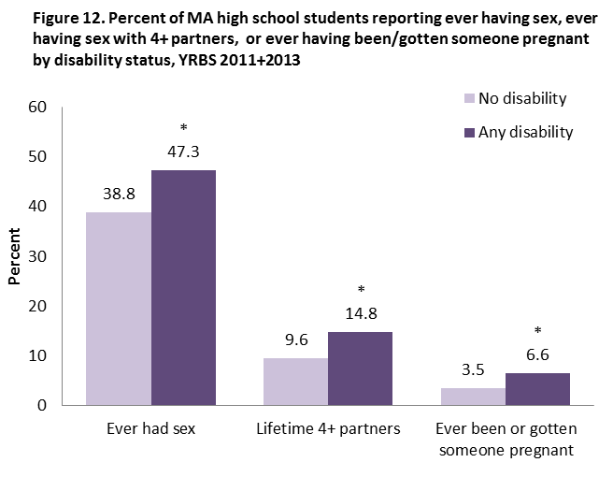
Students with a Disability‡:

- In Massachusetts, students reporting any disability were more likely to report ever having had sex (47.3%) and having had 4+ sexual partners (14.8%) compared to those with no disability (Fig. 12).
- Students reporting any disability were 1.8 times more likely to report ever having been or having gotten someone pregnant than those reporting no disability, 6.6% vs. 3.5% (Fig. 12).
- There were no significant differences in the percent reporting alcohol or drug use prior to last sex or in the percent reporting unprotected sex at last sex (figure not shown).

HIV/STD Screening and Education:

Nationally, almost half of the 20 million new cases of STDs occur among youth ages 15-24. Among sexually active teenage girls, 40% had an STD that could have led to infertility or death18. In 2010, 12.9% of high school students reported being tested for HIV. Black youth accounted for 57.4% of all HIV infections reported among youth ages 13-24. Also, 72.1% of all HIV infections were attributed to male-to-male sexual contact19. Regular screenings for STDs are important for early detection, as some STDs may not have clear signs or physical symptoms18.

MA YRBS survey: MA high school students were asked: “Have you ever been tested for HIV, the virus that causes AIDS? (Do not count tests done if you donated blood)”, “Have you ever been tested for other sexually transmitted diseases (STDs) such as genital herpes, chlamydia, syphilis, or genital warts?”, “Have you ever been taught about AIDS or HIV infection in school?”, and “During the past 12 months, how often did you talk with your parents or other adults in your family about sexuality or ways to prevent HIV infection, other sexually transmitted diseases (STDs), or pregnancy?”
Screening findings in Massachusetts:

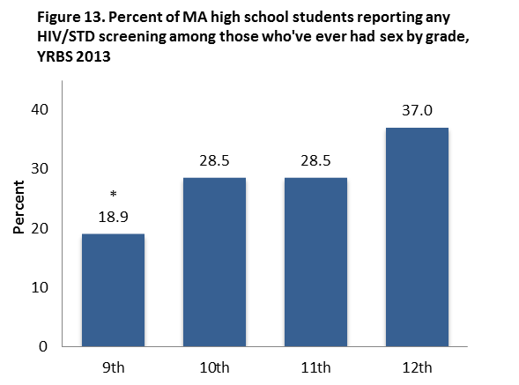
- Among students who reported ever having had sex, 9th graders were least likely to report ever having been tested for HIV and other STDs like genital herpes, chlamydia, syphilis, or genital warts compared to those in higher grades (18.9% vs. ≥ 28.5%) (Fig. 13).

Education findings in Massachusetts:

- 85.4% of all students reported having ever been taught in school about AIDS or HIV infection (figure not shown).
- 41.4% of all students reported speaking with their parents or other family adults in the last year about sexuality or ways to prevent HIV infection, STDs, or pregnancy (figure not shown).

‡ Students were considered to have a disability if they responded ‘Yes’ to either YRBS questions: “Do you have any long-term learning disabilities?” and “Do you have any physical disabilities or long-term health problems? (Long-term means 6 months or more).”
* Statistically significant at 95% confidence level

Community Partners

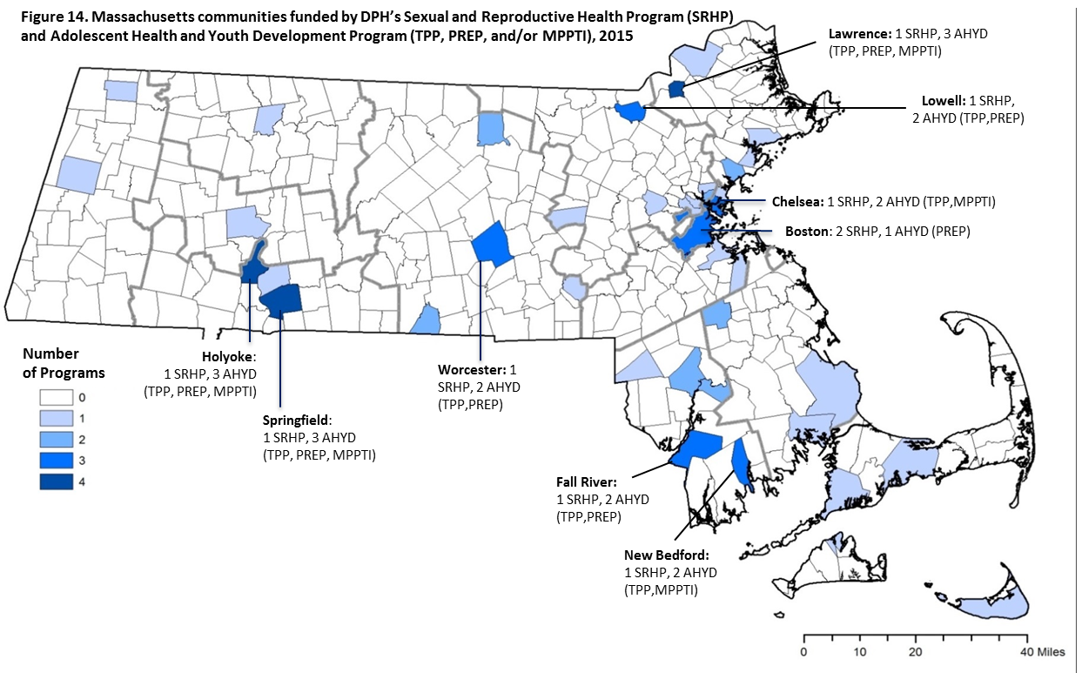

Resources:

Rape Crisis Centers: Provide statewide, comprehensive, free services to survivors of sexual assault and rape, including 24/7 hotlines, 24/7 accompaniment to hospitals, individual and group counseling, and referrals. More info: Call 1-800-841-8371(English), 1-800-223-5001(Español), or visit www.JaneDoe.org or www.mass.gov/dph/sexualassaultservices

Mass Alliance for Teen Pregnancy: Resource for information, programs, and policies related to teen pregnancy, locally and in the state www.massteenpregnancy.org

www.Littleblackbookhealth.org: Guide to help young adults access health insurance plans that meet their sexual and reproductive health care needs

www.Bedsider.org: Interactive website to help young adults navigate different birth control methods

Analytical notes:
- Percent calculated as those who responded 'Yes' over all who responded to that question.
- Missing responses are not included; therefore total responses vary by question.
- Data was either combined across surveys (YRBS + YHS) and/or survey years (2011 + 2013) if sample size was insufficient (N<100).
- Statistical significance was determined by non-overlapping 95% confidence intervals and, if needed, Wald log-linear chi-square test (α=0.05).
- Stock images were used and were not of any students in the YRBS and YHS sample.

Acknowledgements: The Massachusetts Adolescent Health Data Brief was produced by the Health Survey Program, in collaboration with the Sexual and Reproductive Health Program and Adolescent Health and Youth Development Program at DPH to raise public awareness of sexual risk behaviors, experiences, and disparities among teens in the Commonwealth and the importance of prevention efforts. Thank you to students and faculty of Massachusetts public schools who participated in the surveys and to ESE and the Center for Survey Research of UMass-Boston for their collaboration to make these surveys possible. The YRBS and YHS surveys and related reports are available at: www.mass.gov/dph/hsp.

References: 1.US DHHS. (2011). Healthy People 2020 family planning objectives. | 2.Kirby, D. (2007). Emerging Answers 2007: Research Findings on Programs to Reduce Teen Pregnancy and Sexually Transmitted Diseases. Washington, DC: National Campaign to Prevent Teen and Unplanned Pregnancy. | 3.Association of Maternal & Child Health Programs. Life Course Indicator: Early Sexual Intercourse (LC-50) (2014). | 4.Kaplan, D. L. et al. (2013). Early age of first sex and health risk in an urban adolescent population. J Sch Health, 83(5), 350-356. | 5.Epstein, M. et al. (2014). Understanding the link between early sexual initiation and later sexually transmitted infection: test and replication in two longitudinal studies. J Adolesc Health, 54(4), 435-441. | 6.Magnusson, B. M. et al. (2012). Early age at first intercourse and subsequent gaps in contraceptive use. J Womens Health, 21(1), 73-79. | 7.The National Campaign to Prevent Teen and Unplanned Pregnancy (2012). Why It Matters: Teen Childbearing, Education, and Economic WellBeing. | 8. Guttmacher Institute, Contraceptive Needs and Services, 2012, New York: Guttmacher Institute, 2014. | 9.Teen Births, Massachusetts: 2013. Boston, MA: ODMOA, MDPH. Dec 2014. | 10.The National Campaign to Prevent Teen and Unplanned Pregnancy (2014). Fast Facts: Teen Pregnancy in the United States. | 11.Kahn L. et al., CDC. (2011). Sexual Identity, Sex of Sexual Contacts, and Health-Risk Behaviors Among Students in Grades 9-12 - YRBS, Selected Sites, United States, 2001–2009. MMWR. 2011 Jun 10; 60(SS07):1-133. | 12.Blake, S. M. et al. (2001). Preventing sexual risk behaviors among gay, lesbian, and bisexual adolescents: The benefits of gay-sensitive HIV instruction in schools. Am. J. Public Health, 91(6), 940. | 13.Greydanus, D. E., & Omar, H. A. (2008). Sexuality issues and gynecologic care of adolescents with developmental disabilities. Pediatr Clin North Am, 55(6), 1315-1335. | 14.US DHHS, CDC, National Center for HIV/AIDS, Viral Hepatitis, STD, and TB Prevention (2013). HIV, Other STD, and Teen Pregnancy Prevention and Massachusetts Students. | 15.Gowen, L. K., & Aue, N. (2011). Sexual Health Disparities Among Disenfranchised Youth. Portland, OR: Public Health Division, Oregon Health Authority and Research and Training Center for Pathways to Positive Futures, Portland State University. | 16.MacKay, A. P. et al. (2009). Sexual and Reproductive Health of Persons Aged 10-24 Years-United States, 2002-2007. US DHHS, CDC. | 17.Murphy, N., & Young, P. C. (2005). Sexuality in children and adolescents with disabilities. Dev Med Child Neurol, 47(09), 640-644. | 18.US DHHS, Office of Adolescent Health. Sexually Transmitted Diseases. | 19.CDC (2012). Vital signs: HIV infection, testing, and risk behaviors among youths-United States. MMWR, 61(47), 971. | 20. Martin, S. & Macy, RJ. (2009) Sexual Violence Against Women: Impact on High-Risk Health Behaviors and Reproductive Health. VAW.net

MASSACHUSETTS DEPARTMENT OF PUBLIC HEALTH www.mass.gov/dph/hsp | Released Winter 2016

