Commonwealth of Massachusetts



Environmentally
Preferable Products (EPP)
Procurement Program

Annual Report

Fiscal Year 2011

July 1, 2010 – June 30, 2011

Compiled by:

Environmentally Preferable Products Procurement Program
Operational Services Division
March 1, 2012

Table of Contents

Executive Summary 3

- Program Purpose and Overview 5

- Ongoing Program Initiatives 6

- Key Accomplishments of FY2011 8
    - Achieved an 6% Increase in EPP Purchases 8
    - Tracked Over $3 million in Cost Savings 9
    - Lead the Year 2 Implementation of Executive Order #515 12
    - Managed and Negotiated 3% Savings FAC59 Renewal 13
    - Essential Role in Awarding 3 New EPP Statewide Contracts 14
    - Actively Participated in Webinars / Conferences 15
    - Integrated EPP into OSD’s Annual Event 18
    - Recognized by the US Environmental Protection Agency 19

- Spreadsheet Tracking of FY2011 EPP Purchases 20

- Reviewing the Data 24

- Conclusion 25

- Considerations for Next Year 25

APPENDIX

Massachusetts Executive Order #515 Fact Sheet: Summary of EO#515 Key Directives

Toxics Reduction Task Force FY2010 Progress Report

US Environmental Protection Agency Recognizes Massachusetts’ Achievements in Energy Efficiency

Commonwealth of Massachusetts
Environmentally Preferable Products (EPP) Procurement Program
Fiscal Year 2011 Report
Executive Summary
This report summarizes the achievements of the Commonwealth of Massachusetts’ Environmentally Preferable Products (EPP) Procurement Program (EPP Program) during Fiscal Year 2011 (FY2011) and the progress made in working with state and local government agencies and departments to promote green procurement practices and implement the directives of Executive Order #515, Establishing an Environmental Purchasing Policy, issued on October 27, 2009. Since the Program’s inception in late 1994, thousands of EPPs have been incorporated into an estimated four dozen statewide contracts and the state’s purchases of these goods and services have grown from $5 million to over $305 million per year.
Massachusetts’ EPP Program was one of the first comprehensive efforts in the United States to use government purchasing as an effective strategy to address environmental and public health issues. It gained momentum over the years by reaching out to purchasers in state agencies, municipalities, school districts, higher education, and local governments across the country to engage their support and it remains positioned as leader in this field today.
Readers will see from the accomplishments listed below that in order to document its progress, the EPP Program tracks and reports on the purchases made by state agencies and other contract users. Such data indicates an ever increasing use of EPPs that also serve to save the Commonwealth millions of dollars per year through their use. Additionally, the EPP Program has succeeded in quantifying the improved conditions for public health and the environment resulting from the purchase of products made with recycled content. Statistics and illustrative “equivalents” are provided in Section III of this document.

Key FY2011 Accomplishments
Throughout the 16+ years that the EPP Program has existed at the Operational Services Division (OSD), the EPP Program has consistently met or exceeded its established goals on an annual basis and continues to be considered as the national leader among environmental purchasing programs at the state government level. Over the years, the Program has been the recipient of numerous national awards and in 2009 the program Director was personally honored with Governor’s Manuel Carballo Award for Excellence in Public Service. (Details of the Governor’s award can be seen here).
Some of the key accomplishments achieved by the EPP Program in FY2011 include the following:
- Documented an 6% increase in the purchase of EPPs overall by state agencies and political subdivisions from $288 million to over $305 million for the year;
- Tracked over $3 million in cost savings, reduced carbon emissions by over 20,000 tons and a quantified a host of other environmental benefits realized through EPP purchases;
- Led the interagency Toxics Reduction Task Force, formed as a result of Executive Order 515, in their second year of work to assist a targeted group of state agencies in identifying the greatest opportunities for reducing toxic substances in their purchasing activities;
- Managed and negotiated an estimated 3% cost savings for the renewal of the multi-state contract FAC59, Green Cleaning Products, Programs, Equipment and Supplies statewide contract and increased contract utilization by more than 7%;
- Played an essential role in the research, specification writing and awarding of three new statewide contracts that include EPPs, including office equipment, lawns and ground equipment and biodiesel;
- Actively participated in numerous webinars, training sessions and conferences aimed at raising the awareness of Massachusetts’ EPP efforts and the benefits of green purchasing;
- Integrated the former EPP trade show into the larger OSD annual trade show and product demonstration event, further illustrating the mainstreaming of green products and services;
STATE OF MASSACHUSETTS – BEST PRACTICES TO ENSURE PURCHASING OF ENERGY STAR QUALIFIED EQUIPMENT
- Recognized by the US Environmental Protection Agency for innovative leadership in utilizing state contracts to achieve “best practices” in procuring energy efficient equipment across many fronts.

Conclusion and Looking Ahead
The EPP Program takes pride in the accomplishments of increasing the overall EPP purchases by more than 6%, maintaining a cost savings total of over $3 million for a second consecutive year, succeeding in addressing the directives of Executive Order 515 and actively participating in various webinars and conferences to raise the awareness of environmental purchasing on a national level. As a result of the Program’s cumulative efforts throughout the year, buyers in Massachusetts and elsewhere will have the benefit of higher quality products produced in the marketplace at cost-competitive prices. It’s a win-win for all on many levels.
As the Program transitions into Fiscal Year 2012, some of the goals established include:
- Improving upon the current system of tracking the EPP purchases made by state agencies and other contract users to more clearly understand the contracting trends and opportunities;
- Working with OSD’s Strategic Sourcing Services Leads and other interagency partners to increase the contract utilization of those contracts that best serve to accomplish the goals of Executive Order 515; such contracts will include, Green Cleaning Products, Janitorial Cleaning Services, and others. The EPP Program also plans to engage the help of the vendors on these contracts to accomplish the goals;
- Continuing to serve as an EPP resource and active partner to national organizations such as the National Association of State Procurement Officials (NASPO) to raise the awareness of green purchasing benefits and incorporate consistent EPP criteria and standards across a broader spectrum of national contracts;
- Strengthening the current network of interagency relationships and non-profit partners to expand upon the existing program of education and outreach with a particular focus on reducing toxics in purchasing and utilizing social networking as a means of communicating these efforts to the broadest audience possible; and
- Researching on-line tools and/or working to improve current tools, to more easily calculate the benefits of environmental purchasing.
I. Program Purpose and Overview

Massachusetts defines EPPs as products and services that have a lesser or reduced effect on human health and the environment when compared to competing products and services that serve the same purpose. Examples include:
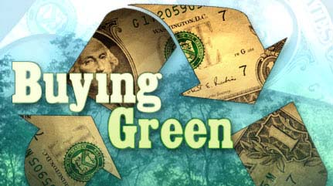
- recycled-content paper and plastic products;
- waste reducing compostable items;
- reduced-toxicity cleaning products and practices such as integrated pest management;
- furnishings made with sustainable materials;
- renewable energy and alternative-fuel vehicles;
- water conservation practices and devices and more;
- energy efficient office and industrial equipment, lighting and fixtures.
Along with their reduced environmental footprint, EPPs can help stimulate the Massachusetts and US economy stimulate the Massachusetts and US economy by working toward stabilizing the markets for recycled materials, supporting recycling businesses and programs and turning a significant portion of the solid waste stream, otherwise headed for landfills, into usable durable products. The Program also works with the state’s manufacturers and suppliers to identify emerging technologies that represent new opportunities for resource conservation and long-term cost savings.
The primary goal of the Environmentally Preferable Products (EPP) Procurement Program is to leverage the Commonwealth’s purchasing power to reduce the environmental and health impacts of the state government’s activities, foster markets for recycled content products and promote the purchase of those goods and services that conserve energy, water and other resources while reducing waste and toxic substances. Based in the Operational Services Division (OSD), the central procurement agency for the Commonwealth of Massachusetts, the EPP Program is well situated to assist state agencies, independent departments, municipalities, public schools, higher education and other Commonwealth buyers to green the purchasing practices of the state in recognition of the fact that procurement is an effective strategy for addressing environmental concerns and protecting public health.
In recognition of the EPP Program’s success over the years in promoting responsible purchasing practices, the Patrick Murray administration issued Executive Order #515 in October, 2009 which served to put in place an official Environmental Purchasing Policy for the Commonwealth. This directive outlines the process by which state agencies increase their purchases of green products and services and indicates the key target areas to prioritize.
Currently in its seventeenth year, the EPP Program works with an interagency team comprised of representatives from the Office of Technical Assistance (OTA), Department of Public Health (DPH), Department of Environmental Protection (DEP), Division of Occupational Safety (DOS), and the Toxic Use Reduction Institute (TURI) based at the University Of Massachusetts Lowell Campus to implement the directives of Executive Order 515. The EPP Program collaborates with the Executive Office of Environmental Affairs, Department of Energy Resources, Green Communities Program, and Clean Cities Program to promote energy efficiency and encourage the use of renewable energy sources. On a daily basis, the EPP Program works closely with strategic sourcing teams at OSD to assist in the research of information related to EPPs, draft EPP product specifications, and educate purchasers on environmental issues.
The growth of the EPP Program from its inception in late 1994, as well as information on the Executive Order and other related initiatives can be viewed on the EPP Website.
II. Ongoing Program Initiatives
With the issuance of the Governor’s Executive Order 515, Establishing an Environmental Purchasing Policy in 2009, the successful history of the EPP Program was recognized by the highest office in the state, their responsibilities were expanded to take the lead in implementing the Order and support was provided to encourage increased growth across multiple fronts of environmental purchasing. While incorporating environmental standards and criteria into the state contracting process has always been a fundamental charge of the EPP Program, the advent of the new directive placed a priority on reducing the use of toxic substances throughout the government and the EPP Program was to enlist other relevant agencies to share in leading the efforts.
The formation of an Advisory Committee to provide guidance and information on markets and industry trends was required, as well as the creation of a Toxics Reduction Task Force to assist agencies in identifying and eliminating purchases of products that contain toxic chemicals. Reducing the use of hazardous substances, particularly in the areas of janitorial cleaning products and services, to improve conditions for human health across a broad range of facilities and schools is a critical component of this EO. Agencies are instructed to cooperate with the Task Force and the EPP Program in these efforts, use EPP Statewide Contracts where they are available, incorporate similar criteria into any departmental contracts and integrate environmental goals into the performance measurements of procurement officers and other appropriate staff.
In addition, part-way through the fiscal year, there were changes in the senior staff at OSD and changes in the overall contracting process have been introduced. The agency began moving beyond contract management as usual and transitioning to a process of strategic sourcing, in which many factors, such as market trends, cumulative purchasing activity and vendor feedback are considered prior to renewing or issuing a new contract. The EPP Program views this change as a positive development for achieving the EPP Program goals, as the total cost of ownership (TCO) benefits inherent to EPP purchases have the opportunity for greater emphasis under the strategic sourcing approach.
As a result, the program looks forward to continuing its primary mission to work directly with OSD’s various contracting groups to research and develop specifications for green products, educate buyers on the benefits of EPPs and reach out to the business community to encourage their participation in this process. To date, the EPP Program has been able to develop model contract language for dozens of statewide contracts and hundreds of products that save time and labor for many state and local governments seeking to make more responsible procurements. In addition, these efforts have created greater demand and lower pricing for many products and services and have fostered the establishment of credible standards and certifications for verifying green products in the marketplace that both suppliers and purchasers can understand and feel confident in supporting.
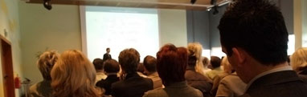
As the EPP Program continues to serve as an important resource for the Commonwealth agencies and departments, local government, school districts and higher education, as well as other governments and organizations across the country with respect to environmental purchasing, some of their primary initiatives include the following:
- Working with the staff at OSD to institutionalize green purchasing goals and initiatives into the core strategic sourcing practices now being implemented;
- Providing leadership on a national level by participating in the development of green purchasing standards, collaborating with other states interested in adopting EPP Programs and presenting at various national and state conferences across the country;
- Extending the current program of outreach and education to an even broader audience that includes small businesses, educational purchasing cooperatives, consumers and others;
- Assisting the business community in understanding the benefits of offering EPPs to state buyers as a means of strengthening the local and regional economy and moving markets in a sustainable direction;
- Serving on interagency teams to implement the green initiatives established by the current administration and promoting the establishment of other environmental purchasing goals;
- Updating and simplifying the online tools to track both the economic and environmental benefits of using EPPs and annually report on the Commonwealth’s progress. A snapshot of the EPP website is provided here, with a link to enable readers to access the entire site.

EPP Website:
The EPP Program’s website is updated on an ongoing basis to provide current comprehensive information to agencies and others looking to implement environmental purchasing policies and guidance to suppliers and manufacturers interested in doing business with the state. A copy of the actual Executive Order #515 as well as two fact sheets summarizing the initiatives outlined in the directive are posted to the home page of the site. Other topics covered on the site discuss how to access EPP state contracts in Massachusetts, where to find guidance documents and other resources featuring green purchasing issues, information on and registration forms for the Annual EPP Vendor Fair and Conference, reports on the Program’s progress over the years, links to EPP resources across the country and more.

III. Key Accomplishments in FY2011

1. Increased the Purchase of EPPs from $288 Million to Over $305 Million
Documenting the growth in purchases of environmental products and services from year to year is one of the most important strategies the EPP Program has utilized to demonstrate to public purchasers that “green is good,” and the practice of buying green is clearly being embraced by facilities, offices, schools and others across the state not only to address environmental issues, but secure high performing quality products that can also save money.
OSD offers hundreds of green products and services across an estimated four dozen statewide contracts. Through the efforts of the EPP Program, the agency includes flexible language in virtually all contracts to allow for the addition of new innovative environmental technologies as they may become available during the contract term or at the time of renewal. In addition, most Requests for Response (RFRs), or contract bids, include EPP criteria in the contract evaluation process.
The table below distinguishes green purchases in two ways:
- Recycled content products are those items made with a percentage of post-consumer recycled material. The percentage typically meets the federal minimum requirement, but often exceeds it. OSD has also adopted minimum post-consumer recycled content standards within various contracts for products not always identified by the federal government, such as carpeting, recycling and composting vessels, traffic cones and more.
- EPPs and Services include products and services with environmental attributes other than recycled content, such as energy efficiency, water conservation, toxics reduction, integrated pest management, and green janitorial service providers, to name a few.
The table also breaks out those purchases from state agencies and those from cities, towns, schools and other political subdivisions as well as those from the Massachusetts Department of Transportation (MassDOT). Identifying which departments of the state are (or are not) purchasing EPPs, enables OSD and the EPP Program to better target those agencies or departments that require additional outreach and education on the benefits of using state contracts containing EPPs.

Massachusetts FY2011 Sales of Environmentally Preferable Products and Services
and Recycled Content Products
Type of Purchase | State Agencies | Political Subdivisions | Mass Dept. of Transportation  (MassDOT) | EPP Total
EPPs and Services | $55,628,727 | $50,125,398 | $0 | $105,754,125
Recycled Products | $38,510,902 | $23,224,795 | $137,852,362 | $199,588,059
GRAND TOTAL | $94,139,629 | $73,350,193 | $137,852,362 | $305,342,184
As MassDOT has very specific needs with respects to their road construction and maintenance operations, the agency uses a number of departmental (as opposed to statewide) contracts for their purchases. Thus, such items as recycled content road materials are not reflected in the vendor reports received by OSD and MassDOT’s data is submitted separately. MassDOT also purchases other EPPs and Services, but the dollars for those items are included in the total indicated for state agencies.
NOTE: An alphabetical list of all recycled content and other EPP purchases along with the corresponding purchase (dollar) amount is provided in Section IV of this report.
2. Tracked over $3 Million in Cost Savings
Cost Savings. Cost savings associated with the purchase of EPPs may occur at a number of stages: at the point of purchase, as part of the use or operation of the product, as a result of less required maintenance, or at the time of disposal. For purposes of this report, the estimates provided on cost savings are realized primarily from energy and operational savings with respects to compact fluorescent lighting (CFLs), office equipment and computers and from a lower purchase price with respects to remanufactured toner cartridges.
In FY2011, through the use of two on-line tools (see next page), the EPP Program was able to calculate cost savings derived from the purchase of the following products:
- Compact fluorescent light (CFL) bulbs and fixtures;
- Energy efficient office equipment (copiers, scanners multi-function devices and facsimile machines);
- Computer desktops, monitors, laptops, and notebooks; and
- Remanufactured toner cartridges.
The cost savings for just these selected products alone totaled over $3 million for the year.

FY2011 Summary: CFLs, Office Equipment, Computers and Remanufactured Toner Cartridge Purchases
Cost Savings
CFLs (savings / less energy use) | $1,141,251
CFLs (savings / reduced labor) | $528,376
Office equipment (savings / less energy use) | $30,293
Computer Components (savings / less energy) | $1,098,422
Remanufactured cartridges (savings / lower cost) | $386,712
TOTAL COST SAVINGS | $3,185,054
Cost Savings Rationale
The Strategic Sourcing Services Leads at OSD project potential (and track actual) cost savings based on a number of factors, such as price negotiations at the time of a contract renewal or award and fluctuations in the marketplace for those goods and services. The cost savings derived from purchasing environmentally preferable products occurs on another level. Except for the remanufactured toner cartridges mentioned above, buyers realize a savings with EPPs (when compared to purchases of traditional products) as a result of:
- operational efficiencies, where less energy, water or other resource is used;
- maintenance efficiencies, because the products are more durable, longer lasting and require less periodic up keep, as with plastic lumber, CFLs and LED lighting;
- waste reduction attributes that address the fact that less packaging, or unnecessary materials are used that later have to be stored, handled and disposed of at a cost, and
- eliminating toxic substances and substituting with more benign chemicals and/or technologies that do not require harsh chemicals to perform well often simplifies the number of purchases needed, avoids costly equipment and supplies needed to handle harsh materials and serves to promote healthier work environments while reducing the risk of worker injury.
Environmental Benefits. There are many environmental and public health benefits associated with the purchase of EPPs. The tool that the EPP Program uses to quantify these as accurately as possible is only capable of examining a limited number of products containing post-consumer recycled materials. Those products involve the following:
- Paper products including office papers, janitorial and food service paper goods and lottery tickets;
- Plastic products including recycling containers, compost bins and trash can liners;
- Remanufactured toner cartridges;
- Recycled glass highway spheres (glass beads in highway paint);
- Recycled mulch (from tree stumps), and
- Remanufactured antifreeze.
EnviroCalc, the tool used to quantify recycled products (see below) is pre-populated with such data as the weight of the most common unit of measure for that product, the actual percentage of post-consumer content inherent to the product, and a drop down box in which to designate the type of material included in the products (e.g. paper, plastic). The purchaser need only add the quantity purchased to obtain the information on environmental benefits. Along with receiving an estimate of such benefits as landfill space saved, or number of trees saved, the purchases are also translated into equivalents that further illustrate the benefits in easily understood terms (e.g. annual solid waste generation for X number of households and the number of cars taken off the road). See the table below for actual calculations from the FY11 EPP purchases.
In FY11, the EPP Program was somewhat limited in resources for conducting the environmental benefits calculations; however, details are provided below for purchases of remanufactured toner cartridges and a variety of paper products.

FY2011 Summary: Recycled Content Products including:
- Remanufactured toner cartridges
- Office papers and envelopes
- Janitorial paper products
Environmental Benefit Estimate |  |  | Equivalent to…
Weight of Material Recycled | 5,416 | tons | Annual solid waste generation of | 2,545 | households
Landfill space savings | 17,768 | cubic yards |  | 888 | loaded garbage trucks
Wood saved | 72,727 | trees |  | 727 | acres of wood plantation
Energy saved | 86,020 | million BTU | Energy content of | 14,831 | barrels of oil
Carbon dioxide emissions | 20,086 | tons | Annual tailpipe emissions of | 3,944 | cars

About the Calculators
The EPP Program uses two on-line calculators to identify and quantify the benefits discussed in this section of the report:
- EnviroCalc – An excel spreadsheet tool created by OSD’s EPP Program staff several years ago that is designed to calculate energy and cost savings for CFLs and selected computer components and has the capability to quantify environmental benefits for a number of products made with recycled materials. The tool can be downloaded from the EPP Website.
- Energy Star Savings Calculator – A calculator developed by the US Environmental Protection Agency and the Department of Energy to estimate the energy consumption and operating costs of office equipment (including certain computer components) and the savings generated from using the power management features built into the equipment. It also contains an estimated utility rate for each individual state across the country. The EPP Program verified the rate indicated for Massachusetts with OSD’s Strategic Sourcing and Services Lead for electricity and other energy procurements. See EnergyStar.gov for more information on the capabilities and assumptions built into the tool.
- Manual Calculations – To determine the cost savings for the remanufactured cartridges, the EPP Program uses the data contained in the statewide contract vendor reports to compare pricing of remanufactured cartridges against the cost of an Original Equipment Manufacturer (OEM) cartridge. The process is time intensive as like model cartridges must first be identified to accurately report the dollar savings. In FY11, comparable OEM model numbers could not be identified for all remanufactured products sold, so those cartridges were not included in this report. As the EPP Program continues to work with OSD’s Strategic Sourcing Services Leads to improve on the reporting process from the vendors, future reports should prove to be more inclusive and it is anticipated that the savings dollars for remanufactured cartridges will increase accordingly.

3. Lead the Year 2 Implementation of Executive Order #515
During this second year since the issuance of Executive Order 515, the EPP Program drew on the guidance set forth by the Advisory Committee in year one and worked with the newly formed Toxic Reduction Task Force (TRTF) to implement the strategy developed by the group within a couple months after its formation. The initial process called on the State Purchasing Agent to send out a written communication to all agency heads. The resulting Policy Guidance Document #10-26 went out in February, 2010 to all Cabinet Secretaries, Executive Department Heads, Chief Fiscal Officers, General Counsels and Procurement Liaisons on Executive Order 515. Among other things, the document noted the necessity for each agency to designate an EPP liaison to work with OSD and the Task Force. The names of these individual were to be provided to the EPP Program and from there the Task Force would take steps to assist each agency in addressing the directives of the Executive Order.

By mid-summer of 2010, it was clear that the majority of state agencies were not responding as actively as needed to the requirement of designating an EPP liaison to take the lead in implementing the Executive Order within their agency. The Task Force had since been analyzing the purchasing data related to cleaning products and decided that it would be more manageable to focus on those agencies that purchase the highest volume of cleaning chemicals, equipment and supplies. To this end, the top six agencies identified include the Department of Corrections (DOC), both the Chelsea and Holyoke Soldier’s Homes (CHE and HLY), Department of Public Health (DPH), Department of Mental Health (DMH) and the Department of Youth Services (DYS). The Department of Conservation and Recreation was added to this group because of the interest of the agency staff to transition to green cleaning products despite the unique diversity in cleaning applications inherent to this agency.
In the process of reaching out to the aforementioned targeted group of seven state agencies, the Task Force discovered that certain agencies had already implemented initial steps in transitioning to greener cleaning products and were experiencing some interesting success. Two of the more proactive agencies are the Department of Corrections, who is actually in the process of formulating cleaning chemicals to comply with the Commonwealth’s green standards, and the Chelsea Soldier’s Home. CHE has already transitioned to less toxic cleaning products in such areas as floor cleaning, glass, foodservice cleaners, and more. The task Force plans to use the successes realized by these two agencies to promote better practices and purchases to the other targeted departments.
While the Task Force members plan to actively continue their discussions with the individual targeted state agencies noted in this report, the group also realizes that key to any significant future success is the improvement of certain processes currently in place. The key processes on which the Task Force agreed to direct their attention in the upcoming year include the following:
- Increasing the utilization of the Statewide Contract titled, Green Cleaning Products, Programs, Equipment and Supplies;
- Developing a more accurate system of tracking and recording agency purchases of green cleaning products and other EPPs;
- Expanding upon the educational opportunities currently available on the benefits of using EPPs;
- Focusing on the apparent overuse of toxic disinfectants and sanitizers within the cleaning operations of many facilities.
Greater detail concerning how the EPP Program and the Task Force will execute the key initiatives bulleted above can be found in the updated FY2011 Annual Progress Report for the Toxics Reduction Task Force which is posted on the home page of the EPP website EPP Website.
4. Managed and Negotiated the Green Cleaning Products Multi-State Contract Renewal

The contract that most significantly impacts the efforts of the EPP Program to carry out the directives of Executive Order 515 is statewide contract, Green Cleaning Products, Programs, Equipment and Supplies. The contract, managed by the EPP Program Director, involves the participation of New York, Vermont and Connecticut and is awarded to 20 vendors across the four states.
In FY2011, although one vendor was dropped from the contract as a result of non-performance, renewals were negotiated for the remaining 20 vendors, realizing an estimated 3% or more cost savings for Commonwealth buyers across various product categories. Several vendors were extremely competitive by offering lower pricing across the entire product spectrum, while others focused on specific items and product categories. All vendors provided discounts in various product categories in the range of 1% to 25%, with the majority offering at least a 3% discount on their selected items. The participating states were pleased and impressed with the results.
The contract covers a comprehensive selection of products, equipment and supplies pertaining to cleaning operations and all vendors awarded provide facility audits to assist agencies to cost-effectively transition to green chemicals – free of charge. FY2011 marked the second year of the contract and the EPP Program reported an estimated increase in contract purchases of 52%. While this was a favorable growth rate, the greatest amount of increase did not occur within the product categories that would serve to fulfill the requirements of the Executive Order 515; namely the cleaning chemicals and chemical-free (or reduced chemical) equipment.
The EPP Program proceeded to analyze the purchasing data from these Statewide Contract vendors and compared it to the data available in the Commonwealth’s accounting system (MMARS). It was clear that chemicals were still being purchased; however, purchases were being made from numerous other statewide contracts and such products did not meet the requirements of the Executive Order. As a result, the Program commenced work with OSD’s Strategic Sourcing Services Leads to identify those contracts that offered a duplication of products and/or products that were non-compliant with the specifications established in the Governor’s directive.
By the end of FY2011, the EPP Program had conducted a strategic sourcing session with OSD’s Strategic Sourcing Services Lead for the contract covering Grocery and Related Paper Products and Foodservice Supplies and determined that the paper products portion of this contract should be rolled into the green cleaning contract. During the upcoming calendar year, the EPP Program plans to work with other OSD teams to issue a new Maintenance, Repair and Operations (MRO) contract as well as a new Prime Grocer (non-food) Contract, as they represent areas of overlap with the Green Cleaning Products, Programs, Equipment and Supplies Statewide Contract.
The definition for “green cleaning products” used in the award of statewide contract Green Cleaning Products, Programs, Equipment and Supplies and cited in the Executive Order, requires that all chemicals (with the exception of disinfectants and sanitizers) must be third-party certified by either Green Seal or EcoLogo, unless such independent certification is not yet available. The standards established by these organizations are created through an open and transparent process and a long period where public comment is invited. The certifications not only verify the product’s environmental claims, but the products are tested for performance as well.
For this reason, the EPP Program is now working with the service providers under statewide contract for Janitorial Services, to ensure that the chemicals they are using comply with the Executive Order.
5. Essential Role in Researching and Awarding Three New Statewide Contracts
New EPP Contracts for FY2011
Throughout the years, one of the most important responsibilities of the EPP Program has been to provide assistance to the interagency strategic sourcing teams in understanding the increased availability and high quality performance of green products and working with them to award statewide contracts containing these goods and services. While many of these teams are more capable today of issuing EPP contracts without as much direct assistance, they still look to the EPP Program to ensure that the specifications are up to date and valid, to explain any emerging third-party standards that are more commonly being used to define what should be considered as green and to speak to new team members who may not be as familiar with the aspects of environmental purchasing.
To stay current on the environmental purchasing front, the EPP Program interfaces with the vendor community to learn about new product developments and any innovative technologies that may represent energy or water conservation, reduced use of toxic substances, less waste, or similar benefits. The Program also reaches out to other state and municipal governments to learn about green purchasing activities and works collaboratively with standard setting organizations and non-profits dedicated to fostering solutions through green purchasing.
In FY2011, the EPP Program worked with the Office Equipment, Facilities and Energy/Fuels strategic sourcing teams at OSD to award three new statewide contracts containing EPPs. Some features of each new contract are noted below, including the contract number and title as well as the general procurement area in which they fall. A seventy page illustrated guide to these contracts and all other Massachusetts EPP statewide contracts can be accessed by downloading from the EPP Website under the bullet Download Publications, Reports and Tools.
- Office Equipment and Supplies Contracts
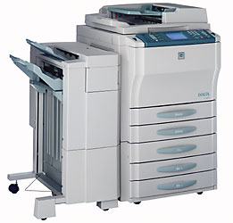
- Photocopier, Facsimile, Digital Duplicating Equipment and Services/Supplies and Printer Supplies. This equipment offered under this contract must meet the most recent Energy Star standards and it must be compatible with recycled/remanufactured supplies. The vast majority of the imaging equipment available on the contract includes multi-functional devices and can be connected to the computer network and serve as a printer or to scanners; most have duplexing (double-sided printing) capabilities.
- Facility and Operations Related Contracts
- Lawns and Grounds Equipment, Parts and Service. Along with traditional equipment, this contract also provides equipment that represents an environmental alternative wherever possible. Such equipment may use alternative fuel (e.g. compressed natural gas), offer an opportunity for reduced fuel usage, or provide other environmental benefits.
- Energy and Fuel Related Contracts
- Biodiesel. This contract expanded the selection of bulk biodiesel blends to include B10 and B15 in addition to the B5 and B20 blends that carried over from the prior contract. Biodiesel is a renewable fuel made from agricultural resources, vegetable oils and/or animal fats; any of the above provides the same amount of energy. It reduces particulate matter and tailpipe emissions that impact climate change, such as CO₂ (although some increase in NO_{x} may occur depending on the duty cycle of the engine. It is particularly suitable for sensitive environments.
6. Actively Participated in Webinars, Training and National Conferences
Conferences, Webinars and Workshops
In FY2011, the EPP Program focused a good portion of their attention on educating agencies on the purchasing requirements established in Executive Order 515 and working with organizations and other states to increase the demand for green products on the broadest scale possible. To this end, the EPP Program participated in multiple training venues during the course of the year to reach out to buyers and businesses both local and national, some of which are included here:
US Environmental Protection Agency’s (EPA) Design for the Environment: July, 2010 – The EPP Program hosted a meeting at OSD and included interagency personnel and non-profits in the health field to discuss the issues related to Design for the Environment (DfE) labeling and the implications for the Green Cleaning Products, Programs, Equipment and Supplies Statewide Contract . Although the EPA contends that the label is equal to the third-party certifications required by the Massachusetts’ multi-state contract, the group determined that it has yet to meet the same high standard.
Healthy Schools Network (HSN): September, 2010 – The EPP Program served as the primary presenter in a 1.5 hour webinar hosted by the HSN to provide information to an audience from the northeast region on the Massachusetts Statewide Contract Green Cleaning Products, Programs, Equipment and Supplies and the progress the state has made on green cleaning initiatives.

OSD’s Training and Outreach Agency Workshop, September: 2010 The EPP Program Director and OSD’s Training Director conducted a half-day training session for a dozen state agency representatives on the requirements of Executive Order 515 and how to use statewide contracts to achieve compliance. The session was well received by all participants.
Massachusetts Association of Public Purchasing Officials (MAPPO): October, 2010 – The quarterly meeting for this group was held in Salem, MA and the EPP Program Director participated as a speaker to discuss EO515, FAC59 and green procurement in general with MAPPO members.
Leading by Example Awards at the State House: October, 2010 – OSD and the EPP Program support this event by conducting outreach to state agencies and municipalities to encourage participation; the State Purchasing Agent also participated as a presenter of the awards at the State House ceremony.
Electric Vehicle Conference: October 2010 – In order to stay abreast of the emerging technologies being introduced to Massachusetts fleet managers, the EPP program attended the full-day conference in Lowell hosted by the Clean Cities Program to learn about the upcoming electric charging stations and opportunities for the Commonwealth.
Supplier Diversity Office (SDO) Kick-off Conference: October, 2010 – For the purpose of encouraging women/minority owned businesses to adopt EPP policies, the Program staffed a table at the Boston Convention Center to speak to attendees about the benefits of offering green products and services.
Massachusetts Facility Managers Association (MAFMA): December, 2010 – To promote the directives of Executive Order 515, the EPP Program worked with a contract consultant and a representative of the Toxics Use Reduction Institute (TURI) to design and successfully conduct three training sessions within the curriculum of DCAM’s MAFMA University Program; locations included Springfield, Plymouth and Grafton, MA. Close to three dozen state agencies attended overall and learned how to better use the state contracts to comply with the directive.
Product Stewardship Institute (PSI): December, 2010 – The EPP Program participated as one of three presenters in a 1.5 hour webinar sponsored by PSI titled Procurement: What Role Can it Play in Driving Greater Product Stewardship? There were an estimated 200 attendees on the webinar from across the country. The webinar served to inform participants of MA’s leadership in green procurement, with a particular focus on Executive Order 515 and the FAC59 contract.
National Association of State Procurement Officials (NASPO) Marketing Meeting: April, 2011 – The EPP served as a member on the NASPO event planning committee for the Annual Marketing Meeting held this year Boston. The organization agreed to include a workshop session on green procurement titled, “Gaining the Green Advantage in State Contract Bids” that was developed and conducted by the EPP Program and involved state purchasers from CO, MN, TN and a representative from the Responsible Purchasing Network (RPN). The NASPO How to Market to State Governments Meeting provides unique opportunities for private-sector representatives to network with state procurement officials to discuss issues and alert them to products that are available for procurement. On-on-One sessions with state representatives and regional roundtables are also provided.

Department of Environmental Protection Buy Green Workshop: April, 2012 – MassDEP invited the EPP Program to conduct a workshop for municipalities on the opportunities on statewide contracts to buy green products and save money. Interested state agencies also attended to witness demos of chemical free technologies by the Toxics Use Reduction Institute and hear from the Responsible Purchasing Network about how cities in other states are reducing costs with EPPs.
Green Statewide Training and Resources Exposition (Green STAR), May, 2011) – The EPP Program worked with participating agencies to finalize the slate of nine EPP workshops for the event, including Greening State Fleets and Fuels, Cleaning and Infection Control Using Green Cleaners, Innovative Outdoor lighting, Energy Savings Opportunities, Recycling Multiple Materials, and more. This was the first year in which the EPP Vendor Fair was not held, so green workshops were an important element at the show. (More information on the event and the EPP Program’s role is included on page 18 of this report).
EcoLogo Standards Development for CCD-146: June, 2011 – This process involved several conference calls with organizations across the country and a final submission of comments on how the EcoLogo CCD-146 Standard for Hard Surface Cleaning Products should be updated. A particular focus of the discussion was on retaining the criteria in the standard to address asthma causing agents in cleaning products. MA uses EcoLogo and Green Seal independent standards in their FAC59 statewide contract for green cleaning products and programs.
Environmental Business Council (EBC) of New England: June, 2011 – The EBC invited the EPP Program to speak to their audience of local businesses and other participants on availability, high performance and benefits of purchasing and using EPPs.
Interagency Teams, National Work Groups and Local Program Support
The EPP Program serves on several interagency committees within Massachusetts for the purpose of working with related agencies to identify and promote opportunities for energy efficiency, toxics use reduction, and waste minimization. On a national scale, the Program collaborates with other state government purchasers and purchasing organizations to share information and experiences on green procurements as a means to strengthen alliances across state borders and reduce unnecessary duplication of effort with respects to contracting work. Some of the more notable networking efforts on both fronts include the following:
Massachusetts’ Initiatives
- Green Communities - Eighty-six cities and towns from all regions of the state, ranging in population from 393 to 617,594 residents, are now designated as Commonwealth "Green Communities." The most recent members are now ranked as clean energy leaders and are eligible for municipal renewable power and energy efficiency grants. The EPP Program collaborates with this group to promote purchases of EPPs beyond energy related items.
- Leading by Example (LBE) Program – The LBE Program works to reduce the overall environmental impacts of state government operations, particularly climate and energy impacts. LBE also promotes sustainability activities within state government including waste reduction, water conservation, green buildings, alternatives fuels, efficient transportation, and recycling. The EPP Program Director represents OSD as a member of the LBE Council and collaborates with the membership agencies to implement EPP initiatives.

National Collaboration
- Responsible Purchasing Network (RPN) – As a founding member of the organization and an active participant on the RPN steering committee, the EPP Program was involved in helping to forge a two-year alliance between the RPN and the National Association of State Procurement Officials (NASPO). The relationship should serve to bring consistent, well-researched information on green purchasing to a national purchasing membership.

- NASPO Green Purchasing Committee – As the winner of two NASPO Cronin Club Awards in the past, the EPP Program serves on this committee to bring the experiences and expertise in the environmental purchasing arena to this national platform. Accomplishments to date include a twelve chapter Green Purchasing Guide for use by NASPO members, inclusion of EPP sessions into conference agendas and steps to green the cooperative contracting process.
- Product Stewardship Institute (PSI) – This is a national non-profit membership-based organization located in Boston, Massachusetts. PSI works with state and local government agencies to partner with manufacturers, retailers, environmental groups, federal agencies, and other key stakeholders to reduce the health and environmental impacts of consumer products. The EPP Program works with PSI by participating in webinars, including them at OSD’s trade shows and including specifications in appropriate Statewide Contracts to promote their approach.
7. Integrated the Former EPP Trade Show into the OSD Annual Event
For fifteen consecutive years (FY1995 – FY2010), the EPP Program collaborated with other state agency environmental programs to conduct an annual conference and trade show titled, the Environmentally Preferable Products (EPP) Vendor Fair and Conference, that was solely dedicated to educating state and local purchasers on the quality and benefits of EPPs and services. In the last several years that the event was held, the total number of registered attendees had grown to over 1200 and the number of EPP exhibitors was capped at 175. It featured a dozen workshops that discussed such products as chemical-free cleaning options, alternative fuel vehicles, recycled content carpet and flooring, water conservation devices, energy efficient equipment and more and always included a keynote speaker at lunch to provide a unique perspective to the state’s progress in environmental purchasing and/or to related global issues.
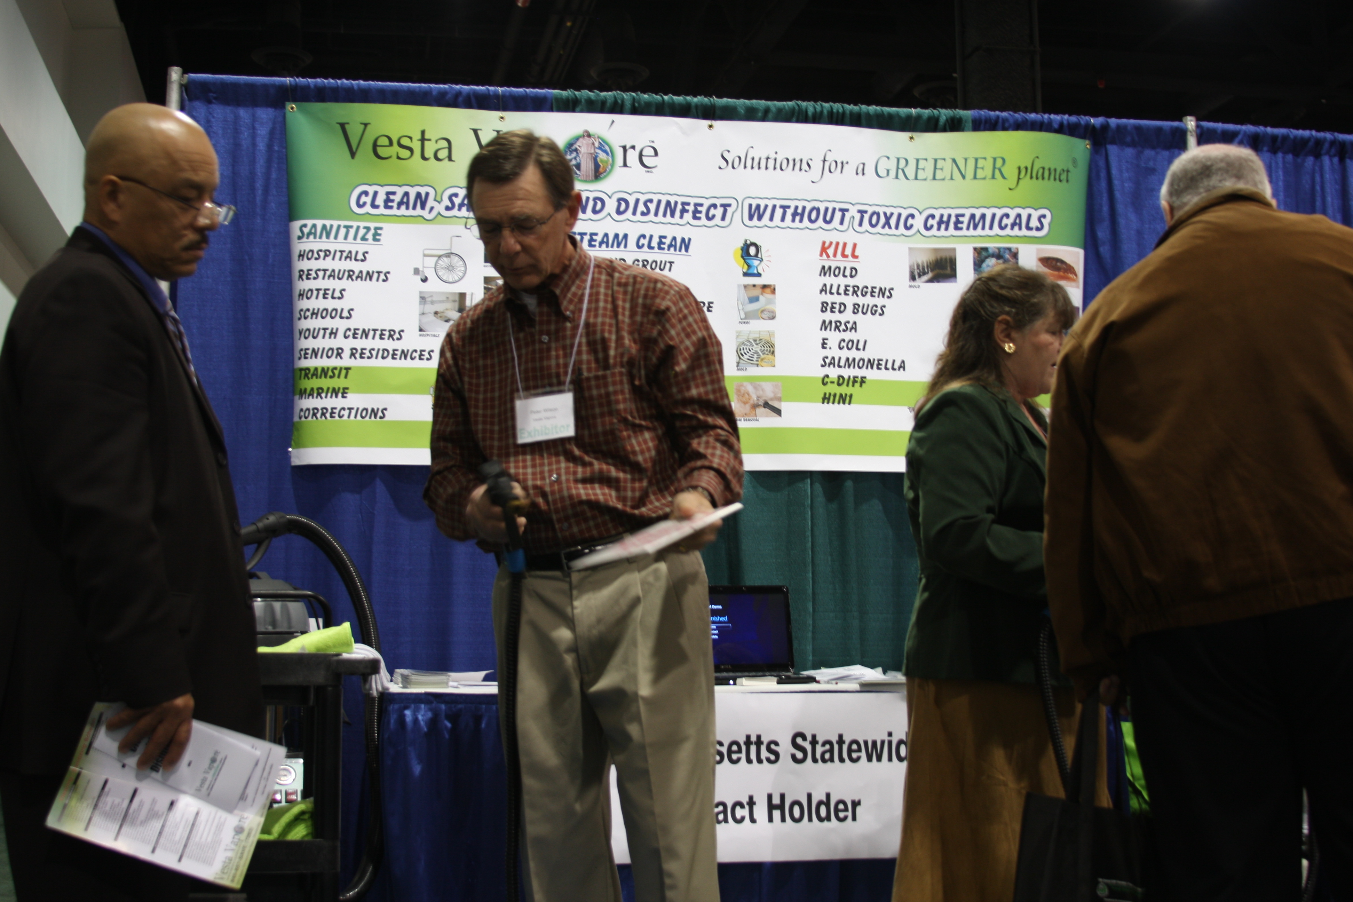
However, in FY2011 OSD made the strategic decision to combine their two annual events, the EPP Vendor Fair and the Statewide Training and Resources (STAR) trade show into one all-encompassing show titled GreenSTAR. The joining of the venues was done for several reasons, but perhaps most importantly it illustrated the mainstreaming of green products and services.
While a number of other OSD staff were responsible for various aspects of planning the May, 2011 event, the EPP Program was asked to assume the responsibility of negotiating the contract and terms with the Boston Convention and Education Center (BCEC) and take the lead on the management of the show set-up and conference day activities. The EPP Program also worked with participating agencies to finalize the slate of nine EPP workshops for the event, including Greening State Fleets and Fuels, Cleaning and Infection Control Using Green Cleaners, Innovative Outdoor lighting, Energy Savings Opportunities, Recycling Multiple Materials, and more. The Program’s Director also organized a workshop on green cleaning and staffed an exhibit booth in the showroom to educate buyers on environmental issues and cost saving opportunities available from EPPs on state contract.
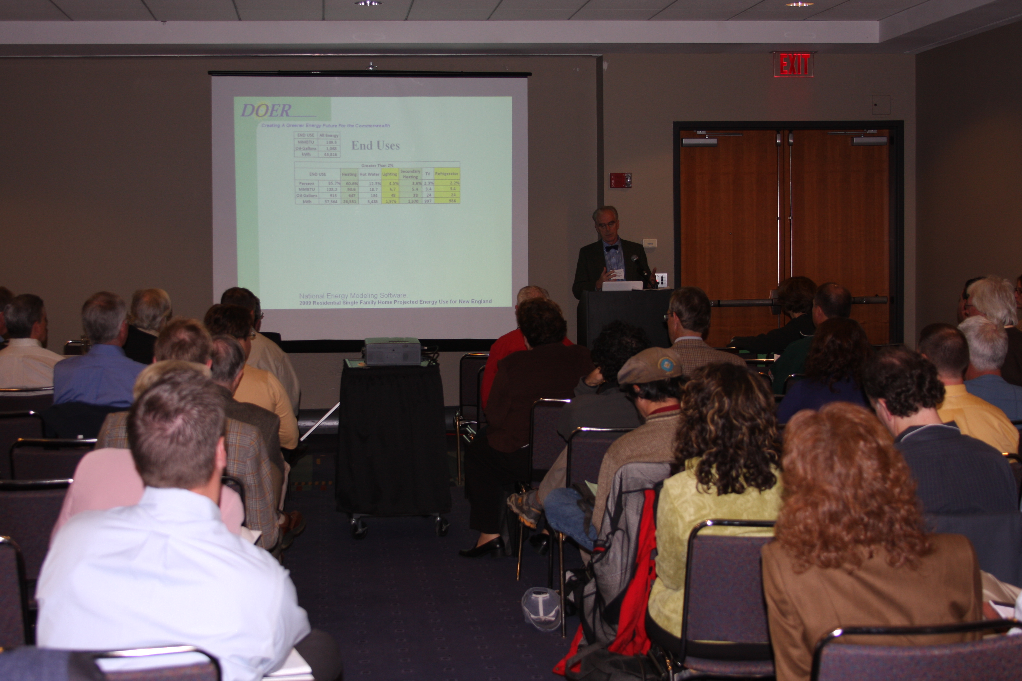
The combined venue was well attended and received. There were 400 exhibitors and close to 1500 registered attendees from state and local governments, higher education and neighboring states. While OSD plans to rename and rebrand the conference going forward, the combination of green and conventional products and services will continue. Within this framework, the EPP Program looks forward to working with the exhibitors of the upcoming show to consider initiatives such as implementing practices to “green their booth” and featuring company-wide environmental initiatives in their marketing brochures and on their websites. The EPP Program also plans to encourage more EPP vendors awarded on state contracts to exhibit at the show in an effort to send the most visual message possible that EPPs are no longer considered “alternatives,” they are the product of choice in many areas and for many reasons.
8. Recognized by the US Environmental Protection Agency
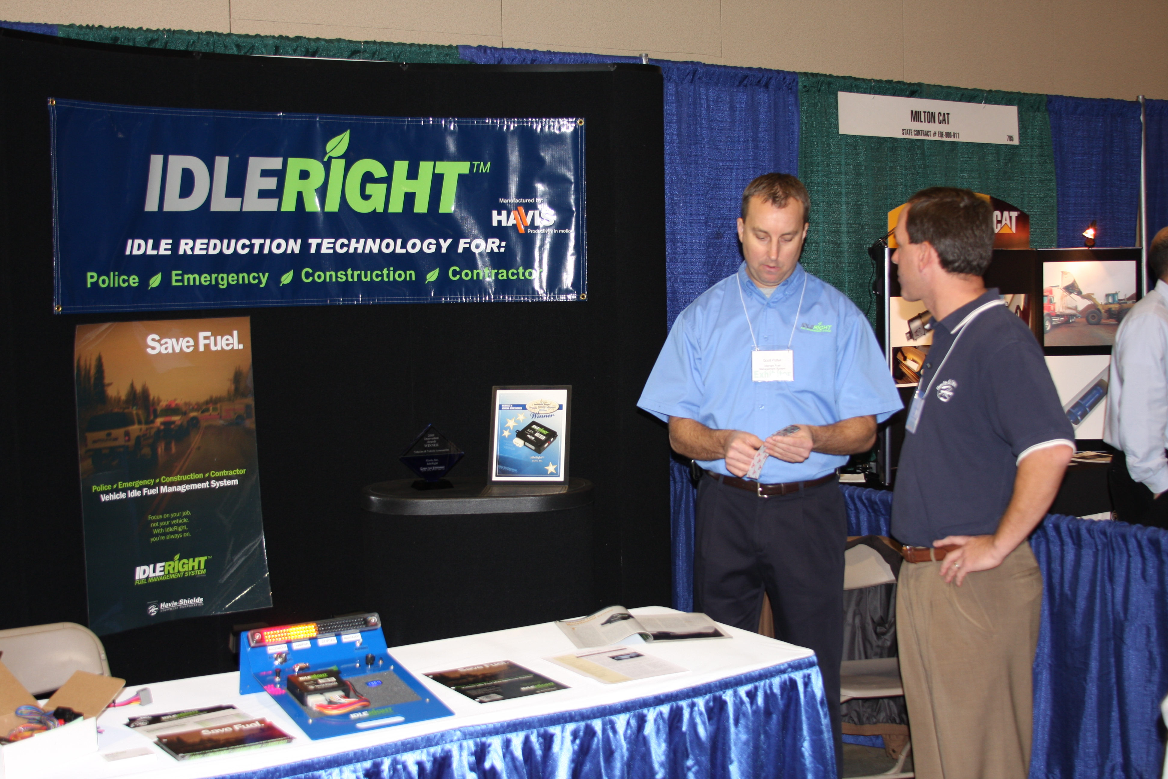
The Commonwealth of Massachusetts was recognized in FY11 by the US Environmental Protection Agency (EPA) for its best practices to ensure the purchasing of ENERGY STAR qualified equipment. ENERGY STAR is a USEPA Program that helps businesses and individuals fight climate change through superior energy efficiency. The EPA’s review commends the OSD for their top down leadership approach in promoting energy efficiency through the state procurement process. It also highlights the high level Commonwealth mandates that require the purchase and use of ENERGY STAR rated equipment and other products as well as OSD’s innovative contract specifications and strategies that embrace the power management capabilities of the products to ensure maximum energy conservation and significant long term cost savings. (Details here)
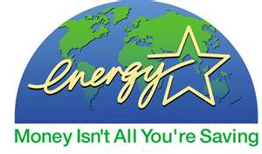
The EPA highlights the following efforts of the Commonwealth’s to ensure the purchasing of ENERGY STAR qualified equipment:
- At the highest levels of the organization, policy set to require the procurement of ENERGY STAR qualified products.
Executive Order 484 established the Leading by Example program, whose purpose is to “Oversee and coordinate efforts of state agencies, including all UMass campuses and all state and community colleges, to reduce their environmental impact.” In addition, Executive Order 515 requires state agencies to “procure only ENERGY STAR rated equipment, appliances, HVAC equipment, and other ENERGY STAR rated products unless such products can be demonstrated to be cost prohibitive over their life.”
- Specify ENERGY STAR in Requests for Responses (RFRs) and contracts.
The OSD has successfully incorporated specifications for energy efficiency into more than a dozen RFRs and statewide contracts, including but not limited to electrical and lighting supplies, IT hardware, and cleaning equipment. All state RFRs require an EPP form be filled out that includes information about their purchasing of energy efficient office equipment.
- Train all appropriate parties.
The OSD offers a number of free training opportunities for both the buying community (Commonwealth staff, municipalities, other public entities) and selling community (current vendors on statewide contracts and other vendors wishing to do business with the Commonwealth). Where appropriate, these trainings also include an explanation of ENERGY STAR requirements.
- Enforce the contract requirements.
During the RFR process, potential bidders must provide documents verifying their ability to meet ENERGY STAR purchasing requirements. State agencies are also required to purchase through the Commonwealth of Massachusetts Procurement Access and Solicitation System (Comm-PASS), which affords a simple way to locate the appropriate state contracts, which all require ENERGY STAR qualified products.
- Require power management.
Massachusetts requires the enablement of power management “sleep” features on equipment. Vendors are required to offer training on activating power management features of office equipment as well. Executive Order 515 strives to “Ensure that all ENERGY STAR equipment has the power saving mode enabled at the time of installation and that all staff are aware of and use these functions and their benefits.”
“The Commonwealth of Massachusetts is proud of their commitment to energy efficiency – including completely embracing ENERGY STAR products and activating sleep setting on office equipment.”

Marcia Deegler, Director of Environmental Purchasing, Commonwealth of Massachusetts

IV. Specific Tracking of FY2011 EPP Purchases
One of the strategies that the EPP Program utilizes to illustrate the impact of their efforts on Commonwealth purchasing practices is to annually track the purchases made by state agencies and other entities using the statewide contracts. During the sixteen years that the Program has been operational at OSD, these purchases have climbed from $5 million in FY1995 to over $305 million as tracked in this FY2011 report.
Overall, the FY2011 EPP purchases represent an estimated 6% increase over FY10 purchases.
Below are two tables of information outlining the FY2011 purchases of Environmentally Preferable Products by state agencies and political subdivisions (cities, towns, schools and other eligible contract users). The tables differentiate between EPPs and Services (products with attributes other than recycled content, such as energy efficiency, toxics reduction, etc.) and products with a percentage of post-consumer Recycled Content. Making this distinction enables the EPP Program to better identify areas of success as well as those areas in need of further development. It also serves to target areas in which to focus growth to more efficiently achieve the goals of Executive Order 515. Additional comments on the data are included at the end of this section.
EPPs and Services
EPPs and Services | FY2011 Political Subdivisions | FY2011  State Agencies | FY2011  EPP Total Purchases | FY2010  Total | Dollar Difference | % Increase or Decrease
Appliances, Energy Efficient | $42,161 | $47,579 | $89,740 | 0 | $88,001 | N/A
Art & Instructional School Supplies | $1,383,383 | $0 | $1,383,383 | $1,062,068 | $321,315 | 30%
Asbestos and Lead Paint Abatement | $518,292 | $204,377 | $722,669 | $201,550 | $521,119 | 259%
Biodegradable Garden Bags/Pots | $9,314 | $1,380 | $10,694 | $0 | $10,694 | N/A
Biodiesel Automotive Fuel | $273,769 | $3,152,444 | $3,426,213 | $2,225,377 | $1,200,836 | 54%
Bio-Heat #2 heat fuel (mostly B5) | $57,556 | $55,230 | $112,786 | $105,092 | $7,694 | 7%
Cleaning Products, EPP, Chemicals, Equipment, Chemical-Free Technologies | $1,262,594 | $602,805 | $1,865,399 | $1,750,251 | $115,148 | 7%
Composting Toilets | $0 | $110,249 | $110,249 | $24,333 | $85,916 | 353%
Copiers, Printers, Fax and Equipment, Energy Efficient | $20,280,230 | $4,261,680 | $24,541,910 | $19,770,870 | $4,771,040 | 24%
Deicers, Road, Environmentally Preferable | $21,536 | $0 | $21,536 | $1,896 | $19,640 | 1036%
Diesel Emission Control Retrofits | $1,468,900 | $0 | $1,468,900 | $183,000 | $1,285,900 | 703%
Document Solutions, Microfiche, Microfilm and Imaging Equipment, Software, Supplies & Services | $0 | $2,184,373 | $2,184,373 | $1,828,819 | $355,554 | 19%
Electrical and Lighting Supplies and Equipment, Signs | $1,370,170 | $593,536 | $1,963,706 | $1,074,184 | $889,522 | 83%
Energy Advisors, Consulting | $344,988 | $979,140 | $1,324,128 | $589,050 | $735,078 | 125%
Environmental Consulting Services | $67,448 | $84,789 | $152,237 | $583,030 | -$430,793 | -74%
Environmental Diagnostic and Testing Services | $518,291 | $204,379 | $722,670 | $571,361 | $151,309 | 26%
EPPs and Services (continued)
EPPs and Services  (continued) | FY2011 Political Subdivisions | FY2011 State Agencies | FY2011 Total | FY2010 Total | Dollar Difference | % Increase or Decrease
Food Service Equipment, Energy Efficient | $608,911 | $124,088 | $732,999 | $826,546 | -$93,547 | -11%
Hazardous Materials/Collection Services- Including Lamps/ Ballasts Recycling |  | $1,076,881 | $1,076,881 | $713,372 | $363,509 | 51%
Industrial/Commercial Supplies, Energy Efficient | $118,922 | $71,331 | $190,253 | $971,619 | -$781,366 | -80%
Integrated Pest Management | $672,839 | $607,432 | $1,280,271 | $1,815,483 | -$535,212 | -29%
Janitorial Cleaning Services, EPP | $0 | $3,151,740 | $3,151,740 | $378,081 | $2,773,659 | 734%
Lawns and Ground Equipment, EPP | $333,137 | $5,310 | $338,447 | $0 | $338,447 | N/A
Lubricants, bio-based | $0 | $1,997 | $1,997 | $1,049 | $948 | 90%
Mail Machines (Energy Star) | $505,819 | $300,218 | $806,037 | $0 | $806,037 | N/A
Marketing and Advertising (EPP) | $365,121 | $24,405 | $389,526 | $0 | $389,526 | N/A
Moving Services (bio-diesel and/or reusable crates) | $1,029,425 | $1,324,248 | $2,353,673 | $203,257 | $2,150,416 | 1058%
Paint, Low VOC | $7,317 | $51,482 | $58,799 | $23,499 | $35,300 | 150%
PCs and Peripherals, Energy Efficient* | $7,677,149 | $30,708,596 | $46,060,013 | $38,385,745 | -$7674,268 | -17%
Propane Fuel | $209,954 | $928,051 | $1,138,005 | $0 | $1,138,005 | N/A
Roofing Materials, Sustainable | $1,058,749 | $243 | $1,058,992 | $0 | $1,058,992 | N/A
Scrap Tire Disposal Services* | $0 | $57,949 | $57,949 | $44,628 | $13,321 | 30%
Solid Waste and Recycling Services | $135,019 | $1,271,975 | $1,406,994 | $2,269,549 | -$862,555 | -38%
Trash Compactors, Solar | $991,342 | $1,567,806 | $2,559,148 | $1,071,000 | $1,488,148 | 139%
Ultra Low Sulfur Diesel | $8,419,549 | $1,239,790 | $9,659,339 | $4,983,718 | $4,675,621 | 94%
Vehicles, Hybrid | $304,699 | $138,055 | $442,754 | $1,094,325 | -$651,571 | -60%
Vehicles, Hybrid Plug-in and/or Charging Stations | $0 | $117,348 | $117,348 | $39,980 | $77,368 | 194%
Vehicles, Short-term Rental (Hybrid only) | $0 | $39,959 | $39,959 | $39,959 | $0 | 0%
Water Conservation Devices (Plumbing) | $13,254 | $2,406 | $15,660 | $39,959 | -$24,299 | -61%
Water Filtration/Reverse Osmosis System | $55,561 | $157,374 | $212,935 | $499,172 | -$286,237 | -57%
Water Treatment / Ionization & Reduced Chemicals Systems | $0 | $176,062 | $176,062 | $119,229 | $56,833 | 48%
Wood Products, Sustainable | $0 | $2,019 | $2,019 | $0 | $2,019 | N/A
SUBTOTAL  EPPs and Services | $50,125,398 | $55,628,727 | $105,745,125 | $91,167,058 | $14,587,067 | 16%

Recycled Content Products
Recycled Content Products | FY2011 Political Subdivisions | FY2011 State Agencies | FY2011 Total Purchases | FY2010 Total | Dollar Difference | % Increase or Decrease
Antifreeze, Remanufactured | $2,314 | $1,334 | $3,648 | $9,209 | -$5,561 | -60%
Automotive Parts, Remanufactured | $554 | $1,295 | $1,849 | $0 | $1,849 | N/A
Boxes, Corrugated and Packing Supplies, Recycled | $0 | $29,038 | $29,038 $0 | $29,038 | 0% | 0%
Building Materials and Supplies | $37,012 | $123,595 | $160,607 | $1,038,055 | -$877,448 | -85%
Carpeting, Various, Recycled | $725,710 | $528,605 | $1,254,315 | $2,026,612 | -$772,297 | -38%
Compost and Mulch (Landscaping) | $191,484 | $232,001 | $423,485 | $101,095 | $322,390 | 319%
Containers and Carts, Recycling Set-Out | $3,460,013 | $0 | $3,460,013 | $2,830,507 | $629,506 | 22%
Envelopes, Recycled | $347,888 | $1,298,353 | $1,646,241 | $1,476,840 | $169,401 | 11%
Food Service Items, Recycled or Biodegradable (plates, cups, napkins, etc.) | $197,300 | $594,749 | $792,049 | $771,496 | $20,553 | 3%
Glass Beads, Recycled | $0 | $74,100 | $74,100 | $125,550 | -$51,450 | -41%
Home Composting Bins, Recycled Plastic | $129,776 | $0 | $129,776 | $46,765 | $83,011 | 178%
Janitorial Paper Products, Recycled | $1,140,098 | $790,137 | $1,930,235 | $1,290,570 | $639,665 | 50%
Lottery Tickets, Recycled Paper* | $0 | $4,434,134 | $4,434,134 | $4,434,134 | $0 | 0%
Motor Oil, Re-Refined | $27,117 | $197,311 | $224,428 | $215,462 | $8,965 | 4%
Office Paper/Computer Forms | $3,183,185 | $3,804,919 | $6,988,104 | $3,213,590 | $3,774,515 | 117%
Office Supplies (non-paper, recycled) | $38,890 | $80,919 | $119,810 | $0 | $119,810 | N/A
Office, School and Library Furniture, Accessories and Installation | $3,502,866 | $4,113,697 | $7,616,563 | $15,642,004 | -$8,025,441 | -51%
Plastic Lumber, Furniture, Playground Equipment, Signs, etc. | $1,480,533 | $164,125 | $1,644,658 | $2,598,584 | -$953,926 | -37%
Printing, Recycled | $1,566,303 | $19,215,443 | $20,781,746 | $23,082,911 | -$2,301,165 | -10%
Promotional Items | $74,443 | $122,006 | $196,449 | $207,840 | -$11,391 | -5%
Rain Barrels, Recycled | $57,005 | $0 | $57,005 | $17,129 | $39,876 | 233%
Tires, Retread | $1,370 | $16,949 | $18,319 | $7,893 | $10,426 | 132%
Toner Cartridges, Remanufactured | $5,108,735 | $2,438,222 | $7,546,957 | $1,451,849 | $6,095,108 | 420%
Traffic Cones/Safety Products, Recycled Total | $12,097 | $79,073 | $91,170 | $50,305 | $40,865 | 81%
Trash Bags, Plastic, Imprinted (curbside) | $1,759,149 | $0 | $1,759,149 | $135,138 | $1,624,011 | 1202%
Trash Liners, Plastic, Janitorial, Recycled or Biodegradable | $180,954 | $170,896 | $351,850 | $445,329 | -$93,479 | -21%
SUBTOTAL  Recycled Content Products | $23,224,795 | $38,510,902 | $61,735,697 | $61,247,704 | $487,793 | 1%
Aluminum Sheeting, Recycled | $0 | $629,399 | $629,399 | $629,399 | $0 | 0%
Concrete with Additives and Density Fill (MHD) | $0 | $53,806,350 | $53,806,350 | $3,105,662 | $50,700,688 | 1633%
Recycled Content Products (continued)
Recycled Content Products | FY11 Political Subdivisions | FY11 State Agencies | FY11 Total Purchases | FY10 Total | Dollar Difference | % Increase or Decrease
Controlled Density Fill/Fly Ash (MHD) | $0 | $276,649 | $276,649 | $824,472 | -$547,823 | -66%
Loam with Compost (MHD) | $0 | $1,432,861 | $1,432,861 | $50,136,833 | -$48,703,972 | -97%
Pavement Millings Mulch (MHD) | $0 | $1,134,476 | $1,134,476 | $783,552 | $350,924 | 45%
Pavement with Rap and Reclaimed Pavement (MHD) | $0 | $79,150,182 | $79,150,182 | $0 | $79,150,182 | N/A
Reclaimed Pavement (Base and Substrate) | $0 | $642,394 | $642,394 | $78,112,141 | -$77,469,747 | -99%
Rubberized Asphalt Sealer (MHD) | $0 | $373,359 | $373,359 | $1,714,336 | -$1,340,977 | -78%
Rubberized Stress Absorbing Membrane Interlayer (MHD) | $0 | $406,692 | $406,692 | $0 | $406,692 | N/A
GRAND TOTAL  EPPs / Services and Recycled Content Products | $73,350,193 | $231991,990 | $305,342,184 | $287,721,356 | $17,620,827 | 6%

Purchases by Massachusetts Department of Transportation (MassDOT)
The line items in the table above shaded in green represent those products purchased specifically by MassDOT for highway construction and maintenance purposes. In recognition of the fact that MassDOT has consciously increased their use of recycled materials across several product areas, the EPP Program highlights them separately in order to acknowledge their proactive EPP initiatives. Moving into FY2012 MassDOT states that their tracking system is improving as well and the Commonwealth my see additional recycled content items included in their data collection in the future.

Source of the Reporting Data
To track the purchases of environmentally preferable products, the EPP Program relies primarily on the reports obtained from sales reports that the statewide contract vendors are required to submit at the close of the Fiscal Year or at the end of a contract term. While many vendors are reliable, some submit only partial data and others may not respond at all.
As OSD transitions to the Strategic Sourcing approach mentioned earlier in this report, obtaining accurate data from vendors on the contract activity is essential. Therefore, beginning in FY2012, OSD has informed all contract vendors that the reports will now be due on a quarterly basis to more closely follow purchasing trends and foster more efficient contract management.

V. Reviewing the Data
As readers consider the purchasing data presented in the two tables above, they should understand that there are a few factors beyond the actual purchasing demand for a products or services that are not immediately evident in the information provided in this report. For instance, if an N/A appears in the “% Increase or Decrease” column, it represents the fact that this particular line item was not tracked separately in prior fiscal years. Purchases of that product or service may have been combined in a larger grouping, or not significant enough to warrant individual tracking. If a zero appears in that same column, it symbolizes that accurate data was not available from vendors or other sources for FY11 and the FY10 data was used as a placeholder until such data is obtained. Finally, on occasion, purchasing fluctuations up or down may simply be the result of better data collection this fiscal year than last.
As OSD will be receiving quarterly (as opposed to annual) reports from all statewide contract vendors beginning in Fiscal Year 2012 (FY12), the EPP Program and other OSD staff will be able to monitor submissions more closely, resulting in more consistent, complete and accurate purchasing data. However, based on what is available this year, several observations can still be rendered:
  - There are almost twice as many product categories in which purchases increased rather than decreased. This can be viewed as a testament to the diligent efforts of the EPP Program to continue a comprehensive program of education and outreach to buyers throughout the state to encourage them to use and purchase green products. It also speaks the fact that EPPs are proving to be a cost-effective and high performing alternative to conventional products and thus, more buyers are making the switch across an expanded group of product and service categories.
  - The most significant growth appears in the EPPs and Services with a 16% increase in purchasing volume, as compared to Recycled Products that rose by only 1%. This trend may be evidence of the fact that many energy efficient EPPs such as lighting, office equipment and green cleaning equipment offer significant cost savings to buyers, particularly over the life of the product. The fact that these products are also becoming cost competitive when compared to conventional goods makes the decision to buy green that much easier.
  - Trends in the product areas specifically targeted by Executive Order 515 and its predecessor Executive Order 484 are positive and very strong in selected categories. While Executive Order 515 focuses primarily on toxics reduction, the prior Executive Order 484 addressed energy efficiency and greater use of alternative fuels for vehicles. With respects to toxics reduction, the FY11 data indicates that the purchase of green cleaning and equipment increased by 7% and the use of the state contract for green janitorial services swelled by over $2.7 million, or over 700%. Although the EPP Program would like nothing better than to take credit for the increase in services, the reality is that the contract had just been awarded in the prior fiscal year and only a limited number of purchases were possible. However, the large volume of purchasing being done clearly signifies that the contract is popular and the EPP Program looks forward doing even better in the upcoming fiscal year. Similarly, purchases of energy efficient lighting products grew by 83% and in FY11 the Commonwealth began acquiring plug-in hybrid vehicles as well as several electric vehicle charging stations to promote the use of alternative fuel options in for certain applications.
VI. Conclusion
FY2011 proved to be a busy and exciting year for the EPP Program as overall EPP purchases grew by more than 6%, cost savings remained consistently strong for the second year in a row, progress was made in implementing the directives of Executive Order 515 and the interest in environmental purchasing on a national level increased significantly over the prior period. This latter trend is particularly important because as state and local governments across the country increase their demand for greener products, a financial incentive is provided to manufacturers and suppliers to be more innovative and focus their attention on these goods and services. For buyers in Massachusetts and elsewhere, this added competition in the marketplace means higher quality products at better prices. It’s a win-win for all on many levels.
Certainly Governor Patrick’s and Lt. Governor Murray’s Executive Order #515 served as a critical stimulus on the state level for the growth in EPP purchases; however the EPP Program also attributes a large portion of the state’s success to the cooperation received by such agencies as the Department of Energy Resources, MassDEP, Division of Capital Asset Management, and MassDOT, and most importantly the continued support over the years from OSD’s Leadership Team and the Strategic Sourcing Services Leads responsible for incorporating EPPs into all statewide contracts.

VII. Considerations for Next Year
As OSD continues to embrace strategic sourcing techniques to re-evaluate and improve upon the state contracting process, the EPP Program anticipates even greater growth next year in environmental purchasing. The reason is that among other things, strategic sourcing places an importance on:
- Total Cost of Ownership – a benefit inherent to most environmental purchases;
- Developing a strategy that includes environmental and public health impacts of a purchase;
- Tracking purchasing results in order to better direct the success of the long-term procurement.
As a result, the EPP Program looks forward to working in FY2012 with the staff at OSD, interagency colleagues and national partners to consider the following:
- Developing a more efficient and accurate system of tracking and reporting the EPP purchases made by state agencies and other contract users as a means to better gauge areas of opportunity for cost savings as well as environmental and public health improvements;
- Improving the contract utilization of the, Green Cleaning Products Statewide Contract to increase the use of products targeted by EO515 (e.g. green chemicals, equipment, chemical-free technologies) by 10% over the 7% increase realized this past fiscal year. One strategy the EPP program will employ to accomplish this is to work with the vendors on the contract to develop marketing plans aimed at increasing purchases in those areas;
- Providing greater support to national organizations such as NASPO to raise the awareness of green purchasing benefits, share product specifications on green products and work to integrate EPPs across a broader spectrum of multi-state cooperative contracts;
- Collaborating with related agencies and non-profits to build a comprehensive program of education and training with a particular focus on reducing toxics in purchasing and utilizing social networking as a means of communicating these efforts to the broadest audience possible; and
- Researching on-line tools and/or working to improve current tools, to more easily calculate the benefits of environmental purchasing.
APPENDIX

  - Fact Sheet - Summary of EO#515 Directives
This was the first fact sheet created to inform agencies about the fundamental purpose and critical requirements in the new Executive Order. It contains the segments bulleted below, along with other information related to the EPP Program and other agency partners collaborating on the implementation.
- Key Executive Order Initiatives
- Who is responsible for implementing the EO?
- How are agencies impacted by the EO?
- Frequently Asked Questions?
The document is posted on the home page of the EPP website and can be accessed directly here.

B. Toxics Reduction Task Force Annual Progress Report
Readers can view and download a copy of the second annual report written by the Toxics Reduction Task Force that highlights the process and progress made to date as well as the upcoming challenges to consider in moving forward with the implementation of EO#515. Access this report from the EPP website using the home page bullet titled, “Download Publications, Reports and Tools” and then the secondary bullet titled, “Reports and Handbooks:” EPP Website.

C. US EPA Recognizes MA for Leadership in Energy Efficiency
The Commonwealth of Massachusetts is recognized for its best practices in the area of Energy Star by the United States Environmental Protection Agency (USEPA). The case study can be found at http://www.energystar.gov/ia/products/power_mgt/downloads/MA_Case_Study.pdf. The two page review recognizes Massachusetts, and particularly the Operational Services Division (OSD), for their top down leadership approach in promoting energy efficiency through the state procurement process. It highlights the Commonwealth's high level mandates that require the purchase and use of Energy Star® rated equipment and other products and OSD's innovative contract specifications and strategies that embrace the power management capabilities of the products to ensure maximum energy conservation as well as significant long term cost savings

