Commonwealth of Massachusetts
Executive Office of Health and Human Services

Virtual Gateway



Purchase of Service (POS) Provider Data Management Agency User Manual
Release 3.0

Table of Contents

Chapter 1: Introduction and Overview to the Virtual Gateway 1
Introduction 1
What is the Virtual Gateway? 1
System Requirements 3
Chapter 2: Getting Started 4
Overview 4
Accessing PDM through the Virtual Gateway 4
Maintaining Account Information 8
Virtual Gateway Customer Service Information 9
Navigation Basics 10
Error Messages 11
Online Help Links 12
Customer Service and Training 12
Chapter 3: Purchase of Service (POS) Provider Data Management 14
Introduction 14
Overview 14
Agency Benefits 14
Key Functionality 15
Target Audience 15
Chapter 4: Search for a POS Provider 16
Introduction 16
Search Page 16
Search for a POS Provider 17
Chapter 5: Agency Business Functions 18
Introduction 18
Viewing Agency Business Functions Page (View Role) 19
Viewing Agency Business Functions Page (Update Role) 19
Agency Business Functions (View Role) 20
Agency Business Functions (Update Role) 22
Chapter 6: Viewing Provider Data Management Information 24
Overview 24
Introduction 24
Purchase of Service (POS) Integrity Unit 25
Provider Summary Information Page 26
Provider Summary Information Functions 27
Viewing General Information Detail 29
General Information Detail Page 29
General Information Detail Functions 30
Viewing EOHHS Services Taxonomy Information 31
Other Services Provided Detail Page 32
Viewing Provider Contract Summary Information 33
POS Provider Contract Detail Page 34
Viewing Provider Qualification Information 35
Provider Qualification Page 36
Viewing Financial Measures 37
Detail Financial Measures Page 37
Chapter 7: Provider Qualification Information 39
Overview 39
Provider Qualification Information 39
Accessing the Provider Qualification Page 40
Viewing Provider (Organizational) Information 41
Provider Qualifications Page 42
Editing Provider Qualifications 43
Editing Corrective Measures Based on Independent CPA Audit 44
Chapter 8: Required Forms and Documents 46
Overview 46
Accessing the View Required Forms and Documents Page 46
Required Forms and Documents Page 47
Viewing Information 47
Available Forms and Documents 48
Downloading Templates 48

Copyright © 2005 Massachusetts Executive Office of Health and Human Services (EOHHS).
The copyright for the original documentation and all associated materials, job aids, lesson plans, and worksheets, and other original work related to the EOHHS Virtual Gateway remain with the original author. Virtual Gateway authorized users are permitted to copy or download and use these copyrighted materials free of charge and without acquiring permission from the author.
However, in the event a Virtual Gateway user intends to make use of these copyrighted materials in a website or publications, regardless of whether that use is for profit or not, said user must acquire prior permission from the author.

Introduction and Overview to the Virtual Gateway
Introduction | Provider Data Management is an online service that gives Purchase of Service (POS) providers a single place to view, upload and edit information commonly requested by Health and Human Services agencies. The service also provides EOHHS agencies with a single place to view provider information (login required).  This module discusses the following topics:  - What is the Virtual Gateway  - System Requirements  - Accessing the Virtual Gateway  - Password management  - Accessing agency services
What is the Virtual Gateway? | The Virtual Gateway is a single point on the internet for accessing programs and services offered by the Executive Office of Health and Human Services (EOHHS).  The ultimate goal of the Virtual Gateway is to streamline service access and coordinate service delivery. It serves three important groups:  - Internal Health and Human Services staff  - Service provider staff  - Consumers  In addition to PDM, the Virtual Gateway also offers:  - Catalog: An online catalog with descriptions of several of the most widely used programs in Health and Human Services.  - Screening & Referral: A short online survey for consumers and providers to determine potential eligibility for select EOHHS programs. Multiple services can be assessed at the same time.  - Common Intake: A single, online data collection tool for registered providers to create applications for multiple programs and services.  - Enterprise Invoice Management/Enterprise System Management (EIM/ESM): A web-based billing and service delivery reporting system for Purchase of Service (POS) providers and is one of the many services offered through the Virtual Gateway. Use of specific EIM/ESM modules is discussed in later modules.  - Transitional Assistance Gateway: An online inquiry tool for registered agencies to view secure case management information for various transitional assistance programs, including Food Stamps, financial assistance, and homeless services (login required).  - Service and Transition Planning: An online tool for registered EOHHS staff and providers to support collaborative treatment planning and referral services for certain clients served by EOHHS (login required).  - IRIS Services for Deaf and Hard of Hearing Consumers: An online service for providers to request ASL interpreter or CART services on behalf of consumers; for ASL interpreters and CART reporters to post availability schedules, review and apply for open jobs (login required).  - Homeless Management Information Systems: The Homeless Management Information Systems (HMIS) perform data collection to capture information about citizens who experience homelessness (login required).  - Mental Retardation Quality Management Reporting (HCSIS): A service for POS providers, Department of Mental Retardation (DMR) staff, human rights coordinators, and others to file clinical information and reports on incidents, medication, restraints, and investigations for DMR clients (login required).  - Senior Information Management System (SIMS): An online data collection, case management, and reporting tool for Executive Office of Elderly Affairs (EOEA) agencies and providers. It enables users to track various programs for elders, including intake and referral, home care, nutrition, clinical assessments, and more (login required).

System Requirements | System Requirements for the Virtual Gateway  All computers used to access the Virtual Gateway require Internet Explorer 6.0 or higher.  For the PDM application, the minimum system requirements are:  - Windows (98, 2000 or XP Business)  - Internet Explorer 6.0 or higher  - 800x600 screen resolution  - 300MHz CPU and 128MB RAM  Additionally, the preferred system features to enhance the performance of PDM are:  - Windows XP (Business Class)  - 1024x768 screen resolution  - 500MHz CPU and 256MB RAM  Acceptable Alternatives:  - Operating System  - Mac OS X  - Browsers:  - Safari (Mac)  - Firefox  - Netscape  Note: Testing on the PDM application has not been conducted on these alternative platforms therefore compatibility issues may result.  Tip: If a lower screen resolution is selected, then the user needs to select the “Smaller” text size.  - Select the View menu from the Internet Explorer browser.  - Select Text Size>>Smaller.

Getting Started

Overview | This chapter provides information about the following topics:  - Accessing Provider Data Management (PDM) through the Virtual Gateway as POS Provider.  - Password Management  - Navigation Basics
Accessing PDM through the Virtual Gateway | Access to PDM is through Virtual Gateway Provider Services.  - Access the Virtual Gateway home page at www.mass.gov/vg and click the Logon link.  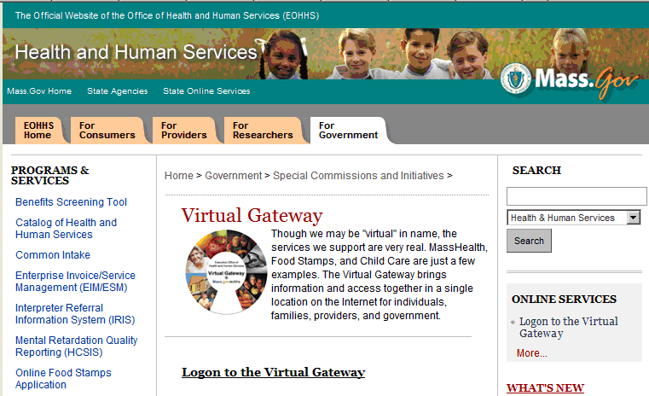  - From the Welcome Virtual Gateway User page, enter your Virtual Gateway Username (user ID) and Password.  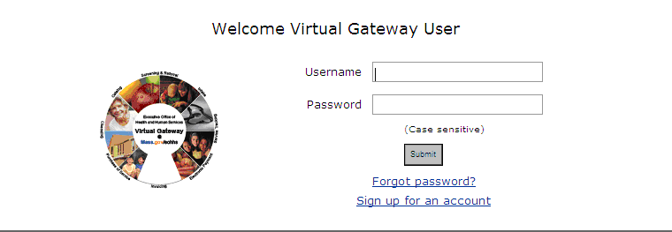  If you are an existing user, enter your current password.  If you are a new user, enter the temporary password you received from the Virtual Gateway in your New User email.  - Click the [Submit] button.  If you do not need to change your password, the following Business Service page will appear; it provides you access to your specific business service(s). **  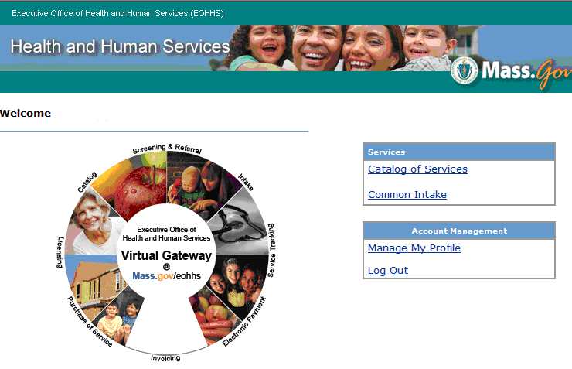  Business services you have access to will display here.  ** If you are associated with more than one organization, you may be directed to the following page prior to the Business Service page:  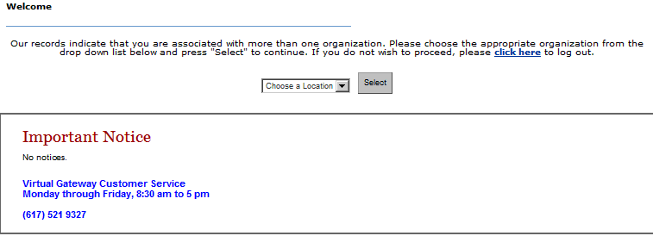  Click the appropriate organization from the drop down list and click [Select] to continue. You will be directed to the appropriate business service page.  Changing your password and answering security questions  The Change Password page automatically appears if you are a new user or your password has expired.  Please read and follow the password requirements on the Change Password page to successfully change your password. The Virtual Gateway Customer Service team is available to help if you have any questions or run into problems (see contact information on the last page).  - Read the password requirements on the Change Password page. The format for your password must match the minimum password requirements listed on this page.  - Enter and confirm your new password in the required fields (see Password Notes and Tips below).  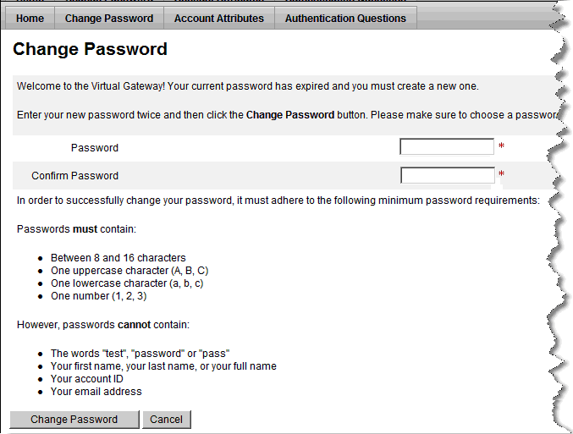  Note: In order to successfully change your password, you must adhere to the minimum password requirements listed on this page.  Tip: Do not enter passwords that you have recently used.  - Click the [Change Password] button.  Once you have successfully changed your password:  - New Users: The Virtual Gateway Terms and Conditions of Use page appears  - Existing Users: The Business Services page appears  - [New Users] Read the Terms and Conditions of Use and click the [Agree] button to continue.  Note: Users are required to agree to the Virtual Gateway Terms and Conditions of Use upon first login. If you choose to select Disagree, you will not be able to access the Virtual Gateway.  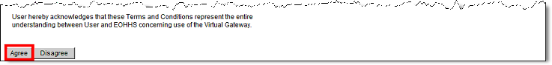  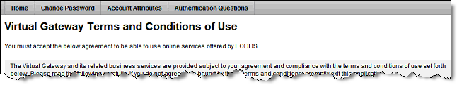  The Authentication Questions page appears.  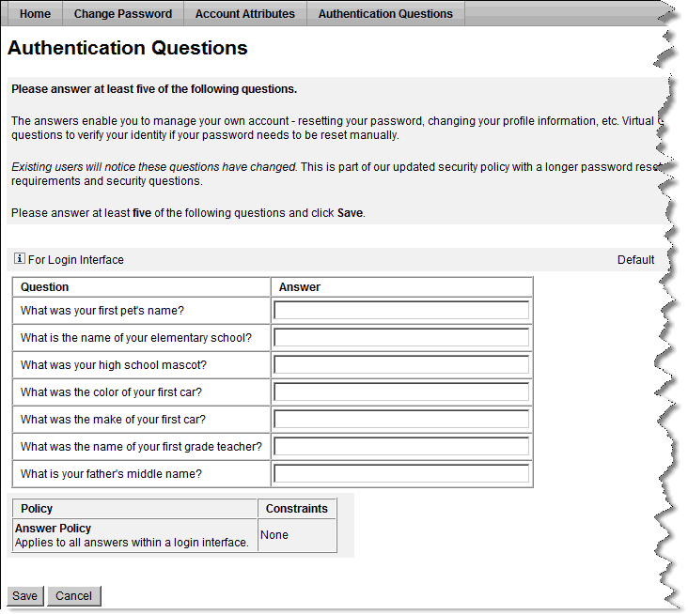  - Answer 5 of the 7 of the security questions (they are not case sensitive). Select responses that will be easy for you to remember.  - Click the [Save] button to save your responses.  - The Business Services page appears for new users or if your password expired  - The Manage My Profile page reappears if you selected this link from the Business Services Page (Click the [Business Services Page] button to exit Manage My Profile.)  Password and Security Notes and Tips  - Any time you change your password, forget your password, or call Virtual Gateway Customer Service with a password question, you will need to answer some of the seven authentication questions or provide other security information as verification. Questions are chosen at random.  - Use passwords and responses that you are likely to remember, and be sure to not post this information where others can access it.  - If you feel your password has been compromised, change your password immediately.  - If you receive the error message “Invalid user name & password. Please try again,” retype your Username and Password and click Submit. If after several attempts you still receive this message, call Virtual Gateway Customer Service for assistance.  - You cannot reuse recently used passwords.  Maintaining Account Information  Note: When your password expires, you will automatically be directed to the Change Password page to update you password.  ~~ Changing your password before the expiration date ~~  - Log in to the Gateway. The Business Services page will display.  - Click the Manage My Profile link in the [Account Management] section on the right side of the page.  - Click the Change Password tab.  - Update your password and click Change Password.  The Business Services page will display.  Forgot your password?  - From the Welcome Virtual Gateway User login page, click the Forgot Password? link.  - Enter your Username and click the [Submit] button.  - Enter the answers to the security authentication questions and click the [Login] button.  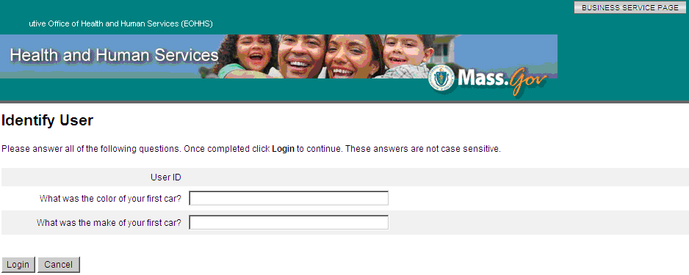  - Enter and verify your new password and click the [Change Password] button.  The Welcome to Virtual Gateway User page appears.  - Log in using your Username and new Password.  ~~ Managing or changing your account information ~~  - Log in to the Virtual Gateway using your Username and Password.  - Click the Manage My Profile link in the [Account Management] section on the right side of the page.  The Manage My Profile page appears.  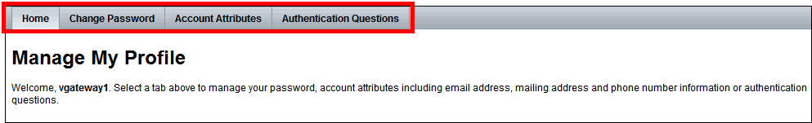  Under the Manage My Profile, you can manage or change your:  - Password (Change Password tab)  - Phone Number or Email Address (Account Attributes tab)  - Security Questions (Authentication Questions tab)  - Select the appropriate tab located at the top of the page to change your account information. Follow all instructions provided.  - Click the [Save] button to save any changes.  - Click the [Business Services Page] button to return to the Business Services page.  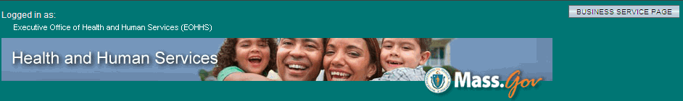
Virtual Gateway  Customer Service Information | The Virtual Gateway Customer Service is available to assist with:  - General questions regarding the Virtual Gateway  - Technical questions or system issues  - Questions regarding how to use PDM  - Password resets  Please be prepared to provide the following:  - Name, organization, phone number, email address  - Module/page/field you were working on (if applicable)  - Description of the issue or error message  - Perceived criticality  You can reach the Virtual Gateway Customer Service at 1-(800)-421-0938 from 8:30 a.m. to 5 p.m. Please leave a message if calling after hours.
Navigation Basics | Breadcrumbs are a roadmap of how you navigated from one place to the next in PDM. They provide you with a map of where you started, the next step in that workflow, and what page you are currently working on.  The following is an example of a breadcrumb.  Using the hyperlinks provided allows you to navigate to other pages within PDM.  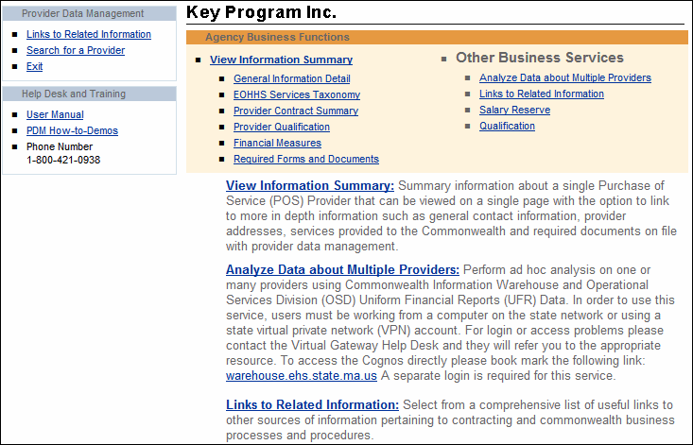  Hyperlinks  Navigating to other pages to view more detailed information about a provider can also be performed by using the Go To Details link available on the Provider Summary Information page.  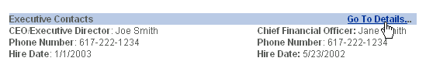
Error Messages |  | Error Messages will appear on the page. You will be prompted to correct answers until all the required fields have valid entries.  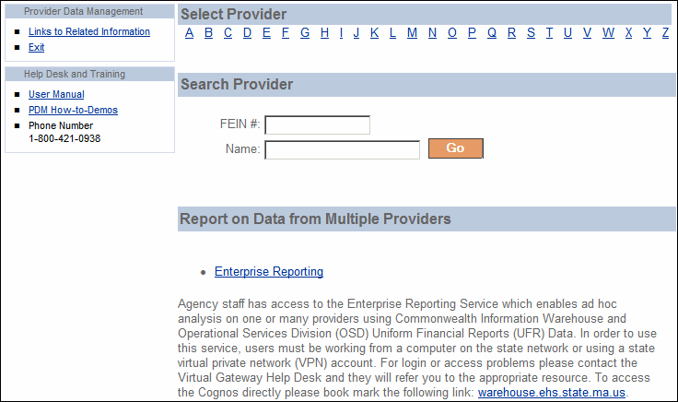
Online Help Links |  | You can use these page links to navigate and view help information.
  Function | Action
  To view PDM User Manual Information | Click the User Manual link.  Result: The Provider Data Management Training and Assistance Materials page appears.
  To view movie demonstrations of how to navigate PDM Business Services | Click the PDM How-to Demos link.  Result: The Provider Data Management Training and Assistance Materials page appears; scroll to bottom of the page.
Customer Service and Training |  | Having trouble with navigating and procedures within PDM or understanding business process behind the procedure? This section describes how to get help right from within PDM.  The following is a sample of PDM’s help section which links to the Training and Assistance Materials page accessible through the Virtual Gateway. The Virtual Gateway Customer Service phone number is also provided below.  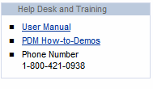

Notes:

Purchase of Service (POS) Provider Data Management
Introduction | Welcome to the Provider Data Management (PDM) Business Service.  The PDM Business Service is a web-based, secretariat wide service, where Purchase of Service providers are able to store standard forms and documents, view contract information, maintain and update their organizational profile, and view the pre-populated financial assessment measures.
Overview | The PDM Business Service is intended to serve as a well-organized, user-friendly, easily navigated “filing system” of provider data.  It is important to note that the application requires both web-based data entry and population of the PDM data from external source systems.  It will store basic organizational information, standard forms, and applications either completed on-line in PDM or in other source systems, such as the Uniform Financial Report (UFR) from the OSD eFiling website, and the Commonwealth Information Warehouse (CIW).  Weekly data pulls from MMARS, the Commonwealth’s management accounting and reporting system, maintains current contract encumbrance and expenditure data for each provider. Hyperlinks to other Commonwealth websites, such as the Corporations Division of the Secretary of State’s Office (SEC), the Operational Services Division (OSD), and the Office of the State Comptroller (OSC) will permit easy access to general information for all users of PDM.
Agency  Benefits | Agency benefits will include:  - Easy access to provider data that normally would have been collected through many different sources  - The ability to query the PDM service to produce reports by selecting data elements from one or more provider records for comparative analysis
Key Functionality | There are three main business functions to the PDM workflow. These business functions include:  - View data  - Update provider qualification data  - Perform ad hoc reporting on one or more providers using the Enterprise Reporting Tool
Target Audience | While the PDM Service focuses on three key business functions, some functions are unavailable depending on your role. PDM focuses on the following four roles:  - All Providers will be able to view information.  - Some Providers will be able to update information (depending on access level).  - State Agencies will be able to view and print standard reports and create ad hoc reports.  - EOHHS Provider Qualification Staff will have the capability to post provider qualification information and corrective measures based on a review of the following documents:  - CPA prepared Uniform Financial Statements and Independent Auditor’s Report (UFR)  - Office of the State Auditor (OSA) audit reports  - EOHHS Financial Reviews  - EOHHS Agency Financial Reviews  - Surplus Revenue Retention (SRR) Summary

Search for a POS Provider
Introduction | You can use the Search page to select or search for a POS Provider, or click the Enterprise Reporting Service link to compare information about one or more providers.  Tip: The Search page offers you three options: select using the Provider’s first initial, search by FEIN or by provider name. You can enter either a partial or an entire FEIN/TIN or Name.
Search Page | The following is an example of the Search page.

Search for a POS Provider | Follow these steps to select or search for a POS Provider:  - To select a Provider, click the letter that corresponds to that particular Provider.  Result: POS Provider links appear with this first initial letter.  OR  To search for a Provider, type the Providers FEIN/TIN, or Name. Click GO.  Result: The POS Provider’s link appears.  - Click the POS Provider link.  Result: The Agency Business Functions page appears.

Agency Business Functions
Introduction | From the Agency Business Functions page, you can access additional PDM pages where you can:  - View a quick summary of information on the selected provider  - View more detailed information about the provider including:  - EOHHS Service Taxonomy  - Contract Summary  - Qualification Data  - Financial Measures  - Required Forms and Documents  - Update Provider Qualification Data  - Access Enterprise Reporting Service to view standard reports or create ad hoc reports on one or more providers  - View a list of links to other related information  - Search for a Provider  - Exit PDM  Important: The Agency Business Functions pages view varies depending on the user’s role.  Users with a view role can access links to view information.  Users with an update role can access links to view and edit information.
Viewing Agency Business Functions Page  (View Role) | The following is an example of the Agency Business Functions page (view role).
Viewing Agency Business Functions Page  (Update Role) | The following is an example of the Agency Business Functions page (Provider Qualification Staff).  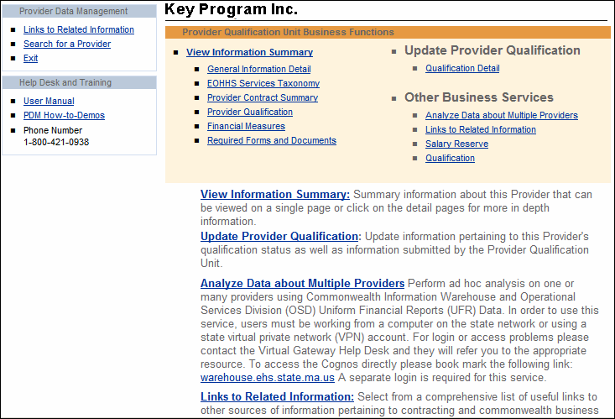
Agency Business  Functions  (View Role) | The following table lists the functions and actions of the Agency Business Functions page.  From this page, you can navigate to view Provider information.
  Function | Action
  To view a quick summary of important information about a Provider: | Click the View Information Summary link.  Result: The Provider Summary Information page appears.
  To view contact and general corporate information: | Click the General Information Detail link.  Result: The General Information Detail page appears.
  To view information on available services, both contracted and non-contracted through EOHHS: | Click the EOHHS Services Taxonomy link.  Result: The Services Provided Detail page appears.
  To view a Provider’s Contract information: | Click the Provider Contract Summary link.  Result: The POS Provider Contract Detail page appears.
  To view a Provider’s Qualification information: | See Page 23 (of this document) for the Action Steps to view the Provider Qualification information.  Result: The Provider Qualification page appears.
  To view Financial Measures and the Uniform Financial Report (UFR) filing status: | Click the Financial Measures link.  Result: The Detail Financial Measures page appears.
  To View Required Forms and Documents: | Click the Required Forms and Documents link.  Result: The View Required Forms and Documents page appears.
Function | Action
To view a comprehensive list of related information: | Click the Links to Related Information link under Other Business Services.  Result: The Related Links page appears.
To exit PDM: | Click the Exit link located at the top left corner of the page under >Provider Data Management.  Result: The PDM window closes.

The user remains logged into the Virtual Gateway Business Services.
Agency Business Functions  (Update Role) | You can use this function to navigate to update provider information.
  Function | Action
  To access and update Provider Qualification data | Select the name of the provider to be updated.  From the Agency’s Business Functions Page, under the Other Business Services bullet, click on the Qualification Link.  Result: The Organization Expenditure Summary page appears.  From the Organization Expenditure Summary page, go to the left navigation panel and click on the Provider Qualification bullet under the Edit Qualifications section.  Result: The Provider Qualification page appears.  From the Provider Qualification page, select the PQ Year from the drop down box that you want to update information:  - Once you’ve selected the PQ Year, you can view or edit information in the appropriate fields.  - Click the Save button.  Tips: When you click the Clear button, the modified information is cleared and the fields are repopulated back to the data that was last saved (prior to entering the new information).  Be aware that all Comments entered can be viewed by the provider.

Notes:

Viewing Provider Data Management Information
Overview | PDM allows you to view information in two ways:  - View summary information  - Access more detailed information with links to other pages  Note: The majority of the data for the Provider Data Management Business Services is sourced from the Commonwealth Information Warehouse (CIW), OSD UFR database, EOHHS agencies, and the remaining information is submitted by the providers.
Introduction | Use the Provider Summary Information page to view the following summary information about a Provider. Check for current content  - Contact Information  - Executive Contacts  - General Corporate Information  - Services Provided to Commonwealth  - Provider’s EOHHS POS Contract Summary  - Provider’s Commonwealth Revenue  - Provider Qualification  - Financial Measures  - Required Forms and Documents on File
Purchase of Service (POS) Integrity Unit | The Purchase of Service (POS) Integrity Unit:  - Develops policies and procedures to qualify all providers.  - Standardizes the Financial Assessment Measures and establishes benchmarks. The Financial Measures assist EOHHS agencies in assessing the financial stability of a provider, and are pre- populated in PDM when the Operational Services Division (OSD) receives a Provider’s annual Uniform Financial Report (UFR) and parses the information into the OSD database.  - Coordinates external audit report responses in conjunction with the appropriate agencies.  Note: This unit is responsible for monitoring the update of a provider’s annual qualification status and, if necessary, entering comments about the provider using the Provider Qualification page.
Provider Summary  Information  Page | Access the Provider Summary Information page by clicking the View Information Summary link from the Business Functions page.  The following is an example of the Provider Summary Information page.  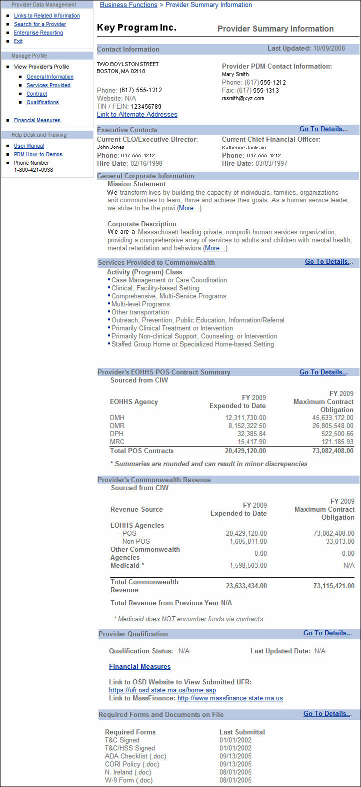
Provider Summary Information Functions | You can use the following links to navigate to more detailed information about a POS Provider’s organization.  Tip: After viewing information on additional PDM pages, click the browser Back button to return to the Provider Summary Information page.
  Function | Action
  To view the POS Provider’s Alternate Mailing address | Click Link to Alternate Addresses.  Result: The General Information Detail page appears.
  To e-mail the Provider PDM contact | Click the Provider PDM Contact e-mail address located within the Contact Information section of the page.  Result: A blank Outlook e-mail message page appears.
  To view more information about mission statement and corporate description | At the end of the paragraph, click (More…).  Result: The General Information Detail page appears.
  To view more information about services provided | Next to the Services Provided to the Commonwealth heading, click Go To Details….  Result: The Other Services Provided Detail page appears.
  To view more information about contracts | Next to the Provider’s EOHHS POS Contract Summary heading, click Go To Details….  Result: The POS Provider Contract Detail page appears.
Function | Action
To view more information about the provider’s qualification | See page 23 (of this document) for the Action Steps to view the Provider Qualification information. Result: The Provider Qualification page appears.
To view more information about Financial Measures and the Uniform Financial Report (UFR) filing status | Click the Financial Measures link.  Result: The Detail Financial Measures page appears.
To view submitted UFR from the OSD website | Click the following link:  https://ufr.osd.state.ma.us/home.asp
To view information from the MassFinance website | Click the following link:  http://www.massfinance.state.ma.us
To view a specific form on file | Next to the Required Forms and Documents on File heading, click Go To Details…  Result: The View Required Forms and Documents page appears.
To return to the top of the page | Click the Top link.
To return to the Business Functions page | Click the Business Functions link located at the top of the page.

Viewing General Information Detail | Use the General Information Detail page to view the following information about a Provider.  - Corporate Contact Information  - Provider’s PDM Contact  - Executive Contacts  - General Corporate Information  - Mission Statement  - Corporate Description
General Information Detail Page | Access the General Information Detail page by clicking the General Information Detail link from the Business Functions page.  The following is an example of the General Information Detail page.  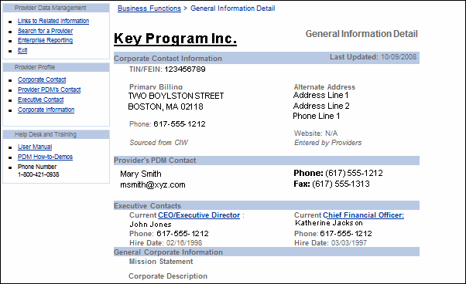
General Information Detail Functions | You can use the following links to navigate to more detailed information for a POS Provider’s organization.
  Function | Action
  To view the Provider history information | Click the Provider’s name hyperlink.  Result: The Provider Audit Trail page appears.  Click Back to return to the General Information Detail page.
  To go to the Provider Organization’s website | Click the Provider’s website address located within the Corporate Contact section of the page.  Result: Internet Explorer opens to the Provider’s website.
  To e-mail the Provider PDM Contact | Click the Provider’s PDM Contact e-mail address located within the Provider’s PDM Contact section of the page.  Result: A blank Outlook e-mail message page appears.
  To view CEO/Executive Director hire information for the POS Provider’s organization | Click the CEO/Executive Director link.  Result: The CEO Audit Trail page appears.  Click Back to return to the General Information Detail page.
  To view Chief Financial Officer hire information for the POS Provider’s organization | Click the Chief Financial Officer link.  Result: The CFO Audit Trail page appears.  Click Back to return to the General Information Detail page.
  Tip: To return to the Business Functions page, click the Business Functions link at the top of the page.
Viewing EOHHS Services Taxonomy  Information | Use the Other Services Provided Detail page to view the following information about a Provider.  - Current services contracted through EOHHS  - Other services offered by the Provider but not contracted through EOHHS  Note: The current services provided data is sourced from the contract information in the Commonwealth Information Warehouse (CIW). Information about services offered but not contracted through EOHHS is entered by the provider.
Other Services Provided Detail Page | Access the Other Services Provided Detail page by clicking the EOHHS Services Taxonomy link from the Business Functions page.  The following is an example of the Other Services Provided Detail page.  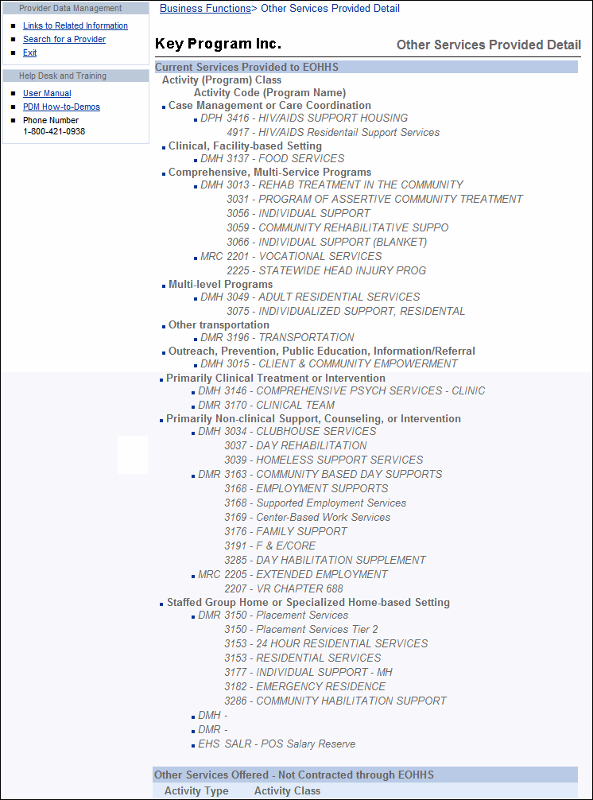
Viewing Provider Contract Summary  Information | Use the POS Provider Contract Detail page to view the following information about the POS Provider’s contracts for the current fiscal year:  - Activity Code  - Activity Name  - Doc ID  - Object Code  - Annual Contract Amount  - Expended to Date  - Unexpended Amount  - Totals and Grand Totals for Annual Contract Amount, Expended to Date and Unexpended Amount
The POS Provider Contract Detail page will include the following five object codes:
- MM3 - Purchased Human and Social Services for Clients - Medical or Health Care Related
- M03 – Purchased Human and Social Services for Clients - Non-Medical
- M1M – Non-Medical or Non-Health Care Related Client Services Provided by Individuals within Organizations
- M2M – Medical or Health Care Related Client Services Provided by Individuals within Organizations
- M04 – Services Purchased in Support of Human and Social Services for Clients
POS Provider Contract Detail Page | Access the POS Provider Contract Detail page by clicking the Provider Contract Summary link from the Business Functions page.  The following is an example of the POS Provider Contract Detail page.  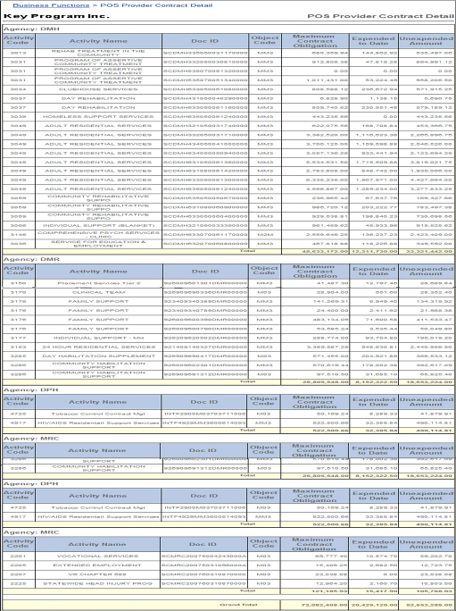  Tip: To return to the Business Functions page, click the Business Functions link located at the top of the page.
Viewing Provider Qualification  Information |  | Use the Provider Qualification page to view the following results about a POS Provider’s qualification:  - Principal Purchasing Agency (PPA)  - UFR Filer  - Qualification Status  - UFR Filing Period Reviewed  - Date UFR Received by OSD  - Date Qualification Status Last Updated  - Independent Auditor’s Opinion  - Auditor’s Going Concern Issues  - Type of Financial Submission  - Findings / Concerns  - PPA Comments
Provider Qualification Page |  | To access the Provider Qualification page, from the Provider’s Business Functions page, click on the Qualification link located under the Other Business Services bullet. Then from the Organization Expenditure Summary page, go to the left Navigation panel and click on the Provider Qualification bullet under the Edit Qualification section.  Important: These sections of the Provider Qualification page will be populated when the EOHHS Principal Purchasing Agency (PPA) Provider Qualification Officer (PQO) completes the review process.  The following is an example of the Provider Qualification page.  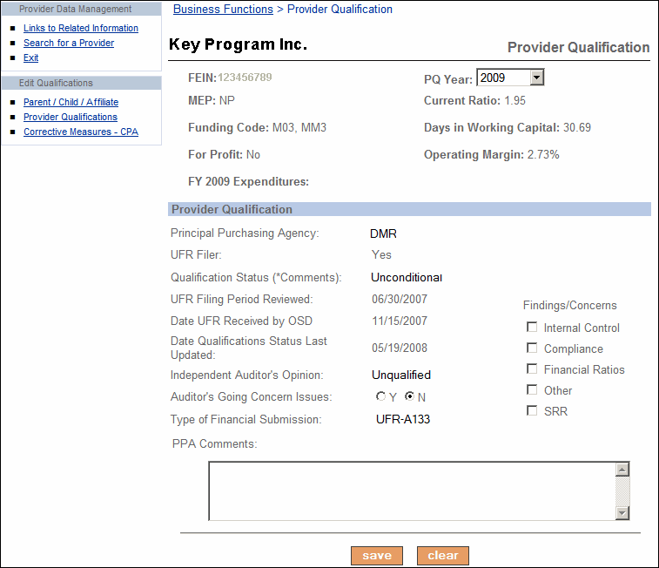  Tip: To return to the Business Functions page, click the Business Functions link located at the top of the page.
Viewing Financial Measures |  | The Financial Measures assist agencies in assessing the financial stability of a provider.  The EOHHS Purchase of Service (POS) Integrity Unit established the standard Financial Assessment Measures and benchmarks.  The Financial Measures page is pre-populated when the Operational Services Division (OSD) receives a Provider’s annual Uniform Financial Report (UFR) and parses the information into the OSD database.
Detail Financial Measures Page |  | Access the Detail Financial Measures page by clicking the Financial Measures link from the Business Functions page. The following is an example of the Detail Financial Measures page.  Note: The last three fiscal years data displays in PDM.  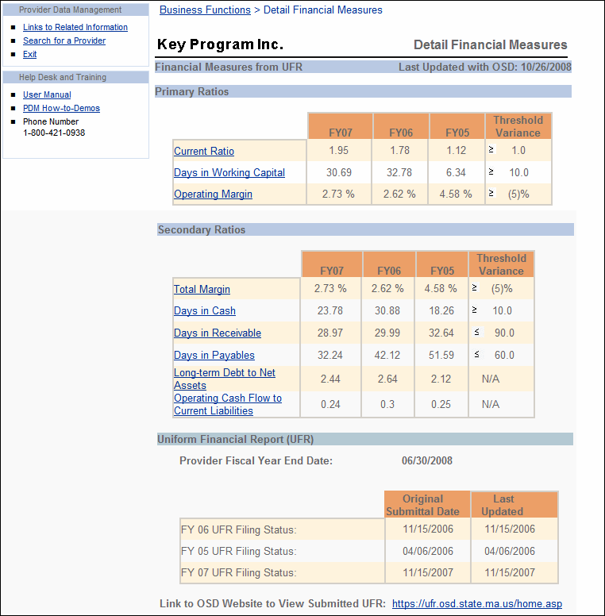  Tip: To return to the Business Functions page, click the Business Functions link located at the top of the page.
Notes:

Provider Qualification Information

Overview | PDM allows the Provider Qualification Staff to update provider qualification information, therefore reducing the amount of paperwork and input required from providers.  Note: All PDM data fields can be edited by the Purchase of Service (POS) Integrity Unit.
Provider Qualification Information | You can view the following POS Provider system generated information:  - Provider FEIN  - Multiple Entity Provider (MEP)  - Funding Codes  - For Profit Status  - Fiscal Year Expenditures  - Financial Assessment Measures  - Principal Purchasing Agency (PPA)  - UFR Filer  - UFR Filing Period Reviewed  - Date UFR Received by OSD  - Date Qualification Status Last Updated  You can edit the following information:  - Qualification Status  - Independent Auditor’s Opinion  - Auditor’s Going Concern Issues  - Type of Financial Submission  - Findings / Concerns  - PPA Comments
Accessing the Provider Qualification  Page | To access the Provider Qualification page, from the Provider’s Business Functions page, click on the Qualification link located under the Other Business Services bullet. Then from the Organization Expenditure Summary page, go to the left Navigation panel and click on the Provider Qualification bullet under the Edit Qualification section.  Result: The Provider Qualification page appears.
Viewing Provider (Organizational) Information | Important information to view on this page about the parent provider includes the affiliated organizations and respective funding.  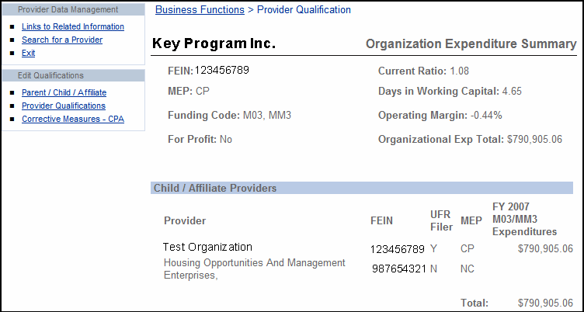  This page identifies the parent organization, all affiliated organizations, and their respective funding.  Note: The Financial Assessment Measure fields will be updated when the UFR Filer data changes.
Provider Qualifications  Page | The following is an example of the Provider Qualification page.  The PQ Year field defaults to the current fiscal year. You can edit the last three fiscal years data or view the last five fiscal years data by selecting the year from the drop down box.  Provider Correspondence  The provider will receive an annual letter by email of the organization’s current qualification status and a subsequent letter each time there is a qualification status change.
Editing  Provider Qualifications | The PPA Provider Qualification Officer completes the information on this page except for the PPA and UFR Filer status fields. These two fields can only be edited by the POS Integrity Unit.  Follow these steps to update new data for Provider Qualification information.  - Enter information in appropriate fields  - Click the [Save] button.  Tips:  - When you click the Clear button the modified information is cleared out and the fields are repopulated back to the data that was last saved.  - Be aware that all comments entered can be viewed by the provider.  To return to the Business Function page, click the Business Functions link located at the top of the page.
Editing Corrective Measures Based on Independent CPA Audit | The following is an example of the Corrective Measures Based on Independent CPA Audit Findings page.  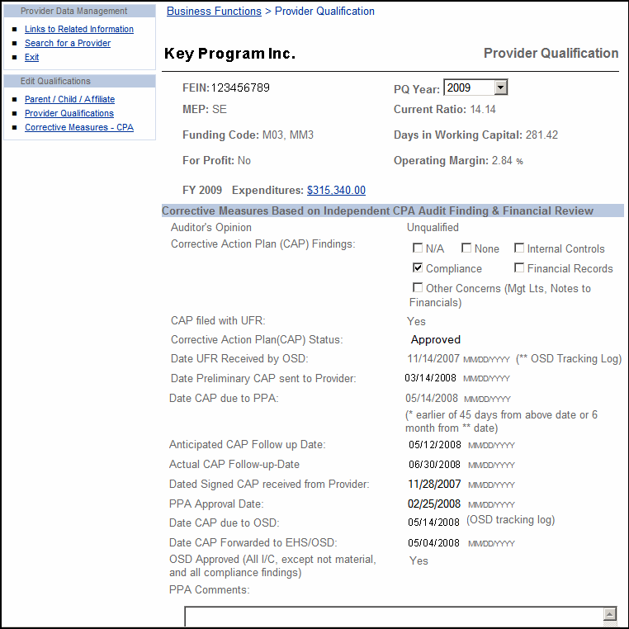  The PPA PQO completes information on this page.  Follow these steps to enter new data for Corrective Measures Based on Independent CPA Audit Findings information.  - Enter information in appropriate fields.  - Click the [Save] button.  Tips:  - When you click the Clear button the modified information is cleared out and the fields are repopulated back to the data that was last saved.  - Be aware that all comments entered can be viewed by the provider.  To return to the Business Function page, click the Business Functions link located at the top of the page.
Notes:

Required Forms and Documents
Overview | Both Provider and Agency users can use the view required forms and documents on file.  Providers will now be able to submit required forms and documents to EOHHS by using the PDM service.  This chapter contains the following topics:  - Accessing Required Forms and Documents page  - Viewing Information  - Available Forms and Documents  - Downloading Templates
Accessing the View Required Forms and Documents Page | Use the View Required Forms and Documents page to see which forms and documents are on file.  You can access the View Required Forms and Documents page from the Agency Business Functions page.  Click the Required Forms and Documents link under View Information Summary.  Result: The View Required Forms and Documents page appears.
Required Forms and Documents Page  Screen Tip  View a specific form on file by clicking the On File link for the Status  The status of On File means the forms were uploaded to PDM. | The following is an example of the View Required Forms and Documents page.  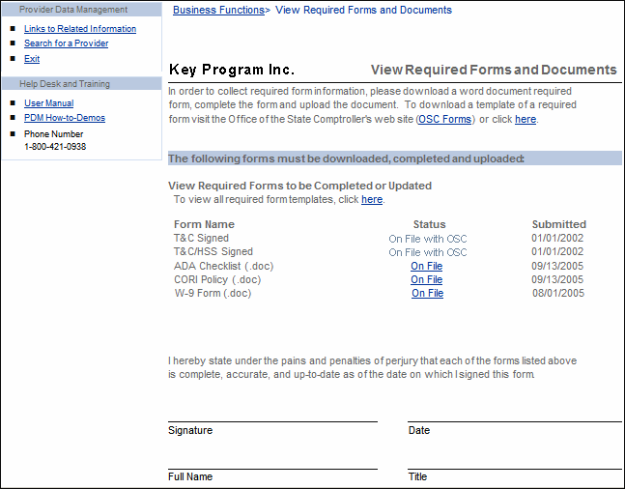
Viewing Information | All uploaded forms can be viewed online; both the Commonwealth Terms and Conditions and the Health and Human Services Terms and Conditions only have available their status and the date of submission. These fields are sourced from MMARS – CIW.

Function |  | Action
To view the information about a form unavailable online |  | Review the Status column on View Required Forms and Documents page.
To view a form or document available online |  | Click the link next to the form or document you want to review.
 | Note: This page includes a signature section that will be used by providers to confirm that all forms uploaded to PDM are up to date. When specified in a Request for Response (RFR), this page can be printed, signed, and submitted as part of the new RFR process. Refer to RFR document for specific submittal requirements.
Available Forms and Documents | The following table lists the forms and documents that are available to view and download from PDM.

Standard Forms and Documents | Availability on PDM
T & C Form | Status and date only
T & C/HHS Form | Status and date only
ADA Checklist | View form/document
Affirmative Action Plan | View form/document
Business Reference Form | View form/document
CORI Policy | View form/document
Disaster Plan | View form/document
Disciplinary Policy | View form/document
Human Rights Policy | View form/document
Personnel Policy | View form/document
Provider’s Training Policy | View form/document
Massachusetts Substitute W-9 Form | View form/document

Downloading  Templates | Templates for most required forms and documents can be downloaded from PDM Required Forms List page. Other templates are available through links to pages at OSC and OSD websites.
 | Access the Required Forms list page by clicking the here link.

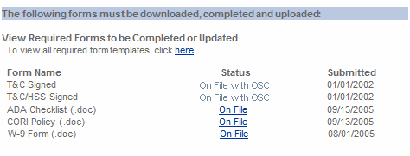
The following is a sample of the Required Forms List page, from which you can download most templates.
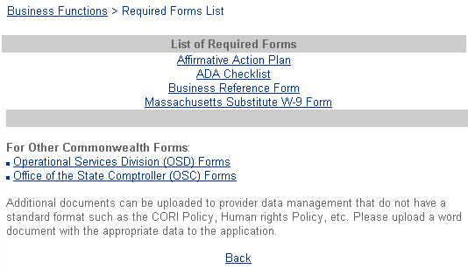
 |  |  | Following is a list of the templates available and the site from which they can be downloaded.
 |  | Template |  |  | Download from….
 |  | Affirmative Action Plan |  |  | PDM
 |  | ADA Checklist |  |  | PDM
 |  | Business Reference Form |  |  | PDM
 |  | Massachusetts Substitute W-9 |  |  | PDM
Follow these steps to download a template.
Step | Action
1 | Click the name of the required form.  Result: A dialog box appears, asking whether you want to Open or Save the file.  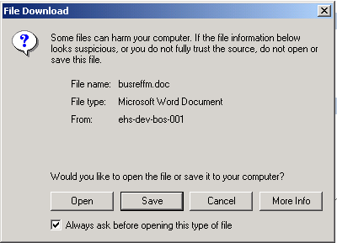
2 | Click Save.  Result: A Save As…dialog box appears.  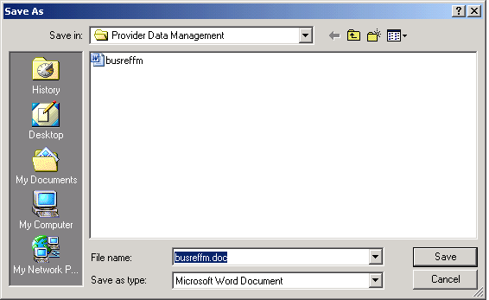

Step | Action
3 | Type the file name and navigate to the location where you want the file. Click Save.  Result: After a moment, a Download Complete dialog box appears.  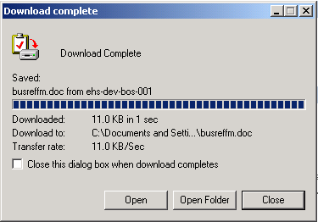
4 | Click Close to close the Download dialog box.  Result: The file has been saved onto your computer.

Notes:

