

Injury Surveillance Program, MA Department of Public Health Spring 2014
Suicide and self-inflicted injuries among Massachusetts residents are a significant yet largely preventable public health problem. The purpose of this bulletin is to provide information for practitioners and prevention specialists on the magnitude, trends, and risk factors for suicides and self-inflicted injuries. While suicide refers to completed suicides, nonfatal self-inflicted injuries can include both suicide attempts and non suicidal self-injury. The MDPH Suicide Prevention Program works in collaboration with multiple state, national, and local partners to reduce these injuries.

2011 Suicide Data:
- In 2011, there were 588¹ suicides that occurred in Massachusetts; a rate of 8.9/100,000 persons. The number of suicides was 2.9 times higher than homicides (N=202).

- Massachusetts has lower rates of suicides compared to the US. The US age adjusted rate in 2010, the most recent year for which data are available, was 12.1/100,000 compared to 8.7/100,000 for Massachusetts.(CDC)

- During the period of 2003-2011, approximately 4,500 persons died of suicide in Massachusetts. Suicide rates increased an average of 4% per year. The overall increase was 35%; from 6.6 to 8.9.² There were 164 more suicides in 2011 than in 2003.

- The increase in suicide rates was primarily among White, non-Hispanic males whose rates increased an average of 5% per year between 2003 and 2011.²

- Samaritans’ organizations in Massachusetts responded to 198,080 crisis calls in 2012.³

¹ This number represents the final count for 2011 and may differ from previously reported preliminary numbers.

² This trend was statistically significant.

³ This number includes repeat callers (individuals contacting hotlines more than once). Samaritans, Inc.; Samaritans of Fall River/New Bedford, Inc.; Samaritans of Merrimack Valley; Samaritans on the Cape & Islands.

⁴ Hospital Discharges and Emergency Department Visits are MA residents. Deaths are MA occurrent.

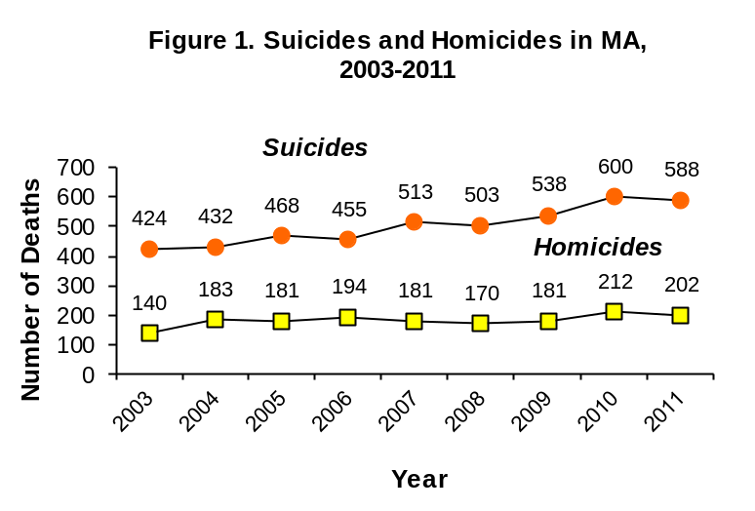
Source: Massachusetts Violent Death Reporting System, Massachusetts Department of Public Health

Source: Massachusetts Violent Death Reporting System
Figure 2. Number of Suicides and Hospital Discharges and Emergency Department Discharges for Nonfatal Self-Inflicted Injury, MA ⁴

588
Completed Suicides (2011)
6,720
Emergency Department Visits for Self-Inflicted Injuries (FY2007)

4,398 Hospital Discharges for Self-Inflicted Injuries (FY2012)

6,252
Emergency Department Visits for Self-Inflicted Injuries (FY2012)

Sources: Massachusetts Violent Death Reporting System, Massachusetts
Department of Public Health; Massachusetts Hospital Discharge Database,
Massachusetts Emergency Department Discharges Database, Massachusetts
Center for Health Information and Analysis

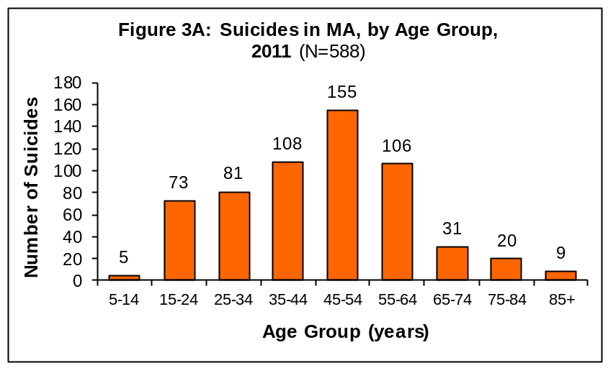
Suicides:
- Most suicides occur in the middle age population: 26% of all suicides were among individuals age 45-54. Between 2003 and 2011 the suicide rates among this age group increased an average of 6.4% per year.

- Suicides among males exceeded females by 3 to 1. In 2011, there were 441 suicides among males (13.8/100,000) compared with 147 among females (4.3/100,000).

- Among males, the highest rate of suicide was among those 45-54 years of age (22.9/ 100,000, N=113).

- Among females the highest rate of suicide was also among those 45-54 years of age (8.1/100,000, N=42).

Nonfatal Self-Inflicted Injuries, Hospital Discharges in FY12:
- The overall rate of hospital discharges for self-inflicted injury among MA residents was 66.8/100,000 (N=4,398).

- Females had a higher rate (72.5/100,000, N=2,462) than males (60.7/100,000, N=1,936).

- Females had higher rates of hospital discharges for self-inflicted injury than males for all age groups except 75-84 and 85+ year age groups.

- Among females, the highest rate was in the 15-24 year age group (120.2/100,000, N=559). Among males, the highest rate was in the 35-44 year age group (105.9/100,000, N=447).

⁵ Rates are not calculated on counts less than 5.
Suicides and Hospitalizations for Nonfatal Self-inflicted Injuries by Age Group and Sex
Source: Massachusetts Violent Death Reporting System, Massachusetts Department of Public Health

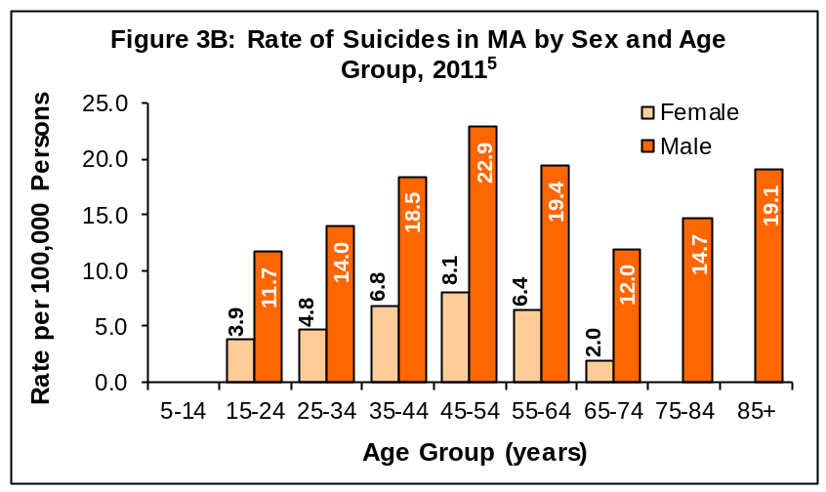
^{<5}

^{<5}

Source: Massachusetts Violent Death Reporting System, Massachusetts Department of Public Health

^{<5}

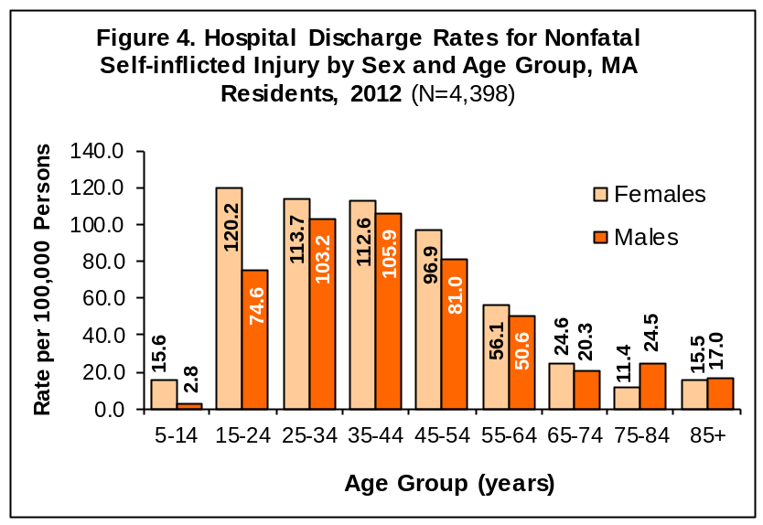
Source: Massachusetts Hospital Discharge Database, Massachusetts Center for Health Information
and Analysis

Suicides by Race/Ethnicity and Suicide and Nonfatal Self-inflicted Hospitalizations by Method

- From 2007-2011 the average annual age-adjusted suicide rate was highest among White, non-Hispanic males (14.5/100,000, N=1,898).⁷

- Similarly White, non-Hispanic females had a higher rate (4.0/100,000, N=555) of suicide compared to Black, non-Hispanic , Asian non-Hispanic, and Hispanic females.⁷

⁶Rates are age-adjusted using the Standard US Census 2000 population. The five most recent years of data were used to improve the stability of the rates.

⁷ Statistically significant at the p < .05 level. Please refer to the Methods section for an explanation on statistical significance.

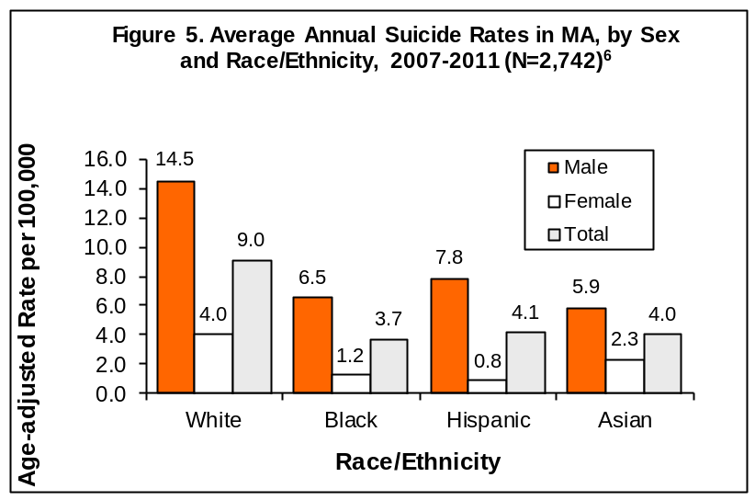
Source: Massachusetts Violent Death Reporting System, Massachusetts Department of Public Health

Figure 6A and B: Suicides and Hospital Discharges for Nonfatal Self-Inflicted Injury by Method, Massachusetts

Figure 6A.
Figure 6B.

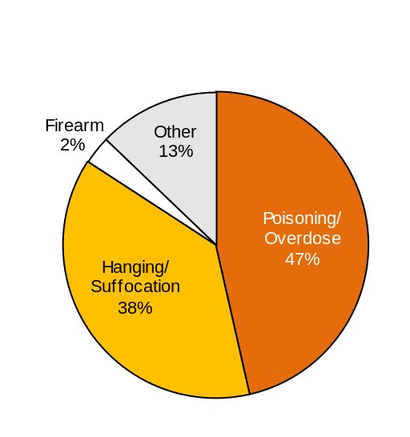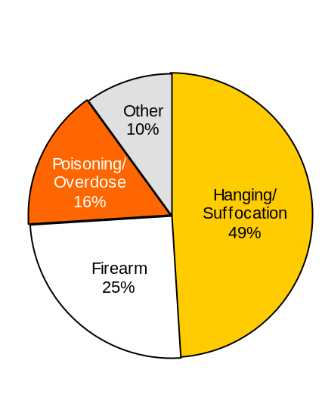
Hospital Discharges for Nonfatal Self-inflicted Injuries, MA Residents, FY2012 (N=4,398)

Suicides in MA, 2011
(N=588)
Males (N=441) Females (N=147)

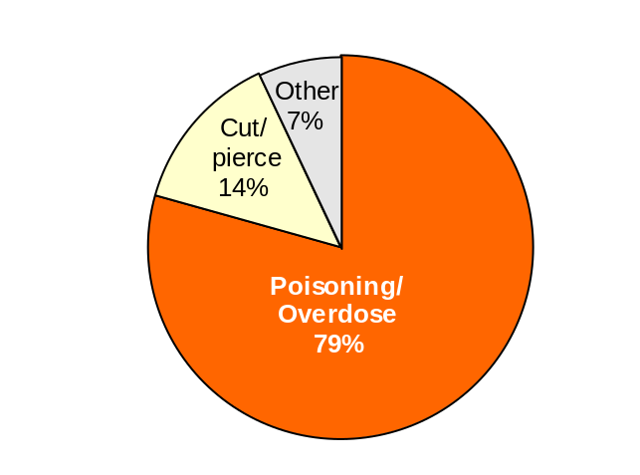

Source: Massachusetts Violent Death Reporting System, Massachusetts Department of Public Health and Massachusetts Hospital Discharge Database, Massachusetts Center for Health Information and Analysis

- In 2011, suicide methods varied by sex. For males, suffocation/hanging (N=217) and firearm (N=110) were the most common methods used. For females, the leading methods were poisoning (N=69) and suffocation/hanging (N=56).

- In FY2012, the leading method of nonfatal self-inflicted injuries resulting in hospitalization was poisoning. This did not vary by sex.

Circumstances Associated with Suicide in Massachusetts
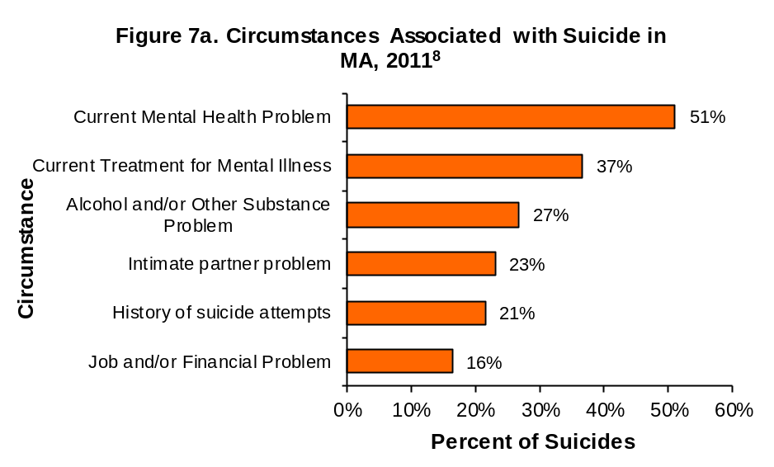
Circumstance data provides useful information for better understanding what may have precipitated a suicide and informs prevention programming. Information presented shows circumstances known.
- 51% of suicide victims had a documented current mental health problem such as depression or other mental illness.

- 37% were currently receiving some form of mental health treatment.

- 27% had an alcohol and/or other substance use problem noted.

- 23% had a noted problem with a former or current intimate partner (such as divorce, break-up or argument.)⁹

- 21% had a history of suicide attempts.

- 16% had a job problem, such as increased pressure at work, feared layoff, recent layoff and/or financial problem.

⁸More than one circumstance may be noted for a suicide.

⁹ “Intimate Partner Problem” refers to any problem with a current or former intimate partner and may or may not involve violence.

Source: Massachusetts Violent Death Reporting System, Massachusetts Department of Public Health

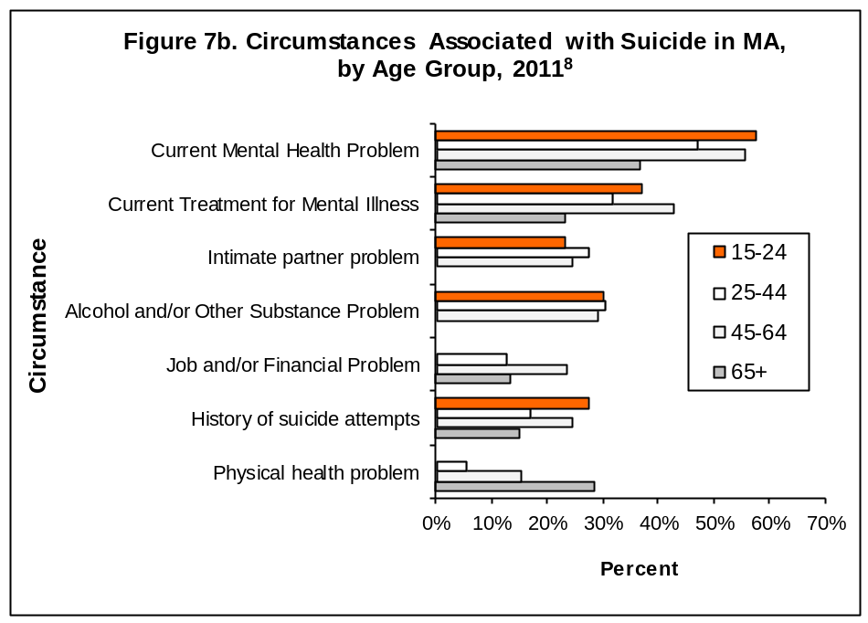

Source: Massachusetts Violent Death Reporting System, Massachusetts Department of Public Health

There were differences in circumstances when analyzed by age group. In 2011:
- 15-24 year olds had a higher percent of current mental health problem compared to persons 65 and over.
- 45-64 year olds had a higher percent of current treatment for mental health problem than 25-44 year olds and persons 65 and over.
- 45-64 year olds had a higher percent of job/financial problem than persons 25-44.
- Individuals ages 65 and over had the highest percent of physical health problem compared to all
other age groups.

Suicidal Thoughts and Behaviors in Youth
The MA Youth Risk Behavior Survey, (MA YRBS) an anonymous written self report survey of youth in public high schools in MA, indicated that in 2011:
- 18% of high school students reported a self-inflicted injury that was not a suicide attempt

- 13% of students seriously considered suicide during the past year, 12% made a suicide plan and 7% made an attempt

- 25% of high school students reported feeling so sad or depressed daily for at least two weeks during the previous year that they discontinued usual activities. A significantly larger percentage of females (32%) than males (19%) reported feeling this way (not depicted)

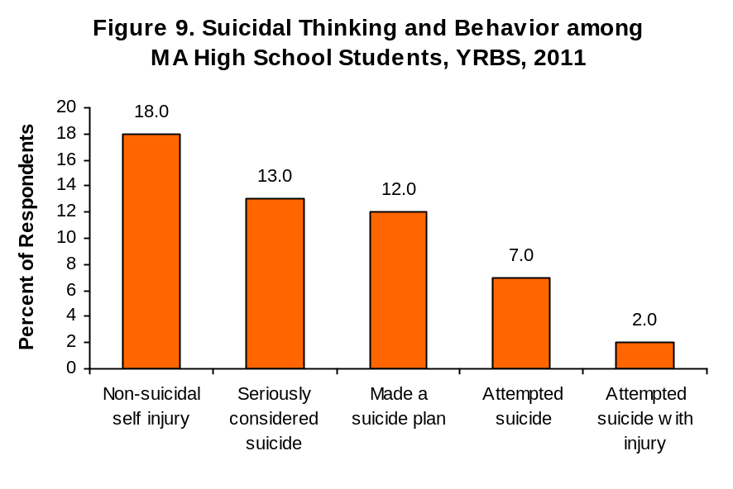
Source: Massachusetts Youth Risk Behavior Survey, 2011, weighted data

Survey findings from the MA YRBS can also show the relationship between victimization and suicide attempts. As the number of victimization types experienced increases, so does the percent of those students attempting suicide. The victimization types from YRBS include:

- students who had ever been bullied on school property during the past 12 months

- students who did not go to school on one or more of the past 30 days because they felt they would be unsafe at school or on their way to or from school

- students who had been threatened or injured with a weapon such as a gun, knife, or club on school property one or more times during the past 12 months

- students who had ever been hurt physically by a date or someone they were going out with

- students who responded that someone had ever had sexual contact with them against their will.

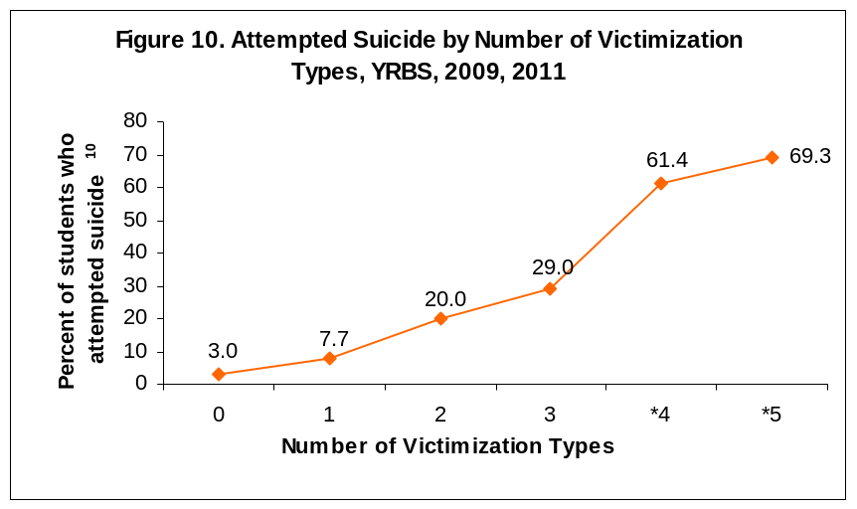
Source: Massachusetts Youth Risk Behavior Survey, questions on survey in 2009 and 2011, weighted data

* Estimates may be unreliable due to small numbers, interpret with caution

¹⁰Attempted suicide one or more times in the past 12 months

Resources
For more information on suicide data or to learn more about suicide prevention activities in Massachusetts,
please contact:
Injury Surveillance Program  Bureau of Health Information, Statistics, Research, and Evaluation  Massachusetts Department of Public Health  250 Washington Street, 6th Floor  Boston, MA 02108  Phone: 617-624-5648 (general injury)  Phone: 617-624-5664 (MAVDRS)  http://www.mass.gov/dph/isp | Bureau of Substance Abuse Services  Massachusetts Department of Public Health  250 Washington Street, 3rd Floor  Boston, MA 02108  1-800-327-5050  TTY 1-888-448-8321  http://www.mass.gov/dph/bsas  Massachusetts Coalition for Suicide Prevention  Phone: 617-297-8774  info@masspreventssuicide.org  24-hour help lines  Samaritans: National LifeLine:  1-877-870-HOPE (4673) 1-800-273-TALK (8255)  Samariteens: TTY: 1-800-799-4TTY (4889)  1-800-252-TEEN (8336)
Massachusetts Suicide Prevention Program
Bureau of Community Health and Prevention
Massachusetts Department of Public Health
250 Washington Street, 4th Floor
Boston, MA 02108
Phone: 617-624-6076
http://www.mass.gov/dph/suicideprevention
Methods

General Notes:
All suicides and self-inflicted injuries were ascertained using guidelines recommended by the Centers for Disease Control and Prevention and are based upon the International Classification of Disease codes for morbidity and mortality. The most recently available year of data for each data source was used for this bulletin. All rates reported in this bulletin are crude rates with the exception of Figure 5. Age-adjusted rates are used for Figure 5 to minimize distortions that may occur by differences in age distribution among compared groups. Rates presented in Figure 1 of this bulletin cannot be compared to bulletins published prior to 2008 due to a methodology change. In prior bulletins individuals less than 10 were excluded in both the numerator and denominator due to the rarity of children <10 completing suicide. For consistency with other publications the analysis was modified to include all ages for both numerator and denominator. This change results in slightly lower rates. Prior to data year 2010 death data was from the Massachusetts Registry of Vital Records and Statistics and included Massachusetts residents regardless of where the death occurred.
Data Sources:
- Death Data: MA Violent Death Reporting System, MA Department of Public Health. The National Violent Death Reporting System is a Centers for Disease Control and Prevention funded system in 18 states that links data from death certificates, medical examiner files, and police reports to provide a more complete picture of the circumstances surrounding violent deaths. The Massachusetts Violent Death Reporting System (MAVDRS) operates within the Injury Surveillance Program at the Massachusetts Department of Public Health. MAVDRS captures all violent deaths (homicides, suicides, deaths of undetermined intent and all firearm deaths) occurring in MA and has been collecting data since 2003. Data reported are for calendar year. Data were analyzed by icd-10. Data Includes Massachusetts occurrent deaths regardless of residency.
- Statewide Acute-care Hospital Discharges: MA Inpatient Hospital Discharge Database, MA Center for Health Information and Analysis. Data reported are for fiscal years (October 1 -September 30). Deaths occurring during the hospital stay and transfers to another acute care facility were excluded from the counts presented. All discharge diagnoses were analyzed to ascertain injury.
- Statewide Emergency Department Discharges at Acute Care Hospitals: MA Emergency Department Discharge Database, MA Center for Health Information and Analysis. Data reported are for fiscal years (October 1 -September 30). Deaths occurring during treatment or those admitted to the hospital were excluded from the counts presented. All discharge diagnoses were analyzed to ascertain injury.
- Suicide Crisis Data: Samaritans, Inc.; Samaritans of Fall River; Samaritans of Merrimack Valley; Samaritans on the Cape & Islands.
- MA Youth Risk Behavior Survey: MA Department of Education, MA Department of Public Health, and CDC MMWR Vol. 61, No. 4, June 2012.
- Population Data: National Center for Health Statistics. Postcensal estimates of the resident population of the United States for July 1, 2010-July 1, 2011, by year, county, single-year of age (0, 1, 2, .., 85 years and over), bridged race, Hispanic origin, and sex (Vintage 2011). Prepared under a collaborative arrangement with the U.S. Census Bureau. Available from: http://www.cdc.gov/nchs/nvss/bridged_race.htm as of July 18, 2012 following release by the U.S. Census Bureau of the unabridged Vintage 2011 postcensal estimates by 5-year age group on May 17, 2012.
- U.S. injury rates and U.S. population were accessed from Centers for Disease Control and Prevention, National Center for Injury Prevention and Control. Web-based Injury Statistics Query and Reporting System (WISQARS)

Statistical Significance: A result that is statistically significant is one that is unlikely to have occurred by chance alone, and is therefore, likely to represent a true relationship between a risk factor such as race, age, or sex and a disease or injury of interest. Statistical significance does not necessarily imply importance and should not be the only consideration when exploring an issue. Because a rate is not “statistically” significant does not mean there is not a real problem that could or should be addressed.

This publication was supported by cooperative agreements #U17/CCU124799, #U17/CCU122394 and #U17/CE001316 from the Centers for Disease Control and Prevention. Its contents are solely the responsibility of the authors and do not represent the official views of the Centers for Disease Control and Prevention.

