Massachusetts Birth Defects

2011-2012

Massachusetts Birth Defects Monitoring Program

Bureau of Family Health and Nutrition

Massachusetts Department of Public Health

May 2016

Charles D. Baker, Governor

Karyn E. Polito, Lieutenant Governor
Marylou Sudders, Secretary, Executive Office of Health and Human Services
Monica Bharel, MD, MPH, Commissioner, Massachusetts Department of Public Health
Ron Benham, Director, Bureau of Family Health and Nutrition, Acting Director, Massachusetts Center for Birth Defects Research and Prevention

Acknowledgements

This report was prepared by Rebecca Liberman and Cathleen Higgins, Massachusetts Center for Birth Defects Research and Prevention.

We would like to thank the Massachusetts Center for Birth Defects Research and Prevention staff who contributed to this report, including: Marlene Anderka, Xiaoli Chen, Dominique Heinke, Angela Lin, and Gerlinde Munshi.

Data in this report have been collected through the efforts of Center field staff, including: Roberta Aucoin, Mitcheka Jalali, Washa Liu, Daniel Sexton, Lori Tetrault and Ashley Tracey.

We would like to acknowledge the following individuals and organizations for their time and commitment in supporting the Center:

Lewis Holmes, MD, MassGeneral Hospital for Children

Carol Louik, ScD, Slone Epidemiology Center, Boston University

Allen Mitchell, MD, Slone Epidemiology Center, Boston University

Martha Werler, ScD, Department of Epidemiology, Boston University School of Public Health

Ed Doherty, March of Dimes Massachusetts Chapter

Massachusetts Registry of Vital Records and Statistics

Office of Data Management and Outcomes Assessment, Massachusetts Department of
Public Health

National Center on Birth Defects and Developmental Disabilities, Centers for Disease Control and Prevention

For more information, contact:
Massachusetts Department of Public Health
Center for Birth Defects Research and Prevention
250 Washington Street, 5th floor
Boston, MA 02108
(617) 624-5510 or 1-888-302-2101 (toll free)

This report can be found on our website: www.mass.gov/dph/birthdefects

TABLE OF CONTENTS

EXECUTIVE SUMMARY 5

Chapter 1: INTRODUCTION 9

Chapter 2: METHODS 12

Chapter 3: PREVALENCE OF BIRTH DEFECTS 15
Figure 1. Birth Defects by Body System 15
Table 1. Prevalence of Birth Defects 16
Figure 2. Prevalence of Selected Birth Defects, Massachusetts vs. United States 19
Table 2. Prevalence of Selected Birth Defects, Massachusetts vs. United States 20
Figure 3. Pregnancy Outcomes among Live Births with and without Birth Defects 21
Figure 4. Overall Prevalence of Birth Defects by Year, Massachusetts: 2000-2012,
2-year rolling average 22

Chapter 4: PREVALENCE OF BIRTH DEFECTS BY INFANT SEX
AND PLURALITY 23
Figure 5. Prevalence of Selected Birth Defects by Infant Sex 23
Table 3. Prevalence of Birth Defects by Infant Sex 24
Figure 6. Prevalence of Selected Birth Defects by Single and Multiple Births 29
Table 4. Prevalence of Birth Defects by Plurality 30

Chapter 5: PREVALENCE OF BIRTH DEFECTS BY MATERNAL AGE 35
Table 5. Overall Prevalence of Birth Defects by Maternal Age 35
Table 6. Prevalence of Birth Defects by Maternal Age 36
Figure 7. Prevalence of Down Syndrome by Maternal Age 48
Figure 8. Prevalence of Gastroschisis by Maternal Age 49
Figure 9. Prevalence of Gastroschisis by Year and Maternal Age,
Massachusetts 2000-2012 50

Chapter 6: PREVALENCE OF BIRTH DEFECTS BY MATERNAL
RACE/ETHNICITY AND REGION 51
Table 7. Age-Adjusted Prevalence of Birth Defects by Maternal Race/Ethnicity 51
Table 8. Prevalence of Birth Defects by Maternal Race/Ethnicity 52
Figure 10. Prevalence of Birth Defects by Maternal Race/Ethnicity,
Massachusetts: 2007-2012 62
Table 9. Age-Adjusted Prevalence of Birth Defects by Maternal Residence Region 63
Figure 11. Prevalence of Birth Defects by Maternal Residence Region,
Massachusetts: 2007-2012 63

Chapter 7: BIRTH DEFECTS BY SEVERITY, PATTERN,
AND ETIOLOGY 64

Figure 12. Birth Defects by Severity 64

Figure 13. Birth Defects by Pattern 65

Figure 14. Birth Defects by Etiology 66

Chapter 8: OTHER PREGNANCY LOSSES—2012 DATA 67

Figure 15. Prevalence of Birth Defects with and without Other Pregnancy Losses 67

Figure 16. Prevalence of Selected Defects with and without Other Pregnancy Losses 68

Figure 17. Prevalence of Selected Defects including Other Pregnancy Losses,

Massachusetts Compared to US Rates 69
RESOURCES, SUGGESTED CITATION, CONTACT INFORMATION 70

REFERENCES 71

APPENDICES
Appendix 1: Technical Notes 72
Appendix 2: Glossary of Terms Used in this Report 74 Appendix 3: Massachusetts 2011-2012 Live Birth Populations Used in Calculating Rates 79
Appendix 4: ICD-9-CM/BPA Birth Defect Codes Used in this Report and Inclusions/Exclusions 80
Appendix 5: Complete List of ICD-9-CM/BPA Birth Defect Codes and Counts 84
Appendix 6: Selected Birth Defects by Severity 96
Appendix 7: Pre-Pregnancy Multivitamin Use Massachusetts: 2011 97
Appendix 8: Map of Massachusetts Regions 98

EVALUATION FORM 99

EXECUTIVE SUMMARY

One of every 33 infants in the United States is born with a birth defect. Birth defects are defined as conditions that develop before birth affecting the structure of one or more parts of the body (1,2). Although birth defects are rare when compared to other adverse birth outcomes like low birth weight or prematurity, birth defects are the leading cause of death in the first year of life. Nationally, about 20% of all infant deaths are attributable to birth defects. Birth defects may also result in mental and/or physical disability, may require costly medical care, and may cause economic, emotional, and social distress for families.

The causes of many birth defects are poorly understood. Certain genetic and environmental factors have been implicated in selected birth defects. These include prenatal environmental factors, such as infections, exposures to medications or other chemicals, drug or alcohol abuse, and nutritional deficiencies. Some birth defects can be caused by a single abnormal gene, while others arise due to a complex interplay between various genetic and environmental factors.

Studies have shown that the presence of adequate amounts of folic acid (vitamin B9) in the mother’s system before conception and during the first trimester may help prevent birth defects of the brain and spinal cord known as neural tube defects (3). However, for more than 70% of all birth defects, no known cause has been identified (4). Researchers continue to investigate a wide variety of risk factors as possible causes.

The combined lifetime cost for infants born with 12 major structural birth defects in Massachusetts has been estimated at over $200 million dollars (5). Nationally, the lifetime cost of 17 common birth defects has been estimated to be over 9 billion in 2012 dollars (6).

This report presents data on the prevalence of birth defects among live births and stillbirths in Massachusetts during the years 2011 and 2012, as well as selected 2012 data that includes other types of pregnancy losses. Two years of live birth and stillbirth data are combined in this report, since the numbers of cases are often small for individual defects within a single year.

The data allow for some trend analyses. Increasing rates over time may reflect improved case ascertainment. The Birth Defects Monitoring Program is constantly working to improve case-finding, in order to provide the most complete data possible to inform public health policy, planning and prevention efforts.

Prevalence of Birth Defects in Massachusetts

Among Massachusetts residents who delivered in 2011 or 2012, there are 2731 cases (2663 live births and 68 stillbirths) with one or more structural birth defects. This results in a prevalence rate of 187.5 birth defects per 10,000 live births.

Cardiovascular defects are the most commonly occurring birth defects in Massachusetts, followed by musculoskeletal, genitourinary and chromosomal defects.
Of the ten most common specific birth defects, three are cardiovascular—atrial septal defect, ventricular septal defect, and pulmonary valve stenosis. The most common non-cardiovascular defects are polydactyly/syndactyly, club foot, obstructive genitourinary defect, trisomy 21 (Down syndrome), and hypospadias.

Birth Defects in Massachusetts vs. the US

Massachusetts is one of 11 states with active case ascertainment programs and contributes data to published national prevalence estimates for selected birth defects. For most defects, Massachusetts rates in 2011-2012 are similar to the most recent national rates from 2004-2006 (7). However, Massachusetts rates are significantly lower than US rates for anencephaly, spina bifida, cleft lip, and gastroschisis. Massachusetts rates are significantly higher for atrioventricular canal defects and for esophageal atresia/tracheoesophageal fistula. Differences in surveillance system methodology, types of pregnancy outcomes included, and demographic variation may account for the differences in rates for certain birth defects.

Until 2011, Massachusetts only collected information on live birth and stillbirth cases. Limiting the data to live births and stillbirths can result in undercounting of certain birth defects—especially those not compatible with life. Beginning in early 2011, Massachusetts began ascertaining prenatally-diagnosed birth defects in pregnancies that ended in other types of pregnancy losses. A preliminary assessment of the impact of adding these other losses in 2012, the first full year of data available, shows that Massachusetts rates for spina bifida and anencephaly are similar to national rates when these other pregnancy outcomes are included.

Adverse Pregnancy Outcomes

Adverse outcomes such as low birth weight (LBW), prematurity, and small for gestational age (SGA) are more frequent among live births with birth defects than among unaffected infants. Infants with a birth defect are 3 times more likely to have low birth weight (less than 2500 grams) and 2.7 times more likely to be born premature (before 37 weeks) compared to those without birth defects. Cesarean (C-section) deliveries are also more common among live born infants with birth defects than among unaffected infants. In addition, infants with birth defects are roughly 15 times more likely to die in their first year of life.

Infant Sex

The prevalence of birth defects in Massachusetts in 2011-2012 is 216.9 per 10,000 male live births and 156.4 per 10,000 female live births. Males are significantly more likely than females to have obstructive genitourinary defects, club foot, and cleft lip.

Maternal Age

The prevalence of birth defects varies by maternal age. The number of births to older mothers has been increasing over time in Massachusetts (8). Older mothers have a higher prevalence of birth defects compared to younger mothers. Overall birth defect rates were highest for mothers ages 35 years and older (220.7 per 10,000 live births) compared to younger mothers.

There is a strong association between the rate of Down syndrome (trisomy 21) and advanced maternal age. In Massachusetts, the rate of Down syndrome in mothers ages 35 and older is 33.7 per 10,000 live births, over 4 times greater than the rate in mothers younger than 35.

Gastroschisis, a condition in which a child is born with the intestines—and sometimes other organs—protruding through a hole in the abdominal wall, occurs more often among younger mothers. In 2011-2012, mothers less than 20 years old have the highest rate of gastroschisis (13.3 per 10,000 live births) among all age groups.
Assisted Reproductive Technology

It is estimated that 1.5 percent of US infants are conceived through the use of assisted reproductive technology (ART) (9). In 2011, Massachusetts had the highest rate of ART use in the nation. This may be partly due to high rates of insurance coverage for ART in Massachusetts and a higher proportion of older women of reproductive age trying to conceive. Infants conceived by ART have been shown to have an increased risk for certain birth defects compared to those conceived spontaneously (10).

Multiple Births

Birth defects are more common among multiple births (e.g. twins and triplets) than in singleton births. About 4.5% of Massachusetts live births are multiple births (8). The birth defect prevalence rate in 2011-2012 is 181.8 per 10,000 live births for singletons and 311.6 per 10,000 live births for multiples.

Maternal Race/Ethnicity

In Massachusetts and nationally, birth defect rates vary by maternal race and ethnicity. In 2011-2012 in Massachusetts, the overall age-adjusted prevalence rate of birth defects among Hispanic mothers is significantly higher than for white and Asian mothers, and the rate for black mothers is significantly higher than that for Asian mothers. Possible explanations for racial/ethnic differences include genetic variation, diet and lifestyle differences, and varying access to prenatal screening and health care services.

Region

The Massachusetts Executive Office of Health and Human Services divides the state into six regions, which are used for statistical, care coordination, and administrative purposes. In 2011-2012 the overall age-adjusted birth defect prevalence rate was higher in the Western region than in the other regions, but this difference was not statistically significant.

Severity

A severity scale for birth defects was developed in collaboration with Boston University and Massachusetts General Hospital, based on the usual outcome for a specific birth defect, including the need for immediate treatment, the need for long-term care, and the amenability of the defect to correction. “Mild” defects generally require minimal long term care. “Moderate” defects tend to be correctable, although many affected infants have long term care needs. “Serious” defects may often be correctable, but affected infants typically have long term care needs. “Severe” defects are usually incompatible with life.

Approximately 8% of defects are classified as mild, 65% are classified as moderate, and roughly 23% of 2011-2012 cases are considered serious. Severe defects make up 3% of the live birth and stillbirth cases in 2011-2012.

Etiology and Pattern

The surveillance system in Massachusetts collects information on etiology (cause), whenever available. Most cases of birth defects have no known cause.

Pattern refers to whether a birth defect occurs with other defects. Approximately 24% of birth defects occur with defects in other organs or as part of syndromes, while 76% occur as isolated defects or are confined to the same organ, occur with minor defects, or are part of a sequence of developmental events.

Analysis of Trends

The overall prevalence of birth defects in Massachusetts increased slightly but not significantly in 2011-2012 compared with 2009-2010. The overall birth defect rate among live births and stillbirths in 2011-2012 was 187.5 per 10,000 live births compared with 181.5 per 10,000 live births in 2009-2010. This report includes selected trend analyses using current and previous years’ data, with the understanding that better case ascertainment and improved prenatal diagnosis may contribute to changes in birth defect rates.

CHAPTER 1: INTRODUCTION

The Public Health Importance of Birth Defects

Each year in the United States, approximately 120,000 babies—1 in 33—are born with birth defects (1). Birth defects, or congenital anomalies, are serious abnormalities of structure present before birth.

Although birth defects are rare when compared to other adverse birth outcomes, they are the leading cause of infant death in the United States. Nationally, about 20% of all infant deaths result from birth defects (11), which is consistent with the number of infant deaths among cases found in the Massachusetts Birth Defects Monitoring Program surveillance system and with a recent report using Massachusetts death data from vital records (12).

Birth defects may cause significant physical or mental disability. There can be substantial costs to those affected and to their families, including direct costs of medical treatment, developmental services and special education, as well as indirect costs related to loss of work and productivity.

Causes of Birth Defects

The causes of most birth defects are poorly understood, but certain genetic and environmental factors have been reported to be associated with selected defects. These include prenatal environmental factors, such as infections (e.g., rubella), exposures to medications or other chemicals, drug or alcohol abuse, and nutritional deficiencies.

A single abnormal gene can cause certain birth defects. The gene may have an error in its code such as a missing piece or extra genetic material which can result in malformations. Other causes of birth defects may be multifactorial with genes and environmental factors both playing a role. For 70% of birth defects, no known cause has been identified (4). Researchers are looking at a wide variety of environmental exposures and other possible risk factors as potential causes of birth defects.

Birth Defects and Folic Acid

Studies have shown that the presence of adequate amounts of folic acid (vitamin B9) in the mother’s system during the “periconceptional” period (one month before through three months after conception) may help prevent defects of the brain and spinal cord known as neural tube defects. Fortification of cereal grains with folic acid has resulted in a 26% reduction in the number of babies born with these neural tube defects in the US (13). However, some studies in certain populations suggest that not all cases of neural tube defects are preventable by increasing folate intake (14).

Healthy People 2020 Challenges

The Healthy People 2020 objectives (15) include reducing rates of fetal and infant death, lowering the occurrence of neural tube defects, and reducing developmental disability. Birth defects surveillance is a critical component of the public health strategy to achieve these objectives. The birth defects surveillance program in Massachusetts allows the Department of Public Health to monitor the occurrence of birth defects in the state. This data makes it possible to identify changes in birth defect rates over time, to identify geographical areas with unusually high or low rates, and to allow for development of strategies for prevention and for providing services to affected families.

Birth Defects Surveillance in Massachusetts

Since 1999, the Birth Defects Monitoring Program (BDMP) has conducted statewide, population-based active surveillance of birth defects among Massachusetts residents. The BDMP identifies cases with structural birth defects diagnosed through 1 year of age.

The primary focus of the state surveillance system is the identification of major structural birth defects that occur with or without a chromosomal abnormality or other non-chromosomal malformation syndrome.

The program’s active surveillance system uses multiple sources of ascertainment, including delivery and specialty care hospitals, and birthing centers. Vital records serve as an additional source of information, providing demographic and clinical information on cases, and acting as an additional source of case-finding.

Potential birth defect cases, identified through these varied sources, are assigned to medical record abstractors who review maternal and infant medical records. All cases are coded according to the International Classification of Diseases, Ninth Revision, Clinical Modification, modified British Pediatric Association (ICD-9-CM/BPA) system. Complex cases and cases in which the infant died are reviewed by a clinical geneticist.

The birth defects included in Massachusetts surveillance are ICD-9 CM codes ranging from 740.0 to 759.9 and several other selected codes outside this range for defects such as DiGeorge syndrome, Pierre Robin sequence and amniotic bands. A list of the ICD-9-CM/BPA codes for defects presented in this report is provided in Appendix 4.

Economic Impact on Massachusetts

The estimated lifetime cost in Massachusetts for babies born with one of 12 major structural birth defects is $200 million in 2012 dollars (5). This includes direct costs of medical treatment, developmental services and special education, as well as indirect costs to society for lost wages due to early death or occupational limitations. There can also be social and emotional impacts, which are difficult to quantify.

Birth Defects Surveillance Regulations

In 2009, Massachusetts promulgated regulations (105 CMR 302) related to the Massachusetts Birth Defects Monitoring Program, which expanded reporting requirements for birth defects cases identified at or after birth and extended reporting to cases identified prenatally.

The 2011-2012 Surveillance Report

This report presents statewide data on the prevalence of birth defects in live births and stillbirths in Massachusetts during the years 2011 and 2012, as well as selected 2012 data that includes birth defects among other types of pregnancy losses. Most of the data is presented with the years 2011 and 2012 combined, since the numbers are relatively small for individual defects in a single year. Unless otherwise indicated, the case counts and prevalence rates in this report are based on live births and stillbirths.

In early 2011, Massachusetts began ascertaining prenatally-diagnosed birth defects in pregnancies that ended in pregnancy losses other than a live birth or stillbirth. Some 2012 data on these other losses is included in this report, although these data should be interpreted with caution, since only one year of data from a start-up year is included.

The Massachusetts Center for Birth Defects Research and Prevention

The Massachusetts Center for Birth Defects Research and Prevention collects data on birth defects and identifies related trends, searches for potential causative factors associated with birth defects, addresses community concerns about birth defects, provides information to families of children with birth defects, and collects information on related screening and prevention efforts.

CHAPTER 2: METHODS

Case Definition

This report presents data on selected birth defects among deliveries to Massachusetts residents occurring during the calendar years 2011 and 2012. Cases were included if they met the following criteria:

Live birth or stillbirth (fetal death) with a gestational age of at least 20 weeks or with a weight of at least 350 grams OR other type of pregnancy loss (early miscarriage or elective termination—2012 data for selected analyses only)

The infant or fetus had a structural birth defect that met diagnostic criteria listed in Appendix 4.

For live births, the diagnosis must have been confirmed during the first year of life.

Data Collection

Hospitals across the state submit monthly reports with birth defect diagnoses to the BDMP. Abstractors review maternal and infant medical records to collect information for each potential case. Beginning with 2008 births, reporting sites were expanded to include outpatient centers, emergency rooms, day surgery clinics, and laboratories.

Each live born case in the BDMP is linked to a Registry of Vital Records and Statistics record of live birth. Each reportable fetal death case is linked to a fetal death certificate, when available. Demographic and clinical variables, including maternal age, race/ethnicity, gestational age, birth weight, method of delivery, plurality, and region of residence are obtained from the live birth or fetal death certificate. Infant sex is ascertained from birth defects surveillance data because it is usually considered to be more accurate. For stillbirths without a fetal death certificate and for other pregnancy outcomes, demographic and clinical information comes from surveillance data.

Recent changes to the program include:

Early 2011: Began collecting cases diagnosed prenatally that did not result in a live birth or stillbirth (other pregnancy losses)
Late 2011: Began use of electronic case report form for abstraction
Early 2012: Discontinued abstraction at two Rhode Island tertiary hospitals

The discontinuation of data collection at Rhode Island hospitals, where some cases born to Massachusetts residents in the southeastern part of the state deliver or receive treatment, is expected to slightly reduce our case numbers, but the program will continue to ascertain those cases that receive any diagnosis or treatment in Massachusetts. Based on 2008-2009 data, we estimate that fewer than 20 cases per year would be affected by this change, and for many of these we would still be able to obtain the information by contacting a physician.

Quality Control

To ensure data quality, the BDMP performs regular data quality checks. Key demographic and clinical information on live births and fetal deaths is checked against vital records data. The BDMP system includes many built-in logic and range checks, as well as checks for missing information. In addition, each case receives clinical review, which provides an additional layer of checking, as well as ensuring that diagnostic information is as accurate as possible. Regular data reports are run to identify missing or unusual data values, and periodic re-abstraction and data entry checks are also performed.

Confidentiality

The program has developed extensive procedures to safeguard the confidentiality of the data and to protect the privacy of families. These procedures uphold ethical and legal obligations to protect confidentiality and comply with the requirements of state and federal laws.

Data Analysis

A birth defect may occur as a single event or in combination with other defects. If a case had more than one defect within the same defect category, only one of these defects was counted in the category total. If a case had more than one defect in different defect categories, the case was listed in the total for each of these defect categories. Thus the counts in the defect categories presented in the prevalence tables represent the total number of defects and not the total number of cases with birth defects. In this report, maternal age, race/ethnicity, plurality and infant birth weight are drawn from Vital Records, except in rare cases where a stillbirth lacks a fetal death certificate, in which case surveillance data is used instead. Infant sex is drawn from surveillance data because it is generally considered to be more accurate.

The occurrence of birth defects is reported as prevalence. Prevalence is calculated as the number of birth defect cases delivered during the period 2011-2012 per 10,000 live births delivered during the same time period. Prevalence tables include the number of cases found, the estimated prevalence rate per 10,000 live births and the 95% confidence intervals for each rate. The incidence (new cases) of birth defects (based upon the number of embryos conceived within a year) cannot be fully measured because the total number of conceptions and the number of these conceptions resulting in a birth defect are not known (16).

The confidence interval (CI) can be used to assess the magnitude and stability of a rate or ratio. The CI for rates presented in this report consist of a range of possible values around the point estimate that has a 95% chance of including the actual underlying risk of an infant being born with a birth defect. Wide confidence intervals reflect the large variation due to small numbers (see Appendix 1: Technical Notes).

Changes to the Certificate of Live Birth

In early 2011, Massachusetts implemented the 2003 revision of the US Standard Certificate of Live Birth, which includes more racial and ethnic categories and which allows for the selection of multiple racial/ethnic categories. The number of live births classified as Hispanic has increased in recent years (8), perhaps partly as a result of this change.

Limitations

- Defects that are not diagnosed at birth and that do not require hospitalization may be underreported.

- Misclassification of birth defects may occur as a result of surveillance system coding errors or incomplete diagnostic information.

- Limiting the data to live births and stillbirths may result in undercounting of certain birth defects—especially those incompatible with life. For 2012, selected birth defect counts and rates are also presented with other pregnancy losses included.

- Only diagnoses confirmed before 1 year of age are currently included in BDMP surveillance. This may lead to undercounting of defects that are difficult to detect by this time.

- The discontinuation of case abstraction in Rhode Island in 2011 may lead to undercounting of cases that receive no care in Massachusetts, especially cases born to residents of the southeastern part of the state after 2010. Based on 2008-2009 data, we estimate that fewer than 20 cases per year would be affected by this change, and for many of these we would still be able to obtain the information by contacting a physician.

- Patent ductus arteriosus (PDA) is not included in this report, because this defect is often minor and is normal for infants born prematurely.

- Comparisons between Massachusetts data and national estimates should be interpreted with caution, as there are differences in surveillance system methodologies, types of pregnancy outcomes included, and demographic variations.

Additional report notes can be found in Appendix 1: Technical Notes.

Glossary

A glossary of selected terms used in this report is included in Appendix 2.

Chapter 3: Prevalence of Birth Defects

Overall Prevalence of Birth Defects

Among the 145,631 live births to Massachusetts residents in 2011-2012, 2663 live births and 68 stillbirths had at least one structural birth defect. This represents an overall Massachusetts birth defect rate of 187.5 (95% CI: 180.6-194.6) per 10,000 live births. Counts and rates for specific birth defects are shown in Table 1. The most common defects among live births and stillbirths are atrial septal defects, polydactyly/syndactyly, club foot, obstructive genitourinary defects, and trisomy 21 (Down syndrome).

Figure 1 shows the percentage of reported birth defects by defect category. Cardiovascular defects are the most commonly occurring birth defects in Massachusetts, followed by musculoskeletal, genitourinary and chromosomal defects. Because cases can have multiple defects, the same case may be included in more than one body system category.

Figure 1. Birth Defects by Body System, Massachusetts: 2011-2012

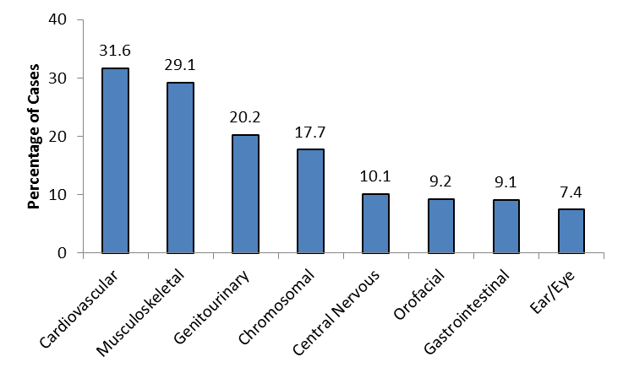

Live births and stillbirths, N=3809 defects among 2731 cases.
Figure shows the percentage of cases with defects in each body system.

Table 1. Prevalence of Birth Defects, Massachusetts: 2011-2012
Defect¹ | Live birth  Count | Stillbirth  Count | Total  Count | Rate per  10,000  Births | 95%  Confidence  Interval
Total | 2663 | 68 | 2731 | 187.5 | 180.6-194.6
Central Nervous System
Anencephaly | 6 | 2 | 8 | 0.55 | 0.24-1.08
Encephalocele | 6 | 0 | 6 | 0.41 | 0.15-0.90
Holoprosencephaly | 8 | 2 | 10 | 0.69 | 0.33-1.26
Hydrocephaly without Spina Bifida | 47 | 3 | 50 | 3.43 | 2.55-4.53
Microcephaly | 28 | 0 | 28 | 1.92 | 1.28-2.78
Spina Bifida with and without Hydrocephaly | 24 | 4 | 28 | 1.92 | 1.28-2.78
Spinal Cord² | 72 | 0 | 72 | 4.94 | 3.87-6.23
Eye
Aniridia | 4 | 0 | 4 | 0.27 | 0.07-0.70
Anophthalmia/Microphthalmia | 14 | 0 | 14 | 0.96 | 0.53-1.61
Congenital Glaucoma, Congenital Cataract | 45 | 0 | 45 | 3.09 | 2.25-4.13
Ear
Anotia/Microtia | 36 | 0 | 36 | 2.47 | 1.73-3.42
Cardiovascular³
Anomalous Pulmonary Venous Connection
Total/Partial Anomalous Pulmonary Venous Connection | 21 | 0 | 21 | 1.44 | 0.89-2.20
Atrioventricular Canal Defects
Atrial Septal Defect (ASD) Primum | 1 | 0 | 1 | 0.07 | 0.00-0.38
Common Atrium | 5 | 0 | 5 | 0.34 | 0.11-0.80
Complete Atrioventricular Canal Defect | 59 | 2 | 61 | 4.19 | 3.20-5.38
Endocardial Cushion Defect, Other specified (OS) and Not otherwise specified (NOS) | 18 | 2 | 20 | 1.37 | 0.84-2.12
Ventricular Septal Defect (VSD), Canal Type | 8 | 1 | 9 | 0.62 | 0.28-1.17
Conotruncal (Outlet) and Aortic Arch
Double Outlet Right Ventricle | 14 | 2 | 16 | 1.10 | 0.63-1.78
Tetralogy of Fallot with and without Pulmonary Atresia | 49 | 1 | 50 | 3.43 | 2.55-4.53
Truncus | 5 | 0 | 5 | 0.34 | 0.11-0.80
dextro-Transposition of the Great Arteries | 34 | 0 | 34 | 2.33 | 1.62-3.26
Ebstein Anomaly
Ebstein Anomaly | 5 | 0 | 5 | 0.34 | 0.11-0.80
Heterotaxy (Laterality Defects)
Heterotaxy | 7 | 1 | 8 | 0.55 | 0.24-1.08
Left-Sided Obstruction
Aortic Valve Stenosis | 16 | 1 | 17 | 1.17 | 0.68-1.87
Aortic Arch Atresia | 1 | 0 | 1 | 0.07 | 0.00-0.38
Coarctation of Aorta | 68 | 0 | 68 | 4.67 | 3.63-5.92
Hypoplastic Left Heart Syndrome | 23 | 1 | 24 | 1.65 | 1.06-2.45
Interrupted Aortic Arch (Type A and NOS) | 4 | 0 | 4 | 0.27 | 0.07-0.70
Right-Sided Obstruction
Pulmonary Stenosis, Valvular | 119 | 0 | 119 | 8.17 | 6.77-9.78
Pulmonary Valve Atresia with intact septum | 6 | 0 | 6 | 0.41 | 0.15-0.90
Pulmonary Valve Atresia with Ventricular Septal Defect | 1 | 0 | 1 | 0.07 | 0.00-0.38
Tricuspid Valve Atresia | 3 | 0 | 3 | 0.21 | 0.04-0.60
Septal Defects
ASD (Secundum and NOS) | 330 | 0 | 330 | 22.66 | 20.28-25.24
VSD (Membranous and NOS) | 169 | 9 | 178 | 12.22 | 10.49-14.16
VSD (Conoventricular/Malalignment) | 22 | 1 | 23 | 1.58 | 1.00-2.37
Single Ventricle and L-TGA
levo-Transposition of the Great Arteries | 5 | 1 | 6 | 0.41 | 0.15-0.90
Single Ventricle | 3 | 0 | 3 | 0.21 | 0.04-0.60
Respiratory
Choanal Atresia | 12 | 0 | 12 | 0.82 | 0.43-1.44
Lung Anomalies² | 37 | 2 | 39 | 2.68 | 1.90-3.66
Orofacial
Cleft Lip with/without Cleft Palate | 93 | 3 | 96 | 6.59 | 5.34-8.05
Cleft Palate without Cleft Lip | 85 | 0 | 85 | 5.84 | 4.66-7.22
Pierre Robin Sequence | 36 | 0 | 36 | 2.47 | 1.73-3.42
Gastrointestinal
Biliary Atresia | 14 | 0 | 14 | 0.96 | 0.53-1.61
Esophageal Atresia/Tracheoesophageal Fistula | 49 | 0 | 49 | 3.36 | 2.49-4.45
Hirschsprung Disease | 23 | 0 | 23 | 1.58 | 1.00-2.37
Rectal and Large Intestinal Atresia/Stenosis | 53 | 2 | 55 | 3.78 | 2.85-4.92
Small Intestinal Atresia | 29 | 4 | 33 | 2.27 | 1.56-3.18
Genitourinary
Bladder Exstrophy | 3 | 0 | 3 | 0.21 | 0.04-0.60
Cloacal Exstrophy | 5 | 2 | 7 | 0.48 | 0.19-0.99
Hypospadias, 2nd or 3rd Degree⁴ | 163 | 0 | 163 | 21.85 | 18.62-25.47
Obstructive Genitourinary Defect | 211 | 2 | 213 | 14.63 | 12.73-16.73
Renal Agenesis/Hypoplasia⁵ | 5 | 0 | 5 | 0.34 | 0.11-0.80
Musculoskeletal
Club Foot | 210 | 7 | 217 | 14.90 | 12.98-17.02
Craniosynostosis | 67 | 0 | 67 | 4.60 | 3.57-5.84
Diaphragmatic Hernia | 32 | 2 | 34 | 2.33 | 1.62-3.26
Gastroschisis | 42 | 2 | 44 | 3.02 | 2.20-4.06
Omphalocele | 25 | 3 | 28 | 1.92 | 1.28-2.78
Polydactyly/Syndactyly | 241 | 3 | 244 | 16.75 | 14.72-18.99
Reduction Deformity, Lower Limbs | 21 | 2 | 23 | 1.58 | 1.00-2.37
Reduction Deformity, Upper Limbs | 43 | 0 | 43 | 2.95 | 2.14-3.98
Skeletal Dysplasia | 26 | 4 | 30 | 2.06 | 1.39-2.94
Chromosomal and other Syndromes
Klinefelter Syndrome | 7 | 0 | 7 | 0.48 | 0.19-0.99
Trisomy 13 | 4 | 2 | 6 | 0.41 | 0.15-0.90
Trisomy 18 | 15 | 21 | 36 | 2.47 | 1.73-3.42
Trisomy 21 (Down Syndrome) | 182 | 12 | 194 | 13.32 | 11.51-15.33
Turner Syndrome ⁶ | 9 | 1 | 10 | 1.34 | 0.64-2.47
Other Chromosomal Syndromes/Other Syndromes² | 231 | 6 | 237 | 16.27 | 14.27-18.48
Other
Amniotic Bands | 18 | 1 | 19 | 1.30 | 0.79-2.04
Skin Anomalies² | 24 | 0 | 24 | 1.65 | 1.06-2.45

¹ Cases can be included in the count for more than one defect. Cases are counted once in the total for a defect category.
² Rate represents a heterogeneous group of defects.
³ Excludes Patent Ductus Arteriosus.
⁴ Rate calculated using male live births.
⁵ Bilateral only.
⁶ Rate calculated using female live births.

Birth Defects in Massachusetts vs. United States

Massachusetts is one of 11 states with active case ascertainment programs and contributes birth defects data to published national prevalence estimates for selected birth defects. For many defects, Massachusetts rates are similar to national rates. However, Massachusetts rates for 2011-2012 are significantly lower than the most recent US rates (7) for anencephaly, spina bifida, cleft lip +/- palate, and gastroschisis. Massachusetts rates are significantly higher for atrioventricular septal defects and for esophageal atresia/tracheoesophageal fistula (Figure 2, Table 2). Differences in surveillance system methodology, types of pregnancy outcomes included, and demographic variation may account for the differences in rates for certain defects. Massachusetts rates in 2011-12 are based on live births and stillbirths, whereas most other programs that contribute to these rates also collect information on elective terminations. This could result in undercounting of certain defects in Massachusetts, especially those not compatible with life. In Chapter 8, we look at the impact of including additional pregnancy outcomes.

Figure 2. Prevalence of Selected Birth Defects,
Massachusetts vs. United States

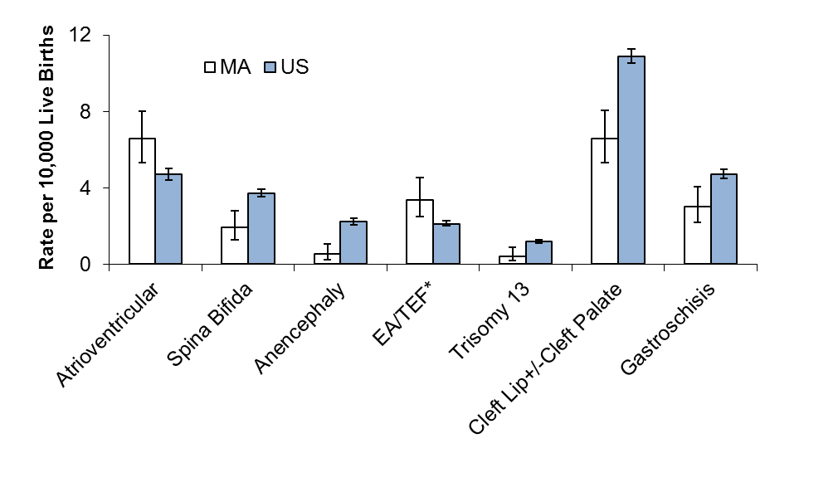

*Includes tracheoesophageal fistula.
MA rates based on live births and stillbirths, N=2731.
US rates based on crude, pooled prevalence data from 11 active case-ascertainment programs, including Massachusetts (7). Nine of the other states contributing to the pooled estimates include elective terminations in addition to live births and stillbirths.
Error bars represent 95% confidence intervals.

Table 2. Prevalence of Selected Birth Defects,
Massachusetts vs. United States
Defect | Count  MA | Rate MA¹ | 95% CI | Rate US² | 95% CI
Anencephaly | 8 | .55 | 0.24-1.08 | 2.23 | 2.07-2.41
Spina bifida without anencephaly | 28 | 1.92 | 1.28-2.78 | 3.72 | 3.52-3.94
Anophthalmia/Microphthalmia | 14 | 0.96 | 0.53-1.61 | 2.10 | 1.94-2.27
Truncus arteriosus (common truncus) | 5 | 0.34 | 0.11-0.80 | 0.74 | 0.65-0.84
Transposition of the Great Arteries | 40 | 2.75 | 1.96-3.74 | 3.04 | 2.85-3.24
Tetralogy of Fallot | 50 | 3.43 | 2.55-4.53 | 4.05 | 3.83-4.28
Atrioventricular septal defect³ | 96 | 6.59 | 5.34-8.05 | 4.70 | 4.45-4.96
Hypoplastic left heart syndrome | 24 | 1.65 | 1.06-2.45 | 2.31 | 2.14-2.48
Cleft Palate without Cleft Lip | 85 | 5.84 | 4.66-7.22 | 6.45 | 6.17-6.74
Cleft Lip with and without Cleft Palate | 96 | 6.59 | 5.34-8.05 | 10.89 | 10.53-11.26
Esophageal Atresia/Tracheoesophageal Fistula | 49 | 3.36 | 2.49-4.45 | 2.12 | 1.96-2.29
Rectal and Large Intestinal Atresia/Stenosis | 55 | 3.78 | 2.85-4.92 | 4.86 | 4.61-5.14
Reduction Deformity, Lower Limbs | 23 | 1.58 | 1.00-2.37 | 1.65 | 1.51-1.80
Reduction Deformity, Upper Limbs | 45 | 2.95 | 2.14-3.98 | 3.64 | 3.43-3.86
Gastroschisis | 44 | 3.02 | 2.20-4.06 | 4.72 | 4.49-4.97
Omphalocele | 28 | 1.92 | 1.28-2.78 | 1.92 | 1.77-2.08
Diaphragmatic Hernia | 34 | 2.33 | 1.62-3.26 | 2.60 | 2.42-2.79
Trisomy 21 (Down Syndrome) | 194 | 13.32 | 11.51-15.33 | 13.48 | 13.08-13.90
Trisomy 13 | 6 | 0.41 | 0.15-0.90 | 1.20 | 1.09-1.33
Trisomy 18 | 36 | 2.47 | 1.73-3.42 | 2.55 | 2.38-2.73

¹ Rate per 10,000 live births. Includes live births and stillbirths, 2011 and 2012.
² Rate per 10,000 live births. US rates based on crude, pooled prevalence data from 11 active case-ascertainment programs, including Massachusetts, from 2004-2006 (7). Nine of the other states contributing to the pooled estimates include elective terminations in addition to live births and stillbirths.
³ Includes endocardial cushion defect, complete atrioventricular canal defect, atrial septal defect (ASD) primum, common atrium, and canal type ventricular septal defect (VSD).

Selected Pregnancy Outcomes

Adverse pregnancy outcomes such as Cesarean section (C-section), low birth weight (LBW), prematurity, and small for gestational age (SGA) are more frequent among infants born with birth defects than among unaffected infants. Infants with a birth defect are 3 times more likely to have low birth weight (less than 2500 grams) or very low birth weight (less than 1500 grams) and 2.7 times more likely to be born premature (before 37 weeks) compared to those without birth defects (Figure 3). Cesarean (C-section) deliveries are more common among live born infants with birth defects (43%) compared to unaffected infants (32%). In addition, infants with birth defects are about 15 times more likely to die in their first year of life.

Figure 3. Pregnancy Outcomes among Live Births with and without Birth Defects, Massachusetts: 2011-2012

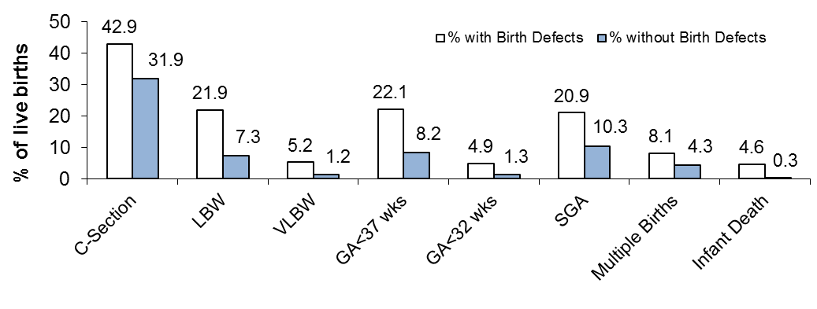

N=2663 live births with birth defects; N=145,631 live births without birth defects.
C-section: Cesarean section; LBW: low birth weight; VLBW: very low birth weight; GA: gestational age; SGA: small-for-gestational age.
SGA calculation based on method described by Oken et al. in 2003, defined as birth weight below the 10th percentile for gestational age based on a sex-specific US standard (17).

Trend Analysis

The rate of birth defects in Massachusetts has increased steadily over time (Figure 4).
This may reflect improvements in case ascertainment or confirmation, changes in the distribution of demographic variables over time (e.g. more births to older mothers), changes in survival to diagnosis, random variation, or true increases in the overall rate of birth defects.

Figure 4. Overall Prevalence of Birth Defects by Year, Massachusetts: 2000-2012,
2-year rolling average

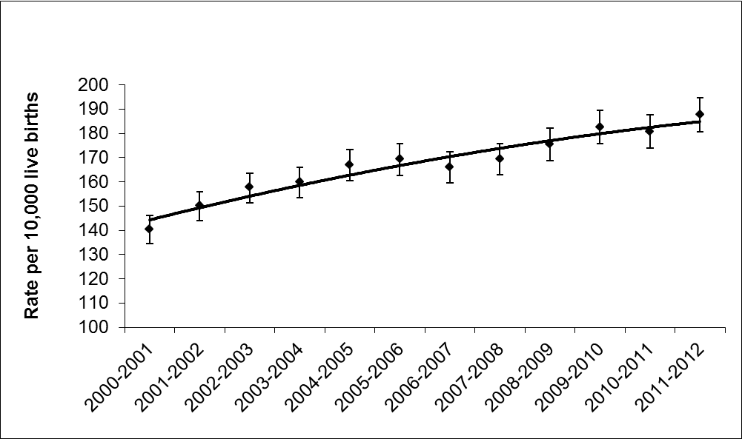

Live births and stillbirths.
Note: Y axis begins at 100.
Error bars represent 95% confidence intervals.
Chapter 4: Prevalence of Birth Defects by Infant Sex and Plurality

Infant Sex

Among males, the prevalence of birth defects in Massachusetts in 2011-2012 is 216.9 (95% CI: 206.6-227.6) per 10,000 live births, and among females the prevalence is 156.4 (95% CI: 147.4-165.5) per 10,000 live births. Males are significantly more likely to have obstructive genitourinary defects, club foot, and cleft lip (Figure 5, Table 3).

Figure 5. Prevalence of Selected Birth Defects by Infant Sex,
Massachusetts: 2011-2012

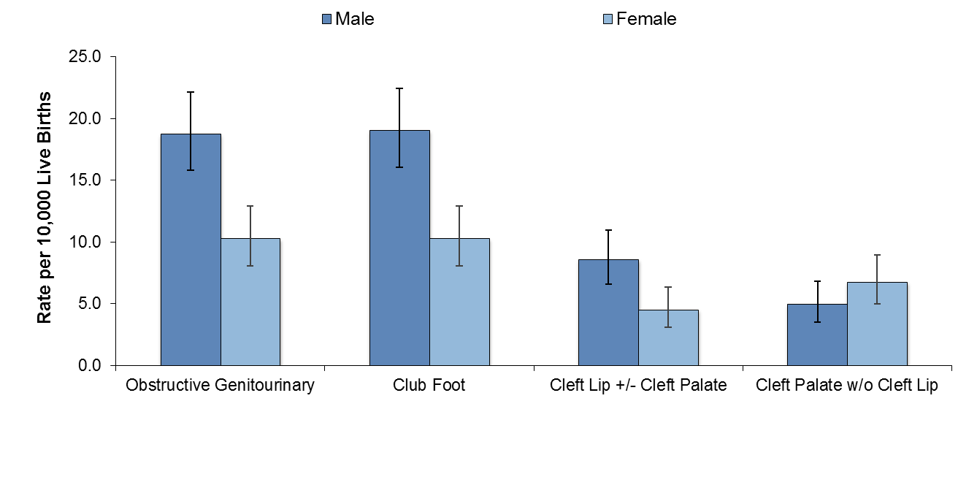

Live births and stillbirths, N=2731.
Error bars represent 95% confidence intervals.

Table 3. Prevalence of Birth Defects by Infant Sex,
Live Births and Stillbirths, Massachusetts: 2011-2012
Defect | Sex | Count | Rate¹ | 95% CI
Central Nervous System
Anencephaly | Male | 7 | 0.99 | 0.40-2.03
 | Female | 1 | 0.13 | 0.00-0.75
Encephalocele | Male | 3 | 0.42 | 0.09-1.23
 | Female | 3 | 0.40 | 0.08-1.18
Holoprosencephaly | Male | 5 | 0.70 | 0.23-1.64
 | Female | 5 | 0.67 | 0.22-1.56
Hydrocephaly without Spina Bifida | Male | 26 | 3.66 | 2.39-5.36
 | Female | 24 | 3.22 | 2.06-4.79
Microcephaly | Male | 14 | 1.97 | 1.08-3.31
 | Female | 14 | 1.88 | 1.03-3.15
Spina Bifida with and without Hydrocephaly | Male | 16 | 2.25 | 1.29-3.66
 | Female | 12 | 1.61 | 0.83-2.81
Spinal Cord | Male | 41 | 5.77 | 4.14-7.83
 | Female | 31 | 4.16 | 2.82-5.90
Eye
Aniridia | Male | 1 | 0.14 | 0.00-0.78
 | Female | 3 | 0.40 | 0.08-1.18
Anophthalmia/Microphthalmia | Male | 5 | 0.70 | 0.23-1.64
 | Female | 9 | 1.21 | 0.55-2.29
Congenital Glaucoma, Congenital Cataract | Male | 25 | 3.52 | 2.28-5.20
 | Female | 20 | 2.68 | 1.64-4.14
Ear
Anotia/Microtia | Male | 20 | 2.82 | 1.72-4.35
 | Female | 16 | 2.14 | 1.23-3.48
Cardiovascular
Anomalous Pulmonary Venous Connection
Total Anomalous Pulmonary Venous Connection | Male | 11 | 1.55 | 0.77-2.77
 | Female | 10 | 1.34 | 0.64-2.47
Atrioventricular Canal Defects
Atrial Septal Defect (ASD) Primum | Male | 1 | 0.14 | 0.00-0.78
 | Female | 0 | - | -
Common Atrium | Male | 1 | 0.14 | 0.00-0.78
 | Female | 4 | 0.54 | 0.15-1.37
Complete Atrioventricular Canal Defect | Male | 23 | 3.24 | 2.05-4.86
 | Female | 38 | 5.09 | 3.60-6.99
Endocardial Cushion Defect, Other specified (OS) and Not otherwise specified (NOS) | Male | 8 | 1.13 | 0.49-2.22
 | Female | 12 | 1.61 | 0.83-2.81
Ventricular Septal Defect (VSD), Canal Type | Male | 7 | 0.99 | 0.40-2.03
 | Female | 2 | 0.27 | 0.03-0.97
Conotruncal (Outlet) and Aortic Arch
Double Outlet Right Ventricle | Male | 11 | 1.55 | 0.77-2.77
 | Female | 5 | 0.67 | 0.22-1.56
Tetralogy of Fallot with and without Pulmonary Atresia | Male | 28 | 3.94 | 2.62-5.70
 | Female | 22 | 2.95 | 1.85-4.47
Truncus | Male | 0 | - | -
 | Female | 5 | 0.67 | 0.22-1.56
dextro-Transposition of the Great Arteries | Male | 24 | 3.38 | 2.16-5.03
 | Female | 10 | 1.34 | 0.64-2.47
Ebstein Anomaly
Ebstein Anomaly | Male | 3 | 0.42 | 0.09-1.23
 | Female | 2 | 0.27 | 0.03-0.97
Heterotaxy (Laterality Defects)
Heterotaxy | Male | 3 | 0.42 | 0.09-1.23
 | Female | 5 | 0.67 | 0.22-1.56
Left-Sided Obstruction
Aortic Valve Stenosis | Male | 9 | 1.27 | 0.58-2.41
 | Female | 8 | 1.07 | 0.46-2.11
Aortic Arch Atresia | Male | 1 | 0.14 | 0.00-0.78
 | Female | 0 | - | -
Coarctation of Aorta | Male | 40 | 5.63 | 4.02-7.67
 | Female | 28 | 3.75 | 2.49-5.42
Hypoplastic Left Heart Syndrome | Male | 14 | 1.97 | 1.08-3.31
 | Female | 10 | 1.34 | 0.64-2.47
Interrupted Aortic Arch (Type A and NOS) | Male | 2 | 0.28 | 0.03-1.02
 | Female | 2 | 0.27 | 0.03-0.97
Right-Sided Obstruction
Pulmonary Stenosis, Valvular | Male | 51 | 7.18 | 5.35-9.44
 | Female | 68 | 9.12 | 7.08-11.56
Pulmonary Valve Atresia with intact septum | Male | 5 | 0.70 | 0.23-1.64
 | Female | 1 | 0.13 | 0.00-0.75
Pulmonary Valve Atresia with VSD | Male | 0 | - | -
 | Female | 1 | 0.13 | 0.00-0.75
Tricuspid Valve Atresia | Male | 3 | 0.42 | 0.09-1.23
 | Female | 0 | - | -
Septal Defects
ASD (Secundum and NOS) | Male | 156 | 21.96 | 18.65-25.69
 | Female | 174 | 23.33 | 19.99-27.06
VSD (Membranous and NOS) | Male | 89 | 12.53 | 10.06-15.42
 | Female | 89 | 11.93 | 9.58-14.68
VSD, Conoventricular/Malalignment | Male | 13 | 1.83 | 0.97-3.13
 | Female | 10 | 1.34 | 0.64-2.47
Single Ventricle and L-TGA
levo-Transposition of the Great Arteries | Male | 4 | 0.56 | 0.15-1.44
 | Female | 2 | 0.27 | 0.03-0.97
Single Ventricle | Male | 2 | 0.28 | 0.03-1.02
 | Female | 1 | 0.13 | 0.00-0.75
Respiratory
Choanal Atresia | Male | 4 | 0.56 | 0.15-1.44
 | Female | 8 | 1.07 | 0.46-2.11
Lung Anomalies | Male | 27 | 3.80 | 2.51-5.53
 | Female | 12 | 1.61 | 0.83-2.81
Orofacial
Cleft Lip with and without Cleft Palate | Male | 64 | 9.01 | 6.94-11.51
 | Female | 32 | 4.29 | 2.93-6.06
Cleft Palate without Cleft Lip | Male | 37 | 5.21 | 3.67-7.18
 | Female | 48 | 6.43 | 4.74-8.53
Pierre Robin Sequence | Male | 17 | 2.39 | 1.39-3.83
 | Female | 19 | 2.55 | 1.53-3.98
Biliary Atresia | Male | 2 | 0.28 | 0.03-1.02
 | Female | 12 | 1.61 | 0.83-2.81
Esophageal Atresia/Tracheoesophageal Fistula | Male | 31 | 4.36 | 2.97-6.19
 | Female | 18 | 2.41 | 1.43-3.81
Hirschsprung Disease | Male | 19 | 2.67 | 1.61-4.18
 | Female | 4 | 0.54 | 0.15-1.37
Rectal and Large Intestinal Atresia/Stenosis | Male | 22 | 3.10 | 1.94-4.69
 | Female | 33 | 4.42 | 3.05-6.21
Small Intestinal Atresia | Male | 18 | 2.53 | 1.50-4.01
 | Female | 15 | 2.01 | 1.13-3.32
Genitourinary
Bladder Exstrophy | Male | 3 | 0.42 | 0.09-1.23
 | Female | 0 | - | -
Cloacal Exstrophy | Male | 0 | - | -
 | Female | 7 | 0.94 | 0.38-1.93
Hypospadias, 2nd or 3rd Degree² | Male | 163 | 22.95 | 19.56-26.75
 | Female | 0 | - | -
Obstructive Genitourinary Defect | Male | 140 | 19.71 | 16.58-23.26
 | Female | 73 | 9.79 | 7.67-12.30
Renal Agenesis/Hypoplasia | Male | 5 | 0.70 | 0.23-1.64
 | Female | 0 | - | -
Musculoskeletal
Club Foot | Male | 142 | 19.99 | 16.84-23.56
 | Female | 73 | 9.79 | 7.67-12.30
Craniosynostosis | Male | 44 | 6.19 | 4.50-8.32
 | Female | 23 | 3.08 | 1.95-4.63
Diaphragmatic Hernia | Male | 15 | 2.11 | 1.18-3.48
 | Female | 19 | 2.55 | 1.53-3.98
Gastroschisis | Male | 25 | 3.52 | 2.28-5.20
 | Female | 18 | 2.41 | 1.43-3.81
Omphalocele | Male | 20 | 2.82 | 1.72-4.35
 | Female | 8 | 1.07 | 0.46-2.11
Polydactyly/Syndactyly | Male | 144 | 20.27 | 17.10-23.87
 | Female | 99 | 13.27 | 10.79-16.16
Reduction Deformity, Lower Limbs | Male | 8 | 1.13 | 0.49-2.22
 | Female | 15 | 2.01 | 1.13-3.32
Reduction Deformity, Upper Limbs | Male | 27 | 3.80 | 2.51-5.53
 | Female | 16 | 2.14 | 1.23-3.48
Skeletal Dysplasia | Male | 12 | 1.69 | 0.87-2.95
 | Female | 18 | 2.41 | 1.43-3.81
Chromosomal and other Syndromes
Klinefelter Syndrome | Male | 7 | 0.99 | 0.40-2.03
 | Female | 0 | - | -
Trisomy 13 | Male | 2 | 0.28 | 0.03-1.02
 | Female | 4 | 0.54 | 0.15-1.37
Trisomy 18 | Male | 13 | 1.83 | 0.97-3.13
 | Female | 23 | 3.08 | 1.95-4.63
Trisomy 21 (Down Syndrome) | Male | 106 | 14.92 | 12.22-18.05
 | Female | 88 | 11.80 | 9.46-14.53
Turner Syndrome ³ | Male | 0 | - | -
 | Female | 10 | 1.34 | 0.64-2.47
Other
Amniotic Bands | Male | 5 | 0.70 | 0.23-1.64
 | Female | 13 | 1.74 | 0.93-2.98
Skin Anomalies | Male | 19 | 2.67 | 1.61-4.18
 | Female | 5 | 0.67 | 0.22-1.56

¹ Rate per 10,000 live births.
² In males.
³ In females.

Plurality

The overall birth defect rate in singletons is 181.8 (95% CI: 174.9-189.0) per 10,000 live births, while the rate in multiples is 311.6 (95% CI: 269.9-357.9) per 10,000 live births. While many individual defects do not differ significantly by plurality (Figure 6), the rates of septal defects, hypospadias, and diaphragmatic hernia are significantly higher in multiples than in singletons (Table 4).

Figure 6. Prevalence of Selected Birth Defects by Single and Multiple Births,
Massachusetts: 2011-2012

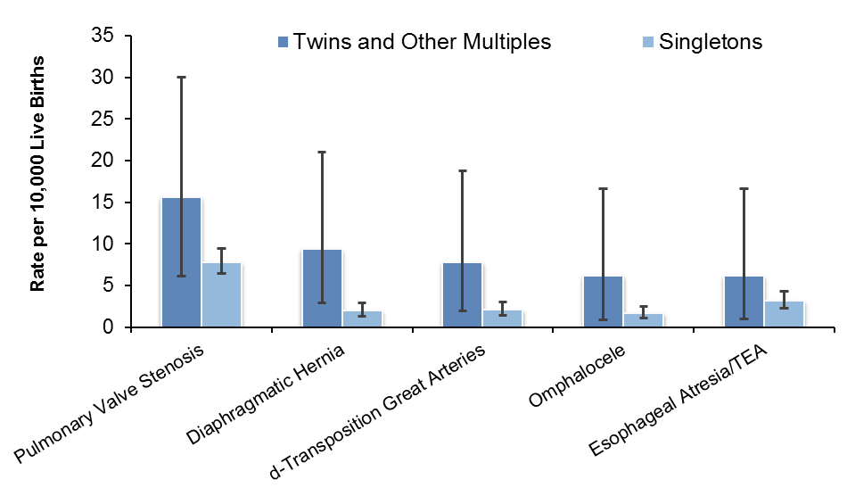

Live births and stillbirths, N=2731.
TEA=tracheoesophageal fistula.
Error bars represent 95% confidence intervals.

Table 4. Prevalence of Birth Defects by Plurality,
Live Births and Stillbirths, Massachusetts: 2011-2012
Defect | Plurality | Count | Rate¹ | 95% CI
Central Nervous System
Anencephaly | Singleton | 7 | 0.50 | 0.20-1.04
 | Multiple | 1 | 1.56 | 0.04-8.68
Encephalocele | Singleton | 6 | 0.43 | 0.16-0.94
 | Multiple | 0 | - | -
Holoprosencephaly | Singleton | 10 | 0.72 | 0.34-1.32
 | Multiple | 0 | - | -
Hydrocephaly without Spina Bifida | Singleton | 45 | 3.23 | 2.36-4.33
 | Multiple | 5 | 7.79 | 2.53-18.18
Microcephaly | Singleton | 27 | 1.94 | 1.28-2.82
 | Multiple | 1 | 1.56 | 0.04-8.68
Spina Bifida with and without Hydrocephaly | Singleton | 28 | 2.01 | 1.34-2.91
 | Multiple | 0 | - | -
Spinal Cord | Singleton | 65 | 4.67 | 3.60-5.95
 | Multiple | 7 | 10.91 | 4.39-22.47
Eye
Aniridia | Singleton | 4 | 0.29 | 0.08-0.74
 | Multiple | 0 | - | -
Anophthalmia/Microphthalmia | Singleton | 13 | 0.93 | 0.50-1.60
 | Multiple | 1 | 1.56 | 0.04-8.68
Congenital Glaucoma, Congenital Cataract | Singleton | 44 | 3.16 | 2.30-4.24
 | Multiple | 1 | 1.56 | 0.04-8.68
Ear
Anotia/Microtia | Singleton | 35 | 2.51 | 1.75-3.50
 | Multiple | 1 | 1.56 | 0.04-8.68
Cardiovascular
Anomalous Pulmonary Venous Connection
Total Anomalous Pulmonary Venous Connection | Singleton | 20 | 1.44 | 0.88-2.22
 | Multiple | 1 | 1.56 | 0.04-8.68
Atrioventricular Canal Defects
Atrial Septal Defect (ASD) primum | Singleton | 1 | 0.07 | 0.00-0.40
 | Multiple | 0 | - | -
Common Atrium | Singleton | 5 | 0.36 | 0.12-0.84
 | Multiple | 0 | - | -
Complete Atrioventricular Canal Defect | Singleton | 57 | 4.09 | 3.10-5.30
 | Multiple | 4 | 6.23 | 1.70-15.96
Endocardial Cushion Defect, Other specified (OS) and Not otherwise specified (NOS) | Singleton | 18 | 1.29 | 0.77-2.04
 | Multiple | 2 | 3.12 | 0.38-11.26
Ventricular Septal Defect (VSD), Canal Type | Singleton | 9 | 0.65 | 0.30-1.23
 | Multiple | 0 | - | -
Conotruncal (Outlet) and Aortic Arch
Double Outlet Right Ventricle | Singleton | 16 | 1.15 | 0.66-1.87
 | Multiple | 0 | - | -
Tetralogy of Fallot with/without Pulmonary Atresia | Singleton | 46 | 3.30 | 2.42-4.41
 | Multiple | 4 | 6.23 | 1.70-15.96
Truncus | Singleton | 3 | 0.22 | 0.04-0.63
 | Multiple | 2 | 3.12 | 0.38-11.26
dextro-Transposition of the Great Arteries | Singleton | 29 | 2.08 | 1.40-2.99
 | Multiple | 5 | 7.79 | 2.53-18.18
Ebstein Anomaly
Ebstein Anomaly | Singleton | 5 | 0.36 | 0.12-0.84
 | Multiple | 0 | - | -
Heterotaxy (Laterality Defects)
Heterotaxy | Singleton | 8 | 0.57 | 0.25-1.13
 | Multiple | 0 | - | -
Left-Sided Obstruction
Aortic Valve Stenosis | Singleton | 15 | 1.08 | 0.60-1.78
 | Multiple | 2 | 3.12 | 0.38-11.26
Aortic arch atresia | Singleton | 1 | 0.07 | 0.00-0.40
 | Multiple | 0 | - | -
Coarctation of Aorta | Singleton | 67 | 4.81 | 3.73-6.11
 | Multiple | 1 | 1.56 | 0.04-8.68
Hypoplastic Left Heart Syndrome | Singleton | 23 | 1.65 | 1.05-2.48
 | Multiple | 1 | 1.56 | 0.04-8.68
Interrupted Aortic Arch (Type A and NOS) | Singleton | 3 | 0.22 | 0.04-0.63
 | Multiple | 1 | 1.56 | 0.04-8.68
Right-Sided Obstruction
Pulmonary Stenosis, Valvular | Singleton | 109 | 7.83 | 6.43-9.45
 | Multiple | 10 | 15.58 | 7.47-28.65
Pulmonary Valve Atresia with intact septum | Singleton | 6 | 0.43 | 0.16-0.94
 | Multiple | 0 | - | -
Pulmonary Valve Atresia with Ventricular Septal Defect | Singleton | 1 | 0.07 | 0.00-0.40
 | Multiple | 0 | - | -
Tricuspid Valve Atresia | Singleton | 3 | 0.22 | 0.04-0.63
 | Multiple | 0 | - | -
Septal Defects
ASD (Secundum and NOS) | Singleton | 295 | 21.19 | 18.84-23.75
 | Multiple | 35 | 54.53 | 37.99-75.84
VSD (Membranous and NOS) | Singleton | 161 | 11.57 | 9.85-13.50
 | Multiple | 17 | 26.49 | 15.43-42.41
VSD, Conoventricular/Malalignment | Singleton | 21 | 1.51 | 0.93-2.31
 | Multiple | 2 | 3.12 | 0.38-11.26
Single Ventricle and L-TGA
levo-Transposition of the Great Arteries | Singleton | 6 | 0.43 | 0.16-0.94
 | Multiple | 0 | - | -
Single Ventricle | Singleton | 3 | 0.22 | 0.04-0.63
 | Multiple | 0 | - | -
Respiratory
Choanal Atresia | Singleton | 9 | 0.65 | 0.30-1.23
 | Multiple | 3 | 4.67 | 0.96-13.66
Lung Anomalies | Singleton | 37 | 2.66 | 1.87-3.66
 | Multiple | 2 | 3.12 | 0.38-11.26
Orofacial
Cleft Lip with and without Cleft Palate | Singleton | 93 | 6.68 | 5.39-8.18
 | Multiple | 3 | 4.67 | 0.96-13.66
Cleft Palate without Cleft Lip | Singleton | 81 | 5.82 | 4.62-7.23
 | Multiple | 4 | 6.23 | 1.70-15.96
Pierre Robin Sequence | Singleton | 34 | 2.44 | 1.69-3.41
 | Multiple | 2 | 3.12 | 0.38-11.26
Gastrointestinal
Biliary Atresia | Singleton | 13 | 0.93 | 0.50-1.60
 | Multiple | 1 | 1.56 | 0.04-8.68
Esophageal Atresia/Tracheoesophageal Fistula | Singleton | 45 | 3.23 | 2.36-4.33
 | Multiple | 4 | 6.23 | 1.70-15.96
Hirschsprung Disease | Singleton | 22 | 1.58 | 0.99-2.39
 | Multiple | 1 | 1.56 | 0.04-8.68
Rectal and Large Intestinal Atresia/Stenosis | Singleton | 54 | 3.88 | 2.91-5.06
 | Multiple | 1 | 1.56 | 0.04-8.68
Small Intestinal Atresia | Singleton | 31 | 2.23 | 1.51-3.16
 | Multiple | 2 | 3.12 | 0.38-11.26
Genitourinary
Bladder Exstrophy | Singleton | 3 | 0.22 | 0.04-0.63
 | Multiple | 0 | - | -
Cloacal Exstrophy | Singleton | 7 | 0.50 | 0.20-1.04
 | Multiple | 0 | - | -
Hypospadias, 2nd or 3rd Degree¹ | Singleton | 142 | 19.90 | 16.76-23.45
 | Multiple | 21 | 64.98 | 40.22-99.32
Obstructive Genitourinary Defect | Singleton | 202 | 14.51 | 12.58-16.66
 | Multiple | 11 | 17.14 | 8.56-30.67
Renal Agenesis/Hypoplasia | Singleton | 4 | 0.29 | 0.08-0.74
 | Multiple | 1 | 1.56 | 0.04-8.68
Musculoskeletal
Club Foot | Singleton | 201 | 14.44 | 12.51-16.58
 | Multiple | 16 | 24.93 | 14.25-40.48
Craniosynostosis | Singleton | 64 | 4.60 | 3.54-5.87
 | Multiple | 3 | 4.67 | 0.96-13.66
Diaphragmatic Hernia | Singleton | 28 | 2.01 | 1.34-2.91
 | Multiple | 6 | 9.35 | 3.43-20.35
Gastroschisis | Singleton | 43 | 3.09 | 2.24-4.16
 | Multiple | 1 | 1.56 | 0.04-8.68
Omphalocele | Singleton | 24 | 1.72 | 1.10-2.57
 | Multiple | 4 | 6.23 | 1.70-15.96
Polydactyly/Syndactyly | Singleton | 233 | 16.74 | 14.66-19.03
 | Multiple | 11 | 17.14 | 8.56-30.67
Reduction Deformity, Lower Limbs | Singleton | 22 | 1.58 | 0.99-2.39
 | Multiple | 1 | 1.56 | 0.04-8.68
Reduction Deformity, Upper Limbs | Singleton | 42 | 3.02 | 2.17-4.08
 | Multiple | 1 | 1.56 | 0.04-8.68
Skeletal Dysplasia | Singleton | 25 | 1.80 | 1.16-2.65
 | Multiple | 5 | 7.79 | 2.53-18.18
Chromosomal/other Syndromes
Klinefelter Syndrome | Singleton | 7 | 0.50 | 0.20-1.04
 | Multiple | 0 | - | -
Trisomy 13 | Singleton | 5 | 0.36 | 0.12-0.84
 | Multiple | 1 | 1.56 | 0.04-8.68
Trisomy 18 | Singleton | 33 | 2.37 | 1.63-3.33
 | Multiple | 3 | 4.67 | 0.96-13.66
Trisomy 21 (Down Syndrome) | Singleton | 181 | 13.00 | 11.18-15.04
 | Multiple | 13 | 20.26 | 10.79-34.64
Turner Syndrome³ | Singleton | 10 | 1.34 | 0.64-2.47
 | Multiple | 0 | - | -
Other
Amniotic Bands | Singleton | 17 | 1.22 | 0.71-1.96
 | Multiple | 2 | 3.12 | 0.38-11.26
Skin Anomalies | Singleton | 24 | 1.72 | 1.10-2.57
 | Multiple | 0 | - | -

¹ Rates per 10,000 live births.
² Rate calculated using male live births.
³ Rate calculated using female live births.

Chapter 5: Prevalence of Birth Defects by Maternal Age

Maternal Age

The prevalence of birth defects varies by maternal age (Table 5), with rates highest for mothers ages 35 years and older (220.7 per 10,000 live births) and second highest for mothers younger than 20 years of age (190.7 per 10,000 live births).

Table 5. Overall Prevalence of Birth Defects by Maternal Age,
Massachusetts: 2011-2012
Maternal Age (years) | Cases | Rate | 95% CI
<20 | 129 | 190.7 | 159.2-226.6
20-24 | 385 | 174.9 | 158.0-193.1
25-29 | 643 | 177.7 | 164.3-191.8
30-34 | 854 | 177.8 | 166.2-190.0
35+ | 720 | 220.7 | 205.0-237.2

Live births and stillbirths, N=2731.
Rate per 10,000 live births.

Monitoring birth defects by maternal age is important in part because the percentage of women giving birth in the state who are age 35 or older has doubled from 11.4% in 1989 to 22.2% in 2011 (8), with more multiple births among mothers over age 35 than among younger mothers.

The use of assisted reproductive technology (ART) is a factor in the increased percentage of women ages 35 and older giving birth and the increased frequency of multiple births among Massachusetts mothers. Massachusetts has the highest ART rate in the nation, with 4.5% of live births conceived with ART (9).

The prevalence rates of specific birth defects by age group are shown in Table 6. Gastroschisis rates are highest in women under 25 years of age, while trisomy 21 (Down syndrome) rates are highest in women ages 35 and older.
Table 6. Prevalence of Birth Defects by Maternal Age
Live Births and Stillbirths, Massachusetts: 2011-2012
Defect | Maternal  Age | Count | Rate¹ | 95% CI
Central Nervous System
Anencephaly | <20 | 0 | - | -
 | 20-24 | 1 | 0.45 | 0.01-2.53
 | 25-29 | 2 | 0.55 | 0.07-2.00
 | 30-34 | 1 | 0.21 | 0.01-1.16
 | 35+ | 4 | 1.23 | 0.33-3.14
Encephalocele | <20 | 0 | - | -
 | 20-24 | 5 | 2.27 | 0.74-5.30
 | 25-29 | 1 | 0.28 | 0.01-1.54
 | 30-34 | 0 | - | -
 | 35+ | 0 | - | -
Holoprosencephaly | <20 | 1 | 1.48 | 0.04-8.24
 | 20-24 | 2 | 0.91 | 0.11-3.28
 | 25-29 | 1 | 0.28 | 0.01-1.54
 | 30-34 | 3 | 0.62 | 0.13-1.83
 | 35+ | 3 | 0.92 | 0.19-2.69
Hydrocephaly without Spina Bifida | <20 | 3 | 4.44 | 0.91-12.96
 | 20-24 | 11 | 5.00 | 2.49-8.94
 | 25-29 | 12 | 3.32 | 1.71-5.79
 | 30-34 | 15 | 3.12 | 1.75-5.15
 | 35+ | 9 | 2.76 | 1.26-5.24
Microcephaly | <20 | 1 | 1.48 | 0.04-8.24
 | 20-24 | 2 | 0.91 | 0.11-3.28
 | 25-29 | 8 | 2.21 | 0.95-4.36
 | 30-34 | 8 | 1.67 | 0.72-3.28
 | 35+ | 9 | 2.76 | 1.26-5.24
Spina Bifida with and without Hydrocephaly | <20 | 2 | 2.96 | 0.36-10.68
 | 20-24 | 5 | 2.27 | 0.74-5.30
 | 25-29 | 6 | 1.66 | 0.61-3.61
 | 30-34 | 7 | 1.46 | 0.59-3.00
 | 35+ | 8 | 2.45 | 1.06-4.83
Spinal Cord | <20 | 0 | - | -
 | 20-24 | 9 | 4.09 | 1.87-7.76
 | 25-29 | 19 | 5.25 | 3.16-8.20
 | 30-34 | 24 | 5.00 | 3.20-7.43
 | 35+ | 20 | 6.13 | 3.74-9.47
Eye
Aniridia | <20 | 0 | - | -
 | 20-24 | 1 | 0.45 | 0.01-2.53
 | 25-29 | 0 | - | -
 | 30-34 | 2 | 0.42 | 0.05-1.50
 | 35+ | 1 | 0.31 | 0.01-1.71
Anophthalmia/Microphthalmia | <20 | 3 | 4.44 | 0.91-12.96
 | 20-24 | 1 | 0.45 | 0.01-2.53
 | 25-29 | 1 | 0.28 | 0.01-1.54
 | 30-34 | 6 | 1.25 | 0.46-2.72
 | 35+ | 3 | 0.92 | 0.19-2.69
Congenital Glaucoma, Congenital Cataract | <20 | 2 | 2.96 | 0.36-10.68
 | 20-24 | 6 | 2.73 | 1.00-5.93
 | 25-29 | 12 | 3.32 | 1.71-5.79
 | 30-34 | 14 | 2.91 | 1.59-4.89
 | 35+ | 11 | 3.37 | 1.68-6.03
Ear
Anotia/Microtia | <20 | 2 | 2.96 | 0.36-10.68
 | 20-24 | 4 | 1.82 | 0.50-4.65
 | 25-29 | 7 | 1.93 | 0.78-3.99
 | 30-34 | 14 | 2.91 | 1.59-4.89
 | 35+ | 9 | 2.76 | 1.26-5.24
Cardiovascular
Anomalous Pulmonary Venous Connection
Total Anomalous Pulmonary Venous Connection | <20 | 0 | - | -
 | 20-24 | 2 | 0.91 | 0.11-3.28
 | 25-29 | 6 | 1.66 | 0.61-3.61
 | 30-34 | 6 | 1.25 | 0.46-2.72
 | 35+ | 7 | 2.15 | 0.86-4.42
Atrioventricular Canal Defects
Atrial Septal Defect (ASD) primum | <20 | 0 | - | -
 | 20-24 | 0 | - | -
 | 25-29 | 0 | - | -
 | 30-34 | 1 | 0.21 | 0.01-1.16
 | 35+ | 0 | - | -
Common Atrium | <20 | 0 | - | -
 | 20-24 | 1 | 0.45 | 0.01-2.53
 | 25-29 | 1 | 0.28 | 0.01-1.54
 | 30-34 | 1 | 0.21 | 0.01-1.16
 | 35+ | 2 | 0.61 | 0.07-2.21
Complete Atrioventricular Canal Defect | <20 | 5 | 7.39 | 2.40-17.25
 | 20-24 | 5 | 2.27 | 0.74-5.30
 | 25-29 | 10 | 2.76 | 1.33-5.08
 | 30-34 | 13 | 2.71 | 1.44-4.63
 | 35+ | 28 | 8.58 | 5.70-12.41
Endocardial Cushion Defect, Other specified (OS) and Not otherwise specified (NOS) | <20 | 1 | 1.48 | 0.04-8.24
 | 20-24 | 6 | 2.73 | 1.00-5.93
 | 25-29 | 1 | 0.28 | 0.01-1.54
 | 30-34 | 5 | 1.04 | 0.34-2.43
 | 35+ | 7 | 2.15 | 0.86-4.42
Ventricular Septal Defect (VSD), canal type | <20 | 0 | - | -
 | 20-24 | 0 | - | -
 | 25-29 | 2 | 0.55 | 0.07-2.00
 | 30-34 | 4 | 0.83 | 0.23-2.13
 | 35+ | 3 | 0.92 | 0.19-2.69
Conotruncal (Outlet) and Aortic Arch
Double Outlet Right Ventricle | <20 | 0 | - | -
 | 20-24 | 4 | 1.82 | 0.50-4.65
 | 25-29 | 3 | 0.83 | 0.17-2.42
 | 30-34 | 5 | 1.04 | 0.34-2.43
 | 35+ | 4 | 1.23 | 0.33-3.14
Tetralogy of Fallot with and without Pulmonary Atresia | <20 | 4 | 5.91 | 1.61-15.14
 | 20-24 | 11 | 5.00 | 2.49-8.94
 | 25-29 | 13 | 3.59 | 1.91-6.14
 | 30-34 | 15 | 3.12 | 1.75-5.15
 | 35+ | 7 | 2.15 | 0.86-4.42
Truncus | <20 | 0 | - | -
 | 20-24 | 1 | 0.45 | 0.01-2.53
 | 25-29 | 2 | 0.55 | 0.07-2.00
 | 30-34 | 0 | - | -
 | 35+ | 2 | 0.61 | 0.07-2.21
dextro-Transposition of the Great Arteries | <20 | 1 | 1.48 | 0.04-8.24
 | 20-24 | 2 | 0.91 | 0.11-3.28
 | 25-29 | 5 | 1.38 | 0.45-3.22
 | 30-34 | 10 | 2.08 | 1.00-3.83
 | 35+ | 16 | 4.90 | 2.80-7.96
Ebstein Anomaly
Ebstein Anomaly | <20 | 0 | - | -
 | 20-24 | 1 | 0.45 | 0.01-2.53
 | 25-29 | 2 | 0.55 | 0.07-2.00
 | 30-34 | 0 | - | -
 | 35+ | 2 | 0.61 | 0.07-2.21
Heterotaxy (Laterality Defects)
Heterotaxy | <20 | 1 | 1.48 | 0.04-8.24
 | 20-24 | 1 | 0.45 | 0.01-2.53
 | 25-29 | 2 | 0.55 | 0.07-2.00
 | 30-34 | 2 | 0.42 | 0.05-1.50
 | 35+ | 2 | 0.61 | 0.07-2.21
Left-Sided Obstruction
Aortic Valve Stenosis | <20 | 2 | 2.96 | 0.36-10.68
 | 20-24 | 2 | 0.91 | 0.11-3.28
 | 25-29 | 3 | 0.83 | 0.17-2.42
 | 30-34 | 5 | 1.04 | 0.34-2.43
 | 35+ | 5 | 1.53 | 0.50-3.58
Aortic arch atresia | <20 | 0 | - | -
 | 20-24 | 0 | - | -
 | 25-29 | 0 | - | -
 | 30-34 | 1 | 0.21 | 0.01-1.16
 | 35+ | 0 | - | -
Coarctation of Aorta | <20 | 3 | 4.44 | 0.91-12.96
 | 20-24 | 11 | 5.00 | 2.49-8.94
 | 25-29 | 12 | 3.32 | 1.71-5.79
 | 30-34 | 27 | 5.62 | 3.70-8.18
 | 35+ | 15 | 4.60 | 2.57-7.58
Hypoplastic Left Heart Syndrome | <20 | 1 | 1.48 | 0.04-8.24
 | 20-24 | 5 | 2.27 | 0.74-5.30
 | 25-29 | 6 | 1.66 | 0.61-3.61
 | 30-34 | 6 | 1.25 | 0.46-2.72
 | 35+ | 6 | 1.84 | 0.67-4.00
Interrupted Aortic Arch (Type A and NOS) | <20 | 0 | - | -
 | 20-24 | 0 | - | -
 | 25-29 | 3 | 0.83 | 0.17-2.42
 | 30-34 | 1 | 0.21 | 0.01-1.16
 | 35+ | 0 | - | -
Right-Sided Obstruction
Pulmonary Stenosis, Valvular | <20 | 4 | 5.91 | 1.61-15.14
 | 20-24 | 15 | 6.81 | 3.81-11.24
 | 25-29 | 33 | 9.12 | 6.28-12.81
 | 30-34 | 39 | 8.12 | 5.77-11.10
 | 35+ | 28 | 8.58 | 5.70-12.41
Pulmonary Valve Atresia with intact septum | <20 | 0 | - | -
 | 20-24 | 2 | 0.91 | 0.11-3.28
 | 25-29 | 1 | 0.28 | 0.01-1.54
 | 30-34 | 1 | 0.21 | 0.01-1.16
 | 35+ | 2 | 0.61 | 0.07-2.21
Pulmonary Valve Atresia with VSD | <20 | 1 | 1.48 | 0.04-8.24
 | 20-24 | 0 | - | -
 | 25-29 | 0 | - | -
 | 30-34 | 0 | - | -
 | 35+ | 0 | - | -
Tricuspid Valve Atresia | <20 | 0 | - | -
 | 20-24 | 0 | - | -
 | 25-29 | 0 | - | -
 | 30-34 | 2 | 0.42 | 0.05-1.50
 | 35+ | 1 | 0.31 | 0.01-1.71
Septal Defects
ASD (Secundum and NOS) | <20 | 10 | 14.78 | 7.09-27.19
 | 20-24 | 47 | 21.35 | 15.69-28.39
 | 25-29 | 74 | 20.45 | 16.06-25.67
 | 30-34 | 102 | 21.23 | 17.31-25.78
 | 35+ | 97 | 29.73 | 24.11-36.27
VSD (Membranous and NOS) | <20 | 6 | 8.87 | 3.26-19.31
 | 20-24 | 25 | 11.36 | 7.35-16.76
 | 25-29 | 38 | 10.50 | 7.43-14.41
 | 30-34 | 59 | 12.28 | 9.35-15.84
 | 35+ | 50 | 15.33 | 11.38-20.21
VSD, Conoventricular/Malalignment | <20 | 0 | - | -
 | 20-24 | 1 | 0.45 | 0.01-2.53
 | 25-29 | 6 | 1.66 | 0.61-3.61
 | 30-34 | 10 | 2.08 | 1.00-3.83
 | 35+ | 6 | 1.84 | 0.67-4.00
Single Ventricle and Levo-Transposition of the Great Arteries
levo-Transposition of the Great Arteries | <20 | 1 | 1.48 | 0.04-8.24
 | 20-24 | 0 | - | -
 | 25-29 | 0 | - | -
 | 30-34 | 2 | 0.42 | 0.05-1.50
 | 35+ | 3 | 0.92 | 0.19-2.69
Single Ventricle | <20 | 0 | - | -
 | 20-24 | 0 | - | -
 | 25-29 | 0 | - | -
 | 30-34 | 3 | 0.62 | 0.13-1.83
 | 35+ | 0 | - | -
Respiratory
Choanal Atresia | <20 | 0 | - | -
 | 20-24 | 1 | 0.45 | 0.01-2.53
 | 25-29 | 2 | 0.55 | 0.07-2.00
 | 30-34 | 3 | 0.62 | 0.13-1.83
 | 35+ | 6 | 1.84 | 0.67-4.00
Lung Anomalies | <20 | 3 | 4.44 | 0.91-12.96
 | 20-24 | 5 | 2.27 | 0.74-5.30
 | 25-29 | 12 | 3.32 | 1.71-5.79
 | 30-34 | 12 | 2.50 | 1.29-4.36
 | 35+ | 7 | 2.15 | 0.86-4.42
Orofacial
Cleft Lip with and without Cleft Palate | <20 | 8 | 11.83 | 5.11-23.30
 | 20-24 | 14 | 6.36 | 3.48-10.67
 | 25-29 | 27 | 7.46 | 4.92-10.86
 | 30-34 | 31 | 6.45 | 4.38-9.16
 | 35+ | 16 | 4.90 | 2.80-7.96
Cleft Palate without Cleft Lip | <20 | 3 | 4.44 | 0.91-12.96
 | 20-24 | 13 | 5.91 | 3.14-10.10
 | 25-29 | 22 | 6.08 | 3.81-9.21
 | 30-34 | 26 | 5.41 | 3.54-7.93
 | 35+ | 21 | 6.44 | 3.98-9.84
Pierre Robin Sequence | <20 | 3 | 4.44 | 0.91-12.96
 | 20-24 | 3 | 1.36 | 0.28-3.98
 | 25-29 | 9 | 2.49 | 1.14-4.72
 | 30-34 | 9 | 1.87 | 0.86-3.56
 | 35+ | 12 | 3.68 | 1.90-6.43
Gastrointestinal
Biliary Atresia | <20 | 1 | 1.48 | 0.04-8.24
 | 20-24 | 0 | - | -
 | 25-29 | 3 | 0.83 | 0.17-2.42
 | 30-34 | 2 | 0.42 | 0.05-1.50
 | 35+ | 8 | 2.45 | 1.06-4.83
Esophageal Atresia/Tracheoesophageal Fistula | <20 | 0 | - | -
 | 20-24 | 7 | 3.18 | 1.28-6.55
 | 25-29 | 9 | 2.49 | 1.14-4.72
 | 30-34 | 15 | 3.12 | 1.75-5.15
 | 35+ | 18 | 5.52 | 3.27-8.72
Hirschsprung Disease | <20 | 0 | - | -
 | 20-24 | 3 | 1.36 | 0.28-3.98
 | 25-29 | 4 | 1.11 | 0.30-2.83
 | 30-34 | 11 | 2.29 | 1.14-4.10
 | 35+ | 5 | 1.53 | 0.50-3.58
Rectal and Large Intestinal Atresia/Stenosis | <20 | 3 | 4.44 | 0.91-12.96
 | 20-24 | 8 | 3.63 | 1.57-7.16
 | 25-29 | 12 | 3.32 | 1.71-5.79
 | 30-34 | 15 | 3.12 | 1.75-5.15
 | 35+ | 17 | 5.21 | 3.04-8.34
Small Intestinal Atresia | <20 | 0 | - | -
 | 20-24 | 3 | 1.36 | 0.28-3.98
 | 25-29 | 10 | 2.76 | 1.33-5.08
 | 30-34 | 10 | 2.08 | 1.00-3.83
 | 35+ | 10 | 3.07 | 1.47-5.64
Genitourinary
Bladder Exstrophy | <20 | 0 | - | -
 | 20-24 | 0 | - | -
 | 25-29 | 2 | 0.55 | 0.07-2.00
 | 30-34 | 1 | 0.21 | 0.01-1.16
 | 35+ | 0 | - | -
Cloacal Exstrophy | <20 | 1 | 1.48 | 0.04-8.24
 | 20-24 | 0 | - | -
 | 25-29 | 1 | 0.28 | 0.01-1.54
 | 30-34 | 4 | 0.83 | 0.23-2.13
 | 35+ | 1 | 0.31 | 0.01-1.71
Hypospadias, 2nd or 3rd Degree² | <20 | 7 | 20.21 | 8.13-41.65
 | 20-24 | 16 | 14.26 | 8.15-23.16
 | 25-29 | 38 | 20.47 | 14.48-28.09
 | 30-34 | 59 | 23.95 | 18.23-30.89
 | 35+ | 43 | 25.73 | 18.62-34.66
Obstructive Genitourinary Defect | <20 | 11 | 16.26 | 8.12-29.10
 | 20-24 | 28 | 12.72 | 8.45-18.38
 | 25-29 | 42 | 11.61 | 8.37-15.69
 | 30-34 | 73 | 15.20 | 11.91-19.11
 | 35+ | 59 | 18.09 | 13.77-23.33
Renal Agenesis/Hypoplasia | <20 | 1 | 1.48 | 0.04-8.24
 | 20-24 | 1 | 0.45 | 0.01-2.53
 | 25-29 | 1 | 0.28 | 0.01-1.54
 | 30-34 | 2 | 0.42 | 0.05-1.50
 | 35+ | 0 | - | -
Musculoskeletal
Club Foot | <20 | 14 | 20.70 | 11.32-34.73
 | 20-24 | 35 | 15.90 | 11.07-22.11
 | 25-29 | 51 | 14.09 | 10.49-18.53
 | 30-34 | 60 | 12.49 | 9.53-16.08
 | 35+ | 57 | 17.47 | 13.23-22.64
Craniosynostosis | <20 | 1 | 1.48 | 0.04-8.24
 | 20-24 | 5 | 2.27 | 0.74-5.30
 | 25-29 | 14 | 3.87 | 2.12-6.49
 | 30-34 | 32 | 6.66 | 4.56-9.40
 | 35+ | 15 | 4.60 | 2.57-7.58
Diaphragmatic Hernia | <20 | 1 | 1.48 | 0.04-8.24
 | 20-24 | 5 | 2.27 | 0.74-5.30
 | 25-29 | 5 | 1.38 | 0.45-3.22
 | 30-34 | 14 | 2.91 | 1.59-4.89
 | 35+ | 9 | 2.76 | 1.26-5.24
Gastroschisis | <20 | 9 | 13.31 | 6.08-25.26
 | 20-24 | 22 | 9.99 | 6.26-15.13
 | 25-29 | 10 | 2.76 | 1.33-5.08
 | 30-34 | 0 | - | -
 | 35+ | 3 | 0.92 | 0.19-2.69
Omphalocele | <20 | 1 | 1.48 | 0.04-8.24
 | 20-24 | 2 | 0.91 | 0.11-3.28
 | 25-29 | 4 | 1.11 | 0.30-2.83
 | 30-34 | 7 | 1.46 | 0.59-3.00
 | 35+ | 14 | 4.29 | 2.35-7.20
Polydactyly/Syndactyly | <20 | 17 | 25.13 | 14.64-40.24
 | 20-24 | 39 | 17.72 | 12.60-24.22
 | 25-29 | 66 | 18.24 | 14.11-23.21
 | 30-34 | 66 | 13.74 | 10.63-17.48
 | 35+ | 56 | 17.17 | 12.97-22.29
Reduction Deformity, Lower Limbs | <20 | 3 | 4.44 | 0.91-12.96
 | 20-24 | 3 | 1.36 | 0.28-3.98
 | 25-29 | 9 | 2.49 | 1.14-4.72
 | 30-34 | 5 | 1.04 | 0.34-2.43
 | 35+ | 3 | 0.92 | 0.19-2.69
Reduction Deformity, Upper Limbs | <20 | 3 | 4.44 | 0.91-12.96
 | 20-24 | 6 | 2.73 | 1.00-5.93
 | 25-29 | 10 | 2.76 | 1.33-5.08
 | 30-34 | 16 | 3.33 | 1.90-5.41
 | 35+ | 8 | 2.45 | 1.06-4.83
Skeletal Dysplasia | <20 | 2 | 2.96 | 0.36-10.68
 | 20-24 | 4 | 1.82 | 0.50-4.65
 | 25-29 | 8 | 2.21 | 0.95-4.36
 | 30-34 | 10 | 2.08 | 1.00-3.83
 | 35+ | 6 | 1.84 | 0.67-4.00
Chromosomal and other Syndromes
Klinefelter Syndrome | <20 | 0 | - | -
 | 20-24 | 1 | 0.45 | 0.01-2.53
 | 25-29 | 0 | - | -
 | 30-34 | 2 | 0.42 | 0.05-1.50
 | 35+ | 4 | 1.23 | 0.33-3.14
Trisomy 13 | <20 | 0 | - | -
 | 20-24 | 1 | 0.45 | 0.01-2.53
 | 25-29 | 4 | 1.11 | 0.30-2.83
 | 30-34 | 0 | - | -
 | 35+ | 1 | 0.31 | 0.01-1.71
Trisomy 18 | <20 | 1 | 1.48 | 0.04-8.24
 | 20-24 | 3 | 1.36 | 0.28-3.98
 | 25-29 | 2 | 0.55 | 0.07-2.00
 | 30-34 | 5 | 1.04 | 0.34-2.43
 | 35+ | 25 | 7.66 | 4.96-11.31
Trisomy 21 (Down Syndrome) | <20 | 4 | 5.91 | 1.61-15.14
 | 20-24 | 15 | 6.81 | 3.81-11.24
 | 25-29 | 22 | 6.08 | 3.81-9.21
 | 30-34 | 43 | 8.95 | 6.48-12.06
 | 35+ | 110 | 33.72 | 27.71-40.64
Turner Syndrome³ | <20 | 0 | - | -
 | 20-24 | 5 | 4.63 | 1.50-10.81
 | 25-29 | 1 | 0.57 | 0.01-3.16
 | 30-34 | 2 | 0.85 | 0.10-3.09
 | 35+ | 2 | 1.26 | 0.15-4.54
Other
Amniotic Bands | <20 | 2 | 2.96 | 0.36-10.68
 | 20-24 | 1 | 0.45 | 0.01-2.53
 | 25-29 | 7 | 1.93 | 0.78-3.99
 | 30-34 | 5 | 1.04 | 0.34-2.43
 | 35+ | 4 | 1.23 | 0.33-3.14
Skin Anomalies | <20 | 2 | 2.96 | 0.36-10.68
 | 20-24 | 2 | 0.91 | 0.11-3.28
 | 25-29 | 7 | 1.93 | 0.78-3.99
 | 30-34 | 6 | 1.25 | 0.46-2.72
 | 35+ | 7 | 2.15 | 0.86-4.42

¹ Rate per 10,000 live births.
² Rate calculated using male live births.
³ Rate calculated using female live births.

Down Syndrome

There is a strong association between Down syndrome and advanced maternal age (Figure 7). In Massachusetts, the rate of Down syndrome in mothers 35 and older is 33.7 per 10,000 live births, which is more than 4 times greater than the rate in mothers younger than 35. This reflects the pattern of higher chromosomal defect rates in general among older women.

Figure 7. Prevalence of Down Syndrome by Maternal Age,
Massachusetts: 2011-2012

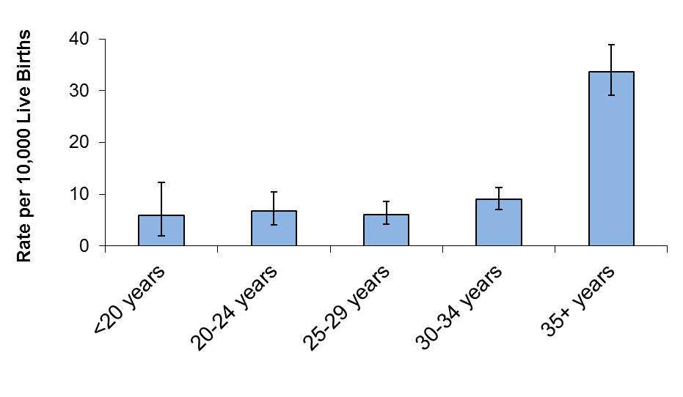

Live births and stillbirths, N=194.
Error bars represent 95% confidence intervals.

Gastroschisis

Mothers ages 19 and under had the highest rate of gastroschisis cases at 13.3 per 10,000 live births (Figure 8). The association between gastroschisis and younger maternal age has been shown in previous studies (18).

Figure 8. Prevalence of Gastroschisis by Maternal Age,
Massachusetts: 2011-2012

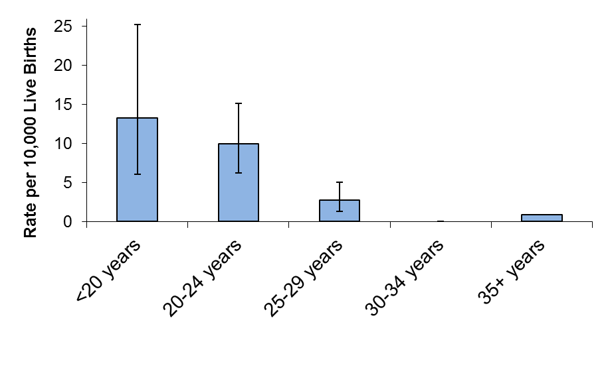

Live births and stillbirths, N=44.
Error bars represent 95% confidence intervals.

Figure 9 presents gastroschisis rates by maternal age in Massachusetts over a 12-year time span.

Figure 9. Prevalence of Gastroschisis by Year and Maternal Age,
Massachusetts: 2000-2012

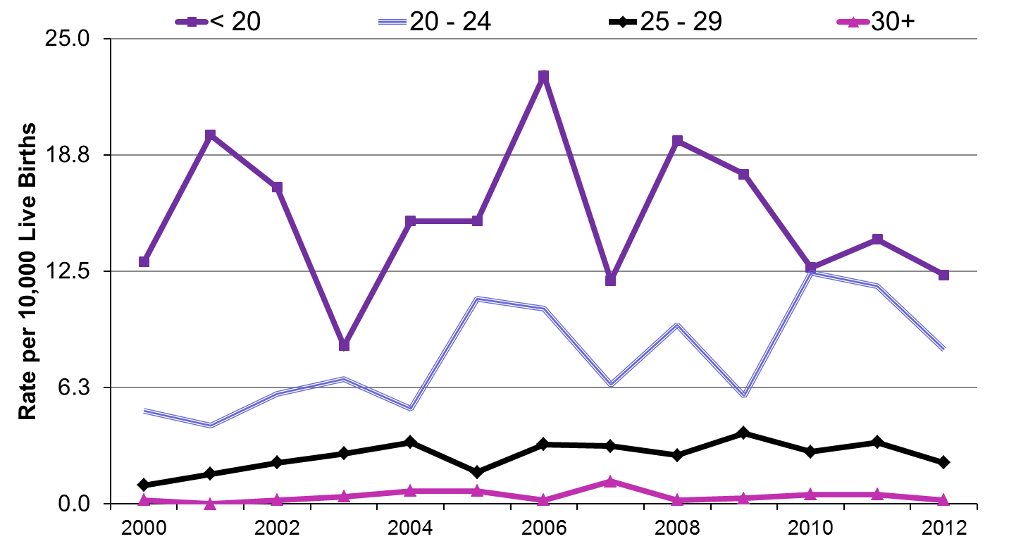

Live births and stillbirths.

Chapter 6: Prevalence of Birth Defects by Maternal Race/Ethnicity
and Region

Maternal Race/Ethnicity

In Massachusetts and nationally, birth defect rates vary by maternal race/ethnicity. Table 7 shows the variation in age-adjusted birth defect rates by racial/ethnic group in Massachusetts during the current reporting period.

Table 7. Age-Adjusted Prevalence of Birth Defects by Maternal Race/Ethnicity,
Massachusetts: 2011-2012

Maternal  Race | Cases | Age-Adjusted  Rate¹ | 95% CI
White, Non-Hispanic | 1690 | 185.5 | 176.6-194.3
Black, Non-Hispanic | 285 | 207.8 | 183.7-232.0
Asian, Non-Hispanic | 190 | 154.8 | 132.8-176.8
Hispanic | 529 | 219.8 | 201.1-238.6
Other, Non-Hispanic² | 30 | 213.6 | 137.2-290.0

Live births and stillbirths, N=2724.
¹ Rate per 10,000 live births, adjusted to statewide maternal age distribution of the birthing
population.
² Includes American Indian.

The age-adjusted birth defect rate in offspring of Hispanic mothers is significantly higher than that of white and Asian mothers. In addition, the age-adjusted birth defect rate among those born to black mothers is significantly higher than the rate among those born to Asian mothers. Possible explanations include genetic variation, diet and lifestyle differences, and varying access to prenatal screening and health care services. For example, data from the 2011 Massachusetts Pregnancy Risk Assessment Monitoring System shows that Hispanic women are less likely to use a multivitamin in the month prior to pregnancy (19). These results are shown in Appendix 7. Table 8 shows the prevalence rates of the individual birth defects by maternal race/ethnicity.
Table 8. Prevalence of Birth Defects by Maternal Race/Ethnicity,
Live Births and Stillbirths, Massachusetts: 2011-2012
Defect | Maternal  Race/Ethnicity¹ | Count | Rate² | 95% CI
Central Nervous System
Anencephaly | White | 4 | 0.44 | 0.12-1.13
 | Black | 0 | - | -
 | Asian | 0 | - | -
 | Hispanic | 4 | 1.55 | 0.42-3.96
Encephalocele | White | 2 | 0.22 | 0.03-0.79
 | Black | 0 | - | -
 | Asian | 0 | - | -
 | Hispanic | 4 | 1.55 | 0.42-3.96
Holoprosencephaly | White | 4 | 0.44 | 0.12-1.13
 | Black | 3 | 2.16 | 0.45-6.31
 | Asian | 0 | - | -
 | Hispanic | 3 | 1.16 | 0.24-3.39
Hydrocephaly without Spina Bifida | White | 28 | 3.08 | 2.04-4.45
 | Black | 3 | 2.16 | 0.45-6.31
 | Asian | 5 | 3.98 | 1.29-9.30
 | Hispanic | 13 | 5.03 | 2.68-8.59
Microcephaly | White | 19 | 2.09 | 1.26-3.26
 | Black | 2 | 1.44 | 0.17-5.20
 | Asian | 3 | 2.39 | 0.49-6.98
 | Hispanic | 4 | 1.55 | 0.42-3.96
Spina with/without Hydrocephaly | White | 18 | 1.98 | 1.17-3.13
 | Black | 2 | 1.44 | 0.17-5.20
 | Asian | 0 | - | -
 | Hispanic | 8 | 3.09 | 1.34-6.09
Spinal Cord | White | 46 | 5.05 | 3.70-6.74
 | Black | 4 | 2.88 | 0.78-7.37
 | Asian | 5 | 3.98 | 1.29-9.30
 | Hispanic | 14 | 5.41 | 2.96-9.08
Eye
Aniridia | White | 3 | 0.33 | 0.07-0.96
 | Black | 1 | 0.72 | 0.02-4.01
 | Asian | 0 | - | -
 | Hispanic | 0 | - | -
Anophthalmia/Microphthalmia | White | 7 | 0.77 | 0.31-1.58
 | Black | 2 | 1.44 | 0.17-5.20
 | Asian | 0 | - | -
 | Hispanic | 5 | 1.93 | 0.63-4.51
Congenital Glaucoma/Congenital Cataract | White | 28 | 3.08 | 2.04-4.45
 | Black | 3 | 2.16 | 0.45-6.31
 | Asian | 3 | 2.39 | 0.49-6.98
 | Hispanic | 11 | 4.25 | 2.12-7.61
Ear
Anotia/Microtia | White | 23 | 2.53 | 1.60-3.79
 | Black | 2 | 1.44 | 0.17-5.20
 | Asian | 4 | 3.19 | 0.87-8.16
 | Hispanic | 7 | 2.71 | 1.09-5.58
Cardiovascular
Anomalous Pulmonary Venous Connection
Total Anomalous Pulmonary Venous Connection | White | 6 | 0.66 | 0.24-1.44
 | Black | 5 | 3.60 | 1.17-8.40
 | Asian | 3 | 2.39 | 0.49-6.98
 | Hispanic | 7 | 2.71 | 1.09-5.58
Atrioventricular Canal Defects
Atrial Septal Defect (ASD) Primum | White | 1 | 0.11 | 0.00-0.61
 | Black | 0 | - | -
 | Asian | 0 | - | -
 | Hispanic | 0 | - | -
Common Atrium | White | 1 | 0.11 | 0.00-0.61
 | Black | 2 | 1.44 | 0.17-5.20
 | Asian | 0 | - | -
 | Hispanic | 2 | 0.77 | 0.09-2.79
Complete Atrioventricular Canal Defect | White | 34 | 3.74 | 2.59-5.22
 | Black | 9 | 6.48 | 2.96-12.30
 | Asian | 4 | 3.19 | 0.87-8.16
 | Hispanic | 14 | 5.41 | 2.96-9.08
Endocardial Cushion Defect, Other specified (OS) and Not otherwise specified (NOS) | White | 9 | 0.99 | 0.45-1.88
 | Black | 3 | 2.16 | 0.45-6.31
 | Asian | 1 | 0.80 | 0.02-4.44
 | Hispanic | 7 | 2.71 | 1.09-5.58
Ventricular Septal Defect (VSD), Canal Type | White | 5 | 0.55 | 0.18-1.28
 | Black | 0 | - | -
 | Asian | 0 | - | -
 | Hispanic | 4 | 1.55 | 0.42-3.96
Conotruncal (Outlet) and Aortic Arch
Double Outlet Right Ventricle | White | 8 | 0.88 | 0.38-1.73
 | Black | 2 | 1.44 | 0.17-5.20
 | Asian | 2 | 1.59 | 0.19-5.76
 | Hispanic | 4 | 1.55 | 0.42-3.96
Interrupted Aortic Arch, Type B | . | . | . | .-.
Tetralogy of Fallot with/without Pulmonary Atresia | White | 35 | 3.85 | 2.68-5.35
 | Black | 4 | 2.88 | 0.78-7.37
 | Asian | 2 | 1.59 | 0.19-5.76
 | Hispanic | 8 | 3.09 | 1.34-6.09
Truncus | White | 2 | 0.22 | 0.03-0.79
 | Black | 1 | 0.72 | 0.02-4.01
 | Asian | 0 | - | -
 | Hispanic | 2 | 0.77 | 0.09-2.79
dextro-Transposition of the Great Arteries | White | 17 | 1.87 | 1.09-2.99
 | Black | 4 | 2.88 | 0.78-7.37
 | Asian | 4 | 3.19 | 0.87-8.16
 | Hispanic | 9 | 3.48 | 1.59-6.61
Ebstein Anomaly
Ebstein Anomaly | White | 3 | 0.33 | 0.07-0.96
 | Black | 0 | - | -
 | Asian | 0 | - | -
 | Hispanic | 2 | 0.77 | 0.09-2.79
Heterotaxy (Laterality Defects)
Heterotaxy | White | 4 | 0.44 | 0.12-1.13
 | Black | 1 | 0.72 | 0.02-4.01
 | Asian | 0 | - | -
 | Hispanic | 3 | 1.16 | 0.24-3.39
Left-Sided Obstruction
Aortic Valve Stenosis | White | 11 | 1.21 | 0.60-2.16
 | Black | 0 | - | -
 | Asian | 2 | 1.59 | 0.19-5.76
 | Hispanic | 4 | 1.55 | 0.42-3.96
Aortic arch Atresia | White | 0 | - | -
 | Black | 0 | - | -
 | Asian | 1 | 0.80 | 0.02-4.44
 | Hispanic | 0 | - | -
Coarctation of Aorta | White | 47 | 5.16 | 3.79-6.87
 | Black | 8 | 5.76 | 2.49-11.35
 | Asian | 2 | 1.59 | 0.19-5.76
 | Hispanic | 11 | 4.25 | 2.12-7.61
Hypoplastic Left Heart Syndrome | White | 14 | 1.54 | 0.84-2.58
 | Black | 1 | 0.72 | 0.02-4.01
 | Asian | 2 | 1.59 | 0.19-5.76
 | Hispanic | 5 | 1.93 | 0.63-4.51
Interrupted Aortic Arch (Type A and NOS) | White | 4 | 0.44 | 0.12-1.13
 | Black | 0 | - | -
 | Asian | 0 | - | -
 | Hispanic | 0 | - | -
Right-Sided Obstruction
Pulmonary Stenosis, Valvular | White | 70 | 7.69 | 6.00-9.72
 | Black | 23 | 16.56 | 10.50-24.84
 | Asian | 6 | 4.78 | 1.75-10.40
 | Hispanic | 17 | 6.57 | 3.83-10.52
Pulmonary Valve Atresia with intact septum | White | 5 | 0.55 | 0.18-1.28
 | Black | 0 | - | -
 | Asian | 0 | - | -
 | Hispanic | 1 | 0.39 | 0.01-2.15
Pulmonary Valve Atresia with VSD | White | 0 | 0.00 | 0.00-0.41
 | Black | 1 | 0.72 | 0.02-4.01
 | Asian | 0 | - | -
 | Hispanic | 0 | - | -
Tricuspid Valve Atresia | White | 2 | 0.22 | 0.03-0.79
 | Black | 0 | - | -
 | Asian | 0 | - | -
 | Hispanic | 1 | 0.39 | 0.01-2.15
Septal Defects
ASD (Secundum and NOS) | White | 201 | 22.09 | 19.14-25.36
 | Black | 37 | 26.64 | 18.75-36.71
 | Asian | 26 | 20.71 | 13.53-30.35
 | Hispanic | 63 | 24.36 | 18.72-31.16
VSD (Membranous and NOS) | White | 103 | 11.32 | 9.24-13.73
 | Black | 17 | 12.24 | 7.13-19.59
 | Asian | 19 | 15.14 | 9.11-23.64
 | Hispanic | 39 | 15.08 | 10.72-20.61
VSD, Conoventricular/Malalignment | White | 9 | 0.99 | 0.45-1.88
 | Black | 3 | 2.16 | 0.45-6.31
 | Asian | 5 | 3.98 | 1.29-9.30
 | Hispanic | 6 | 2.32 | 0.85-5.05
Single Ventricle and levo-Transposition of the Great Arteries
levo-Transposition of the Great Arteries | White | 6 | 0.66 | 0.24-1.44
 | Black | 0 | - | -
 | Asian | 0 | - | -
 | Hispanic | 0 | - | -
Single Ventricle | White | 2 | 0.22 | 0.03-0.79
 | Black | 1 | 0.72 | 0.02-4.01
 | Asian | 0 | - | -
 | Hispanic | 0 | - | -
Respiratory
Choanal Atresia | White | 10 | 1.10 | 0.53-2.02
 | Black | 0 | - | -
 | Asian | 0 | - | -
 | Hispanic | 2 | 0.77 | 0.09-2.79
Lung Anomalies | White | 19 | 2.09 | 1.26-3.26
 | Black | 5 | 3.60 | 1.17-8.40
 | Asian | 3 | 2.39 | 0.49-6.98
 | Hispanic | 11 | 4.25 | 2.12-7.61
Orofacial
Cleft Lip with and without Cleft Palate | White | 58 | 6.37 | 4.84-8.24
 | Black | 7 | 5.04 | 2.03-10.38
 | Asian | 7 | 5.58 | 2.24-11.49
 | Hispanic | 22 | 8.51 | 5.33-12.88
Cleft Palate without Cleft Lip | White | 49 | 5.38 | 3.98-7.12
 | Black | 14 | 10.08 | 5.51-16.91
 | Asian | 7 | 5.58 | 2.24-11.49
 | Hispanic | 14 | 5.41 | 2.96-9.08
Pierre Robin Sequence | White | 22 | 2.42 | 1.51-3.66
 | Black | 3 | 2.16 | 0.45-6.31
 | Asian | 4 | 3.19 | 0.87-8.16
 | Hispanic | 7 | 2.71 | 1.09-5.58
Gastrointestinal
Biliary Atresia | White | 6 | 0.66 | 0.24-1.44
 | Black | 2 | 1.44 | 0.17-5.20
 | Asian | 3 | 2.39 | 0.49-6.98
 | Hispanic | 3 | 1.16 | 0.24-3.39
Esophageal Atresia/Tracheoesophageal Fistula | White | 33 | 3.63 | 2.50-5.09
 | Black | 4 | 2.88 | 0.78-7.37
 | Asian | 0 | - | -
 | Hispanic | 12 | 4.64 | 2.40-8.10
Hirschsprung Disease | White | 12 | 1.32 | 0.68-2.30
 | Black | 3 | 2.16 | 0.45-6.31
 | Asian | 5 | 3.98 | 1.29-9.30
 | Hispanic | 3 | 1.16 | 0.24-3.39
Rectal and Large Intestinal Atresia/Stenosis | White | 38 | 4.18 | 2.95-5.73
 | Black | 2 | 1.44 | 0.17-5.20
 | Asian | 5 | 3.98 | 1.29-9.30
 | Hispanic | 8 | 3.09 | 1.34-6.09
Small Intestinal Atresia | White | 21 | 2.31 | 1.43-3.53
 | Black | 4 | 2.88 | 0.78-7.37
 | Asian | 1 | 0.80 | 0.02-4.44
 | Hispanic | 7 | 2.71 | 1.09-5.58
Bladder Exstrophy | White | 3 | 0.33 | 0.07-0.96
 | Black | 0 | - | -
 | Asian | 0 | - | -
 | Hispanic | 0 | - | -
Cloacal Exstrophy | White | 5 | 0.55 | 0.18-1.28
 | Black | 0 | - | -
 | Asian | 0 | - | -
 | Hispanic | 2 | 0.77 | 0.09-2.79
Hypospadias, 2nd or 3rd Degree³ | White | 117 | 25.11 | 20.76-30.09
 | Black | 17 | 23.83 | 7.13-19.59
 | Asian | 9 | 13.96 | 6.38-26.50
 | Hispanic | 14 | 10.57 | 5.78-17.74
Obstructive Genitourinary Defect | White | 131 | 14.39 | 12.04-17.08
 | Black | 15 | 10.80 | 6.04-17.81
 | Asian | 13 | 10.36 | 5.51-17.71
 | Hispanic | 51 | 19.72 | 14.68-25.93
Renal Agenesis/Hypoplasia | White | 4 | 0.44 | 0.12-1.13
 | Black | 0 | - | -
 | Asian | 0 | - | -
 | Hispanic | 1 | 0.39 | 0.01-2.15
Musculoskeletal
Club Foot | White | 145 | 15.93 | 13.45-18.75
 | Black | 17 | 12.24 | 7.13-19.59
 | Asian | 11 | 8.76 | 4.37-15.68
 | Hispanic | 40 | 15.46 | 11.05-21.06
Craniosynostosis | White | 47 | 5.16 | 3.79-6.87
 | Black | 2 | 1.44 | 0.17-5.20
 | Asian | 4 | 3.19 | 0.87-8.16
 | Hispanic | 12 | 4.64 | 2.40-8.10
Diaphragmatic Hernia | White | 24 | 2.64 | 1.69-3.92
 | Black | 1 | 0.72 | 0.02-4.01
 | Asian | 2 | 1.59 | 0.19-5.76
 | Hispanic | 7 | 2.71 | 1.09-5.58
Gastroschisis | White | 25 | 2.75 | 1.78-4.06
 | Black | 2 | 1.44 | 0.17-5.20
 | Asian | 4 | 3.19 | 0.87-8.16
 | Hispanic | 12 | 4.64 | 2.40-8.10
Omphalocele | White | 20 | 2.20 | 1.34-3.39
 | Black | 0 | - | -
 | Asian | 2 | 1.59 | 0.19-5.76
 | Hispanic | 6 | 2.32 | 0.85-5.05
Polydactyly/Syndactyly | White | 127 | 13.96 | 11.63-16.60
 | Black | 47 | 33.83 | 24.86-44.99
 | Asian | 17 | 13.54 | 7.89-21.68
 | Hispanic | 51 | 19.72 | 14.68-25.93
Reduction Deformity, Lower Limbs | White | 16 | 1.76 | 1.00-2.86
 | Black | 5 | 3.60 | 1.17-8.40
 | Asian | 1 | 0.80 | 0.02-4.44
 | Hispanic | 0 | - | -
Reduction Deformity, Upper Limbs | White | 35 | 3.85 | 2.68-5.35
 | Black | 1 | 0.72 | 0.02-4.01
 | Asian | 1 | 0.80 | 0.02-4.44
 | Hispanic | 6 | 2.32 | 0.85-5.05
Skeletal Dysplasia | White | 21 | 2.31 | 1.43-3.53
 | Black | 2 | 1.44 | 0.17-5.20
 | Asian | 1 | 0.80 | 0.02-4.44
 | Hispanic | 6 | 2.32 | 0.85-5.05
Chromosomal and other Syndromes
Klinefelter Syndrome | White | 3 | 0.33 | 0.07-0.96
 | Black | 0 | - | -
 | Asian | 2 | 1.59 | 0.19-5.76
 | Hispanic | 2 | 0.77 | 0.09-2.79
Trisomy 13 | White | 4 | 0.44 | 0.12-1.13
 | Black | 1 | 0.72 | 0.02-4.01
 | Asian | 0 | - | -
 | Hispanic | 1 | 0.39 | 0.01-2.15
Trisomy 18 | White | 20 | 2.20 | 1.34-3.39
 | Black | 5 | 3.60 | 1.17-8.40
 | Asian | 3 | 2.39 | 0.49-6.98
 | Hispanic | 8 | 3.09 | 1.34-6.09
Trisomy 21 (Down Syndrome) | White | 118 | 12.97 | 10.73-15.53
 | Black | 19 | 13.68 | 8.23-21.36
 | Asian | 9 | 7.17 | 3.28-13.61
 | Hispanic | 47 | 18.17 | 13.35-24.16
Turner Syndrome⁴ | White | 8 | 1.80 | 0.78-3.55
 | Black | 0 | - | -
 | Asian | 1 | 1.64 | 0.04-9.12
 | Hispanic | 0 | - | -
Other
Amniotic Bands | White | 14 | 1.54 | 0.84-2.58
 | Black | 1 | 0.72 | 0.02-4.01
 | Asian | 0 | - | -
 | Hispanic | 4 | 1.55 | 0.42-3.96
Skin Anomalies | White | 13 | 1.43 | 0.76-2.44
 | Black | 2 | 1.44 | 0.17-5.20
 | Asian | 3 | 2.39 | 0.49-6.98
 | Hispanic | 5 | 1.93 | 0.63-4.51

¹ Race/ethnic groups used: White, Non-Hispanic; Black, Non-Hispanic; Asian, Non-Hispanic; Hispanic.
Other, Non-Hispanic not presented due to small numbers.
² Rate per 10,000 live births.
³ Rate calculated using male live births.
⁴ Rate calculated using female live births.

Trends in Maternal Race/Ethnicity

Figure 10 shows the age-adjusted birth defect rates by race/ethnicity between 2007 and 2012 in two-year intervals. Hispanic rates for 2011-2012 are significantly higher than 2009-2010 rates, but are similar to 2007-2008 rates.

Figure 10. Prevalence of Birth Defects by Maternal Race/Ethnicity,
Massachusetts: 2007-2012

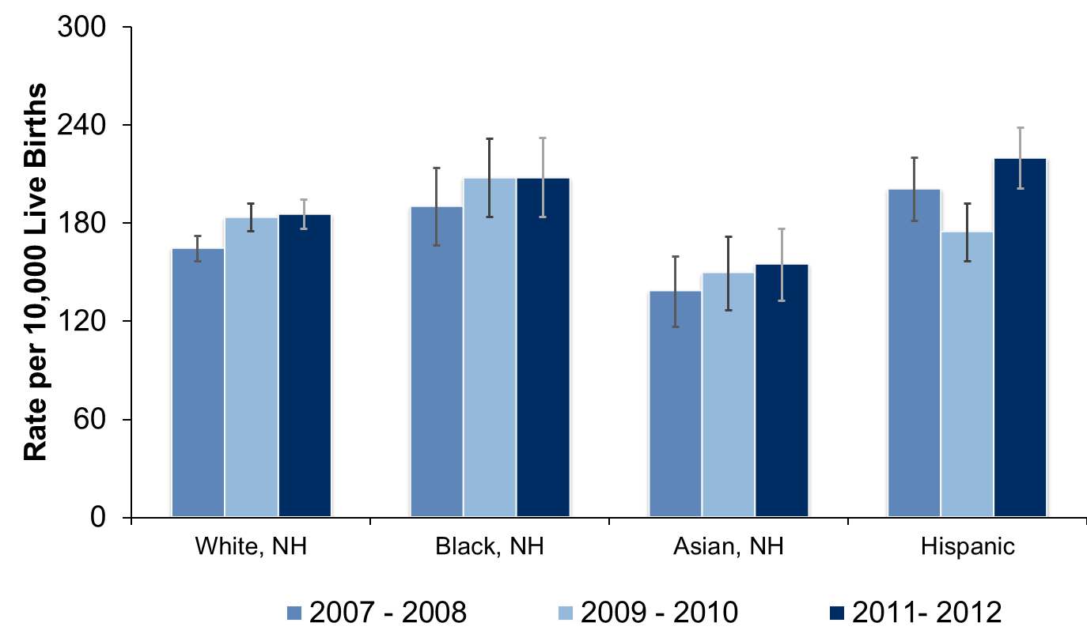

Live births and stillbirths. NH=Non-Hispanic.
Adjusted to statewide maternal age distribution of the birthing population in each 2-year period.
Error bars represent 95% confidence intervals.

Maternal Region of Residence

The Massachusetts Executive Office of Health and Human Services divides the state into six regions for statistical, care coordination and administrative purposes. The six regions are based on geographical groupings of cities and towns: Western, Central, Northeast, Metro West, Southeast, and Boston. A map of these regions is provided in Appendix 8. The age-adjusted birth defect rates by the six regions in 2011-2012 are shown in Table 9. Although not significantly different, the rates range from 182.2 per 10,000 in the Metro West region to 211.6 per 10,000 in the Western region. Rates in the Western region have increased over time (Figure 10), but the 2011-2012 rates are not significantly different from 2009-2010 rates. Regional differences may result from variation in the distribution of maternal and other characteristics across the regions.
Table 9. Age-Adjusted Prevalence of Birth Defects by Maternal Residence Region, Massachusetts: 2011-2012

Region | Cases | Age-Adjusted  Rate¹ | 95% CI
Western | 348 | 211.6 | 189.4-233.8
Central | 341 | 186.6 | 166.8-206.4
Northeast | 558 | 183.7 | 168.5-199.0
Metro West | 620 | 182.2 | 167.9-196.6
Southeast | 482 | 190.8 | 173.8-207.9
Boston | 382 | 185.1 | 166.5-203.6

Live births and stillbirths, N=2731.
¹ Rate per 10,000 live births, adjusted to statewide maternal age distribution of the birthing population.

Figure 11. Prevalence of Birth Defects by Maternal Residence Region,
Massachusetts: 2007-2012

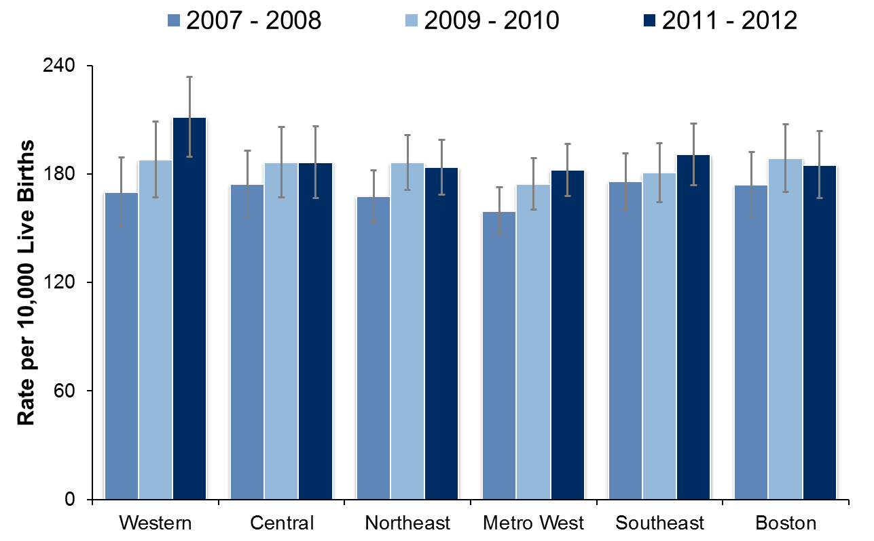

Live births and stillbirths.
Adjusted to statewide maternal age distribution of the birthing population in each 2-year period.
Error bars represent 95% confidence intervals.

Chapter 7: Birth Defects by Severity, Pattern, and Etiology

Severity

Cases with birth defects ascertained in our surveillance system are categorized by their level of severity. A severity scale was developed by the BDMP in collaboration with Boston University and Massachusetts General Hospital. This scale is based on the usual outcome for a specific birth defect, including its typical compatibility with survival, the need for immediate treatment, the need for long-term care and the amenability of the defect to correction.

Birth defect cases were classified as “severe”, “serious”, “moderate”, or “mild”. Each case is assigned a severity level based on the most severe defect. Examples of birth defects by severity category are shown in Appendix 6. Figure 12 shows birth defects classified by severity.

Figure 12. Birth Defects by Severity, Massachusetts: 2011-2012

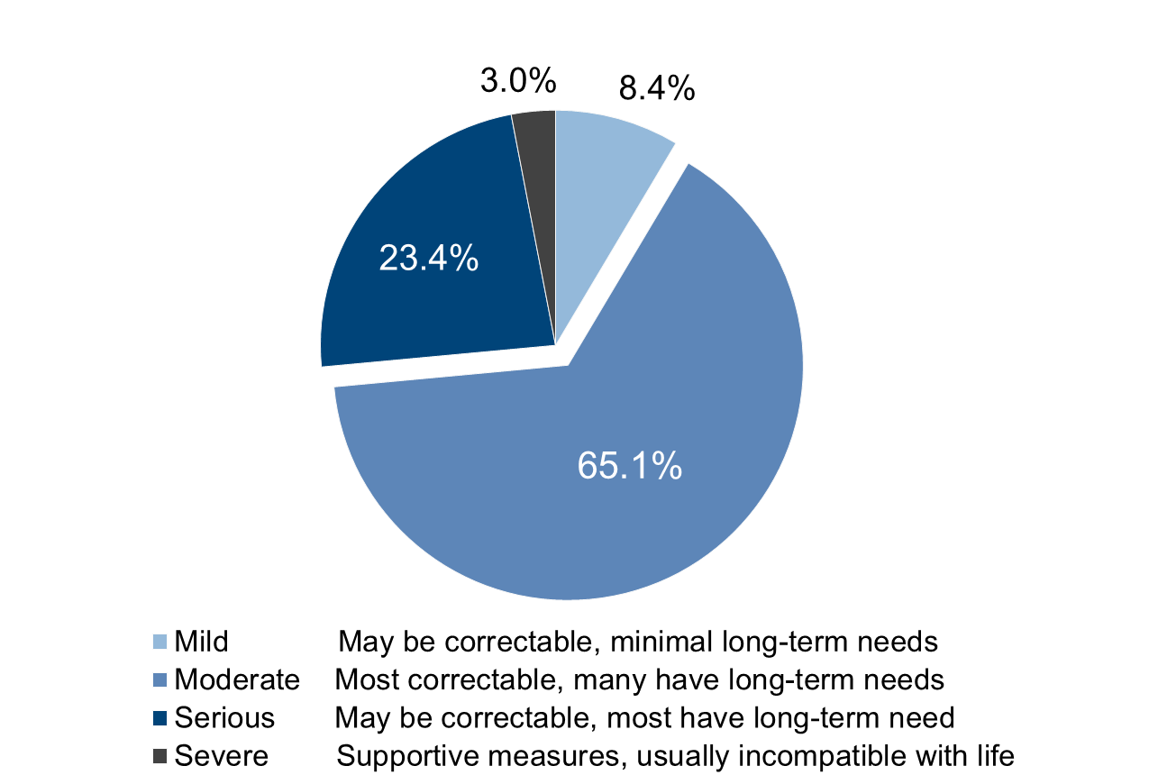

Live births and stillbirths, N=2731.
Percentages may not add to 100% due to rounding.

Approximately 8% of cases had defects that are classified as “mild”. These defects may or may not have required corrective treatment. Most defects were classified as moderate, comprising roughly 65% of the total cases. Cases with these types of defects tend to require medical follow up and sometimes require surgery or other treatment. Approximately 23% of cases were classified as having a “serious” birth defect. Many of these cases need intensive medical care initially, as well as continuing care, and many will have long-term disability.

In 2011-2012, 3% of cases were classified as severe, which is usually incompatible with life.
Within the severity categories, there can be considerable variability, particularly with defects classified as moderate.

Pattern

Cases are also classified based on their pattern (i.e. whether a defect occurs with others). Of the 2731 birth defect cases in 2011-2012, 24.2% had multiple major defects or syndromes (Figure 13). Approximately 40% of these cases had single defects, and 31% of these cases had multiple defects within the same organ or a single major defect with one or more minor defects. The remaining 4.1% of defects are part of a sequence of developmental events. Defects that tend to occur as solitary defects include hypospadias, gastroschisis, and craniosynostosis.

Figure 13. Birth Defects by Pattern, Massachusetts: 2011-2012

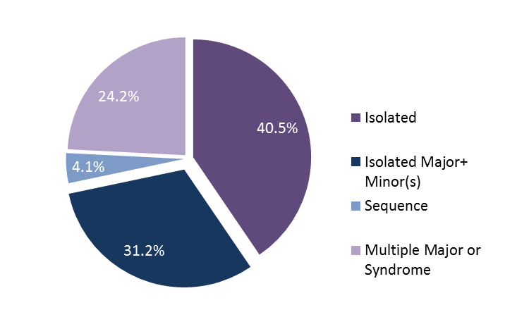

Live births and stillbirths, N=2731.
Percentages may not add to 100% due to rounding.

Etiology

The surveillance system in Massachusetts collects etiology or causal information for birth defects, when available. Cases are classified into etiology categories, with similar cases grouped using knowledge of pathogenesis and embryologic mechanisms. Etiology classification considers each case as a biologic entity rather than a collection of individual defects. The schema was developed based on general principles outlined in the literature (20,21,22).

The majority of birth defects cases in Massachusetts in 2011-2012 (80.3%) had an unknown etiology (Figure 14). Most of the cases with known etiology were whole chromosome abnormalities (extra copy or missing copy of a chromosome), such us trisomy 13 and Turner syndrome.

Figure 14. Birth Defects by Etiology, Massachusetts: 2011-2012

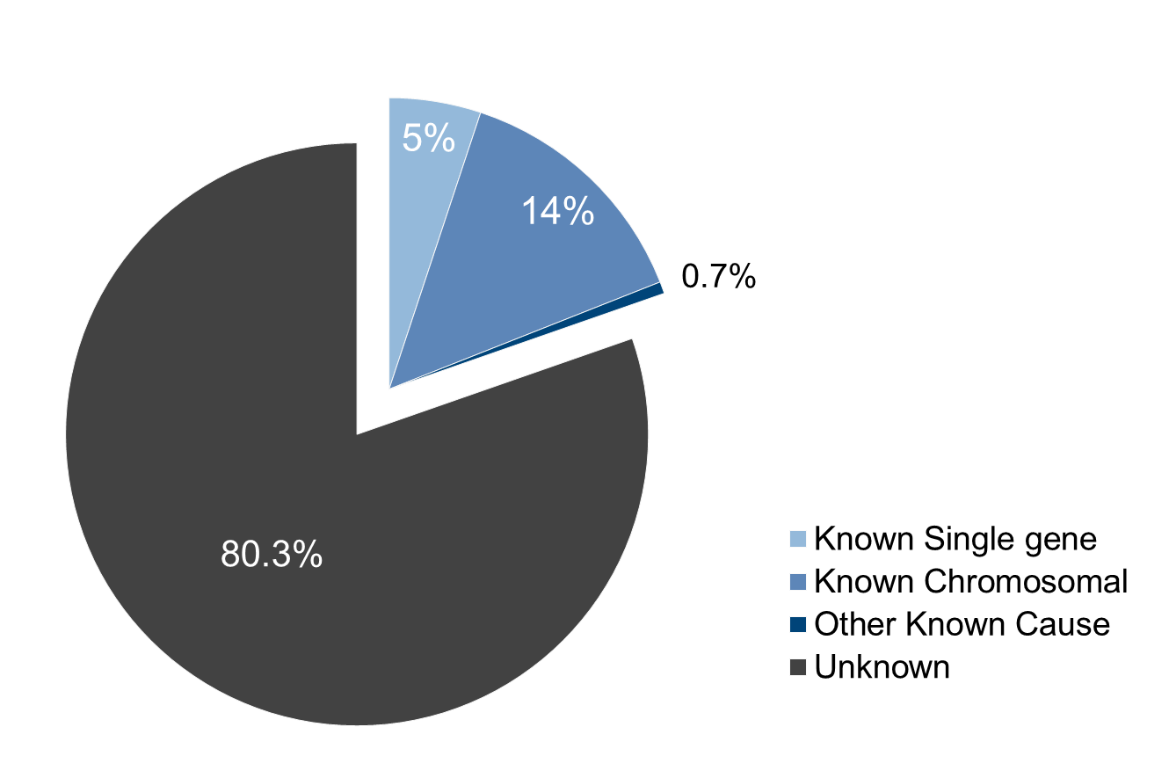

Live births and stillbirths, N=2731.
Percentages may not add to 100% due to rounding.

Other examples of defects with known etiologies include single gene defects, such as achondroplasia, Marfan syndrome (deletion 15q21.1), Smith-Lemli-Opitz syndrome and other defects considered to be a Mendelian syndrome. Examples of known etiologies include teratogens such as thalidomide, maternal conditions, such as diabetes, and conditions of the uterine environment, such as didelphys uterus.

Chapter 8: Other Pregnancy Losses—2012 data

In early 2011, the Massachusetts Birth Defects Monitoring Program began collecting information on prenatally diagnosed cases with an outcome other than live birth or stillbirth (“other pregnancy losses”). These include spontaneous early losses <20 weeks gestation and elective terminations. The first complete year of data that includes other pregnancy losses is 2012. The data on other pregnancy losses should be interpreted with caution, as only one year of data from a start-up period is included.

Including other pregnancy losses adds 361 additional cases and increases the overall birth defects prevalence rate in 2012 from 194.6 (95% CI: 184.7-204.9) to 243.2 (95% CI: 232.1-254.7) per 10,000 live births (Figure 15), which is closer to the 1 in 33 (3%) birth defects rate reported nationally (1).

Figure 15. Prevalence of Birth Defects with and without Other Pregnancy Losses, Massachusetts: 2012

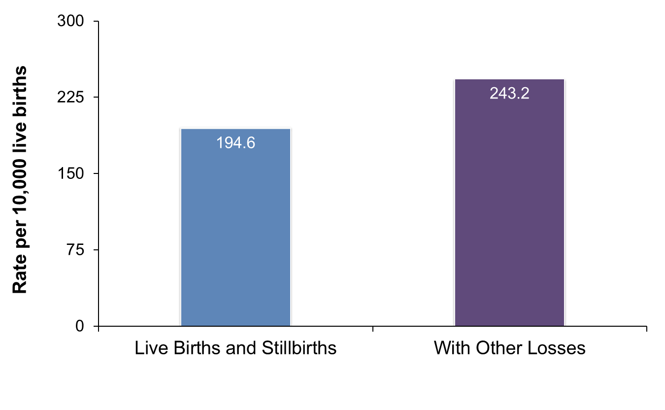

N=2731 live births and stillbirths; N=3092 live births, stillbirths and other pregnancy losses.

Figure 16 shows the rates of selected birth defects in Massachusetts in 2012 among live births and stillbirths alone compared to rates that include other pregnancy losses.

Figure 16. Prevalence of Selected Defects with and without
Other Pregnancy Losses, Massachusetts: 2012

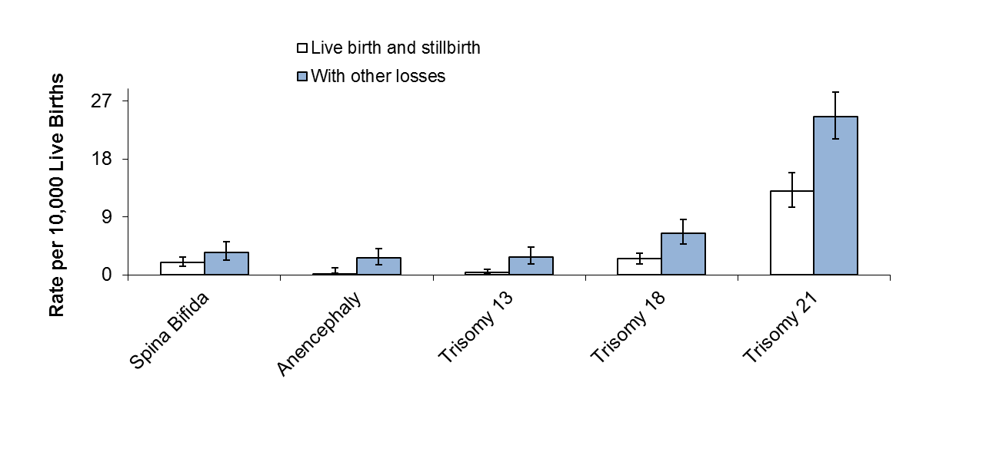

Error bars represent 95% confidence intervals.

The rates of trisomy 13, 18, 21, spina bifida and anencephaly are significantly higher when other losses are included, bringing these rates much closer to national estimates and bringing rates of Down Syndrome and trisomy 18 higher than national estimates, possibly due to the inclusion of early spontaneous losses, which most states do not include (Figure 17).

Figure 17. Prevalence of Selected Defects including
Other Pregnancy Losses, Massachusetts¹ 2012 Compared to US² Rates

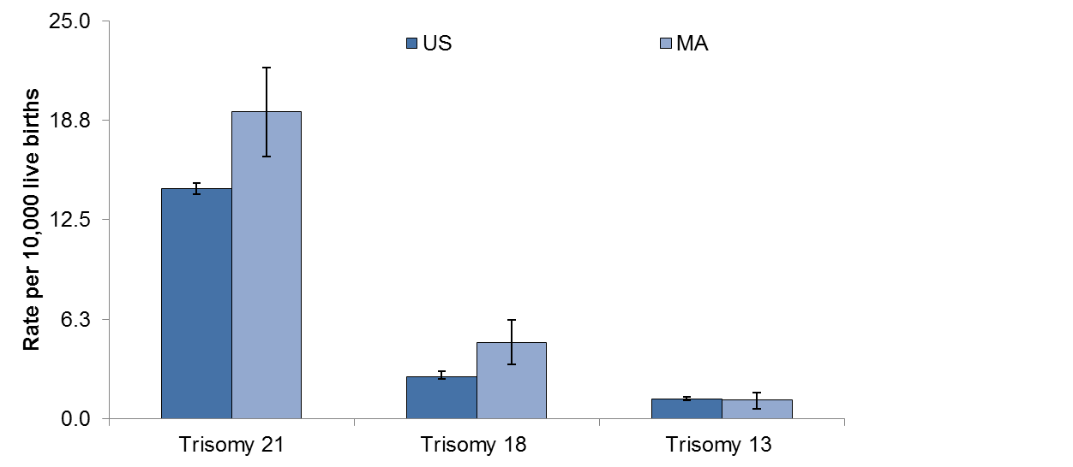

¹Massachusetts rates include live births, stillbirths, and other pregnancy losses. Rates are standardized to US age distribution for 2006.

²US age-adjusted rates from Parker et al. based on crude, pooled prevalence data from 11 active case-ascertainment programs in 2004-2006, including Massachusetts (7). Nine of the other states contributing to the pooled estimates include elective terminations in addition to live births and stillbirths.

Error bars represent 95% confidence intervals.

Resources, Suggested Citation, Contact Information

Resources

For additional information on birth defects:

www.mass.gov/dph/birthdefects

Suggested Citation

Massachusetts Birth Defects 2011-2012. Boston, MA: Center for Birth Defects Research and Prevention, Bureau of Family Health and Nutrition, Massachusetts Department of Public Health. February 2016.

http://www.mass.gov/eohhs/gov/departments/dph/programs/family-health/birth-defect/monitoring/surveillance-reports.html

Friendly URL: www.mass.gov/dph/birthdefects

Contact Information

For more information contact:

Cathleen A. Higgins, Surveillance Coordinator
Massachusetts Department of Public Health
Center for Birth Defects Research and Prevention
250 Washington Street, 5th Floor
Boston, MA 02108
Phone: 617-624-5510
cathleen.higgins@state.ma.us

REFERENCES

- Centers for Disease Control and Prevention (CDC). Birth Defects. http://www.cdc.gov/ncbddd/birthdefects/index.html Accessed February 22, 2016.
- Centers for Disease Control and Prevention (CDC). Facts about Birth Defects. http://www.cdc.gov/ncbddd/birthdefects/facts.html Accessed February 22, 2016.
- Wolff T, Witkop CT, et al. (2009). “Folic Acid Supplementation for the Prevention of Neural Tube Defects: An Update of the Evidence for the U.S. Preventive Services Task Force.” Ann Intern Med 150(9): 632-639.
- Yoon PW, Rassmussen SA, et al. (2001). “The National Birth Defects Prevention Study.” Public Health Reports 116: 32-40.
- Harris JA and James L (1997) “State-by-state cost of birth defects—1992.” Teratology 56(1-2): 11-16. Adjusted for inflation to 2012 dollars using US Bureau of Labor Statistics Inflation calculator.
- Waitzman NJ, et al. (1995) “Economic costs of birth defects and cerebral palsy—United States 1992.” MMWR 44(37):694-9. Adjusted for inflation to 2012 dollars using US Bureau of Labor Statistics Inflation calculator.
- Parker SE, Mai CT, Canfield MA (2010). “Updated National Birth Defects Prevalence Estimates for Selected Birth Defects in the US, 2004-2006.” Birth Defects Research (Part A) 88: 1008-1016.
- Division of Research and Epidemiology, Bureau of Health Information, Statistics, Research, and Evaluation, Massachusetts Department of Public Health (2014) “Massachusetts Births 2011-2012”.
- Sunderam S, Kissen DM, et al. (2014). “Assisted reproductive technology surveillance—United States, 2011.” MMWR Surveillance Summaries 63(SS10): 1-28.
- Reefhuis J, Honein MA, et al. (2009). “Assisted reproductive technology and major structural birth defects in the United States.” Hum Reprod 24(2): 360-10.
- Mathews TJ, MacDorman MF (2013) Infant mortality statistics from the 2010 period linked birth/infant death data set. National Center for Health Statistics: National Vital Statistics Reports. Volume 62, No. 8.
- Division of Research and Epidemiology, Bureau of Health Information, Statistics, Research, and Evaluation, Massachusetts Department of Public Health (2015) “Massachusetts Deaths 2012: Data Brief”.
- Mills JL and Signore C (2004). “Neural tube defect rates before and after food fortification with folic acid.” Birth Defects Res A Clin Mol Teratol 70(11): 844-5.
- Heseker HB, Mason JB, et al. (2008). “Not all cases of neural-tube defect can be prevented by increasing the intake of folic acid.” Br J Nutr: 1-8.
- U.S. Department of Health and Human Services, HealthyPeople.gov: http://www.healthypeople.gov/2020/topics-objectives/topic/maternal-infant-and-child-health/objectives
Accessed August 7, 2015.
- Sever L, Ed. (2004). Guidelines for Conducting Birth Defects Surveillance. Atlanta, National Birth Defects Prevention Network, Inc.
- Oken E, Kleinman KP, Rich-Edwards J, Gilman MW (2003). “A nearly continuous measure of birth weight for gestational age using a United States national reference.” BMC Pediatr. 3:6. Epub 2003 Jul 8.
- Kirby RS, Marshall J, Tanner JP, et al. (2013) “Prevalence and correlates of gastroschisis in 15 states, 1995-2005. Obstet Gyn Aug;122(2 Pt 1): 275-281.
- Office of Data Translation, Bureau of Family Health and Nutrition, Massachusetts Department of Public Health (2015) Massachusetts Pregnancy Risk Assessment Monitoring System (PRAMS) 2011 Surveillance Report.
- Cary J, Feldkamp M, et al. (2005). “An etiologic classification of congenital malformations, including orofacial clefts, in Utah.” Proceedings of the Greenwood Genetic Center 24: 69.
- Rasmussen SA, Olney RS, et al. (2003). “Guidelines for case classification for the National Birth Defects Prevention Study.” Birth Defects Res A Clin Mol Teratol 67(3): 193-201.
- Holmes L (1994) Congenital Malformations in Principles and Practices of Pediatrics. 2nd edition, Lippincott Williams and Wilkins: 277-279.

APPENDICES

Appendix 1: Technical Notes

Data Sources

Surveillance records were matched to records from the Registry of Vital Records and Statistics to obtain demographic and clinical information. For live births, birth certificate data were used as the source of information for maternal age, region of maternal residence (based on city), race/ethnicity, birth weight, plurality and gestational age (clinical estimate). All diagnostic information and infant sex were obtained from surveillance data. All live births were matched to a birth certificate. For fetal deaths that did not match to a fetal death certificate, surveillance data was used to obtain diagnostic and clinical information. Information on other pregnancy losses was obtained from surveillance.

Prevalence, Rates and Confidence Intervals

Prevalence is defined as the number of individuals with a disease or condition over a specified period of time divided by the number of individuals at risk during the same period. The numerator is the number of cases of birth defects. Since the preferred denominator is all pregnancies and since the number of pregnancies cannot be determined, the number of total live births is used as an approximation.

The rates provided in the tables and figures are estimations of the proportion of deliveries with birth defects overall and within subgroups. This rate is expressed as birth defect births per 10,000 live births and is calculated by the formula:

Number of Cases / total number live births x 10,000

Fetal deaths are included in the numerator but not in the denominator, so the result is technically a ratio and not a rate. This method of calculating rates is consistent with the national “Guidelines for Conducting Birth Defects Surveillance” (National Birth Defects Prevention Network, June 2004). Because the number of fetal deaths is so small, the inclusion of fetal deaths in the denominator would not substantially change the ratio.

The confidence interval (CI) is a method of assessing the magnitude and stability of a rate or ratio. The CI represents a range of values that has a 95% probability of including the true rate or ratio. Observed rates are subject to statistical variation. Thus, even if the underlying risk of a birth defect is identical in two subpopulations, the observed rates for the subpopulations may differ because of random variation. The width of the confidence interval indicates the precision of the observed rate as an estimate of the underlying risk of having a birth defect, with a wider interval indicating less certainty about this estimate. The width of the interval reflects the size of the subpopulation and the number of cases of birth defects. Smaller subpopulations with fewer defects lead to wider confidence intervals. The 95% confidence intervals used in the report are calculated using the Poisson method, except for the CIs for the age-adjusted rates, which are calculated using the standard method. If confidence intervals for two rates overlap, this means that we cannot rule out random variation to explain any differences in the rates.

Assignment of Race/Ethnicity

The Center follows the recommendation of the National Center for Health Statistics of classifying births according to the self-reported race/ethnicity of the mother. The 2003 version of the Certificate of Live Birth was implemented in Massachusetts in early 2011 (http://www.cdc.gov/nchs/vital_certs_rev.htm), and this new certificate allows for reporting of more than one racial and ethnic category. Race/ethnicity is a self-reported item and is subject to the usual limitations of this type of information.

Calculation of 2012 Dollars

Calculation of cost of birth defects in 2012 dollars was made using the Bureau of Labor Statistics consumer price index (CPI) Inflation Calculator. The CPI inflation calculator uses the average Consumer Price Index for a given calendar year.

Assignment of Severity

Cases with birth defects were categorized by their level of severity. The severity scale was developed by the Center in collaboration with our partners at Boston University and Massachusetts General Hospital. This scale was based on the usual outcome for a specific birth defect including its typical compatibility with survival, the need for immediate treatment, the need for long-term care and the amenability of the defect to correction.

Some of the rules for assigning severity level are briefly described here. First, each defect labeled by an ICD9/BPA code was assigned a severity score or range of severity scores based on the defining characteristics of the defect. Each case was assigned a severity score based on the most severe defect that occurred within that case. Cases with infant death when a lethal anomaly was not present were reviewed by the Center Clinical Geneticist and manually assigned a severity level. Cases with a syndrome plus an additional defect(s) were categorized according to the severity of the syndrome.

Pattern assignment definitions

Solitary defect: Truly solitary defect

Major and Minor defects: More than one defect of the same organ or body part; Major plus minor defects in different organs or body parts

Sequence: Several defects in different organs/body parts that are related pathogenically

Multiple major defects: Multiple major defects in different organs and/or body parts including all defects that arise from a recognized syndrome.

Isolated vs. Multiple Major designation

Isolated cases: cases that have only a single defect, those with multiple defects within the same organ, those with a single major defect with one or more minor defects, and those with defects that are part of a sequence of developmental events.

Multiple major cases: cases that have multiple major defects in different organs with or without being part of a recognized syndrome.
Appendix 2: Glossary of Terms Used in this Report

Agenesis, aplasia, or hypoplasia The absence or incomplete development of an organ or body part.

Anencephaly Congenital absence of the skull, with cerebral hemispheres completely missing or reduced to small masses attached to the base of the skull. Anencephaly is not compatible with life.

Anophthalmia A developmental defect characterized by complete absence of the eyes, or by the presence of vestigial eyes.

Anotia A congenital absence of one or both ears.

Aortic valve stenosis A cardiac anomaly characterized by a narrowing or stricture of the aortic valve. This condition causes abnormal cardiac circulation and pressure in the heart during contractions. This condition can be repaired surgically in some cases.

Atresia Absence or closure of a normal opening.

Atrial Septal Defect (ASD) A congenital cardiac malformation in which there are one or more openings in the atrial septum (muscular and fibrous wall between the right and left atria) allowing a mixing of oxygenated and unoxygenated blood. The openings vary in size and may resolve without treatment or may require surgical treatment.

Biliary atresia A congenital absence or underdevelopment of one or more of the ducts in the biliary tract. Correctable surgically.

Birthweight The weight of an infant recorded at the time of delivery. It may be recorded in either pounds/ounces or grams.

Birth prevalence the number of birth defect cases at a given time, calculated as follows:

The number of cases with birth defect A in an area and time period
_______________________________________________________ x 10,000

The number of live births in that area and time period

Bladder exstrophy Incomplete closure of the anterior wall of the bladder and the abdominal cavity. The abdominal wall and underlying organs do not fuse properly so that the bladder is exposed on the outside of the body.

Cataract An opacity (clouding) of the lens of the eye.

Choanal atresia or stenosis A congenital anomaly in which a bony or membranous formation blocks the passageway between the nose and the pharynx. This defect is usually repaired surgically after birth.

Cleft lip The congenital failure of the fetal components of the lip to fuse or join, forming a groove or fissure in the lip.

Cleft palate The congenital failure of the palate to fuse properly, forming a grooved depression or fissure in the roof of the mouth. This defect varies in degree of severity. The fissure can extend into the hard and soft palate and into the nasal cavities.

Cluster An apparently unusual concentration of a health condition in a particular area and time period.

Coarctation of the aorta Localized narrowing of the aorta. This condition causes abnormal cardiac circulation and pressure in the heart during contractions. This condition can vary from mild to severe.

Confidence interval (CI) (95%) The interval that contains the true prevalence (which we can only estimate) 95% of the time.

Congenital Existing at or dating from birth.

Craniosynostosis A premature closing of the cranial sutures before or soon after birth. This condition is occasionally associated with other skeletal defects. If no surgical correction is made, the growth of the skull is inhibited, and the head is deformed.

Diaphragmatic hernia A failure of the diaphragm to form completely, leaving a hole. Abdominal organs may protrude through the hole into the chest cavity and interfere with development of the heart and lungs.

Down syndrome (Trisomy 21) The chromosomal abnormality characterized by an extra copy of chromosome 21. In rare cases this syndrome is caused by translocation. Down syndrome can occur in mosaic (i.e. there is a population of normal cells and a population of trisomy 21 cells.) Many infants have congenital heart disease.

Ebstein anomaly A congenital heart defect in which the tricuspid valve is displaced downward into the right ventricle causing abnormal patterns of cardiac circulation.

Embryogenesis The development and growth of an embryo, especially the period from the second through the eighth week after conception.

Encephalocele The protrusion of the brain substance through a defect in the skull.

Endocardial cushion defect A variety of septal defects (malformations of the walls separating the two atria and two ventricles of the heart) resulting from imperfect fusion of the endocardial cushions in the embryonic heart.

Esophageal stenosis or atresia A narrowing or incomplete formation of the esophagus. Usually a surgical emergency. Frequently associated with a tracheoesophageal fistula.

Fetal death See stillbirth.

Fistula An abnormal passage from an internal organ to the body surface or between two internal organs or structures.

Folate A B vitamin necessary for red blood cell production. Folate deficiency can lead to anemia and, during embryogenesis, can affect the normal development of the fetus’ neural tube.

Folic acid One of the B vitamins especially important for a woman to take before conception to help prevent neural tube defect. Folic acid refers to the synthetic vitamin used in supplements, whereas folate is the form found in foods.

Gastroschisis A congenital opening of the abdominal wall with protrusion of the intestines. This condition is surgically treated.

Hernia A protrusion of an organ or part through connective tissue or through a wall of the cavity in which it is normally enclosed.

Hirschsprung disease The congenital absence of autonomic ganglia (nerves controlling involuntary and reflexive movement) in the muscles of the colon. This results in immobility of the intestines and may cause obstruction or stretching of the intestines. This condition is repaired surgically in early childhood by the removal of the affected portion of the intestine.

Holoprosencephaly Failure of the brain to develop into two equal halves, so there is structural abnormality of the brain. There may be associated midline facial defects including cyclopia (fusion of the eye orbits into a single cavity containing one eye) in severe cases. About half the cases are probably due to a single gene defect (the HPE gene). Frequently occurs with Trisomy 13.

Hydrocephalus The abnormal accumulation of fluid within the spaces of the brain.

Hypoplasia A condition of arrested development in which an organ or body part remains below the normal size or in an immature state.

Hypoplastic left heart syndrome Atresia, or marked hypoplasia, of the aortic opening or valve, with hypoplasia of the ascending aorta and defective development of the left ventricle (with mitral valve atresia). This condition is usually fatal if not treated.

Hypospadias A congenital defect in males in which the urinary meatus (urinary outlet) is on the underside of the penis or on the perineum (area between the genitals and the anus). The condition may be surgically corrected if needed for cosmetic, urologic, or reproductive reasons.

Infant A child whose age is less than one year (365 days).

Infant Death Death of a child whose age is less than one year.

Limb defects See Reduction deformities.

Live Birth Any infant who breathes or shows any other evidence of life.

Microcephaly Congenital small size of the head relative to the height, with corresponding small brain size.

Microphthalmia The congenital abnormal smallness of one or both eyes. Can occur in the presence of other ocular defects.

Microtia A small or maldeveloped external ear and atretic or stenotic external auditory canal.

Mosaic In genetics, this refers to an individual organism that has two or more kinds of genetically different cell types. The degree of abnormality depends on the type of tissue containing affected cells. Individuals may vary from near normal to full manifestation of the genetic syndrome. Can occur in any chromosome abnormality syndrome.

Neural tube defect A defect resulting from failure of the neural tube to close in the first month of pregnancy. The major conditions include anencephaly, spina bifida, and encephalocele.

Obstructive genitourinary defect Stenosis or atresia of the urinary tract at any level. Severity of the defect depends largely upon the level of the obstruction. Urine accumulates behind the obstruction and damages the organs.

Omphalocele The protrusion of an organ into the umbilicus. The defect is usually closed surgically soon after birth. Contrast with Gastroschisis.

Other Pregnancy Loss/Other Loss Spontaneous pregnancy loss at less than 20 weeks gestation and weighing less than 350g OR elective termination.

Patent ductus arteriosus (PDA) A hole between the pulmonary artery and the aorta. This is normal in fetal life, but can cause problems after birth. The vast majority close spontaneously and cause no problems. Medical or surgical correction may be done. PDA in a premature infant is not considered a birth defect.

Plurality The number of births to a woman produced in the same gestational period. A singleton is the birth of one infant; twins represent the births of two infants, etc.

Poisson regression A type of statistical analysis based on the Poisson distribution used to compare rates of rare occurrences such as birth defects between different population groups, different areas, or different times.

Prevalence With respect to the prevalence of birth defects, see “Birth prevalence”.

Pulmonary valve atresia or stenosis A congenital heart condition characterized by absence or constriction of the pulmonary valve. This condition causes abnormal cardiac circulation and pressure in the heart during contractions. This condition can vary from mild to severe. Mild forms are relatively well tolerated and require no intervention. More severe forms are surgically corrected.

Reduction defects of the lower limbs The congenital absence of a portion of the lower limb.

Reduction defects of the upper limbs The congenital absence of a portion of the upper limb.

Renal agenesis The failure of embryonic development of the kidney.

Small for gestational age (SGA) Term used to describe an infant whose birth weight is below the 10th percentile (i.e. below 90% of infants) for gestational age on basis of a sex-specific US standard (Oken, 2003).

Spina bifida A neural tube defect resulting from failure of the spinal neural tube to close. The spinal cord and/or meninges may or may not protrude. This usually results in damage to the spinal cord with paralysis of the involved limbs. Includes myelomeningocele (involving both spinal cord and meninges) and meningocele (involving just the meninges).

Stenosis A narrowing or constriction of the diameter of a bodily passage or orifice.

Stenosis or atresia of large intestine, rectum and anus The absence, closure or constriction of the large intestine, rectum or anus. Can be surgically corrected or bypassed.

Stenosis or atresia of the small intestine A narrowing or incomplete formation of the small intestine obstructing movement of food through the digestive tract.

Stillbirth (Fetal Death) Death of a fetus delivered of at least 20 weeks gestation, or with a weight of at least 350 grams.

Tetralogy of Fallot A congenital cardiac anomaly consisting of four defects: ventricular septal defect, pulmonary valve stenosis or atresia, displacement of the aorta to the right, and hypertrophy of right ventricle. The condition is corrected surgically.

Tracheoesophageal fistula An abnormal passage between the esophagus and trachea.
Corrected surgically. It is frequently associated with esophageal atresia.

Translocation The rearrangement of genetic material within the same chromosome or the transfer of a segment of one chromosome to another one. People with balanced translocations do not always manifest genetic syndromes, but may be carriers of genetic syndromes and can have children with unbalanced translocations. Can occur with any chromosomal anomaly syndrome.

Transposition of the great vessels (Transposition of the great arteries/TGA) A congenital malformation in which the aorta arises from the right ventricle and the pulmonary artery from the left ventricle (opposite of normal), so that the venous return from the peripheral circulation is recirculated without being oxygenated in the lungs. Can occur in Levo (L-) or Dextro (d-) form. Dextro usually requires immediate surgical correction.

Tricuspid valve atresia or stenosis A congenital cardiac condition characterized by the absence or constriction of the tricuspid valve. The opening between the right atrium and right ventricle is absent or restricted, and normal circulation is not possible. This condition is often associated with other cardiac defects. This condition is surgically corrected depending on the severity.

Trisomy A chromosomal abnormality characterized by one more than the normal number of chromosomes. Normally, cells contain two of each chromosome. In trisomy, cells contain three copies of a specific chromosome.

Trisomy 13 The chromosomal abnormality caused by an extra chromosome 13. The syndrome can occur in mosaic so that there is a population of normal cells and a population of trisomy 13 cells. The syndrome is characterized by impaired midline facial development, cleft lip and palate, polydactyly and mental retardation. Most infants do not survive beyond 6 months of life.

Trisomy 18 The chromosomal abnormality characterized by an extra copy of chromosome 18. Trisomy 18 can occur in mosaic. The syndrome is characterized by mental retardation, neonatal hepatitis, low-set ears, skull malformation and short digits. Cardiac and renal anomalies are also common. Survival for more than a few months is rare.

Trisomy 21 See Down syndrome.

Truncus arteriosus A congenital heart defect in which the common arterial trunk fails to divide into pulmonary artery and aorta. This is corrected surgically.

Ventricle One of the two lower chambers of the heart (plural ventricles). The right ventricle sends blood to the lungs, and the left ventricle passes oxygen-rich blood to the rest of the body.

Ventricular Septal Defect (VSD) A congenital cardiac malformation in which there are one or more openings in the ventricular septum (muscular and fibrous wall between the right and left ventricle or right and left lower chambers of the heart) allowing a mixing of oxygenated and deoxygenated blood. The openings vary in size and may resolve without treatment or require surgical treatment.

Definitions adapted from: Texas Department of State Health Services Glossary of Birth Defects Terms, April 2010

Appendix 3: Massachusetts 2011-2012 Live Birth Populations
Used in Calculating Rates

Numbers of Live Births to Massachusetts Residents
 |  | 2011  N=73,174 | 2012  N=72,457 | Total  N=145,631
By Maternal Age | <20 | 3511 | 3253 | 6764
 | 20-24 | 11,145 | 10,869 | 22,014
 | 25-29 | 18,241 | 17,947 | 36,188
 | 30-34 | 24,017 | 24,020 | 48,037
 | 35+ | 16,256 | 16,367 | 32,623
 | Unknown | 4 | 1 | 5
By Infant Sex | Male | 37,512 | 37,086 | 74,598
 | Female | 35,660 | 35,369 | 71,029
 | Unknown/Ambiguous | 2 | 2 | 4
By Plurality | Singleton | 69,931 | 69,274 | 139,213
 | Multiple Birth | 3235 | 3183 | 6418
By Maternal Race/Ethnicity | White | 45,974 | 45,032 | 91,006
 | Black | 6999 | 6892 | 13,891
 | Hispanic | 12,777 | 13,088 | 25,865
 | Asian/Pacific Islander | 6023 | 6530 | 12,553
 | American Indian | 265 | 253 | 518
 | Other | 523 | 395 | 918
 | Unknown | 613 | 267 | 880
By Region | Western | 8567 | 8397 | 16,964
 | Central | 9297 | 9254 | 18,551
 | Northeast | 15,336 | 15,192 | 30,528
 | Metro West | 16,889 | 16,698 | 33,587
 | Southeast | 12,708 | 12,668 | 25,376
 | Boston | 10,377 | 10,247 | 20,624

Based on data from Massachusetts Registry of Vital Records and Statistics. Division of Research and Epidemiology, Bureau of Health Information, Statistics, Research, and Evaluation, Massachusetts Department of Public Health (2014) “Massachusetts Births 2011-2012”.

Appendix 4: ICD-9-CM/BPA Birth Defect Codes Used in this Report
and Inclusions/Exclusions

Birth Defect | ICD-9-CM Codes¹ | Modified ICD-9-CM/BPA Codes² | Comments
Central Nervous System
Anencephaly | 740.0 –740.1 | 740.00 – 740.10
Encephalocele | 742.0 | 742.00 – 742.09
Holoprosencephaly | 742.2 | 742.26
Hydrocephaly without Spina Bifida | 742.3 | 742.30-742.32, 742.38-742.39
Microcephaly | 742.1 | 742.10 | Incl. if 2 standard deviations below the mean, adjusted for sex, gestational age and length
Spina bifida with and without Hydrocephaly | 741.0, 741.9  740.0 - 740.1 | 741.00 – 741.99  740.00 – 740.10
Spinal Cord anomalies | 348.0, 745.51, 742.53, 742.59 | 742.52,742.54,742.58
Eye
Aniridia | 743.45 | 743.42-743.424
Anophthalmia/Microphthalmia | 743.0, 743.1 | 743.00 – 743.10
Congenital Glaucoma/Congenital Cataract | 743.30 – 743.34 | 743.20, 743.32, 743.35, 743.36
Ear
Anotia/Microtia | 744.01, 744.23 | 744.01, 744.21
Cardiovascular
Aortic Arch Atresia | 747.22 | 747.200 | Without Hypoplastic Left Heart Syndrome
Aortic Valve Stenosis | 746.3 | 746.30
Atrial Septal Defect (ASD), Primum | 745.61 | 745.60
ASD, Secundum, and Not otherwise specified (NOS) | 745.5 | 745.51 – 745.59 | Includes ASD Secundum, Other and  not otherwise specified (NOS)
Coarctation of Aorta | 747.10 | 747.10 – 747.19
Common Atrium | 745.69 | 745.61
Complete Atrioventricular Canal Defect | 745.69 | 745.62, 745.63
Dextro-Transposition of the Great Arteries | 745.10 | 745.10, 745.11 | Excludes 745.19 (NOS)
Double Outlet Right Ventricle | 745.11 | 745.185, 186, 188, 189
Ebstein Anomaly | 746.2 | 746.20
Endocardial cushion defect | 745.60, 745.69 | 745.68, 745.69 | Includes other specified (OS) and NOS
Hypoplastic Left Heart Syndrome | 746.7 | 746.70
Interrupted Aortic Arch | 747.11 | 747.215 – 747.217 | Includes Type A, Type B and NOS
Levo-Transposition of the Great Arteries | 745.10, 745.12 | 745.12
Partial anomalous pulmonary venous connection | 747.42 | 747.43
Pulmonary Valve Atresia | 746.01 | 746.00, 746.03 | With intact ventricular septum (746.000), with VSD (746.030)
Pulmonary Stenosis, Valvular | 746.02 | 746.01
Single Ventricle | 745.3 | 745.3
Tetralogy of Fallot with/without pulmonary valve atresia | 745.2 | 745.20 – 745.21, 747.31 | 747.31 is Pulmonary artery atresia with septal defect
Total anomalous pulmonary venous connection | 747.41 | 747.42
Tricuspid Valve Atresia | 746.1 | 746.10 | Excludes tricuspid valve stenosis (746.106)
Truncus | 745.0 | 745.00  (excluding 745.01)
Ventricular Septal Defect (VSD), Canal Type | 745.69 | 745.685
VSD, Conoventricular/Malalignment | 745.4 | 745.487 | Excludes canal type and muscular (745.486).
VSD, Membranous or NOS | 745.4 | 745.485, 745.49 | Excludes canal type and muscular (745.486).
Respiratory
Choanal Atresia | 748.0 | 748.00
Lung Anomalies | 748.4, 748.5 | 748.40, 748.41, 748.48, 748.50, 748.51, 748.52, 748.58, 748.88
Orofacial
Cleft Palate without Cleft Lip | 749.0 | 749.00 – 749.09 | Excludes isolated submucous cleft palate
Cleft lip with/without Cleft Palate | 749.1, 749.2 | 749.10 – 749.19, 749.20-749.29
Pierre Robin Sequence | 756.0 | 524.080
Gastrointestinal
Biliary Atresia | 751.61 | 751.65
Esophageal Atresia/  Tracheoesophageal Fistula | 750.3 | 750.30 – 750.35
Hirschsprung Disease | 751.3 | 751.30-751.34
Rectal and Large Intestinal Atresia/Stenosis | 751.2 | 751.20 – 751.24
Small Intestinal Atresia | 751.1 | 751.10 – 751.19
Genitourinary
Bladder Exstrophy | 753.5 | 753.50
Cloacal Exstrophy | 751.5 | 751.555
Hypospadias, 2nd or 3rd degree | 752.61 | 752.60 – 752.62  (excluding 752.61 and 752.621) | In males only
Obstructive Genitourinary Defect | 753.2, 753.6 | 753.20-753.22, 753.29, 753.60-753.69 | Includes posterior urethral valve  requires surgery or other defect
Renal Agenesis/Hypoplasia | 753.0 | 753.00 – 753.01 | Bilateral only
Musculoskeletal
Club Foot | 754.51, 754.70 | 754.50, 754.73 (excluding 754.735) | Requires casting or surgery
Craniosynostosis | No specific code | 756.00 – 756.03
Diaphragmatic Hernia | 756.6 | 756.60-756.605, 756.61 – 756.617, 756.618-756.619
Gastroschisis | 756.73 | 756.71
Omphalocele | 756.72 | 756.70
Polydactyly/syndactyly | 755.0, 755.1 | 755.005, 755.01-755.03, 755.095-755.096, 755.10-755.13, 755.19-755.199 | Hands require bone or cartilage involvement. Excludes webbing of toes 2-3
Reduction Deformity, Lower limbs | 755.3 | 755.30 – 755.39 | 755.4 codes not used
Reduction Deformity, Upper limbs | 755.2 | 755.20 – 755.29 | 755.4 codes not used
Skeletal Dysplasia | 755.55, 756.4, 756.5 | 755.555,  756.41, 756.43, 756.447, 756.46, 756.480, 756.49, 756.50, 756.53, 756.54, 756.575, 756.58, 756.59
Chromosomal
Klinefelter Syndrome | 758.7 | 758.70-758.71, 758.79
Trisomy 13 | 758.1 | 758.10 – 758.19
Trisomy 18 | 758.2 | 758.20 – 758.29
Trisomy 21 (Down syndrome) | 758.0 | 758.00 – 758.09
Turner Syndrome | 758.6 | 758.60 – 758.69 | In females only
Other
Amniotic Bands | No specific code | 658.80
Heterotaxy/Situs Inversus | 759.3 | 759.30-759.33, 759.35-759.395 | Displayed as part of the group of cardiovascular defects in tables
Skin Anomalies | 757.1, 757.31, 757.39, 757.4, 757.8 | 757.34, 757.36, 757.48, 757.80, 757.35, 757.33, 757.11, 757.19, 757.195-757.197

¹ International Classification of Diseases, 9th Revision.
² Centers for Disease Control/Clinical Modification, British Pediatric Association.

Appendix 5: Complete List of ICD-9-CM/BPA Birth Defect Codes and Counts
Massachusetts, Live Births and Stillbirths: 2011-2012

ICD-9-CM/BPA Code Label | Code | Count
Cardiovascular
Anomalous Pulmonary Venous Connection
Partial anomalous pulmonary venous return/connection/drainage | 747430 | 9
Total anomalous pulmonary venous return/connection/drainage | 747420 | 12
Atrioventricular Canal Defects
Atrial septal defect (ASD), primum type | 745600 | 1
Common Atrium | 745610 | 5
Complete atrioventricular canal | 745630 | 60
Complete atrioventricular canal with ventricular septal defect | 745620 | 1
Endocardial cushion defect, Not otherwise specified (NOS) | 745690 | 3
Endocardial cushion defect, Other specified (OS) | 745680 | 17
Ventricular septal defect (VSD), inflow type (subtricuspid, canal-type) | 745685 | 9
Conotruncal and Aortic Arch
Dextro-transposition of great arteries with intact ventricular septum | 745100 | 17
Dextro-transposition of great arteries with VSD | 745110 | 17
Double-outlet right ventricle with normally related great arteries | 745185 | 8
Double-outlet right ventricle with transposed great arteries | 745186 | 5
Double-outlet right ventricle, NOS | 745189 | 2
Double-outlet right ventricle, OS | 745188 | 1
Pulmonary atresia with VSD (Tetralogy of Fallot with pulmonary atresia) | 747310 | 7
Tetralogy of Fallot | 745200 | 43
Truncus Arteriosus | 745000 | 5
Ebstein Anomaly
Ebstein Malformation or Anomaly | 746200 | 5
Heterotaxy (Laterality Defects)
Situs ambiguus, left; left isomerism | 759360 | 1
Situs ambiguus, sidedness NOS | 759380 | 4
Situs ambiguus, sidedness unclear | 759370 | 2
Situs inversus abdominis | 759330 | 1
Left-Sided Obstruction
Aorta: Atresia/absence | 747200 | 1
Aortic stenosis, valvar | 746300 | 17
Coarctation of the aorta, postductal (distal) | 747110 | 1
Coarctation of the aorta, preductal (proximal) | 747100 | 1
Coarctation of the aorta, juxtaductal | 747120 | 10
Coarctation of the aorta, NOS | 747190 | 56
Hypoplastic left heart syndrome | 746700 | 24
Interrupted aortic arch, NOS | 747215 | 1
Interrupted aortic arch, type A | 747216 | 3
Right-Sided Obstruction
Pulmonary valve atresia with VSD (not 747.310) | 746030 | 1
Pulmonary valve atresia/intact ventricular septum | 746000 | 6
Pulmonic stenosis, valvar | 746010 | 119
Tricuspid atresia | 746100 | 3
Septal Defects
Atrial septal defect, NOS | 745599 | 27
Atrial septal defect, OS | 745580 | 1
Atrial septal defect (ASD), Secundum type | 745510 | 302
Ventricular septal defect (VSD), NOS | 745490 | 10
VSD, Malalignment-type (type I, subarterial) | 745487 | 23
VSD, Perimembranous (type II, membranous) | 745485 | 168
Single Ventricle and L-TGA
Levo-Transposition of the great arteries/great vessels/ventricular inversion  Excludes: dextrocardia (use 746.800) | 745120 | 6
Single ventricle, NOS | 745300 | 2
Single ventricle, Double Inlet Left Ventricle | 745310 | 1
Other Cardiovascular
Anomalies of coronary artery or sinus | 746885 | 17
Aorta: Hypoplasia | 747210 | 4
Aorta: Congenital aneurysm/dilatation | 747270 | 2
Aorta: Other specified anomalies | 747280 | 1
Aorta: Persistent right aortic arch | 747230 | 16
Aorta: Vascular ring/double aortic arch/vascular ring compression of trachea | 747250 | 5
Aortic septal defect/aorto pulmonary window. Excludes ASD (use 745.590) | 745010 | 7
Aortic valve: bicuspid/insufficiency or regurgitation Excludes ‘mild', ‘minimal', 'trivial', or 'physiologic' | 746400 | 1
Aortic valve: Other specified anomalies/aortic valve atresia.  Excludes: supravalvular aortic stenosis (747.220) | 746480 | 18
Arteriovenous malformation, peripheral Excludes: pulmonary (747.340), cerebral (747.800), and retinal (743.510) arteriovenous malformations | 747620 | 1
Bicuspid Aortic Valve | 746470 | 74
Cerebral vessels: Other anomalies/vein of Galen | 747810 | 1
Circulatory system: Other specified anomalies. Excludes aneurysms: coronary, peripheral, pulmonary, retinal, ruptured cerebral | 747880 | 2
Cor triatriatum | 746820 | 2
Great veins: Other specified anomalies | 747480 | 6
Heart: Other specified anomalies/ectopia cordis/mesocardia/conduction defects, NOS | 746880 | 37
Mitral valve: Absence, atresia, or hypoplasia | 746505 | 1
Mitral valve: Congenital mitral stenosis | 746500 | 5
Pericardium: Anomalies | 746850 | 1
Peripheral arteries: Other anomalies/aberrant subclavian artery | 747640 | 13
Peripheral vascular system: Other anomalies/primary pulmonary artery hypertension | 747680 | 2
Persistent left superior vena cava | 747410 | 14
Pulmonary artery: other specified/pulmonary artery hypoplasia | 747380 | 4
Pulmonary artery: stenosis. Use 746.995 if artery or valve is not specified | 747320 | 12
Pulmonary infundibular (subvalvular) stenosis | 746830 | 5
Pulmonary valve: Other specified anomalies. Excludes: infundibular stenosis (746.830) | 746080 | 31
Situs: Dextrocardia without situs inversus/dextrocardia with situs solitus | 746800 | 5
Tricuspid stenosis or hypoplasia | 746106 | 2
Central Nervous System
Agyria and lissencephaly | 742240 | 3
Anencephaly | 740020 | 8
Brain cysts: Cerebral/subependymal/periventricular | 742420 | 3
Brain, reduction defect OS (Includes colpocephaly, pachygyria, schizencephaly) and absent septum pellucidum | 742280 | 12
Brain: Other specified anomalies cortical atrophy/cranial nerve defects | 742480 | 4
Cerebellar Hypoplasia | 742235 | 5
Cerebellum anomalies | 742230 | 4
Cerebrum anomalies | 742200 | 3
Corpus callosum anomalies | 742210 | 77
Dandy-Walker Malformation | 742310 | 12
Encephalocele, NOS | 742090 | 1
Encephalocele, Occipital | 742000 | 3
Encephalocele, Parietal | 742086 | 2
Enlarged brain and head/enlarged head/enlarged brain/megalencephaly/macrocephaly | 742400 | 20
Holoprosencephaly, Alobar | 742265 | 2
Holoprosencephaly, Lobar | 742267 | 3
Holoprosencephaly, NOS | 742260 | 2
Holoprosencephaly, Semilobar | 742266 | 3
Hydranencephaly | 742320 | 2
Hydrocephaly, NOS | 742390 | 15
Hydrocephaly, Anomalies of Aqueduct of Sylvius | 742300 | 18
Hydrocephaly, Other Specified | 742380 | 3
Lipomeningocele, Highest level, lumbar, No mentioned hydrocephalus, closed lesion | 741853 | 1
Lipomeningomyelocele, Highest level, lumbar, No mentioned hydrocephalus, closed lesion | 741843 | 3
Meningocele, Highest level unspecified, No mentioned hydrocephalus, unspecified open/closed lesion | 741919 | 1
Meningocele, Highest level, lumbar, No mentioned hydrocephalus, unspecified open/closed lesion | 741913 | 1
Meningocele, Highest level, sacral, No mentioned hydrocephalus, closed lesion | 741814 | 1
Meningocele, Highest level, thoracic, No mentioned hydrocephalus, closed lesion | 741812 | 1
Meningomyelocele/myelomeningocele, Highest level, lumbar, Arnold Chiari malformation ± hydrocephalus, closed lesion | 741103 | 1
Meningomyelocele/myelomeningocele, Highest level, lumbar, Arnold Chiari malformation ± hydrocephalus, open lesion | 741003 | 14
Meningomyelocele/myelomeningocele, Highest level, lumbar, No hydrocephalus, unspecified open/closed lesion | 741903 | 1
Meningomyelocele/myelomeningocele, Highest level, sacral, Arnold Chiari malformation ± hydrocephalus, open lesion | 741004 | 1
Meningomyelocele/myelomeningocele, Highest level, sacral, No hydrocephalus, open lesion | 741704 | 1
Microcephalus | 742100 | 28
Microgyria/polymicrogyria | 742250 | 11
Myelocele, Highest level, lumbar, Arnold Chiari malformation ± hydrocephalus, open lesion | 741023 | 1
Myelocystocele, Highest level, lumbar, No mentioned hydrocephalus, closed lesion | 741833 | 1
Spinal cord: Other specified anomalies (Includes tethered cord and arachnoid cyst) | 742580 | 72
Chromosomal
22q11 deletion | 758370 | 9
Apert syndrome/Acrocephalosyndactyly types I or II | 756055 | 2
Autosome Other: Other specified anomalies/marker/Ring, derivative, mosaic, isochrome, "additional" material, inversions Excludes "pericentric inversion 9" | 758580 | 14
Deletion 17p or 18p/deletion of short arm chromosome 17 or 18 | 758350 | 3
Deletion 17q or 18q/deletion of the long arm of chromosome 17 or 18 | 758340 | 4
Deletion 21q, monosomy 21, or a G-group NOS (archaic) | 758300 | 1
Deletion 5p/Cri du chat syndrome | 758310 | 3
Deletion: Autosome (not X or Y) (1-16, 4q,5q,19,20) | 758380 | 32
Down syndrome: diagnosed clinically, but no karyotype in record | 758090 | 1
Down syndrome: mosaic | 758040 | 2
Down syndrome: translocation 21, duplication 21q, Robertsonian translocation, isochrome 21q | 758020 | 7
Down syndrome: trisomy 21 | 758000 | 184
Ehlers-Danlos syndrome | 756850 | 1
Ellis-van Creveld syndrome | 756525 | 1
Goldenhar syndrome/oculoauriculovertebral dysplasia | 756060 | 4
Hemifacial microsomia | 756065 | 10
Klinefelter syndrome, NOS | 758790 | 1
Klinefelter syndrome: 47, XXY | 758700 | 6
Malformation syndrome OS: VATER/VACTERL/Acardia/Angelman/Bloom/CHARGE/hemihyper/Meckel-Gruber/Neu-Laxova/PentalogyCantrell/Sotos/TownesBrock/Walker Warburg/Weaver/VCFS/Shprintzen | 759890 | 29
Malformation syndromes-face: Aarskog/BOF/BOR/Fraser/FreemanSheldon/Kabuki/Miller-Dieker/Noonan/Opitz G oral-facial-digita/Oto-palato-digital/Septo-optic dysplasia/Waardenburg/Williams | 759800 | 20
Malformation syndromes-limbs: Baller-Gerold/Carpenter/caudal regression/Fryns/Holt-Oram/Klippel-Trenaunay-Webe/Limb Body Wall/Roberts/Rubinstein-Taybi/sirenomelia/thrombocytopenia-absent radius | 759840 | 5
Malformation syndromes-metabolic: Alagille/Alport/Beckwith-Wiedemann/Johansen-Blizzard/leprechaunism/Lowe/Menkes (kinky hair)/Prader-Willi/Zellweger | 759870 | 20
Malformation syndromes-other skeletal: Marfan/Stickler/Beemer Langer | 759860 | 4
Malformation syndromes-short stature: Smith-Lemli-Optiz/de Lange/Cockayne/Laurence-Moon-Biedl/Russell-Silver/Seckel | 759820 | 2
Moebius syndrome (multiple cranial nerve palsies) | 352600 | 1
Mosaic XO/XY, 45X/46XY Excludes: Turner phenotype (758.610) | 758800 | 1
Mosaic XY/XXY, 46XY/47XXY. Excludes: Klinefelter phenotype (758.710) | 758820 | 1
Other craniofacial syndromes/Hallermann-Streiff syndrome | 756046 | 2
Other specified acrocephalosyndactylies | 756057 | 1
Other specified DNA based diagnosis | 758999 | 4
Other Translocations Including Unbalanced and Other Balanced Translocations | 758540 | 8
Sex chromosome: Other specified anomaly/fragile X | 758880 | 3
Sturge-Weber syndrome/Encephalocutaneous angiomatosis | 759610 | 3
Treacher-Collins syndrome/Mandibulofacial dysostosis | 756045 | 1
Trisomy 13 (archaic Patau syndrome): cytogenetics result in record | 758100 | 5
Trisomy 13: translocation trisomy with duplication 13q | 758120 | 1
Trisomy 18 (archaic Edwards syndrome): cytogenetics result in record | 758200 | 36
Trisomy 8 | 758500 | 1
Trisomy, partial | 758530 | 24
Trisomy: Other total trisomy syndromes/trisomy 22/trisomy, NOS | 758520 | 1
Tuberous sclerosis/Bourneville's disease | 759500 | 5
Turner phenotype: karyotype 45,X [XO] Note: The 7586xx code series that follows excludes pure gonadal dysgenesis(752.720) | 758600 | 5
Turner phenotype: variant karyotypes, e.g. Isochromosome, mosaic (eg X, XX,XY), partial X deletion, ring X chromosome. Excludes: Turner phenotype with normal karyotype | 758610 | 5
XXX female/47XXX/Triple X syndrome | 758850 | 7
XYY, male/47,XYY/mosaic XYY male | 758840 | 2
DiGeorge syndrome | 279110 | 8
Ear
Absence or stricture of auditory canal | 744000 | 12
Anomaly of inner ear/congenital anomaly of membranous labyrinth or organ of Corti | 744030 | 11
Anomaly of middle ear/fusion of ossicles | 744020 | 5
Anotia, Right | 744012 | 1
Ear: Accessory auricle/polyotia | 744100 | 39
Ear: Other specified anomalies (see also 744.230)/Darwin tubercle | 744280 | 4
Ear: Unspecified anomalies with hearing impairment/congenital deafness, NOS | 744090 | 2
Ear: Other misshapen ear/cleft/malformed/pointed/elfin, pixie-like/lop/cauliflower/absent or decreased cartilage -- a conditional exclusion if <36wks | 744230 | 9
Ear: Unspecified anomalies/congenital anomaly (any part)/anomaly, deformity, NOS | 744300 | 1
Microtia, Bilateral | 744214 | 5
Microtia, Left | 744211 | 10
Microtia, Right | 744212 | 20
Eye
Absence of iris/Aniridia, Bilateral | 743424 | 4
Anophthalmos, Bilateral | 743004 | 1
Anterior segment: OS colobomas and anomalies (Use for Rieger Syndrome, use 759.800. For Reiger anomaly, use 743.470-474) | 743480 | 1
Anterior segment: Unspecified colobomas and anomalies | 743490 | 4
Buphthalmos/Congenital Glaucoma, Bilateral | 743204 | 6
Buphthalmos/Congenital Glaucoma, Left | 743201 | 1
Buphthalmos/Congenital Glaucoma, Right | 743202 | 6
Cataract, anterior polar, Bilateral | 743354 | 2
Cataract, anterior polar, Right | 743352 | 1
Cataract, NOS, Left | 743321 | 7
Cataract, NOS, Bilateral | 743324 | 13
Cataract, NOS, Right | 743322 | 8
Cataract, other specified, Left | 743361 | 1
Choroid: Coloboma | 743535 | 1
Cornea, other anomalies. Excludes: megalocornea (use 743.220) | 743410 | 3
Eye: Other specified anomalies/exophthalmos/epicanthal folds/downward slant/Brushfield spots | 743800 | 9
Eyelid: Entropion | 743620 | 1
Eyelids: Coloboma | 743636 | 2
Iris,other anomalies: polycoria/ectopic pupil (For Peters syndrome, use 759.800. For Peters Anomaly, use 743.460-469) Excludes: Brushfield spots | 743440 | 1
Iris: Coloboma | 743430 | 5
Microphthalmos, Bilateral | 743104 | 9
Microphthalmos, Left | 743101 | 2
Microphthalmos, Right | 743102 | 2
Optic disc: Specified anomalies/hypoplastic optic nerve/coloboma of the optic disc | 743520 | 15
Peters Anomaly, Left | 743461 | 1
Peters Anomaly, Right | 743462 | 1
Retina: Specified anomalies/congenital retinal aneurysm. Excludes: Stickler syndrome (use 759.860) | 743510 | 3
Tear ducts: Stenosis, stricture, or obstruction of lacrimal duct | 743650 | 3
Vitreous humor: Specified anomalies (includes persistent hyperplastic primary vitreous) | 743500 | 4
Gastrointestinal
Agenesis or hypoplasia of gallbladder | 751630 | 1
Anal atresia with fistula | 751230 | 28
Anal atresia without mention of fistula | 751240 | 18
Anomalies of mesentery | 751410 | 1
Biliary atresia, extrahepatic or NOS (use 751.670 for intrahepatic) | 751650 | 14
Choledochal cysts | 751660 | 5
Congenital adhesions or bands of omentum and peritoneum/Ladd's bands | 751420 | 2
Congenital anal fistula | 751540 | 1
Cystic or fibrocystic disease of liver | 751610 | 1
Duodenal web | 751560 | 2
Duplication of anus, appendix, cecum, or intestine/enterogenous cyst | 751500 | 10
Ectopic (displaced, anteriorly placed) anus | 751530 | 15
Esophageal atresia with TE fistula | 750310 | 39
Esophageal atresia without TE fistula | 750300 | 6
Hirschsprung disease, NOS | 751330 | 1
Hirschsprung disease: Long-segment (aganglionosis beyond rectum) | 751310 | 14
Intestinal atresia/stenosis, Duodenum | 751100 | 21
Intestinal atresia/stenosis, Ileum | 751120 | 8
Intestinal atresia/stenosis, Jejunum | 751110 | 3
Intestinal atresia/stenosis, Large Intestine, NOS | 751200 | 3
Intestinal atresia/stenosis, Small Intestine, NOS | 751190 | 1
Intestine: Other specified anomalies/rectal fissures | 751580 | 2
Larynx, trachea, and bronchus: Unspecified anomalies | 748390 | 1
Malrotation: Other specified and unspecified | 751490 | 43
Malrotation: Small intestine alone | 751495 | 1
Meckel's diverticulum | 751010 | 6
Microcolon | 751520 | 2
Other anomalies of gallbladder/duplication of gall bladder | 751640 | 1
Other specified anomalies of esophagus | 750480 | 1
Other tracheoesophageal anomalies | 750380 | 1
Pancreas: Annular | 751720 | 8
Persistent omphalomesenteric duct/persistent vitelline duct | 751000 | 5
Tracheoesophageal fistula without mention of esophageal atresia | 750320 | 1
Tracheoesophageal fistula, "H" type | 750325 | 3
Rectal atresia/stenosis with fistula | 751210 | 1
Rectal atresia/stenosis without mention of fistula | 751220 | 5
Genitourinary
Absence of bladder or urethra | 753800 | 1
Absence of testis/monorchidism, NOS | 752800 | 2
Aplasia or hypoplasia of testis and scrotum/hypoplastic scrotum due to cryptorchidism | 752810 | 2
Atresia, stricture, or stenosis of ureter/ureteropelvic junction obstruction or stenosis/ureterovesical junction obstruction or stenosis/hypoplastic ureter | 753210 | 1
Bladder exstrophy | 753500 | 3
Cloacal exstrophy | 751550 | 7
Congenital diverticulum or hernia of bladder | 753820 | 3
Congenital hydronephrosis/pyelocaliectasis | 753200 | 206
Double urethra or urinary meatus | 753840 | 1
Gynecological: OS anomalies of cervix, vagina, or external female genitalia | 752480 | 2
Gynecological: Ovaries absence or agenesis | 752000 | 1
Gynecological: Ovaries, Multiple cysts | 752085 | 3
Gynecological: Ovaries, Other specified anomalies | 752080 | 2
Gynecological: Uterus absence or agenesis | 752300 | 1
Gynecological: Uterus doubling/doubling of uterus (any degree) or associated with doubling of cervix and vagina | 752200 | 3
Gynecological: Uterus, other anomalies/bicornuate/unicornis | 752380 | 2
Gynecological: Vulva Absence or anomaly | 752440 | 1
Hypospadias, Second Degree | 752606 | 54
Hypospadias, Second Degree with chordee | 752626 | 68
Hypospadias, Third Degree | 752607 | 10
Hypospadias, Third Degree with chordee | 752627 | 31
Indeterminate sex, NOS/ambiguous genitalia | 752790 | 16
Kidney/renal: absence, agenesis, dysplasia, or hypoplasia, NOS | 753009 | 24
Kidney/renal: cyst, single | 753100 | 5
Kidney: Double or triple, pelvis/pyelon duplex or triplex | 753310 | 11
Kidney: Ectopic/pelvic | 753330 | 6
Kidney: Lobulated, fused, or horseshoe/crossed fused ectopia | 753320 | 9
Kidney: Other specified anomalies | 753380 | 1
Kidney: Other specified disease/cystic NOS | 753180 | 2
Kidneys: Multicystic renal dysplasia/multicystic kidney | 753160 | 23
Kidneys: Polycystic, adult type | 753120 | 1
Kidneys: Polycystic, infantile type | 753110 | 10
Megaloureter, NOS/hydroureter | 753220 | 4
Obstruction, atresia or stenosis of urinary meatus/meatal stenosis | 753630 | 1
Penis: Other anomalies/concealed penis/absent or hooded foreskin | 752860 | 60
Penis: Small/hypoplastic/micropenis | 752865 | 7
Renal agenesis, bilateral | 753000 | 4
Renal agenesis, right + renal hypoplasia, left | 753007 | 1
Testis and scrotum: Other anomalies/polyorchidism/bifid scrotum. Excludes: torsion of the testes or spermatic cord | 752820 | 21
True hermaphroditism/ovotestis | 752700 | 1
Urachus: Cyst | 753710 | 6
Urachus: Other and unspecified anomaly | 753790 | 3
Urachus: Patent | 753700 | 2
Ureter: Accessory/double ureter/duplex collecting system | 753410 | 28
Ureter: Ectopic | 753420 | 1
Ureter: Other specified anomalies/ureterocele | 753480 | 8
Ureter: Variations of vesicoureteral reflux | 753485 | 41
Urethra: Congenital posterior urethral valves or posterior urethral obstruction | 753600 | 1
Musculoskeletal
Absence of foot or toes, Bilateral | 755349 | 4
Absence of foot or toes, Left | 755346 | 6
Absence of foot or toes, Right | 755347 | 3
Absence of hand or fingers, Bilateral | 755249 | 1
Absence of hand or fingers, Left | 755246 | 12
Absence of hand or fingers, Right | 755247 | 5
Absence of the forearm and hand, Left | 755241 | 3
Absence of the lower leg and foot, Left | 755341 | 2
Achondroplasia | 756430 | 12
Anomalies of elbow and upper arm | 755540 | 1
Anomalies of fingers/camptodactyly/macro-/brachy-/clino-, triphalangeal thumb. Excludes: acrocephalosyndactyly (use756.050)/Apert syndrome (use 756.055) | 755500 | 32
Anomalies of forearm, NOS | 755530 | 1
Arthrogryposis multiplex congenita/distal arthrogryposis syndrome. Includes: one or more flexion contractures of individual joints | 755800 | 4
Bowing, tibia and/or fibula | 754410 | 1
Certain musculoskeletal anomalies face, face, jaw: Use for asymmetry of face | 754000 | 8
Club foot, NOS/talipes, NOS | 754730 | 99
Club foot: Metatarsus varus or adductus | 754520 | 19
Club foot: Complex varus deformities | 754530 | 2
Club foot: Talipes calcaneovarus | 754510 | 2
Club foot: Talipes equinovarus | 754500 | 81
Congenital deformities of foot, NOS | 754735 | 1
Congenital postural scoliosis | 754200 | 21
Craniosynostosis, Coronal, Bilateral | 756014 | 5
Craniosynostosis, Coronal, Left | 756011 | 5
Craniosynostosis, Coronal, Right | 756012 | 9
Craniosynostosis, Lambdoidal, Left | 756021 | 3
Craniosynostosis, Metopic | 756006 | 10
Craniosynostosis, Sagittal | 756005 | 32
Craniosynostosis, Unspecified Type, Laterality Unknown | 756000 | 3
Diaghragmatic hernia, Morgagni, Bilateral | 756619 | 1
Diaphragm: Eventration | 756620 | 3
Diaphragmatic hernia, Bochdalek, Left | 756611 | 3
Diaphragmatic hernia, Morgagni, Left | 756616 | 2
Diaphragmatic hernia, Morgagni, Right | 756617 | 3
Diaphragmatic hernia, NOS (includes absent/hemidiaphragm), Laterality Unknown | 756600 | 1
Diaphragmatic hernia, NOS (includes absent/hemidiaphragm), Left | 756601 | 21
Diaphragmatic hernia, NOS (includes absent/hemidiaphragm), Right | 756602 | 3
Dislocation of knee, congenital | 754440 | 1
Fibular aplasia/hypoplasia, Left | 755371 | 1
Fibular aplasia/hypoplasia, Right | 755372 | 1
Gastroschisis | 756710 | 44
Genu recurvatum | 754430 | 5
Hallux or great toe only missing or hypoplastic, Left | 755361 | 1
Hallux or great toe only missing or hypoplastic, Right | 755362 | 1
Infantile cortical hyperostosis/Caffey syndrome | 756530 | 1
Longitudinal deficiency of arm, NOS, Right | 755252 | 1
Lower limb: hypoplasia/Toes, feet, legs: hypoplasia. Excludes: aplasia of or absent lower limb (see 755.3) | 755685 | 7
Lower limb: other specified anomalies/hyperextended legs/shortening of legs | 755680 | 1
Omphalocele | 756700 | 28
Osteogenesis imperfecta | 756500 | 8
Osteopetrosis/Albers-Schonberg syndrome/marble bones | 756540 | 1
Other absent or hypoplastic muscle/absent pectoralis major. Excludes: prune belly syndrome (use 756.720) | 756810 | 1
Other and unspecified anomalies of abdominal wall | 756790 | 3
Other specified chondrodystrophy. Excludes: Conradi's (use 756.575) | 756480 | 2
Other specified deformities of ankle and/or toes/dorsiflexion of foot. Excludes: widely spaced first and second toes | 754780 | 11
Other specified osteodystrophies | 756580 | 5
Other specified valgus deformities of foot | 754680 | 1
Poland syndrome or anomaly | 756800 | 1
Polydactyly fingers/postaxial polydactyly, Type A | 755005 | 64
Polydactyly: Accessory big toe (preaxial) | 755030 | 8
Polydactyly: Accessory digits foot, NOS (preaxial, postaxial not specified) | 755096 | 6
Polydactyly: Accessory digits hand, NOS (preaxial, postaxial not specified) | 755095 | 5
Polydactyly: Accessory thumbs (preaxial polydactyly) | 755010 | 49
Polydactyly: Accessory toes (postaxial) | 755020 | 38
Prune belly syndrome | 756720 | 1
Radial aplasia/hypoplasia, Right | 755267 | 1
Ribs: Absence | 756300 | 5
Ribs: Extra | 756330 | 3
Ribs: Other anomalies | 756340 | 1
Sacral agenesis | 756175 | 1
Skull and face bone: Other specified anomalies/localized skull defects/mid-facial hypoplasia/prominent maxilla/hypotelorism/flat occiput/prominent occiput | 756080 | 4
Spine: Kyphosis/kyphoscoliosis | 756120 | 3
Split-Foot, Bilateral | 755359 | 1
Split-Hand, Bilateral | 755259 | 4
Split-Hand, Left | 755256 | 4
Syndactyly: Fused fingers | 755100 | 13
Syndactyly: Fused toes | 755120 | 6
Syndactyly: Unspecified (webbed vs. fused) thumb and/or fingers, NOS | 755193 | 2
Syndactyly: Unspecified (webbed vs. fused) Toes | 755199 | 3
Syndactyly: Unspecified toes | 755194 | 1
Syndactyly: Unspecified, laterality not specified | 755196 | 2
Syndactyly: Webbed fingers | 755110 | 15
Syndactyly: Webbed toes. Exclude webbing between toes 2-3 | 755130 | 32
Talipes calcaneovalgus | 754600 | 9
Thanatophoric dwarfism | 756447 | 1
Thumb only missing or hypoplastic, Bilateral | 755264 | 2
Thumb only missing or hypoplastic, Left | 755261 | 2
Thumb only missing or hypoplastic, Right | 755262 | 8
Tibial aplasia/hypoplasia, Right | 755367 | 2
Unspecified reduction defect of lower limb | 755390 | 1
Unspecified varus deformities of feet | 754590 | 3
Upper limb: Hypoplasia/Fingers, hands, or arms: hypoplasia. Excludes: aplasia or absent upper limb (use 755.2) | 755585 | 12
Vertebrae, cervical: anomalies | 756140 | 2
Vertebrae, lumbar: anomalies | 756160 | 3
Vertebrae, lumbar: hemivertebrae | 756165 | 4
Vertebrae, sacrococcygeal: anomalies/agenesis of sacrum. Excludes: pilonidal sinus (use 685.100) | 756170 | 13
Vertebrae, thoracic: anomalies | 756150 | 10
Vertebrae, thoracic: hemivertebrae | 756155 | 12
Vertebrae: Hemivertebrae, NOS | 756185 | 1
Vertebrae: Other specified anomalies | 756180 | 1
Orofacial
Branchial cleft, sinus, fistula, cyst, or pit | 744400 | 23
Cleft hard palate, Bilateral | 749010 | 9
Cleft hard palate, Central | 749020 | 4
Cleft hard palate, NOS | 749030 | 16
Cleft lip and palate, Bilateral cleft lip | 749210 | 17
Cleft lip and palate, Central cleft lip | 749220 | 2
Cleft lip and palate, NOS | 749290 | 3
Cleft lip and palate, Unilateral cleft lip, Left | 749201 | 18
Cleft lip and palate, Unilateral cleft lip, Right | 749202 | 12
Cleft lip, Bilateral | 749110 | 6
Cleft lip, NOS | 749195 | 1
Cleft lip, Unilateral, Left | 749101 | 23
Cleft lip, Unilateral, Right | 749102 | 10
Cleft lip, Unilateral, Side Unknown | 749103 | 1
Cleft palate, NOS | 749090 | 13
Cleft soft palate, Central | 749060 | 2
Cleft soft palate, NOS | 749070 | 41
Cleft: Incomplete Cleft lip/microform/pseudo/fused lip/healed lip | 749190 | 3
Face or neck: Other specified anomalies (e.g. Facial cleft) | 744880 | 9
Nose: OS anomalies (small nose and nostril/absent nasal septum ) | 748180 | 21
Other branchial cleft anomalies dermal sinus of head | 744480 | 22
Pierre Robin sequence | 524080 | 36
Tongue: Dislocation or displacement/glossoptosis | 750130 | 1
Tongue: large/macroglossia | 750120 | 1
Respiratory
Hypoplasia of lung or pulmonary hypoplasia -- a conditional in infants <36wks. | 748510 | 3
Choanal atresia, Bilateral | 748014 | 5
Choanal atresia, Left | 748011 | 2
Choanal atresia, Right | 748012 | 5
Choanal stenosis | 748000 | 10
Larynx: Cleft/laryngotracheoesophageal cleft --use for laryngeal atresia/stenosis | 748385 | 8
Lung agenesis or aplasia | 748500 | 2
Lung cysts: Congenital cystic adenomatoid malformation, OS | 748480 | 14
Lung cysts: Single | 748400 | 2
Lung: Bilobed right/right lung with left lung bronchial pattern | 748625 | 1
Lung: other specified dysplasia/fusion of lobes | 748580 | 1
Lung: sequestration | 748520 | 15
Nose: Agenesis or underdevelopment | 748100 | 1
Other anomalies of trachea. Excludes: vascular ring compression of the trachea (use 747.250) | 748330 | 1
Respiratory system: Other specified anomalies/congenital lobar emphysema/lymphangiectasia of lung | 748880 | 2
Other
Adrenogenital syndrome/adrenal hyperplasia | 255200 | 6
Amniotic band sequence | 658800 | 19
Anomalies of thymus/absent thymus | 759240 | 4
Anomalies of thyroid gland | 759210 | 1
Collodion baby | 757110 | 3
Epidermolysis bullosa | 757330 | 4
Hair: Other specified anomalies | 757480 | 1
Hamartomas: Other specified | 759680 | 2
Ichthyosiform erythroderma | 757197 | 3
Multiple congenital anomalies (anomaly or deformity, multiple, NOS) | 759700 | 4
Other and unspecified ichthyosis | 757190 | 4
Skin: Other specified anomalies/scalp defects. For specified anomalies of skin use 757.390 For specified anomalies of hair, use 757.480. For specified anomalies of nails use 757.580 | 757800 | 7
Spleen: Absence/asplenia | 759000 | 6
Spleen: Accessory. Includes polysplenia | 759040 | 2
Thyroglossal duct anomalies/thyroglossal cyst | 759220 | 2
X-linked ichthyosis | 757196 | 2
Note: Some of the defects included in this table would not be reported if they occurred alone but are reported here because they occur along with a reportable defect from the list in Appendix 4.

NOS: Not otherwise specified; OS: Other, specified

Appendix 6: Selected Birth Defects by Severity

Examples of Severe Birth Defects (usually incompatible with life)
Anencephaly
Bilateral renal agenesis
Trisomy 13
Trisomy 18
Examples of Serious Birth Defects (may be correctable, most have long-term needs)
Anophthalmia
Biliary atresia
Bladder exstrophy
Cloacal exstrophy
Encephalocele
Hypoplastic left heart syndrome
Spina bifida
Trisomy 21/Down syndrome
Examples of Moderate Birth Defects (most are correctable, many have long-term needs)
Choanal atresia
Cleft lip/palate
Diaphragmatic hernia
Esophageal atresia/tracheoesophageal fistula
Gastroschisis
Hirschsprung disease
Intestinal atresia
Imperforate anus/rectal atresia and stenosis
Microtia
Omphalocele
Tetralogy of Fallot
Examples of Mild Birth Defects (may be correctable, minimal long-term needs)
Microphthalmia
Polydactyly/syndactyly

Appendix 7: Pre-Pregnancy Multivitamin Use
Massachusetts: 2011

Prevalence of Multivitamin Use in the Month Prior to Pregnancy,
Massachusetts: 2011

Frequency | %
Didn’t take a multivitamin at all | 46.9
1-3 times per week | 6.1
4-6 times per week | 7.7
Daily | 39.4

Daily Multivitamin Use in the Month Prior to Pregnancy
by Socio-demographic Characteristics, Massachusetts: 2011

Characteristic | Weighted n | Weighted % |  | 95% Confidence Interval
Total | 27520 | 39.4 |  | 36.2 | - | 42.7
Maternal race/ethnicity
White, non-Hispanic | 18917 | 43.9 |  | 39.2 | - | 48.7
Black, non-Hispanic | 2019 | 31.4 |  | 24.7 | - | 39.0
Hispanic | 3190 | 25.7 |  | 21.0 | - | 31.0
Asian, non-Hispanic | 2202 | 44.6 |  | 35.1 | - | 54.5
Other, non-Hispanic | 890 | 33.6 |  | 20.5 | - | 49.9
Maternal age (years)
<20 | 530 | 14.7 |  | 6.7 | - | 29.2
20-29 | 7524 | 27.1 |  | 22.6 | - | 32.0
30-39 | 17910 | 50.2 |  | 45.5 | - | 54.9
40+ | 1557 | 55.4 |  | 39.9 | - | 70.0
Maternal education
<High school | 1432 | 19.9 |  | 13.7 | - | 28.1
High school diploma | 4055 | 24.2 |  | 18.6 | - | 30.8
Some college | 4692 | 30.6 |  | 24.5 | - | 37.4
College graduate | 16759 | 56.6 |  | 51.4 | - | 61.6
Household poverty level
≤100% FPL¹ | 3892 | 22.2 |  | 17.5 | - | 27.7
>100% FPL | 21909 | 47.5 |  | 43.3 | - | 51.8
Maternal nativity
Non-US-born | 7548 | 35.3 |  | 30.7 | - | 40.2
US-born | 19840 | 41.0 |  | 36.8 | - | 45.3

¹Federal Poverty Line

Source: Office of Data Translation, Bureau of Family Health and Nutrition, Massachusetts Department of Public Health (2015) Massachusetts Pregnancy Risk Assessment Monitoring System (PRAMS) 2011 Surveillance Report.

Appendix 8: Map of Massachusetts Regions

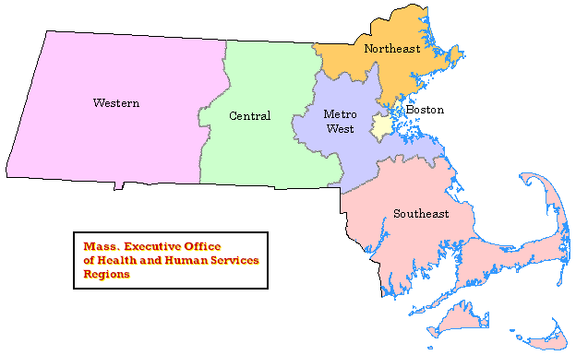
190.8
182.2
186.6
211.6
183.7

Massachusetts Birth Defects 2011-2012 Evaluation Form

TO OUR READERS:
To better serve our users, we are enclosing this evaluation form. Please complete this questionnaire and Fax, email or mail using the contact information at the bottom of this page.

What tables and figures do you find MOST useful?

What tables and figures do you find LEAST useful?

Are there other tables and figures that you would like added to this publication? If yes, please describe.

Do you have other comments or suggestions?

Thank you.

Please return your comments to:

Cathleen A. Higgins, Surveillance Coordinator
Center for Birth Defects Research and Prevention
Bureau of Family Health & Nutrition
Massachusetts Department of Public Health
250 Washington Street, 5th floor, Boston, MA 02108
Phone: 617-624-5510
Fax: 617-624-5574
cathleen.higgins@state.ma.us

