Cancer in Massachusetts by Race and Ethnicity, 2000-2004
The Massachusetts Cancer Registry, Massachusetts Department of Public Health



TABLE OF CONTENTS

Page

Purpose 1
Methods 1
Data Sources 1
Technical Notes 2
Background 5
Race and Ethnicity in Massachusetts 5
Cancer Counts 6
Cancer Incidence Rates 7
Cancer Rates among Males 8
Cancer Rates among Females 9
Median Age at Cancer Diagnosis 10
Stage at Diagnosis 11
Tumor Size at Diagnosis…………………………………………………… 13
Cancer by Selected Ethnic Groups 14
Cancer Mortality 18
Disparities in Cancer Incidence and Mortality 20
Discussion and Implications for Prevention and Early Detection 24
Acknowledgements. 29
References 30

Appendices 33
Appendix A: Race codes for the Massachusetts Cancer Registry 33
Appendix B: Hispanic ethnicity codes for the Massachusetts Cancer Registry 33
Appendix C: Invasive cancer counts and percents by primary site
and racial/ethnic group, males, Massachusetts, 2000-2004 34
Appendix D: Invasive cancer counts and percents by primary site
and racial/ethnic group, females, Massachusetts, 2000-2004 35
Appendix E: Population estimates by age, race/ethnicity, and sex,
Massachusetts, 2000-2004 36
Listing of Tables and Figures

Figure 1. Racial/ethnic distribution of the Massachusetts population, 2005 estimates 6

Figure 2. Racial distribution of new cancer cases by race/ethnicity and sex,
Massachusetts, 2000-2004 7

Figure 3. Age-adjusted incidence rates and 95% confidence limits of all cancer
sites combined by race/ethnicity and sex, Massachusetts, 2000-2004 8

Table 1. Rank and age-adjusted incidence rates of the ten leading cancers by
race/ethnicity, Massachusetts males, 2000-2004 9

Table 2. Rank and age-adjusted incidence rates of the ten leading cancers by
race/ethnicity, Massachusetts females, 2000-2004 10

Figure 4. Median age at diagnosis of leading cancers by race/ethnicity
and sex, Massachusetts, 2000-2004 11

Figure 5. Stage at diagnosis by race/ethnicity for prostate cancer, Massachusetts
males, 2000-2004 12

Figure 6. Stage at diagnosis by race/ethnicity for breast cancer, Massachusetts
females, 2000-2004 13

Figure 7. Tumor size at diagnosis by race/ethnicity for breast cancer, Massachusetts
females, 2000-2004 14

Figure 8. Distribution of the five leading cancers by Hispanic origin and sex,
Massachusetts, 2000-2004 15

Figure 9. Distribution of the five leading cancers among Haitians, by sex,
Massachusetts, 2000-2004 16

Figure 10. Distribution of the five leading cancers among persons born in a
Portuguese-speaking country, by sex, Massachusetts, 2000-2004 16

Figure 11. Distribution of the five leading cancers by Asian origin and sex,
Massachusetts, 2000-2004 17

Table 3. Rank and age-adjusted mortality rates for the ten leading causes of
cancer deaths by race/ethnicity, Massachusetts males, 2000-2004 19

Table 4. Rank and age-adjusted mortality rates for the ten leading causes of
cancer deaths by race/ethnicity, Massachusetts females, 2000-2004 20

Cancer in Massachusetts by Race and Ethnicity, 2000-2004
The Massachusetts Cancer Registry, Massachusetts Department of Public Health

PURPOSE

Cancer in Massachusetts by Race and Ethnicity, 2000-2004 provides data on the incidence of and mortality due to cancer from 2000-2004 among residents of Massachusetts, specifically focusing on disparities by race/ethnicity. This report presents Massachusetts cancer data for four main race/ethnicities: white, non-Hispanic; black, non-Hispanic; Asian/Pacific Islander, non-Hispanic; and Hispanic. For the sake of simplicity, non-Hispanic will be represented as NH throughout the report. This report includes a description of the racial and ethnic groups in Massachusetts, data on the number of cancers and rates by race/ethnicity, median ages at diagnosis, tumor size and stage at diagnosis by race/ethnicity, and data on cancer mortality by racial and ethnic groups. In addition, the most common cancers for selected Asian and Hispanic ethnic groups, Haitians, and persons born in Portuguese-speaking countries will be presented. At the end of the report, the data will be summarized and implications for use in cancer prevention will be explored.

METHODS

Data Sources

Massachusetts Cancer Registry (MCR): All Massachusetts incidence data are provided by the Massachusetts Cancer Registry, which is part of the Massachusetts Department of Public Health (MDPH). The MCR is a population-based cancer registry that began collecting reports of newly diagnosed cancer cases in 1982. In 2004, the MCR collected reports from all Massachusetts acute care hospitals, one medical practice association, selected physician specialties (including 230 dermatology offices), and 2 dermatopathology labs. The MCR also identifies cancers noted on death certificates that were not previously reported to the MCR. The North American Association of Central Cancer Registries (NAACCR) has estimated that MCR case ascertainment is over 95% complete, resulting in gold certification of the registry.¹ The Massachusetts cancer cases presented in this report are primary cases of invasive cancer—cancers that have moved beyond their area of origin to invade surrounding tissue—that were diagnosed among Massachusetts residents, unless noted otherwise.

Massachusetts Registry of Vital Records and Statistics: Massachusetts death data were obtained from the MDPH’s Registry of Vital Records and Statistics, which has legal responsibility for collecting reports of deaths of Massachusetts residents.

Behavioral Risk Factor Surveillance System (BRFSS): The Behavioral Risk Factor Surveillance System (BRFSS) is an ongoing random-digit-dial telephone survey of adults ages 18 and older that is conducted in all states in collaboration with the federal Centers for Disease Control and Prevention (CDC). The survey has been conducted in Massachusetts since 1986. The BRFSS collects data on a variety of health risk factors, preventive behaviors, chronic conditions, and emerging public health issues. The information obtained in this survey assists in identifying the need for health interventions, monitoring the effectiveness of existing interventions and prevention programs, developing health policy and legislation, and measuring progress toward attaining state and national health objectives.

Technical Notes

Statistical Terms:

Incidence – The number of people who are newly diagnosed with a disease, condition, or illness during a particular time period. The incidence data presented here were coded using the International Classification of Disease for Oncology (ICD-O) coding system.

Mortality – The number of people who die from a disease, condition, or illness during a particular time period. The mortality data presented here were obtained from the Massachusetts Registry of Vital Records and Statistics and are based on International Classification of Disease, Tenth Revision (ICD-10) codes.

Age-specific rate – This is a rate among people of a particular age range in a given time period. Age-specific rates were calculated by dividing the number of people in an age group who were newly diagnosed with cancer (incidence) or died of cancer (mortality) by the number of people in that same age group overall.

Age-adjusted rate – This is a rate that takes into account the age structure of a population, allowing for the comparison of populations with different age distributions. Age-adjusted rates were calculated by weighting the age-specific rates for a given year by the age distribution of the 2000 U.S. standard population. The weighted age-specific rates were then added to produce the adjusted rate for all ages combined. Rates should only be compared if they have been adjusted to the same standard population.

Example: Calculation of 1999 Age-adjusted Mortality Rate, Massachusetts: All Causes of Death

A | B | C | D | E
Age | # of deaths (1999) | Population (1998) | 2000 US standard | Age-adjusted rate (using 2000 standard)=[((B/C)*D)*100000]
<1 | 418 | 79860 | 0.013818 | 7.2
1-4 | 65 | 320000 | 0.055317 | 1.1
5-14 | 100 | 806670 | 0.145565 | 1.8
15-24 | 407 | 883830 | 0.138646 | 6.4
25-34 | 701 | 1005337 | 0.135573 | 9.5
35-44 | 1696 | 1019365 | 0.162613 | 27.1
45-54 | 2870 | 818660 | 0.134834 | 47.3
55-64 | 4561 | 495555 | 0.087247 | 80.3
65-74 | 9782 | 442003 | 0.066037 | 146.1
75-84 | 17397 | 299482 | 0.044842 | 260.5
85+ | 17765 | 120501 | 0.015508 | 228.5
Total |  |  |  | 815.9

Median age at diagnosis – The median age at cancer diagnosis is the age at which half the ages at diagnosis are older and half are younger. This is an indicator of the age distribution of a cancer.

Population estimates – The population estimates for this report were produced by the National Center for Health Statistics (NCHS) in collaboration with the Census Bureau’s Population Estimation Program. Each year, in addition to the most recent year’s population estimates, the Census Bureau also revises the previous year’s estimates, including the Census 2000 estimates. The 2004 population estimates file includes new estimates for 2000-2003. The NCHS takes the Census Bureau population estimates file and reallocates the multiple race categories required by the 1997 Office of Management and Budget (OMB) back into the four race categories specified in the 1977 OMB specifications so that the estimates will be compatible with previous years’ populations.

Confidence limits (CLs) [also called confidence intervals (CIs)] – This is a range of values determined by the degree of variability of the data, within which the true value should lie. The 95% confidence intervals presented in this report mean that 95 times out of 100 this range of values will contain the true one. The confidence interval indicates the precision of the rate calculation; the wider the interval, the less certain the rate. Statistically, the width of the interval reflects the size of the population and the number of events; smaller populations and smaller numbers of cases yield less precise estimates that have wider confidence intervals. In this report, confidence intervals were used as a conservative statistical test to estimate the difference between the age-adjusted incidence or mortality rates, with the probability of error of 5% or less (p<=0.05, or p-value less than 0.05).

Statistical significance – An estimate of the probability that the difference between groups is due to chance alone. In this report, differences in cancer stage and tumor size at diagnosis between groups were considered statistically significant when the p-value was less than or equal to 0.05.

Race/Ethnicity:

Race/ethnicity – The categories presented in this report are mutually exclusive; that is, cases are only included in one race/ethnicity category. Please refer to Appendices A and B, respectively, for complete listings of race categories and Hispanic ethnicities collected by the MCR. As part of the NAACCR standards, information on race, Hispanic ethnicity, and country of birth is required on the cancer reporting form.¹ Since 2000, there have been five race fields to account for those people who identify as multi-racial. For the sake of simplicity, and since multi-racial individuals account for less than .0001% of reported cancer cases in Massachusetts, this report will rely on the primary race reported. Reporting on race is complete for 98% of the cases diagnosed between 2000 and 2004.

Race/ethnicity data for incident cancer cases are based on information in the medical record. Because of this, errors in the source documents may lead to incorrect classification of race/ethnicity. Some race/ethnicity categories may be under-reported if race/ethnicity is not available for all cases. Counts and rates may under-represent the true incidence of cancer in some racial/ethnic populations. A recent study comparing race and ethnicity data from the Greater Bay Area Cancer Registry to self-reported race and ethnicity data showed the highest accuracy for white and black non-Hispanics (>90%), moderate accuracy for Hispanics and some Asian subgroups (70-90%), and very low accuracy for American Indians (<20%).² The MCR recently performed a quality assurance study on the data for Asian race and Hispanic ethnicity and improved the accuracy of those data.

To help correctly classify Hispanic ethnicity, the MCR used the NAACCR Hispanic Identification Algorithm (NHIA). This algorithm was applied to cases with an unknown Spanish/Hispanic origin and cases that had been classified as Hispanic based on a Spanish surname only. The algorithm uses last name, maiden name, birthplace, race, and sex to determine the ethnicity of these cases.

Race/ethnicity data for cancer deaths are based on information from death certificates as reported by next-of-kin and funeral directors. Errors in these source documents may lead to incorrect classification of race/ethnicity.

Calculation of incidence rates for selected ethnicities – Age-adjusted incidence rates were calculated for ethnic groups for which there were reasonably complete cancer incidence data and population data. The groups that fell into this category were Chinese, Vietnamese, and Haitians.

Chinese and Vietnamese ethnicities are collected by the MCR. Specific Hispanic ethnicities (Mexican, Puerto Rican, Cuban, Dominican, and Central/South American) are also collected by the MCR, although Dominican ethnicity has only been collected since 2005. About 32% of Hispanics are classified as Hispanic-not otherwise specified (NOS) in this report. Since there was no way to know for certain which Hispanic ethnic group these NOS cases were, it was felt that any rates generated for specific Hispanic ethnicities would likely be underestimates of the true rates.

Portuguese and Haitian ethnicities are not collected by the MCR. For this report, data on these ethnicities are based solely on the country of birth. Still, the rates may be underestimated as a result of Haitians with birth country listed as missing or unknown. Korean rates were not calculated due to the small number of overall cases. South Asians and persons born in Portuguese-speaking countries (Portugal, Cape Verde, and Brazil) were excluded because these categories include multiple countries, making rate calculations more difficult and subject to more calculation errors.

Cancer Terms:

Primary cancer site – The particular area of the body where a cancer originates. For example, a primary case of lung cancer originated in the lung.

Unknown primary site – Cells from the primary cancer have spread from the site of origin, and the site of origin cannot be determined. Usually the tumor cells are found away from the primary site, in either a regional or distant location.

Invasive cancer – A cancer that has spread beyond the layer of tissue in which it developed and is growing into surrounding healthy tissues. Note: in this report, only invasive cancers are presented, with the exception of urinary bladder cancer. Both in situ and invasive cancers are presented for this site. In situ and localized stages can be difficult to distinguish for urinary bladder cancer and tend to be classified at the discretion of the pathologist.

Stages of cancer –
- In situ (early stage) – This is the earliest stage of cancer, before the cancer has spread, when it is limited to a number of small cells and has not invaded the organ itself.
- Localized (early stage) – Cancer is found only in the body part (organ) where it began; it hasn’t spread to any other parts.
- Regional (late stage) – The cancer has spread beyond the original point where it started to the surrounding parts of the body (other tissues).
- Distant (late stage) – The cancer has spread to parts of the body far away from the original point where it began. This is the most difficult stage to treat, since the cancer has spread through the body.
- Unstaged – There is not enough information about the cancer to assign a stage.

Tumor size – the size of a tumor at diagnosis, measured in millimeters. It can be used to determine the extent of disease at the time of diagnosis and, in some cancers, to predict survival time.
BACKGROUND

Race and Ethnicity in Massachusetts

For the purposes of this report, the racial/ethnic categories used will be white NH, black NH, Asian NH, and Hispanic. While Native American is also a census category, the number of cancer cases in this group during the period of interest was too small (59) to perform any meaningful analyses. Readers interested in national trends for Native Americans can refer to the Annual Report to the Nation on the Status of Cancer, 1975–2004, Featuring Cancer in American Indians and Alaska Natives.³

The following are United States Census Bureau definitions of the racial/ethnic groups used in this report.

Whites, as defined by the U.S. Census, are people having origins in any of the original peoples of Europe, the Middle East, or North Africa.⁴ White NHs are whites who are not “persons of Mexican, Puerto Rican, Cuban, Central or South American, or other Spanish culture or origin.”⁴ According to 2005 U.S. Census estimates, white NHs constituted 80.1% of the Massachusetts population and 67.9% of the United States population. In Massachusetts, the predominant white NH ancestries from the 2000 Census were Irish (22.5%), Italian (13.5%), English (11.4%), French (8.0%), and German (5.9%).

Blacks or African Americans, as defined by the U.S. Census, are people having origins in any of the black racial groups of Africa.⁴ While the vast majority of blacks in Massachusetts were born in the United States (71%), there are significant numbers who were born in Haiti (11%), other Caribbean nations (9%), and the African continent, particularly the nations of West Africa (9%). Black NHs are blacks who are not “persons of Mexican, Puerto Rican, Cuban, Central or South American, or other Spanish culture or origin.”⁴ According to 2005 U.S. Census estimates, black NHs constituted 6.2% of the Massachusetts population in and 12.6% of the United States population. In 2000, the most recent year for city-specific data, black NHs constituted a greater percentage of the population in the following cities than for the state as a whole: Boston (25.3%), Springfield (21.0%), Cambridge (11.9%), and Worcester (6.9%).

Asians, as defined by the U.S. census, are people having origins in any of the original peoples of the Far East, Southeast Asia, or the Indian subcontinent.⁴ While part of the Asian continent, people from the Middle East are classified by the Census Bureau as white. Asian, non-Hispanics are Asians who are not “persons of Mexican, Puerto Rican, Cuban, Central or South American, or other Spanish culture or origin.”⁴ According to 2005 U.S. Census estimates, Asian NHs constituted 5.0% of the Massachusetts population and 4.6% of the United States population. The 2000 Massachusetts Asian population was composed primarily of Chinese (34.4%), South Asians (19.8%), Vietnamese (14.3%), Cambodians (8.3%), Koreans (7.3%), Japanese (4.4%), and Filipinos (3.5%). In 2000, Asian NHs constituted a greater percentage than in the state as a whole in Lowell (16.5%), Cambridge (11.9%), and Boston (7.5%). The percentage of Asians in Lowell is particularly high due to the Cambodian population, which represents 57.0% of the Asian and 9.0% of the total population in that city. This area has the second-largest Cambodian population in the U.S., behind Los Angeles.⁵

Hispanics, as defined by the U.S. Census, are “persons of Mexican, Puerto Rican, Cuban, Central or South American, or other Spanish culture or origin regardless of race.”⁴ According to 2005 U.S. Census estimates, Hispanics constituted 7.9% of the Massachusetts population and 14.4% of the United States population. The 2005 American Community Survey of the US Census estimated that the Massachusetts Hispanic population was composed of Puerto Ricans (44.4%), Central and South Americans (24.1%), Dominicans (16.4%), Mexicans (7.0%), Cubans (1.6%), and other (6.5%). In 2000, Hispanics constituted a greater percentage than in the state as a whole in Lawrence (59.7%), Springfield (27.2%), Worcester (15.1%), Boston (14.4%), Lowell (14.0%), and New Bedford (10.2%). According to 2000 U.S. Census data, the Hispanic population continued to be concentrated in urban areas, but the Hispanic population was somewhat more dispersed than in 1990, with some urban areas having larger Puerto Rican populations and others having larger Dominican or Central American populations.⁶ Lawrence, with a nearly 60% Hispanic population, 36.8% of whom are Puerto Rican and 37.6% of whom are Dominican, is the only city in New England where Hispanics are the majority.⁷

The racial/ethnic breakdowns for Massachusetts are presented in Figure 1. Since the percent breakdowns for males and females are nearly identical, this figure presents data for all Massachusetts residents.

Figure 1. Racial/ethnic distribution of the Massachusetts population, 2005 US census estimates

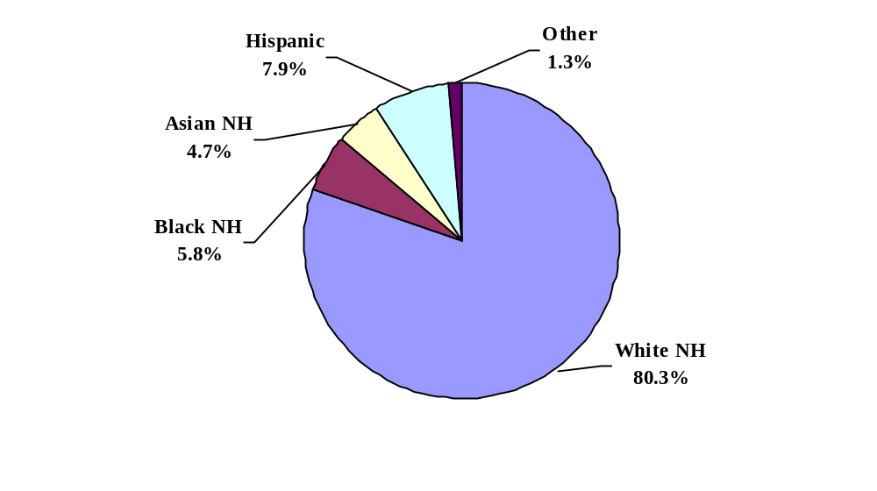

CANCER COUNTS

From 2000-2004, there were 88,132 cases of invasive cancer, including in situ bladder cancer, reported to the MCR among male residents of Massachusetts. The majority of the cancers occurred among white NH males (90.6%) (Figure 2).

From 2000-2004, there were 86,587 cases of invasive cancer, including in situ bladder cancer, reported to the MCR among female residents of Massachusetts. The majority of cancers occurred among white NH females (91.2%) (Figure 2).

Figure 2. Racial distribution of new cancer cases by race/ethnicity and sex, Massachusetts, 2000-2004.

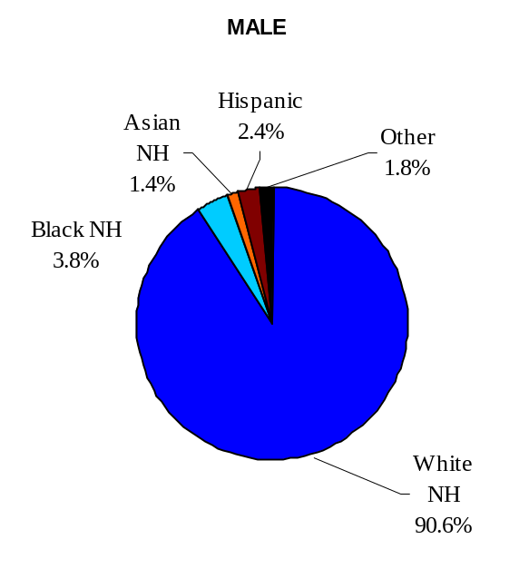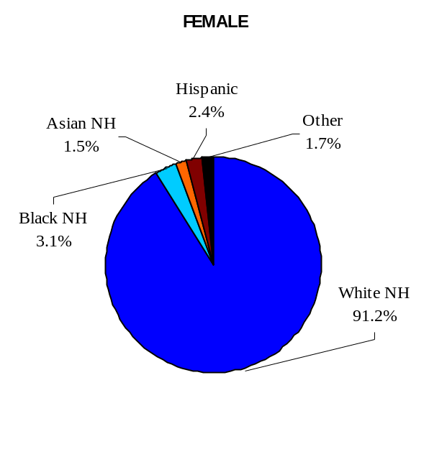
Data source: Massachusetts Cancer Registry

This report focuses on the major cancers diagnosed in Massachusetts residents. Please see Appendices C and D for a complete listing of all invasive cancers by sex and race/ethnicity in Massachusetts from 2000-2004. Population estimates used to determine incidence and mortality rates are found in Appendix E.

Cancer Incidence Rates

Among males, black NHs had the highest age-adjusted incidence rate of all cancer types combined, with 635.9 cases per 100,000 males, and Asian NHs had the lowest rate of all cancer types combined, with 325.8 cases per 100,000, for the years 2000-2004. Among females, white NHs had the highest incidence rate of all cancer types combined, with 462.5 cases per 100,000 females, and Asian NHs had the lowest incidence rate of all cancer types combined, with 270.1 cases per 100,000. For each racial/ethnic group, males had a higher overall rate of cancer than females. The rates for black NH males and white NH females were statistically significantly higher than for the other respective racial/ethnic and sex groups (Figure 3).

Figure 3. Age-adjusted* incidence rates and 95% confidence limits of all cancer sites combined by race/ethnicity and sex, Massachusetts, 2000-2004

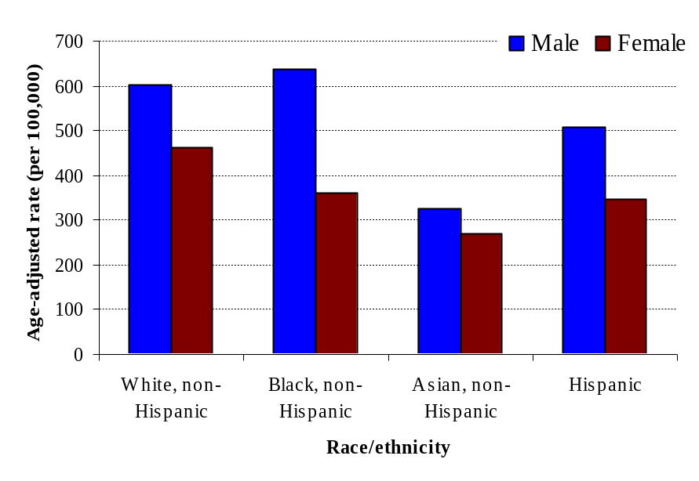
 | White non-Hispanic | Black non-Hispanic | Asian non-Hispanic | Hispanic
Male | 603.7 (599.5-607.9) | 635.9  (613.1-658.6) | 325.8 (305.6-346) | 506.7 (481.9-531.5)
Female | 462.5 (459.2-465.7) | 358.9 (345.2-372.7) | 270.1 (254.3-286) | 345.5 (329.1-362)
* Age-adjusted to the 2000 U.S. Standard Population
Data source: Massachusetts Cancer Registry

Cancer Rates among Males

Prostate cancer was the most commonly diagnosed cancer for each of the race/ethnicity categories among Massachusetts males (Table 1). Black NH males had the highest age-adjusted incidence rate of prostate cancer with 271.8 cases per 100,000, a rate that was statistically significantly higher than any other racial/ethnic group. Lung cancer was second and colorectal cancer was third for all non-Hispanic males. Colorectal cancer was second and lung cancer third for Hispanic males. Lung cancer rates were statistically significantly elevated for both white and black NH males as compared with the other two racial/ethnic groups. Colorectal cancer rates were statistically significantly elevated for white NH males, as were cancers of the urinary bladder and melanoma. Asian NH males had statistically significantly elevated rates of liver cancer. For urinary bladder, kidney, and pancreatic cancers, the rates for Asian NH males were statistically significantly lower than for the other racial/ethnic groups. Asian NH, black NH, and Hispanic males all had statistically significantly higher rates of stomach cancer than white NH males.

Table 1. Rank and age-adjusted* incidence rates of the ten leading cancers by race/ethnicity, Massachusetts males, 2000-2004

 | White NH | Black NH | Asian NH | Hispanic
RANK | Rate (95% CL) | Rate (95% CL) | Rate (95% CL) | Rate (95% CL)
 | All Cancers 603.7 (599.5-607.9) | All Cancers 635.9 (613.1-658.6) | All Cancers 325.8 (305.6-346.0) | All Cancers 506.7 (481.9-531.5)
1 | Prostate  170.6 (168.4-172.9) | Prostate  271.8 (256.9-286.6) | Prostate  77.9 (67.8-88.0) | Prostate  183.7 (168.6-198.8)
2 | Bronchus & Lung  87.0 (85.4-88.6) | Bronchus & Lung  88.5 (79.9-97.2) | Bronchus & Lung  49.7 (41.5-57.9) | Colorectal  48.6 (40.8-56.4)
3 | Colorectal  69.7 (68.3-71.1) | Colorectal  53.7 (47.0-60.5) | Colorectal  47.0 (39.2-54.7) | Bronchus & Lung  49.3 (41.3-57.3)
4 | Urinary Bladder +  48.6 (47.4-49.8) | Urinary Bladder +  22.0 (17.5-26.4) | Liver & Intrahepatic Bile Ducts  28.6 (23.3-33.9) | Urinary Bladder+  27.8 (21.5-34.2)
5 | Melanoma  26.1 (25.2-27.0) | Non-Hodgkin Lymphoma  19.9 (16.2-23.6) | Stomach  15.8 (11.1-20.4) | Stomach  21.3 (16.0-26.5)
6 | Non-Hodgkin Lymphoma  23.4 (22.6-24.2) | Stomach  19.5 (15.2-23.8) | Non-Hodgkin Lymphoma  15.0 (10.8-19.3) | Non-Hodgkin Lymphoma  20.1 (15.8-24.5)
7 | Kidney & Renal Pelvis  19.0 (18.3-19.7) | Kidney & Renal Pelvis  17.5 (13.9-21.1) | Oral Cavity & Pharynx  14.2 (10.2-18.2) | Oral Cavity & Pharynx  18.2 (13.8-22.7)
8 | Oral Cavity & Pharynx  16.4 (15.7-17.0) | Oral Cavity & Pharynx  16.1 (12.7-19.6)  Pancreas  16.1 (12.4-19.8) | Urinary Bladder +  9.7 (6.2-13.2) | Kidney/Renal Pelvis  16.7 (12.3-21.1)
9 | Leukemia  15.0 (14.3-15.6) | Liver & Intrahepatic Bile Ducts  13.9 (10.7-17.1) | Kidney & Renal Pelvis  6.4 (3.9-9.0) | Liver & Intrahepatic Bile Ducts  16.2 (12.3-20.2)
10 | Pancreas  13.0 (12.4-13.6) | Multiple Myeloma  12.7 (9.5-15.9) | Pancreas  6.3 (3.5-9.1) | Leukemia  11.5 (7.9-15.1)
* Age-adjusted to the 2000 U.S. Standard Population.
+ Urinary Bladder includes in situ and invasive cases
Data source: Massachusetts Cancer Registry

Cancer Rates among Females

Breast cancer was the most commonly diagnosed cancer for each of the race/ethnicity categories among Massachusetts females (Table 2). Lung cancer was second and colorectal cancer was third for white NH and black NH females, while colorectal cancer was second and lung cancer was third for both Asian NH and Hispanic females. White NH females had statistically significantly elevated age-adjusted incidence rates of cancers of the breast, the lung, the ovaries, the urinary bladder, and melanoma compared with the other groups. Compared with black NH females, white NHs had statistically significantly elevated rates of uterine cancer. Their uterine cancer rates were comparable to those of Hispanics. Colorectal and lung cancer rates were statistically significantly lower for Asian NH and Hispanic females compared with the other two groups. Thyroid cancer rates were elevated for Asian NH females, but not statistically significantly as compared with White NH and Hispanic females. Additionally, black NH and Hispanic females had statistically significantly elevated rates of cervical cancer compared with white NHs and Asian NHs.

Table 2. Rank and age-adjusted* incidence rates of the ten leading cancers by race/ethnicity, Massachusetts females, 2000-2004

 | White NH | Black NH | Asian NH | Hispanic
RANK | Rate (95% CL) | Rate (95% CL) | Rate (95% CL) | Rate (95% CL)
 | All Cancers  462.5 (459.2-465.7) | All Cancers  358.9 (345.2-372.7) | All Cancers  270.1 (254.3-286.0) | All Cancers  345.5 (329.1-362.0)
1 | Breast  140.2 (138.4-142.0) | Breast  103.2 (96.0-110.4) | Breast  68.8 (61.2-76.4) | Breast  93.3 (85.1-101.5)
2 | Bronchus & Lung  64.1 (62.9-65.3) | Bronchus & Lung  48.4 (43.2-53.6) | Colorectal  33.8 (28.0-39.7) | Colorectal  36.3 (30.7-41.9)
3 | Colorectal  49.5 (48.5-50.6) | Colorectal  45.7 (40.6-50.7) | Bronchus & Lung  30.3 (24.6-36.0) | Bronchus & Lung  27.1 (22.2-32.1)
4 | Corpus Uteri/Uterus  28.7 (27.9-29.5) | Corpus Uteri/Uterus  19.9 (16.6-23.1) | Thyroid  19.4 (15.7-23.1) | Corpus Uteri/Uterus  23.6 (19.5-27.7)
5 | Melanoma  18.5 (17.8-19.1) | Non-Hodgkin Lymphoma  12.4 (9.9-15.0) | Corpus Uteri/Uterus  16.0 (12.3-19.8) | Non-Hodgkin Lymphoma  17.6 (13.7-21.4)
6 | Non-Hodgkin Lymphoma  16.8 (16.2-17.5) | Thyroid  10.6 (8.4-12.7) | Non-Hodgkin Lymphoma  12.0 (8.6-15.4) | Thyroid  14.3 (11.4-17.1)
7 | Thyroid  15.8 (15.2-16.5) | Pancreas  9.9 (7.5-12.3) | Stomach  10.9 (7.5-14.3) | Cervix Uteri/Uterus  12.8 (9.9-15.8)
8 | Ovary  15.3 (14.7-15.9) | Cervix Uteri  9.2 (7.1-11.3) | Oral Cavity & Pharynx  8.6 (5.9-11.2) | Stomach  10.8 (7.8-13.9)
9 | Urinary Bladder  13.3 (12.8-13.9) | Stomach  8.2 (6.0-10.3) | Ovary  8.3 (5.7-10.8) | Leukemia  9.3 (6.7-11.9)
10 | Pancreas  10.7 (10.2-11.1) | Kidney & Renal Pelvis  8.1 (6.1-10.1) | Pancreas  7.9 (5.0-10.9) | Pancreas  8.7 (5.9-11.6)
* Age-adjusted to the 2000 U.S. Standard Population.
Data source: Massachusetts Cancer Registry

MEDIAN AGE AT CANCER DIAGNOSIS

Median ages at cancer diagnosis tended to be older for white NHs as compared with the other racial/ethnic groups. The median age at cancer diagnosis for all cancers combined for males was statistically significantly higher for white NHs (68) compared with black NHs (63), Asian NHs (64), and Hispanics (60). The median age at cancer diagnosis for all cancers combined was similarly statistically significantly higher for white NH females (67) compared with black NHs (60), Asian NHs (55), and Hispanics (55). Colorectal cancer was diagnosed at a statistically significantly younger median age for black NH, Asian NH, and Hispanic males and females compared with white NH males and females. The median age at breast cancer diagnosis was statistically significantly younger for Asian NH, black NH, and Hispanic females compared with white NH females. White NH males were diagnosed at a statistically significantly older median age for prostate cancer compared with black NH and Hispanic males. White males and females were diagnosed with lung cancer at a significantly older median age than black NH and Hispanic males and females. The median ages at diagnosis did not differ significantly between Asian NH and white NH males for prostate cancer or between Asian NH and white NH males and females for lung cancer. (Figure 4)

Figure 4. Median age at diagnosis of leading cancers by race/ethnicity and sex, Massachusetts, 2000-2004

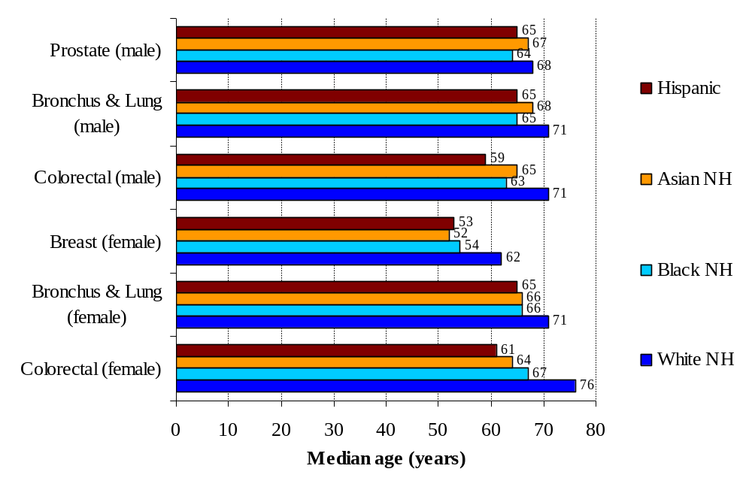 Data source: Massachusetts Cancer Registry

STAGE AT DIAGNOSIS

The stage at which a cancer is diagnosed can be important in determining how to best treat the cancer and can be indicative of how early in the disease process a person is diagnosed. Cancers are staged based on clinical and pathological exams. Please refer to the Technical Notes section at the beginning of this report for staging information. Please note also that prostate cancer is staged using three stage classifications. Its staging does not include in situ cancers, and combines local and regional stages into one stage.⁸

The four racial/ethnic groups were analyzed by stage at diagnosis for female breast cancer, prostate cancer, colorectal cancer, lung cancer, and uterine cancer. (The percentage of cancers that were unstaged did not vary statistically significantly by race/ethnicity, and were omitted from the analyses.) Hispanic males were statistically significantly more likely to be diagnosed at a later stage (regional or distant) of colorectal cancer than white NH males (65% v. 57%). Additionally, Asian NH males were statistically significantly more likely to be diagnosed at a later stage (regional or distant) of lung cancer than white NH males (88% v. 80%). There were no significant differences in stage at diagnosis of lung cancer when comparing black NH males or Hispanic males to white NH males. Black NH males, the group with the highest rates of prostate cancer, had a slightly higher percentage of cases diagnosed at a later stage (regional or distant) than white NH males (14% v. 12%, a statistically significant difference). As compared with white NH females, black NH females were statistically significantly more likely to be diagnosed at a later stage for both breast cancer (42% v. 32%) and uterine cancer (41% v. 24%). There were no statistically significant differences in stage at diagnosis for breast or uterine cancers between Asian NH females, Hispanic females, and white NH females. Figures 5 and 6 illustrate how the distribution of stage at diagnosis differs by racial/ethnic groups for prostate cancer and breast cancer, the most common cancers among males and females, respectively.

Figure 5. Stage at diagnosis by race/ethnicity for prostate cancer, Massachusetts males, 2000-2004

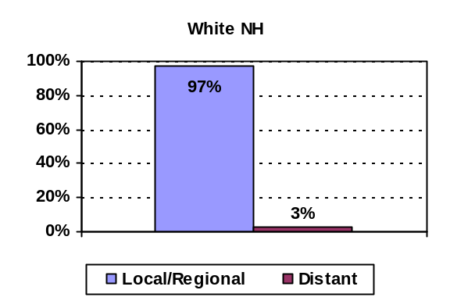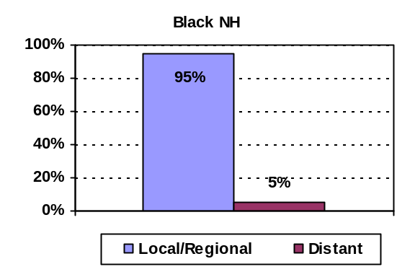
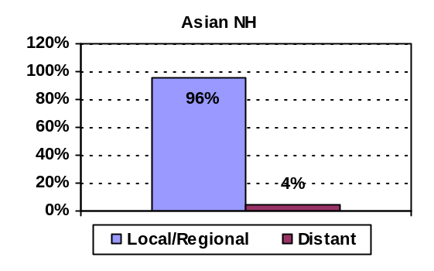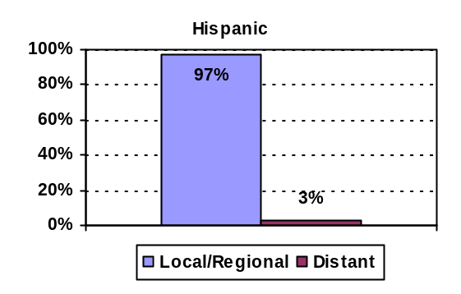
Data source: Massachusetts Cancer Registry

Figure 6. Stage at diagnosis by race/ethnicity for breast cancer, Massachusetts females, 2000-2004

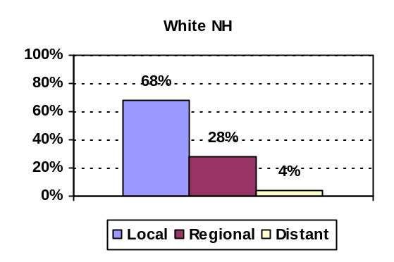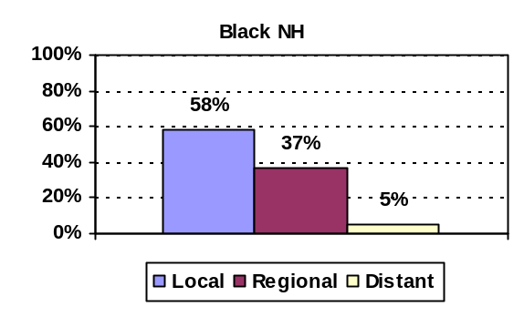
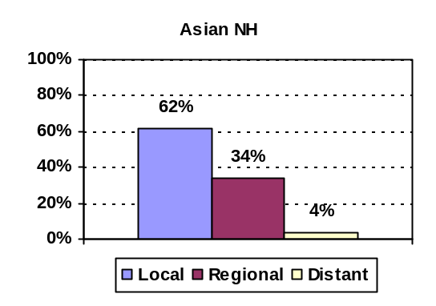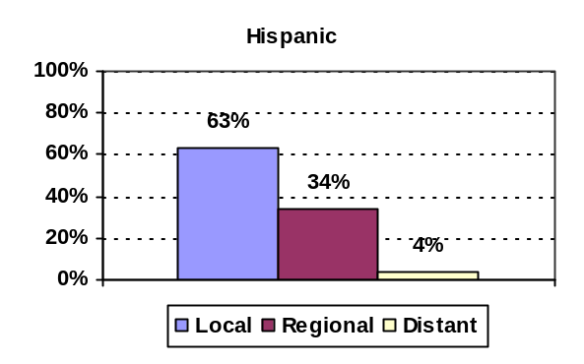
Data source: Massachusetts Cancer Registry

Tumor Size At Diagnosis

In addition to differences in stage among the four racial/ethnic groups, differences in tumor size at diagnosis were also compared. There were no significant differences among males for the three major cancers (prostate, colorectal, and lung). It should be noted that tumor sizes for prostate cancer can be difficult to measure due to their small size and the fact that the cancers are often multifocal, appearing in more than one location.⁹ As a result of this, the majority (nearly 90%) of prostate cancer cases are missing tumor size. There were no significant differences in tumor size among females by racial/ethnic group for colorectal and lung cancer. Hispanic and Black NH females, however, had a statistically significantly larger median tumor size at diagnosis of breast cancer [19 and 16 millimeters (mm), respectively] as compared with white NH females (15 mm). Comparisons of tumor size at diagnosis for female breast cancer are presented in Figure 7. Please note that tumor size data were available for 93% of female breast cancer cases. While data were available for only 35% of uterine cancer cases, the median tumor size at diagnosis for black NH females (51 mm) was statistically significantly larger than the tumor size for white NH females (35 mm).

Figure 7. Tumor size at diagnosis by race/ethnicity for breast cancer, Massachusetts females, 2000-2004

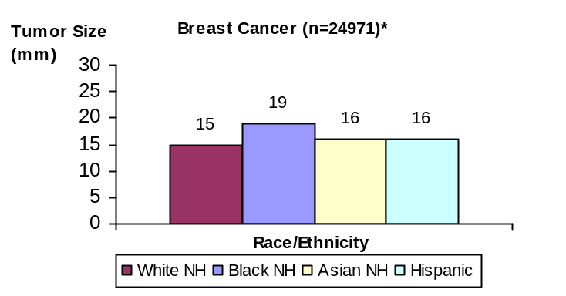
Data source: Massachusetts Cancer Registry. * Cases with tumor size data
+ Tumor size statistically significantly larger than for white NH

CANCER BY SELECTED ETHNIC GROUPS

The incidence of cancer in several major ethnic groups within the larger Hispanic and Asian populations, and the distribution of the top five cancers in these groups, were further analyzed. In addition to these groups, cancer cases among persons born in Haiti and those born in Portuguese-speaking countries (Portugal, Brazil, and Cape Verde) were also separately analyzed. For specific ethnic groups with more complete cancer and population data (specifically, Chinese, Vietnamese, and Haitians), age-adjusted rates were calculated. Please refer to the Technical Notes for background on these analyses.

Among the Hispanic ethnicities, prostate cancer was the most common cancer for all four male Hispanic groups. For Dominican males, prostate cancer represented 45% of cancers, far more than in the other groups. Dominican females had the highest percentage of breast cancer cases (45%) compared with the other groups (25-30%). The percentage of cervical cancer cases was highest among Latin American females (born in Central or South America, except Brazil) (7%), higher than the percentage for Hispanic females overall (4%). (See Figure 8.)

Figure 8. Distribution of the five leading cancers by Hispanic origin and sex, Massachusetts, 2000-2004
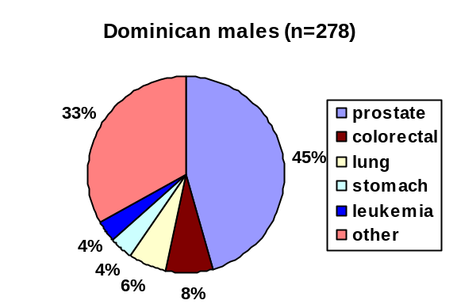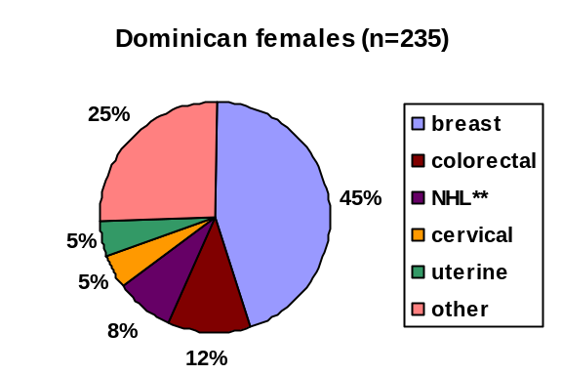
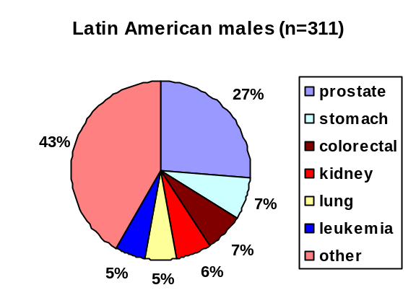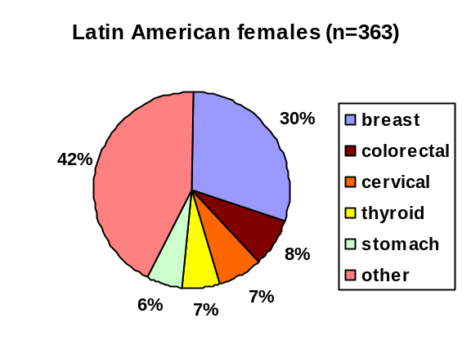
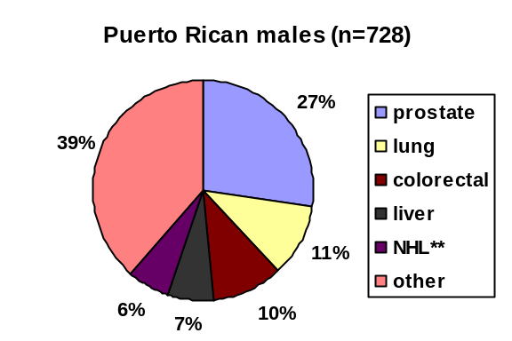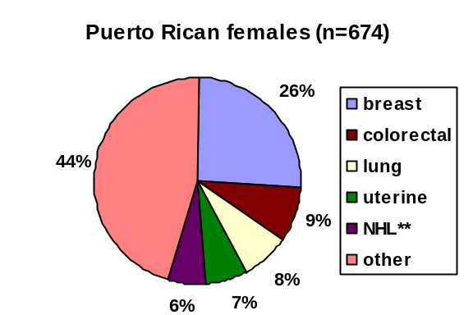
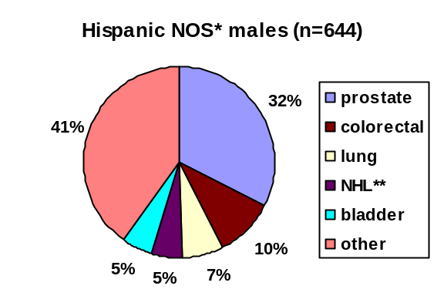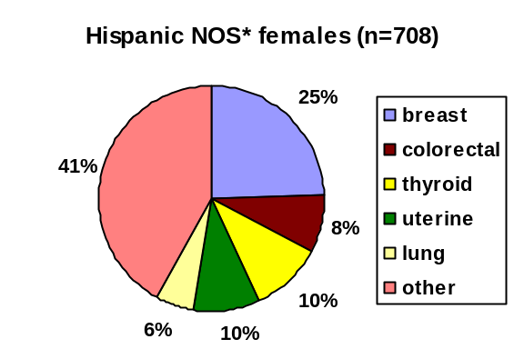
* Indicates not otherwise specified; ** indicates non-Hodgkin lymphoma
Data source: Massachusetts Cancer Registry

Among Haitians, prostate cancer was the leading cancer for males, representing 51% of all cancer cases. Breast cancer was the leading cancer for Haitian females, representing 33% of all cancer cases. Of note, lung cancer cases represented less than 5% of cancer cases in Haitian females. The number of lung cancer cases for females was too small to determine rates. Ninety-six percent of Haitians in the MCR database are classified as black NH. Compared with black NH males as a whole, Haitian males had a statistically significantly lower rate of lung cancer (49.7 cases per 100,000) and a statistically significantly higher rate of prostate cancer (416.0 cases per 100,000). (See Figure 9.)

Figure 9. Distribution of the five leading cancers among Haitians, by sex, Massachusetts, 2000-2004

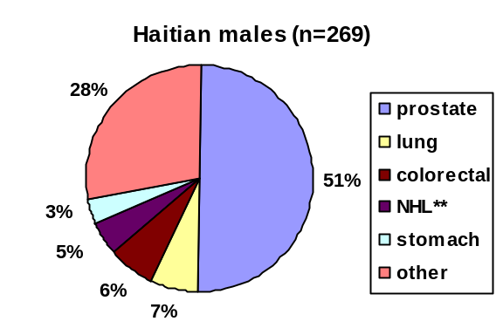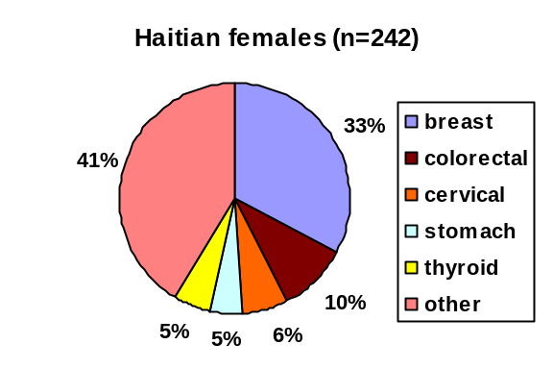
Data source: Massachusetts Cancer Registry; ** indicates non-Hodgkin lymphoma

Among persons born in a Portuguese-speaking country, prostate and lung cancers were the leading cancers among males and breast and colorectal cancers were the leading cancers among females. (See Figure 10.)

Figure 10. Distribution of the five leading cancers among persons born in a Portuguese-speaking country*, by sex, Massachusetts, 2000-2004

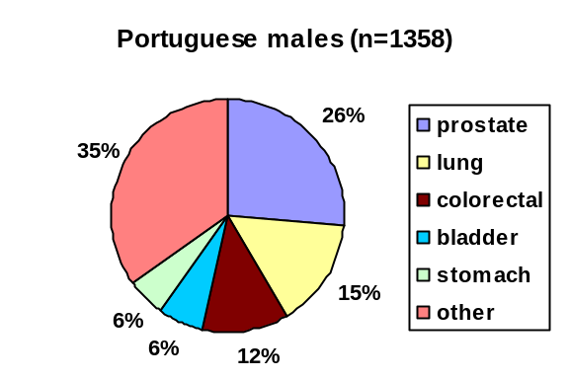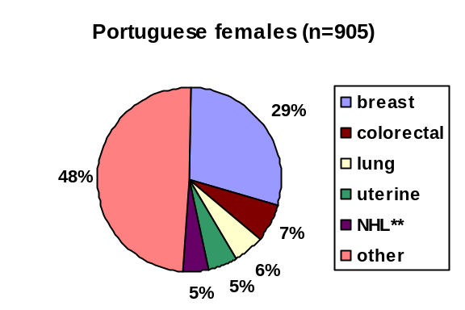
* Born in Portugal, Brazil, or Cape Verde; ** indicates non-Hodgkin lymphoma
Data source: Massachusetts Cancer Registry

Among the Asian ethnicities, the percentage of prostate cancer was the highest for South Asians (Indian, Pakistani, Sri Lankan, Bhutanese, Sikkimese, Nepalese, and Bangladeshi), at 29%. Prostate cancer was still the most commonly diagnosed cancer in all Asian ethnicities other than Koreans, for whom stomach cancer was the most common. Liver cancer was among the top five cancers for Chinese (10%), Vietnamese (13%), and Korean males (11%) and thyroid cancer was ranked among the top five cancers for Vietnamese (14%), Korean (13%), South Asian (8%), and Chinese (7%) females. Since there were fewer than 20 cases in most categories for Chinese and Vietnamese persons, rates in these populations were calculated for only a few cancers. Compared with Asian NH males as a whole, Vietnamese males had statistically significantly elevated rates of lung cancer (65.5/100,000) and liver cancer (56.0/100,000). Their rate of lung cancer was comparable to that of white NH males. (See Figure 11.)

Figure 11. Distribution of the five leading cancers by Asian origin and sex, Massachusetts, 2000-2004

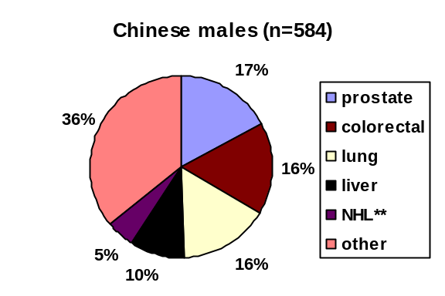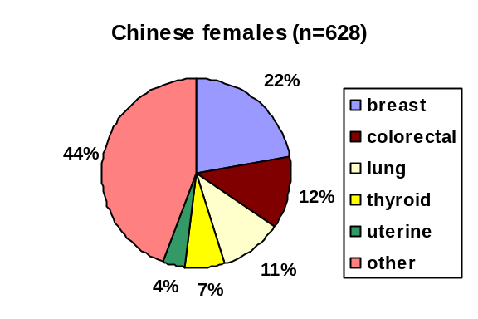
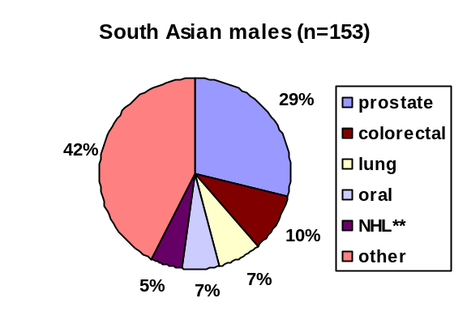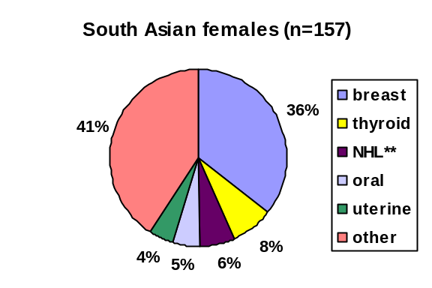
Data source: Massachusetts Cancer Registry; ** indicates non-Hodgkin lymphoma.

Figure 11. (continued) Distribution of the five leading cancers by Asian origin and sex, Massachusetts, 2000-2004

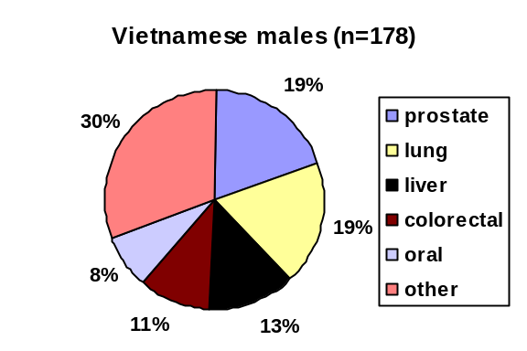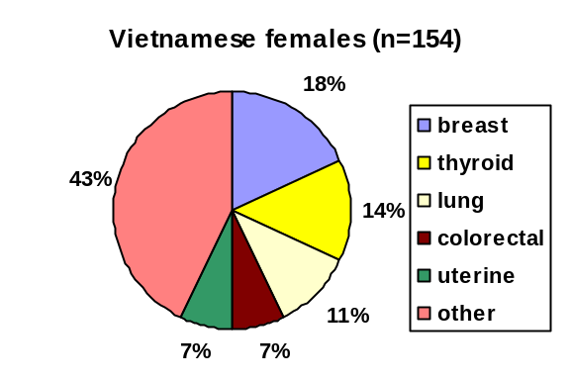
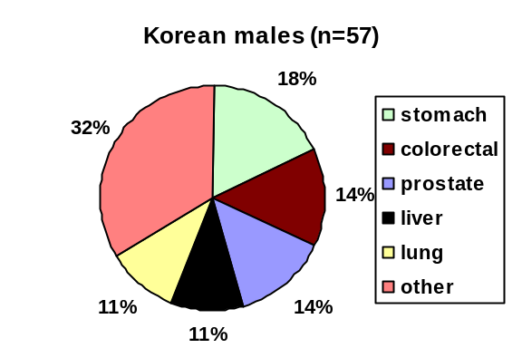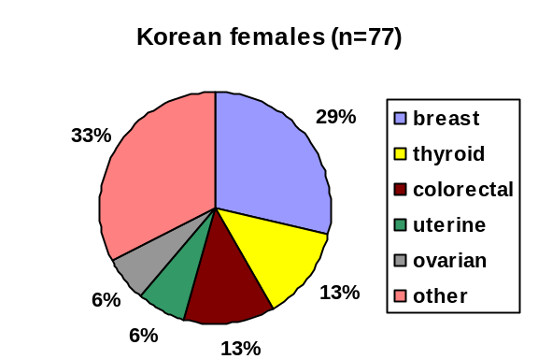
Data source: Massachusetts Cancer Registry; ** indicates non-Hodgkin lymphoma.

Cancer Mortality

In this section, the ten leading causes of cancer deaths are compared for racial/ethnicity groups. Rates were not calculated when there were fewer than 20 deaths for a specific cancer by race/ethnicity.

Males: For all cancers combined from 2000-2004, black NH males had a statistically significantly elevated death rate as compared with the other three racial/ethnic groups. White NH males, in turn, had a statistically significantly elevated death rate when compared with Asian NH and Hispanic males (Table 3). Black NH males had statistically significantly elevated death rates for lung cancer and for prostate cancer compared with white NH males. The death rate for liver cancer was statistically significantly elevated in black NH and Asian NH males compared with white NH males.

Table 3. Rank and age-adjusted* mortality rates for the ten leading causes of cancer deaths by race/ethnicity, Massachusetts males, 2000-2004

 | White NH | Black NH | Asian NH | Hispanic
RANK | Rate (95% CL) | Rate (95% CL) | Rate (95% CL) | Rate (95% CL)
 | All Cancers  244.3 (241.6-247.0) | All Cancers  301.0 (284.3-317.8) | All Cancers  121.2 (108.1-134.3) | All Cancers  134.5 (120.9-148.1)
1 | Bronchus & Lung  69.7 (68.2-71.1) | Bronchus & Lung  80.0 (71.5-88.4) | Bronchus & Lung  39.7 (32.0-47.4) | Bronchus & Lung  31.6 (25.1-38.0)
2 | Prostate  27.1 (26.2-28.0) | Prostate  56.9 (48.9-64.9) | Liver & Intrahepatic Bile Ducts  16.1 (12.1-20.1) | Prostate  15.7 (10.6-20.9)
3 | Colorectal  25.1 (24.2-25.9) | Colorectal  27.0 (21.9-32.0) | Colorectal  9.2 (5.6-12.9) | Colorectal  12.4 (8.0-16.7)
4 | Pancreas  13.1 (12.5-13.7) | Pancreas  16.8 (13.0-20.7) | — | Pancreas  9.4 (5.7-13.0)
5 | Esophagus  10.0 (9.4-10.5) | Stomach  15.0 (11.2-18.7) | — | Liver & Intrahepatic Bile Ducts  9.2 (6.2-12.2)
6 | Non-Hodgkin Lymphoma  9.6 (9.0-10.1) | Liver & Intrahepatic Bile Ducts  12.4 (9.3-15.5) | — | Esophagus  6.3 (3.5-9.2)
7 | Bladder  9.1 (8.6-9.6) | Esophagus  10.3 (7.3-13.3) | — | —
8 | Liver & Intrahepatic Bile Ducts  6.6 (6.2-7.1) | Bladder  7.7 (4.8-10.5)  Multiple Myeloma  7.7 (5.1-10.3) | — | —
9 | Stomach  6.4 (6.0-6.9) | Non-Hodgkin Lymphoma  7.3 (4.8-9.7) | — | —
10 | Melanoma  6.2 (5.8-6.6) | Kidney  4.6 (2.5-6.6) | — | —
— indicates that fewer than 20 deaths occurred.
* Age-adjusted to the 2000 U.S. Standard Population.
Data source: Massachusetts Registry of Vital Records and Statistics .

Females: For all cancers combined from 2000-2004, the mortality rates for white NH and black NH females were comparable and statistically significantly elevated when compared with Asian NH and Hispanic females (Table 4). Breast cancer and colorectal cancer mortality rates were similarly statistically significantly elevated for black NH and white NH females compared with the other two groups. Lung cancer and ovarian cancer death rates were statistically significantly elevated for white NH females compared with black NH females. The death rates for liver cancer were elevated for Hispanic and Asian NH females compared with the other two groups. Ovarian cancer mortality rates were statistically significantly elevated for white NH females.

Table 4. Rank and age-adjusted* mortality rates for the ten leading causes of cancer deaths by race/ethnicity, Massachusetts females, 2000-2004

 | White NH | Black NH | Asian NH | Hispanic
RANK | Rate (95% CL) | Rate (95% CL) | Rate (95% CL) | Rate (95% CL)
 | All Cancers  172.7 (170.8-174.7) | All Cancers  176.2 (166.3-186.1) | All Cancers  90.5 (80.5-100.4) | All Cancers  92.1 (82.9-101.3)
1 | Bronchus & Lung  46.5 (45.5-47.5) | Bronchus & Lung  36.2 (31.7-40.7) | Bronchus & Lung  19.4 (14.7-24.1) | Breast  12.6 (9.5-15.7)
2 | Breast  26.2 (25.4-27.0) | Breast  28.4 (24.5-32.2) | Colorectal  9.6 (6.2-13.0) | Bronchus & Lung  12.1 (8.7-15.6)
3 | Colorectal  17.2 (16.6-17.8) | Colorectal  18.9 (15.6-22.2) | Breast  8.5 (5.6-11.5) | Colorectal  8.6 (5.8-11.5)
4 | Pancreas  10.2 (9.7-10.6) | Pancreas  11.1 (8.6-13.7) | Pancreas  6.4 (3.7-9.1) | Pancreas  7.8 (5.0-10.6)
5 | Ovarian  9.6 (9.1-10.1) | Uterine  7.6 (5.5-9.6) | Liver & Intrahepatic Bile Ducts  5.6 (3.1-8.0) | Liver & Intrahepatic Bile Ducts  4.5 (2.4-6.6)
6 | Non-Hodgkin Lymphoma  6.5 (6.2-6.9) | Non-Hodgkin Lymphoma  6.8 (4.8-8.7) | — | —
7 | Uterine  4.3 (4.0-4.6) | Stomach  5.8 (4.0-7.6) | — | —
8 | Stomach  3.1 (2.9-3.3) | Multiple Myeloma  5.6 (3.8-7.5) | — | —
9 | Multiple Myeloma  3.0 (2.7-3.2) | Ovarian  5.4 (3.7-7.2) | — | —
10 | Liver & Intrahepatic Bile Ducts  2.4 (2.2-2.6) | Liver & Intrahepatic Bile Ducts  3.9 (2.4-5.4) | — | —
— indicates that fewer than 20 deaths occurred.
* Age-adjusted to the 2000 U.S. Standard Population.
Data source: Massachusetts Registry of Vital Records and Statistics

DISPARITIES IN CANCER INCIDENCE AND MORTALITY

For this section, only statistically significant differences will be presented unless otherwise noted.

Cancer among males:

- For black NH males, the incidence rate of prostate cancer was 1.6 times higher than for white NH males, and the mortality rate was 2.1 times higher. Both differences were significant.

- The incidence rate of lung cancer for black NH males was similar to that for white NH males, but the mortality rate was 1.2 times higher, a significant difference.

- The incidence rate of stomach cancer for black NH males was 1.8 times higher than that of white NH males, and the mortality rate was 2.3 times higher. Both differences were significant.

- The incidence rate of colorectal cancer for black NH males was significantly lower than that of white NH males, but the mortality rate was higher, though not significantly so.

Cancer among females:

- The incidence rate of breast cancer was 1.4 times higher for white NH females compared with black NH females, a significant difference. The mortality rate was 1.1 times higher among black NH females than among white NH females, but the difference was not significant.

- The incidence rate of uterine cancer was 1.4 times higher among white NH females than among black NH females, but the mortality rate was 1.8 higher among black NH females than among white NH females. Both differences were significant.

- The incidence rate of cervical cancer in black NH females was 1.5 times higher than that of white NH females, a significant difference. The mortality rate for black NH females was nearly twice that of white NH females, a non-significant difference.

Cancer among white non-Hispanics:

- White NH females had a statistically significantly elevated overall rate of cancer compared with the other three racial/ethnic groups. White NH males had a significantly lower rate compared with black NH males, but a significantly elevated rate when compared with those of Asian NHs and Hispanics.

- Compared with the other three racial/ethnic groups, white NH males had significantly higher incidence rates of urinary bladder cancer, colorectal cancer, melanoma, and testicular cancer.

- Compared with the other three racial/ethnic groups, white NH females had significantly higher incidence rates of breast cancer, lung cancer, uterine cancer, melanoma, and urinary bladder cancer.

- Compared with the other three racial/ethnic groups, both white NH males and females had a significantly higher overall median age at cancer diagnosis.

- Compared with the other three racial/ethnic groups, white NH males were diagnosed at a significantly older age for colorectal cancer, non-Hodgkin lymphoma, and leukemia.

- Compared with the other three racial/ethnic groups, white NH females were diagnosed at a significantly older age for breast cancer, colorectal cancer, non-Hodgkin lymphoma, and leukemia.

Cancer among black non-Hispanics:

- Overall, black NH males had a significantly elevated overall rate of cancer compared with the other three groups. Black NH females had a significantly lower overall rate of cancer compared with white NH females.

- Compared with white NH males, black NH males had significantly higher rates of prostate cancer. Their rate of prostate cancer was the highest rate of any cancer among all the racial/ethnic and sex groups.

- The median ages at diagnosis of colorectal cancer, leukemia, and non-Hodgkin lymphoma were significantly lower for black NH males compared with white NH males. The median age of diagnosis of breast cancer was significantly among black NH females compared with white NH females.

- Compared with white NH females, black NH females had significantly higher rates of multiple myeloma, stomach cancer, and cervical cancer.

- Black NH males were significantly more likely to be diagnosed at a regional or distant stage of prostate cancer than white NH males.

- Black NH females were significantly more likely to be diagnosed at a regional or distant stage of breast and uterine cancer than white NH females.

- Black NH females had significantly larger tumor sizes at diagnosis for breast and uterine cancers than white NH females.

- The rate of prostate cancer among Haitian males was significantly elevated compared with all other racial/ethnic groups.

- Black NH males had significantly elevated mortality rates for all cancers combined, prostate cancer, lung cancer, and stomach cancer compared with white NH males.

- Black NH females had a significantly elevated mortality rate for uterine cancer compared with white NH females.

Cancer among Asian non-Hispanics:

- Overall, the rates of cancer among Asian NH males and females were significantly lower than all the other racial/ethnic groups.

- Both Asian NH males and females had significantly elevated rates of liver cancer compared with white NHs, but not with black NHs or Hispanics.

- Asian NH females had significantly elevated rates of thyroid cancer compared with black NHs and elevated, though not significantly, rates compared with white NH and Hispanic females.

- The median age at diagnosis was significantly lower for ovarian cancer in Asian NH females compared with other racial/ethnic groups.

- Asian NH males were significantly more likely to be diagnosed at a later stage (regional or distant) of lung cancer than white NHs.

- Mortality and incidence rates for liver cancer were significantly higher for Asian NH males compared with the other racial/ethnic groups. Mortality and incidence rates of liver cancer for Asian NH females were significantly higher than for white NH females, but were comparable with those of black NH and Hispanic females.

- Among Asian ethnic groups, stomach cancer was the leading cancer for Korean males. Thyroid cancer ranked in the top five for Vietnamese and Korean females. Liver cancer ranked in the top five for Chinese, Korean, and Vietnamese males. The lung cancer incidence rate among Vietnamese males was significantly elevated compared with all other Asian, Hispanic, and black NH males; it was comparable to the white NH rate. The rate of liver cancer among Vietnamese males was significantly elevated compared with all Asian NH males.

Cancer among Hispanics:

- Overall cancer rates among Hispanic males were significantly lower than those of white and black NH males, but significantly higher than those of Asian NH males. The overall cancer rates for Hispanic females, however, were only significantly lower than those of white NH females. Their rates were significantly higher than those of Asian NH females and comparable to those of black NH females.

- Both Hispanic males and females had significantly elevated rates of liver cancer compared with white NHs.

- Hispanic males were significantly more likely to be diagnosed with a regional or distant stage of colorectal cancer than white NH males.

- Hispanic females had the highest rates of cervical cancer of any racial/ethnic groups, significantly higher than those of white NHs and Asian NHs.

- Compared with white NH males and females, the median ages at diagnosis for Hispanic males were significantly lower for colorectal cancer, leukemia, and non-Hodgkin lymphoma, and were significantly lower for colorectal and breast cancer among Hispanic females.

- For lung, colorectal, and breast cancer, Hispanic females had significantly larger tumor sizes at diagnosis compared with white NH females.

- Among Hispanic ethnicity groups, prostate cancer was the predominant cancer for all four male Hispanic groups. For Dominican males, prostate cancer represented 45% of cancers, far more than the other groups and roughly the same percentage as black NH males overall (42%). Among females, Dominicans had the highest percentage of breast cancer cases (45%) compared with the other groups (25-30%). The percentage of cervical cancer cases was highest among Latin American females (7%), higher than the percentage for Hispanic females overall (4%).

DISCUSSION AND IMPLICATIONS FOR PREVENTION AND EARLY DETECTION

As shown in this report, cancer strikes all races and ethnicities. In some cases, it is evenly distributed, but in others there are significant differences. This final section of the report will address a few of the major differences by cancer type, along with risk factors and implications for prevention and early detection.

Prostate Cancer

The prostate cancer rate in black NH males was the highest of any cancer in any racial/ethnic or sex group in the state, consistent with national trends. It is not known why these rates are elevated. Additionally, black NH males in Massachusetts were statistically significantly more likely to be diagnosed with prostate cancer at a later stage. It has been hypothesized that socioeconomic factors may contribute to explain the fact that black males are diagnosed at later stages, as they make up approximately 12% of the total U.S. population, yet account for one-third of the nation’s poor.¹⁰ Many studies, however, have found that socioeconomic factors alone cannot adequately explain the higher percentage of advanced disease in blacks and that further research needs to address biological and genetic susceptibility factors in addition to socioeconomic factors.¹⁰

Despite the inconclusive theories as to the causes of the higher rates and later presentation, the importance of screening in this group is clear. The prostate specific antigen blood test (PSA) and the digital rectal exam (DRE) are both screening tests for prostate cancer. There were, however, no significant differences between black NH males, white NH males and Hispanics having had a PSA test or a DRE in the previous year according to 2004 BRFSS data from Massachusetts. Since Haitians were also found to have statistically significantly elevated rates of prostate cancer, it is important to offer prostate screening programs targeted to this group.¹¹

Colorectal Cancer

White NH males had statistically significantly elevated rates of colorectal cancer, although 2004 BRFSS data showed no significant difference between white NHs, black NHs, and Hispanics (both sexes combined) with regard to colorectal cancer screening (fecal occult blood test or colonoscopy) in the past five years. Despite having lower incidence rates than white NH males, Hispanic males were significantly more likely to be diagnosed at a more advanced stage of colorectal cancer than were white NHs. According to national statistics from 2000-2003, Hispanics were more likely to be diagnosed with an advanced stage of colorectal cancer than white NHs.¹² Despite black NH males having lower incidence rates of colorectal cancer, they had elevated mortality rates compared with white NH males. Neither the incidence rates nor the mortality rates for colorectal cancer were statistically significantly different between black NH and white NH females. Hispanic females had a significantly lower incidence rate of colorectal cancer compared with white NH females. There were no racial/ethnic differences in stage at diagnosis among females. A recent article that reviewed the results of several studies on colorectal cancer survival concluded that race itself was only marginally significant after adjusting for socioeconomic factors and treatment.¹³

Some of the major risk factors for colon cancer include a past history of colorectal cancer, a history of polyps, a history of bowel disease, a family history of colorectal cancer, a diet high in fat, lack of exercise, being overweight, and smoking.¹⁴ According to the 2004 BRFSS data, white NH males were significantly less likely to be obese and significantly more likely to have engaged in leisure time physical activity than black NH males. There were no significant differences in smoking rates.

Lung Cancer

Lung cancer incidence rates did not differ statistically significantly between black and white NH males, but the mortality rates were statistically significantly higher for black NH males. Lung cancer rates were statistically significantly higher for white NH females than black NH females, and white NH females also had statistically significantly higher mortality rates than black NH females. Studies have suggested that the higher mortality rates among black NH males may be due to their being less likely than whites to receive surgery after being diagnosed with an early stage lung cancer, even after controlling for socioeconomic factors.¹⁵

Asian NH males were statistically significantly more likely to be diagnosed at a later stage of lung cancer. This finding agrees with a recent study on lung cancer among Asian immigrants, which suggested language barriers are a factor that may delay diagnosis and treatment. Additionally, self-reported smoking status has been shown to underestimate true smoking status in Asian immigrants.¹⁶ Of note, lung cancer cases represented less than 5% of cancer cases in Haitian females, which was much lower than in black NH females overall (13%), perhaps owing to the statistically significantly lower smoking rates among Haitian women compared with U.S.-born black women.¹⁷ Lung cancer rates were statistically significantly elevated for Vietnamese males, which reflected similar findings in California. ¹⁸ Studies have revealed a smoking prevalence of 72.8% among males in Vietnam¹⁹ and a prevalence of 43.0% in Massachusetts, nearly twice that of Massachusetts males as a whole.²⁰.

Breast Cancer

White NH females had statistically significantly elevated rates of breast cancer compared with black NH females. Black NH females were statistically significantly younger at diagnosis (54 vs. 63), however, and were significantly more likely to be diagnosed at a later stage and with a larger tumor size. Risk factors for breast cancer include family history, earlier breast radiation, early menarche (first period before age 12) or late menopause (after age 55), not having children or having them after 30, and hormone replacement therapy.²¹

2005 BRFSS data showed no significant difference in breast cancer screening rates among white NHs, black NHs, and Hispanics in the past two years. The nearly ten-year difference in median ages, however, suggests the importance of breast cancer screening among younger black NH females. While black NH females had lower incidence rates of breast cancer than white NH females, their mortality rates were higher. Both later stage at diagnosis and higher mortality rates for breast cancer among black NH females compared with whites have been widely documented.²² A recent study that examined race and breast cancer survival found that socioeconomic status, even more than race, was associated with stage at diagnosis, type of treatment received, and likelihood of death.²³

Liver Cancer

Asian males and females had statistically significantly elevated rates of liver cancer compared with all other groups. It is believed that much of this is due to chronic Hepatitis B infection (HBV) acquired through maternal transmission, which disproportionately affects East Asians. In a recent study that screened for chronic HBV infection in New York City, prevalence figures varied from 4.6% among those born in South Korea to 21.4% among those born in China.²⁴ Hepatitis B screening programs geared toward East Asians are vital in reducing the incidence of liver cancer by identifying people with chronic HBV infection so that they may receive treatment and decrease their risk of developing liver cancer.

Both black NHs and Hispanics also suffer from statistically significantly higher rates of liver cancer compared with white NHs. Since liver cancer is strongly associated with both Hepatitis B and C infection, it is important that people who are at an increased risk for these infections (injection drug use, blood transfusion recipient before 1992, and a history of unprotected sex with an infected partner being the major risk factors) be tested for these viruses.^{25, 26} Additionally, alcohol abuse can lead to cirrhosis of the liver, which in turn can lead to liver cancer.²⁷

Cervical Cancer

Rates of cervical cancer were statistically significantly elevated among black NH and Hispanic females. Nearly 100% of females with cervical cancer have evidence of infection with human papillomavirus (HPV), which has been recognized as the main cause of cervical cancer. While infection with HPV appears necessary for cervical cancer to develop, most infected females do not develop the disease.²⁸ Certain types of sexual behavior that increase a woman’s chance of getting HPV infection include having sex at an early age, having many sexual partners, and having sex with uncircumcised males. Females with HPV who smoke are twice as likely as non-smokers to get the disease, as are females who are co-infected with HIV and/or chlamydia.²⁹ HPV infection occurs in younger females and is less common in females over 30. On average, invasive disease appears many years after infection; the median ages of diagnosis among black NH females and Hispanic females in Massachusetts were 48 and 47, respectively and did not significantly differ from that of white NH females (50). The U.S. Food and Drug Administration recently approved a vaccine for HPV for females to prevent cervical cancer caused by HPV. Regular cervical cancer screening with a Pap test is recommended for all females starting within three years of when a woman begins sexual activity or at age 21, whichever comes first. Cervical cancer was once the leading cause of death for females in the U.S., but the incidence and mortality rates have declined statistically significantly, primarily due to the use of the Pap test.²⁹ 2004 BRFSS data showed no significant differences among black NHs, white NHs, and Hispanics with regard to cervical cancer screening in the past three years. Despite these developments, however, mortality rates of cervical cancer for black NH females are twice those of white NHs, though not statistically significantly different.

Uterine Cancer

As with breast cancer, the incidence rates of uterine cancer for white NH females were statistically significantly elevated compared with black NH females, but the mortality rates were statistically significantly elevated for black NH females compared with white NHs. Additionally, black NH females were statistically significantly more likely to be diagnosed at a later stage and with a larger tumor size than white NHs. A recent study examining differences in uterine cancer survival between white NHs and black NHs showed that even when patients with advanced uterine cancer received similar therapy, however, black NH females still had a lower overall survival rate, indicating the need for further studies on disparities.³⁰

Some factors that may increase the risk for developing uterine cancer include prior pelvic radiation therapy, certain types of estrogen replacement therapy, treatment with tamoxifen (a hormonal drug used for breast cancer treatment and breast cancer risk reduction), infertility, diabetes, menstrual periods before age 12, and menopause after age 52. There are currently no screening tests for this cancer, but a Pap smear sometimes incidentally detects this cancer.³¹

Urinary Bladder Cancer

Both white NH males and females had statistically significantly elevated rates of urinary bladder cancer relative to other racial/ethnic groups. It is not known why there is a difference in incidence. Some of the risk factors include smoking and occupational exposure to certain chemicals such as benzidine and beta-naphthylamine, which are sometimes used in the dye industry.³² It is important to have any changes in bladder function, such as blood in the urine, checked by a physician.

Melanoma

The statistically significantly elevated melanoma rates for white NH males and females were not surprising, given that lighter skin is more susceptible to skin cancer. The most important prevention for this disease is limiting direct sun exposure by using sunscreen and covering the skin. Additionally, abnormal appearances or changes in moles should be examined by a physician.³³

Other Cancers

Multiple myeloma nationally is twice as prevalent in blacks than whites ³⁴ There are no known reasons for this disparity and, unfortunately, no known preventive measures. It is a rare cancer, with an incidence rate of 7.6/100,000 for black NH females and 12.7/100,000 for black NH males in Massachusetts. These rates are nearly twice the rates for white NH males and females and are statistically significantly elevated for both sexes.

Testicular cancer incidence rates were statistically significantly higher among white NH males than among black NH males/than among other racial ethnic groups in Massachusetts. The reason for this difference is unknown.³⁵ It is important to have any testicular lump checked by a physician.

Ovarian cancer incidence rates were statistically significantly higher for white NH females compared to the other three groups as were mortality rates. These rates reflect the national data. Some of the risk factors include a diet high in fats, not having had children, an early menarche (<12) or a late menopause (>50), a previous diagnosis of breast cancer, and a family history of ovarian cancer.³⁶

For Korean males, stomach cancer was the most common cancer. This is consistent with other studies and may be the result of heavy salt consumption and cooking methods such as broiling and salting.³⁷

Conclusions:

Many of the disparities presented in this report cannot be explained and are most likely the result of complex interactions between genetic variations, environmental factors, and specific health behaviors.³⁸ In looking for biological answers to racial disparities, the fact that racial and ethnic categories are defined by the U.S. Census based on social categories rather than biological science or classification needs to be taken into account.³⁹ Uniform access to health care may also play a role in disparities. According to a recent survey from the U.S. Department of Health & Human Services’ Agency for Healthcare Research and Quality (AHRQ), about 30% of Hispanics and 20% of black Americans lack a usual source of health care, compared with 16% of whites.⁴⁰

While cancer treatments have become more effective, it remains troubling that mortality rates for black NH males in Massachusetts are significantly elevated for prostate cancer, lung cancer, and stomach cancer compared with white NH males, and mortality rates for black NH females are significantly elevated for uterine cancer and elevated, though not significantly, for cervical cancer and breast cancer compared with white NHs. Additionally, mortality rates for Asian NH males and females are significantly elevated for liver cancer when compared with white NHs.

Such disparities in mortality, along with those in tumor size and stage at diagnosis, support the importance of improving awareness and access to health care for screening and early treatment. According to a study supported by AHRQ, the length of time between an abnormal screening mammogram and the follow-up diagnostic tests needed to determine whether a woman has breast cancer is more than twice as long in Asian, black, and Hispanic women as white women.⁴⁰ As part of its 2010 goal to reduce disparities in health care such as this, the U.S. Centers for Disease Control and Prevention (CDC) funds the National Breast and Cervical Cancer Early Detection Program. A component of this program addresses the elimination of barriers to routine screening and creating paths to quicker treatment.⁴¹ For all cancers, access to timely medical treatment once a diagnosis has occurred is imperative and can mean the difference between short- and long-term survival.

ACKNOWLEDGEMENTS

Thanks to Richard Knowlton for preparing this report. Special thanks to Melissa Liu for her diligent review of and insightful comments on earlier drafts. Special thanks as well to Laurie MacDougall for her thorough edits of the final draft and to Bertina Backus and Susan Gershman for their comments. Thanks are also given to Malena Hood and James West in the Division of Research and Epidemiology and to staff in the Registry of Vital Records and Statistics for providing the mortality and population data. We acknowledge the Centers for Disease Control and Prevention for its support of the staff and the printing of this report under cooperative agreement 1 U58 DP000821-01 awarded to the Massachusetts Department of Public Health. Its contents are solely the responsibility of the authors and do not necessarily represent the official views of the Centers for Disease Control and Prevention.

REFERENCES

- Havener L, Hultstrom D, eds. Standards for Cancer Registries, Volume II: Data Standards and Data Dictionary, 11th Edition. Springfield, IL: North American Association of Central Cancer Registries; 2006.

- Gomez SL, Glaser SL. Misclassification of race/ethnicity in a population-based cancer registry (United States). Cancer Causes Control. 2006;17:771-781.

- Espey DK, Wu X-C, Swan J, et al. Annual report to the nation on the status of cancer, 1975-2004, featuring cancer in American Indians and Alaska Natives. Cancer. 2007;110:2119-2152.

- Grieco EM, Cassidy RC. Overview of Race and Hispanic Origin: Census 2000 Brief. Washington, DC: U.S. Census Bureau; 2001. Publication C2KBR/01-1. Available at: http://www.census.gov/ prod/2001pubs/c2kbr01-1.pdf. Accessed March 4, 2008.

- Southeast Asia Resource Action Center (SERAC). Cambodian Refugees. Available at: http://www.searac.org/cambref.html. Accessed March 10, 2008.

- Bureau of Health Statistics, Research, and Evaluation. Hispanic Births in Massachusetts 1996-1999. Boston, MA: Massachusetts Department of Public Health; 2001.

- Jones C. Latinos in Lawrence, Massachusetts. Boston, MA: Mauricio Gaston Institute for Latino Community Development and Public Policy; 2003.

- Massachusetts Cancer Registry. Cancer Incidence and Mortality in Massachusetts 1999-2003: Statewide Report. Boston, MA: Massachusetts Department of Public Health; 2006.

- Eichelberger LE, Koch MO, Daggy JK, et al. Predicting tumor volume in radical prostatectomy specimens from patients with prostate cancer. Am J Clin Pathol. 2003;120:386-391.

- Hoffman RM, Gilliland FD, Eley JW, et al. Racial and ethnic differences in advanced-stage prostate cancer: the Prostate Cancer Outcomes Study. J Natl Cancer Inst. 2001:93:388-395.

- Kleier JA. Prostate cancer in black men of African-Caribbean descent. J Cult Divers. 2003;10:56-61.

- American Cancer Society. Cancer Facts & Figures for Hispanics/Latinos 2006-2008. Available at: http://www.cancer.org/downloads/STT/CAFF2006HispPWSecured.pdf. Accessed February 26, 2008.

- Du XL, Meyer TE, Franzini L. Meta-analysis of racial disparities in survival in association with socioeconomic status among men and women with colon cancer. Cancer. 2007;109:2161-2170.

- American Cancer Society. Overview: Colon and Rectum Cancer. What Causes Colorectal Cancer? Available at: http://www.cancer.org/docroot/CRI/content/CRI_2_2_2X_What_causes_colorectal_ cancer.asp?sitearea=. Accessed February 26, 2008.

- American Cancer Society. Cancer Facts & Figures for African Americans 2007-2008. Available at: http://www.cancer.org/downloads/STT/CAFF2007AAacspdf2007.pdf. Accessed February 26, 2008.

- Finlay GA, Joseph B, Rodrigues CR, Griffith J, White AC. Advanced presentation of lung cancer in Asian immigrants. Chest. 2002;122:1938-1943.

- Taylor KL, Kerner JF, Gold KF, Mandelblatt JS. Ever vs never smoking among an urban, multiethnic sample of Haitian-, Caribbean-, and U.S.-born blacks. Prev Med. 1997;26:855-865.

- McCracken M, Olsen M, Chen MS Jr, et al.. Cancer incidence, mortality, and associated risk factors among Asian Americans of Chinese, Filipino, Vietnamese, Korean, and Japanese ethnicities. CA Cancer J Clin. 2007; 57:190-205.

- Jenkins CN, Dai PX, Ngoc DH, et al. Tobacco use in Vietnam. Prevalence, predictors, and the role of the transnational tobacco corporations. JAMA. 1997; 277:1726-1731.

- Wiecha JM, Lee V, Hodgkins J. Patterns of smoking, risk factors for smoking, and smoking cessation among Vietnamese men in Massachusetts (United States). Tob Control. 1998;7:27-34.

- American Cancer Society Overview: Breast Cancer. What Causes Breast Cancer? Available at: http://www.cancer.org/docroot/CRI/content/CRI_2_2_2X_What_causes_breast_cancer_5.asp?sitearea. Accessed February 26, 2008.

- Lantz PM, Mujahid M, Schwartz K, et al. The influence of race, ethnicity, and individual socioeconomic factors on breast cancer stage at diagnosis. Am J Public Health. 2006;96:2173-2178.

- Bradley C, Given C, Roberts C. Race, socioeconomic status, and breast cancer treatment and survival. J Natl Cancer Inst. 2002;94:490-496.

- Pollack H, Wan K, Ramos R, et al. Screening for chronic hepatitis B among Asian/Pacific Islander populations – New York City, 2005. MMWR. 2006;55:505-509.

- American Liver Foundation. Hepatitis B – What You Need to Know. Available at: http://www.liverfoundation.org/downloads/alf_download_22.pdf. Accessed March 4, 2008.

- American Liver Foundation. Hepatitis C – What You Need to Know. Available at: http://www.liverfoundation.org/downloads/alf_download_24.pdf. Accessed March 4, 2008.

- American Liver Foundation. Liver Cancer – What You Need to Know. Available at: http://www.liverfoundation.org/downloads/alf_download_27.pdf. Accessed March 4, 2008.

- American Cancer Society. Cancer Facts & Figures 2005: Cancers Linked to Infectious Diseases (special section). Available at: http://www.cancer.org/downloads/STT/CAFF2005f4PWSecured.pdf. Accessed March 4, 2008.

- American Cancer Society. Detailed Guide: Cervical Cancer. What Is Cervical Cancer? Available at: http://www.cancer.org/docroot/CRI/content/CRI_2_4_1X_What_is_cervical_cancer_8.asp. Accessed March 4, 2008.

- Maxwell GL, Tian C, Risinger J, et al. Racial disparity in survival among patients with advanced/recurrent endometrial adenocarcinoma: a Gynecologic Oncology Group study. Cancer. 2006;107:2197-2205.

- American Cancer Society. Detailed Guide: Uterine Sarcoma. What Are the Risk Factors for Uterine Sarcoma? Available at: http://www.cancer.org/docroot/CRI/content/CRI_2_4_2X_What_are_the_ risk_factors_for_uterine_sarcoma_63.asp?rnav=cri. Accessed March 4, 2008.

- American Cancer Society. Detailed Guide: Bladder Cancer. What Are the Risk Factors for Bladder Cancer? Available at: http://www.cancer.org/docroot/CRI/content/CRI_2_4_2X_What_are_the_risk_ factors_for_bladder_cancer_44.asp?rnav=cri. Accessed March 4, 2008.

- American Cancer Society. Overview: Skin Cancer – Melanoma. What Causes Melanoma Skin Cancer? Available at: http://www.cancer.org/docroot/CRI/content/CRI_2_2_2X_What_causes_ melanoma_skin_cancer_50.asp?sitearea. Accessed March 4, 2008.

- American Cancer Society. Overview: Multiple Myeloma. What Causes Multiple Myeloma? Available at: http://www.cancer.org/docroot/CRI/content/CRI_2_2_2x_What_Causes_Multiple_ Myeloma.asp?sitearea=. Accessed March 4, 2008.

- American Cancer Society. Overview: Testicular Cancer. What Causes Testicular Cancer? Available at: http://www.cancer.org/docroot/CRI/content/CRI_2_2_2x_What_Causes_Testicular_Cancer_41. asp?sitearea. Accessed March 4, 2008.

- The Johns Hopkins Ovarian Cancer Center of Excellence. Ovarian Cancer Symptoms. Available at: http://www.ovariancancercenter.org/basics/symptoms.cfm. Accessed March 11, 2008.

- Lee J-K, Park B-J, Yoo K-Y, Ahn Y-O. Dietary factors and stomach cancer: a case-control study in Korea. Int J Epidemiol. 1995;24:33-41.

- Johnson CJ, Carson SL. Cancer in Idaho by Race and Ethnicity: 1990-2001. Boise, ID: Cancer Data Registry of Idaho; 2003.

- Brawley OW. Some perspective on black-white cancer statistics. CA Cancer J Clin. 2002;52:322-325.

- U.S. Department of Health & Human Services. Addressing Racial and Ethnic Disparities in Health Care (Fact Sheet). Available at: http://www.ahrq.gov/research/disparit.htm, Accessed March 4, 2008.

- Centers for Disease Control and Prevention. National Breast and Cervical Cancer Early Detection Program. Available at : http://www.cdc.gov/cancer/NBCCEDP/, Accessed March 4, 2008.

APPENDIX A: Race codes for the Massachusetts Cancer Registry
Race 1 | Code | Race 1 | Code
White; Caucasian | 01 | Chamorran | 21
Black; African American; Negro | 02 | Guamanian, NOS | 22
American Indian; Aleutian; Eskimo; |  | Polynesian, NOS | 25
Native North, South or Central American | 03 | Tahitian | 26
Chinese | 04 | Samoan | 27
Japanese | 05 | Tongan | 28
Filipino | 06 | Melanesian, NOS | 30
Hawaiian (Native) | 07 | Fiji Islander | 31
Korean | 08 | New Guinean | 32
Asian Indian; Pakistani | 09 | Asian, NOS; other Asian race (including Bangladeshi, Bhutanese, Burmese/Myanmaran, Indonesian, Nepalese, Sikkimese, Sri Lankan)
Vietnamese | 10
Laotian | 11 |  | 96
Hmong | 12
Kampuchean; Cambodian; Khmer | 13 | Pacific Islander, NOS | 97
Thai | 14 | some other known race | 98
Micronesian, NOS | 20 | unknown | 99

APPENDIX B: Hispanic ethnicity codes for the Massachusetts Cancer Registry
Origin | Code | Origin | Code
non-Spanish; non-Hispanic  (including Brazilians, Portuguese, Cape Verdeans, and Filipinos) | 0 | other specific Spanish/Hispanic origin (including Spanish Europeans) | 5
Mexican; Chicano | 1 | Spanish/Hispanic/Latino, NOS/Latina, NOS (There is evidence other than surname/maiden name that the person is Hispanic, but he/she cannot be assigned to any of the categories 1-5.) | 6
Puerto Rican | 2 | Spanish surname only (The only evidence of person’s Hispanic origin is maiden name/surname, and there is no evidence that the person is non-Hispanic | 7
Cuban | 3 | Dominican Republic origin | 8
Central American or South American except Brazilian* | 4 | unknown whether Spanish/Hispanic or not | 9

APPENDIX C: Invasive cancer counts and percents by primary site and racial/ethnic group, males, Massachusetts, 2000-2004

Primary Site | White NH | Black NH | Asian NH | Hispanic | Total*
TOTAL | 79,913 (91%) | 3,377 (4%) | 1,196 (1%) | 2,149 (2%) | 88,132
Anal | 184 (88%) | 12 (6%) | <5 | 7 (3%) | 209
Bladder (in situ and invasive) | 6,354 (96%) | 103 (1%) | 34 (<1%) | 92 (1%) | 6,636
Bone | 111 (78%) | 9 (6%) | 6 (4%) | 14 (10%) | 143
Brain | 1,195 (91%) | 30 (2%) | 26 (2%) | 43 (3%) | 1,307
Breast | 181 (90%) | 10 (5%) | <5 | <5 | 200
Bronchus & Lung | 11,481 (93%) | 449 (4%) | 164 (1%) | 178 (1%) | 12,338
Colon / Rectum | 9,176 (92%) | 279 (3%) | 166 (2%) | 201 (2%) | 9,927
Esophagus | 1,559 (92%) | 57 (3%) | 15 (1%) | 44 (3%) | 1,689
Gall Bladder | 106 (90%) | 5 (4%) | <5 | <5 | 118
Hodgkin Lymphoma | 511 (91%) | 16 (<1%) | 5 (<1%) | 22 (4%) | 563
Kidney/Renal Pelvis | 2,550 (91%) | 103 (4%) | 26 (1%) | 74 (3%) | 2,799
Larynx | 995 (91%) | 42 (4%) | 8 (1%) | 34 (3%) | 1,098
Leukemia | 1,939 (91%) | 58 (3%) | 27 (1%) | 69 (3%) | 2,132
Liver & Intrahepatic Bile Ducts | 1,050 (77%) | 83 (6%) | 126 (9%) | 85 (6%) | 1,362
Melanoma | 3,472 (93%) | <5 | 5 (<1%) | 21 (<1%) | 3,744
Myeloma | 893 (89%) | 67 (7%) | 6 (<1%) | 26 (2%) | 1,003
Non-Hodgkin Lymphoma | 3,086 (89%) | 131 (4%) | 61 (2%) | 119 (3%) | 3,449
Oral Cavity & Pharynx | 2,232 (89%) | 96 (4%) | 61 (2%) | 87 (3%) | 2,504
Other Biliary | 279 (91%) | 9 (3%) | 10 (3%) | 7 (2%) | 307
Pancreas | 1,717 (91%) | 82 (4%) | 23 (1%) | 42 (2%) | 1,877
Prostate | 22,815 (88%) | 1,412 (5%) | 256 (1%) | 670 (2%) | 25,774
Small Intestine | 277 (92%) | 15 (5%) | <5 | <5 | 301
Soft Tissue | 459 (88%) | 22 (4%) | 10 (2%) | 24 (5%) | 519
Stomach | 1,447 (85%) | 90 (5%) | 54 (3%) | 86 (5%) | 1,693
Testis | 913 (92%) | 11 (1%) | 14 (1%) | 40 (4%) | 994
Thyroid | 721 (89%) | 19 (2%) | 14 (2%) | 23 (3%) | 809
Unknown Primary Site | 1,693 (91%) | 85 (5%) | 29 (2%) | 43 (2%) | 1,866
* includes all races.
Data source: Massachusetts Cancer Registry
Note: cell counts of fewer than 5 are not provided due to confidentiality issues.

APPENDIX D: Invasive cancer counts and percents by primary site and racial/ethnic group, females, Massachusetts, 2000-2004

Primary Site | White NH | Black NH | Asian NH | Hispanic | Total*
TOTAL | 79,199 (91%) | 2,721 (3%) | 1,269 (1%) | 2,109 (2%) | 86,587
Anal | 234 (89%) | 15 (6%) | <5 | 9 (3%) | 264
Bladder (in situ and invasive) | 2,426 (96%) | 36 (1%) | 14 (<1%) | 35 (1%) | 2,537
Bone | 117 (91%) | <5 | <5 | <5 | 129
Brain | 1,018 (91%) | 23 (2%) | 10 (1%) | 49 (4%) | 1,113
Breast | 23,201 (92%) | 817 (3%) | 350 (1%) | 603 (2%) | 25,294
Bronchus & Lung | 11,214 (94%) | 345 (3%) | 116 (1%) | 136 (1%) | 11,898
Cervix | 920 (79%) | 78 (7%) | 35 (3%) | 95 (8%) | 1,155
Colon / Rectum | 9,302 (92%) | 322 (3%) | 140 (1%) | 193 (2%) | 10,061
Esophagus | 445 (90%) | 29 (6%) | <5 | 14 (3%) | 494
Gall Bladder | 234 (84%) | 20 (7%) | <5 | 19 (7%) | 278
Hodgkin Lymphoma | 426 (88%) | 21 (4%) | 9 (2%) | 25 (5%) | 483
Kidney/Renal Pelvis | 1,689 (92%) | 65 (4%) | 16 (1%) | 34 (2%) | 1,825
Larynx | 286 (90%) | 15 (5%) | 0 (0%) | 10 (3%) | 316
Leukemia | 1,644 (91%) | 60 (3%) | 23 (1%) | 66 (4%) | 1,813
Liver & Intrahepatic Bile Ducts | 418 (82%) | 31 (6%) | 27 (5%) | 33 (6%) | 511
Melanoma | 2,933 (91%) | 9 (<1%) | 9 (<1%) | 27 (1%) | 3,212
Myeloma | 713 (89%) | 52 (6%) | 6 (1%) | 23 (3%) | 801
Non-Hodgkin Lymphoma | 2,966 (91%) | 96 (3%) | 57 (2%) | 103 (3%) | 3,270
Oral Cavity & Pharynx | 1,091 (88%) | 49 (4%) | 45 (4%) | 32 (2%) | 1,244
Other Biliary | 221 (90%) | 8 (3%) | 7 (3%) | 7 (3%) | 245
Ovary | 2,563 (93%) | 45 (2%) | 47 (2%) | 48 (2%) | 2,744
Pancreas | 1,984 (92%) | 68 (3%) | 29 (1%) | 43 (2%) | 2,149
Small Intestine | 228 (87%) | 19 (7%) | 6 (2%) | 7 (3%) | 262
Soft Tissue | 379 (86%) | 25 (6%) | <5 | 26 (6%) | 442
Stomach | 914 (84%) | 58 (5%) | 44 (4%) | 57 (5%) | 1,086
Thyroid | 2,306 (85%) | 95 (3%) | 122 (4%) | 123 (4%) | 2,727
Unknown Primary Site | 1,972 (92%) | 72 (3%) | 30 (1%) | 48 (2%) | 2,139
Uterus | 4,757 (91%) | 148 (3%) | 77 (1%) | 152 (3%) | 5,219
* includes all races.
Data source: Massachusetts Cancer Registry

APPENDIX E: Population estimates by age, race/ethnicity, and sex, Massachusetts, 2000-2004

 | White, non-Hispanic |  |  | Black, non-Hispanic |  |  | Asian, non-Hispanic |  |  | Hispanic
Age Group | Males | Females | Total | Males | Females | Total | Males | Females | Total | Males | Females | Total
0-4 | 748,209 | 712,559 | 1,460,768 | 79,907 | 76,625 | 156,532 | 52,788 | 51,833 | 104,621 | 123,916 | 119,121 | 243,037
5-9 | 792,840 | 751,389 | 1,544,229 | 81,057 | 76,874 | 157,931 | 47,445 | 48,582 | 96,027 | 116,913 | 111,540 | 228,453
10-14 | 851,216 | 806,765 | 1,657,981 | 87,495 | 84,630 | 172,125 | 46,567 | 43,799 | 90,366 | 116,502 | 111,232 | 227,734
15-19 | 820,712 | 783,050 | 1,603,762 | 78,955 | 75,100 | 154,055 | 49,723 | 52,084 | 101,807 | 103,380 | 96,230 | 199,610
20-24 | 788,221 | 803,628 | 1,591,849 | 76,913 | 79,913 | 156,826 | 67,174 | 74,063 | 141,237 | 122,245 | 116,352 | 238,597
25-29 | 772,101 | 798,361 | 1,570,462 | 68,660 | 74,090 | 142,750 | 81,518 | 84,716 | 166,234 | 114,815 | 110,919 | 225,734
30-34 | 918,827 | 947,406 | 1,866,233 | 71,432 | 78,924 | 150,356 | 80,934 | 80,290 | 161,224 | 106,114 | 108,103 | 214,217
35-39 | 1,048,436 | 1,076,015 | 2,124,451 | 74,972 | 81,267 | 156,239 | 65,723 | 64,205 | 129,928 | 95,740 | 100,310 | 196,050
40-44 | 1,105,620 | 1,140,590 | 2,246,210 | 71,737 | 77,199 | 148,936 | 52,763 | 52,293 | 105,056 | 76,303 | 81,760 | 158,063
45-49 | 1,024,662 | 1,071,422 | 2,096,084 | 58,890 | 63,325 | 122,215 | 41,205 | 44,129 | 85,334 | 55,812 | 61,807 | 117,619
50-54 | 918,463 | 970,904 | 1,889,367 | 46,580 | 52,492 | 99,072 | 32,787 | 35,007 | 67,794 | 40,815 | 47,471 | 88,286
55-59 | 742,133 | 796,829 | 1,538,962 | 33,086 | 40,362 | 73,448 | 22,507 | 23,492 | 45,999 | 28,132 | 34,072 | 62,204
60-64 | 542,914 | 600,477 | 1,143,391 | 23,902 | 30,690 | 54,592 | 17,048 | 18,050 | 35,098 | 19,152 | 23,398 | 42,550
65-69 | 438,489 | 507,221 | 945,710 | 17,577 | 23,752 | 41,329 | 13,134 | 14,097 | 27,231 | 12,151 | 16,769 | 28,920
70-74 | 405,042 | 525,227 | 930,269 | 13,233 | 19,661 | 32,894 | 9,573 | 11,492 | 21,065 | 8,419 | 12,355 | 20,774
75-79 | 350,949 | 512,261 | 863,210 | 9,574 | 15,939 | 25,513 | 6,461 | 8,276 | 14,737 | 5,834 | 8,472 | 14,306
80-84 | 235,468 | 414,246 | 649,714 | 5,587 | 10,947 | 16,534 | 3,376 | 4,970 | 8,346 | 3,190 | 5,430 | 8,620
85+ | 170,532 | 433,271 | 603,803 | 4,234 | 9,640 | 13,874 | 2,432 | 4,080 | 6,512 | 2,735 | 5,128 | 7,863

Data source: National Center for Health Statistics

