LEAD POISONING

Where Does Lead Come From?

Lead is a metal that hurts the brain, kidneys and nervous system of children. Lead poisoning is caused by too much lead in the body. Most children get lead poisoning from paint in older homes. Lead does not only come from paint.
Children can get lead poisoning from other places.

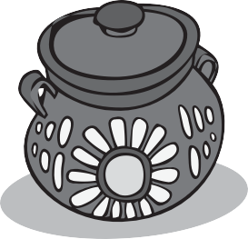
Glazed pottery

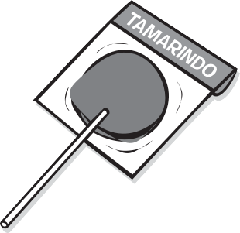

Mexican candy

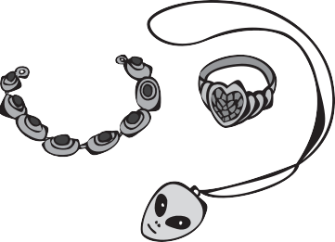
Toy jewelry

Lead is in Handmade Pots and Dishes
- Glazed pottery, like beanpots
- Metal pots with lead solder (samovars)

Lead is in many Workplaces
Workplaces where lead is found include:
- Construction work
- Auto repair and work with batteries
- Plumbing
- Places where people do welding or soldering

Lead is in Products from Other Countries
- Imported candy, especially candy from Mexico
- Make-up
- Imported cans of food
- Toy jewelry
- Home remedies (see other side)

Lead is in the Environment
- Leaded gasoline in other countries
- Dirt
- Plumbing pipes and water

Lead is in some Crafts and Sports
- Stained-glass making
- Bullets
- Fishing sinkers

Call for free: 1-800-532-9571
Assistance available in other languages.

Home Remedies That Contain Lead

www.mass.gov/dph/clppp
These products often have lead in them. Even small amounts of lead can harm children. Be aware of these lead dangers.

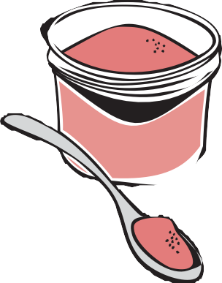Mexican and/or Central American Communities
Azarcon A bright orange powder used for treating stomachaches, or “empacho”. Also called Rueda, Corol, Alarcon, Maria Luisa or Ligo.

Greta A yellow powder used to cure stomachaches in Mexico.

Asian Indian and/or Middle Eastern Communities Ghasard A brown powder used for stomachaches.

Bala Goli A round, flat black bean dissolved in “gripe water” used for stomachaches.

Kandu A red powder used for stomachaches.

Kohl A powder used for eye make-up, teething and skin infections.
Also called Alkohl or Hashmi Surma.

Asian Communities
Paylooah A red powder used for rash or fever in Vietnam.

Ba-Baw-San An herbal medicine used to treat colic pain or to pacify young children in China.

Childhood Lead Poisoning
Prevention Program (CLPPP)
Call: 1-800-532-9571 or 1-617-624-5757
TTY: 1-617-624-5286
Email: clppp@state.ma.us
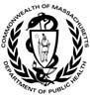On the web: www.mass.gov/dph/clppp

Massachusetts Department of Public Health
Bureau of Environmental Health 2015

