Executive Office of Health and Human Services
Massachusetts Department of Public Health

Health Professions Data Series
Licensed Practical Nurse 2013
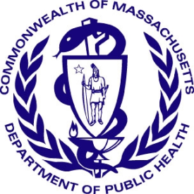

Deval L. Patrick, Governor
John W. Polanowicz, Secretary
Cheryl Bartlett, Commissioner

November 2014
Massachusetts Health Professions Data Series:
Licensed Practical Nurse 2013
OVERVIEW
The Massachusetts Health Professions Data Series: Licensed Practical Nurse (LPN) 2013 Report provides data about workforce demographics of LPNs licensed to practice in Massachusetts. This report is part of the Department of Public Health’s Health Professions Data Series, which currently reports on seven licensed health professions: dentists, dental hygienists, pharmacists, physicians, physician assistants, registered nurses, and licensed practical nurses.
The Massachusetts Health Professions Data Series: Licensed Practical Nurse 2013 Report represents data from the second cycle of Massachusetts’ health professional workforce data collection. This data series was launched during the 2010 clinician license renewal cycle in coordination with the Division of Health Professions Licensure and its biennial clinician renewal cycle.
The data series responds to the need for quality and timely data on demographics and employment characteristics of the Commonwealth’s healthcare workforce. With a response rate of 84% the 2013 report is a timely source of robust data.
Chapter 224 of the Acts of 2012: An Act Improving the Quality of Health Care and Reducing Costs Through Increased Transparency, Efficiency and Innovation continues and expands the work of the Health Care Workforce Center established initially in the Acts of 2008. The publication of this data series is a significant step toward fulfilling the mandates of Chapter 224. It complements and contributes to ongoing health care access and payment reform initiatives in the Commonwealth, and federal efforts including the National Center for Health Workforce Analysis Assessment.
The data series characterizes the workforce from a supply perspective. It enhances the Commonwealth’s ability to identify trends and patterns in the Commonwealth’s healthcare workforce that will impact access to health care professionals and the services they provide. The data is integral to current and future decisions about healthcare workforce development, education, training, recruitment, and retention. It will also help to ensure the availability of a highly qualified, diverse, and culturally and linguistically competent workforce to meet the current and future needs of all Massachusetts residents.
¹ Chapter 224 of the Acts of 2012: An Act Improving Quality of Health Care and Reducing Costs Through Increased Transparency, Efficiency and Innovation: http://malegislature.gov/Laws/SessionLaws/Acts/2012/Chapter224

Background
During the 2013 license renewal cycle, a total of 19,734 Licensed Practical Nurses (LPNs) renewed their license. Of those, 84% (n=16,520) renewed online and completed the 2013 online survey containing 25 workforce survey questions. The survey included questions related to demographics, education, employment characteristics and future work plans. Among these online renewals, 78% (n=12,688) reported working in Massachusetts and 4% reported working in another U.S. state for their primary nursing position.
The following data represents the responses of Registered Nurses who completed an online renewal between October 2012 and March 2014.
Demographics n=16,520
Gender:

Race:
White, Non-Hispanic (NH) | 72%
Black, NH | 17%
Asian, NH | 1%
American Indian / Alaska Native, NH | <1%
Native Hawaiian / Pacific Islander, NH | <1%
Hispanic | 3%
Multi-racial | <1%
Decline to Answer | 5%

² Language fluency defined as ability to communicate with and provide adequate care to patients without the use of a translator (n=16,520).
³ Source: US Census Bureau, 2008-2012 American Community Survey. These are the 4 most common non-English languages spoken at home in Massachusetts
Education n=16,520
The vast majority (96%) of LPNs reported that a diploma or certificate program qualified them for their first U.S. practical/vocational nursing license, while 4% qualified with an Associate Degree. 87% received those degrees/credentials in MA, 12% in another U.S. state, and less than 1% in a US territory or foreign country.
Of the 16,520 respondents, 4,566 (28%) reported having an associate degree or higher in a non-nursing field (Figure 3).
1,383 (8%) of respondents are currently enrolled in a Registered Nurse (RN) Degree Program. Of those, 73% are enrolled in an Associate Degree program, 17% in a Baccalaureate program, and 10% in a Master’s Program. 525 (3%) respondents are currently on a wait list for admission into an RN program and 2,202 (13%) are taking prerequisites in order to apply.
4,427 (27%) of LPNs possess one or more health care education certificates. Figure 4 shows the most commonly reported health care education certificates.

Future Plans n=16,520
Plans Regarding Nursing Practice within the Next Five Years
No Change in Work Status | 26% |  | Return to Nursing | 6%
Increase Nursing Hours | 4% |  | Leave Nursing | 1%
Reduce Nursing Hours | 3% |  | Plan to Retire | 7%
Change Nursing Position | 5% |  | Other | 11%
Seek Additional Education | 38%
Employment Characteristics
Figure 5. LPN Employment Status
12,591 – Employed in Nursing Field
12,688 - Primary Employment in MA
16,520 Total Respondents
607 Employed in Other US State

157 – Unemployed
65 – Retired from Nursing
3,003 - Did Not Report an Employment Location
97 – Employed in Non-Nursing Field
Full-time: 75%⁴
Part-time: 18%
Per Diem: 11%
Volunteer: <1%

⁴ Percentages do not add up to 100% due to respondents’ ability to report more than one employment status.
Of the 157 nurses that reported being unemployed, the most frequently reported reasons include: taking care of home/family (31%), unable to find a nursing position (24%), disability (11%) and schooling (8%).
The following data represent responses from the 12,591 Licensed Practical Nurses who reported working full-time, part-time, per diem, or voluntary basis in nursing in Massachusetts.
Respondents were asked to identify the setting which best describes their primary nursing position. Figure 6 shows the most commonly reported primary practice settings. Work settings that represent less than 1% of the responses are not included in the figure. These settings include public health, academic settings, occupational health, and insurance organizations.
Respondents were also asked to identify the role that best describes their primary nursing position. The table below lists the most commonly reported responses.
Staff Nurse | 53%
Charge Nurse | 18%
Supervisor | 4%
Manager/Director | 4%

88% of LPNs reported providing direct patient care on a routine basis in their primary roles.
Figure 7 displays the most frequently reported areas of practice in primary nursing positions. Practice areas that received less than 4% of responses are not included in this figure.
Of the 12,591 LPN’s who are employed in the field of nursing in Massachusetts, 2,072 (16%) also reported having a second nursing position.

Geographic Distribution n=12,591
Figure 8. LPN Primary Practice Distribution by County
Berkshire
3.2%
Hampshire
2.1%
Essex
12.0%
Suffolk
7.3%
Norfolk
9.1%

Hampden
7.5%
Franklin
1.0%
Worcester
14.1%
Middlesex
19.6%
Plymouth
9.0%
Bristol
11.1%

Barnstable
3.6%
Dukes
0.2%

Nantucket
0.1%

<1%
1 - 5%
6 - 10%
11 - 15%
16 - 20%
Percent of All Primary Practices Located in County
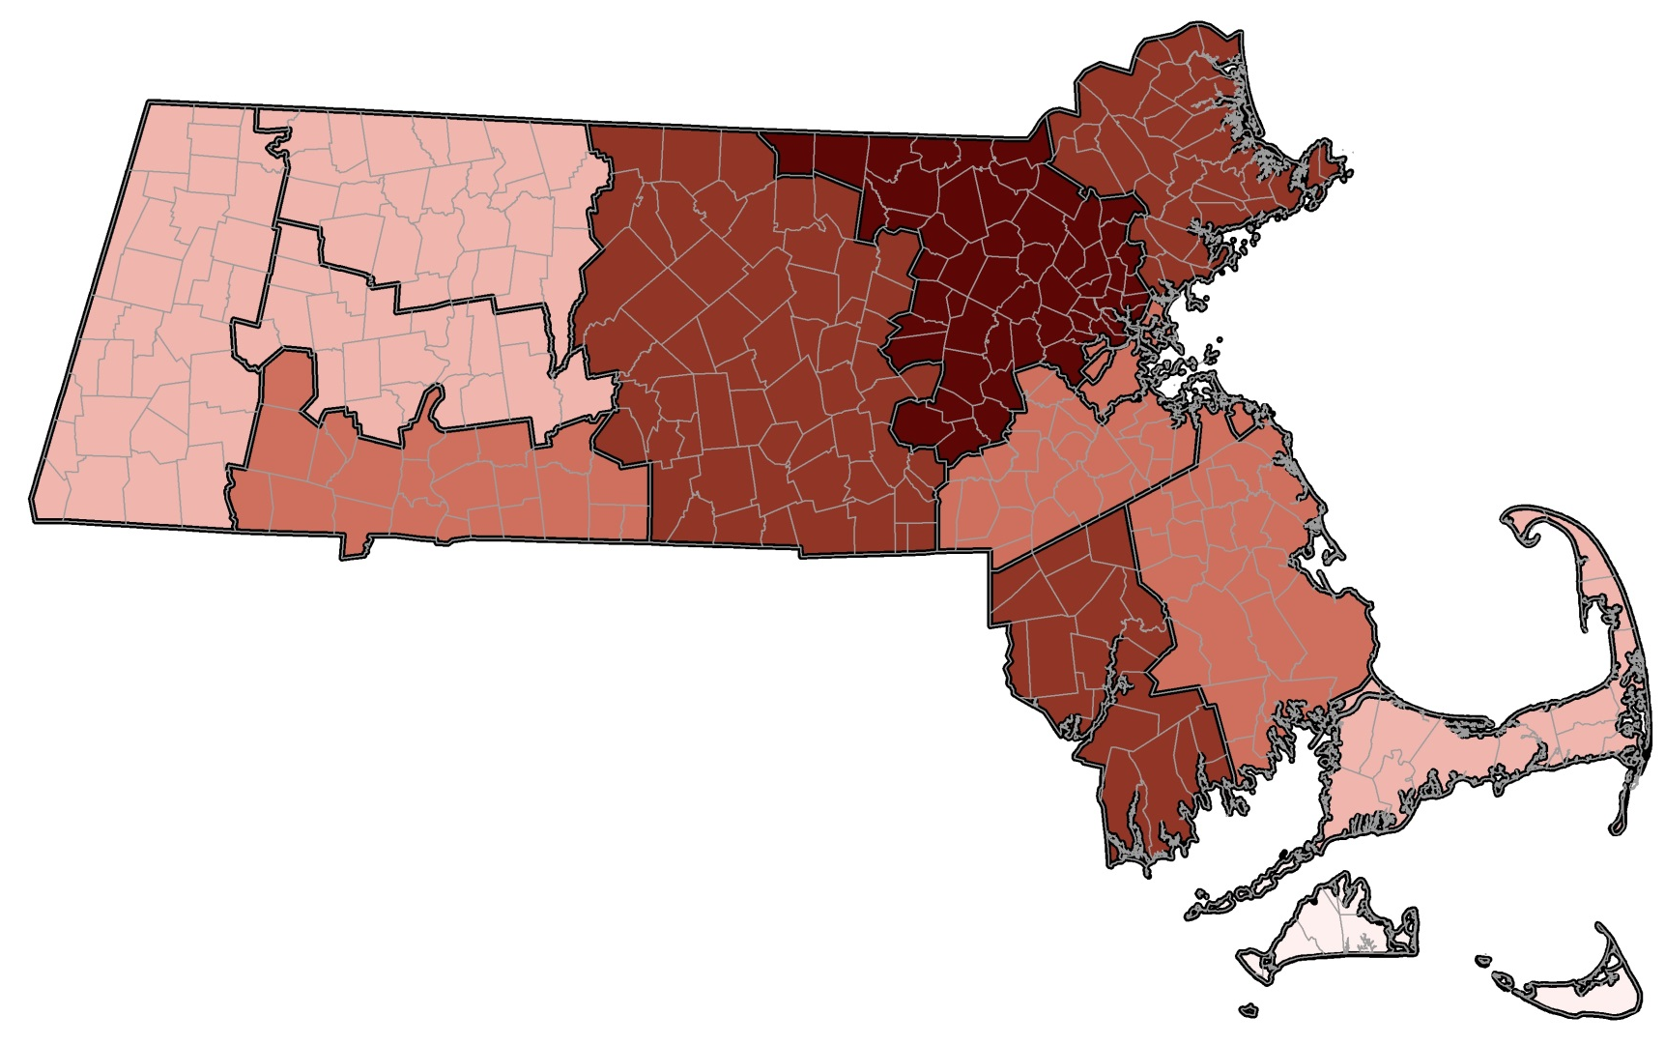

This report was developed by the
Massachusetts Department of Public Health

Bureau of Community Health and Prevention
Health Care Workforce Center

Bureau of Health Care Safety and Quality
Division Health Professions Licensure
Board of Registration in Nursing

For additional information about the Health Professions
Data Series or this Licensed Practical Nurse Report
Please contact the
Massachusetts Health Care Workforce Center
at the
Massachusetts Department of Public Health

Website: mass.gov/dph/hcworkforcecenter
Email: HCWorkforceCenter@state.ma.us

