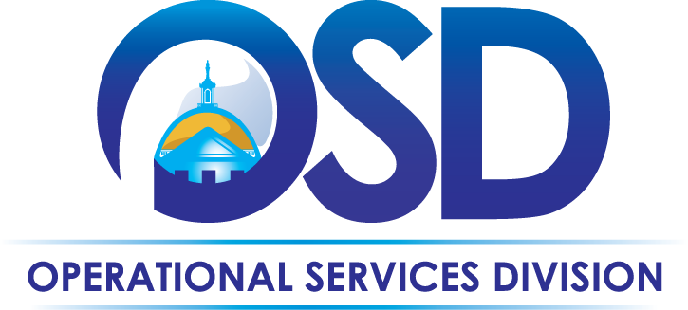
The Commonwealth of Massachusetts
Operational Services Division
Office of Vehicle Management

Maintenance & Repair Overview

Executive Branch vehicles up to 10,000 GVW are automatically enrolled in the Fleet Response Maintenance Management Program. Every Agency must properly maintain, repair and service their vehicles to preserve the performance, safety and useful life of the vehicle.
Fleet Response
1-800-338-0619
Monday – Friday: 8 AM – 8 PM
Saturday: 9 AM – 4 PM
Fleet Response offers:
- A network of authorized shops across the Commonwealth, including National Account vendors, dealers and repair shops
- 24-Hour Roadside Assistance
- Warranty Recovery Assistance
- Direct billing of all expenses to the Agency
Important! There is an additional charge to Agencies for using an Out-of-Network vendor

Fleet Response Packet:
A packet of information is provided for all State vehicles enrolled in Fleet Response programs for maintenance and/or accident repair. Packets should be kept in the vehicle glove box for easy access to the following:
- Introductory memo that highlights program procedures
- Tri-fold Vehicle Maintenance Schedule
  - Specific vehicle, agency and organization (billing) information
  - List of preventive maintenance services and the mileage intervals when they should be completed
  - Instructions and forms for reporting an accident (please refer to the Accident Procedures Overview for guidance on accident reporting and repair processes)
To request a replacement tri-fold Vehicle Maintenance Schedule, contact OVM at 617-720-3185.

Emergency Roadside Assistance:
- Services available 24/7, including fuel delivery, jump starts and assistance with flat tires, towing and/or lock-out
  - Tows will be completed to the nearest In-Network service facility

Preventive Maintenance (PM):
Preventive maintenance helps avert major mechanical problems when completed on a regular basis. OVM currently utilizes a PM schedule of 3,000 mile increments for service intervals.
- For routine services, such as lube, oil and filter changes, tire rotation and brake, transmission or cooling system inspections, take the vehicle to an In-Network maintenance vendor and present the tri-fold Vehicle Maintenance Schedule when requesting service
  - Contact Fleet Response at 800-338-0619 to locate an In-Network vendor & schedule service
- Watch for tire wear patterns which may indicate a tire rotation is needed between scheduled PM services
  - Maintain manufacturer-recommended tire pressure for greater fuel economy and to extend tire life
Whenever possible, appointments should be made with the vendor prior to bringing a vehicle in for PM.

At the Shop:
- Identify the driver & their vehicle as part of Commonwealth and enrolled in the Fleet Response program
- Present the tri-fold Vehicle Maintenance Schedule at time of service
  - Drivers may authorize charges for scheduled PM service, plus repairs up to $100
    - Drivers should consult with their Agency Fleet Manager before authorizing repairs
  - The facility must call Fleet Response to receive authorization for repairs over $100
- When the driver picks up the vehicle, he/she must verify all work
  - If the driver is satisfied with the work, he/she must sign the receipt
  - If the work is not complete, or is unsatisfactory, driver should not accept the vehicle or sign the receipt, and should call Fleet Response for assistance in ensuring the work is completed satisfactorily

Unscheduled Repairs / Mechanical Problems:
A Fleet Response Service Specialist must review and approve all maintenance and repairs greater than $100.
- For any repair service expected to exceed $100, call Fleet Response before scheduling service
  - When calling, be prepared to provide:
    - Plate number (printed inside the tri-fold)
    - Current odometer reading
    - Description of problem or service request
- The Specialist will recommend a local In-Network repair facility based on the work that the vehicle needs

Warranty Repairs and Recovery:
To ensure that the Commonwealth receives warranty protection, it is essential that each vehicle follow the preventive maintenance schedule provided by Fleet Response on the tri-fold
- Warranty repairs and manufacturer recalls must be performed by an authorized In-Network dealership
- To confirm warranty coverage and coordinate warranty work, call Fleet Response

Approval & Payment Process for Maintenance and Repairs
Repairs are not recommended if the vehicle has reached the end of its reasonable mechanical life. All work performed is initially billed to Fleet Response from the authorized In-Network supplier.
Owned Vehicles
- Agencies must review and approve all owned vehicle maintenance and repair requests that are over the established approval limits set by OVM for Fleet Response (as outlined in the Policies & Procedures Manual)
  - This process is facilitated and documented by OVM via email
- Fleet Response will invoice Agencies on a monthly basis for owned vehicle maintenance and repairs
Leased Vehicles
- OVM is responsible for reviewing and approving all leased vehicle maintenance and repair requests
  - Most costs for leased vehicle maintenance and repairs are included in the monthly lease amount
- Once the vehicle is considered off-lease, the vehicle status changes from leased to owned

Rental for Maintenance Repairs
If a state vehicle is not available due to extensive maintenance or repairs, and another state vehicle is not available, a short-term rental may be requested with Agency approval. A contract is in place for rental vehicles; OVM09 Short-Term Rental of Various Light Duty Vehicles. View the Contract User Guide on the OSD website at www.mass.gov/osd.
A rental vehicle used as a replacement for a state vehicle that is in the shop is considered a state vehicle for the purpose of policy compliance. For example, all personal commuting in a rental vehicle must be reported as fringe benefit income and the driver is responsible for any tickets or violations incurred.

Car Washes
The appearance of a State vehicle must be maintained to protect the resale value of the vehicle.
- Car washes and interior vacuum are recommended at least once a month
- Your department may develop additional guidelines on car washes

