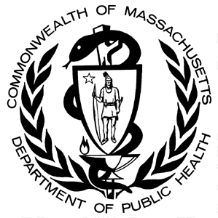
Data Brief:
Sharps Injuries among Hospital Workers in Massachusetts: Findings from the Massachusetts Sharps Injury Surveillance System, 2013
Massachusetts Department of Public Health february, 2016

Data Highlights and Prevention Measures
- 2,947 sharps injuries (SIs) were reported in 2013. The SI rate for workers in all Massachusetts Department of Public Health (DPH) licensed hospitals was 15.9 SIs per 100 licensed beds, similar to rates for the three previous years (Figure 2). Comparable findings were observed in rates for employees (per full time employee equivalents) in acute care hospitals only (data not shown). These findings (Figure 2) suggest that the earlier observed decline in rates from 2002-2010 is leveling off. This plateauing could reflect a positive change, i.e., increases in worker reporting of these injuries. Nevertheless, these findings underscore the need for a continuing commitment to preventing SIs. Hospitals, in interpreting their own SI rates, need to understand the employee reporting practices in their facilities.

- SIs related to injection procedures continued to account for a substantial proportion (29%) of the total injuries. Of these, nearly 80% are related to subcutaneous injections, and 75% involve Sharps with Engineered Sharps Injury Protections (SESIPs) (Table 6). This high percentage of SESIPs likely reflects increased use of SESIPS as required. However, while use of these devices is critical to preventing SIs, they are not failsafe. Inexperience and lack of training in use of these devices, as well as flaws in product design, can contribute to injuries with these devices. Comprehensive SI prevention programs and continuous quality improvement should include training in use of SESIPS and safe work practices and seek input from front line workers in selecting devices.

- Twenty percent of SIs involved devices that were part of a pre-packaged kit (Table 7). Of these, hypodermic needles were the device most commonly involved in SIs. Notably, 22% of SIs with hypodermic needles from kits and 39% of SI with scalpels from kits involve non-SESIPs (Figure 4). Hospitals are encouraged to work with suppliers to ensure that kits with SESIPs are provided.

- The presence of a SI prevention feature is most crucial after the device is used. There were 271 SIs due to non-SESIPs that involved commonly used devices for which SEIPS are widely available. Of these, 178 (66%) occurred after use of the device (Table 9). These injuries could be thought of as “never events” in that use of SESIPs could have likely prevented the injury.

Since 2001, hospitals licensed by the Massachusetts Department of Public Health (DPH) have been required to report data on sharps injuries among workers to the Department annually (MGL/Chapter 111 s 53D). Data have been collected from all DPH licensed hospitals (approximately 99 hospitals) since 2001. This report includes data on sharps injuries that occurred during 2013.

The Massachusetts Sharps Injury Surveillance System is intended to provide information to assist Massachusetts hospitals and hospital workers in targeting and evaluating efforts to reduce the incidence of sharps injuries and the associated human and economic costs. For a more comprehensive description of the system, please see: http://www.mass.gov/eohhs/docs/dph/occupational-health/injuries/injuries-hospital-2004.pdf.

Key Definitions

Sharps injury (also referred to as an exposure incident): An exposure to blood or other potentially infectious materials as a result of an incident involving a contaminated sharp device that pierces the skin or mucous membranes. An injury with a clean sharp or device (before use) through contaminated gloves or other contaminated mediums is also considered a sharps injury. An injury involving a clean device without any contact with infectious materials is not considered an exposure incident.

Sharps device: Any object that can penetrate the skin or any part of the body and result in an exposure incident, including but not limited to needle devices, scalpels, lancets, broken glass, and broken capillary tubes.

Population under surveillance: All health care workers in acute and non-acute care hospitals licensed by DPH, as well as any satellite units (e.g., ambulatory care centers) operating under a hospital license.

Surveillance Period: Calendar year 2013.

Sharps injury rates: Sharps injury rates indicate the probability or risk of a worker sustaining a sharps injury within the surveillance period. Numbers are the counts of sharps injuries. A large hospital may have many workers who sustain sharps injuries but the rate of injury may be low. Conversely, in a smaller hospital, relatively few workers may sustain sharps injuries but the risk may be high. Both rates and numbers of injuries must be considered when targeting and evaluating prevention efforts. The rates presented in this report were calculated by dividing the number of sharps injuries among all workers by the number of licensed beds. Confidence intervals (CI) are presented for each rate. We modelled trends in annual rates using both negative binomial and joinpoint regressions. Negative binomial regression was used to model the overall trends of these rates from 2002 to 2013. Joinpoint regression was used to identify any changes in the trends over the same period.

Sharps with engineered sharps injury protections (SESIPs): Needle devices and non-needle sharps used for withdrawing body fluids, accessing a vein or artery, or administering medications or other fluids, with built-in sharps injury prevention features or mechanisms that effectively reduce the risk of an exposure incident.

Findings

Table 1. |  | Number and rate of sharps injuries among hospital workers by hospital characteristics, Massachusetts, 2013
 |  |  |  | Number of Hospitals |  | Number of sharps injuries |  | Rate per 100 licensed beds |  | 95% CI
Hospital size
 | Small (< 100 licensed beds) |  |  | 28 |  | 217 |  | 13.3 |  | 11.6-14.9
 | Medium (101-300 licensed beds) |  |  | 55 |  | 1,021 |  | 10.4 |  | 9.8-11.0
 | Large (>300 licensed beds) |  |  | 14 |  | 1,709 |  | 24.1 |  | 23.1-25.1
Service Type
 | Acute care |  |  | 77 |  | 2,870 |  | 18.5 |  | 17.9-19.1
 | Non-acute care* |  |  | 20 |  | 77 |  | 2.5 |  | 2.0-3.1
Teaching Status
 | Teaching |  |  | 18 |  | 1,856 |  | 27.2 |  | 26.2-28.3
 | Non-teaching |  |  | 79 |  | 1,091 |  | 8.8 |  | 8.8-9.9
Total |  |  |  | 97 |  | 2,947 |  | 15.9 |  | 15.4-16.4
*Non-acute care hospitals include chronic care and rehabilitation facilities.

Figure 1. Number and rate of sharps injuries per licensed beds among all workers in acute and non-acute care hospitals, Massachusetts, 2013

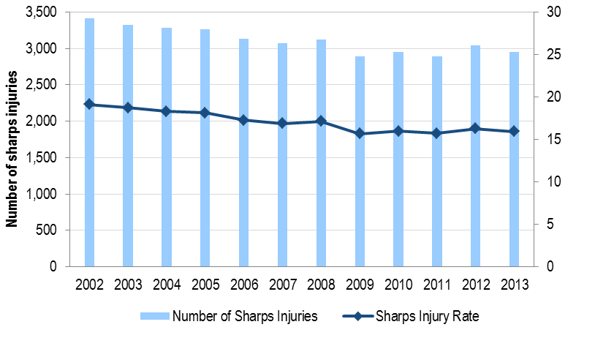
Sharps injuries per 100 licensed beds
In all hospitals among both employees and non-employees from 2002 to 2013, there was a statistically significant (p ≤ 0.05) decrease for the sharps injury rate (# of sharps injuries/ # of licensed beds) over the 12 year period. The rate decreased by 16.8% from 19.1 in 2002 to 15.9 in 2013. When using joinpoint, a statically significant (p ≤ 0.05) leveling off was observed beginning in 2010.

Figure 2. Number and rate of sharps injuries per licensed beds among all workers in acute care hospitals only, Massachusetts, 2013
In acute care hospitals among both employees and non-employees from 2002 to 2013, there was a statistically significant (p ≤ 0.05) decrease in the rate of sharp injuries from 2002 to 2013. During this period the rates of injuries decreased by 19.9% from 23.1 in 2002 to 18.5 in 2013. While the rates for the past five years appear to be holding steady, this leveling off was not statistically significant (p ≤ 0.05). A similar pattern was observed when calculating the rate of sharps injuries among employees of acute care hospitals by full time equivalents (FTEs).
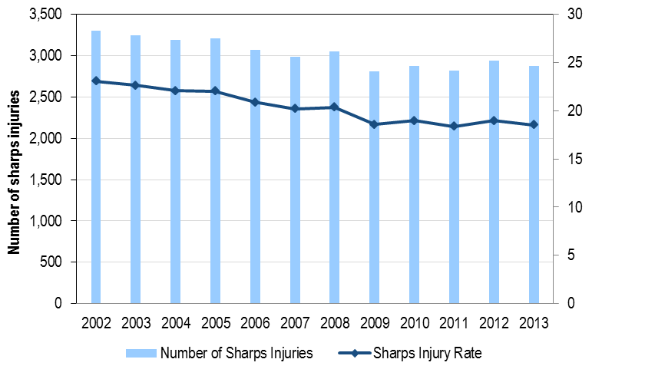
Sharps injuries per 100 licensed beds

Table 2. |  | Sharps injuries among hospital workers by worker and incident characteristics by hospital size, Massachusetts, 2013
 |  |  |  |  |  |  | Hospital Size
 |  |  | All Hospitals |  |  |  | Small |  |  |  | Medium |  |  |  | Large
 |  |  | 97 hospitals |  |  |  | 26 hospitals |  |  |  | 56 hospitals |  |  |  | 15 hospitals
 |  |  | N |  | % |  | N |  | % |  | N |  | % |  | N |  | %
Work status of injured worker |  |  | 2,947 |  | 100 |  | 217 |  | 100 |  | 1,017 |  | 100 |  | 1,713 |  | 100
 | Employee |  | 2,508 |  | 85 |  | 178 |  | 82 |  | 850 |  | 84 |  | 1,480 |  | 86
 | Non-Employee Practitioner |  | 322 |  | 11 |  | 25 |  | 12 |  | 110 |  | 11 |  | 187 |  | 11
 | Student |  | 84 |  | 3 |  | 8 |  | 4 |  | 35 |  | 3 |  | 41 |  | 2
 | Temporary / Contract Worker |  | 32 |  | 1 |  | 6 |  | 3 |  | 21 |  | 2 |  | 5 |  | <1
 | Other / Unknown / Not answered |  | 1 |  | <1 |  | 0 |  | 0 |  | 1 |  | <1 |  | 0 |  | 0
Occupation |  |  | 2,947 |  | 100 |  | 217 |  | 100 |  | 1,017 |  | 100 |  | 1,713 |  | 100
 | Physician |  | 1,150 |  | 39 |  | 85 |  | 39 |  | 265 |  | 26 |  | 800 |  | 47
 | Nurse |  | 1,063 |  | 36 |  | 84 |  | 39 |  | 416 |  | 41 |  | 563 |  | 33
 | Technician |  | 462 |  | 16 |  | 31 |  | 14 |  | 220 |  | 22 |  | 211 |  | 12
 | Support Services |  | 127 |  | 4 |  | 9 |  | 4 |  | 47 |  | 5 |  | 71 |  | 4
 | Dental Staff |  | 14 |  | <1 |  | 0 |  | 0 |  | 6 |  | 1 |  | 8 |  | <1
 | Other Medical Staff |  | 69 |  | 2 |  | 7 |  | 3 |  | 38 |  | 4 |  | 24 |  | 1
 | Other / Unknown / Not answered |  | 62 |  | 2 |  | 1 |  | <1 |  | 25 |  | 2 |  | 36 |  | 2
Department where injury occurred |  |  | 2,947 |  | 100 |  | 217 |  | 100 |  | 1,017 |  | 100 |  | 1,713 |  | 100
 | Operating and Procedure Rooms |  | 1,301 |  | 44 |  | 89 |  | 41 |  | 416 |  | 41 |  | 796 |  | 46
 | Inpatient Units |  | 605 |  | 21 |  | 43 |  | 20 |  | 261 |  | 26 |  | 301 |  | 18
 | Emergency Department |  | 275 |  | 9 |  | 33 |  | 15 |  | 116 |  | 11 |  | 126 |  | 7
 | Intensive Care Units |  | 248 |  | 8 |  | 11 |  | 5 |  | 66 |  | 6 |  | 171 |  | 10
 | Outpatient areas |  | 182 |  | 6 |  | 11 |  | 5 |  | 53 |  | 5 |  | 118 |  | 7
 | Laboratories |  | 128 |  | 4 |  | 9 |  | 4 |  | 27 |  | 3 |  | 92 |  | 5
 | Other / Unknown / Not answered |  | 208 |  | 7 |  | 21 |  | 9 |  | 78 |  | 7 |  | 109 |  | 6
Device involved in the injury |  |  | 2,947 |  | 100 |  | 217 |  | 100 |  | 1,017 |  | 100 |  | 1,713 |  | 100
 | Hypodermic needle/syringe |  | 974 |  | 33 |  | 69 |  | 32 |  | 367 |  | 36 |  | 538 |  | 31
 | Suture needle |  | 647 |  | 22 |  | 40 |  | 18 |  | 180 |  | 18 |  | 427 |  | 25
 | Other hollow bore needle |  | 301 |  | 10 |  | 27 |  | 12 |  | 106 |  | 10 |  | 168 |  | 10
 | Scalpel blade |  | 232 |  | 8 |  | 14 |  | 6 |  | 59 |  | 6 |  | 159 |  | 9
 | Winged steel needle |  | 214 |  | 7 |  | 20 |  | 9 |  | 97 |  | 10 |  | 97 |  | 6
 | Vacuum tube collection holder/needle |  | 86 |  | 3 |  | 6 |  | 3 |  | 51 |  | 5 |  | 29 |  | 2
 | Glass |  | 24 |  | 1 |  | 0 |  | 0 |  | 3 |  | <1 |  | 21 |  | 1
 | Other / Unknown / Not answered |  | 469 |  | 16 |  | 41 |  | 18 |  | 154 |  | 15 |  | 274 |  | 16
Procedure for which the device was used |  |  | 2,947 |  | 100 |  | 217 |  | 100 |  | 1,017 |  | 100 |  | 1,713 |  | 100
 | Injection |  | 849 |  | 29 |  | 62 |  | 29 |  | 325 |  | 32 |  | 462 |  | 27
 | Suturing |  | 653 |  | 22 |  | 45 |  | 21 |  | 183 |  | 18 |  | 425 |  | 25
 | Making the incision |  | 362 |  | 12 |  | 20 |  | 9 |  | 96 |  | 9 |  | 246 |  | 14
 | Blood procedures |  | 341 |  | 12 |  | 29 |  | 13 |  | 155 |  | 15 |  | 157 |  | 9
 | Line procedures |  | 320 |  | 11 |  | 26 |  | 12 |  | 118 |  | 12 |  | 176 |  | 10
 | To obtain body fluid or tissue sample |  | 72 |  | 2 |  | 6 |  | 3 |  | 24 |  | 2 |  | 42 |  | 2
 | Dental procedures |  | 22 |  | 1 |  | 0 |  | 0 |  | 5 |  | <1 |  | 17 |  | 1
 | Other / Unknown / Not answered |  | 328 |  | 11 |  | 29 |  | 13 |  | 111 |  | 10 |  | 188 |  | 11

Table 3. | Sharps injuries among hospital workers by occupation by hollow bore device, Massachusetts, 2013
 |  |  |  |  | Hollow Bore
Occupation | Total |  |  |  | Hypodermic |  |  |  | Winged-Steel |  |  |  | Vacuum |  |  |  | Other Hollow
 |  |  |  |  | Needle |  |  |  | Needle |  |  |  | Tube |  |  |  | Bore
 | N |  | % |  | N |  | % |  | N |  | % |  | N |  | % |  | N |  | %
Nurse | 830 |  | 100 |  | 566 |  | 68 |  | 88 |  | 11 |  | 34 |  | 4 |  | 142 |  | 17
Physician | 373 |  | 100 |  | 251 |  | 67 |  | 8 |  | 2 |  | 3 |  | 1 |  | 111 |  | 30
Technician | 238 |  | 100 |  | 89 |  | 37 |  | 83 |  | 35 |  | 36 |  | 15 |  | 30 |  | 13
Support Services | 49 |  | 100 |  | 28 |  | 57 |  | 8 |  | 16 |  | 2 |  | 4 |  | 11 |  | 23
All Others/Not Answered | 85 |  | 100 |  | 40 |  | 47 |  | 27 |  | 32 |  | 11 |  | 13 |  | 7 |  | 8
Total | 1,575 |  | 100 |  | 974 |  | 62 |  | 214 |  | 14 |  | 86 |  | 5 |  | 301 |  | 19

Table 4. | Sharps injuries among hospital workers by occupation by solid bore device, Massachusetts, 2013
Occupation | Total |  |  |  | Suture Needle |  |  |  | Scalpel |  |  |  | Other/
 |  |  |  |  |  |  |  |  |  |  |  |  | Unknown
 | N |  | % |  | N |  | % |  | N |  | % |  | N |  | %
Physician | 777 |  | 100 |  | 466 |  | 60 |  | 138 |  | 18 |  | 173 |  | 22
Nurse | 233 |  | 100 |  | 91 |  | 39 |  | 29 |  | 12 |  | 113 |  | 49
Technician | 224 |  | 100 |  | 74 |  | 33 |  | 58 |  | 26 |  | 92 |  | 41
Support Services | 78 |  | 100 |  | 5 |  | 6 |  | 4 |  | 5 |  | 69 |  | 89
All Others/Not Answered | 60 |  | 100 |  | 11 |  | 18 |  | 3 |  | 5 |  | 46 |  | 77
Total | 1,372 |  | 100 |  | 647 |  | 47 |  | 232 |  | 17 |  | 493 |  | 36

Table 5. |  | Sharps injuries among hospitals workers by SESIP by hospital size: all devices and excluding suture needles, Massachusetts, 2013
 |  |  |  |  |  |  | Hospital Size
 |  |  | All Hospitals |  |  |  | Small |  |  |  | Medium |  |  |  | Large
 |  |  | 97 hospitals |  |  |  | 26 hospitals |  |  |  | 56 hospitals |  |  |  | 15 hospitals
Sharps Injury Protections |  |  | N |  | % |  | N |  | % |  | N |  | % |  | N |  | %
All devices |  |  | 2,947` |  | 100 |  | 217 |  | 100 |  | 1,017 |  | 100 |  | 1,713 |  | 100
 | SESIP |  | 1,341 |  | 46 |  | 102 |  | 47 |  | 544 |  | 53 |  | 695 |  | 41
 | Non-SESIP |  | 1,458 |  | 49 |  | 110 |  | 45 |  | 416 |  | 41 |  | 932 |  | 54
 | Unknown/Not answered |  | 148 |  | 5 |  | 5 |  | 2 |  | 57 |  | 6 |  | 86 |  | 5
Devices excluding suture needles |  |  | 2,300 |  | 100 |  | 177 |  | 100 |  | 837 |  | 100 |  | 1,286 |  | 100
 | SESIP |  | 1,301 |  | 57 |  | 102 |  | 58 |  | 539 |  | 64 |  | 660 |  | 51
 | Non-SESIP |  | 859 |  | 37 |  | 71 |  | 40 |  | 244 |  | 29 |  | 544 |  | 42
 | Unknown/Not answered |  | 140 |  | 6 |  | 4 |  | 3 |  | 54 |  | 6 |  | 82 |  | 6
ª Hospital size: small= <100 licensed beds; medium=101-300 licensed beds; large=>300 licensed beds

Figure 3. | Sharps injuries among hospital workers by device and SESIP, Massachusetts, 2013

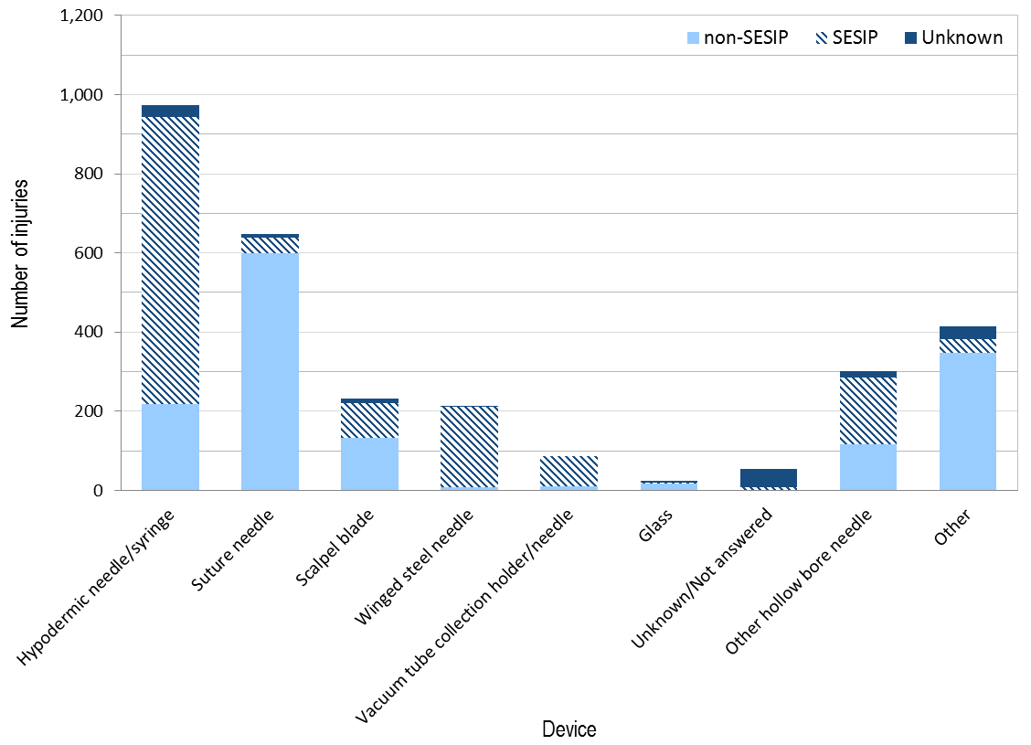

Table 6. |  | Sharps injuries among hospital workers by procedure and SESIP, Massachusetts, 2013
Procedure |  |  | Total |  |  |  | SESIP |  |  |  | Non-SESIP |  |  |  | Unknown
 |  |  | N |  | % |  | N |  | % |  | N |  | % |  | N |  | %
Injection procedures |  |  | 849 |  | 29 |  | 635 |  | 47 |  | 192 |  | 13 |  | 22 |  | 15
 | Subcutaneous injection |  | 668 |  | 23 |  | 508 |  | 38 |  | 145 |  | 10 |  | 15 |  | 10
 | Intramuscular injection |  | 117 |  | 4 |  | 101 |  | 8 |  | 14 |  | 1 |  | 2 |  | 1
 | Other injections |  | 64 |  | 2 |  | 26 |  | 2 |  | 33 |  | 2 |  | 5 |  | 5
Blood procedures |  |  | 341 |  | 12 |  | 305 |  | 23 |  | 28 |  | 2 |  | 8 |  | 5
 | Percutaneous venous puncture |  | 231 |  | 8 |  | 228 |  | 17 |  | 2 |  | <1 |  | 1 |  | 1
 | Finger stick/Heel stick |  | 39 |  | 1 |  | 19 |  | 1 |  | 14 |  | 1 |  | 6 |  | 4
 | Percutaneous arterial puncture |  | 26 |  | <1 |  | 24 |  | 2 |  | 2 |  | <1 |  | 0 |  | 0
 | Other blood procedures |  | 45 |  | 2 |  | 34 |  | 3 |  | 10 |  | 1 |  | 1 |  | 1
Line procedures |  |  | 320 |  | 11 |  | 216 |  | 16 |  | 97 |  | 7 |  | 7 |  | 5
 | To insert peripheral IV/set up heparin lock |  | 119 |  | 4 |  | 113 |  | 8 |  | 4 |  | <1 |  | 2 |  | 1
 | To insert central line |  | 44 |  | 2 |  | 14 |  | 1 |  | 28 |  | 2 |  | 2 |  | 1
 | Other line procedures |  | 157 |  | 5 |  | 89 |  | 7 |  | 65 |  | 4 |  | 3 |  | 2
Other procedures |  |  | 1,437 |  | 49 |  | 185 |  | 14 |  | 1,141 |  | 78 |  | 111 |  | 75
Total |  |  | 2,947 |  | 100 |  | 1,341 |  | 100 |  | 1,458 |  | 100 |  | 148 |  | 100

Table 7. |  | Sharps injuries among hospitals workers involving devices included in prepackaged kits by hospital size, Massachusetts, 2013
 |  |  |  |  |  |  | Hospital Size
 |  |  | All Hospitals |  |  |  | Small |  |  |  | Medium |  |  |  | Large
 |  |  | 97 hospitals |  |  |  | 26 hospitals |  |  |  | 56 hospitals |  |  |  | 15 hospitals
 |  |  | N |  | % |  | N |  | % |  | N |  | % |  | N |  | %
Device included in prepackaged kit
 | Yes |  | 591 |  | 20 |  | 45 |  | 21 |  | 270 |  | 27 |  | 276 |  | 16
 | No |  | 2,245 |  | 76 |  | 167 |  | 77 |  | 693 |  | 68 |  | 1,385 |  | 81
 | Unknown/Not answered |  | 111 |  | 4 |  | 5 |  | 2 |  | 54 |  | 5 |  | 52 |  | 3
Total |  |  | 2,947 |  | 100 |  | 217 |  | 100 |  | 1,017 |  | 100 |  | 1,713 |  | 100
ª Hospital size: small <100 licensed beds; medium 101-300 licensed beds; large >300 licensed beds

Figure 4. | Sharps injuries among hospital workers involving devices from prepackaged kits by SESIP, Massachusetts, 2013
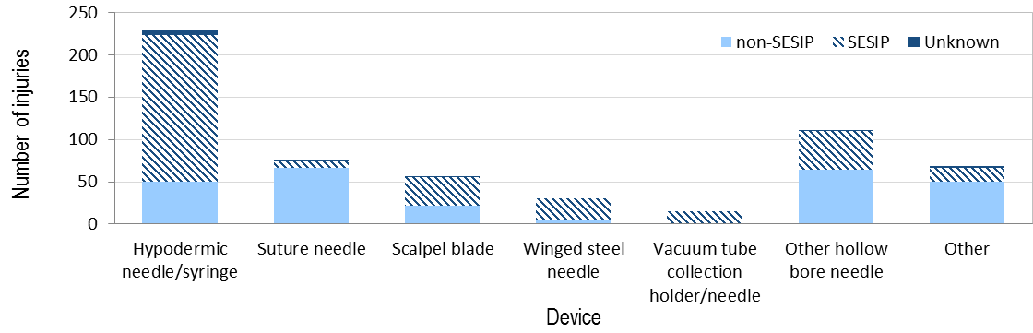

Table 8. |  |  | Sharps injuries among hospital workers by when and how the injury occurred, Massachusetts, 2013
 |  |  |  |  |  |  |  | Hospital Size
 |  |  |  | All Hospitals |  |  |  | Small |  |  |  | Medium |  |  |  | Large
 |  |  |  | 97 hospitals |  |  |  | 26 hospitals |  |  |  | 56 hospitals |  |  |  | 15 hospitals
 |  |  |  | N |  | % |  | N |  | % |  | N |  | % |  | N |  | %
Before use of the item |  |  |  | 28 |  | 1 |  | 4 |  | 2 |  | 6 |  | 1 |  | 18 |  | 1
During use of the item |  |  |  | 1,292 |  | 44 |  | 90 |  | 41 |  | 394 |  | 39 |  | 808 |  | 47
 | Suturing |  |  | 367 |  | 12 |  | 21 |  | 10 |  | 89 |  | 9 |  | 257 |  | 15
 | Manipulate needle in patient |  |  | 249 |  | 8 |  | 21 |  | 10 |  | 86 |  | 8 |  | 142 |  | 8
 | Patient moved and jarred device |  |  | 195 |  | 7 |  | 20 |  | 9 |  | 80 |  | 8 |  | 95 |  | 6
 | Handle/pass equipment |  |  | 139 |  | 5 |  | 7 |  | 3 |  | 29 |  | 3 |  | 103 |  | 6
 | Collision with worker or sharp |  |  | 137 |  | 5 |  | 8 |  | 4 |  | 53 |  | 5 |  | 76 |  | 4
 | Access IV line |  |  | 21 |  | 1 |  | 2 |  | 1 |  | 4 |  | <1 |  | 15 |  | 1
 | Recap needle |  |  | 9 |  | <1 |  | 1 |  | <1 |  | 2 |  | <1 |  | 6 |  | <1
 | Device malfunction |  |  | 2 |  | <1 |  | 0 |  | 0 |  | 1 |  | <1 |  | 1 |  | <1
 | Other / Unknown / Nonclassifiable |  |  | 173 |  | 6 |  | 10 |  | 5 |  | 50 |  | 5 |  | 113 |  | 7
After use, before disposal |  |  |  | 1,208 |  | 41 |  | 94 |  | 43 |  | 442 |  | 43 |  | 672 |  | 39
 | Activating injury protection mechanism |  |  | 240 |  | 8 |  | 15 |  | 7 |  | 107 |  | 11 |  | 118 |  | 7
 | Handle/pass equipment |  |  | 215 |  | 7 |  | 8 |  | 4 |  | 72 |  | 7 |  | 135 |  | 8
 | Collision with worker or sharp |  |  | 189 |  | 6 |  | 20 |  | 9 |  | 58 |  | 6 |  | 111 |  | 6
 | During clean-up |  |  | 186 |  | 6 |  | 8 |  | 4 |  | 57 |  | 6 |  | 121 |  | 7
 | Recap needle |  |  | 80 |  | 3 |  | 6 |  | 3 |  | 27 |  | 3 |  | 47 |  | 3
 | Sharps injury prevention mechanism |  |  | 76 |  | 3 |  | 11 |  | 5 |  | 35 |  | 3 |  | 30 |  | 2
 |  | not activated
 | Improper disposal |  |  | 54 |  | 2 |  | 3 |  | 1 |  | 17 |  | 2 |  | 34 |  | 2
 | Device malfunction |  |  | 51 |  | 2 |  | 3 |  | 1 |  | 25 |  | 2 |  | 23 |  | 1
 | Patient moved and jarred device |  |  | 14 |  | <1 |  | 3 |  | 1 |  | 7 |  | 1 |  | 4 |  | <1
 | Access IV line |  |  | 6 |  | <1 |  | 2 |  | 1 |  | 2 |  | <1 |  | 2 |  | <1
 | Other / Unknown / Nonclassifiable |  |  | 97 |  | 3 |  | 15 |  | 7 |  | 35 |  | 3 |  | 47 |  | 3
During or after disposal of item |  |  |  | 277 |  | 9 |  | 17 |  | 8 |  | 118 |  | 12 |  | 142 |  | 8
 | During sharps disposal |  |  | 157 |  | 5 |  | 7 |  | 3 |  | 65 |  | 6 |  | 85 |  | 5
 | Improper Disposal |  |  | 102 |  | 3 |  | 7 |  | 3 |  | 44 |  | 4 |  | 51 |  | 3
 | Device malfunction |  |  | 3 |  | <1 |  | 0 |  | 0 |  | 1 |  | <1 |  | 2 |  | <1
 | Other / Unknown / Nonclassifiable |  |  | 15 |  | 1 |  | 3 |  | 1 |  | 8 |  | 1 |  | 4 |  | <1
Unknown / Not answered / Nonclassifiable |  |  |  | 142 |  | 5 |  | 12 |  | 6 |  | 57 |  | 6 |  | 73 |  | 4
Total |  |  |  | 2,947 |  | 100 |  | 217 |  | 100 |  | 1,017 |  | 100 |  | 1,713 |  | 100
ª Hospital size: small<100 licensed beds; medium 101-300 licensed beds; large >300 licensed beds

Table 9. | Sharps injuries involving select devices without sharps injury prevention features but for which SESIPs are widely available, by when the injury occurred, Massachusetts, 2013
Time of Injury
Hospital Size
Device |  | Total |  |  |  | Before use |  |  |  |  | During use |  |  |  | After use, |  |  |  |  | During or after disposal |  |  |  |  | Unknown/
 |  |  |  |  |  | use |  |  |  |  |  |  |  |  | Before Disposal* |  |  |  |  | Disposal* |  |  |  |  | Non-classifiable
 |  | N |  | % |  | N |  | % |  | N |  |  | % |  |  | N |  | % |  | N |  | % |  |  |  |  | N |  | %
Hypodermic Needle/Syringe |  | 216 |  | 100 |  | 1 |  | <11 |  | 61 |  |  | 28 |  |  | 119 |  | 55 |  | 30 |  | 14 |  |  |  |  | 5 |  | 2
IV Stylet |  | 41 |  | 100 |  | 0 |  | 0 |  | 21 |  |  | 51 |  |  | 15 |  | 37 |  | 4 |  | 10 |  |  |  |  | 1 |  | 2
Vacuum Tube Collection Holder |  | 10 |  | 100 |  | 0 |  | 0 |  | 4 |  |  | 40 |  |  | 5 |  | 50 |  | 1 |  | 10 |  |  |  |  | 0 |  | 0
Winged-Steele Needle Holder |  | 4 |  | 100 |  | 0 |  | 0 |  | 0 |  |  | 0 |  |  | 4 |  | 100 |  | 0 |  | 0 |  |  |  |  | 0 |  | 0
Total |  | 271 |  | 100
*SESIPs offer protection during the period after use. Injuries presented in this table that occurred after use (n=178) can be considered “never events” – events that could have been prevented with the use of SESIPS.

Table 10. |  | Sharps injuries among hospital workers by occupation (detailed), Massachusetts, 2013
 |  |  | N |  | % |  |  |  | N |  | %
Physician |  |  | 1,150 |  | 39 |  | Support Services |  | 127 |  | 4
 | Intern/Resident |  | 424 |  | 14 |  |  | Housekeeper | 70 |  | 2
 | MD |  | 322 |  | 11 |  |  | Central supply | 43 |  | 1
 | Fellow |  | 134 |  | 5 |  |  | Maintenance | 5 |  | <1
 | Physician Assistant |  | 97 |  | 3 |  |  | Attendant/orderly | 3 |  | <1
 | Surgeon |  | 69 |  | 2 |  |  | Safety/security | 1 |  | <1
 | Medical Student |  | 66 |  | 2 |  |  | Other ancillary staff | 5 |  | <1
 | Anesthesiologist |  | 30 |  | 1
 | Radiologist |  | 8 |  | <1 |  | Other Medical Staff |  | 69 |  | 2
 |  |  |  |  |  |  |  | Medical assistant | 60 |  | 2
Nurse |  |  | 1,063 |  | 36 |  |  | Other medical staff | 9 |  | <1
 | RN or LPN |  | 921 |  | 31
 | Nursing practitioner |  | 38 |  | 1
 | Nurse assistant |  | 34 |  | 1 |  | Dental Staff |  | 14 |  | <1
 | Patient care technician |  | 31 |  | 1 |  |  | Dental assistant/tech | 8 |  | <1
 | Nurse anesthetist |  | 15 |  | 1 |  |  | Dentist | 3 |  | <1
 | Nurse midwife |  | 13 |  | <1 |  |  | Dental hygienist | 2 |  | <1
 | Nursing student |  | 11 |  | <1 |  |  | Dental student | 1 |  | <1
Technician |  |  | 462 |  | 16 |  | Other |  | 60 |  | 2
 | OR/Surgical technician |  | 202 |  | 7 |  |  | Researcher | 22 |  | 1
 | Phlebotomist |  | 95 |  | 3 |  |  | EMT/paramedic | 3 |  | <1
 | Radiologic technician |  | 46 |  | 2 |  |  | Counselor/social worker | 2 |  | <1
 | Clinical lab technician |  | 44 |  | 1 |  |  | Clerical/administrative | 1 |  | <1
 | Respiratory therapist/ Tech |  | 19 |  | 1 |  |  | Other student | 25 |  | 1
 | Hemodialysis technician |  | 4 |  | <1 |  |  | Other | 7 |  | <1
 | Psychiatric technician |  | 1 |  | <1
 | Other technician |  | 51 |  | 2 |  |  | Unknown/Not Answered | 2 |  | <1
 |  |  |  |  |  |  |  | Total | 2,947 |  | 100

Table 11. |  | Sharps injuries among hospital workers by department (detailed), Massachusetts, 2013
 |  |  | N |  | % |  |  |  |  | N |  | %
Operating and Procedure Rooms |  |  | 1,301 |  | 44 |  | Laboratory |  |  | 128 |  | 4
 | Operating room |  | 965 |  | 33 |  |  |  | Histology/pathology | 38 |  | 1
 | Labor and delivery |  | 87 |  | 3 |  |  |  | Clinical chemistry | 10 |  | <1
 | Radiology |  | 84 |  | 3 |  |  |  | Microbiology | 4 |  | <1
 | Cardiac catheterization laboratory |  | 54 |  | 2 |  |  |  | Blood bank | 6 |  | <1
 | Hematology/oncology |  | 36 |  | 1 |  |  |  | Morgue/autopsy room | 8 |  | <1
 | Phlebotomy room |  | 24 |  | 1 |  |  |  | Hematology | 1 |  | <1
 | Dialysis |  | 22 |  | 1 |  |  |  | Other laboratory | 38 |  | 1
 | Endoscopy/bronchoscopy/cystoscopy |  | 13 |  | <1 |  |  |  | Laboratory, unspecified | 23 |  | 1
 | Other procedure room |  | 4 |  | <1
 | Procedure room, unspecified |  | 12 |  | <1 |  | Other Areas |  |  | 204 |  | 7
 |  |  |  |  |  |  |  | Central sterile supply |  | 51 |  | 2
Inpatient Units |  |  | 605 |  | 21 |  |  |  | Dermatology | 34 |  | 1
 | Medical/surgical ward |  | 528 |  | 18 |  |  |  | Long term care | 25 |  | 1
 | Psychiatry ward |  | 25 |  | 1 |  |  |  | Rehabilitation unit | 24 |  | 1
 | Obstetrics/gynecology |  | 23 |  | 1 |  |  |  | Exam room | 18 |  | 1
 | Pediatrics |  | 12 |  | <1 |  |  |  | Central trash area | 8 |  | <1
 | Nursery |  | 1 |  | <1 |  |  |  | Pain clinic | 6 |  | <1
 | Patient room, ward unspecified |  | 16 |  | 1 |  |  |  | Anesthesia | 5 |  | <1
 |  |  |  |  |  |  |  |  | Detox unit | 5 |  | <1
Emergency Department |  |  | 275 |  | 9 |  |  |  | Hospital grounds | 3 |  | <1
 |  |  |  |  |  |  |  |  | Pharmacy | 2 |  | <1
Intensive Care Units |  |  | 248 |  | 8 |  |  |  | Laundry room | 2 |  | <1
 | Intensive care unit |  | 222 |  | 8 |  |  |  | Ambulance | 2 |  | <1
 | Post anesthesia care unit |  | 26 |  | 1 |  |  |  | Employee health/ Infection control | 1 |  | <1
 |  |  |  |  |  |  |  |  | Other Location | 18 |  | 1
Outpatient areas |  |  | 182 |  | 6
 | Ambulatory care clinic |  | 86 |  | 3
 | Dental clinic |  | 20 |  | 1 |  | Unknown/Not Answered |  |  | 4 |  | <1
 | Physician’s office |  | 17 |  | 1
 | Home health visit |  | 12 |  | <1
 | Community health center |  | 4 |  | <1 |  | Total |  |  | 2,947 |  | 100
 | Other outpatient areas |  | 43 |  | 1

Table 12. |  |  |  | Sharps injuries among hospital workers by device (detailed), Massachusetts, 2013
 |  |  |  |  | N |  | % |  |  |  |  |  |  |  |  | N |  | %
Hypodermic needles/syringe (hollow bore) |  |  |  |  | 974 |  | 33 |  |  | Glass |  |  |  |  |  | 24 |  | 1
 | Hypodermic needle attached to a disposable syringe  syringe |  |  |  | 842 |  | 29 |  |  |  | Slide |  |  |  | 7 |  |  | <1
 |  | disposable syringe  syringe |  |  |  |  |  |  |  |  | Specimen / Test / Vacuum tube |  |  |  | 5 |  |  | <1
 | Unattached hypodermic needle |  |  |  | 59 |  | 2 |  |  |  | Medication ampule / Vial / IV bottle |  |  |  | 4 |  |  | <1
 | Prefilled cartridge syringe |  |  |  | 48 |  | 2 |  |  |  |  | Pipette |  |  |  | 3 |  | <1
 | Hypodermic Needle Attached to a |  |  |  | 13 |  | <1 |  |  |  |  | Capillary tube |  |  |  | 2 |  | <1
 |  |  | non-disposable syringe |  |  |  |  |  |  |  |  | Other glass item |  |  |  | 3 |  | <1
 | Hypodermic needle attached to IV |  |  |  | 6 |  | <1
 |  |  | tubing |  |  |  |  |  |  | Dental Device of item |  |  |  |  |  | 10 |  | <1
 | Hypodermic needle, unspecified |  |  |  | 6 |  | <1 |  |  |  |  |  | Dental explorer |  |  | 5 |  | <1
 |  |  |  |  |  |  |  |  |  |  |  |  | Dental bur |  |  | 4 |  | <1
Suture Needle |  |  |  |  | 647 |  | 22 |  |  |  |  |  | Other dental device or item |  |  | 1 |  | <1
 | Curved suture needle |  |  |  | 536 |  | 18
 | Straight suture needle |  |  |  | 27 |  | 1 |  |  | Other |  |  |  |  |  | 404 |  | 14
 | Suture needle, unspecified |  |  |  | 84 |  | 3 |  |  |  |  |  | Wire |  |  | 54 |  | 2
 |  |  |  |  |  |  |  |  |  |  |  |  |  | Lancet |  | 44 |  | 1
Other Hollow Bore Needles |  |  |  |  | 301 |  | 10 |  |  |  |  |  | Retractor |  |  | 38 |  | 1
 | IV Stylet |  |  |  | 163 |  | 6 |  |  |  |  |  | Scissors |  |  | 37 |  | 1
 | Huber Needle |  |  |  | 43 |  | 1 |  |  |  |  |  | Electrode |  |  | 27 |  | 1
 | Spinal or epidural needle |  |  |  | 30 |  | 1 |  |  |  |  |  | Bone cutter |  |  | 25 |  | 1
 | Other type of hollow bore needle |  |  |  | 29 |  | 1 |  |  |  |  |  | Cutting blade other than scalpel |  |  | 24 |  | 1
 | Biopsy Needle |  |  |  | 20 |  | 1 |  |  |  |  |  | Pin |  |  | 20 |  | 1
 | Hollow bore needle, unspecified |  |  |  | 16 |  | 1 |  |  |  |  |  | Forceps |  |  | 19 |  | 1
 |  |  |  |  |  |  |  |  |  |  |  |  | Bovie electrocautery device |  |  | 13 |  | 1
Scalpel Blade |  |  |  |  | 232 |  | 8 |  |  |  |  |  | Drill bit |  |  | 10 |  | <1
 |  |  |  |  |  |  |  |  |  |  |  |  | Trocar |  |  | 8 |  | <1
Butterfly Needle |  |  |  |  | 214 |  | 7 |  |  |  |  |  | Staple |  |  | 7 |  | <1
 | Winged Steel needle attached to a |  |  |  | 128 |  | 4 |  |  |  |  |  | Tenaculum |  |  | 6 |  | <1
 |  |  | vacuum tube collection holder |  |  |  |  |  |  |  |  |  | Bone chip/chipped tooth |  |  | 5 |  | <1
 | Winged Steele Needle |  |  |  | 71 |  | 2 |  |  |  |  |  | Other needle |  |  | 4 |  | <1
 | Winged Steele Needle attached to IV |  |  |  | 15 |  | 1 |  |  |  |  |  | Other Type of Sharp Object |  |  | 51 |  | 2
 |  |  | tubing |  |  |  |  |  |  |  |  |  | Needle/unspecified |  |  | 12 |  | <1
Vacuum Tube Collection Holder/Needle |  |  |  |  | 86 |  | 3 |  |  | Unknown/Not Answered |  |  |  |  |  | 55 |  | 2
 | Vacuum tube collection holder/needle |  |  |  | 56 |  | 2
 | Phlebotomy needle (other than winged |  |  |  | 30 |  | 1
 |  |  | steel needle) |  |  |  |  |  |  | Total |  |  |  |  |  | 2,947 |  | 100

Table 13. |  | Sharps injuries among hospital workers by procedure (detailed), Massachusetts, 2013
 |  |  | N |  | % |  |  |  |  | N |  | %
Injection |  |  | 849 |  | 29 |  | Line Procedures |  |  | 320 |  | 11
 | Subcutaneous injection |  | 668 |  | 23 |  |  | To insert a peripheral IV line or |  | 119 |  | 4
 | Intramuscular injection |  | 117 |  | 4 |  |  |  | set up a heparin lock
 | Epidural/spiral anesthesia |  | 22 |  | 1 |  |  | To insert a central IV line |  | 44 |  | 1
 | Other injection |  | 13 |  | <1 |  |  | Draw blood from central or |  | 28 |  | 1
 | Injection, unspecified |  | 29 |  | 1 |  |  |  | peripheral IV line or port
 |  |  |  |  |  |  |  | Other injection into IV site/port |  | 39 |  | 1
Suturing |  |  | 653 |  | 22 |  |  | To insert an arterial line |  | 23 |  | 1
 | Suturing |  | 647 |  | 22 |  |  | Draw Blood from Arterial line  d  draw |  | 12 |  | <1
 | Suture removal |  | 6 |  | <1 |  |  | To flush heparin/saline |  | 12 |  | <1
 |  |  |  |  |  |  |  | To connect IV line |  | 9 |  | <1
Blood Procedures |  |  | 341 |  | 12 |  |  | Other line procedure |  | 27 |  | 1
 | Percutaneous venous puncture |  | 231 |  | 8 |  |  | Line procedure, unspecified |  | 7 |  | <1
 | Finger stick/heel stick |  | 39 |  | 1
 | Percutaneous arterial puncture |  | 26 |  | 1 |  | To Obtain Body Fluid or Tissue Sample |  |  | 72 |  | 2
 | Draw blood from umbilical vessel |  | 13 |  | <1
 | Dialysis/AV Fistula site |  | 12 |  | <1
 | Blood Procedure, unspecified |  | 6 |  | <1 |  | Dental Procedures |  |  | 22 |  | 1
 |  |  |  |  |  |  |  | Oral surgery |  | 10 |  | <1
Making the incision |  |  | 362 |  | 12 |  |  | Dental drilling |  | 4 |  | <1
 | Making the incision |  | 258 |  | 9 |  |  | Restorative |  | 2 |  | <1
 | Cauterization |  | 6 |  | <1 |  |  | Other dental |  | 6 |  | <1
 | Other surgical procedure |  | 61 |  | 2
 | Surgical procedure, unspecified |  | 37 |  | 1 |  | Other |  |  | 220 |  | 7
 |  |  |  |  |  |  |  | To obtain lab specimens |  | 37 |  | 1
 |  |  |  |  |  |  |  | Transferring blood/body fluid to |  | 20 |  | 1
 |  |  |  |  |  |  |  |  | another container
 |  |  |  |  |  |  |  | Drilling |  | 16 |  | 1
 |  |  |  |  |  |  |  | Shaving |  | 10 |  | <1
 |  |  |  |  |  |  |  | During Disposal |  | 2 |  | <1
 |  |  |  |  |  |  |  | Other procedure |  | 135 |  | 5
 |  |  |  |  |  |  | Unknown/Not answered |  |  | 108 |  | 4
 |  |  |  |  |  |  | Total |  |  | 2,947 |  | 100
For all tables presented, percentages may not total 100% due to rounding.

Resources
CDC Sharps Safety for Healthcare Settings: Workbook and Teaching Tools www.cdc.gov/sharpssafety
NIOSH Preventing Needlesticks and Sharps Injuries www.cdc.gov/niosh/topics/bbp/sharps.html
OSHA Bloodborne Pathogens and Needlestick Prevention www.osha.gov/SLTC/bloodbornepathogens

