2015 | Annual report
Addendum
Contents
Message from the Commissioner 1
Meet the MRC Senior Leaders 2
MRC Financial Statements 4
- Vocational Rehabilitation…………………………………3
- Community Living……………………………………………7
- Disability Determination…………………………………8
Consumer Liasion Information 12

Mission and Vision
Mission:
The Massachusetts Rehabilitation Commission (MRC) promotes equality, empowerment and independence of individuals with disabilities. These goals are achieved through enhancing and encouraging personal choice and the right to succeed or fail in the pursuit of independence and employment in the community.

Vision:
The MRC provides comprehensive services to people with disabilities that maximize their quality of life and economic self-sufficiency in the community.

Message from the Commissioner

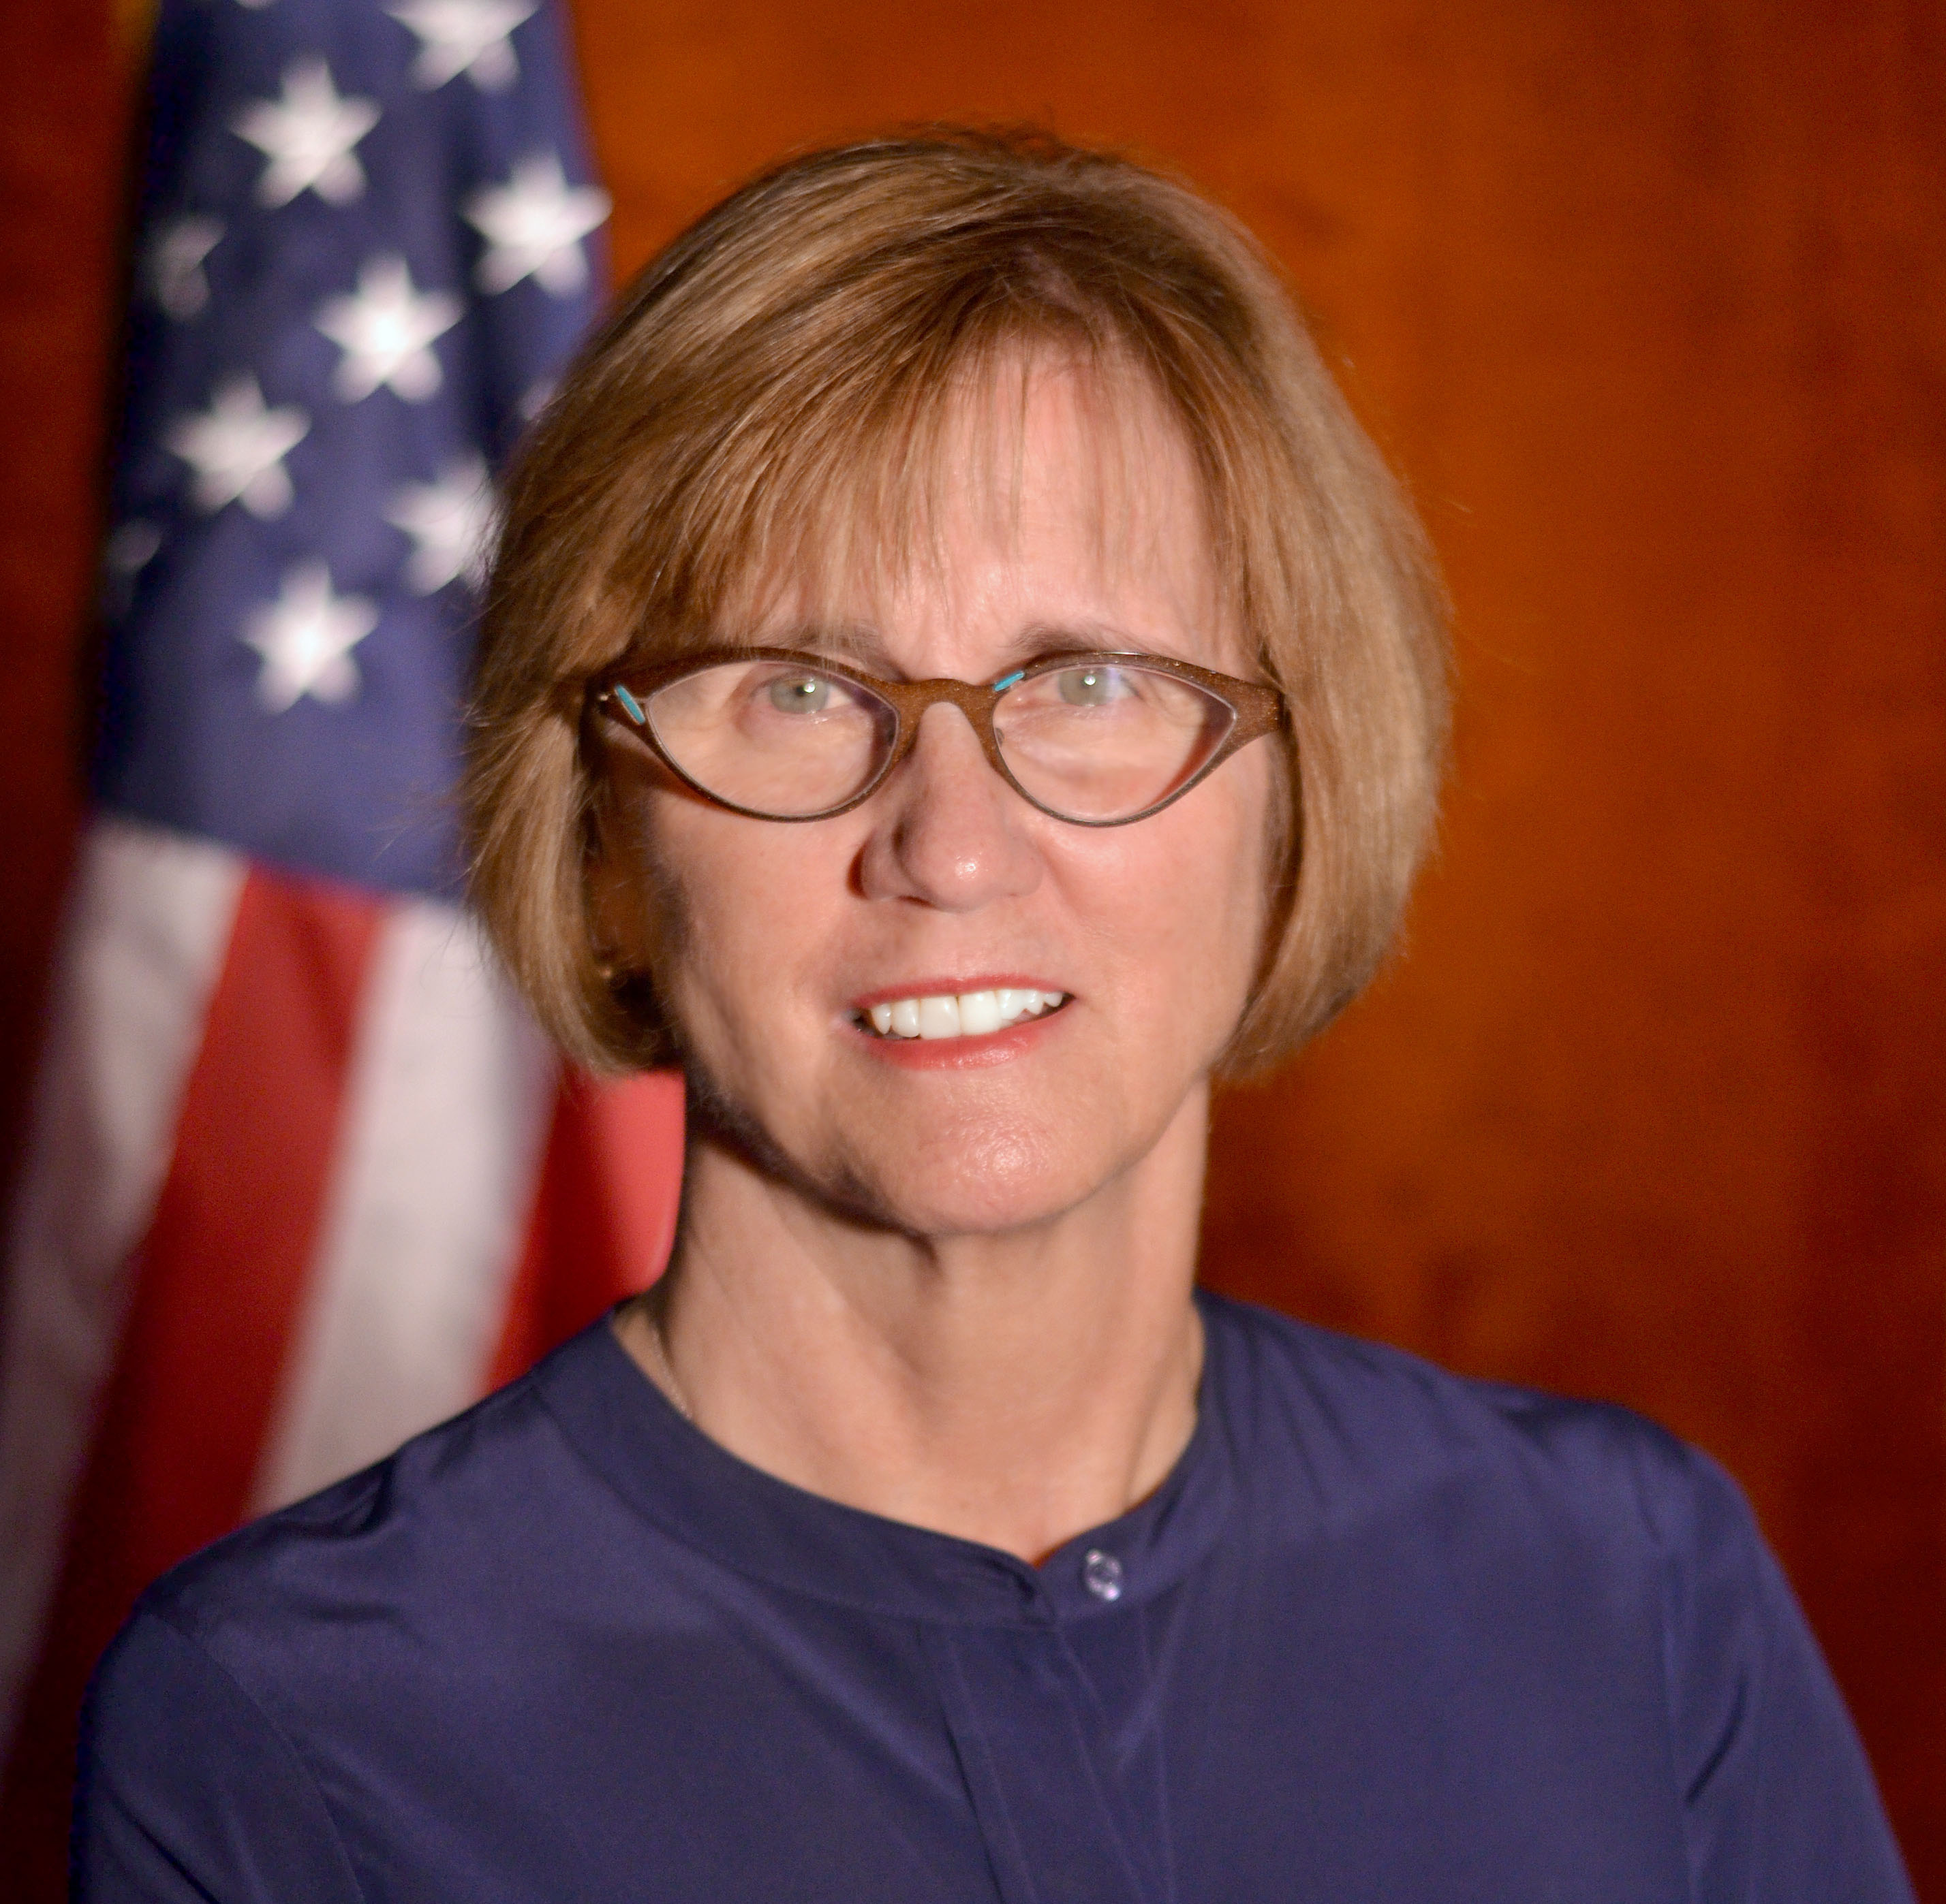
Dear Colleagues:

I am very honored to have been appointed Commissioner of the Massachusetts Rehabilitation Commission (MRC) by Governor Charles D. Baker and EHS Secretary Marylou Sudders in March of 2015. Leading an agency that provides comprehensive services to people with disabilities, MRC is maximizing the quality of life and economic self-sufficiency of people throughout the Commonwealth.
It is with great pleasure I present our addendum annual report for federal fiscal year 2015. This report includes a year in which we celebrated the 25th Anniversary of the passage and accomplishments of the Americans with Disabilities Act of 1990 (ADA) and the start of our #WithMRC Transition Aged Youth marketing campaign.
The MRC is proud of the strong collaborations we have established over the past fifty-nine years with employers, providers, and other state agencies. These partnerships are critical in the work we do to achieve MRC’s mission. One of our highlights was receiving the Gould Award from Associated Industries of Massachusetts (AIM) for the Pharmacy Technician program we developed in partnership with CVS Health. There were 20 consumers successfully hired into CVS stores across the Commonwealth. In FY15, our second year of running this on-the-job training program, we were fortunate to expand our public-private collaboration to include new business partners, Advanced Auto Parts, Enterprise Rent-a-Car, and the Home Depot, and have over 60 consumers successfully complete training programs and are now job-ready.
I am committed to ensuring MRC promotes equality, empowerment and independence of individuals with disabilities. This goal can only be accomplished through enhancing and encouraging personal choice and the right to succeed or fail in the pursuit of independence and employment in the community.

Sincerely,

Adelaide “Nicky” Osborne
Commissioner

Meet the MRC Senior Managers
 | Adelaide “Nicky” Osborne  Commissioner |  | Kasper M. Goshgarian  Deputy Commissioner
 | Richard Arcangeli  General Counsel |  | Tak  Tang  Chief Financial Officer
 | Joan  Phillips  Assistant Commissioner  Vocational Rehabilitation Services | 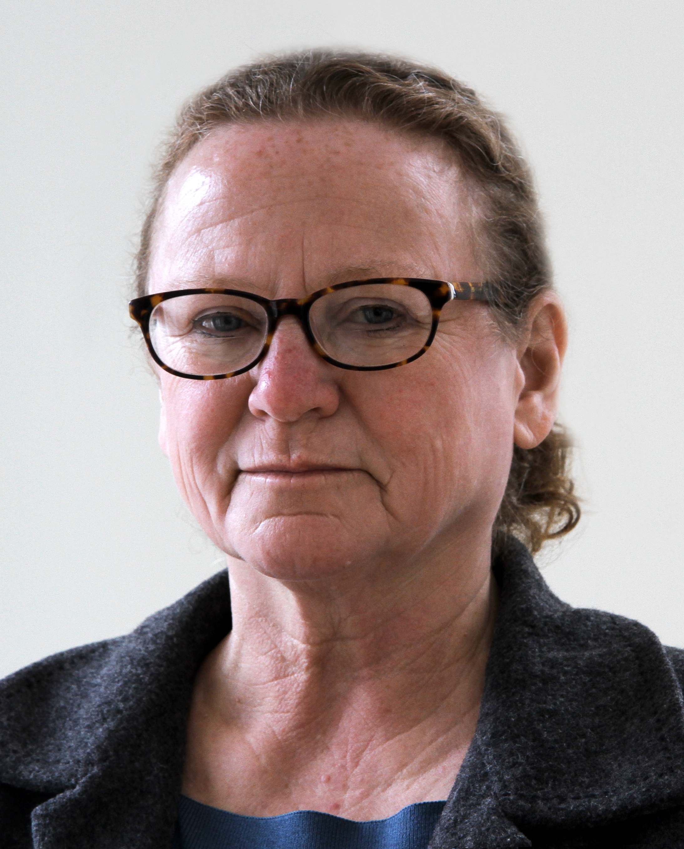 | Patricia  Roda  Assistant Commissioner  Disability Determination Services
Kerri Zanchi was the Assistant Commissioner of the Community Living Services division until the fall of 2015. This position is currently vacant.

MRC Financial Statements

Vocational Rehabilitation: July 1, 2014 – June 30, 2015

VR: Competitive Employment in Massachusetts
The MRC successfully placed 3,737 individuals with disabilities into employment based on their choices, interests, needs and skills in FY15.

These rehabilitated employees earned $67.5 million in their first year of employment.

Estimated public benefits savings from individuals assisted by the MRC in MA were $28 million.

The returns to society based on increases in lifetime earnings range from $14 to $18 for each $1 invested in the MRC Vocational Rehabilitation program.

$5 is returned to the government through income taxes and reduced public assistance payments for every $1 invested in the MRC Vocational Rehabilitation program.

Average Hourly Wage: $12.98
Average Weekly Hours Worked: 26.8

VR: Facts at a Glance

Consumers Actively Receiving Services: 22,100
Consumers Enrolled in Training/Education Programs: 15,086
Consumers with Significant Disabilities Employed: 3,509
Consumers Employed with Medical Insurance: 94.7%
Consumers Satisfied with Services: 81.5%

Vocational Rehabilitation: July 1, 2014 – June 30, 2015

Who are our VR consumers
Psychiatric Disabilities: 39.8%
Learning Disabilities: 22.2%
Orthopedic Disabilities: 10.6%
Substance Abuse: 8.8%
Deaf and Hard of Hearing: 6.7%
Neurological Disabilities: 2.7%
Developmental Disabilities: 2.3%
Traumatic Brain Injury: 1.7%
Other Disabilities: 8.5%

Average Age: 34

Female: 47%
Male: 53%

White: 79.9%
Black: 17.1%
Hispanic: 10.9%
Asian/Pacific Islander: 3.6%
Native American: 0.0%

“In 2000, I went to MRC, with their magic and professionalism they helped me identify my skills and personality and how we could market that. When I was ready, I was able to find a job at The Home Depot. It was perfect I knew the materials (former carpenter) and I could use my personality for customer service. It helped my ego to feel like part of a team. I knew they recognized and valued my talents. They didn’t see all the things wrong with me, but all the things I can do.”
– Anita Pleasant, sales associate, The Home Depot.

Vocational Rehabilitation Youth services: July 1, 2014 – June 30, 2015

Historically, the agency has only looked at the financial information for the three divisions within the MRC; however, with an agency committed to serving transition aged youth and their families we are including the number of youth served, not simply referred.

VR Youth Served (Ages 16-22)*
The Vocational Rehabilitation Program served 7,129 youth ages 16 to 22 during SFY15.

1,201 young consumers were placed in employment, with an average hourly wage of $11.13.

Employed young consumers worked an average of 26.9 hours per week.

100 young consumers participated in the Youth Leadership Network (YLN) and 46 participated in the Youth Leadership Forum (YLF) in SFY2015. These programs promote self-advocacy and self-awareness, and employment and independent living skills for teens and young adults with disabilities ages 14 to 26.

During SFY2015, MRC provided paid summer internship experiences for 207 young consumers across the Commonwealth through Transitional Internship Programs (TIP) and our Worcester Area Office internship program. These internships provide employment related skills and guidance, and references to facilitate permanent future employment opportunities. Based on these successes, MRC significantly expanded summer internship opportunities to start out SFY2016.

VR Youth: Facts at a Glance

Youth Actively Receiving Services: 9,143
Youth Enrolled in Training/Education Programs: 6,894
Average Hourly Wage for Employed Youth: $11.13

* Age at application for MRC services.

Vocational Rehabilitation Youth services: July 1, 2014 – June 30, 2015

Who are our young VR consumers

Males: 58.1%
Females: 41.9%

Referral Source
688 Referral: 33.1%
Lead Education Agency: 17.8%
Transitional Advisory Council Assigned: 0.5%
Other Referral Source: 48.6%

Disability Profile
Sensory/Communicative: 8.2%
Physical/Mobility: 10.1%
Cognitive/Psychological: 81.7%

Community Living: July 1, 2014 – June 30, 2015

CL: Consumers Served
Independent Living Centers:* 6,679
Assistive Technology: 2,062
Brain Injury Services: 1,409
Home Care Services: 1,285
Turning 22 Services: 643
Housing Registry: 397
Protective Services: 448
Waiver Unit Services: 244
Supported Living Services: 189

CL: Services Purchased
Brain Injury Services: $32,049,884
Independent Living Centers: $ 7,136,540
Home Care Services: $ 3,414,031
Supported Living Services: $ 1,687,720
IL Turning 22 Services: $ 1,607,386
Assistive Technology: $ 1,210,761
Protective Services: $ 741,375
Housing Registry: $ 80,000

CL: Facts at a Glance

Total Consumers Actively Receiving Services: 13,356
Total Funds Expended: $47,928,057
Cost per Consumer Served: $3,588.50

* State funded services only.

disability determination: october 1, 2014 – September 30, 2015

DDS: Supplemental Security Income (SSI)/Social Security Disability Insurance (SSDI)

DDS: SSI/ SSDI Claims Processed
Total Receipt of Cases: 86,232
Total Disposition of Cases: 85,508
Initial Claims Filed: 52,503
Initial Claims Disposed: 56,343
% Allowed: 40.6%
Continuing Disability Review Receipts: 16,301
Continuing Disability Review Dispositions: 18,616

DDS: Purchased Services
Consultative Examinations Purchased: 21,719
Consultative Examination Rate: 24.5%
Medical Evidence of Record Purchased: 80,373
Medical Evidence of Record Rate: 90.8%

DDS: MA Supplemental Security Income (SSI)/Social Security Disability Insurance (SSDI)
Total MA Population: 6.75M
MA SSI Recipients, 2014: 188,606
MA SSDI Recipients, 2014: 236,008
Annual SSDI Benefits Paid: $3.26B
Annual SSI Benefits Paid: $1.18B

CL: Facts at a Glance

Total Medical Costs: $8,255,139
Total Budget: $48,689,090
Cost Per Case: $550.10
Total Disposition of SSI/SSDI Cases: 88,508
Accuracy of Initial Decisions: 97%
Federal Accuracy of Decision Standard: 90%

Federal Expenditures

Sum for Federal FY: October 1, 2014 – September 30, 2015

Federal Funds Expended |  | FY2015 | %
Vocational Rehabilitation/Federal |  | $46,376,360 | 46%
Disability Determination Services |  | $47,389,547 | 46%
Independent Living Services |  | $1,525,327 | 2%
Vocational Rehabilitation/SSA |  | $5,230,411 | 5%
Other Federal Spending |  | $1,131,528 | 1%
Supported Employment |  | $328,712 | <1%
Total |  | $101,981,885

State Expenditures

Sum for State FY: July 1, 2014 – June 30, 2015

State Funds Expended | FY2015 | %
Community Services - All Other | $33,574,791 | 46%
Vocational Rehabilitation (VR) | $12,422,773 | 17%
Dept. of Developmental Services (DDS) Allocation - Rolland Case | $5,990,536 | 8%
Head Injury Trust Fund | $6,296,155 | 9%
Home Modification Loan Program | $6,500,000 | 9%
Waiver (Other Allocations) | $7,610,417 | 11%
Total | $72,394,672

Consumer Liaison

The MRC has a staff member working within the Commissioner’s Office as an Ombudsperson who serves as a consumer liaison, primarily to address concerns regarding delivery of services and to answer a variety of disability-related questions. People who typically contact the Ombudsperson include consumers, family members, advocates, legislators and their aides, other state government personnel and MRC staff members.
The Ombudsperson provides information and referral services and assists callers to better understand the services offered by the MRC.
If a complaint is brought forward, the Ombudsperson promptly reviews the matter and works with consumers and MRC staff to find a solution. If this type of intervention does not bring about resolution, there is a formal appeal process. Mediation services are also available to MRC-VR consumers.
The Ombudsperson assists consumers across all service programs and may be contacted by telephone at (617) 204-3603 or (800) 245-6543 (voice and TTY), through the agency website at www.mass.gov/mrc or by writing to the MRC Administrative Office in Boston.

The goal of our services is to promote dignity through employment and community living, one person at a time. We hope all citizens with disabilities in Massachusetts will have the opportunity to contribute as a productive member of their community and family as a result of services provided by the MRC.

Administrative Offices
600 Washington Street
Boston, MA 02111
617-204-3600 (voice)
800-245-6543 (toll free MA)
www.mass.gov/mrc

Find us on Facebook,
Follow us on Twitter, and
Connect with us on LinkedIn!

Charles D. Baker
Governor

Karyn E. Polito
Lieutenant Governor

MaryLou Sudders
Secretary, Executive Office of
Health & Human Services

Adelaide Osborne
Commissioner, MRC

