Arbovirus Surveillance in Massachusetts 2013
Massachusetts Department of Public Health (MDPH)
Arbovirus Surveillance Program

INTRODUCTION

There are two mosquito-borne diseases of concern in Massachusetts, eastern equine encephalitis (EEE), which was identified in 1938, and West Nile virus (WNV), which has been present since 2000. EEE is a rare but serious neuroinvasive disease that causes meningitis or encephalitis and often results in death or severe disability. WNV infection is more common, though typically less severe than EEE; presentation of WNV ranges from febrile illness to neuroinvasive disease. Although up to 51 different species of mosquitoes have been identified in Massachusetts, only a few of these contribute to either WNV or EEE spread. For more information, visit the MDPH website to view Common Mosquitoes That Can Spread Disease in Massachusetts.

Currently there are no available vaccines to prevent human infections from either mosquito-borne virus. Personal protection measures that serve to reduce exposure to mosquitoes and prevent human disease remain the mainstay of prevention. To estimate the risk of human disease during a mosquito season, the MDPH, in cooperation with the local Mosquito Control Projects, conducts surveillance for EEE and WNV using mosquito samples, and specimens from human and veterinary sources. Detailed information about surveillance for these diseases in Massachusetts is available on the MDPH website at Arbovirus Surveillance and Control Plan.

EASTERN EQUINE ENCEPHALITIS VIRUS

Humans
One human case of EEE infection was identified in Massachusetts in 2013.

County | Age Range | Onset Date | Virus Result | Clinical Presentation
Norfolk | >80 | 8/14/2013 | EEE | Encephalitis

Mosquito Samples
Of 6,092 mosquito samples collected in Massachusetts in 2013, 61 (1.0%) were positive for EEE virus in 2013. Positive mosquito samples included 46 (0.76%) Culiseta melanura, nine (0.15%) Coquillettidia perturbans, and one (0.02%) Aedes vexans. Positive samples were identified from 27 towns in six counties. For a complete list of positive mosquito samples by city/town, please see the 2013 Cumulative Mosquito Summary by County and Municipality report posted on the MDPH website.

Animals
Sixteen veterinary samples were submitted for arbovirus testing. Four animal cases of EEE infection were identified in Massachusetts in 2013.

County | Animal Species | Onset Date | Virus Result
Hampshire | Horse | 7/25/2013 | EEE
Hampshire | Horse | 8/2/2013 | EEE
Middlesex | Horse | 8/30/2013 | EEE
Plymouth | Horse | 9/18/2013 | EEE

Birds
Although birds are not routinely tested as part of EEE surveillance, species such as emus or exotic quail may experience sudden illness and mortality due to EEE. Farmed birds showing these signs must be reported promptly to the Massachusetts Department of Agricultural Resources (MDAR).

EEE Geographic Risk Levels
EEE risk maps combine historical data and areas of mosquito habitat with current data on positive virus isolations (in humans, mosquitoes, etc.) and weather conditions. Risk levels are an estimate of the likelihood of an outbreak of human disease and are updated regularly with new surveillance data. Initial and final EEE risk levels from the 2013 season are provided in the following maps. This information will be used to help anticipate risk in 2014, and will be revised as 2014 surveillance data are collected. More detailed information about risk assessment and risk levels is available in the Arbovirus Surveillance and Response Plan on the MDPH web site.

Initial and Final 2013 EEE Risk Categories

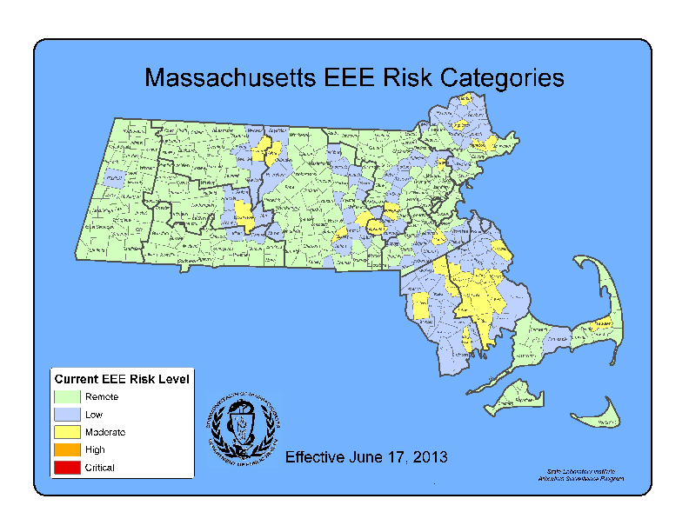 (As defined in Table 2 of the MDPH Arbovirus Surveillance and Response Plan which can be found at www.mass.gov/dph/mosquito under “Information for Local Boards of Health”)
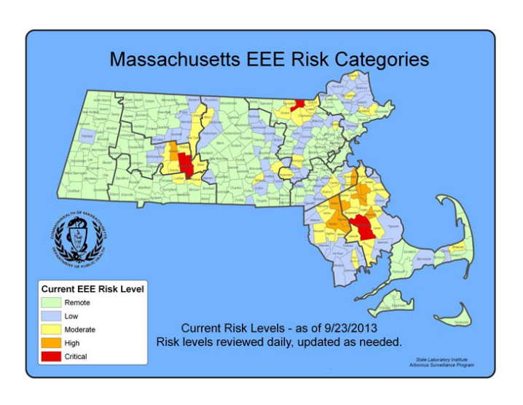

2013 EEE SEASON DISCUSSION

MDPH identified one confirmed human EEE virus infection (case) in 2013 compared to seven confirmed human cases identified in 2012. This decrease in human cases of EEE was also seen across the country, where the number of confirmed human cases nationwide was lower in 2013 (five) than in 2012 (15).
There was a similar decline in EEE virus positive mosquito samples from 267 in 2012 to 61 in 2013. In 2013 MDPH identified 46 EEE positive samples of Culiseta melanura, the enzootic vector of EEE, compared to 146 EEE positive samples of Culiseta melanura in 2012. Mosquito surveillance activities are highly responsive to identifications of EEE virus, with more mosquito trapping and testing in years when EEE activity is increased, this makes year-to-year comparisons somewhat difficult. In general, years with increased EEE human infections can be associated with a similar increase in the percentage of Cs. melanura samples that test positive for EEE virus (see figure below).

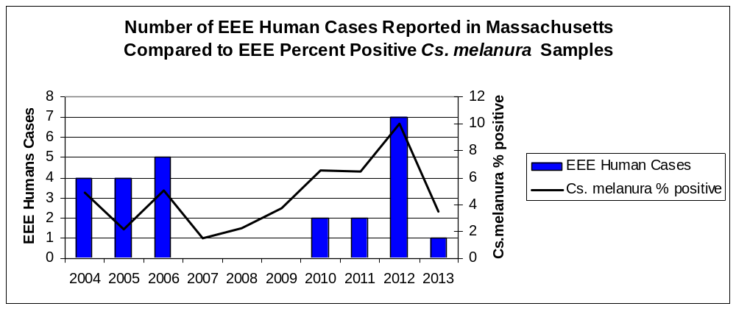

Why was there less EEE activity in 2013 than 2012?

Historically, EEE outbreaks have rarely occurred over periods lasting more than three years, although evidence suggests that previously observed patterns may be changing and must be monitored carefully. Intense EEE activity consistent with outbreaks occurred in 2004-2006 and 2010-2012. Outbreaks are probably supported, in part, by previously unexposed populations of birds necessary to maintain the cycle of virus transmission. Current research suggests that each of these cycles is due to introduction of a new strain of EEE virus. After three years of intense virus activity the population of susceptible birds may not have been adequate to maintain the virus cycle. Other important factors impacting EEE virus cycles include large Cs. melanura mosquito populations which are more likely to support significant EEE activity; and weather conditions, such as significant precipitation events and prolonged periods of high temperatures. In 2012, significant precipitation and prolonged periods of high temperatures provided favorable conditions for mosquito development. While the 2013 mosquito season began with above average precipitation, significant precipitation events declined midway through the season, and cooler evening temperatures occurred during prime transmission season. These conditions may have increased the time necessary for development of new mosquitoes and reduced human exposure to mosquitoes.

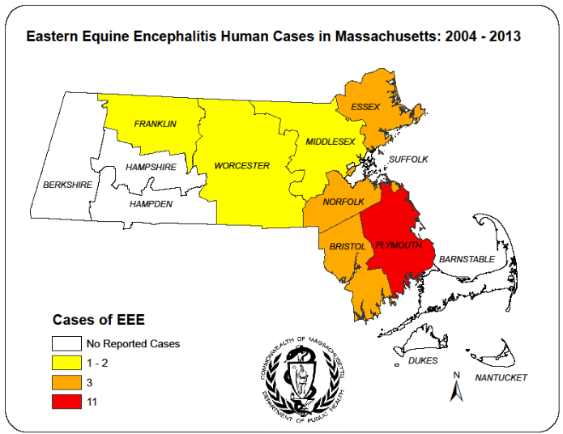
In Massachusetts, human EEE is associated with Culiseta melanura activity. The map to the right illustrates that the area of highest risk for transmission of EEE continues to be southeastern Massachusetts which is the historic area of risk (indicated by circle).

Over the last ten years human EEE has occurred outside of the historic areas of risk and has shown significant variability in its geographic patterns of occurrence during the three successive time periods, indicated below. Cases are mapped by most likely county of exposure, rather than county of residence.
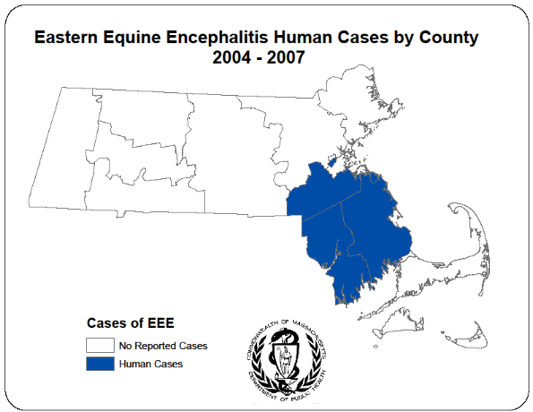
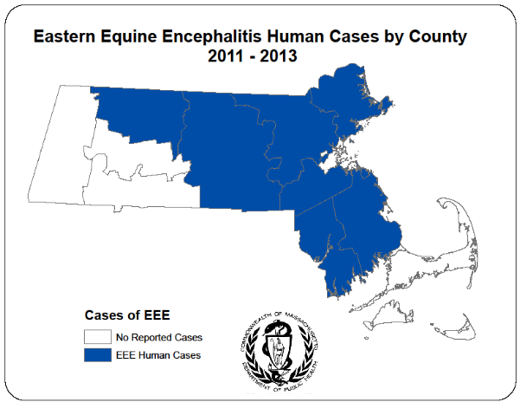
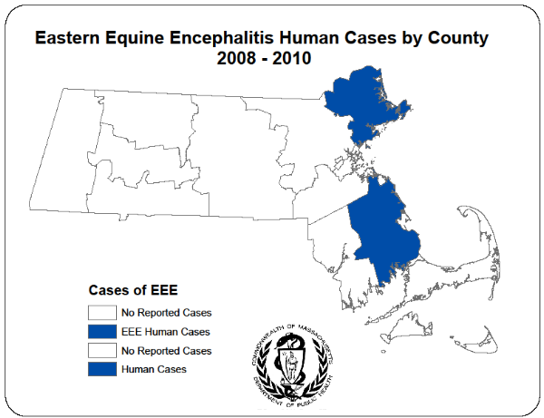

What are the expectations for EEE in 2014?

Mosquito abundance and vector-borne disease risk are affected by multiple environmental factors which vary over time and geographic location. The two most important contributors to mosquito development are precipitation and temperature. All species of mosquito depend on the presence of water for the first stages of life. Mosquito populations increase when precipitation is plentiful and decrease during dry periods. Warmer temperatures shorten both the time it takes for mosquitoes to develop from egg to adult and the time it takes for a mosquito to be able to transmit a pathogen after ingesting an infected blood meal.

Warm and wet winters increase the likelihood of mosquito survival and lead to higher spring mosquito numbers. Changes in expected seasonal precipitation and temperature may occur with climate change and could have dramatic effects on mosquito abundance and transmission rates.

Mosquito populations alone are not sufficient to produce significant EEE risk; infected bird populations are also necessary. Unfortunately, less is known about the factors that lead to large numbers of infected birds, making this component of risk impossible to predict, at this time there is no efficient method to conduct surveillance for infection levels in wild birds.

Both the variability of New England weather and the inability to detect EEE virus infection levels in wild bird populations requires that Massachusetts maintain a robust surveillance system to detect EEE virus in mosquitoes as a tool to assess risk of human disease.

WEST NILE VIRUS

Humans
As of February 10, 2014, there were eight human cases of WNV infection identified in Massachusetts in 2013. The results are summarized in the table below.

2013 Confirmed Cases of Human WNV Infection

County | Age Range | Onset Date | Virus Result | Clinical Presentation
Essex | 51-60 | 9/1/2013 | WNV | Meningitis
Essex | 71-80 | 9/14/2013 | WNV | Meningoencephalitis
Hampden | >80 | 9/22/2013 | WNV | Meningitis
Middlesex | 51-60 | 8/27/2013 | WNV | WNV fever
Norfolk | 31-40 | 8/10/2013 | WNV | Meningitis
Plymouth | 71-80 | 8/18/2013 | WNV | Meningoencephalitis
Plymouth | 71-80 | 10/6/2013 | WNV | Meningoencephalitis
Suffolk | 61-70 | 8/22/2013 | WNV | Meningitis

Presumptive Viremic Blood Donors
WNV is transmissible through blood transfusion. Since June 2003, U.S. regulations have required that blood banks screen donated blood for WNV using direct test for viral genetic material. Positive units are not used and donors are deferred from future donation for 120 days. The AABB (formerly the American Association of Blood Banks) notifies states of all presumptive viremic donors (PVDs) - individuals whose donated blood tests positive using a NAT.

There were two presumptive viremic donors identified in Massachusetts in 2013. The number of presumptive viremic donors nationwide was lower in 2013 (304 as of November 29, 2013) compared with 2012 (597).

County | Donation Date
Middlesex | 9/11/2013
Essex | 9/18/2013

Mosquito Samples
Of 6,092 mosquito samples collected in Massachusetts in 2013, 335 (5.5%) were positive for WNV. Positive mosquito samples included 240 (3.9 %) Culex species. Positive samples were identified in 128 towns in 11 counties. For a complete list of positive mosquito samples by city/town, please see the 2013 Cumulative Mosquito Summary by County and Municipality report posted on the MDPH website.

Animals
Sixteen veterinary samples were submitted for arbovirus testing. Two horses tested positive for WNV in 2013.

County | Animal Species | Onset Date | Virus Result
Bristol | Horse | 9/11/2013 | WNV
Worcester | Horse | 9/26/2013 | WNV

Birds
The MDPH Arbovirus Surveillance Program discontinued routine dead bird reporting in 2009 because it became an unreliable measure of human risk. Bird die-offs can and do occur for reasons unrelated to WNV infection and can be reported to the Massachusetts Division of Fisheries and Wildlife (MDFW). Poultry flocks experiencing sudden illness or mortality should be reported to the Massachusetts Department of Agricultural Resources (MDAR).

WNV Geographic Risk Levels
WNV risk maps are produced by integrating historical data and areas of mosquito habitat with current data on positive virus identifications (in humans, mosquitoes, etc.) and weather conditions. Risk levels serve as a relative measure of the likelihood of an outbreak of human disease and are updated weekly based on that week’s surveillance data. Initial and final WNV risk levels from the 2013 season are provided in the following maps. This information will be used to help predict risk in 2014, and will be revised as 2014 surveillance data are collected. More detailed information about risk assessment and risk levels is available in the Arbovirus Surveillance and Response Plan on the MDPH web site.

Initial and Final 2013 WNV Risk Categories
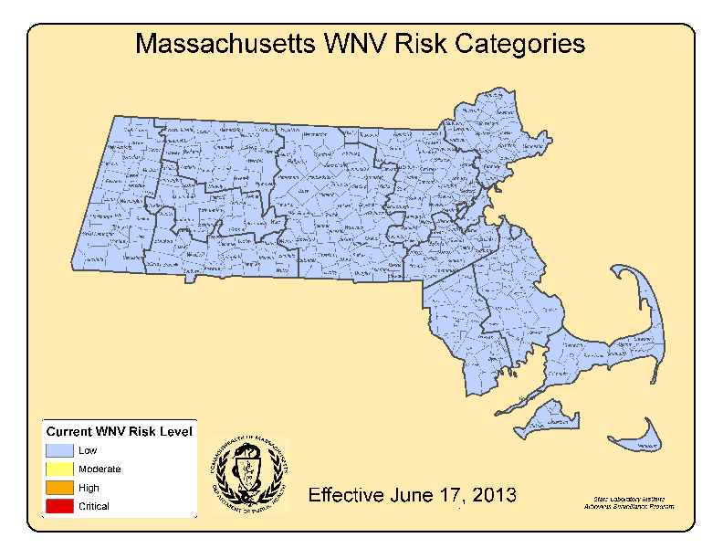 (As described in Table1 of the 2013 MDPH Arbovirus Surveillance and Response Plan which can be found at www.mass.gov/dph/mosquito under “Information for Local Boards of Health”)
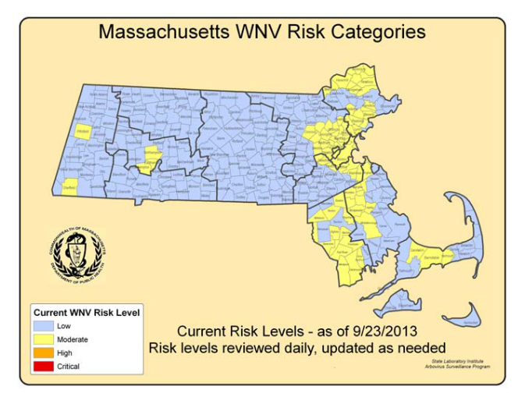

2013 WNV SEASON DISCUSSION

MDPH identified eight confirmed human WNV infections in 2013 compared to 33 confirmed human cases identified in 2012. This decrease in human cases was also seen across the country, where the number of confirmed human cases nationwide was dramatically lower in 2013 (2,271) than in 2012 (5,387). Of the 2,271 cases identified nationally in 2013, 1,140 (50%) were classified as neuroinvasive disease (such as meningitis or encephalitis) and 1,131 (50%) were classified as non-neuroinvasive disease. Sixty-nine percent of the cases were reported from nine states (California, Colorado, Illinois, Minnesota, Nebraska, North Dakota, Oklahoma, South Dakota, and Texas) and 16% of all cases were reported from California.

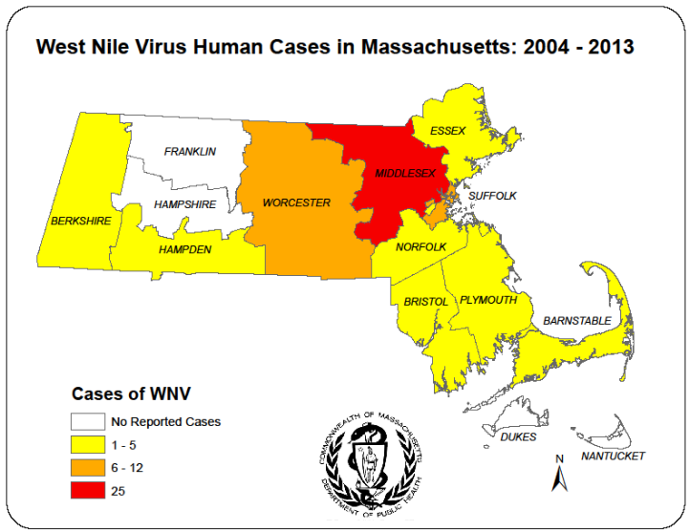
In Massachusetts, the vectors for WNV are primarily Culex species. Culex species are closely associated with human activity. The map to the right demonstrates transmission to humans is highest in counties with high population density.

In 2013, MDPH identified 240 WNV positive Culex species mosquito samples as compared to 268 WNV positive Culex species mosquito samples in 2012. Considering the decrease in human cases of WNV infection that occurred from 2012 to 2013, a decline in WNV positive mosquito samples might also be expected. However, as the graph below demonstrates, the percentage of WNV positive Culex mosquito samples declined only slightly from 2012 to 2013 in comparison to the large decline in WNV human cases.

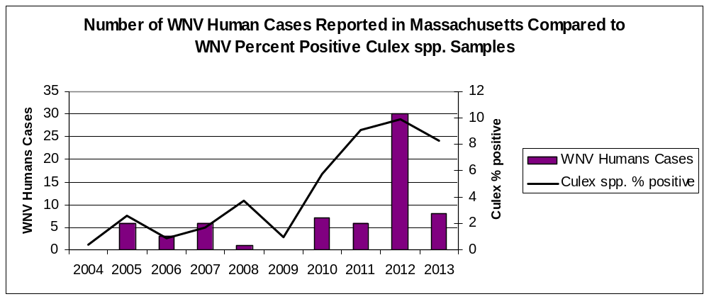

What are the expectations for WNV in 2014?

The primary determinants of human risk during any particular season are populations of Culex mosquito species and the presence of infected birds. The two most important variables for mosquito development are precipitation and temperature. Warmer temperatures shorten both the time it takes for mosquitoes to develop from egg to adult and the time it takes for a mosquito to be able to transmit a pathogen after ingesting an infected blood meal. Culex mosquito populations tend to be greatest during seasons with periodic precipitation events separated by hot, dry days.

Mosquito populations alone are not sufficient to produce significant WNV risk; infected bird populations are also necessary. Unfortunately, less is known about the factors that lead to large numbers of infected birds making this component of risk impossible to predict and there is no efficient way to conduct surveillance for infection levels in wild birds.

The lack of useful pre-season predictive factors limits the ability of MDPH to make any accurate assessments regarding future WNV activity. Both the variability of New England weather, and the inability to detect WNV infection levels in wild bird populations, requires that Massachusetts maintain a robust surveillance system to detect WNV in mosquitoes as a tool to assess risk of human disease. MDPH continues to strive to identify reliable measures to aid in risk assessments.

