COMMBUYS Implementation Guide

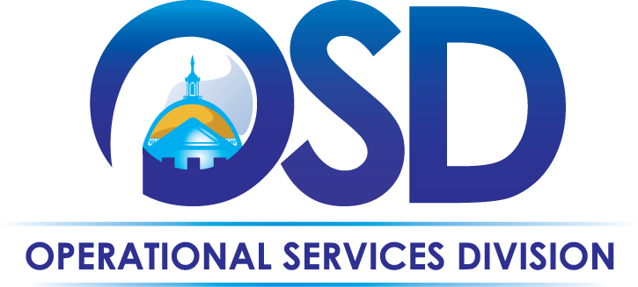

Table of Contents
Section 1: COMMBUYS Overview 5
Who Should Read This Book 5
What is COMMBUYS 5
COMMBUYS Overview 5
Why use COMMBUYS 6
Advantages of Registering 7
Who is Required to use COMMBUYS 8
Who is Eligible to use COMMBUYS 8
OSD Support 8
Section 2: Setting up Your Organization 9
1. Review the COMMBUYS Policy Requirements 10
2. Designate an Organization Administrator (OA) 10
3. Define your Purchasing and Procurement process. 10
4. Complete the COMMBUYS Registration Form 10
5. Map Your Approval Process 11
6. Send Your Staff to Procurement Training 11
OSD is Here for You 11
Section 3: Roles and Security in COMMBUYS 13
The Organization Admin (OA) Role 13
User Roles 14
Assigning Staff to User Roles 16
Section 4: Define Your Purchasing and Procurement Process (Workflow) 17
Purchasing off Your Contracts or a State-Wide Contract (SWC) 18
Conducting a Procurement 19
Section 5: Preparing to Set up Your Organization 21
Mapping Your Current Model to COMMBUYS 21
Guidance for specifying Departments and Locations 21
Example for Departments and Locations 22
Providing Ship-To/Bill-To information 24
The “User” Roles in the COMMBUYS Workflow 24
Organization Setup Examples 25
Section 6: Setting up Approval Paths 29
Guidance for specifying Approval Paths 29
Approval Types and Sequence 30
Organization: Sample Approval Path Overview 31
Section 7: COMMBUYS Training 33
What Training is Right for Me? 34
Organization Administrator (OA) Training 34
Purchasing Training 34
Procurement Training 34
Section 8: Your Next Steps 35
Appendices 37
Appendix I: OA Roles & Responsibilities 39
Overview 39
Account Setup activities that can be completed by the OA 39
Knowledge necessary to complete these tasks: 39
Approval Path Setup activities that can be completed by the OA 40
Appendix II: COMMBUYS Registration Form 41
Section A - Operational Services Division Membership Form 41
Section B - Entity Type & Purchasing Process 42
Section C - Fiscal Year & Document Access 42
Section D - Department/Location & Ship to/Bill to 43
Appendix III: Worksheets 45
Department Hierarchy 46
Departments and Locations 47
Role Assignments 48
Approval Paths 50
Abridged Glossary 51
Readiness Checklist for Purchaser Organizations 53

Section 1: COMMBUYS Overview

Who Should Read This Book
This guide is designed to assist eligible organizations implement COMMBUYS, the Operational Services Division’s (OSD) Government to Business procurement market center. Each section of this book focuses on a specific readiness topic that must be completed in order to ensure an efficient and effective COMMBUYS implementation. Any individuals involved with a COMMBUYS implementation project should read this book. This book is intended to be used during a COMMBUYS implementation project and while working with the OSD COMMBUYS Enablement Team (CET).

What is COMMBUYS
The COMMBUYS system enables electronic ordering through established Statewide and buyer-specific vendor catalogs that provide important purchasing data which can be used to track contract spending, aggregate future purchases, and analyze purchasing patterns and trends. COMMBUYS functionality provides opportunities for Statewide Contracts to improve responsiveness to public entity purchasing needs.

COMMBUYS Overview
The launching of COMMBUYS on March 24, 2014, marks a milestone for the Commonwealth and all the government entities in Massachusetts. For the first time, the Operational Services Division (OSD) is able to provide an enterprise-wide solution to all Executive Departments, non-Executive departments, cities and towns, school districts, and all of higher-education at no cost. COMMBUYS provides a full end-to-end procurement and purchasing system to all government agencies and eligible entities that do not have a procurement module supporting their specific financial system.

COMMBUYS connects all levels of Massachusetts government with businesses, and connects government entities with one another. All activity is performed in a single online portal that is available 24x7x365. It provides market center members with the tools to develop and publish solicitations, receive solicitation responses, conduct evaluations, publish public bid award notifications, shop and order, and enter receiving information---all online. It even provides electronic storage of all documents associated with a solicitation and the purchasing activity against those awarded contracts. The system collects all ordering and spending data and allows for flexible sophisticated reporting.
Vendors can view solicitation and contract information without logging in or registering, and registering with a COMMBUYS account allows an organization full access to all COMMBUYS functions, including purchasing off statewide contracts.

As your partner in the procurement process, OSD has a history of seeking the best value available in the acquisition of the various goods and services essentials to running cost effective government. We believe COMMBUYS offers value for cities and towns across Massachusetts.

Why use COMMBUYS
There are many benefits to using COMMBUYS -- from access to Statewide contracts and online sourcing to bid solicitation and contract management to robust reporting---it’s all here for you.

- State Contract/Catalog Search & Ordering
  - Already licensed by the State for your use
  - Access to statewide contracts (SWC)
  - Savings from State pricing reduces costs by providing access to over 8,000 vendors and their competitive state contract prices
- Online Sourcing & Bid/Solicitation
  - Manage and award proposals online system at no cost
  - Side by side quote comparison
  - immediate access to strategic sourcing by soliciting, evaluating and awarding bids within COMMBUYS
- Vendor/Contract Management
  - Secure one-stop-portal for vendor management – eliminating the time required for your staff to manually track vendors, and store records
- Requisition & Purchase Orders
  - Streamlined ordering workflow
  - Provides procurement work flow - Requisition, Approval Paths, Purchase Orders
- Free to defined eligible entities
  - Web-based; no installation required
- Decrease requisition and approval cycle time maximizing productivity
- Robust Reporting
  - No manual reporting
  - Provide easy access to historical records and audit trails

Advantages of Registering
You don’t have to register to use COMMBUYS. Without registering you can view and search, but registered users can do much more.

Non-registered user can:
- View registered Vendors
- Search for specific items/services, contracts or vendors
- View available Statewide and department contracts
- View solicitations
- Download select documents

Registered buyers who log into COMMBUYS can:
- View detailed contractor catalogs or price sheets
- Compare prices between contract vendors
- Access and place orders directly from catalogs
- Take advantage of automated workflow and approval processes
- Experience significant savings in staff time and paper processing
- View contracts that are specific to the buyer's organization
- Leverage reporting data on your purchases
- Obtain valuable data online for future reference
- Inspect comprehensive online records of the purchasing process

Who is Required to use COMMBUYS
- Executive Departments that are subject to the Operational Services Division’s (OSD) procurement regulations and policies are required to use COMMBUYS.
- All Non-Executive entities that purchase off OSD Statewide Contracts are encouraged, but not required to use COMMBUYS to place their orders.

Who is Eligible to use COMMBUYS
- Massachusetts cities, towns, districts, counties and other political subdivisions
- Massachusetts Executive, Legislative and Judicial Branches, including all Departments and elected offices therein
- Massachusetts independent public authorities, commissions and quasi-public agencies
- Local public libraries, public school districts and charter schools located in Massachusetts
- Public hospitals that are owned by the Commonwealth of Massachusetts
- Massachusetts public institutions of high education
- Other entities when designated in writing by the State Purchasing Agent

OSD Support
In addition to the benefits of COMMBUYS itself, organizations that use COMMBUYS gain access to OSD support and services. We provide one-on-one support, setup services to configure your organization in COMMBUYS, register your users, provide Helpdesk services and Training, and can even create a total customized training program for you.

OSD continually works with purchasing officials to understand how local buyers make purchasing decisions, and explores opportunities to expand statewide contracts to meet emerging needs. Our goal is to enhance collective purchasing opportunities throughout the Commonwealth.

We are excited about your taking advantage of this new technology that dramatically improves public purchasing across the Commonwealth. If you have any questions at any time, please don’t hesitate to contact us at COMMBUYS@state.ma.us

Section 2: Setting up Your Organization
Setting up your organization is easy! The COMMBUYS Enablement Team will meet with you, listen to you, set you up with an initial account, and tailor a solution to fit your needs. We can even build a customized training program for you.

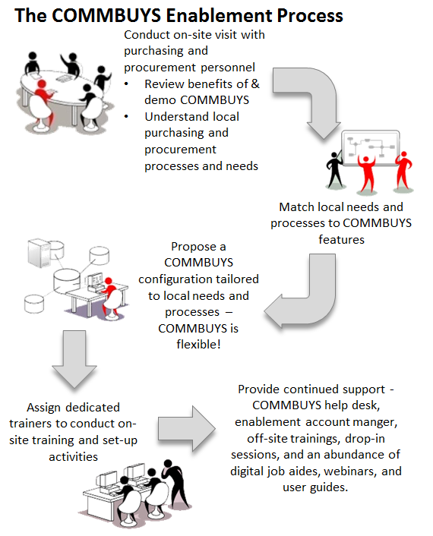
Figure 1: The COMMBUYS Enablement Process

Whether your organization was registered with a previous procurement system or is a new Purchasing entity, you must complete several tasks before your organization can use COMMBUYS.

Review the COMMBUYS Policy Requirements
- Review the terms of use agreements (for both Sellers and Purchasers) that can be found at www.commbuys.com > COMMBUYS > Key Resources: COMMBUYS Resource Center.
Scroll down to the User Agreements and Terms of Use section.
COMMBUYS Agreement and Terms of Use for Sellers
COMMBUYS Agreement and Terms of Use for Purchasers
- All organizations are required to follow their own existing policies. Use of COMMBUYS will not conflict with them.
- If you are subject to 801 CMR, you must adhere to the COMMBUYS Use Policy for Purchasing Organizations
  - OSD policy requirements apply to entities using COMMBUYS when purchasing off a statewide contract.
  - OSD policy requirements for posting bids and awarding contracts apply when an entity uses COMMBUYS to post solicitations.

The COMMBUYS Use Policy for Purchasing Organizations (Word document) is available at www.commbuys.com > COMMBUYS > Key Resources: OSD COMMBUYS Policy. Designate an Organization Administrator (OA)
- Organization Administrators (OAs) play a crucial role for their organizations, ensuring that settings and workflows in COMMBUYS are configured to reflect internal policies and procedures.
- Your OA will be responsible for conceptualizing your organizational setup in COMMBUYS and will maintain your organization’s user accounts. We recommend that you appoint a primary OA and an alternate, if possible.
- OA tasks and responsibilities are detailed in Section 4: The Organization Admin (OA) Role , as well as, Appendix I: OA Roles & Responsibilities.

Define your Purchasing and Procurement process.
- Read Section 4: Define Your Purchasing and Procurement Process.
- Use the worksheets (located at back of this guide) to record information about your system and procurement processes. These worksheets enable your OA to map your current processes to COMMBUYS processes.

Complete the COMMBUYS Registration Form
- Use Appendix II: COMMBUYS Registration Form to provide OSD with the information we will use to create your organization account.
- Note how this form includes your designating a staff member as an Organization Admin (OA).
- OSD will perform the initial setup tasks for your organization. This includes creating/activating your organization’s account as well as creating one Department/Location with one Ship-to and one Bill-to address. The OA is responsible for completing any additional set-up activities. For example, you may want to enter additional users, department, location, and approval paths for your Organization.
- Send the registration form to OSD. Email the Organization Setup Form to COMMBUYS@state.ma.us
Attn: COMMBUYSInternalAdministrator or fax the form to: 617-263-1081.
- Once OSD processes the form, we will email a Login ID and Password to your OA within two business days.
- Your OA will be responsible for completing any additional set up activities.

Map Your Approval Process
- Create Approval Types, and then create Approval Paths, and finally assign approvers.

Send Your Staff to Procurement Training
- Staff responsible for entering and posting bids (solicitations) in COMMBUYS should attend training.
- OSD offers both online and instructor-led courses, as well-as job-aids, recorded webinars, and instructional videos.
- Review the COMMBUYS Training section in this book or visit The OSD Training Courses web site www.commbuys.com > COMMBUYS > Key Resources: Training & Registration > OSD Training Courses

OSD is Here for You
If you require assistance at any point during this process, feel free to contact us. OSD is happy to answer your questions, examine your current business processes, demonstrate how COMMBUYS can benefit your organization, and assist with setting up your account.

Once your organization submits the required information and joins the COMMBUYS community, a COMMBUYS Representative (CBR) will be assigned to your organization.

Your dedicated COMMBUYS Account Manager is: _______________________________________
- If you don’t yet have an assigned account manager and want to meet with the OSD COMMBUYS Enablement Team, send an email to:
commbuysenablement@state.ma.us Attn: Readiness Meeting

- If you have an immediate need to use COMMBUYS to post a bid, please contact the OSD Helpdesk to fast track your request
  - Email: COMMBUYS@state.ma.us Attn: COMMBUYSInternalAdministrator
  - Phone: (888)-MA-STATE (627-8283).

Section 3: Roles and Security in COMMBUYS
COMMBUYS employs a Role-Based Access Control (RBAC) system to ensure activities can only be performed by people authorized to perform those tasks. With RBAC, the permission to do a specific task is assigned to specific roles. Registered COMMBUYS users are assigned roles, and it is through those roles the users acquire the ability to use specific COMMBUYS functions. Since users are not assigned permissions directly, but only acquire them through their roles, management of individual user rights is both easy and manageable.
COMMBUYS uses the following roles:
- Organization Admin
- Inquiry
- Department Access
- Basic Purchaser

The Organization Admin (OA) Role
The Organization Admin role provides the user access to organization, user, and approval path setup. This role is not a purchaser role; it does not allow creating or viewing COMMBUYS documents. The OA role is for setup and maintenance only. No purchasing or procurement activity can occur in COMMBUYS using this role. Basic Purchaser and Department Access are the only two COMMBUYS roles that enable a user to create, edit, and approve.

Your organization’s Organization Administrator (OA) is responsible for preliminary set-up and ongoing maintenance, including, but not limited to:
- Managing system approval paths (workflow) in accordance with agency & local business processes
- Maintaining Organization/Entity-specific data that is required by the system (i.e., “Departments”, “Locations”, “Bill-to” addresses and “Ship-to” addresses.
- Creating and managing common forms and standard templates used by your organization
- Creating user profiles and managing user security, including providing other accounts the ability to do perform specific workflow tasks, such as managing forms and templates.
- Managing user access to reports and various system tools within your organization

OSD strongly suggests your organization identify at least two people to serve in the Organization Administrator role, to provide back-up should one OA be unavailable.

User Roles
There are three basic user roles in COMMBUYS: Inquiry, Department Access, and Basic Purchasing.
OAs assign COMMBUYS users to specific roles in the system and configure specific permissions at the user level.

User Role | Role Description | Activities Enabled by the Role
Inquiry | This is a “view only” role in COMMBUYS. It enables users to view fully processed documents within their Organization, including any internal notes and attachments not visible to the public. Users assigned this role cannot edit or take action (such as approve) on documents. | - View completed Requisitions and Purchase Orders within the Organization.  - View all open and historical bids (solicitations) and contracts, including approval history and non-public attachments intended for internal use only.
Department Access | The Department Access role enables requisition creation, and if authorized by the Organization Administrator, also enables document review and approval. It also enables users to submit requisitions electronically for approval.  The Department Access role can be configured at the user level to enable additional COMMBUYS privileges. | - Prepare Requisitions to order items from Statewide and Department Contracts or for an incidental purchase.  - Check Boxes provide additional user rights:  - Approvals: Gives this user approval rights and is allowed to be on approval paths.  - PO Receipts for DA Role: Must be checked if user is to do Receiving (Phase II).  - Enable Change Order Creation: Must be checked if user is allowed to create Open Market Change Orders.  - Department Buyer: Must be checked to allow user to be selected as a buyer for a requisition or purchase order.  - Disallow Ad-Hoc reporting: If checked; this DA user will not have ability to create ad-hoc reports. i.e. The Ad-hoc icon will be invisible to the DA user.  - Two Way Match: If checked, this DA user will have the ability to set PO Invoice Method to “Two Way Match” (Phase II).  - Participate in evaluating and scoring responses to a solicitation, if authorized by the OA.  Note: Individuals participating in bid evaluations will require the Department Access user role to review and score bid submissions.
 | DA Department/Location Superuser | - Rights to the entire department or location (based on selection).  - Ability to take control and work with any requisition for the department/location.
 | DA Requisitioner | - Full Department Access rights; can generate all requisition types.
 | DA Contract Shopper | - Can only create release requisitions against master blankets and contracts.
Basic Purchaser | The Basic Purchaser role includes all the capabilities of the Department Access role, plus the ability to create and review Requisitions, Bids, Purchase Orders, and Contracts. | - Create requisitions to purchase goods or services from Statewide Contracts or for eligible non-contract (Open Market) purchases if desired (e.g. create a Requisition for a good or service not on a Statewide Contract and for which procurement will need to be conducted).  - Create, post, and manage bids (solicitations) in COMMBUYS, including the set-up of selection criteria, development and attachment of supplementary documents (i.e., RFRs, etc.).  - Post contracts to COMMBUYS.  - Manage contracts and change orders/amendments after award.
 | Basic Purchasing Supervisor is not a distinct role, but is activated for selected BP roles via a check box. The supervisor has the right to review and take action on documents. | - The right to review and take action on all documents from selected BP users within your organization.
Table 1: Role Descriptions

Assigning Staff to User Roles
The following table contains examples of purchasing and procurement activities typically performed by staff. Match the activity to the corresponding COMMBUYS user role. As COMMBUYS enables organizations to delegate the preparation of requisitions, you should consider staff members who prepare paper requisitions today and to whom you may choose to assign the appropriate role so that they will be able to prepare requisitions online, eliminating the manual process.

Use the Role Assignment worksheets in the appendix to record the names of employees and their roles.

Activity | Role Required
 | Inquiry | Dept. Access | Basic Purchaser
Preparing Requisitions to purchase goods or services from statewide contracts |  | X | X
Creating Purchase Orders from approved requisitions for goods or services |  |  | X
Conducting procurements, creating solicitations, establishing contracts |  |  | X
Serving on an evaluation committee for a bid; reviewing bid submissions |  | X | X
Viewing documents for auditing and research purposes | X | X | X
Creating requisitions on behalf of other Departments/Locations |  | Access Required | X
Approving requisitions to purchase goods or services off a statewide contract |  | Access Required | X
Table 2: Activities -Role Matrix

Section 4: Define Your Purchasing and Procurement Process (Workflow)
In Section 2: Setting up Your Organization you learned that designating an Organization Administrator (OA) is an essential first step in setting up your organization’s COMMBUYS account. It is critical that the OA, possibly working with others, examines your organization’s current processes and maps them. In order to work effectively, COMMBUYS must replicate your current workflow. Use the examples in this guide and the worksheets in the appendices to process your ideas and map the workflows.
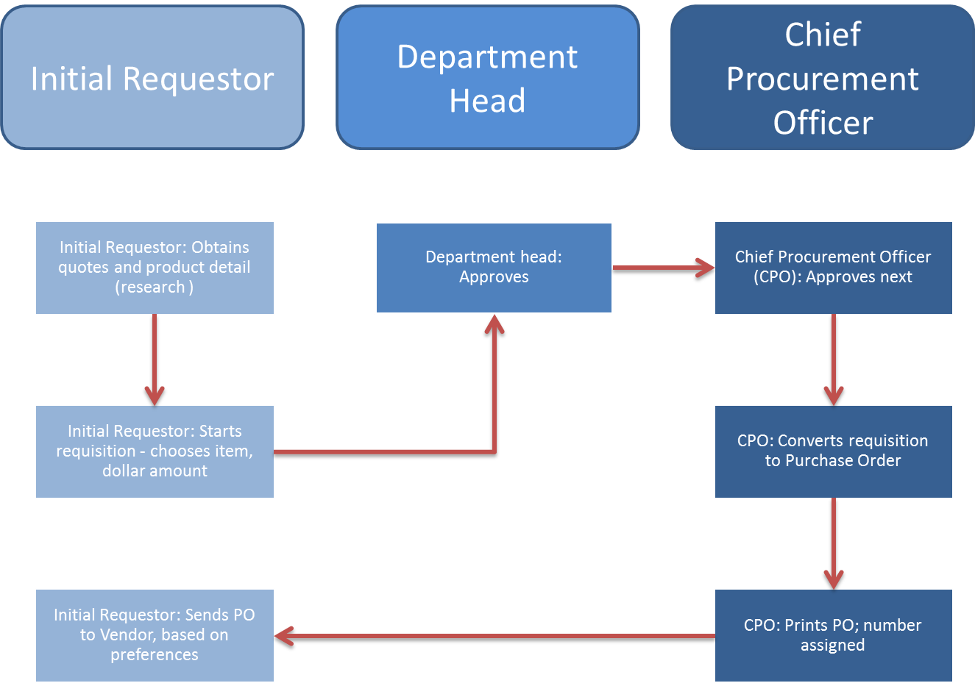
Figure 2: Example Organization Non-COMMBUYS Purchasing Workflow

Use the examples in this guide and the worksheets in the appendices to process your ideas and map your workflows.

Purchasing off Your Contracts or a State-Wide Contract (SWC)
The following chart describes COMMBUYS purchasing-related activities using a contract, and how these tasks are accomplished in COMMBUYS. This scenario is for illustrative purposes only; your organization may have to add steps to account for internal requirements. A Requester is one who makes a request to purchase a good/service; this is not a COMMBUYS user role. A Purchaser is one who makes the purchase; this is not a COMMBUYS user role.

Current Process | Corresponding COMMBUYS Step | Benefits and Considerations
Initial Requestor: Obtains quotes and product detail | Requestors need COMMBUYS login credentials.  The resulting list includes the names of the SWC vendors that sell the desired goods & services | All requests for goods & services are documented in COMMBUYS.  Buyers require login credentials.
Initial Requestor: Starts requisition - chooses item, dollar amount | After the search, the COMMBUYS user enters an online Requisition. | Staff must learn to use the search capabilities in COMMBUYS to purchase from Statewide Contracts.
Department head: Approves | Automatically forwarded | Requisitions can be set up with an approval process specific to your organization!
Chief Procurement Officer approves next | Automatically forwarded | Workflow processes can be set up to facilitate online approvals.
CPO converts requisition to purchase order | After approval an authorized person converts the Requisition to a Purchase Order or the Requisition can be converted to an RFQ. | Online Purchase Order created from the Requisition saves data entry time.
CPO prints out PO, number assigned  Requestor sends PO to Vendor based on preferences | - Purchase Order is sent electronically to the Vendor.  - RFQ that can be posted and sent electronically to multiple SWC vendors for a quote. | Sending Purchase Orders electronically to the contract vendors saves processing time!
Table 3: Current Process in COMMBUYS

Note:
- Note: In COMMBUYS, solicitations (e.g. RFQ, RFR, RFI, etc.) are referred to as a “Bid.
- Vendor responses (“Quotes”) must be sent using COMMBUYS.

Conducting a Procurement
The following chart describes procurement activity in COMMBUYS. This scenario is for illustrative purposes only; your organization may have to add steps to account for internal requirements.

Procurement Process | Impact
Procurement staff creates a Requisition, converts it to a Bid (Solicitation) and posts it through COMMBUYS. | One Portal - Information entered on one document (Requisition) will carry over to the next (Bid), upon required approval.  Organization approval paths, created by the Org Admin, will allow current organization workflow to occur online.
Vendors respond in COMMBUYS with Quotes (“bid responses”). A vendor must register in COMMBUYS in order to respond. | Save paper/electronic record- Bid responses saved online in electronic format.
Procurement or contract staff can evaluate vendor quotes using an automated evaluation function. | Online Evaluation Tool Feature provides the ability to establish evaluation criteria in COMMBUYS that will calculate the points as assigned by the evaluation team.
All Vendors submitting bids will receive system generated emails of award status. | Automated features save staff time!
COMMBUYS forwards solicitation information to populate the contract document in COMMBUYS; this is now known as a Master Blanket Purchase Order. | Easy access- Requisitions, Purchase Orders, and Contracts will all be linked and available online for viewing or printing.
Table 4: Procurement with COMMBUYS

Section 5: Preparing to Set up Your Organization

Mapping Your Current Model to COMMBUYS
- OSD strongly encourages you to examine your agency’s structure, in order to determine your specific business needs. Pre-implementation planning will enable your organization to leverage the full power of COMMBUYS. Prior to setting up Departments and Locations in COMMBUYS, your organization’s key decision-makers, including the OA, Chief Procurement Officer, COMMBUYS Liaison, and Supplier Diversity Officer, should already be part of the planning process.
- Mapping your current model includes, but is not limited to, adding Departments, Addresses, Locations, Users, and Approval Paths.

Guidance for specifying Departments and Locations
- OSD initially sets up each new Organization with one generic Department and one generic Location.
- Organization Administrators have the ability to modify and update that Department and Location information, and can add more Departments or Locations, based on their business needs, but are not required to.
- OAs are responsible for setting up their Organization-specific information based on decisions made at the Agency level. Keep things simple: Calculate the minimum number of Departments and Locations you need to support your business. Your OA can add Departments and Locations as needed.
- When considering Department and Location data for your Organization, think about your sourcing, procurement and purchasing practices. Use the following example diagrams to determine how best to specify Departments and Locations.
- Use the Appendix Worksheets to record your answers.
- OSD manages the COMMBUYS system-wide document, accounting and interface settings to support Commonwealth purchasing policy.
- In COMMBUYS, one MMARS department or entity = one Organization.
  - For example, EHS, DMR, DPH are all COMMBUYS Organizations.
- While OSD manages global settings, Organizations control their own Department and Location data, workflow (document routing for approval), and user security.
- Other eligible entities that choose to use COMMBUYS, such as municipalities, require an assigned Organization, and must complete additional organizational set-up in order to use the system’s full functionality.
- It is up to the municipality to decide how to best organize its COMMBUYS activity.

Every Organization will have at least one Department and one Location set up for it. Executive Agencies must have a Default Data Conversion Department (DDCD) that is used to organize all historical data from COMM-PASS. This DDCD should be left alone and not used. New departments and locations must be created and used for all subsequent activity. Organizations with complex approval processes based on hierarchy may need to establish additional Departments and Locations to support their approval and reporting needs.

Example for Departments and Locations
There are many ways to map your organization. The rest of this section contains several examples and the appendix contains worksheets to assist you. The following example for the town of Mayberry clearly depicts the town organization structure with departments and locations and ship-to addresses.
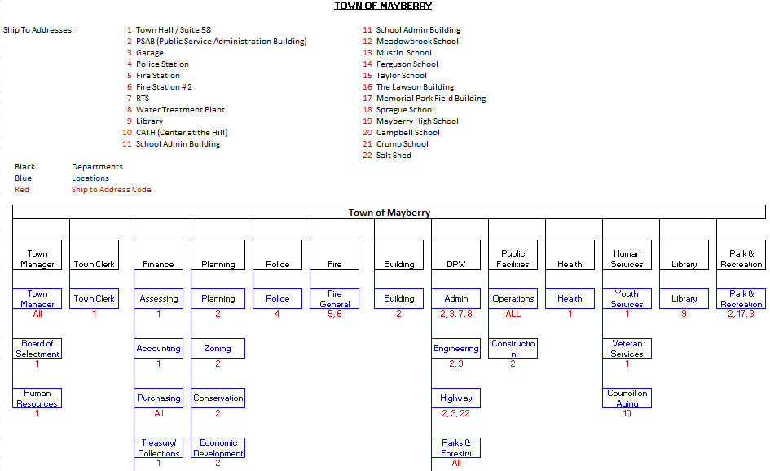
Figure 3: Sample Department Hierarchy

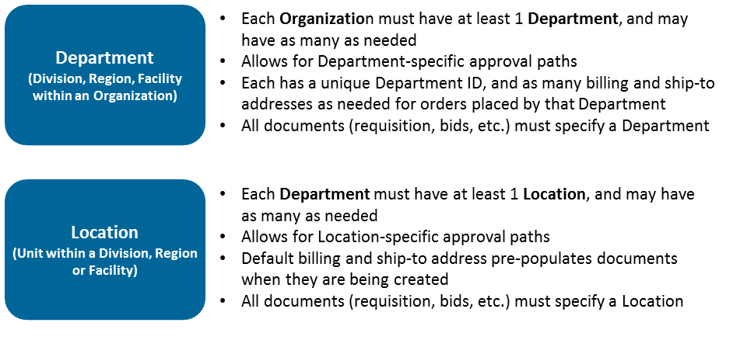
Figure 4: Departments and Locations

- COMMBUYS requires unique Department and Location IDs.
- You must choose and add your own IDs.
- The Department ID is a 5-character alphanumeric field.
- Use Department and Location names that are familiar to those who will use the system. Recommendations for setting up Department and Location IDs are covered in Organization Administrator training.
- In the following COMMBUYS screen image note the organization’s Department, Location, and respective IDs are displayed. All COMMBUYS users and the general public are able to view this information.

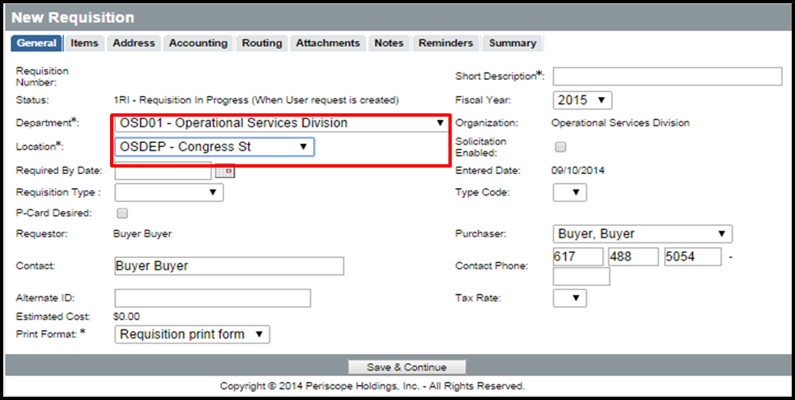
Figure 5: COMMBUYS displays Department and Location Information

- OSD Recommends: Use a naming convention that makes sense for your organization.
- Use the worksheets in the appendices to record your Department and Location IDs and names.

Providing Ship-To/Bill-To information
- As you develop your organization model, you will need to specify Bill-To and Ship-To addresses for each Location.
- This process requires the OA enter into COMMBUYS all the possible addresses for the organization.
- Remember that Locations are subsets of Departments. Therefore, addresses entered can be made accessible to Department Access and Basic Purchasing users.
- Users can be granted permission to select or modify Ship-To and Bill-To addresses.
- Documents will be pre-populated with a default Bill-To and Ship-To address.

The “User” Roles in the COMMBUYS Workflow
- As you learned in the Role and Security section, Department Access and Basic Purchasing are the only two roles in COMMBUYS that can create documents.
- Only after you have finalized your organization layout and created departments and locations, should you add COMMBUYS users for your organization.
- Placing users in the proper Department and Location are important for creating approval paths that mimic your agency’s current workflow.
  - For example: the Requestor/Purchaser or the Approver in COMMBUYS can convert an approved Requisition into either a Purchase Order or a Solicitation.

Consider: How does your organization determine how requests for purchases or solicitations are routed to the Purchasing leads, the staff that sources or buys the goods or services?

Organization Setup Examples
Example I: Simple setup: Small organization or organization with centralized purchasing.

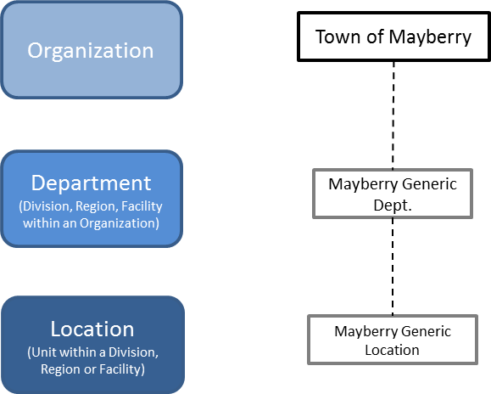

Example II: Municipality setup: Two separate departments and locations; useful when approvals are required, with approvers at each location or department.

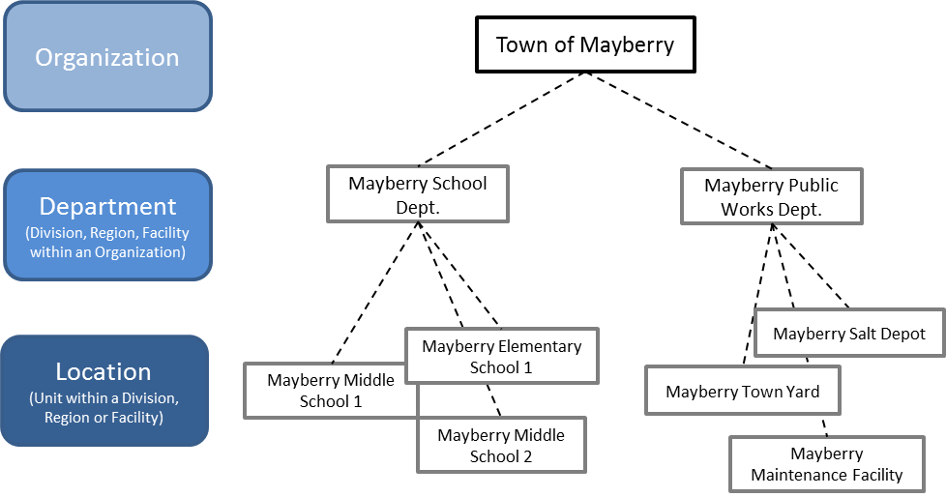

Example III: The departments represent physical agency locations, and the COMMBUYS locations are business functions. This scenario is similar to the Municipality example. This option should be used when there is a unique approval process for each location.

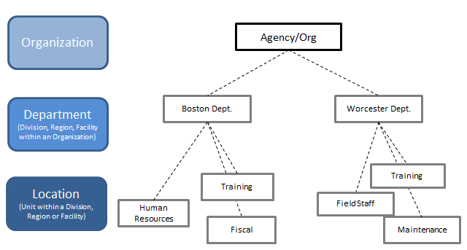

Example IV: In this scenario the departments represent business functions, and the COMMBUYS locations are physical locations.
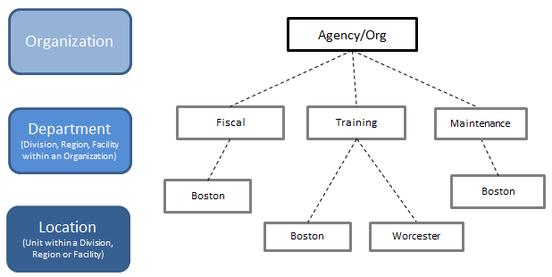

Note: Both setups allow for the creation of approval paths that are based on current agency/municipality workflows.
Example V: In this setup the departments describe a type of function or business unit, and use the locations as physical locations.

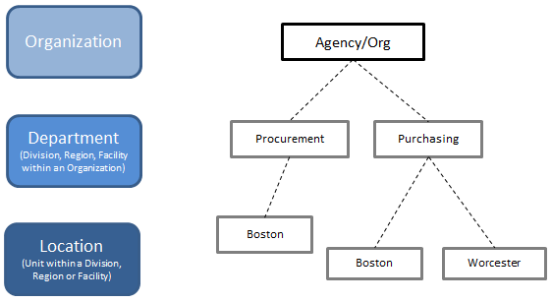

The appendix includes worksheets to assist your planning. The following sample table depicts a completed worksheet.

Organization for Town of Mayberry

Departments | Locations | Default Bill-To Address | Default Ship-To Address | Primary and Alternate Approver for Location*
Mayberry School Dept. | Mayberry Elementary School 1 | Town of Mayberry School Dept.,  Town Hall,  15 Main Street, Mayberry, MA 00000 | Drumlin Meadowbrook Elementary School,  13 Maple Street, Mayberry, MA 00000 | John Doe primary,  Jim Doe alternate,  technology purchases must also be approved by Mary Smith
 | Mayberry Middle School 1 | Town of Mayberry School Dept.,  Town Hall,  15 Main Street, Mayberry, MA 00000 | TJ Mustin  Middle School,  95 Summer St., Mayberry MA 00000 | John Doe primary,  Jim Doe alternate,  technology purchases must also be approved by Mary Smith
 | Mayberry Middle School 2 | Town of Mayberry School Dept.,  Town Hall,  15 Main Street, Mayberry, MA 00000 | Ernest Ferguson  Middle School,  57 Winter St., Mayberry MA 00000 | John Doe primary,  Jim Doe alternate,  technology purchases must also be approved by Mary Smith
Mayberry Public Works Dept. | Mayberry Salt Depot | Town of Mayberry Public Works Dept., Town Hall,  15 Main Street, Mayberry, MA 00000 | 42 Maple Street,  Springfield, MA 01444 | Janet Graves primary and Joan Jameson alternate for all Salt Depot purchases
 | Mayberry Town Yard | Town of Mayberry Public Works Dept., Town Hall,  15 Main Street, Mayberry, MA 00000 | 99 Poplar Street,  Springfield, MA 01443 | Janet Graves primary and Joan Jameson alternate for all Town Yard purchases
 | Mayberry Maintenance Facility | Town of Mayberry Public Works Dept., Town Hall,  15 Main Street, Mayberry, MA 00000 | 99 Poplar Street,  Springfield, MA 01443 | Janet Graves primary and Joan Jameson alternate for all Maintenance Facility purchases over $1000
Table 5: Completed Worksheet for Town of Mayberry

* If needed

Section 6: Setting up Approval Paths

Guidance for specifying Approval Paths
In COMMBUYS, Agency Approval Paths are specific paths for documents, such as Requisitions, which require authorizations. Approval paths can be based on a variety of criteria including department, location, document type, dollar amount, or other desired criteria.
Each approval path is set up individually, but approval paths can work in a “cascading” fashion, which requires all possible paths that pertain to the submitted document be completed. Auto-Cascading approval paths automatically attach to documents and route them to the appropriate approvers. For example: You intend to order a large amount of office furniture. The standard approval path for your Agency is your supervisor and department head, but in the case of a large dollar amount, the Requisition requires the Fiscal department’s approval. These paths can be set-up in COMMBUYS; Auto-Cascading will require both paths are approved before the order can move forward.
Organization Administrators can set up individual approval paths for each criterion: one path for the department (with the path to include your supervisor and Agency head – based on your default department) and one for the item (with the path to include the Fiscal department). These approval paths will route the document automatically to those specific approvers in the order you set up in COMMBUYS.
In most organizations, approval paths will be based on one or several of the variables in the list below, and your current procedures should inform both approval path needs and Department/Location setup.
Variables to consider:
- The (estimated) dollar amounts of the items being procured
- The stage of the purchasing/procurement process, by document type.
- Requisitions – the request to purchase goods or services
- Solicitations – the “bid” prior to publishing for vendor response
- Solicitation Award Recommendations – prior to contract award/negotiation
- Purchase Orders and Contracts, prior to being “sent” to vendors
- Change Orders, prior to applying them to a PO or Contract
- Note: If your organization uses MMARS, Purchase Orders, Contracts, and Change Orders must include, at a minimum, approval by someone authorized to approve encumbrances in MMARS, in order to comply with DHSA.
- The business unit (Departments and Locations, in COMMBUYS terminology) originating the purchasing request
- The commodities being purchased or procured

Approval Types and Sequence
In order to sequence approvals in COMMBUYS, the Organization Administrator (OA) must transform the organization’s current approval types into COMMBUYS Approval Types and an associated Approval Type Sequence. At least one Approval Type is required before an Approval Path can be created. The Type is used to determine the sequence in which approvals must occur when a document triggers multiple layers of approval.

If your organization needs only a few approval paths, you may be able to start with a generic approval type called “All Approvals”.

For example, if your location requires supervisor approvals at the Location level, consider whether you want those Location supervisor approvals to occur before or after Department level approval. If approvals depend on the item/service being purchased or the dollar value of the purchase, consider whether you want the approval at the Location level to take place before or after commodity or dollar-based approvals.

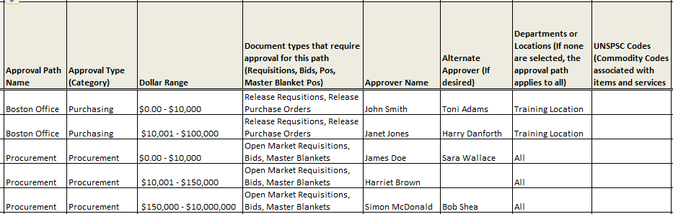
Figure 6: Example Agency Approval Process

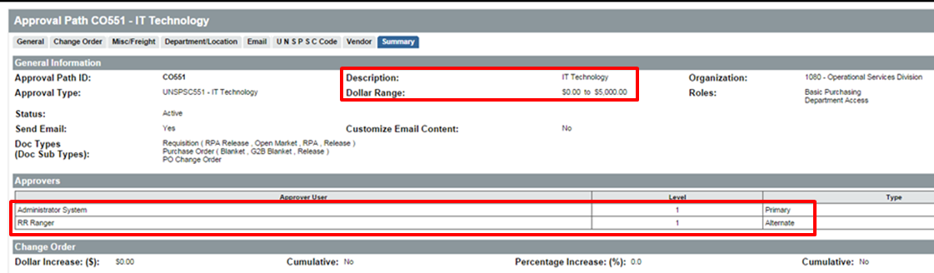
Figure 7: Example COMMBUYS Approval Path Screenshot

Organization: Sample Approval Path Overview
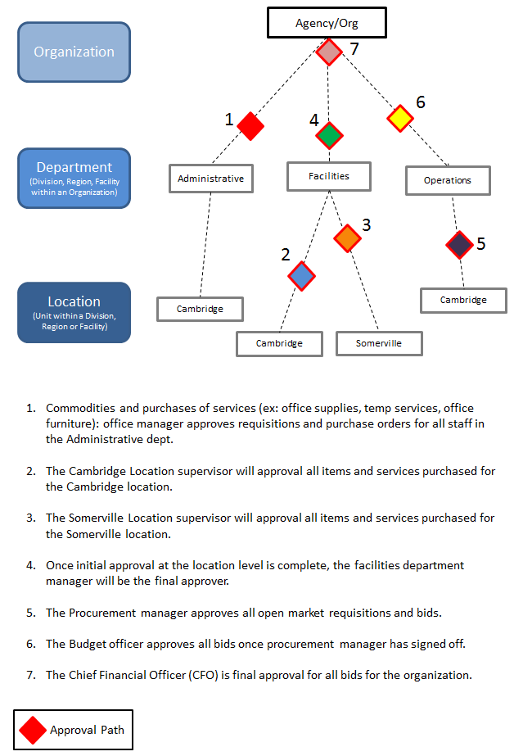
Figure 8: Sample Approval Path

Section 7: COMMBUYS Training
As the COMMBUYS Enablement Team works with you, it will design a customized training program for your organization. OSD offers a wide variety of Training formats, including online and instructor-led courses, recorded webinars, and instructional videos. Additional resources include demonstrations, fact sheets and job-aids.

All COMMBUYS users can register for regularly scheduled instructor-led classes. Buyers who have already attended training can register for drop-in sessions that provide guidance and follow-up support to small groups or individuals who have specific questions and concerns.

Further information is available at the COMMBUYS websites:

Topic | Internet Path (Breadcrumb)
COMMBUYS Training and Registration  View buyer or seller webinars. | http://www.commbuys.com > COMMBUYS > Key Resources: Training & Registration
OSD Training Courses  Register for instructor-led courses or view the Cancellation policy. | http://www.commbuys.com > COMMBUYS > Key Resources: Training & Registration > OSD Training Courses
Job Aids for Purchasers  A collection of how-to documents. | http://www.commbuys.com > Job Aids for Purchaser
Job Aids for Sellers  A collection of how-to documents. | http://www.commbuys.com > Job Aids for Seller
OSD Training and Event Calendar  A calendar that provides quick and easy access to upcoming activities. | http://www.mass.gov/anf > Budget, Taxes & Procurement > Procurement Information > OSD Events and Training > OSD Training and Event Calendar
COMMBUYS Resource Center  Your one-stop page for COMMBUYS readiness, awareness & enablement information | http://www.commbuys.com > COMMBUYS > COMMBUYS Resource Center
Table: COMMBUYS online Training Resources

In addition to scheduled courses, the OSD Training Outreach and Marketing Team is available to teach at your site or participate at your association's meeting.

If interested, please complete the Onsite Training Request Form , which is available at:
www.mass.gov/anf > Procurement Information & Resources > OSD Events and Training > OSD Training Courses > Online Training Request Form

What Training is Right for Me?
OSD offers training for all your staff members who perform purchasing and procurement activities. The training is available in a wide variety of Training formats, including online and instructor-led courses, recorded webinars, and instructional videos. Additional resources include demonstrations, fact sheets and job-aids.

Organization Administrator (OA) Training
Intended Audience: Designated Organizational Administrators and backups.
Description: Provides in-depth review and hands-on practice of organization information, approval, workflow and user profile set-up activities. This course covers activity in detail, ensuring OAs are prepared to fulfill their role.

Purchasing Training
Intended Audience: Staff responsible for purchasing of goods and/or services from statewide and department contracts.
Description: Provides an introduction to COMMBUYS, new terminology, system navigation, and policy and instruction to purchase from Statewide or Department contracts. Participants learn to use COMMBUYS search functions, including how to search for specific items and/or services using a line item catalog or a punch-out catalog; create a request using a Requisition document, convert an approved Requisition to a Purchase Order or Bid, and create Change Orders.

Procurement Training
Intended Audience: Procurement officers and others involved in the processing of soliciting goods and/or services not available on the Statewide Contracts.
Description: Covers solicitation development, solicitation amendments, the use of templates, managing attachments, online bid evaluation, contract award, and posting awarded contracts online.

Section 8: Your Next Steps

Task | Target Date | Completed?
Schedule a meeting with the OSD COMMBUYS Enablement Team to discuss your current business process and how COMMBUYS can provide additional benefits.
Identify an Organization Administrator (OA).

Work with a COMMBUYS representative to incorporate the CB features and functions with your businesses process workflow.
Complete the OA Authorization Form
Mail the OA Authorization Form to OSD
Define Your Purchasing and Procurement Process
Complete the Organization/Department/Location Setup Form
Fax or email the Organization/Department/Location Setup Form to OSD
Finish reading this workbook.

Review the policy requirements; read the OSD COMMBUYS Policy document.
Review the Agreement and Terms of Use for Purchasers document.
If your organization plans to post bids, read the Agreement and Terms of Use for Sellers document.
Receive COMMBUYS Login and password for organization OA
Receive name of your dedicated COMMBUYS Account Manager

Identify and designate staff for COMMBUYS Training
Schedule Training for designated staff

Initial Training complete for all staff chosen for COMMBUYS Training
Initial COMMBUYS Organization setup: Minimum one Department and one Location, with one Bill-To address and one Ship-To address; at least one user.
All Departments and Locations entered into COMMBUYS

Appendices

Appendix I: OA Roles & Responsibilities

Overview
Organization Administrators (OAs) play a crucial role for their organizations, ensuring that settings and workflows in COMMBUYS are configured to reflect internal policies and procedures. In addition, the Organization Administrator maintains users and their permission levels in the system. Permissions include specifying individuals with authority to approve purchases. It is critical that the OA is in alignment with department executives, decision-makers, and security officers to ensure COMMBUYS supports the business effectively.

General Responsibilities | Pages
Review the COMMBUYS Policies | 10
Register for/attend COMMBUYS Training Classes | 11, 33
Complete COMMBUYS Setup Activities | 9,13,17,21,29,35,39

Use the worksheets (see appendices) to record your organization processes and workflows. The information you provide will enable OSD to set up a basic account for you with one Location, one Bill-to address, and one Ship-to Address. The basic setup performed by OSD will enable your organization to use COMMBUYS once the Organization Administrator receives a Login ID and Password.

Account Setup activities that can be completed by the OA
- Work with your Procurement and/or Fiscal Officer to design an organizational structure that best meets the organizational needs of the organization. Use the samples in this book and the worksheets in the appendixes.
- Identify each person in your organization that might use COMMBUYS to purchase or procure goods and services.
  - add new users,
  - identify the roles and permission levels to be assigned to each user, and
  - maintain user account information on an ongoing basis
- Log in to COMMBUYS to create additional department and location records.
- Ship to and Bill to addresses will need to be entered in COMMBUYS by creating a department record. Create as many Ship to and Bill to addresses as necessary in order to conduct the purchasing and procurement business of the Organization.
- Determine whether to route requisitions to Purchasers based on Location Default Purchaser settings or Commodity Code (see Workflow below).

Knowledge necessary to complete these tasks:
- Understand how your organization is structured for purchasing and procurement
- Attend COMMBUYS Organization Administrator Training
- Understand COMMBUYS user roles and their functionality and attend COMMBUYS Organization Administrator Training

Approval Path Setup activities that can be completed by the OA
Initial setup of approval paths is not required, but most organizations will want to ensure that designated approval users are assigned to an approval path that enables them to conduct and approve transactions at a level consistent with the department’s internal controls.

- Enter into COMMBUYS the approver names (people who will be notified to approve any document).
- Identify the Approval Types and Approval Paths required by your organization.
- Create the Approval Types in COMMBUYS.
- Enter the Approval Paths for the specific documents that require approvals based on identified criteria. For example:
  - one path for the department (enter the supervisor and department head – based on the default department), and
  - one path for the item (the IT department – based on the item’s UNSPSC code) that will route the document automatically to those specific approvers.
- Assigns the Approval Type to each Approval Path.
- Assign a priority
- If not using the “Default Purchaser Location” setting when creating Locations, determine who (Basic Purchasing User) will be the “Catch All” for any unassigned commodities and assign any specific commodities to purchasers as needed. Note: This is for the purpose of routing approved requisitions in “Ready for Purchasing” status to someone with a Basic Purchasing role after initial approval to determine whether to create a bid, convert to PO and send to a vendor, or cancel a request. The Purchaser on a document can be reassigned as needed to support the workload distribution among purchasers and sourcing personnel.

Appendix II: COMMBUYS Registration Form

Section A - Operational Services Division Membership Form
Operational Services Division Membership Form (All Fields Required)
Designated COMMBUYS Organization Administrator Name:
Title:
Please Check One: | COMMBUYS Organization Administrator  COMMBUYS Back up Organization Administrator
Purchasing Organization Name:
Address Line 1 (Valid street address):
Address Line 2
City, State Zip Code:
Telephone Number:
Fax Number:
E-Mail Address:
Organization Website:

APPROVALS (All Signatures Are Required) |  | TITLE | DATE
COMMBUYS Organization Administrator Signature
Department Head Signature (or equivalent)
Chief Procurement Officer Signature(or equivalent)
Chief Fiscal Officer Signature(or equivalent)

If an organization/department does include individuals with the titles identified in the signature lines of this form, at its discretion, OSD may waive the requirements contained in this form and will work with the organization/department to ensure that proper authorization to establish an account is provided.

NOTE: The Organization Administrator will be given the role of Organization Administrator in COMMBUYS.

REMINDER: The COMMBUYS Organization Administrator responsibilities include working with the Agency Chief Procurement Officer and the Internal Administrator at the Operational Services Division (OSD) to ensure that control over the COMMBUYS system within your department is maintained at all times. You will be held accountable for security of the COMMBUYS system as it applies to your department.

ONCE COMPLETED, SCAN AND EMAIL THIS FORM TO: commbuys@state.ma.us

If this form has been filled out in its entirety and executed by all required signatories but the Organization Administrator has not yet attended the required COMMBUYS training(s), the Organization Administrator may request OSD to act as interim Organization Administrator, in order to post or administer certain documents. In such situations, OSD’s COMMBUYS Help Desk can activate your organization in the COMMBUYS system and act as interim Organization Administrator. This designation would be in effect until the designated COMMBUYS Organization Administrator has attended the required training sessions.

Section B - Entity Type & Purchasing Process
Entity Type:  Select One by double-clicking the appropriate box | Purchasing Process:  Select One by double-clicking the appropriate box
Executive Department | Centralized - all department purchases are processed by a central organization Centralized – all department purchases are processed by a central organization  Decentralized - each town/city department is responsible for processing purchases for their department
Independent Agency
Non-Executive Department
Municipality (including municipal school departments)
Public Authority or Commission
Regional school department or charter school
Regional Planning Agency
Regional Transportation Agency
Other – Type:

Section C - Fiscal Year & Document Access
Field | Explanation/Example: | Your data:
Fiscal Year Start Date | Start date of the current fiscal year
Fiscal Year End Date | End date of the current fiscal year
Fiscal Year Roll Days | Determines when users may start building documents for the next fiscal year and the amount of time after Fiscal Year end date to complete transactions for the previous year.
Do you want to limit Document Access for Department Access Users? | If yes, End users will be limited to viewing only the documents for their specific Department, School, etc. If no, End users will be able to view the documents for all Departments within this Organization. Example: If yes, Police Dept. end users will only be able to see requisitions, purchase orders, etc. for the Police Dept. | Yes  No

Section D - Department/Location & Ship to/Bill to
Complete this section to allow OSD to create one Department and Location for the above Organization. Each Eligible Entity can have multiple departments/locations; however OSD will only set up one department/location. Organization Administrators can create additional department/location (as need).
Example: Organization: City of Salem
Department 1: City of Salem - Town Hall
Department 2: Department of Public Works
Department 3: Salem Public Schools
Field | Explanation/Example: |  |  |  |  |  | Your data:
Department Name | Name of Department as it will display in CB/Finance Division
Department ID | 5 character abbreviation for the Department (no spaces)/FD001
Ship To Address | Same as Organization address (above) Different than Organization address (enter below)
Street Address (Valid street address):
City: |  | State: |  | ZIP:
Phone: |  | Fax: |  | Email:
Bill To Address | Same as Organization address (above) Different than Organization address (enter below)
Street Address:
City: |  | State: |  | ZIP:
Phone: |  | Fax: |  | Email:
Location Name | Name of Location as it will display in CB/Procurement
Location ID | 5 character abbreviation for the Location (no spaces)/FD001
Default Ship To Address | Same as Organization address (above) Same as Department Address (above)
Default Bill to Address | Same as Organization address (above) Same as Department Address (above)

NOTE: A prerequisite to this form is the “Designation of COMMBUYS Organization Administrator Membership Form”. By submitting this form and related materials, the Organization agrees to the COMMBUYS Agreement and Terms of Use for Organizations, and agrees that individuals using the system on behalf of the Organization will adhere to the COMMBUYS Agreement and Terms of Use for Purchasers.

APPROVALS (All Signatures Are Required) |  | Date
COMMBUYS Organization Administrator Signature
Chief Procurement Officer Signature

REMINDER: The COMMBUYS Organization Administrator responsibilities include working with the Agency Chief Procurement Officer and the Internal Administrator at the Operational Services Division (OSD) to ensure that control over the COMMBUYS system within your department is maintained at all times. You will be held accountable for security of the COMMBUYS system as it applies to your department.
ONCE COMPLETED, SCAN AND EMAIL THIS FORM TO: commbuys@state.ma.us

Appendix III: Worksheets
Use the following worksheets to document your organization structure and workflow considerations. After completing all tables, Organization Administrators (OAs) should have all the information they need to complete the organization setup in COMMBUYS.

Department Hierarchy
Organization: ___________________________________________

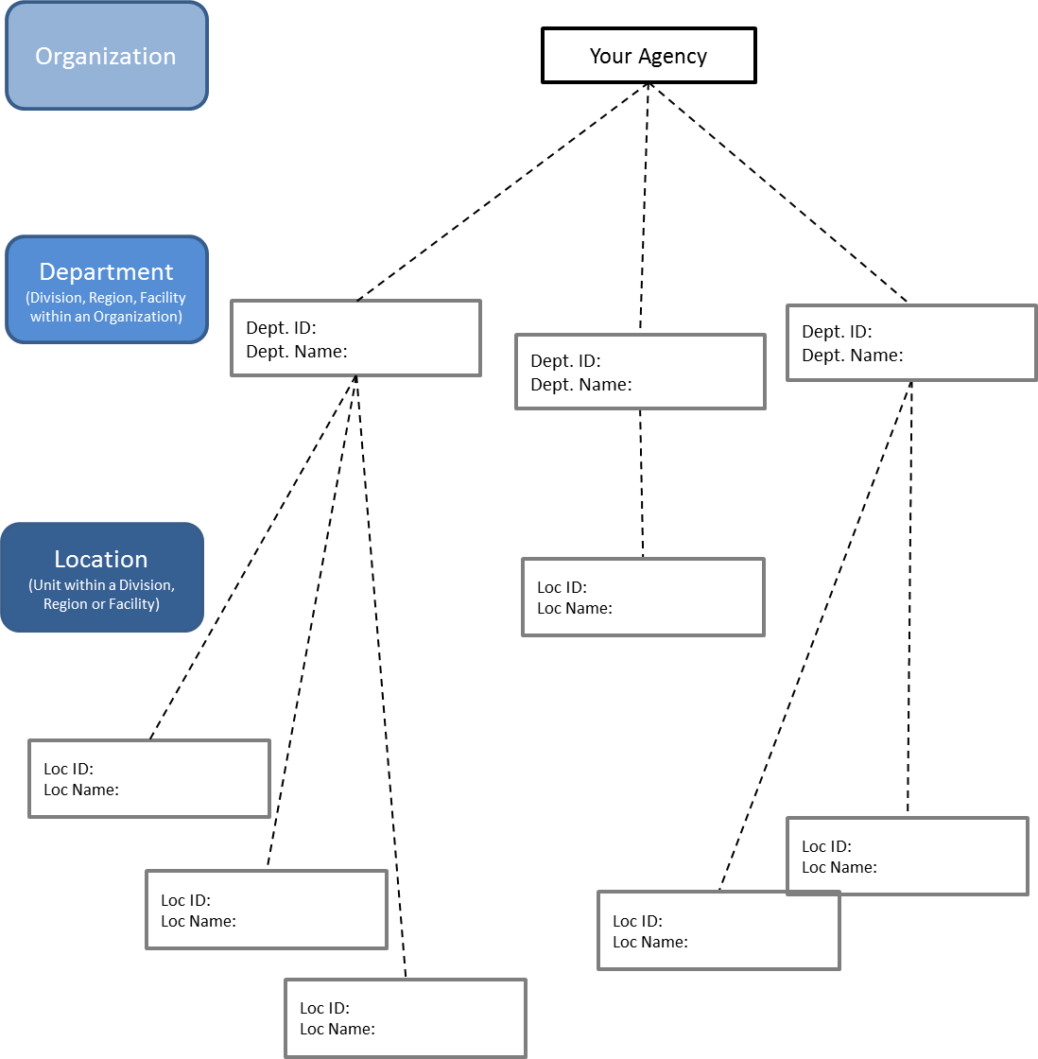

Departments and Locations
Organization: ___________________________________________

Department Name | Dept.  ID* | Location Name | Default  Bill-to  Address | Default  Ship-to Address | Primary and Alternate Approver for Department or Location | Other Addresses needed by this Department

* The Department ID is a 5-character alphanumeric field. Use an identification/sequencing scheme that makes sense to your organization.

Role Assignments
Organization: ___________________________________________
User Role | Role Description | Employees in this role
Inquiry | This is a “view only” role in COMMBUYS. The Inquiry role enables a user to view fully processed documents within their Organization, including any internal notes and attachments not visible to the public, but does not allow the user assigned this role to edit or take action (such as approve) on documents.  - View completed Requisitions and Purchase Orders within the Organization.  - View all open and historical bids (solicitations) and contracts, including approval history and non-public attachments intended for internal use only.
Department Access | The Department Access role enables requisition creation, and if authorized by the Organization Administrator, document review and approval. Department Access allows users to submit requisitions electronically for approval.  - Prepare requisitions to order items from Statewide and Department Contracts or for an incidental purchase  - Check Boxes:  - Approvals: Gives this user approval rights and is allowed to be on approval paths  - Allow PO Receipts for DA Role: Must be checked if user is to do Receiving (Phase II)  - Enable Change Order Creation: Must be checked if user is allowed to create Open Market Change Orders  - Department Buyer Enabled: Must be checked to allow user to be selected as a buyer for a requisition or purchase order  - Disallow Ad-Hoc reporting: If checked; this DA user will not have ability to create ad-hoc report i.e. Ad-hoc icon invisible to DA user role on upper right corner (Phase II)  - Allow Two Way Match: If checked, this DA user will have the ability to set PO Invoice Method to “Two Way Match” (Phase II)  - Participate in evaluating and scoring responses to a solicitation, if authorized by the Org. Admin. Note: Individuals participating in bid evaluations will require the Department Access user role to review and score bid submissions
DA Department/Location Superuser:
- Superusers have rights to the entire department or location (based on selection).
- The user can then take control of any requisition for the department/location and work on it.
DA Requisitioner:
The user has full Department Access rights and can generate all types of requisitions.
DA Contract Shopper:
Can only create release requisitions against master blankets and contracts.
Basic Purchaser  (includes all capabilities of the DA role) | The Basic Purchaser role includes all the capabilities of the Department Access role, plus the ability to create and review Requisitions, Bids, Purchase Orders, and Contracts.
 | Basic Purchasing Supervisor is not a distinct role, but is activated for selected BP roles via a check box. The supervisor has the right to review and take action on documents.

Approval Paths
Organization: ____________________________________________________

Approval Path Name | Approval Type¹ | Dollar Range | Document types requiring approval for this path² | Name of Approver | Name of alternate Approver³ | Departments or Locations⁴ | UNSPSC Codes⁵

- Category of the Approval
- Examples: Requisitions, Bids, Purchase Orders, Master Blanket PO
- Optional
- if none are selected then the approval path applies to all
- For information on UNSPSC codes visit www.unspsc.org

Abridged Glossary
A complete glossary of COMMBUYS terms is available online at www.commbuys.com > COMMBUYS > Key Resources: COMMBUYS Glossary

COMMBUYS Terms | COMMBUYS Definitions
Approval Types / Approval Paths | Refer to the approval workflow for specific documents as defined by the Organization Administrator.
Approver / Proxy | As referenced with respect to approving documents in COMMBUYS, an Approver / Proxy will be a Basic Purchaser or Department Access user who has been granted access to approve and who has been placed on an approval path by their Organization Administrator.
Bid | Bid documents enable Basic Purchasing users to conduct solicitations. Users complete Bids by defining the solicitation process to be used, indicating the relevant dates, creating the item(s) that can be bid upon, identifying vendors to notify, and attaching the appropriate terms, conditions, instructions, etc.  Once approved, Bids can be published on the web to enable electronic response by registered vendors. After the response time has ended, Bid responses can be viewed, evaluated and awarded via the Bid Tab.
Blanket Purchase Order (PO) | Blanket POs capture term contract agreements and allow for the processing of Release Requisitions against them for the life of the contract. Blanket POs record all Releases against the contract, including which items were ordered and how much was spent.
Department | Work unit, at least one department is required by to be set up in COMMBUYS, for each Organization.
Internal Administrator | Internal Administrators serve as the top-level administrator within the system and are able to determine which organizations and vendors have access to the system, as well as to manage centralized document and accounting settings, access restrictions and the look and architecture of the system.
Location | Work unit, at least one location is required by to be set up in COMMBUYS, for each Organization.
Master Blanket Purchase Order or MBPO | As referenced in COMMBUYS, a Contract is referred to as Master Blanket Purchase Order (MBPO or just Blanket) and will be used when referring to both Statewide and Departmental Contracts.
Organization | All purchaser entities are referred to in COMMBUYS as Organizations. OSD is the “parent” organization that controls most document, accounting and interface settings that drive core system functionality and which are inherited by other organizations in COMMBUYS (“child organizations”).  Every user and document within COMMBUYS must be associated with a particular business unit, with the business units organized in three hierarchical levels:  • Organization (all Departments, Cities and Towns will be set up as Organizations),  • Department (Divisions, institutions, programs and units within each Organization), and  • Location (more discrete areas within each Department, such as offices, branches and sections).
Organization Administrator | Organization Administrators are able to manage the procurement process for an organization, including its Departments, Locations, users and approval paths. Procurement managers have the role of Organization Administrator.
Purchase Order | Purchase Order (PO) documents represent any agreement with a vendor to provide goods or services, including term contracts, orders against contracts, or one-time purchases. POs are completed by indicating the type of PO, adding items, and indicating ship-to and bill-to addresses and accounting information. Unilateral and bilateral amendments can be processed via Change Orders created from within the PO.
Quote | Quote documents are the mechanism used by vendors to respond to solicitation opportunities. Users complete Quotes by providing price quotes for solicited items, answering any posed questions and denoting acceptance/non-acceptance of the Terms and Conditions of the solicitation.
Registered Vendor | Vendors that subscribe to or register in COMMBUYS are referred to as Registered Vendors and their user role is referred to as a Seller Administrator.
Release or Release Order | Releases provide an ordering method for products/services currently on-contract. Standard Releases must route through Purchasing before being sent to the vendor. Department Access users can send Direct Releases to the vendor without Purchasing user involvement.
Request for Payment Authorization (RPA) | Requests for Payment Authorization (RPAs) in COMMBUYS are used to request funds for a product that has already been purchased, or services that have already been provided. Once approved, RPAs immediately become completely received POs with In-Progress Invoices.
Requisition | Requisition documents enable Basic Purchasing and Department Access users to initiate the purchasing process. Users complete Requisitions by designating the requisition type, adding items, and indicating ship-to and bill-to addresses and accounting information.
Seller | Seller is the role for vendor users accessing the system to view and respond to solicitation opportunities (Bids) and acknowledge received Purchase Orders.
Seller Administrator | Seller Administrators manage the users and data for their vendor account.
UNSPSC | The United Nations Standard Products and Services Code (UNSPSC) is an internationally accepted standard of commodity codes that is used in COMMBUYS.

Readiness Checklist for Purchaser Organizations
What does readiness look like?
On the purchasing side:
- The Organization Administrator has set up approval paths to ensure that requisitions are properly approved, converted to POs and sent to the vendor
- Those on staff making simple catalog purchases (for example, ordering office supplies) are familiar with the ordering process, know how to search for items in catalogs, and have login access to COMMBUYS
- Those on staff needing to collect quotes prior to purchase understand the Open Market Requisition process and have login access to COMMBUYS
- Procurement staff understand how to prepare and post a bid and can manage the lifecycle of the bid online
- Contract administrators have enabled their Departmental contracts in COMMBUYS
- Departmental bill to and ship to addresses

Readiness in Detail

What? | How? | Resources
Users and approvals paths are set-up in COMMBUYS | Organization Administrator has attended training and completed necessary COMMBUYS set-up tasks:  - Departments and Locations are specified  - Bill to / Ship to addresses  - Approval paths are specified  - Users have been added and assigned appropriate roles  Dependency:  Organization Administrators understand user roles in COMMBUYS and how to tailor roles to specific user needs and appropriate levels of access. | - Organization Administrator instructor-led training classes  - Drop-in sessions  - Job Aids  - Department Readiness Team support
Departmental contracts are set up in COMMBUYS | Designated contract administrators have Basic Purchaser access to COMMBUYS and have:  - Created Master Blanket POs for their Departmental Contacts, either from migrated Comm-PASS data or from scratch  - vendors and catalog types have been associated with each Departmental contract  Dependency:  Departmental contract vendors need to be registered in COMMBUYS in order for Departments to complete the contract set-up process and use the contracts. | - ✓ Job Aids (2) for Master Blanket PO enablement in COMMBUYS  - ✓ Department Readiness Team support
Department personnel can initiate purchases | Staff have been assigned the appropriate user role by their Organization Administrator and are able to:  - Initiate a Requisition, either for a catalog purchase or to request quotes  - Search for items  - Complete a Requisition and submit it for approval  - Make sure the PO is sent to the vendor | - Purchasing instructor-led training  - Job Aids  - Webcasts  - Help Desk  - General Purchasing Overview sessions  - Department Readiness Team support
Procurement staff can manage bids | Staff have been assigned the appropriate user role by their Organization Administrator and are able to:  - Create a Bid-enabled Requisition (either cloned from a previous bid or from scratch)  - Set up the online evaluation process  - Accept quotes online  - Review and score bids online  - Award online and create PO | - Procurement instructor-led training  - Job Aids  - Webcasts  - Help Desk  - Department Readiness Team support
Purchase Order review and approval happens in a timely way | Approvers have been assigned the appropriate user role and permissions and know how:  - To use their dashboard to find documents awaiting their approval, and  - Know how to approve or disapprove documents | - Purchasing instructor-led training  - Job Aids  - Webcasts  - Help Desk  - Department Readiness  - Team support
Department staff are proficient at searching in COMMBUYS | The Advanced Search function in COMMBUYS can be a powerful tool to:  - Search for contracts  - Search for items and services on contracts  - Search for vendors  - Search for bids  Key word search capabilities enable searching on any term in the COMMBUYS system. | - ✓ Drop-in Sessions  - ✓ Job Aids  - ✓ Webcasts  - ✓ Help Desk  - ✓ Department Readiness Team support  - ✓ Webinars (as scheduled)

