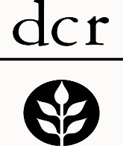
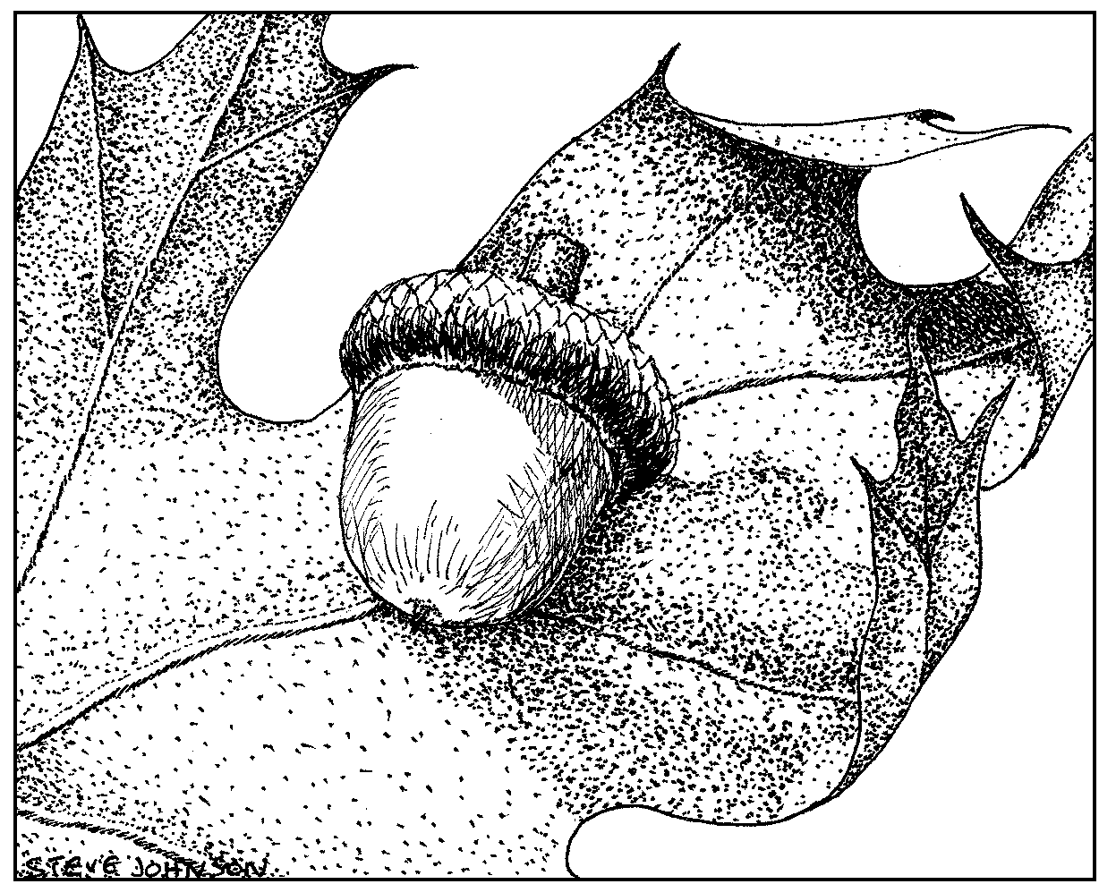
Woodland Enhancement Plan
DCR Working Forest Initiative

For property belonging to:

Prepared by:

