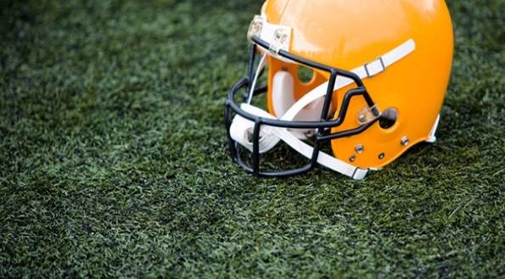

**DATA** **BRIEF:** **Sports-Related** **Concussions** **among** **Massachusetts** **Youth**

**Health** **Survey** **Program,** **Office** **of** **Data** **Management** **and** **Outcomes** **Assessment Summer** **2016**

**Massachusetts** **Department** **of** **Public** **Health** **|** [**www.mass.gov/dph/hsp**](http://www.mass.gov/dph/hsp)

Passed in 2011, the *Head* *Injuries* *and* *Concussions* *in* *Extracurricular* *Activities* regulations apply to all public middle and high schools with grades 6-12 that provide extracurricular sports activities. They also apply to other schools subject to rules of the Massachusetts Interscholastic Athletic Association. The regulations mandate:

**0**

**Middle** **school**

**Introduction**

Concussions are serious, particularly for young developing brains. For some students, symptoms can last weeks or months. A concussion is a type of traumatic brain injury caused by a bump, blow, or jolt to the head or by a hit to the body that causes the head and brain to move rapidly back and forth. This can damage brain cells and create chemical changes in the brain. Although concussions are usually not life-threatening, the effects of a concussion can cause long-term memory, learning, motor control, and/or speech problems.1 Youth concussion safety laws have now been passed by all 50 states.

The Massachusetts Department of Public Health (MDPH)’s Youth Health Survey asks middle and high school students if they have experienced symptoms† of a concussion in the last year, and if so, what actions were taken. This fact sheet describes data on youth sports concussions and policies in Massachusetts to both prevent concussions among youth and ensure that appropriate management is followed.

1

**Massachusetts** **Sports** **Concussion** **Regulation** **(105** **CMR** **201.000)**

▪Schools and school districts must have policies governing the prevention and management of concussions; ▪School staff, students, and parents must take an annual training on sports-related concussions;

▪Student athletes prior to every sports season must submit the Pre-participation Form;

▪Any student showing signs and symptoms of a concussion must be removed from play immediately, may not return to practice that day, and must be medically evaluated before returning to play;

▪Every student who is diagnosed with a concussion must have a graduated “Return to Play” plan and must not return to practice until he/she is medically cleared.

▪Specifically identified clinicians who have verified MDPH-approved training on post-traumatic head injury management are authorized to provide medical clearance.

For more information, go to: www.mass.gov/sportsconcussion

21.3

18.3 *

15.7 * 14.0

†Symptoms include being “knocked out”, memory problems, double or blurry vision, headaches, “pressure” in the head, nausea or vomiting.

**High** **school** *Significantly lower than in 2009 and 2011.

**5**

**10**

**15**

**20** 19.2 20.8 19.9 19.3

**Percent**

2009 2011 2013 2015 **25**

Source: Massachusetts Youth Health Survey 2009-2015

**Figure** **1.** **Percent** **of** **MA** **student** **athletes** **who** **reported** **symptoms†** **of** **a** **concussion** **while** **playing** **sports** **in** **past** **12** **months**



**Massachusetts** **Youth** **Health** **Survey** **Findings**

**Technical** **notes:** Percent calculated do not include missing responses. Youth Health Survey data are self-reported, voluntary, cross-sectional, and from a sample of public school students. Students in private schools, state custody, or other educational settings are not represented. Students who have severe limitations or disabilities, or who are often absent from school may be under-represented. Statistical significance set at the 95% confidence level.

▪In 2015, 19% of middle school and 14% of high school student athletes reported symptoms of a

▪Almost 50% of students who reported symptoms of a sports-related concussion continued to

2

sports-related concussion (Fig. 1).

▪The percentages of high school students reporting these symptoms in 2015 and 2013 were significantly lower than prior years, while the percentages for middle school students have remained relatively constant (Fig. 1).

Play sports that day (Fig. 2).

**Conclusions** **and** **Next** **Steps**

▪In 2015, 19% of middle school and 14% of high school student athletes reported symptoms of a sports concussion in the past year. In addition, almost half of student athletes may not be reporting symptoms and receiving the appropriate medical evaluation.

▪The difference in prevalence of high school versus middle school student athletes reporting symptoms of a sports-related concussion may be due to changes in policies and practices or improved awareness at the high school level.

▪Massachusetts regulations require collaboration among and education for school staff, parents, students, and medical providers to improve the identification and management of concussions.

▪Young athletes need to be encouraged to report their symptoms and take the necessary steps to recover.

▪MDPH is implementing the sports concussion regulations and is collaborating with schools and providers to collect data and provide training and technical assistance.

**Figure** **2.** **Actions** **taken** **following** **reported** **symptoms†** **of** **a** **sports-related** **concussion** **among** **MA** **student** **athletes**

Source: Massachusetts Youth Health Survey 2015, combined middle and high school data †Symptoms included being “knocked out”, memory problems, double or blurry vision, headaches, “pressure” in the head, nausea or vomiting.

**Reference:** 1Centers for Disease Control and Prevention (2015) Heads Up. Accessed at www.cdc.gov/headsup/basics/concussion_whatis.html.

**Resources**

**MDPH’s Injury Prevention and Control Program:**

* [www.mass.gov/sportsconcussion](http://www.mass.gov/sportsconcussion)

**Massachusetts Interscholastic Athletic Association:**

* [www.miaa.net](http://www.miaa.net/)

**Brain Injury Association of MA:**

* [www.biama.org](http://www.biama.org)

**CDC** **Heads Up**:

* [www.cdc.gov/headsup/index.html](http://www.cdc.gov/headsup/index.html)