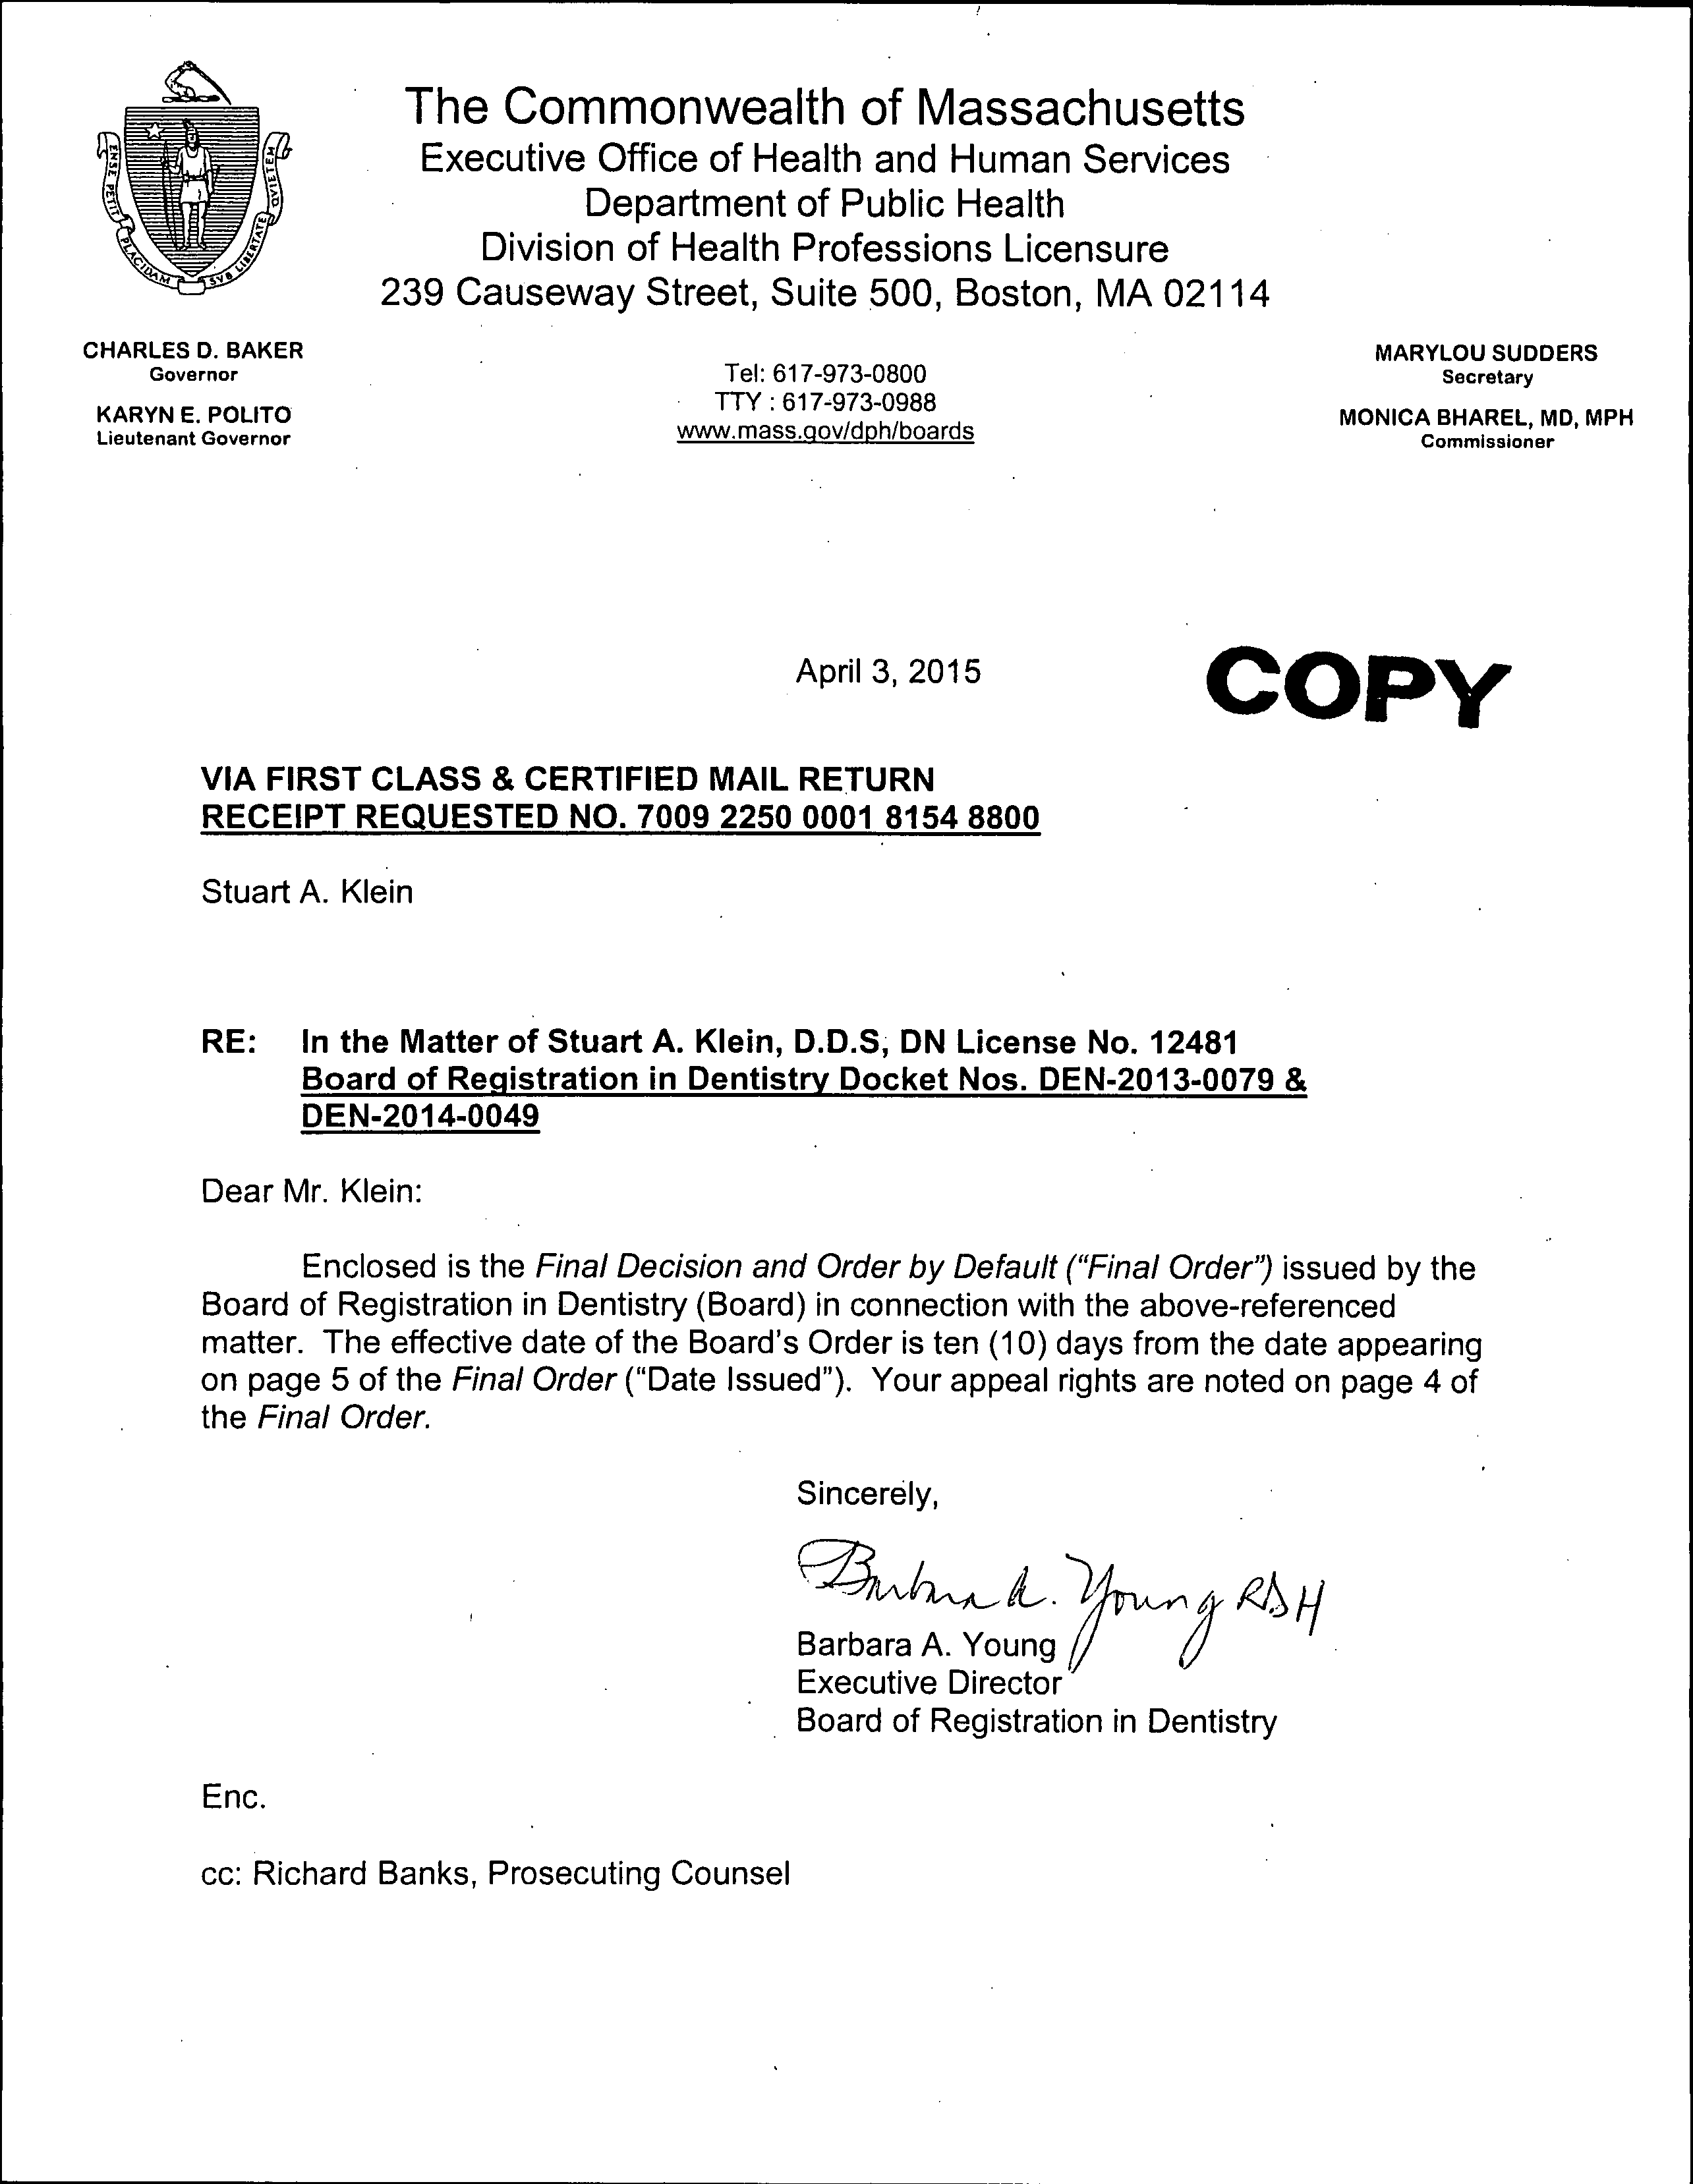

redacted

COMMONWEALTH OF MASSACHUSETTS

SUFFOLK COUNTY BOARD OF REGISTRATION IN DENTISTRY

)
In the Matter of )
STUART A. KLEIN, D.D.S. )
License No. DN12481 )
Expired 3/31/14 )

Docket Nos. DEN-2013-0079
DEN-2014-0049

FINAL DECISION AND ORDER BY DEFAULT

On December 31, 2014, the Board of Registration in Dentistry ("Board") issued and duly served on -Stuart A. Klein, D.D.S. ("Respondent") an Order to Show Cause ("Show Cause Order") 1 alleging violations of statutes and regulations relating to the practice of dentistry in Massachusetts. In addition to stating the allegations against the Respondent, the Show Cause Order notified Respondent that he was required to submit an Answer to the Show Cause Order within 21 days of receipt of the Show Cause Order.2 Additionally, the Show Cause Order also notified Respondent that he had 21 from the
receipt of the Show Cause Order in which to request a hearing on the allegations. 3 4 Both the Show Cause Order and the cover letter accompanying it notified the Respondent that failure to submit an Answer within 21 days would "[... ] result in the entry of default in the captioned matter" and, that upon making a finding of default "[ ... ] the Board may enter a Final Decision and Order that assumes the truth of the allegations in the Show_
/
Cause Order and may revoke, suspend, or take other disciplinary action against

1 Pursuant to 801 CMR 1.01(6) (a).
- In accordance with 801 CMR 1.01(6) (d) (2).
- Pursuant to M.G.L. c. 112, § 61.
4 Respondent was also notified that failure to timely submit a Request for Hearing would constitute a waiver of the right to a hearing.

Respondent's license ... including any right to renew':" Respondent's license." A copy of the Show Cause Order is attached to this Final Decision and Order by Default and is incorporated herein by reference.
As of the date of this Final Decision and Order by Default, Respondent has failed to file either an Answer or a Request for Hearing.
The Board has afforded Respondent an opportunity for a full and fair hearing on the allegations in the Show Cause Order as required by M.G.L. c. 30A, § 10, and sufficient notice of the issues involved to afford Respondent reasonable opportunity to prepare and present evidence and argument as required by M.G.L. c. 30A, § 11(1). The Board has also notified Respondent of the obligation under. 801 CMR 1.01(6)(d) to file an Answer to the Show Cause Order within 21 days of its receipt and of the consequences of failing to file an Answer or otherwise respond.
As authorized by M.G.L. c. 30A, § 10(2), the Board may make informal disposition of any adjudicatory proceeding by default. Upon default, the allegations of the complaint set forth in the Show Cause Order against Respondent are accepted as true. Danca Corp. v. Raytheon Co., 28 Mass. App. Ct. 942, 943 (1990).
Based on the foregoing, the Board enters a default in the above-captioned matter and, consequently, the allegations in the Order to Show Cause ("OTSC"), incorporated herein by reference and attached hereto at Exhibit 1, are deemed to be true and Respondent has waived the right to be heard. In accordance with the Board) authority and statutory mandate, the Board orders as follows:

ORDER

Based on its Final Decision by Default, the Board suspends indefinitely Respondent's license to practice dentistry in Massachusetts, license no. DNJ2481. The Board further suspends indefinitely Respondent's right to renew his dental license.
Respondent is hereby ordered to return any dental license or permit issued to him by the Board, whether current or expired, to the Board's office at 239 Causeway Street, Boston, Massachusetts 02114, by hand or by certified mail, within ten (10) days of the Effective Date set forth below.
Respondent shall not practice as a dentist in Massachusetts on or after the

Effective Date of this Order. "Practice as a dentist" includes, but is not limited to, holding himself out as being able to diagnose, treat, operate or prescribe for any disease, pain, injury, deficiency, deformity or other condition of the human teeth, alveolar process,
gums or jaws, and associated parts, intraorally or extraorally, or if he either offers or undertakes by any method to diagnose, treat, operate or prescribe for any disease, pain, injury, deficiency, deformity or other .condition of the same. The Board shall refer any evidence of unlicensed practice to appropriate law enforcement authorities for prosecution as provided by M.G.L. c. 112, §§52 and 65.
The Board may choose to reinstate Respondent's dental license if the Board

determines in its sole discretion that reinstatement is in the best interest of the public health, safety, and welfare.
Respondent may petition the Board for reinstatement of his dental license in

writing no earlier than one year from the effective date of this Order. Respondent's petition for reinstatement shall satisfy the requirements of 234 CMR 4.16 and the Board

may request additional documentation prior to acting on Respondent's petition for reinstatement.
The Board's approval of Respondent's petition for license reinstatement may be conditioned upon, and immediately followed by, probation of Respondent’s dental license for a period of time, as well as other restrictions and requirements that the Board may then determine in its sole discretion are in the best interest of the public health, safety, and welfare.
The Board voted to adopt the within Final Decision and Order by Default at its
meeting held on April 1, 2015, by the following vote: In favor: Dr. Stephen C. DuLong, Dr. Milton Glicksman, Dr. David Samuels, Dr. Cynthia M. Stevens, Ms. Kathleen Held, M.Ed., Ms. Lois Sobel, RDH and Ward Cromer, Ph.D.; Opposed: none; Abstained: none; Recused: none. ·

EFFECTIVE DATE OF ORDER

This Final Decision and Order by Default becomes effective upon the tenth (101h)

day from the date it is issued (see "Date Issued" below).

RIGHTTO APPEAL

Respondent is hereby notified of the right to appeal this Final Decision and Order by Default to the Supreme Judicial Court within thirty (30) days of receipt of notice of this Final Decision and Order by Default pursuant to M.G.L. c. 112, § 64 or by filing a claim for judicial review in Superior Court within thirty (30) days of receipt of notice of this Final Decision and Order by Default pursuant to M.G.L. c. 30A, § 14.

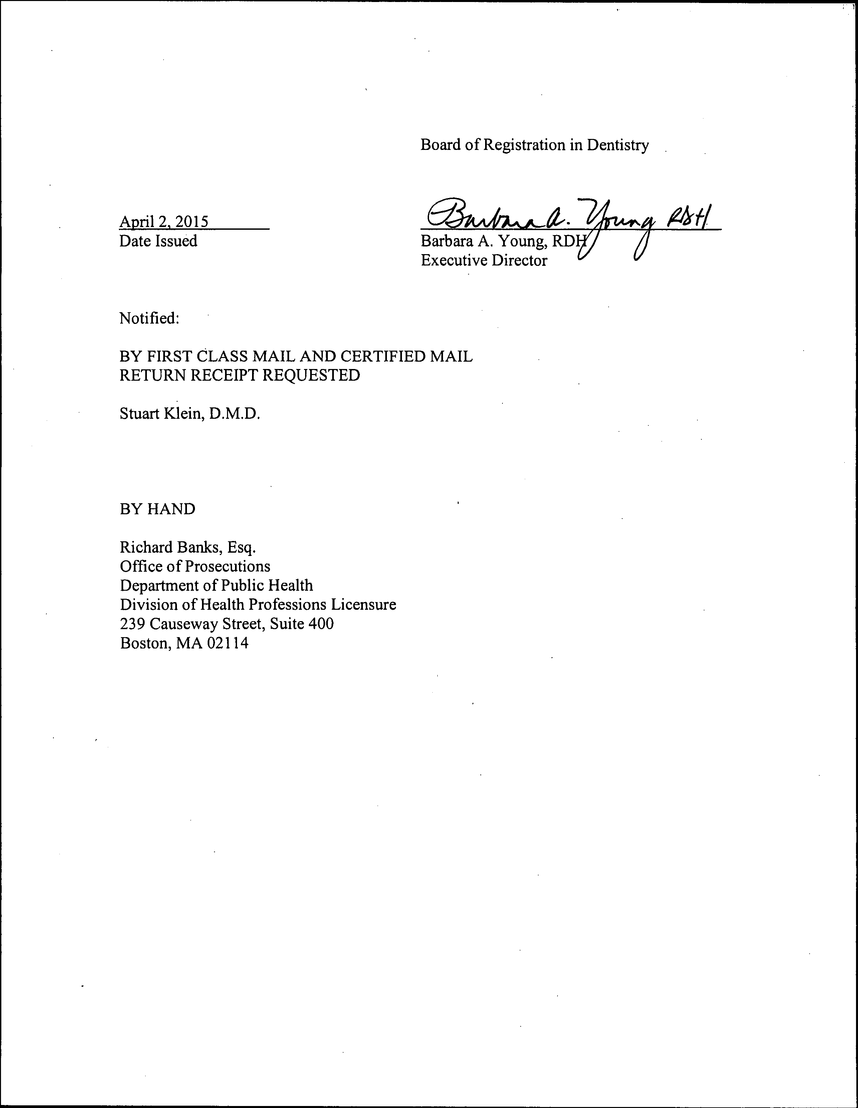

redacted

EXHIBIT 1

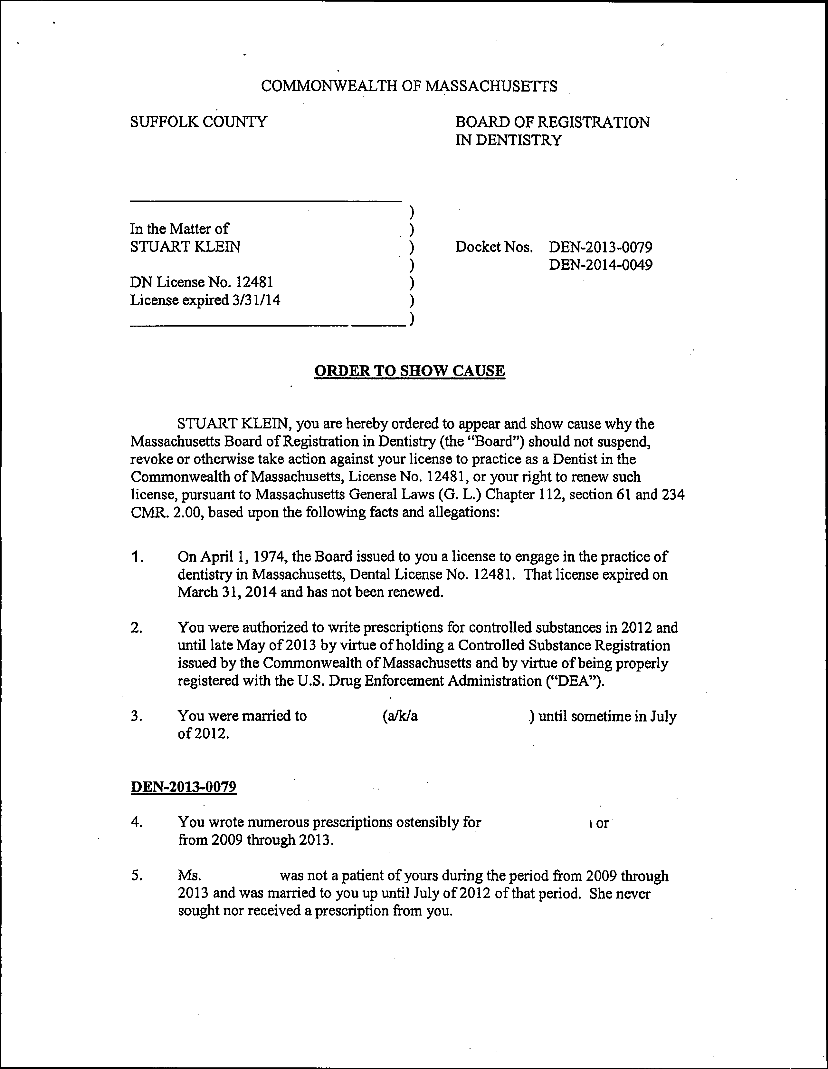

redacted redacted

redacted redacted

redacted

redacted

redacted

redacted

redacted

redacted

redacted

redacted

redacted

redacted
redacted

redacted

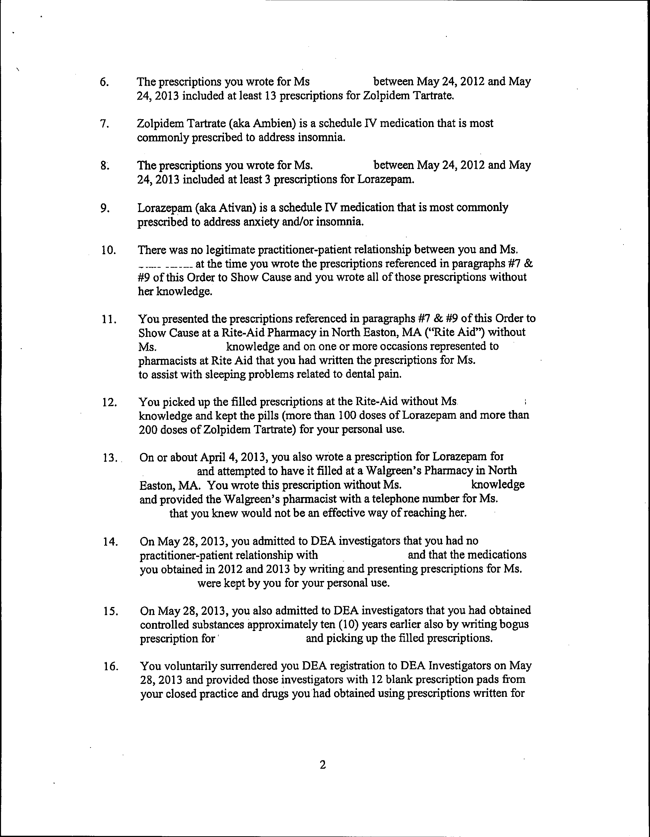
redacted

redacted

redacted

redacted

..

DEN-2014-0049

- Your Massachusetts Controlled Substance Registration expired on August 31, 2013.

- On April25, 2014, despite the fact that you had previously surrendered your DEA Registration and your Massachusetts Controlled Substance Registration had expired, you wrote a prescription for yourself for Decadron on a prescription form containing your name, the address of your former practice, and your surrendered DEA registration number.

- You presented that prescription at the Rite-Aid Pharmacy in North Easton and in an attempt to have it filled, but the pharmacist on duty at Rite-Aid refused to fill the prescription.

- You failed to furnish the Board and its investigators with documents which were requested by Board investigators. ·

***

- Your conduct warrants disciplinary action by the Board against your license to practice as a Dentist pursuant to Board regulation 234 CMR 9.05 (1) due to your misconduct in the practice of dentistry, unprofessional conduct, and/or conduct that undermines public confidence in the integrity of the dental profession.

- Your conduct warrants disciplinary action by the Board against your license to practice a8 a Dentist pursuant to Board regulation 234 CMR 9.05 (2) and your
violation of:

  - 234 CMR 5.06 (1) -prohibiting the prescribing of schedule IV controlled substances other than as allowed by M.G.L. 94C or 105 CMR 700.00 and

2) 234 CMR 5.06 (2) -prohibiting the prescribing of schedule N controlled substances for your personal use and outside the course of professional practice;

- Your conduct warrants disciplinary action by the Board against your license to practice as a Dentist pursuant to Board regulation 234 CMR 9.05 (13) by virtue of your failure to provide Board investigators with requested documents.

- Your conduct warrants disciplinary action by the Board against your license to practice as a Dentist pursuant to Board regulation 234 CMR 9.05 (14) by virtue of your having committed acts which violate recognized standards of care.

- Your conduct as described above is in violation of M.G.L. c.94C, s. 19(a) and consequently your conduct warrants disciplinary action by the Board against your license to practice as a Dentist pursuant to Board regulation 234 CMR 9.05 (19).

3

- Your conduct as described above, warrants disciplinary action by the Board against your license to practice as a Dentist pursuant to G. L. c. 112, §61 for repeated irregularities in billing third party payers.

- Your conduct, as described above, also constitutes unprofessional conduct and conduct which undermines public confidence in the integrity of the profession. Sugarman v. Board of Registration in Medicine, 422 Mass. 338, 342 (1996); see also Kvitka v. Board of Registration in Medicine, 407 Mass. 140, cert. denied, 498 U.S. 823 (1990); Raymond v. Board of Registration in Medicine, 387 Mass.
708, 713 (1982).

***

You have a right to an adjudicatory hearing (''hearing") on the allegations contained in the Order to Show Cause before the Board acts to suspend, revoke, or impose other discipline against your license. G.L. c. 112, § 61. Your right to a hearing may be claimed by submitting a written request for a hearing within twenty-one (21} days of receipt of this Order to Show Cause. You must also submit an Answer to this Order to Show Cause in accordance with 801 CMR 1.01(6) (d) within twenty-one (21} days of receipt of this Order to Show Cause. The Board will give you prior written notice of the time and place of the hearing following receipt of a written request for a hearing.

Hearings shall be conducted in accordance with the State Administrative Procedure Act, G.L. c. 30A, §§ 10 and 11, and the Standard Adjudicatory Rules of Practice and Procedure, 801 CMR 1.01 and 1.03, under which you are granted certain rights including, but not limited to, the rights: to a hearing, to secure legal counsel or another representative to represent your interests, to call and examine witnesses, to cross­ examine witnesses who testify against you, to testify on your own behalf, to introduce evidence, and to make arguments in support of your position.

The Board will make an audio recording of any hearing conducted in the captioned matter. In the event that you wish to appeal a final decision of the Board, it is incumbent on you to supply a reviewing court with a "proper record" of the proceeding,
which may include a written transcript. New Bedford Gas and Light Co. v: Board of
Assessors of Dartmouth, 368 Mass. 745, 749-750 (1975). If you wish to provide for a
written transcript, you must arrange for, and bear the cost of, a stenographer's presence at any hearing; and if a written transcript is prepared at your request, then said transcript shall also be provided to the Board, at your expense, for inclusion in the record. G.L. c. 30A, § 11(6), 801 CMR 1.01 10(k); 801 CMR 1.01 10(i).

Your failure to submit a written request for a hearing within 21 days of receipt of this Order to Show Cause shall constitute a waiver of the right to a hearing on the allegations herein and on any Board disciplinary action. Your failure to submit an Answer to the Order to Show Cause within 21 days of receipt of the Order to Show Cause shall result in the entry of default in the captioned matter. If you are defaulted, the Board may enter a Final Decision and Order that assumes the truth of the allegations in this Order to Show Cause, and may revoke, suspend, or take other disciplinary action against your license to practice as a Dentist in the Commonwealth of Massachusetts, including any right to renew your license.
4

A copy of any written request for a hearing and a copy of your Answer, as well as copies of all future pleadings related to the captioned matter, shall be provided to Prosecuting Counsel. Prosecuting Counsel for this matter is: ·

Richard L. Banks, Jr., Esq. Prosecuting Counsel
Office of the General Counsel Department of Public Health
239 Causeway Street
Boston, MA 02114

You or your representative may examine Board records relative to this case prior to the date of the hearing during regular business hours at the office of the Prosecuting Counsel. If you elect to undertake such an examination, then please contact Prosecuting Counsel in advance at (617) 973-0835 to schedule a time that is mutually convenient.

By:
BOARD OF REGISTRATION
IN DENTISTRY,

Dr. Cynthia Stevens, Chairman

Richard L. Banks, Jr. Esq. Department of Public Health
..,

5

